CW-06 Step 2 Reading Comprehension Check
Student Name: Tanuska Biswakarma
Student ID: 002682850
Date: 04/23/2026

SECTION A — Key Concept Explanations
1) Why DECIMAL(10,2) instead of FLOAT for salary?
Response (4-6 sentences): DECIMAL(10,2) is used for salary because it stores numbers exactly as they are, with two digits after the decimal point. This is important for money, where even a small rounding error can cause problems in calculations like totals or taxes. FLOAT, on the other hand, stores numbers approximately, which can lead to slight inaccuracies. These small errors may not seem big, but they can add up over time in financial data. Using DECIMAL ensures that values stay accurate and consistent. That’s why it is the better choice for storing salaries.

2) WHERE vs HAVING with one query example
Response (4-6 sentences): WHERE and HAVING are both used to filter data, but they work at different stages of a query. WHERE filters rows before grouping happens, while HAVING filters the grouped results after calculations like COUNT or SUM. For example, in a query that counts employees in each department, WHERE salary > 50000 removes rows before grouping, and HAVING COUNT(*) > 5keeps only departments with more than 5 employees. You cannot use aggregate functions like COUNT in the WHEREclause. Instead, you must use HAVING for that purpose. Understanding this difference helps you write correct queries.

3) PRIMARY KEY + AUTO_INCREMENT and data integrity
Response (4-6 sentences): A PRIMARY KEY makes sure that each row in a table is unique and cannot be empty. When you add AUTO_INCREMENT, the database automatically gives each new row a unique number. This helps avoid mistakes like duplicate IDs or missing values. It also makes it easier to connect tables using relationships, since each record can be clearly identified. This combination improves data integrity by keeping the data accurate and organized. Overall, it helps maintain a reliable database structure.

4) SQL execution order and debugging
Response (4-6 sentences): SQL does not run queries in the same order they are written, which can sometimes be confusing. The database processes parts of the query in a specific order, starting with FROM, then WHERE, followed by GROUP BY, HAVING, SELECT, and finally ORDER BY. Knowing this order helps explain why some things, like column aliases, cannot be used in certain parts of the query. When debugging, you can check each step to find where the problem occurs. This makes it easier to fix errors and understand how your query works. Learning the execution order is very helpful for writing and troubleshooting SQL.

SECTION B — Applied SQL Examples
Example A (Filtering + Sorting)
SQL Query:
-- Filter by department
SELECT emp_name, salary
FROM employees
WHERE department_name = 'Engineering'
ORDER BY salary DESC;

Output evidence (paste screenshot/table):
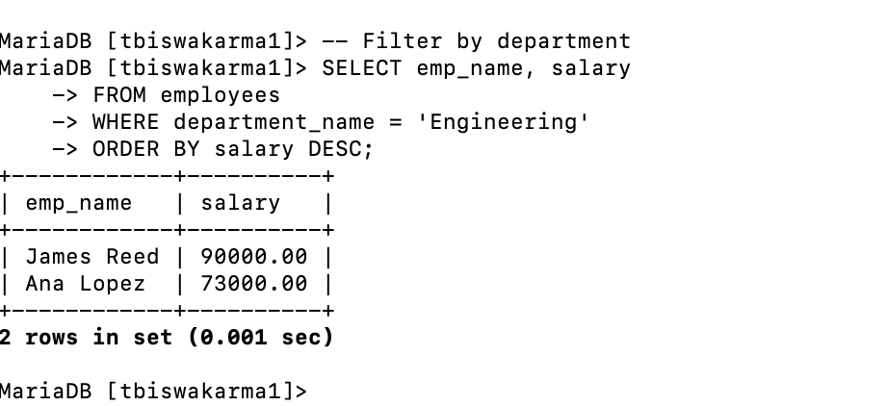
Interpretation (3-5 sentences): The query shows employees who work in the Engineering department and lists their salaries from highest to lowest. From the result, James Reed earns the highest salary at 90,000, followed by Ana Lopez with 73,000. This means the sorting using ORDER BY salary DESC is working correctly. Only employees from the Engineering department are included, so the WHERE condition is also correct. Overall, the query successfully filters and organizes the data as intended.

Example B (Aggregate/Group)
SQL Query:
-- Group by department with avg salary
SELECT department_name, COUNT(*) AS emp_count,
AVG(salary) AS avg_sal
FROM employees
GROUP BY department_name;
Output evidence (paste screenshot/table):
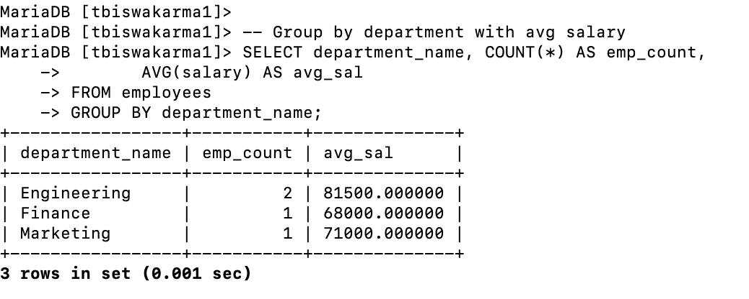
Interpretation (3-5 sentences): This query groups employees by their department and calculates how many employees are in each one along with the average salary. From the result, the Engineering department has 2 employees with an average salary of 81,500. Finance and Marketing each have 1 employee, with average salaries of 68,000 and 71,000. This shows that Engineering has the highest overall average salary among the departments. The query correctly uses GROUP BY to organize the data and COUNT and AVG to summarize it.

SECTION C — Reading Reflection
Prompt: How did Step 2 SQL understanding change your plan for Step 3 PHP CRUD?
Response (1-2 paragraphs): Step 2 helped me better understand how to organize and retrieve data using SQL, which made planning Step 3 much clearer. I learned how to filter data with WHERE, group it with GROUP BY, and use functions like COUNT and AVG. This showed me how the database will respond to different queries, so I can design my PHP CRUD operations more effectively. For example, I now know how to write queries for reading (SELECT) specific records or summarizing data when needed.
Because of this understanding, I can plan my PHP CRUD functions with more confidence. I know how to structure queries for creating, reading, updating, and deleting data, and how to make sure the right data is being handled. It also helps me avoid mistakes, like using the wrong conditions or not grouping data properly. Overall, Step 2 made it easier to connect the database part with the PHP code in Step 3.

Academic Integrity Statement:
I confirm these responses are my own work and reflect my understanding of the Step 2 reading assignment.

