**PROJECT TITLE:**

**To Supply Leftover Food to Poor**

**College Name: SRI KRISHNA ADITHYA COLLEGE OF ARTS AND SCIENCE COIMBATORE-641042.**

**College Code**: bruag

**TEAM ID : NM2025TMID22147**

**TEAM MEMBERS ARE:**

**Team Leader Name:** Tanusri P

**Email:**  tanusri16p@gmail.com

**Team Member:** SUBHASHINI M

**Email: msubhashini0402@gmail.com**

**Team Member:** SUBHIKSHAA A

**Email: subhikshaa000** @gmail.com

**Team Member:** SURRUTHI S

**Email:**  23bsit161surruthis@skacas.ac.in

**INTRODUCTION:**

Food wastage is one of the major problems in society. At the same time, many people are suffering from hunger. Our project aims to collect leftover food from hotels, restaurants, hostels, and households and distribute it to needy people through volunteers.

**Objective:**

Reduce food wastage.

Supply food to poor and homeless people.

Create awareness about food donation.

Build a sustainable system with technology.

**DEVELOPMENT PHASE:**

**Creating Developer Account:**

**By using this URL - https://www.salesforce.com/form/developer-signup/?d=pb**

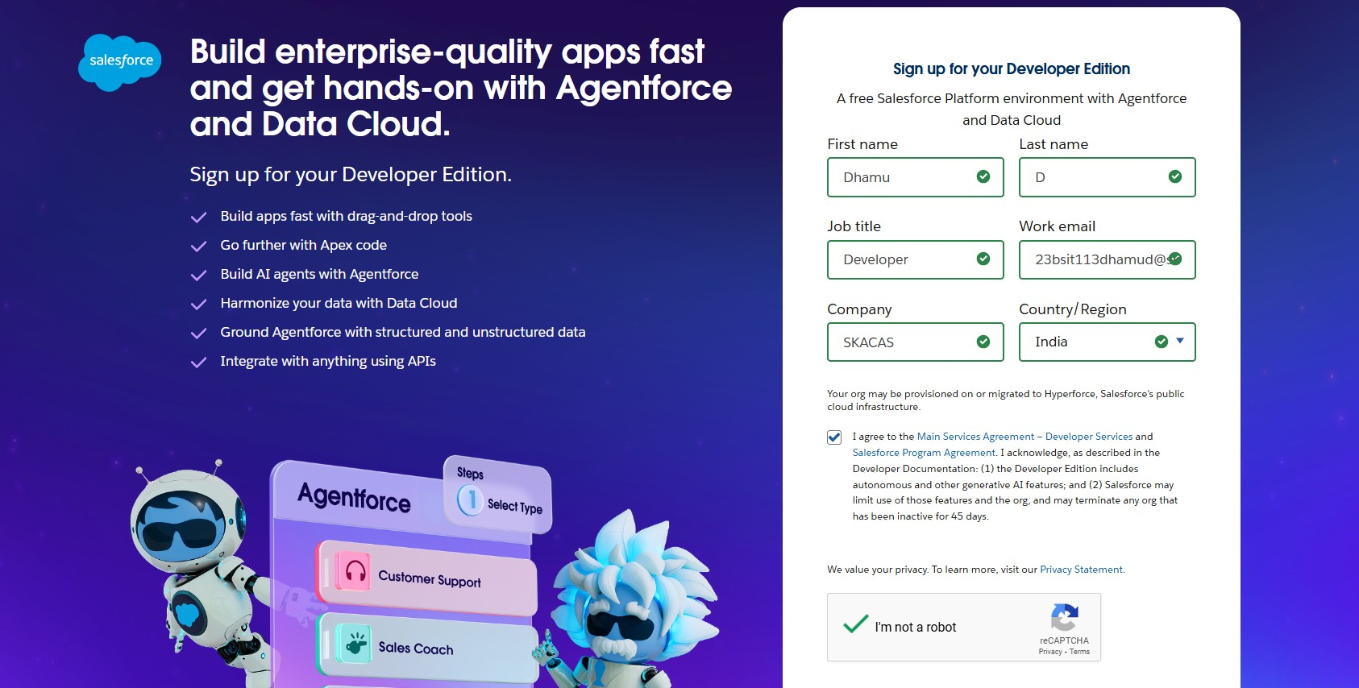

Created objects:

* Venue
* Drop-Off Point
* Task
* Volunteer
* Execution Detail

•

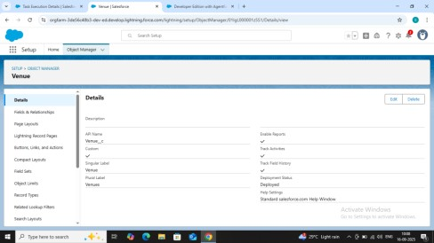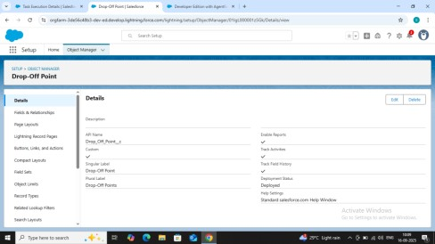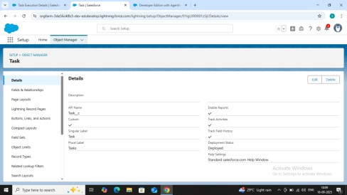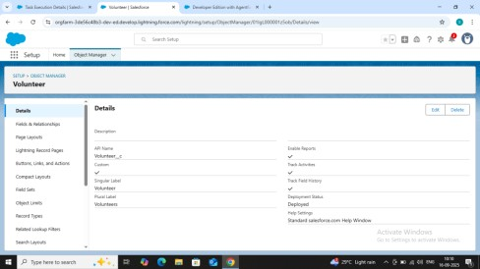

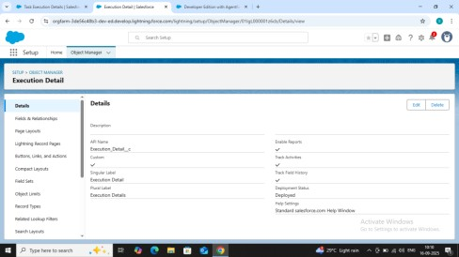

**Created tab:**

* Venue
* Drop-Off Point
* Task
* Volunteer
* Execution Detail

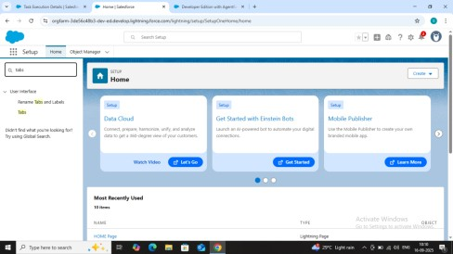

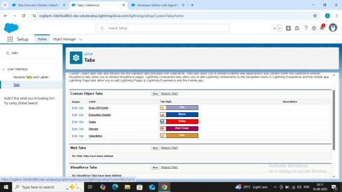

**Created lightning app:**

App Name : FoodConnect

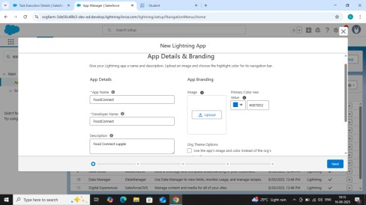

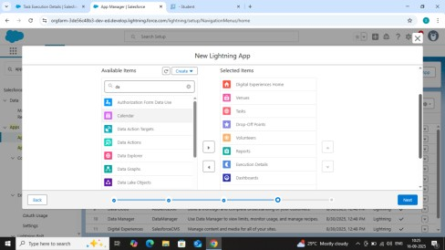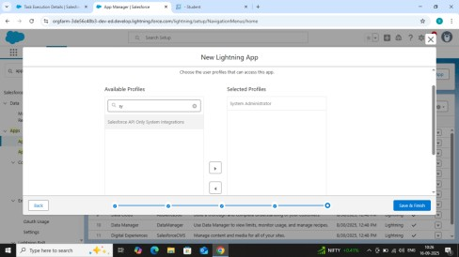

# Creation of fields for the Venue object

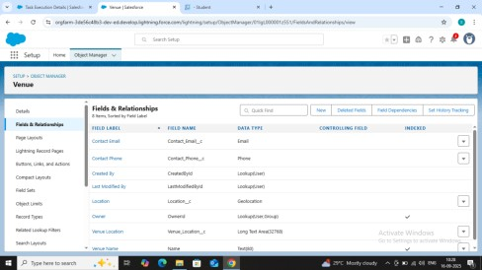

# Creation of fields for the Drop-Off point object

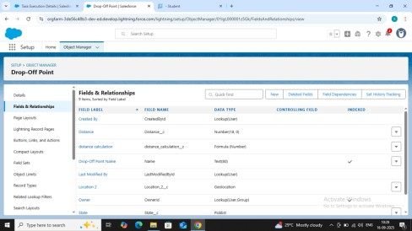

# Creation of fields for the Task object

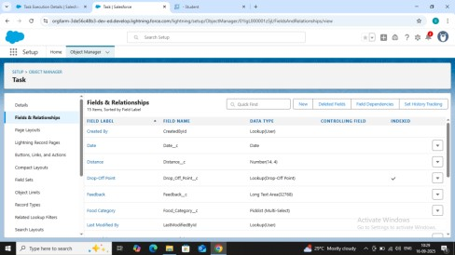

# Creation of fields for the Volunteer object

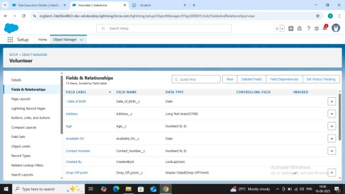

# Creation of fields for the Execution Details object

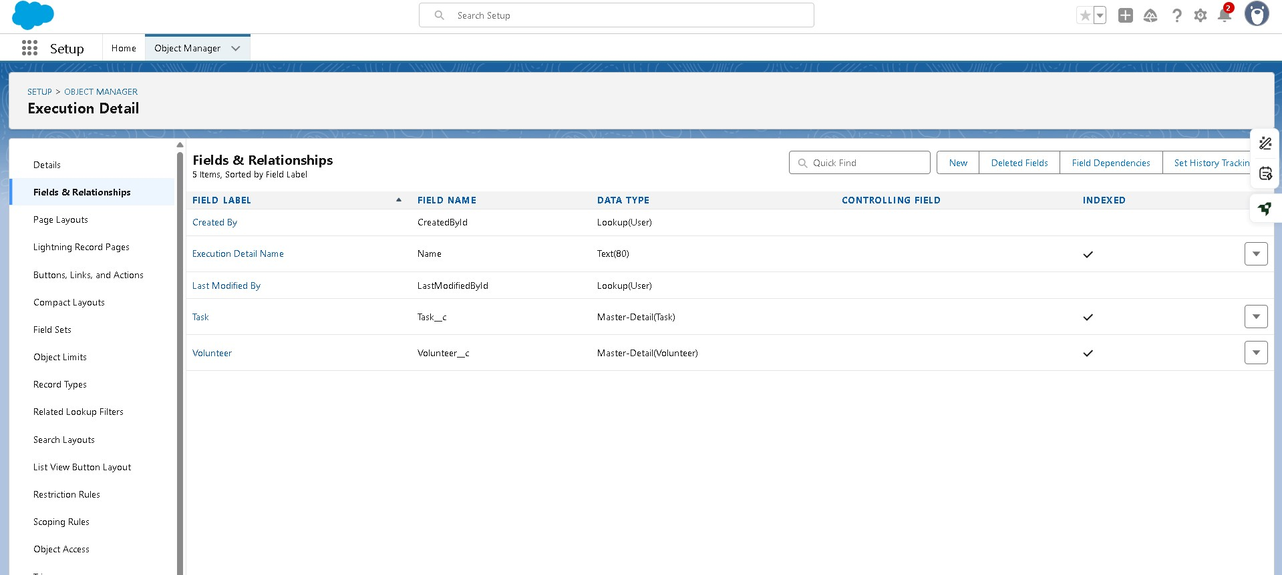

**Create Flow to create a record in Venue object**

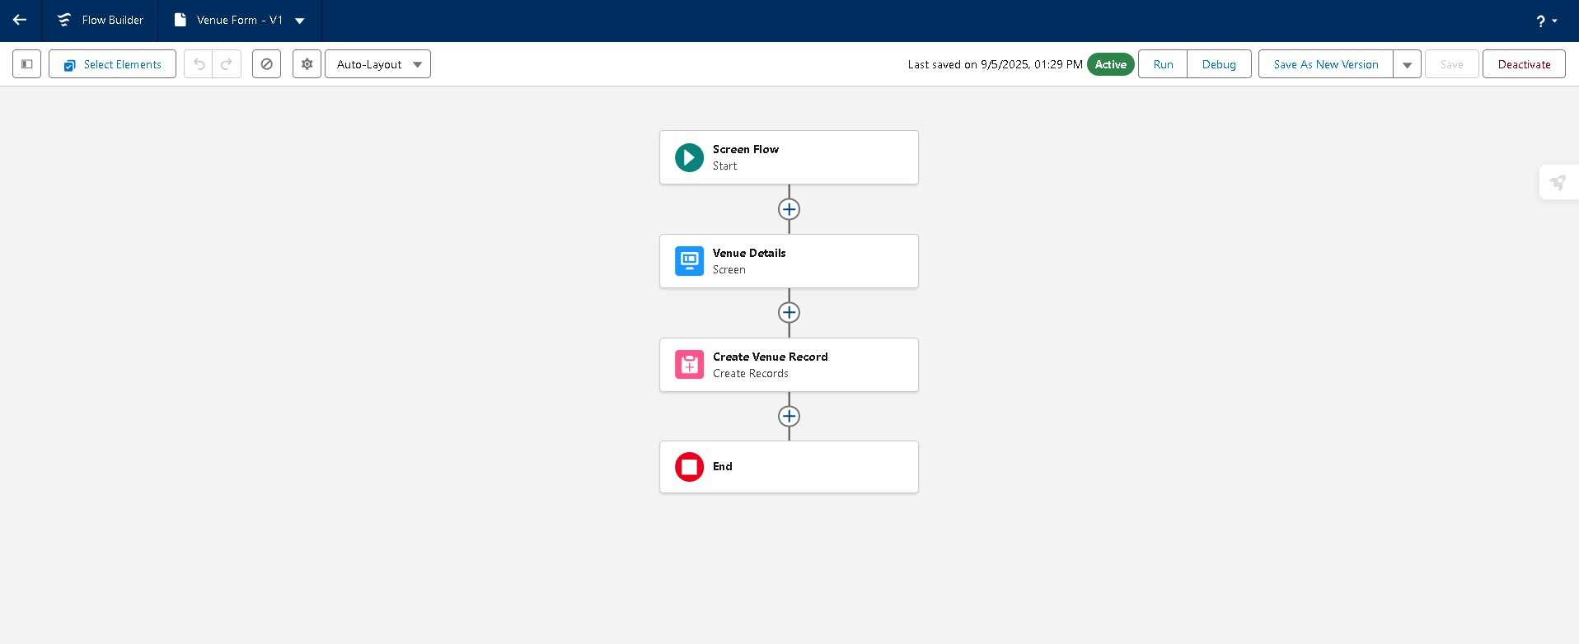

# Create a DropOffTrigger

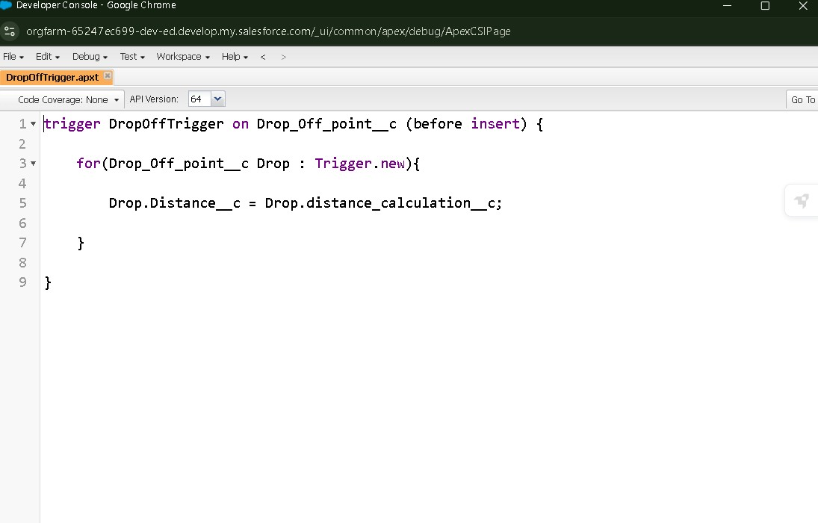

# Create a NGOs Profile

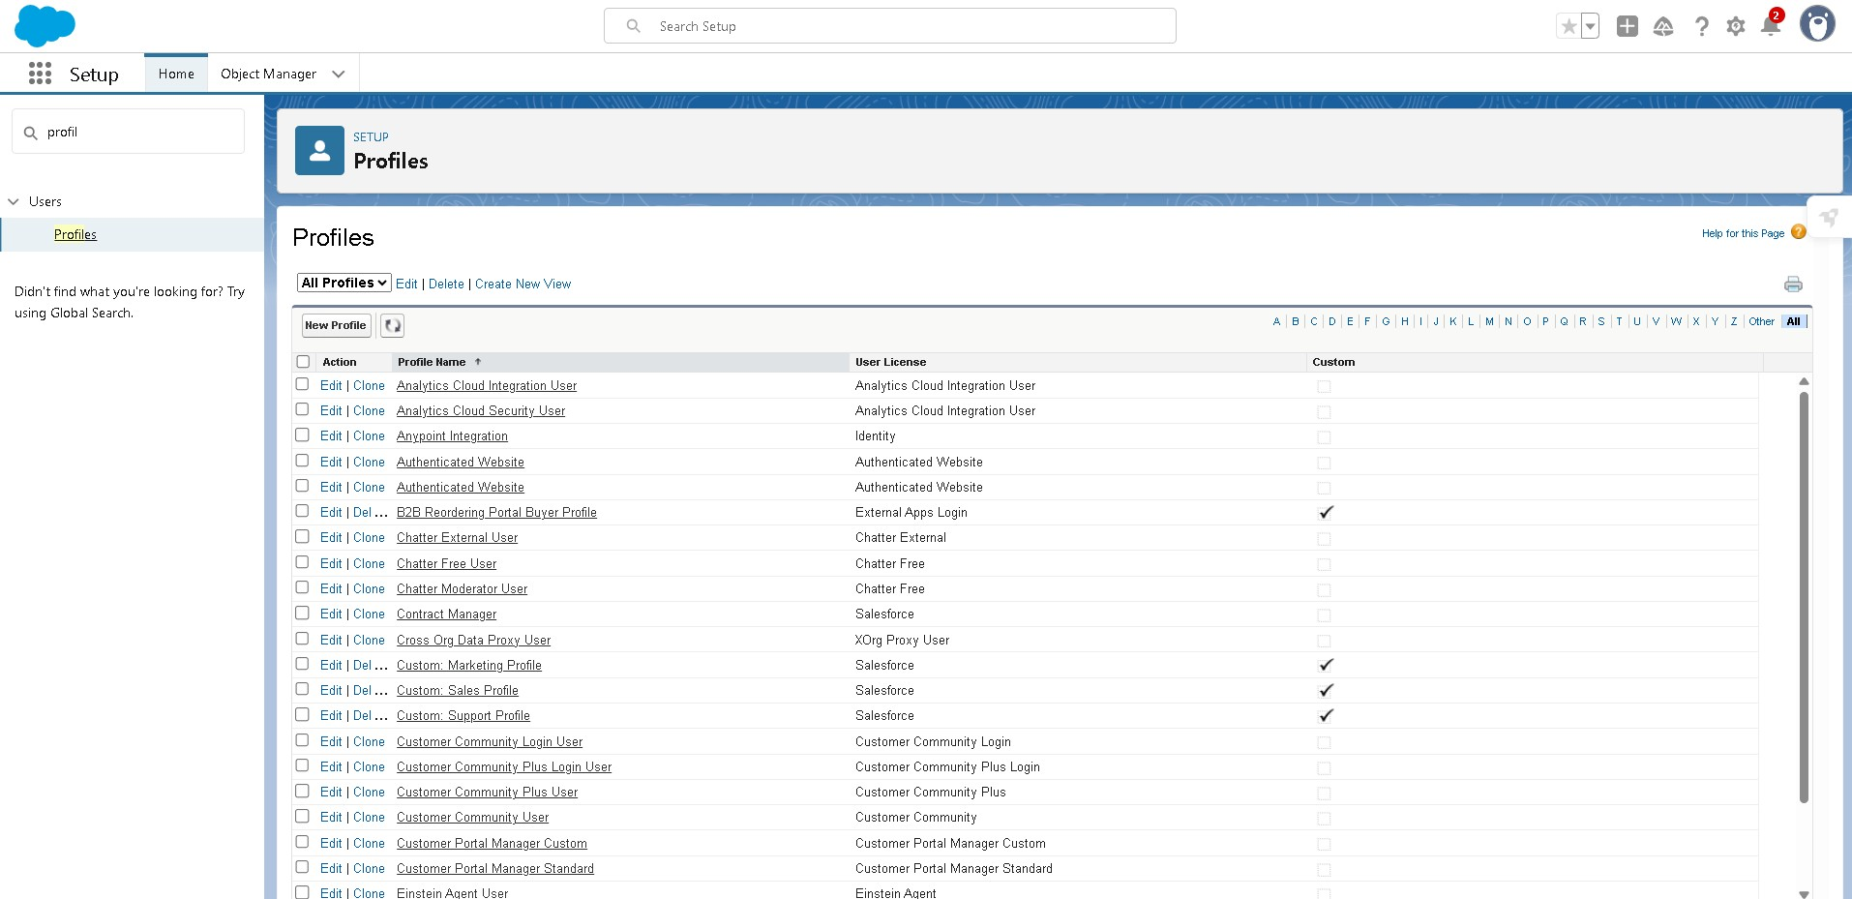

# Creation of User1

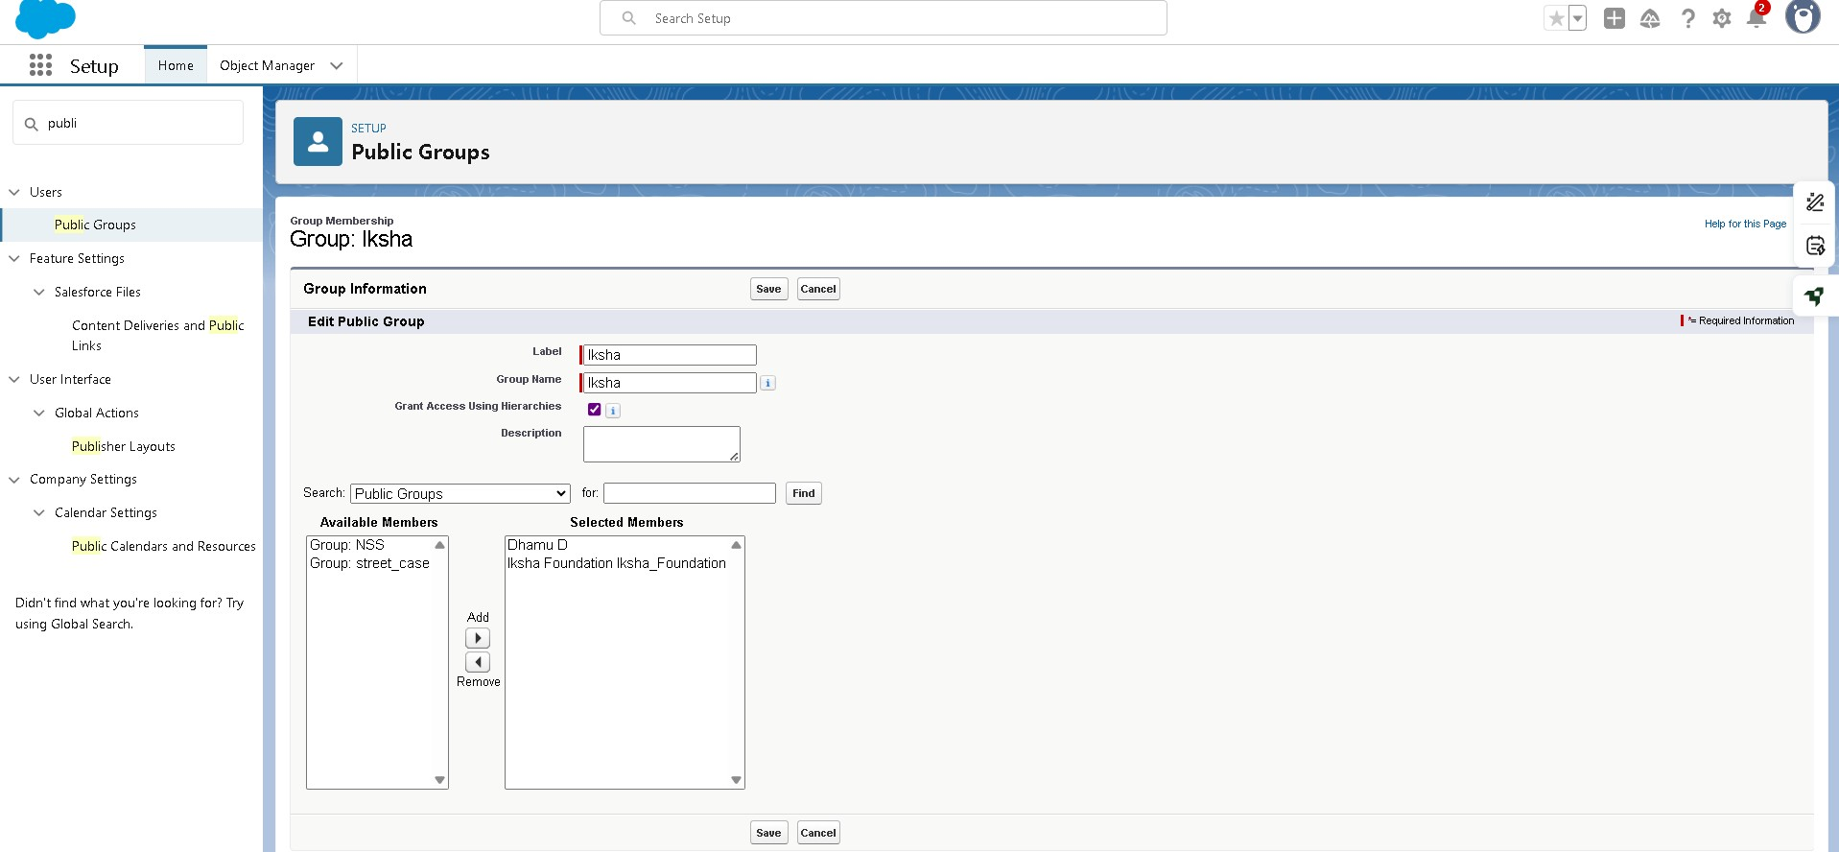

# Creation of User2

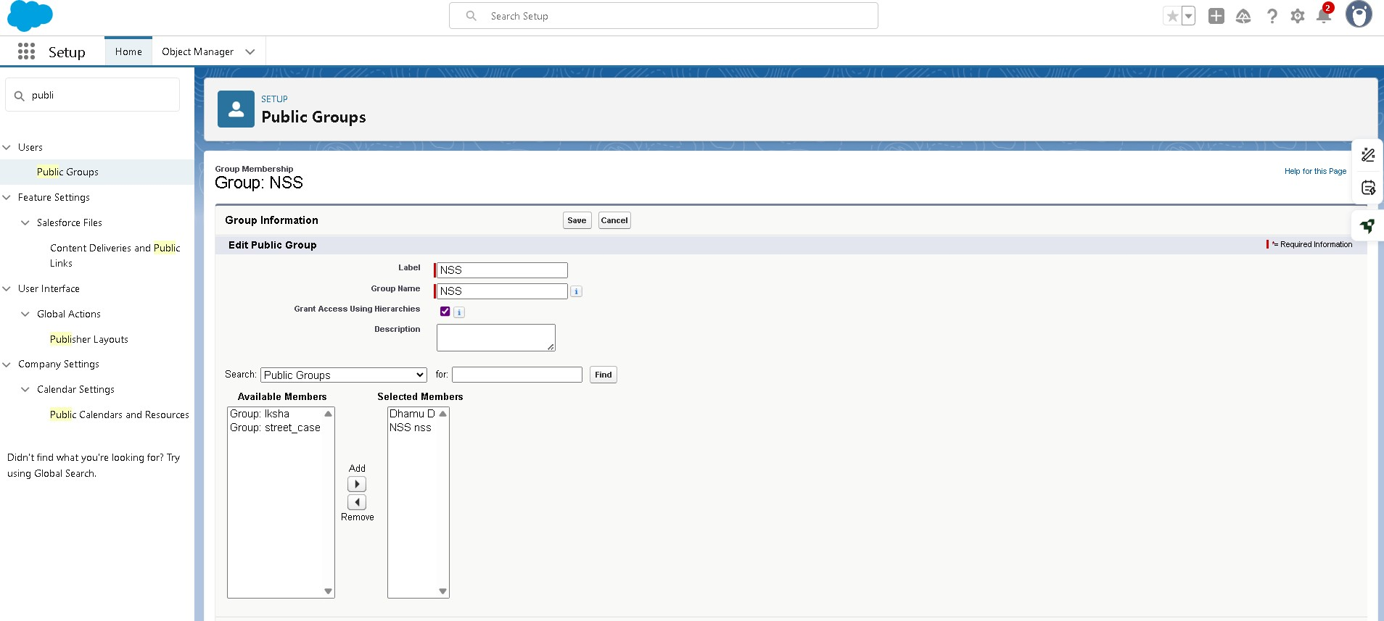

# Creation of User3

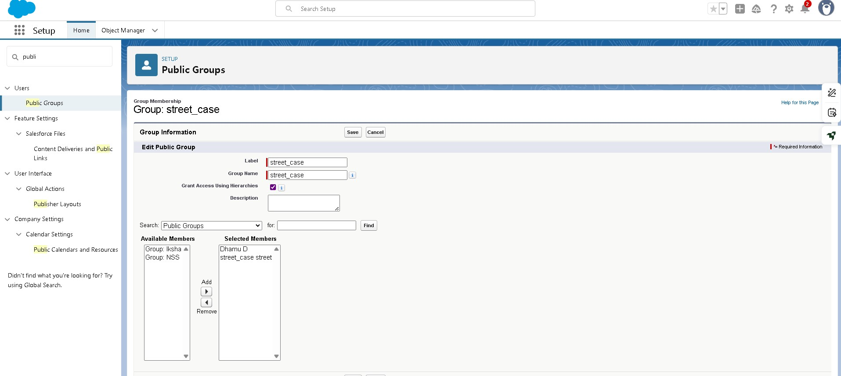

# Creation of Public Groups

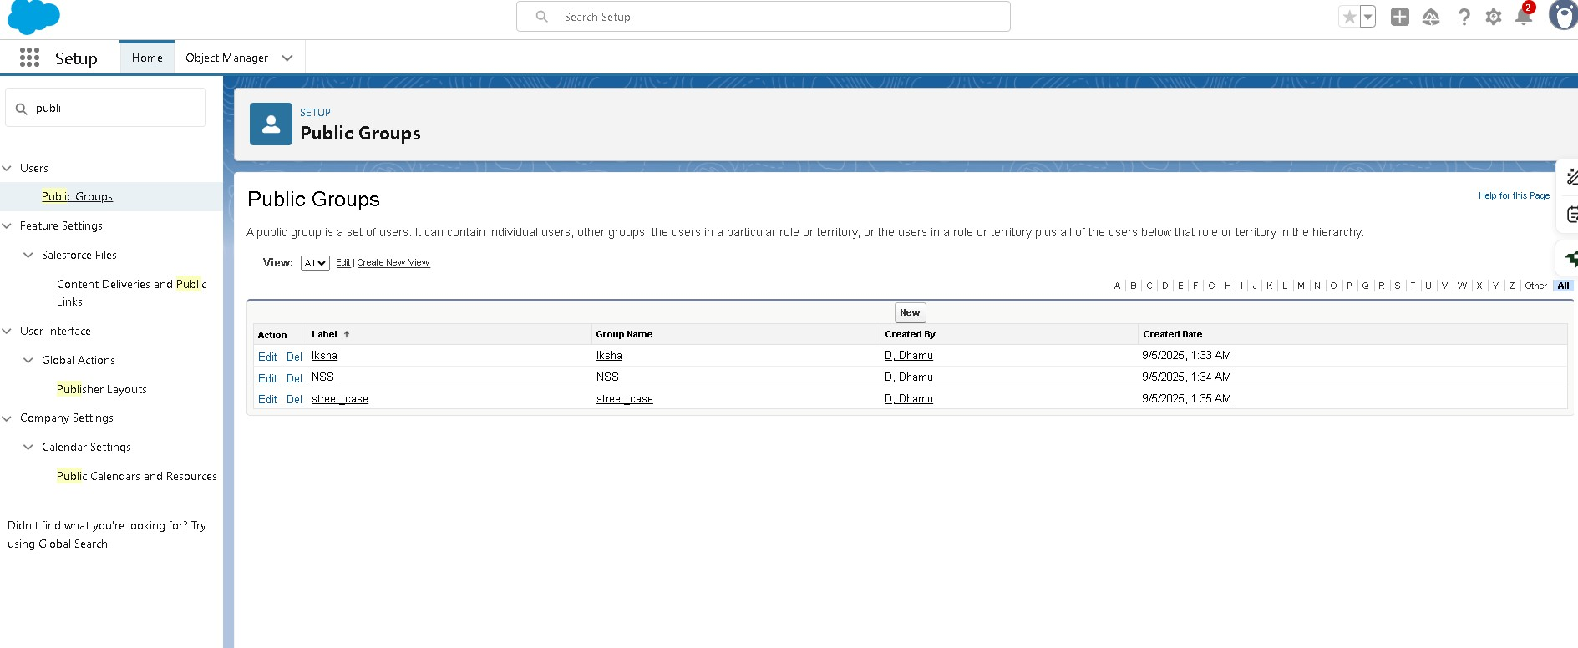

# Creation of Report Types

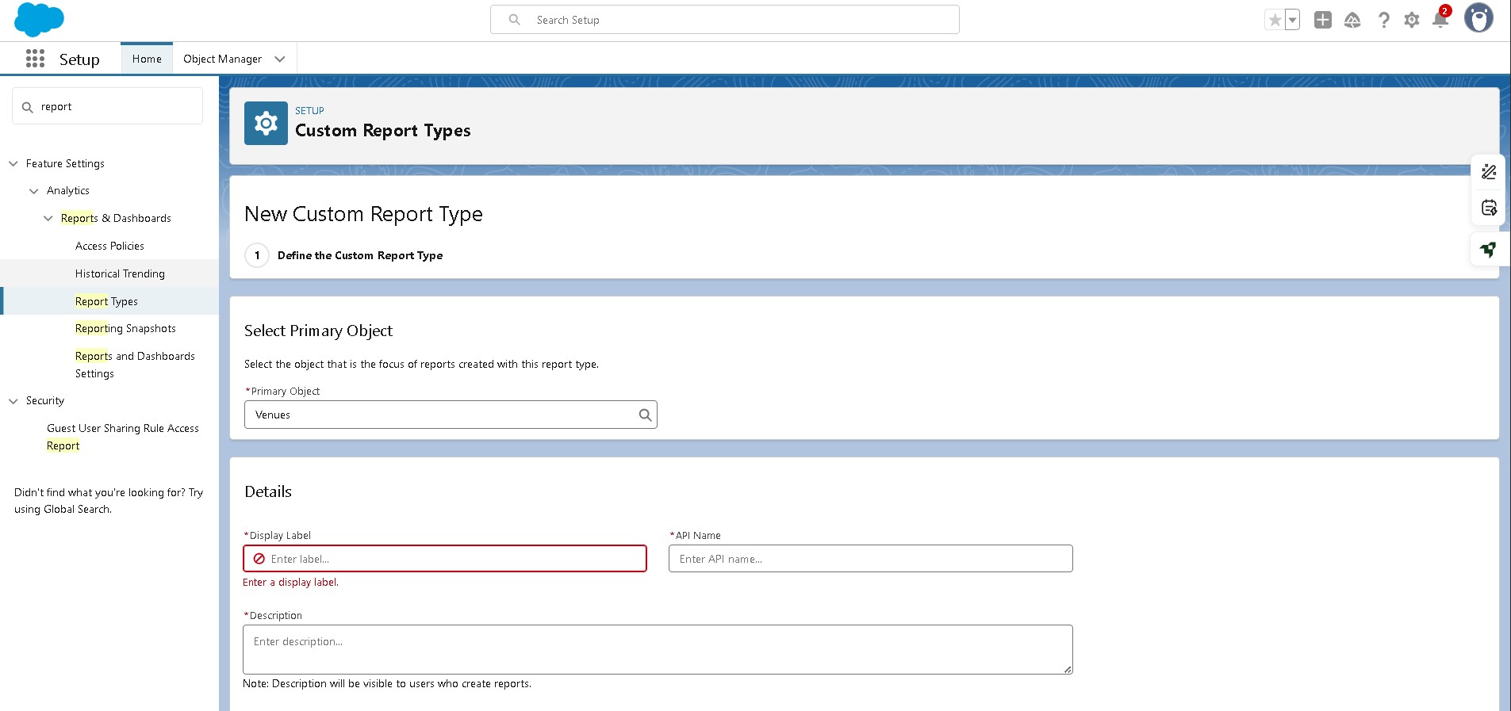

# Creation of Report

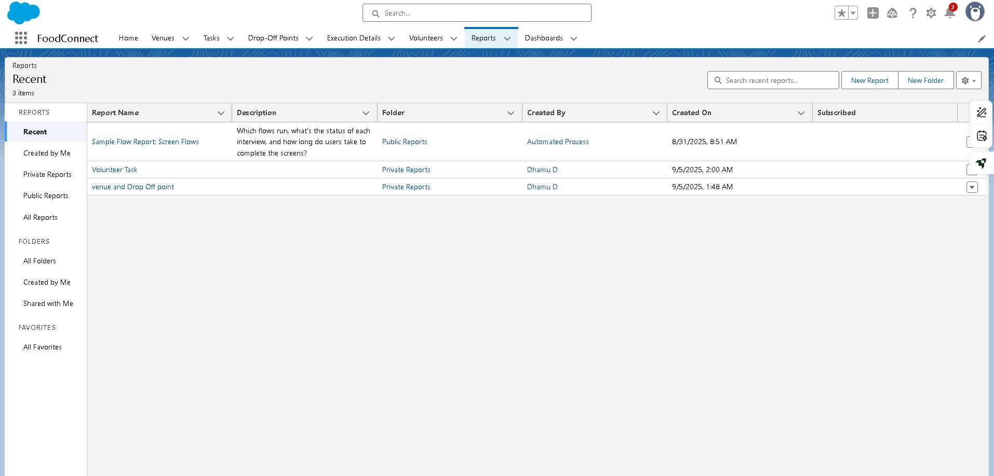

# Adding venue and Drop Off point,Report to the Dashboard

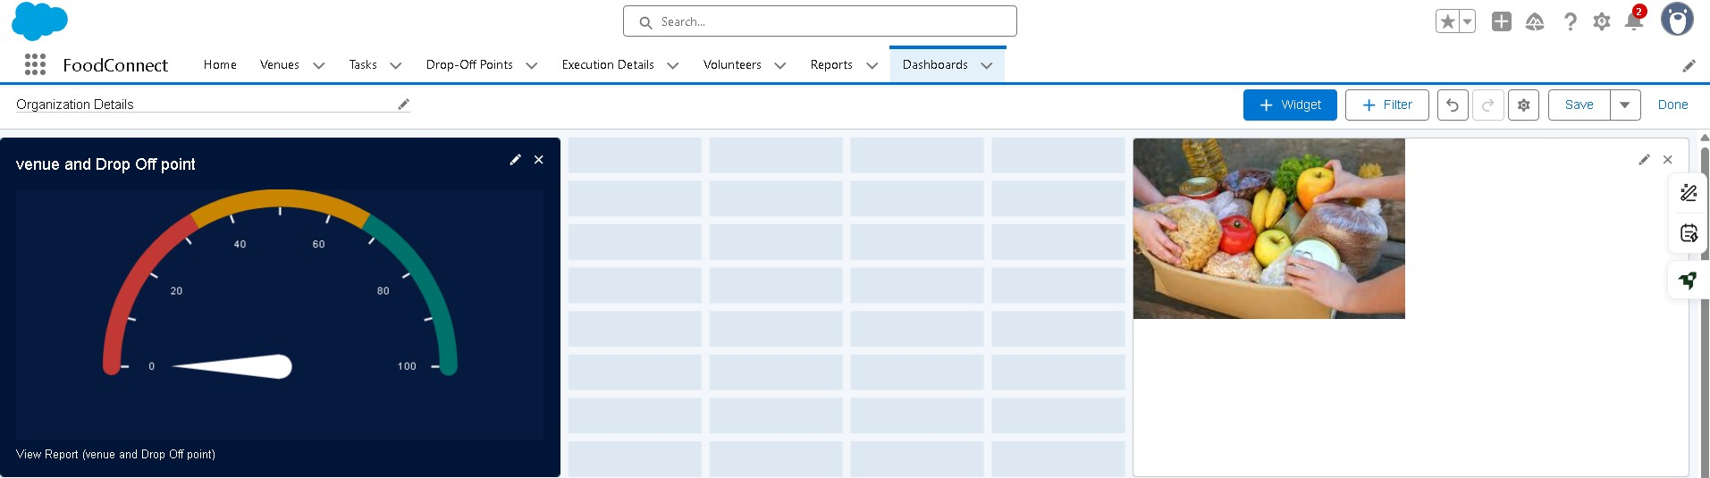

# Adding Volunteer Task Report to the Dashboard

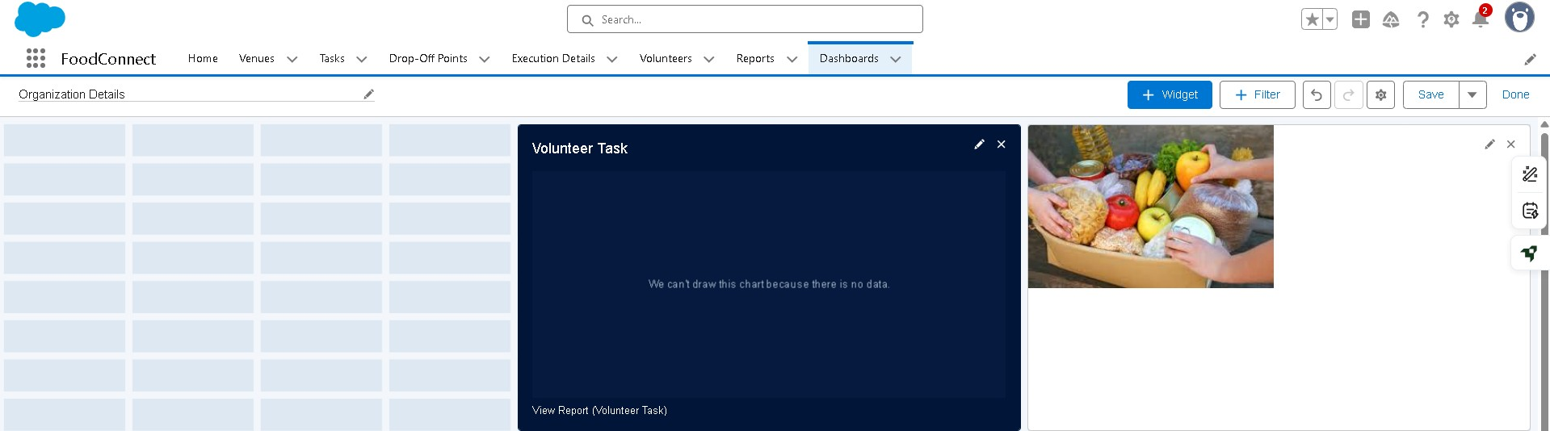

# Creation of sharing rules

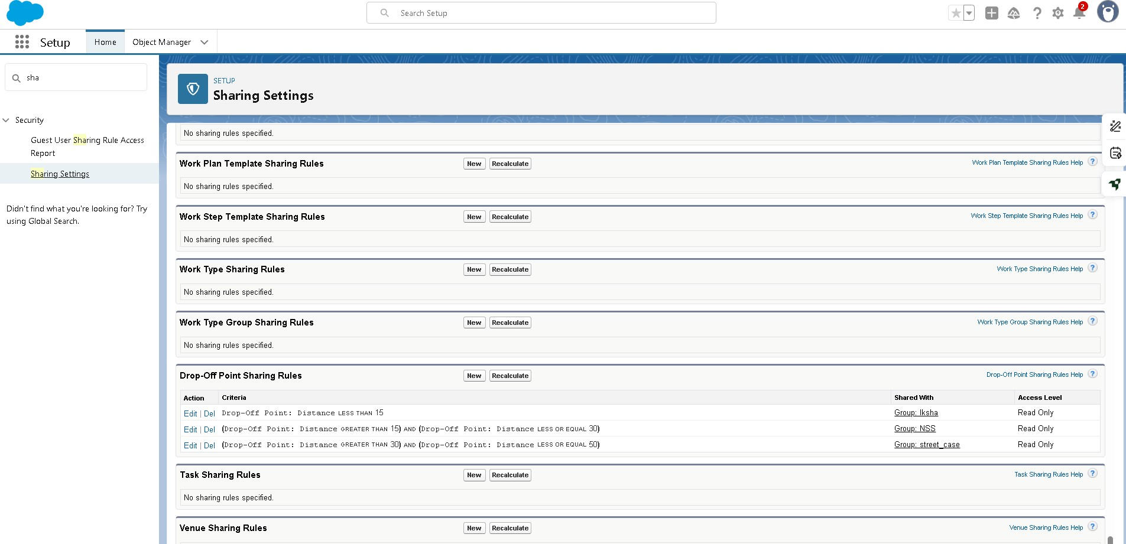

# Result of Home Page

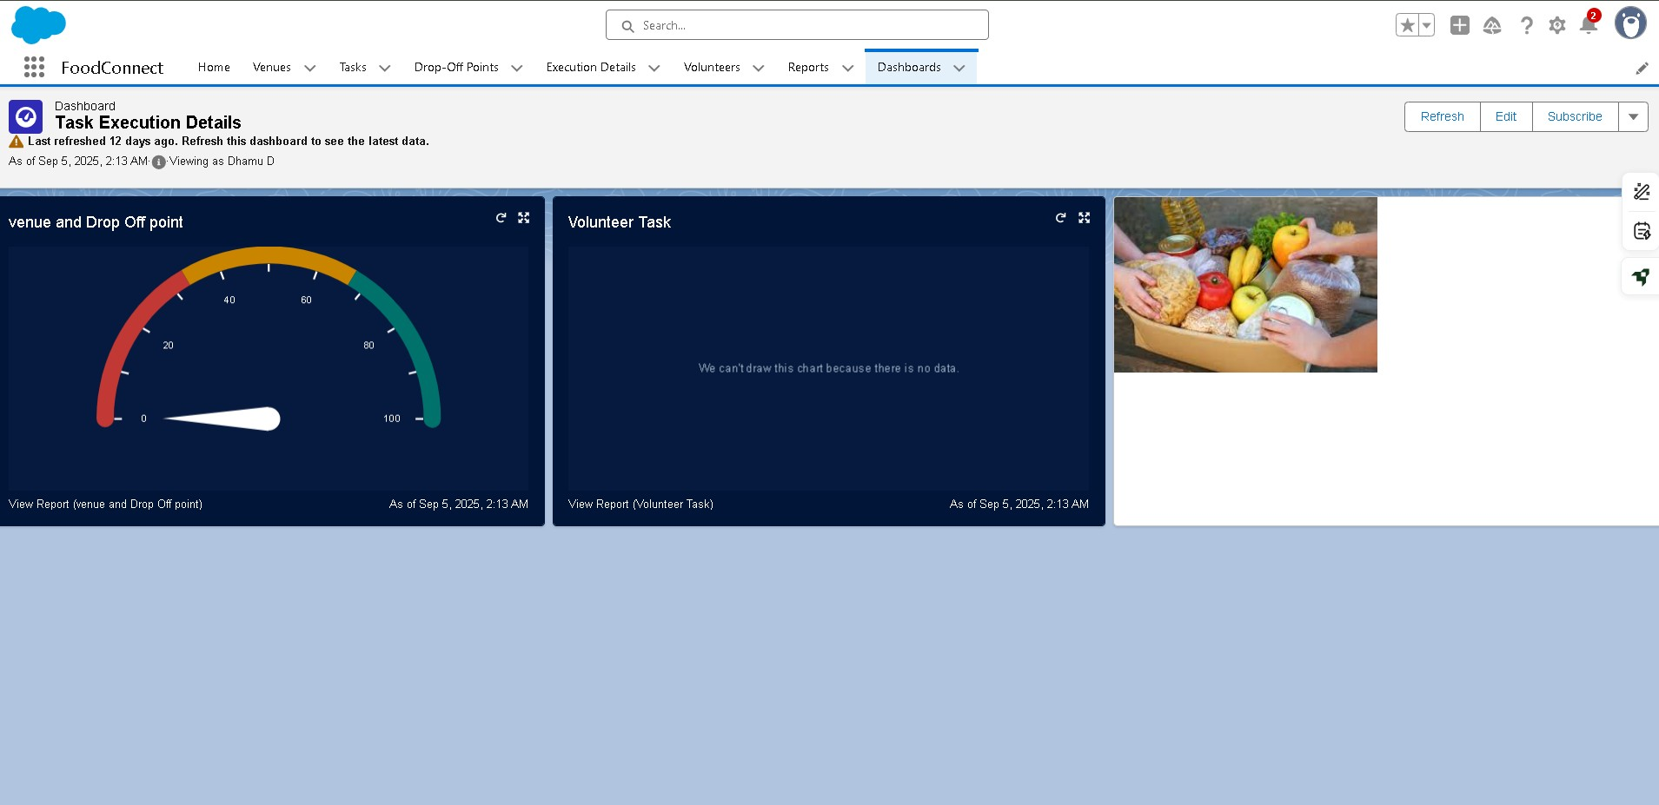

**Conclusion**

This project provides a practical solution to two major issues in our society food wastage and hunger. By creating a system where hotels, restaurants, and households can donate leftover food, and volunteers can collect and distribute it to poor people, we are reducing waste and feeding the needy at the same time.

The project also encourages social responsibility, awareness, and sustainable living. With proper support from NGOs, government, and the community, this initiative can be expanded on a large scale to benefit thousands of people.

Thus, the project proves that small actions like food donation can bring a big positive change in society.