**SCREENSHOTS**

***Request***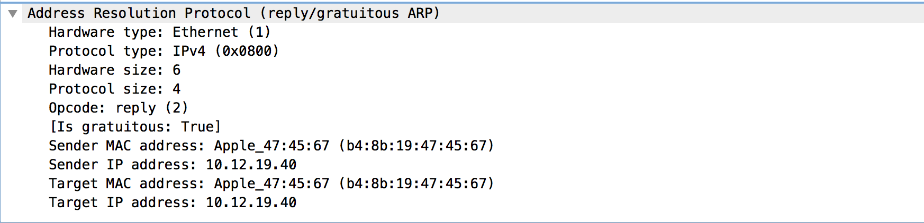

***Reply***

