**Chapter: 3**

Assignment Three References : <https://www.scribd.com>

(The assignment has been done with full understanding and knowledge of concepts)

**P3-21.** A line has a signal-to-noise ratio of 1000 and a bandwidth of 4000 KHz. What is the maximum data rate supported by this line?

Solution: Data Rate = 4000 kHz = 4,000,000 Hz

4,000,000 𝑙𝑜𝑔2 (1 + 1,000)

4,000,000 x 10 = 40,000,000 bps = 40 Mbps

**P3-22.** We measure the performance of a telephone line (4 KHz of bandwidth). When the signal is 10 V, the noise is 5 mV. What is the maximum data rate supported by this telephone line?

Solution: 4000 * log2(10,000/5) =43500 bps.

**P3-23.** A ﬁle contains 2 million bytes. How long does it take to download this ﬁle using a 56-Kbps channel? 1-Mbps channel?

Solution: We have transmission time = (message size)/(bandwidth)

The ﬁle contains 2,000,000 × 8 = 16,000,000 bits.

With a 56-Kbps channel = 56,000 bps, it takes 16,000,000/56,000 = 285.7 s.

With a 1-Mbps channel= 1000,000, it takes 16,000,000/1000,000 =16 s.

**P3-24.** A computer monitor has a resolution of 1200 by 1000 pixels. If each pixel uses 1024 colors, how many bits are needed to send the complete contents of a screen?

Solution: We need 10 bits to show 1024 colors in a binary system, therefore 10 bits are required for each pixel to be addressed.

We need 1200*1000*10 bits to send a complete content of a screen i.e 12,000,000.

**P3-27.** What is the theoretical capacity of a channel in each of the following cases?

Solution:

**a.** Bandwidth: 20 KHz SNRdB = 40

Ans: Capacity C = (B * SNRdB / 3) = 20* (40/3) = 267 Kbps.

**b.** Bandwidth: 200 KHz SNRdB = 4

Ans: Capacity C = (B * SNRdB / 3) = 200 * (4/3) = 267 Kbps.

**c.** Bandwidth: 1 MHz SNRdB = 20

Ans: C = (B * SNRdB / 3) = 1 * (20/3) = 6.67 Mbps.

**P3-32.** How many bits can ﬁt on a link with a 2 ms delay if the bandwidth of the link is

**a.** 1 Mbps?

Ans: 2,000 bits

**b.** 10 Mbps?

Ans: 20,000 bits

**c.** 100 Mbps?

Ans: 2,00,000 bits.

**Chapter: 4**

**Q4-1.** List three techniques of digital-to-digital conversion.

Ans: The three techniques are: Line Coding, Block Coding and Scrambling.

**Q4-2.** Distinguish between a signal element and a data element.

Ans: A data element is the smallest entity that can represent a piece of information (bit). Whereas, a signal element is the shortest unit (time wise) of a digital signal.

**Q4-3.** Distinguish between data rate and signal rate.

Ans: The data rate deﬁnes the number of data elements (bits) sent in 1s. Whereas, the signal rate is the number of signal elements sent in 1s.

(The data rate is sometimes called the bit rate and the signal rate is sometimes called the pulse rate, the modulation rate, or the baud rate)

**Q4-4.** Deﬁne baseline wandering and its effect on digital transmission.

Ans: A drift caused by the long string of 0s and 1s is known as Baseline Wandering. Its effect on digital transmission is that its makes difﬁcult for the receiver to decode the signal correctly.

**Q4-5.** Deﬁne a DC component and its effect on digital transmission.

Ans: When the voltage level in a digital signal is constant for a while, the spectrum creates very low frequencies, these frequencies around zero, called DC components*.* Its effect on digital transmission is that it presents problems for a system that cannot pass low frequencies.

**Q4-6.** Deﬁne the characteristics of a self-synchronizing signal.

Ans: It includes timing information in the data being transmitted.

**Q4-7.** List ﬁve line coding schemes discussed in this book.

Ans: Unipolar, polar, bipolar, multilevel, and multi transition coding.

**Q4-8.** Deﬁne block coding and give its purpose.

Ans: Block coding provides redundancy to ensure synchronization and to provide inherent error detecting. In general, block coding changes a block of m bits into a block of n bits, where n is larger than m.

**Q4-9.** Deﬁne scrambling and give its purpose.

Ans: Scrambling is a technique that substitutes long zero level pulses with a combination of other levels without increasing the number of bits.

**P4-1.** Calculate the value of the signal rate for each case in Figure 4.2(book) if the data rate is 1 Mbps and c = 1/2.

**Solution**: We know that the relationship between Data rate and signal is c * N (1/r).

Now: r = 1, So, s = 1/2 * 10 raise to the power 6 * (1/1) = 0.5 Mbaud.

r = 0.5, So, s = 1/2 * 10 raise to the power 6 * (1/0.5) = 1 Mbaud.

r = 2, So, s = 1/2 * 10 raise to the power 6 * (1/2) = 0.25 Mbaud.

r = 4/3, s = 1/2 * 10 raise to the power 6 * (1/(4/3) ) = 0.375 Mbaud.

**P4-2.** In a digital transmission, the sender clock is 0.2 percent faster than the receiver clock. How many extra bits per second does the sender send if the data rate is 1 Mbps?

**Solution:** Sender clock is 0.2% = 0.2/100 = 0.002.

The data rate is 1 Mbps. ( i.e 10 raise to the power 6) So Extra bits = 0.002 * 1 Mbps = 2000 bits.

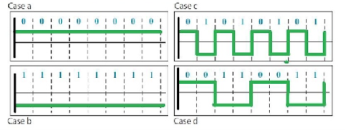

**P4-3.** Draw the graph of the NRZ-L scheme using each of the following data streams, assuming that the last signal level has been positive. From the graphs, guess the bandwidth for this scheme using the average number of changes in the signal level. Compare your guess with the corresponding entry in Table 4.1.

**a.** 00000000 **b.** 11111111 **c.** 01010101 **d.** 00110011

**Solution:**

**P4-4.** Repeat Problem P4-3 for the NRZ-I scheme.

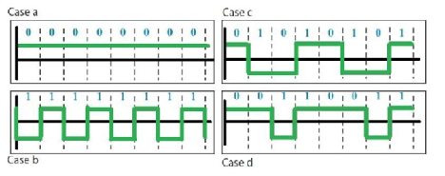Solution:

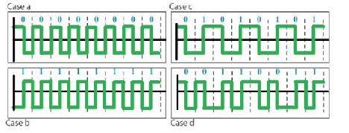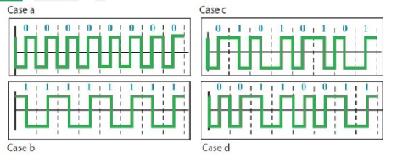

**P4-5.** Repeat Problem P4-3 for the Manchester scheme.

**P4-6.** Repeat Problem P4-3 for the differential Manchester scheme.

**P4-7.** Repeat Problem P4-3 for the 2B1Q scheme, but use the following data streams.

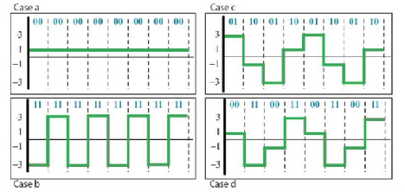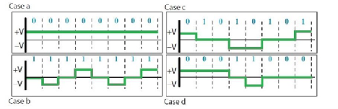

**a.** 0000000000000000 **b.** 1111111111111111 **c.** 0101010101010101 **d.** 0011001100110011

**P4-8.** Repeat Problem P4-3 for the MLT-3 scheme, but use the following data streams. **a.** 00000000 **b.** 11111111 **c.** 01010101 **d.** 00011000

**P4-9.** Find the 8-bit data stream for each case depicted in Figure 4.36.

Solution: NRZ-I = 10011001, Differential Manchester = 11000100, AMI = 01110001.

**P4-10.** An NRZ-I signal has a data rate of 100 Kbps. Using Figure 4.6, calculate the value of the normalized energy (P) for frequencies at 0 Hz, 50 KHz, and 100 KHz.

**Solution:** a) f/N = 0/100 = 0->P = 1.0

b) f/N = 50/100 = 1/2 -> P = 0.5.

c) f/N = 100/100 = 1 -> P = 0.0.

**P4-11.** A Manchester signal has a data rate of 100 Kbps. Using Figure 4.8, calculate the value of the normalized energy (P) for frequencies at 0 Hz, 50 KHz, 100 KHz.

**Solution:** a) f/N = 0/100 = 0->P = 0.0 .

b) f/N = 50/100 = 1/2 -> P = 0.3

c) f/N = 100/100 = 1/1 -> P = 0.4

d) f/N = 150/100 = 1.5 -> P = 0.0.

**P4-12.** The input stream to a 4B/5B block encoder is **0100** **0000** **0000** **0000** **0000** **0001**

Answer the following questions:

**a.** What is the output stream?

**Ans:** **01010** **11110** **11110** **11110** **11110** **01001**

**b.** What is the length of the longest consecutive sequence of 0s in the input?

**Ans:** **21**

**c.** What is the length of the longest consecutive sequence of 0s in the output?

**Ans:** **2**

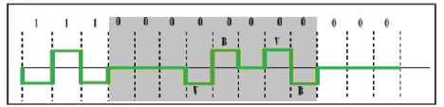

**P4-13.** How many invalid (unused) code sequences can we have in 5B/6B encoding? How many in 3B/4B encoding?

**Solution:** In 5B/6B, we have 25 = 32 data sequences and 26 = 64 code sequences. The number of unused code sequences are 32 (64-32).

In 3B/4B, we have 23 = 8 data sequences and 24 = 16 code sequences. The number of unused code sequences are 8 (16-8).

**P4-14.** What is the result of scrambling the sequence 11100000000000 using each of the following scrambling techniques? Assume that the last non-zero signal level has been positive.

**a.** B8ZS

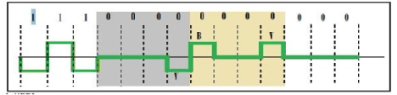**b.** HDB3 (The number of nonzero pulses is odd after the last substitution.