**SUPPORTING DOCUMENTS:**

**Reference – Answer 2 and 3**

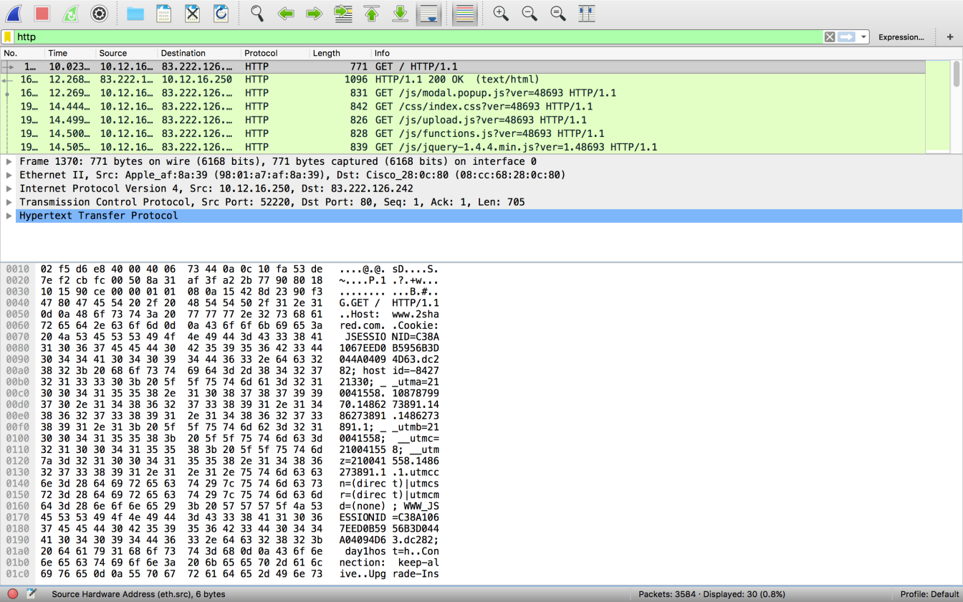

**References to Answer 5**

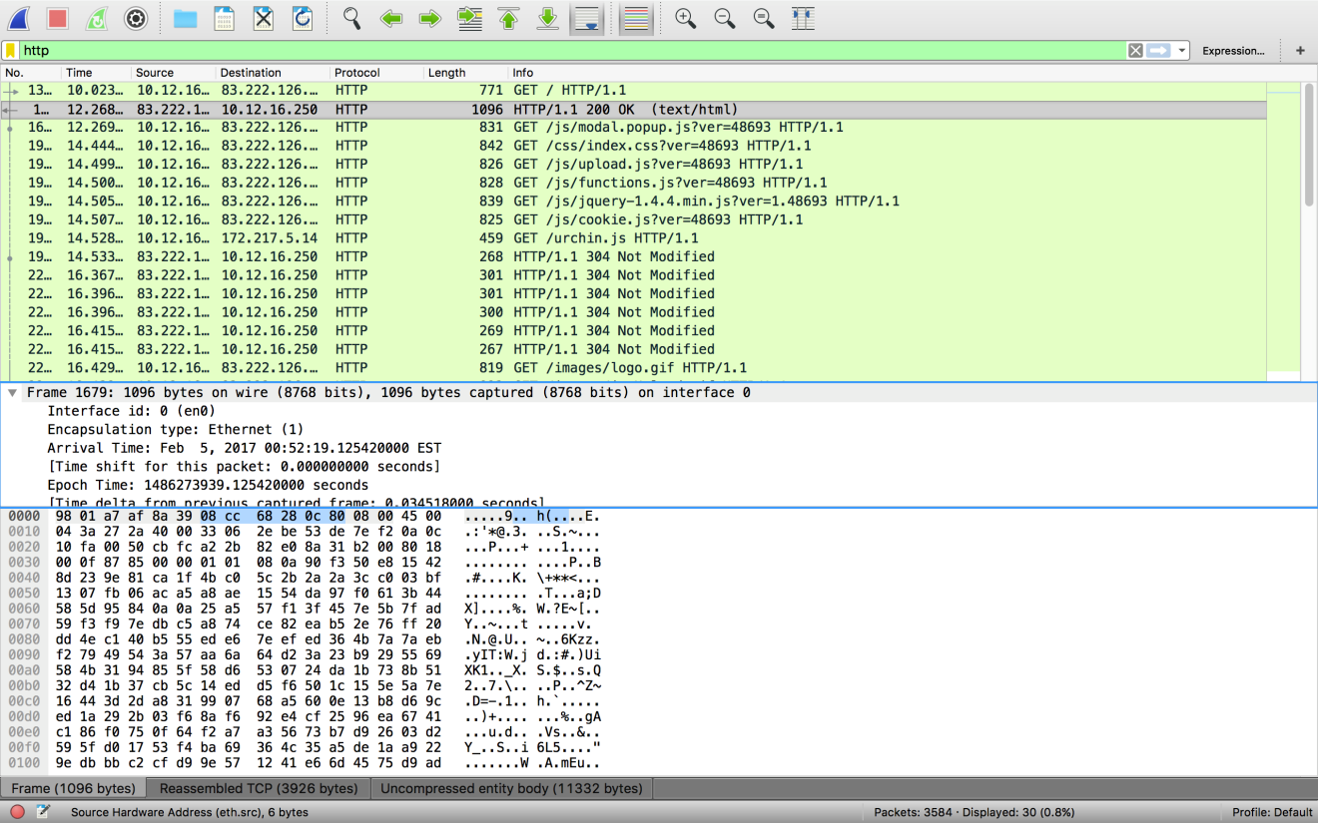

**Reference to Answer 6 and 8 (in calculation):**

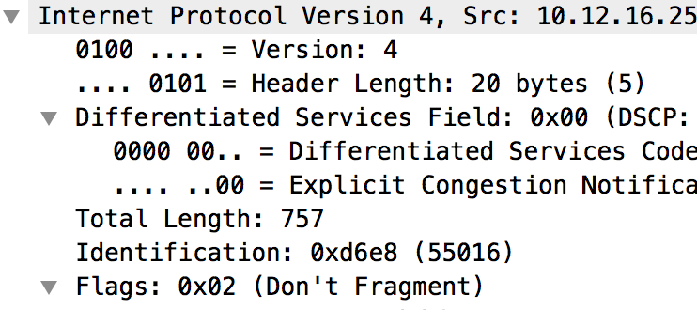

**Picture Reference to Answer 7:**

