**Name**: Tanveen Kaur

**Student ID**: 1014603

**Program** **1**

**Due Date**: 9/27/2016

**Date of Re-Submission**: 10/04/2016

**Table of Contents**

Screenshots 1

Documented Source Code 1-3

Things Learned…………………………………………………………………………….4

Comments………………………………………………………………………………….4

**Screenshots:** 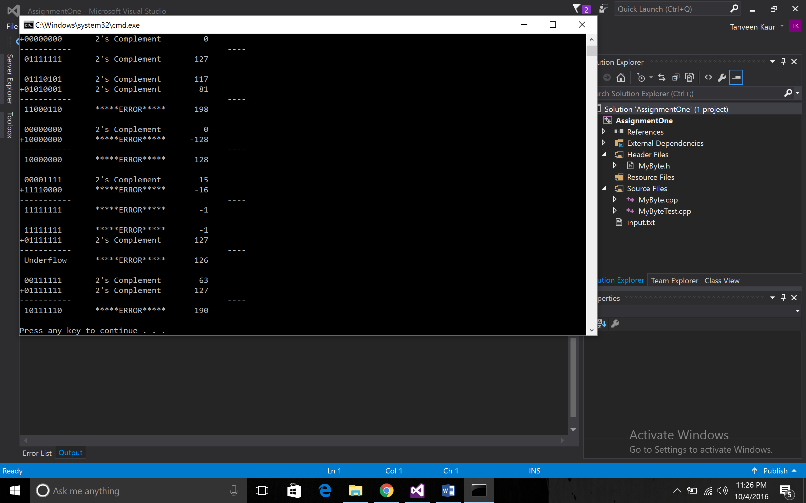

**Picture:1 *OUTPUT***

**Source Code:**

// MyByteTest.cpp

// Author: Tanveen Kaur

// Date: 10/04/2016

// Compiler Used: VB

// *<header file >*

**#include <iostream>**

**#include <fstream>**

**#include <iomanip>**

**using namespace std;**

**#include "MyByte.h"**

**int main()**

**{**

**cout << "Program Starting ...\n\n";**

**cout << "Opening Files ...\n\n";**

**ifstream in;**

**in.open("input.txt");**

**ofstream out;**

**out.open("output.txt");**

**cout << "Files Opened Successfully ...\n\n";**

**Byte b1, b2, sum;**

**int dec_sum;**

**while (in >> b1 && in >> b2)**

**{**

**// Number crunching part**

**sum = b1 + b2;**

**dec_sum = b1.toDecimal() + b2.toDecimal();**

**// Output to screen**

**cout << " " << b1 << "\t" << b1.getcomplementtype()**

**<< "\t" << std::right << std::setw(8) << b1.toDecimal() << endl;**

**cout << "+" << b2 << "\t" << b2.getcomplementtype()**

**<< "\t" << std::right << std::setw(8) << b2.toDecimal() << endl;**

**cout << "-----------\t\t\t\t"**

**<< std::right << std::setw(8) << "----" << endl;**

**cout << " " << sum << "\t" << sum.getcomplementtype()**

**<< "\t" << std::right << std::setw(8) << dec_sum << endl << endl;**

**// Output to file**

**out << " " << b1 << "\t" << b1.getcomplementtype()**

**<< "\t" << std::right << std::setw(8) << b1.toDecimal() << endl;**

**out << "+" << b2 << "\t" << b2.getcomplementtype()**

**<< "\t" << std::right << std::setw(8) << b2.toDecimal() << endl;**

**out << "-----------\t\t\t\t\t\t"**

**<< std::right << std::setw(8) << "----" << endl;**

**out << " " << sum << "\t" << sum.getcomplementtype()**

**<< "\t" << std::right << std::setw(8) << dec_sum << endl << endl;**

**}**

**return 0;**

**}**

// MyByte.cpp

// Author: Tanveen Kaur

// Date: 9/25/2016

// Compiler Used: VB

// *<cpp file >*

// FileName: MyByteTest.cpp

#include <iostream>

#include <fstream>

#include <iomanip>

#include <string>

using namespace std;

#include "MyByte.h"

int main()

{

cout << "Program Starting ...\n\n";

cout << "Opening Files ...\n\n";

ifstream in;

in.open("input.txt");

ofstream out;

out.open("output.txt");

cout << "Files Opened Successfully ...\n\n";

MyByte b1, b2, sum;

int dec_sum;

while (in >> b1 && in >> b2)

{

// Number crunching part

sum = b1 + b2;

dec_sum = b1.toDecimal() + b2.toDecimal();

// Output to screen

cout << " " << b1 << "\t" << b1.getcomplementtype()

<< "\t" << std::right << std::setw(8) << b1.toDecimal() << endl;

cout << "+" << b2 << "\t" << b2.getcomplementtype()

<< "\t" << std::right << std::setw(8) << b2.toDecimal() << endl;

cout << "-----------\t\t\t\t"

<< std::right << std::setw(8) << "----" << endl;

cout << " " << sum << "\t" << sum.getcomplementtype()

<< "\t" << std::right << std::setw(8) << dec_sum << endl << endl;

// Output to file

out << " " << b1 << "\t" << b1.getcomplementtype()

<< "\t" << std::right << std::setw(8) << b1.toDecimal() << endl;

out << "+" << b2 << "\t" << b2.getcomplementtype()

<< "\t" << std::right << std::setw(8) << b2.toDecimal() << endl;

out << "-----------\t\t\t\t\t\t"

<< std::right << std::setw(8) << "----" << endl;

out << " " << sum << "\t" << sum.getcomplementtype()

<< "\t" << std::right << std::setw(8) << dec_sum << endl << endl;

}

return 0;

}

// MyByte.h

// Tanveen Kaur

// Date: 10/04/2016

// Compiler Used:VB

// *<header file>*

#pragma once

#include <iostream>

#include <fstream>

using namespace std;

class MyByte

{

string byte_stream;

public:

int toDecimal();

string getcomplementtype();

MyByte()

{

}

MyByte(string byte_stream_p)

{

byte_stream = byte_stream_p;

}

friend ostream& operator<<(ostream& os, const MyByte& Rhs);

friend istream& operator >> (istream& is, MyByte& Rhs);

MyByte operator+(const MyByte & Rhs);

};

**Things Learned:**

* **Operator Overloading:** Performed +, >> and >> operating overloading
* **Constructors:** Default and parameterized constructors
* **String to Integer Conversion,**
* **File Handling and Input/Output Steams.**

**Comments:** Implementation successful with the desired output.