**Name**: Tanveen Kaur

**Student ID**: 1014603

**Program 2**

**Postman Problem**

**Due Date**: 10/10/2016

**Table of Contents**

Screenshots 1

Documented Source Code .2

Things Learned…………………………………………………………………………….3

Comments………………………………………………………………………………….3

**Screenshots:** 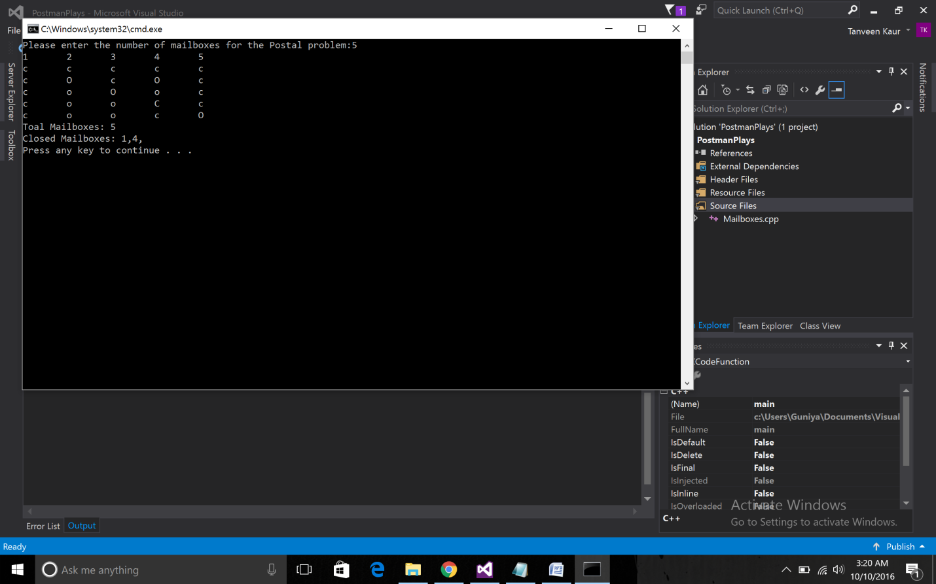

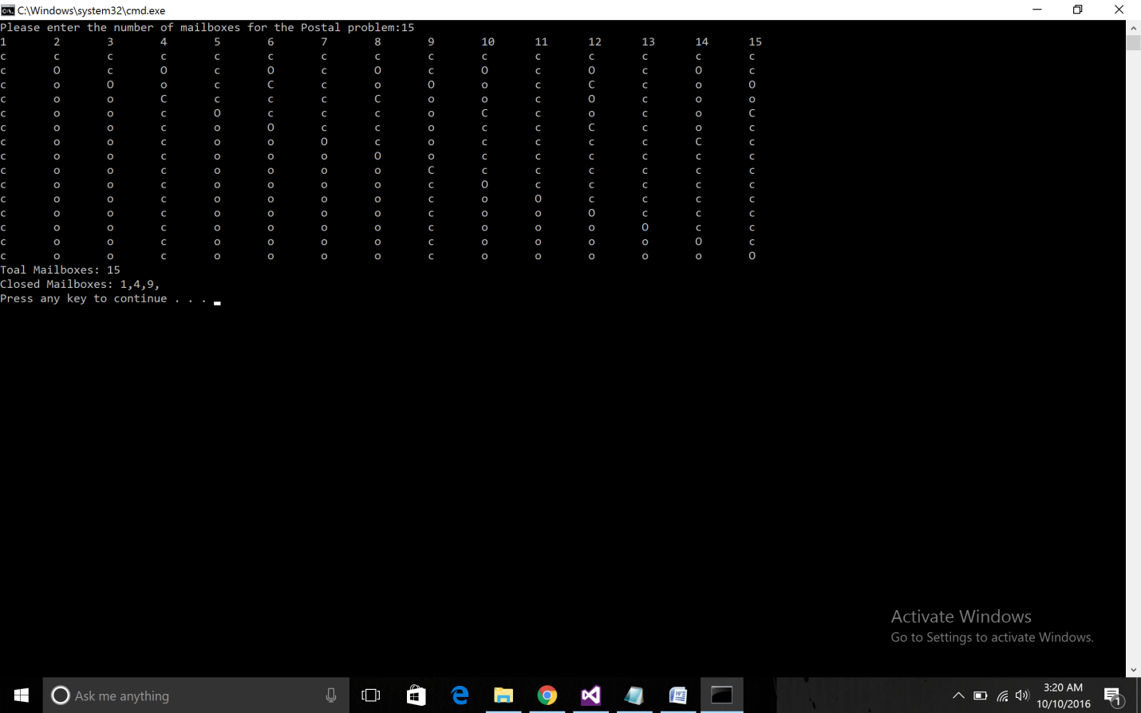**Picture:1 &2 *OUTPUT***

**Source Code:**

// MyByteTest.cpp

// Author: Tanveen Kaur

// Date: 10/10/2016

// Compiler Used: VB

// *<cpp file>*

#include <iostream>

using namespace std;

void main()

{

int n;

cout << "Please enter the number of mailboxes for the Postal problem:";

cin >> n;

char **mails = new char *[n];

for (int i = 0; i < n; i++)

{

mails[i] = new char[n];

}

for (int i = 0; i < n; i++)

{

for (int j = 0; j < n; j++)

{

mails[i][j] = 'c';

}

}

for (int a = 1; a <= n; a++)

{

cout << a << "\t";

}

cout << endl;

for (int i = 1; i < n; i++)

{

for (int j = 0; j < n; j++)

{

mails[i][j] = mails[i - 1][j];

if (mails[i][j] == 'O')

{

mails[i][j] = 'o';

}

else if (mails[i][j] == 'C')

{

mails[i][j] = 'c';

}

}

int c = i;

while (c < n)

{

if (mails[i][c] == 'c' || mails[i][c] == 'C')

{

mails[i][c] = 'O';

}

else if (mails[i - 1][c] == 'o' || mails[i - 1][c] == 'O')

{

mails[i][c] = 'C';

}

c = (c + i);

c++;

}

}

// Printing array values

for (int i = 0; i < n; i++)

{

for (int j = 0; j < n; j++)

{

cout << mails[i][j] << "\t";

}

cout << endl;

}

cout << "Toal Mailboxes: " << n << endl;

cout << "Closed Mailboxes: ";

for (int j = 0; j < n; j++)

{

if (mails[n - 1][j] == 'c' || mails[n - 1][j] == 'C') // scanning all the columns (say on 150th row)

{

cout << j + 1 << ","; // increment because index starts from 0

}

}

cout << endl;

}

**Things Learned:**

* **Use of Multi Dimensional Arrays for dynamic memory allocation.**

**Comments:** Implementation successful with the desired output.