**Assignment 2**

**Task :- 1] Get a project from GitHub create a WAR file of the project in MASTER node.**

**2] deploy that war file on two slaves.(using tomcat)**

**Step 1**

**Launch Jenkins on ec2 instance & host it by using tomcat server.**

**Also install same software like java, maven, git.**

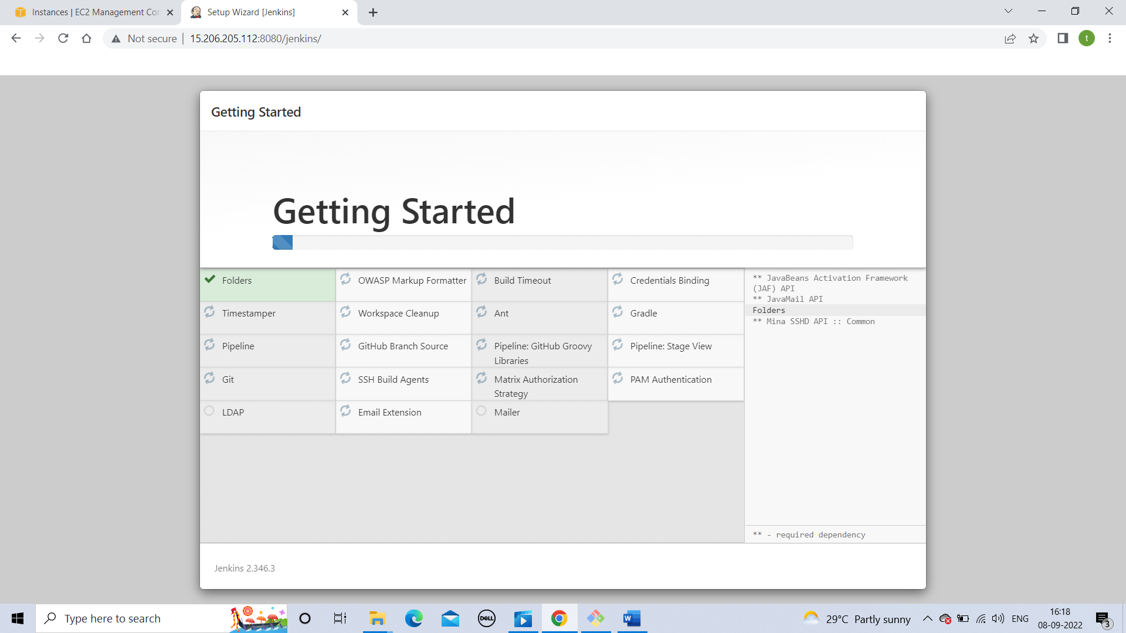

**Step 2**

**Add mavens details in Jenkins. Also u need to create a env. Variable for maven in your instance.**

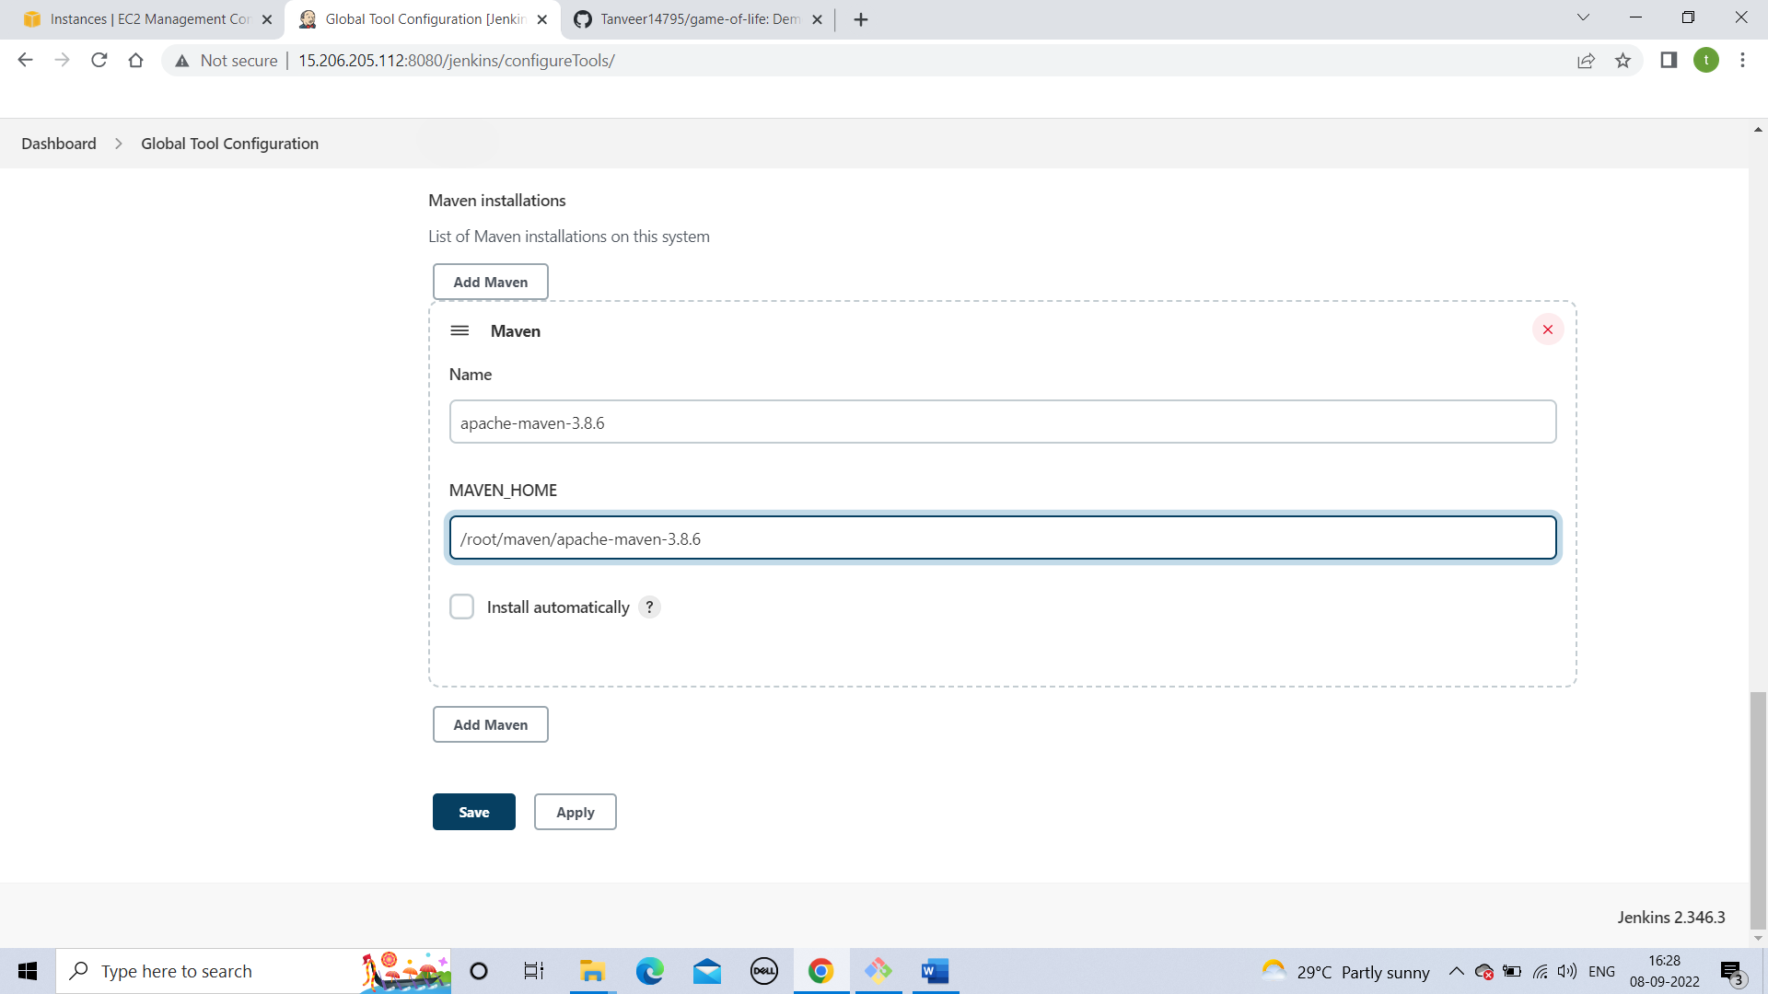

**Step 3**

**Write a pipeline code for clone and create a WAR file.**

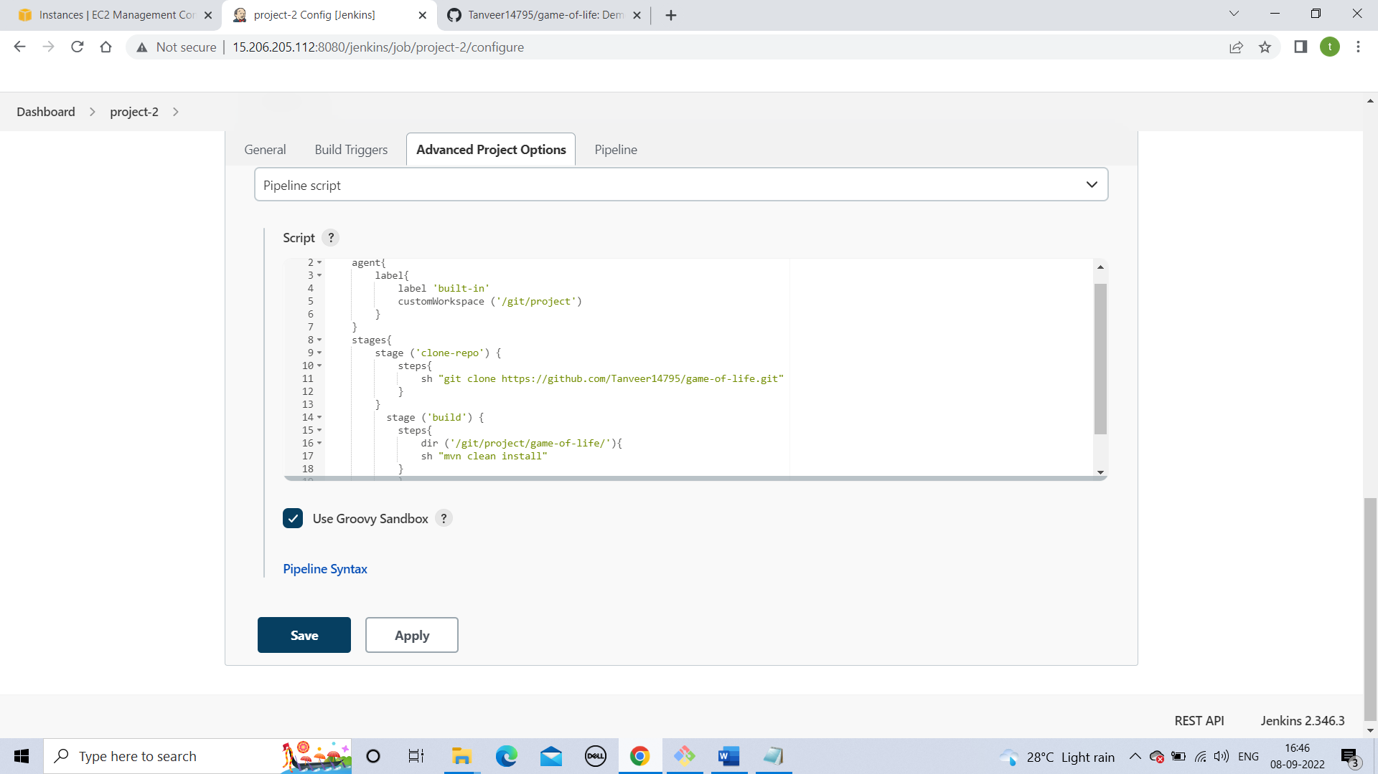

**Run the code.**

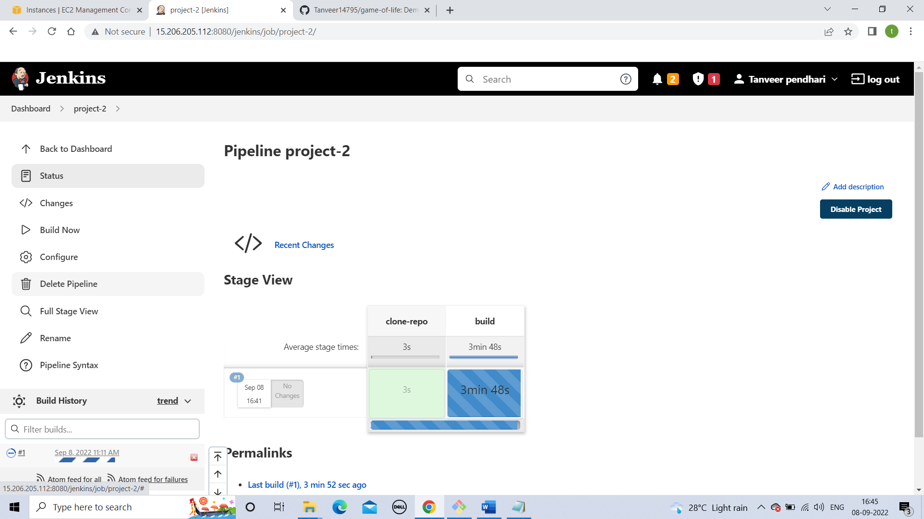

**Step 4**

**Create a two instance.**

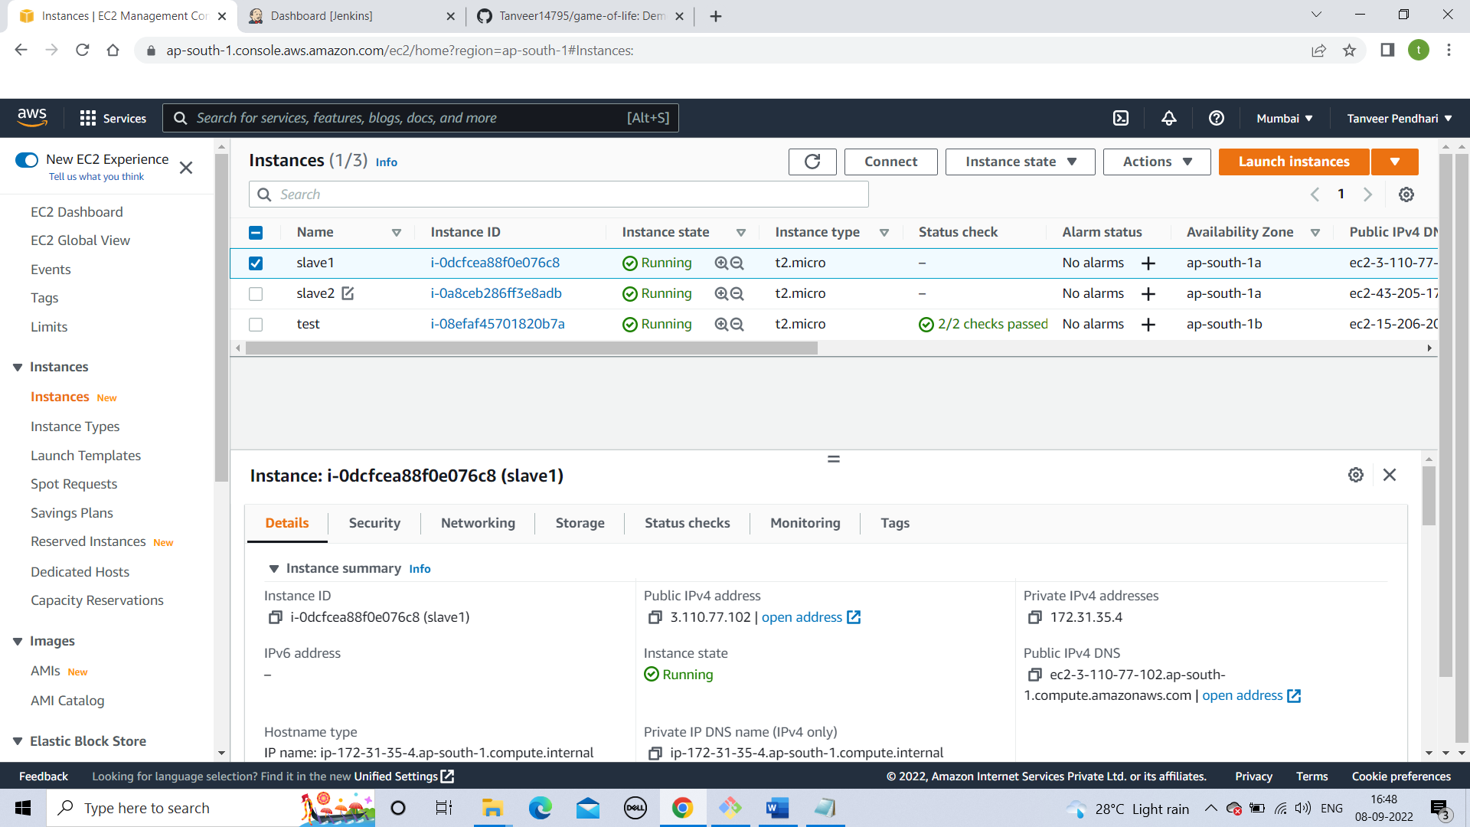

**Step 5**

**Installing java and tomcat in both machines and start your tomcat server**

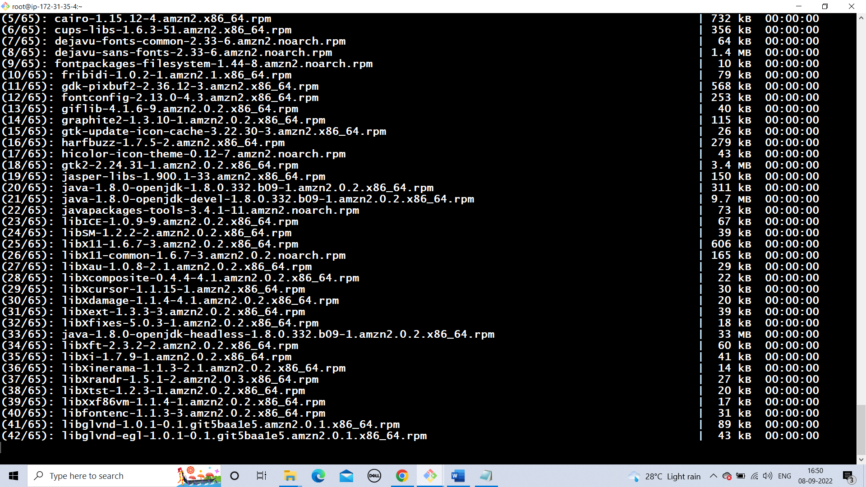

**Step 6**

**Create SSH credentials (manage Jenkins---credentials)**

**Select – SSH username and private key**

**ID- instance private ip**

**Username – ec2-user**

**Private key – add your instance private key**

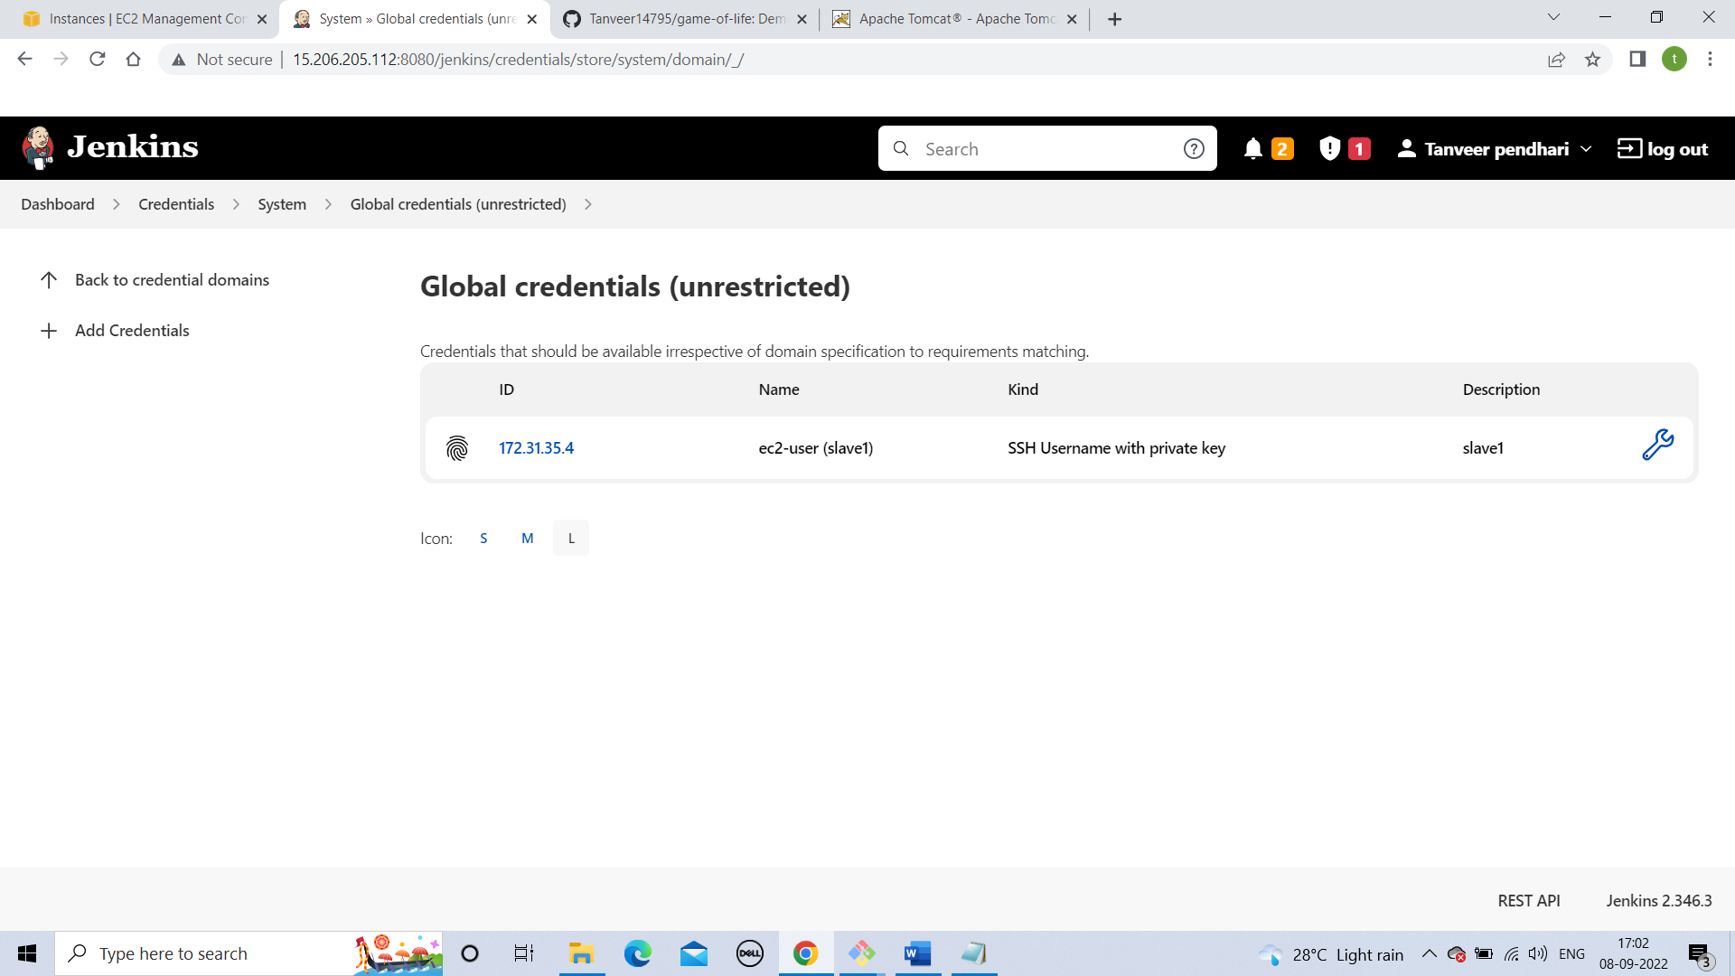

**Step 7**

**Create a node using SSH**

**Host key verification strategy – manually trusted key verification strategy**

**Need to conform the key once.**

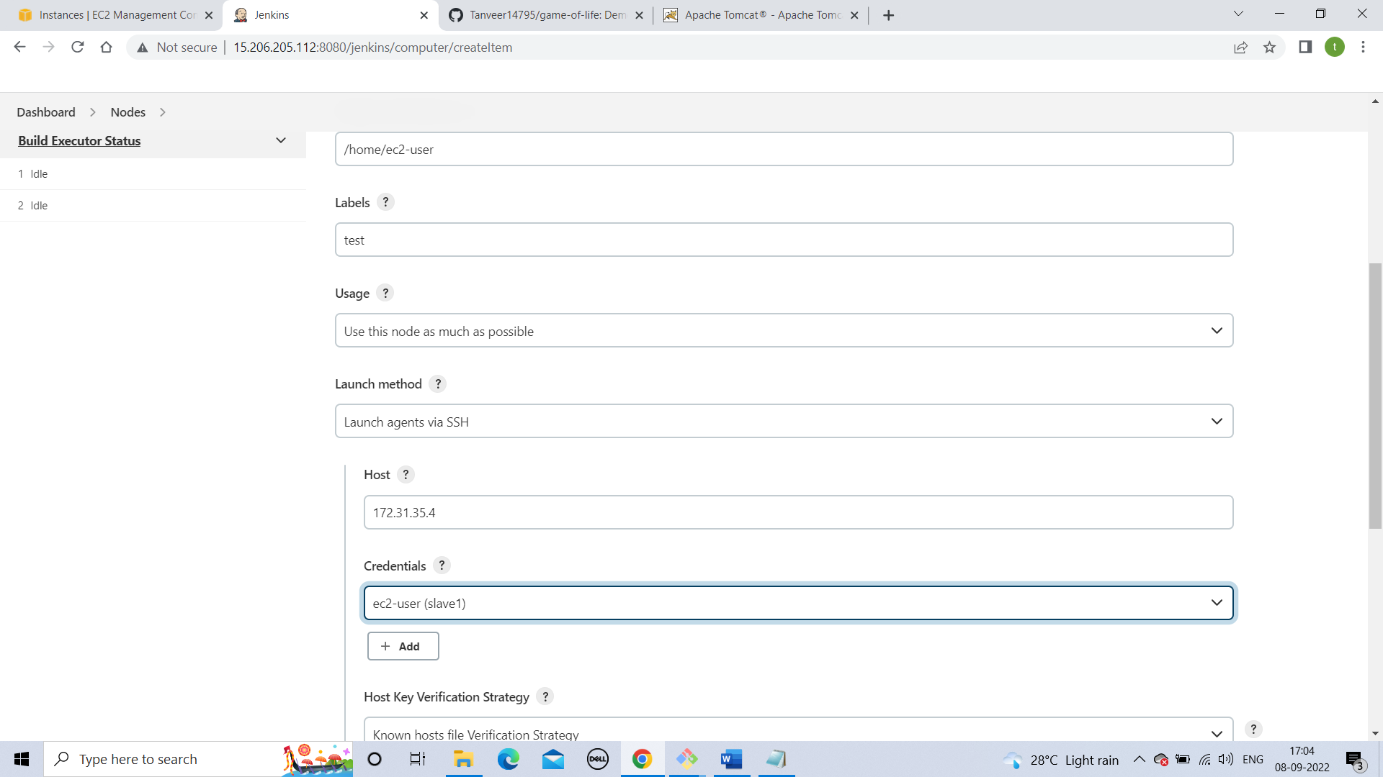

**Step 8**

**Go to your job and a code to copy a file in slaves.**

**I am using SCP command for that.(need to add .pem file and give 400 permission)**

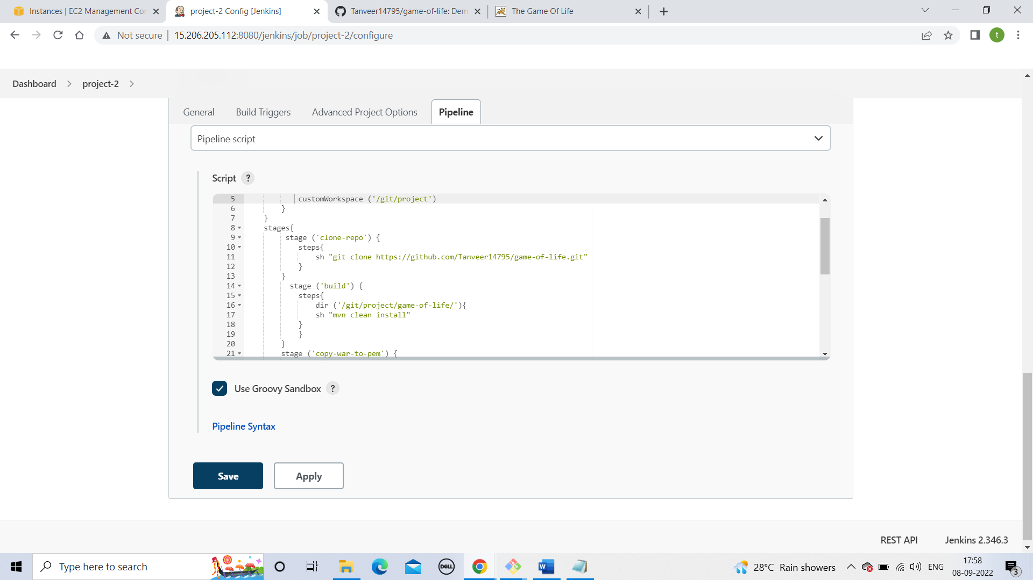

**Step 9**

**Run the build and solve the errors.(at the end i mention errors)**

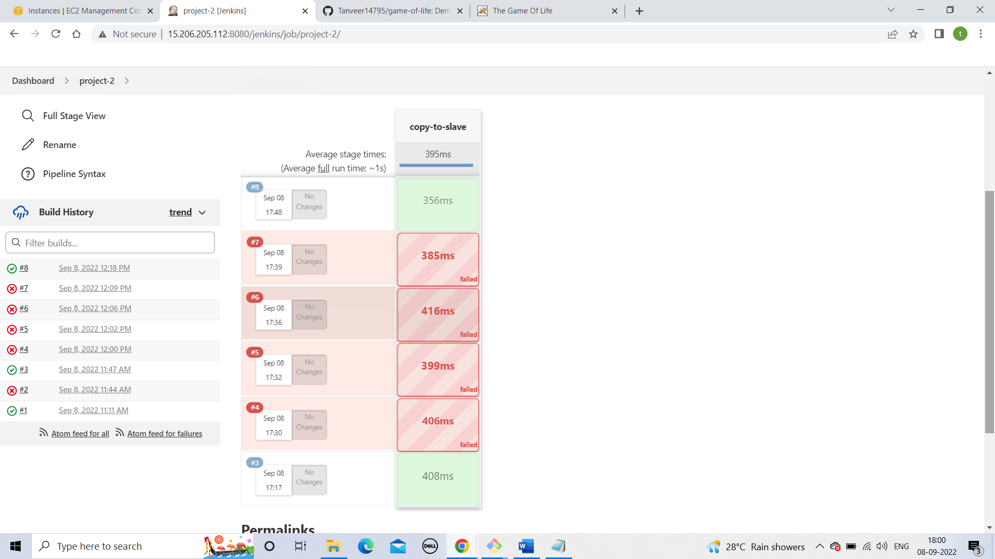

**Step 10**

**Hosting WAR file in two servers by single pipeline code**

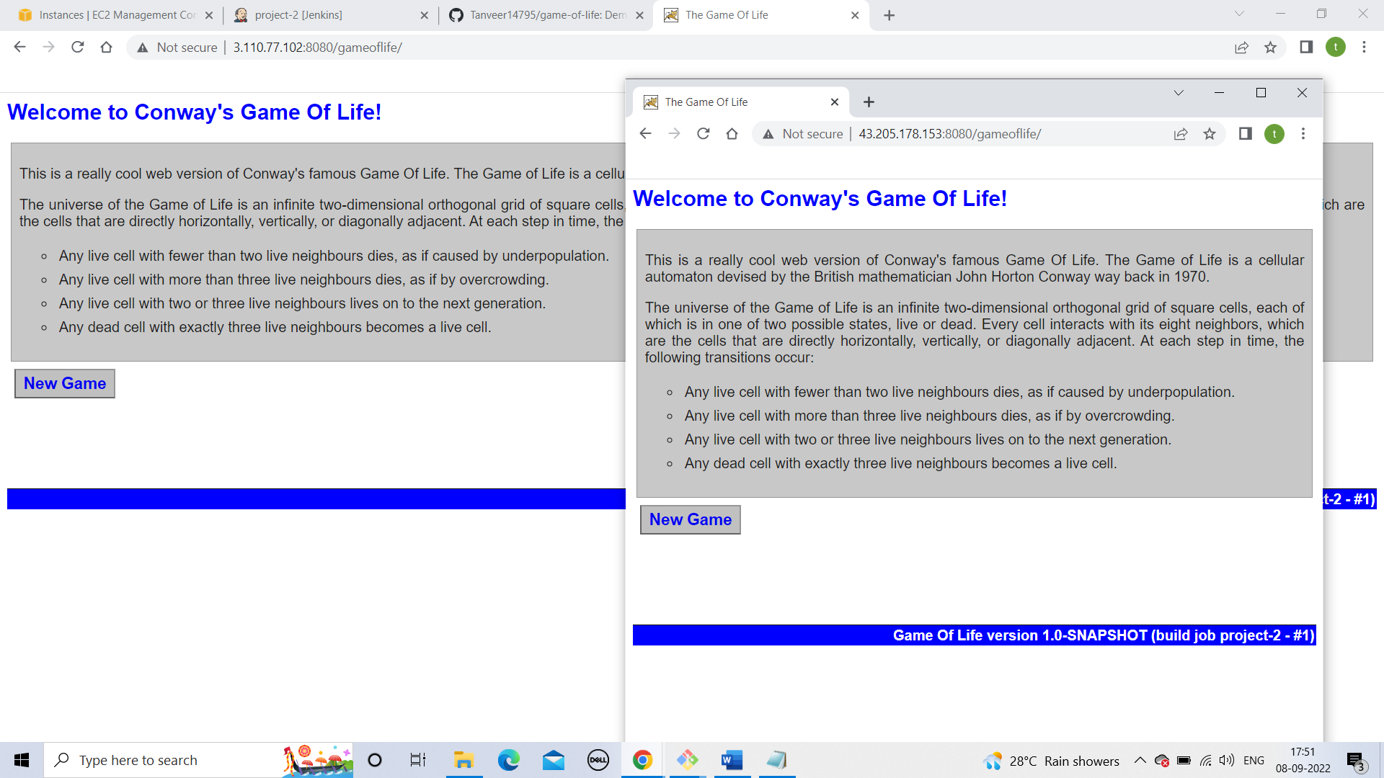

***Pipeline code***

**pipeline{**

**agent{**

**label{**

**label 'built-in'**

**customWorkspace ('/git/project')**

**}**

**}**

**stages{**

**stage ('clone-repo') {**

**steps{**

**sh "git clone https://github.com/Tanveer14795/game-of-life.git"**

**}**

**}**

**stage ('build') {**

**steps{**

**dir ('/git/project/game-of-life/'){**

**sh "mvn clean install"**

**}**

**}**

**}**

**stage ('copy-war-to-pem') {**

**steps{**

**sh "cp /git/project/game-of-life/gameoflife-web/target/gameoflife.war /pem"**

**}**

**}**

**stage ('copy-to-slave') {**

**steps{**

**dir ('/pem'){**

**sh "scp -i test.pem gameoflife.war ec2-user@172.31.35.4:/home/ec2-user/server/apache-tomcat-9.0.65/webapps"**

**}**

**}**

**}**

**stage ('copy-to-slave') {**

**steps{**

**dir ('/pem'){**

**sh "scp -i test.pem gameoflife.war ec2-user@172.31.45.6:/home/ec2-user/server/apache-tomcat-9.0.65/webapps"**

**}**

**}**

**}**

**}**

**}**

**Errors**

**1)command not written properly**

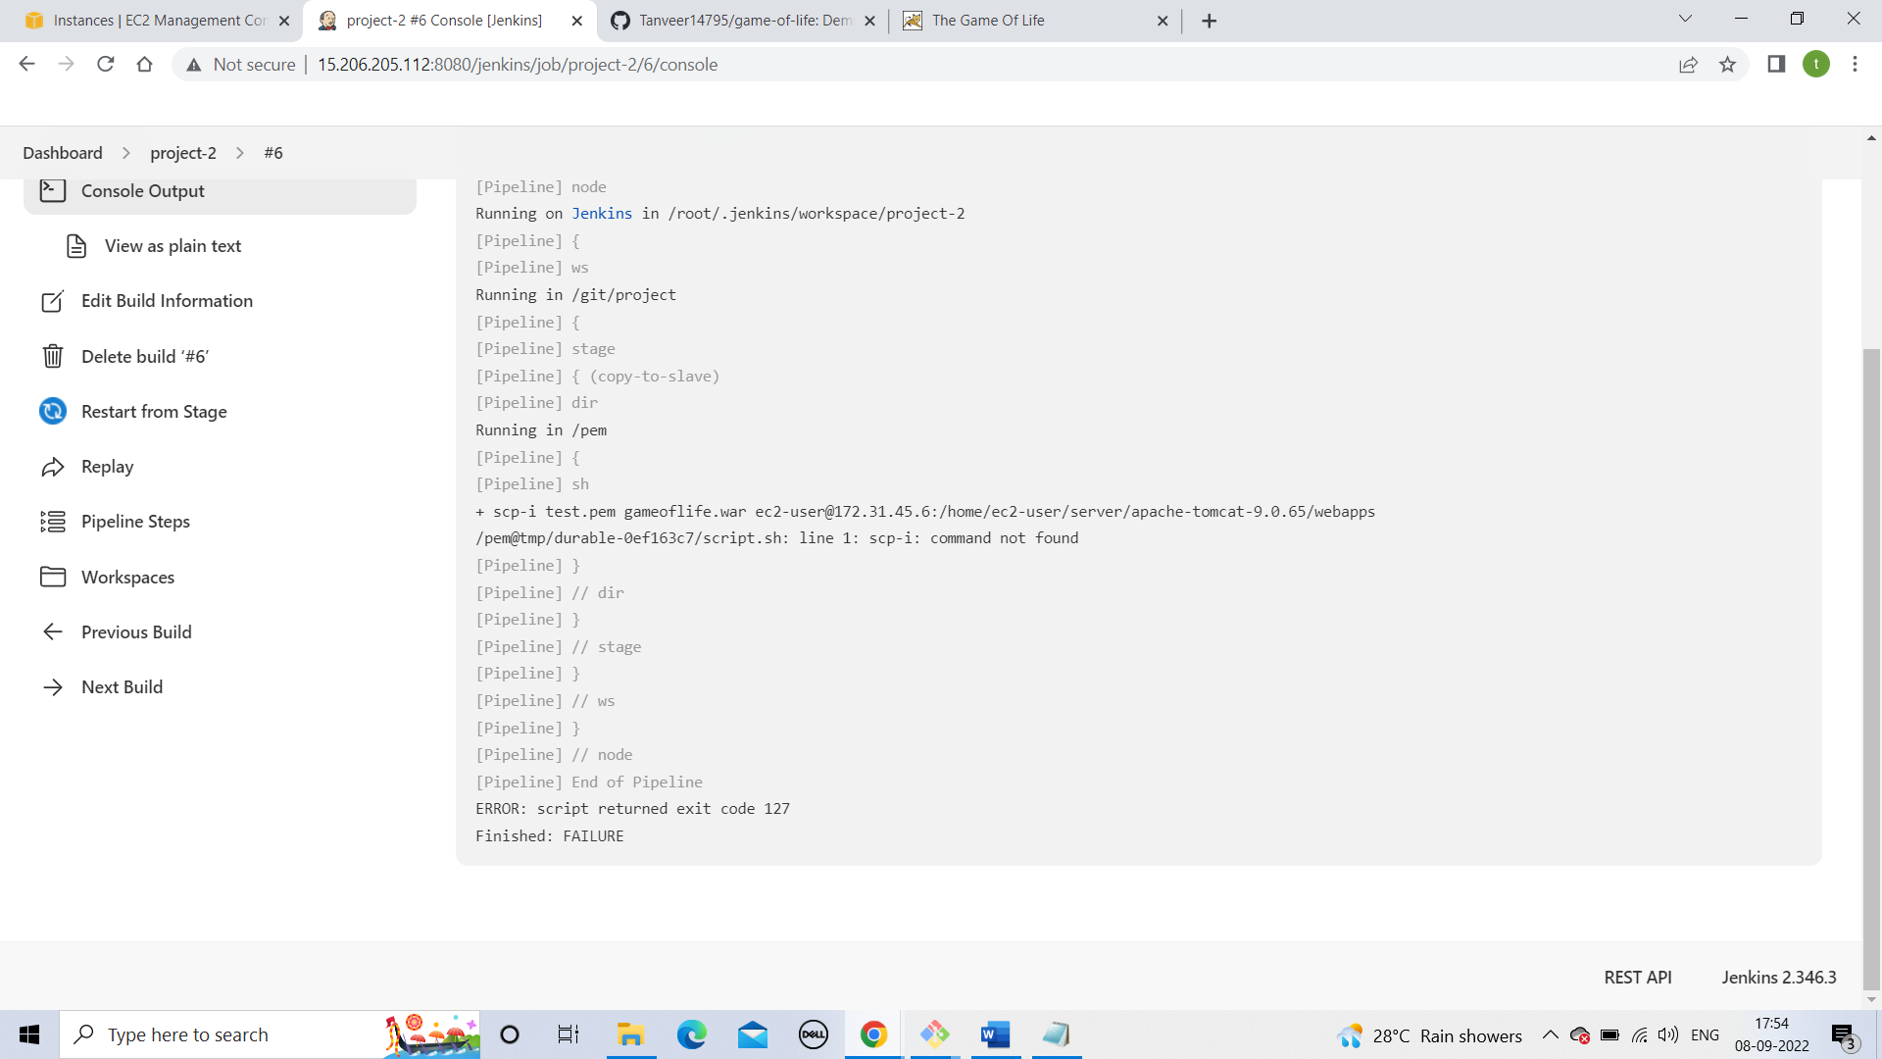

**2)Not define the directory where the pem file is present.**

