Final Project- Exploring the Drivers of Global Happiness: A Statistical Analysis of Social Support, Freedom, and Economic Wealth

Group 4
002085622 – Isaac (Ying Shuo) Su
002410667 - Tanveer Begum

ALY 6010 – Probability Theory and Introductory Statistics
Prof. Yvonne Leung
Date: 15th December 2024

Introduction
Happiness is something that everyone strives for, but what makes people happy. Over the years, researchers and policymakers have tried to understand the key factors that contribute to happiness. The World Happiness Report, released annually, provides a global perspective on this topic. This project uses data from the 2023 report to look at some of the most important influences on happiness, including healthy life expectancy, social support, freedom to make life choices, and GDP per capita. These are all indicators of how individuals and societies are doing.
Initial EDA
We began by exploring the World Happiness Report 2023 dataset to uncover potential patterns and relationships among the variables. Some preliminary observations include:
- Potential Associations: Happiness scores (Ladder.score) appear to be associated with healthy life expectancy and GDP per capita.
- Weaker Trends: Social support and freedom to make life choices show some positive relationships with happiness, though these appear less pronounced.
- Data Distribution: The dataset seems well-distributed, with happiness scores showing a pattern close to a normal distribution.
These early observations suggest possible trends worth investigating further, such as the role of social support in amplifying the effects of life expectancy and freedom on happiness. These insights guided the development of our research questions and hypotheses.
Questions that we explored
- Is the impact of healthy life expectancy on happiness stronger in countries with higher social support?
Our exploration began with a paradox observed in Taiwan, a country renowned for its high social support and exceptional healthcare system. Taiwan's National Health Insurance system provides access to top-tier healthcare, and its healthy life expectancy ranks among the highest globally. Yet, this hasn’t translated into correspondingly high happiness levels.
This paradox was highlighted by Taiwanese writer Chiung Yao, who reflected on aging, quality of life, and even voluntary death. Her insights underscored that longer, healthier lives might not inherently lead to greater happiness, bringing attention to unspoken dimensions of well-being like psychological fulfillment and cultural values.
This inspired us to ask: Does healthy life expectancy truly enhance happiness, and is this effect amplified by robust social support? Using global data, we explored whether the interplay of these variables reveals deeper insights into what shapes happiness.
- Does the interaction between freedom and social support predict happiness better than individual factors alone?
The interaction between freedom and social support intrigued us as we explored how these two pillars of well-being might work together to influence happiness. Freedom to make life choices empowers individuals, offering autonomy and control, while social support provides a safety net of trust and resources, fostering connection and security. But what happens when these two forces intersect? Does their combination predict happiness more effectively than either alone?
Consider a rural village in Norway, where people enjoy both personal freedom and a strong social support network, creating a balance of autonomy and community. Contrast this with New York City, where individual freedom thrives but limited social cohesion might dilute its impact on happiness. These contrasting scenarios raised a key question: Can true happiness emerge from the interplay of these factors? Our study aimed to investigate whether freedom and social support together form a stronger predictor of happiness than individually.
- Does GDP per capita moderate the relationship between freedom to make life choices and happiness?
The link between freedom to make life choices and happiness seems intuitive—greater freedom often leads to greater happiness. However, we wondered if this relationship is influenced by a country’s wealth, measured by GDP per capita. Could economic resources amplify or limit the impact of freedom on happiness?
In high-income countries like Switzerland, citizens enjoy personal freedom alongside the economic means to act on it. Resources, infrastructure, and support systems make pursuing dreams viable and rewarding, directly translating freedom into opportunities for happiness. Conversely, in low-income countries, freedom may exist in principle, but economic constraints—such as limited education or infrastructure—can restrict how much freedom is truly exercised, potentially weakening its impact on happiness.
This contrast led us to ask: Does GDP per capita moderate the relationship between freedom and happiness? We sought to explore whether wealth not only directly enhances happiness but also strengthens the role of freedom in shaping well-being.
Null and Alternative Hypotheses
These hypotheses were tested using regression models with interaction terms, allowing us to see if the effects vary across groups.
1. Is the impact of healthy life expectancy on happiness stronger in countries with higher social support?
Null Hypothesis (H₀) | Alternative Hypothesis (H₁)
Healthy life expectancy does not have a stronger impact on happiness in countries with high social support compared to those with low social support. | Healthy life expectancy has a stronger impact on happiness in countries with high social support.
Overview: We used data on happiness scores, life expectancy, and social support levels to see if social support boosts the positive effects of living a longer, healthy life. The hypothesis test checks if the slopes (relationship strength) are different across social support groups.
2. Does the interaction between freedom and social support predict happiness better than individual factors alone?
Null Hypothesis (H₀) | Alternative Hypothesis (H₁)
The interaction between freedom and social support does not predict happiness better than looking at these factors separately. | The interaction between freedom and social support predicts happiness better than each factor alone.
Overview: This hypothesis examines if freedom and social support work together in a unique way to influence happiness. We tested if combining these two factors in the analysis provides better predictions of happiness than treating them as independent effects.
3. Does GDP per capita moderate the relationship between freedom to make life choices and happiness?
Null Hypothesis (H₀) | Alternative Hypothesis (H₁)
GDP per capita does not change how freedom to make life choices affects happiness. | GDP per capita significantly changes the effect of freedom to make life choices on happiness.
Overview: We explored whether a country’s wealth influences how much freedom contributes to happiness. The hypothesis test compares how the relationship between freedom and happiness changes across income groups (low, medium, high GDP).

Explanation of the Hypothesis Testing and the Result
We used linear regression models to test our hypotheses and understand the relationships between variables in the dataset. Below is how we approached each research question, along with the corresponding results:
1. Healthy Life Expectancy and Social Support
Approach: Countries were grouped into three categories (low, medium, and high) based on their social support levels. For each group, we examined how healthy life expectancy impacts happiness. Interaction terms in the regression model allowed us to test whether the relationship (slope) varied across these groups, highlighting whether higher social support amplifies the effect of healthy life expectancy on happiness.
Key Findings:
- The interaction term between Healthy.life.expectancy and Social_Support_Group was significant (p = 0.0391).
- The slope was steepest for the high social support group, indicating a stronger positive relationship between healthy life expectancy and happiness in these countries.
- Graphical Representation: The red line (high social support) shows a steeper slope compared to the blue (medium) and green (low) lines, visually confirming the amplifying role of social support.
(Refer to Appendix Figure 1 and Figure 4 for detailed results and visualizations.)
2. Interaction Between Freedom and Social Support
Approach: We tested how personal freedom and social support interact to influence happiness by including an interaction term between Freedom.to.make.life.choices and Social_Support_Group in the regression model. This helped evaluate whether the combination of freedom and social support predicts happiness more effectively than each factor individually.
Key Findings:
- The interaction term between Freedom.to.make.life.choices and Social_Support_Group was significant (p = 0.0001).
- The combined effect of freedom and social support showed stronger predictive value (R² = 0.7323) than individual factors alone.
- Graphical Representation: The red line (high social support) indicates the strongest relationship, while the green line (low social support) shows a weaker slope, confirming the complementary effects of these variables.
(Refer to Appendix Figure 2 and Figure 5 for detailed results and visualizations.)
3. Impact of Freedom on Happiness by GDP Group
Approach: Countries were categorized into three income groups (low, medium, high) based on GDP per capita. We analyzed whether GDP moderates the relationship between freedom and happiness using interaction terms, exploring whether freedom has a greater impact on happiness in wealthier countries.
Key Findings:
- The interaction term between Freedom.to.make.life.choices and GDP_Group was significant (p < 0.001).
- The steepest slope was observed in the high GDP group, confirming that freedom has a greater positive effect on happiness in wealthier countries.
- Graphical Representation: The red line (high GDP) shows the steepest slope, while the green line (low GDP) is flatter, indicating that freedom plays a smaller role in poorer countries.
(Refer to Appendix Figure 3 and Figure 6 for detailed results and visualizations.)
Interpretation of Results
The results provide valuable insights into how different factors influence happiness across various groups:
- Healthy Life Expectancy and Social Support: The results show that social support strengthens the positive effect of healthy life expectancy on happiness. In countries with high social support, people living longer, healthier lives report significantly higher happiness levels compared to countries with lower social support. This highlights the importance of strong social networks in enhancing well-being.
- Freedom and Social Support Interaction: The interaction between freedom and social support predicts happiness better than either factor alone. Countries where people have greater freedom and strong social support systems see higher happiness levels, emphasizing that both individual autonomy and collective support are crucial for well-being.
- GDP Moderation of Freedom’s Effect on Happiness: Freedom’s impact on happiness is much stronger in wealthier countries with higher GDP. This suggests that in wealthier nations, where basic needs are likely met, freedom plays a larger role in driving happiness. In contrast, in poorer countries, other factors may be more critical.
These findings underscore the importance of tailored approaches in policymaking, focusing on strengthening social systems and economic stability while fostering personal freedoms.
Conclusion
Our analysis shows how different factors like healthy life expectancy, social support, freedom to make life choices, and GDP per capita work together to shape happiness. Social support enhances the benefits of healthy life expectancy, showing that strong community connections are crucial for happiness. We also found that combining freedom and social support has a bigger impact on happiness than looking at them individually. Finally, wealthier countries experience a stronger positive impact of freedom on happiness, suggesting that economic stability allows personal freedoms to matter more.
These findings highlight the importance of building strong social systems, ensuring economic stability, and encouraging personal freedoms to improve happiness worldwide. Future research could explore how cultural and psychological factors also play a role in shaping happiness.
Reference:
- PhilippeCodes. (n.d.). World-happiness-report-data-analysis/world happiness report.csv at master · Philippecodes/world-happiness-report-data-analysis. GitHub. https://github.com/PhilippeCodes/World-Happiness-Report-Data-Analysis/blob/master/World%20Happiness%20Report.csv

Appendix
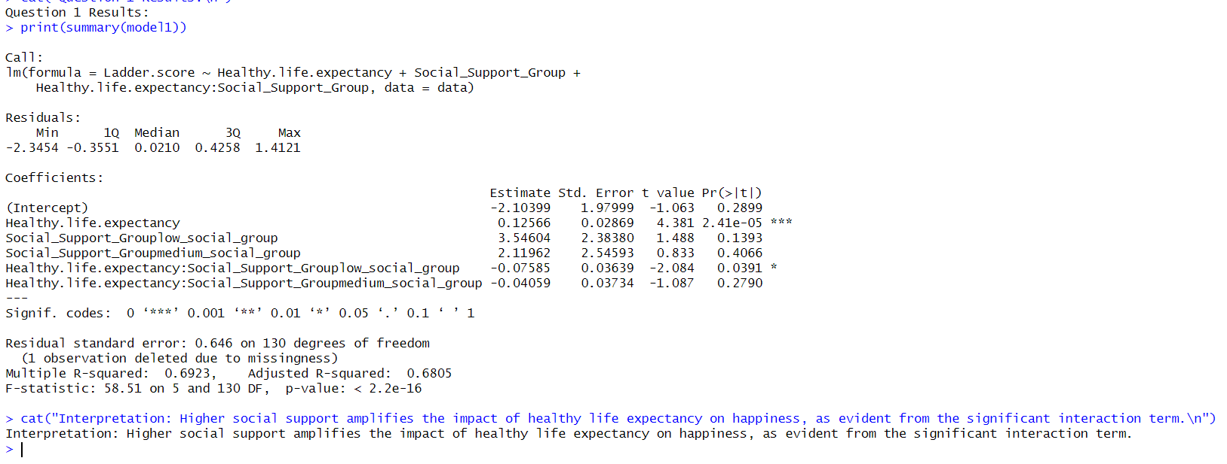Figure 1: Regression Output of Testing Healthy Life Expectancy and Social Support
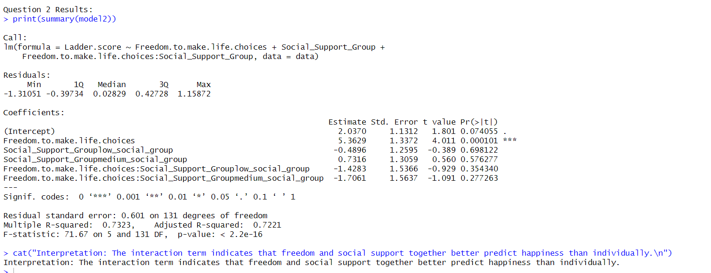
Figure 2: Freedom and Social Support Interaction
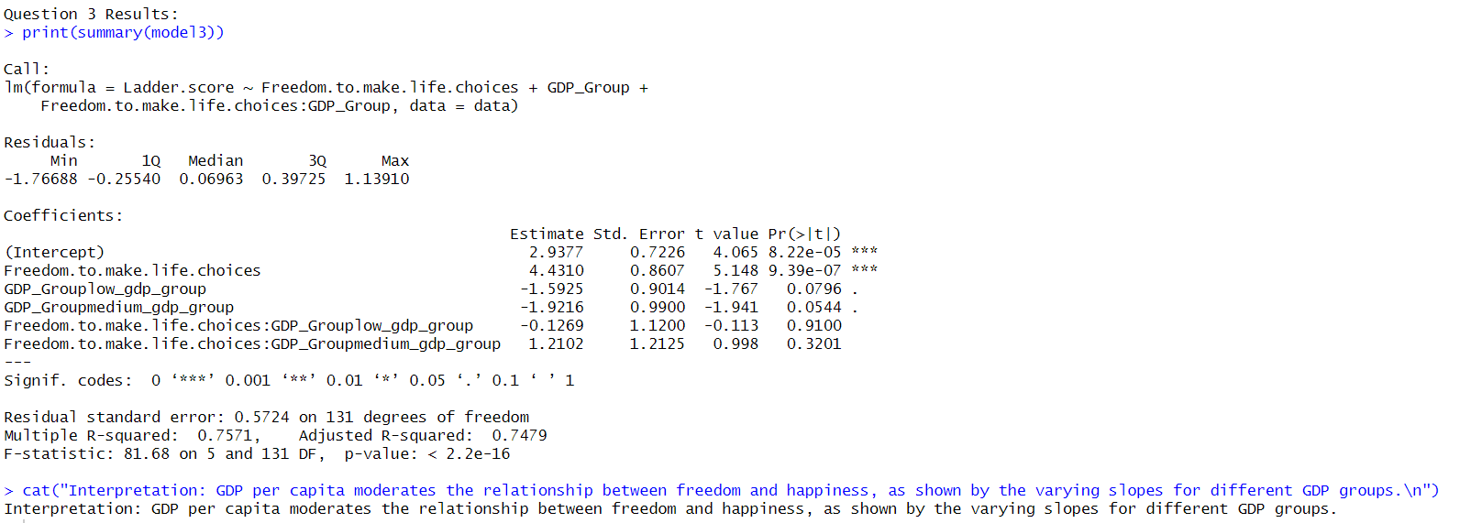
Figure 3: GDP Moderation of Freedom’s Effect on Happiness
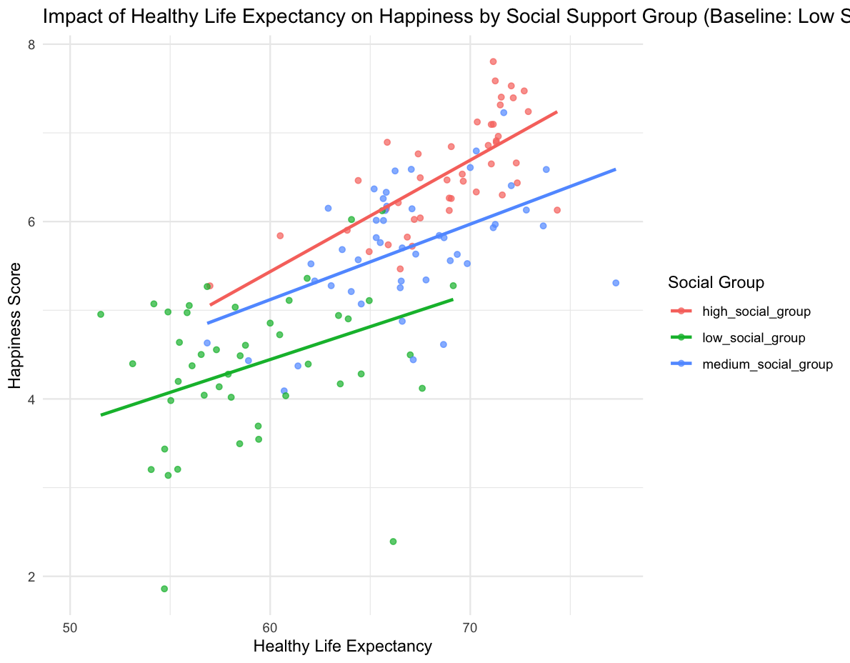
Figure 4: Impact of Healthy Life Expectancy on Happiness by Social Support

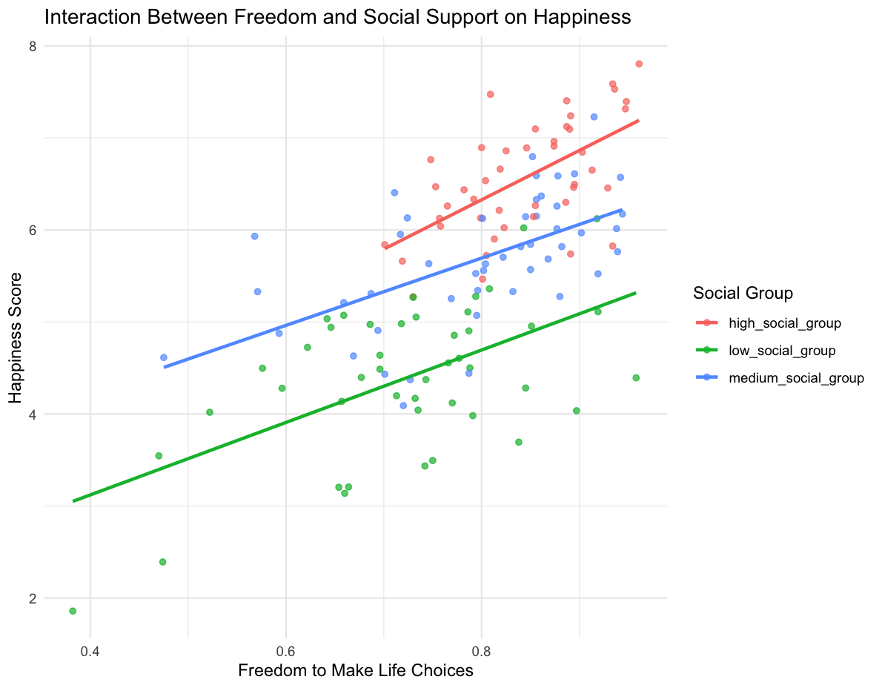
Figure 5: Interaction Between Freedom and Social Support on Happiness
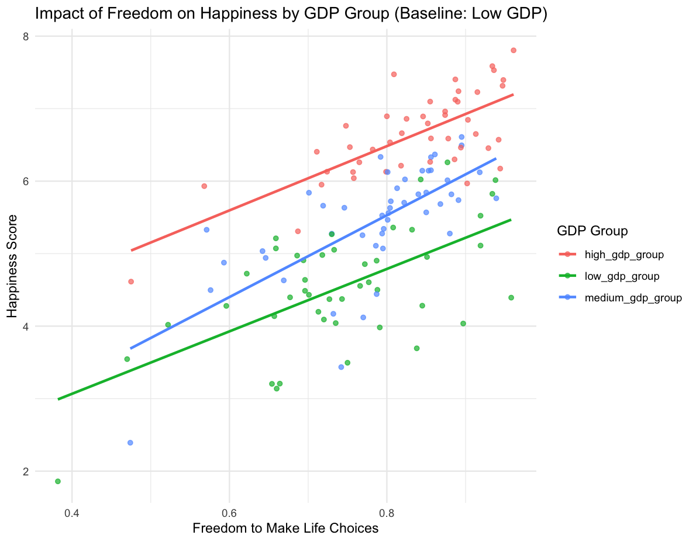
Figure 6: Impact of Freedom on Happiness by GDP Group

