**COMSATS University Islamabad, Abbottabad Campus**

**Department of Computer Science**

**Project Proposal**

**‘SimplyApply’**

**CSC392 Object-Oriented Software Engineering**

Submitted on: <20-10-2022>

**Group Members:**

Leader: Tanveer Ahmad (SP21-BSE-048)

**Syed Kashif Ali Shah (SP21-BSE-062)**

Shabbir Hussain (SP21-BSE-047)

Akhlaq Altaf (SP21-BSE-056)

Mansoor Ashraf (SP21-BSE-064)

Laiba Naeem (SP21-BSE-041)

Laiba Khan (SP21-BSE-074)

Rahil Muqaddam(SP21-BSE-095)

Abeeba Tanveer (SP21-BSE-079)

Contents

CHAPTER 1 PROJECT PROPOSAL 4

Introduction 4

Vision and Business Case 4

Use-Case Model 4

Supplementary Specification 4

Glossary 5

Risk List & Risk Management Plan 6

**1. Malware** 6

**2. Theft & Loss** 6

**3. Unsafe data** 6

**4. Negligence** 7

CHAPTER 2 USE CASES 8

Use Case Diagram 8

Brief Level Use Cases 8

M Akhlaq (Sp21-bse-056) 8

Laiba Khan (SP21-BSE-074) 9

Use Case: View Institute 9

Rahila (SP21-BSE-095) 9

Shabbir Hussain (SP21-BSE-047) 9

Mansoor Ashraf (SP21-BSE-064) 10

Laiba Naeem (sp21-bse-041) 10

Tanveer Ahmad (SP21-BSE-048) 10

Syed Kashif Ali Shah (SP21-BSE-062) 11

Fully Dressed Use Cases 11

Akhlaq Altaf (SP21-BSE-056) 11

Laiba Khan (SP21-BSE-074) 12

Rahila (sp21-bse-095) 15

Areeba Tanveer(SP21-BSE-079) 16

Mansoor Ashraf (SP21-BSE-064) 19

Shabbir Hussain (SP21-BSE-047) 19

Tanveer Ahmad (SP21-BSE-048) 21

Syed Kashif Ali Shah (SP21-BSE-062) 23

Laiba Naeem (sp21-bse-041) 25

CHAPTER 3 System Sequence Diagram 27

System Sequence Diagram: 27

Shabbir Hussain (SP21-BSE-048) 27

Areeba Alam (SP21-BSE-0) 28

Mansoor Ashraf (SP21-BSE-064) 29

Rahila(sp21-bse-095) 29

Tanveer Ahmad (SP21-BSE-048) 31

Syed Kashif Ali Shah(sp21-bse-062) 33

Chapter 4 Domain Model 35

Chapter 5 Operation Contracts 35

Syed Kashif Ali Shah (SP21-BSE-062) 35

Shabbir Hussain (SP21-BSE-048) 36

Tanveer Ahmad (SP21-BSE-048) 37

CHAPTER 6 Logical Architecture 39

# CHAPTER 1 PROJECT PROPOSAL

## Introduction

According to the survey, most of the students studying in different colleges and schools of Abbottabad belong to rural areas which are far away from the desired places of study which is a problem for students because they are compelled to travel a long way to take admission and do other processes. so we have decided to build software that can bring ease for students to complete their admission process along with other primary processes through this software.

## Vision and Business Case

In this project, there is a section named owner, which will be overall controlled by the institutes that provide admission for students and will allow students to access their institute’s information for primary processes. Later on, we have Student section in which students can search for their desired schools and colleges and access their information regarding the admission processes and also they can take admission in that desired institute. With this, there is also a section of visitors through which users can visit the website and check about different institutes present inside this software.

## Use-Case Model

In this project we have different functionalities:

1. Show interest
2. Apply
3. Login
4. Add institutes
5. Verify institutes
6. View institute
7. Remove students
8. Add advertisements
9. Manage Owner
10. Manage institute

## Supplementary Specification

These are some Non Functional Requirements as we together in this inception phase. Security requirements are important factors in this system as classified data will be stored in the database. User (Principal) validation will be done during login to insure that the user is valid and that the user only has access to his or her permission data. General users will only have access through the user interface. The system will have consistent interface formats and button sets and for all form-based applications, will have a form based interface for all data entry and viewing formats. The system will be easily maintained by an authorized trained person (Admin) and it shall respect reports fast as possible in generating report and producing the timetable.

## Glossary

**Show interest:**

Mean select school or college.

**Add institute:**

This only for principal where they will added your school or college.

**Verify institute:**

Board and admin will verify their institute.

**View institute:**

Principal can view your institute page (e.g.: performance, feedback, etc.).

**Add advertisements:**

Principal can add advertisements about your institute.

**Manage owner:**

Admin will manage all the institutes principals.

**Manage institutes:**

Admin will manage all the institutes.

**Authorized trained person:**

Mean admin.

**Owner:**

Mean Principal of institute.

## Risk List & Risk Management Plan

### **1. Malware**

Digital hackers are watching your every move and trick you to download malware and take control of your computer remotely. They use malware to attack computer networks to perpetrate crimes.  Fraudsters use virus, malware, spyware, spams, and phishing to gain access to your sensitive personal information and commit financial crimes. Defend your data against malware through secure servers, whether physical or in cloud, and shield against vulnerabilities.

### **2. Theft & Loss**

Unauthorized users without permissions who have access to sensitive data can cause harm to educational institutions as a result of theft. There is a risk of the sensitive academic data will be leaked by staff. It becomes easy to lose your storage media with backup data due to misplacement or theft. When you suffer data loss due to various incidents such as mechanical damage, power failure, software crash, disasters or loss of your laptops and mobile devices, it is another way of inadvertent data exposure. Keep all your data safe and secure using role-based access control to ensure confidentiality and privacy.

### **3. Unsafe data**

If adequate safety precautions are not taken when files and documents are shared in website, smartphones and tablets via internet networks, the information contained on them might gain access to the devices and get exposed to risks. We can make use of cloud deployments to manage the education system better and better.

### **4. Negligence**

When data is stored in computers or laptops, it has become so natural that people lose the information when files are accidentally deleted or even it could fall into the wrong hands. Ensure a proper backup strategy to keep your data on important devices and run them smoothly without hassles.

|  |  |
| --- | --- |
| Rahila | (login) |
| Laiba Khan | ( view institute) |
| Laiba Naeem | (add institute) |
| Areeba | (add advertisements) |
| Mansoor | (check request, log off) |
| Tanveer Ahmad | (Remove  institute) |
| Akhlaq | (verify institute, manage owner) |
| Shabbir Hussain | Register Institute |
| Syed Kashif Ali shah | Show interest, Apply |

# CHAPTER 2 USE CASES

## Use Case Diagram

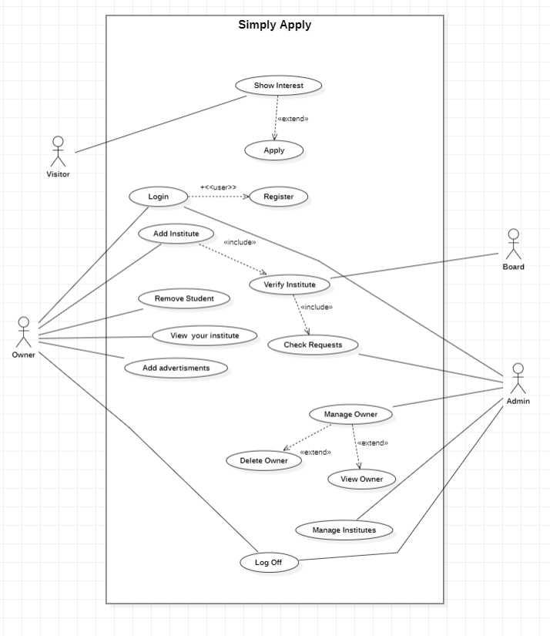

## Brief Level Use Cases

### M Akhlaq (Sp21-bse-056)

#### Brief level use case:

Verification

Admin view all requests from owners of any school college or other institutes where they want to get

permission for institute data record in Simply Apply database, Admin can perform these action with

their request .

He can remove

He can accept

He can ask for other information about their institute

All these actions on the base of authentication from board office.

Use Cases Related with this operation are View Requests, Verify institute, Remove institute, and

advertisement .

### Laiba Khan (SP21-BSE-074)

### Use Case: View Institute

View institute start first Admin will see the enviorment ,staff enviorement staff performance

and adenddence of the insistute.Meanwhile,View institute use case include many section

inorder to access the system ,the section include teacher whom duty is to check student

addendence record and performance for representation of institute. Principle view teacher and

student performance will accountant who manage student staff finanace. After all this

procedure this process will complete.

### Rahila (SP21-BSE-095)

#### Use case: Login

The Login use case in our project is the primary section which has to be performed by user if they want to access the admission process of the system. Meanwhile, the Login Use Case includes two basic sections that are mandatory while accessing to system and the sections are Enter Username and Password which require the basic information of the user in which user enters their name and password and further it will be authenticated by system. So that the user can continue to register process.

### Shabbir Hussain (SP21-BSE-047)

Use Case: Register Account

The use case starts when the user clicks the “Sign Up” tab on the navigation bar. The system displays the signup page that allow users to fill in their username/email address, first and last name and their password. The user keys in the details and clicks “Sign Up” button. The system displays the user’s profile page.

### Mansoor Ashraf (SP21-BSE-064)

#### Use case: Check requests

After being verified from Board Admin will check whether the institute is registered on Board or not. If not, then the registration of that institute will be rejected on website. If yes, then Admin will give permission to owner of the institute to be registered

### Laiba Naeem (sp21-bse-041)

#### Use Case: Process Sale

#### Use case: Add institute

When the owner wants to add institute, he will click on the button “Add institute” then a form will appear in which the owner add the details of the institute he wants to add if the information is correct the institute will be added else he will be notified to correct the errors.

#### Use case: Verify institute

When the owner submits the form of adding institute the system will check if that institute is verified by the board or not if its verified the institute will be added else the owner will write application to board to verify the institute.

#### Use case: Check requests

After adding and verifying the institute in the website the Owner (Principal of institute) and admin (admin of website) can check the requests of the students who showed interest and registered themselves for institutes.

### Tanveer Ahmad (SP21-BSE-048)

#### Use-Case: Manage Institute

Mange institute is Admin use case in which admin can perform CRUD operation

On institute. Admin can ADD Institute, Delete Institute, Update Institute and can Retrieve Institute

Information about institute

#### Use-Case: Logoff

In logoff use case Admin just logoff his account

### Syed Kashif Ali Shah (SP21-BSE-062)

#### Use Case: Show Interest

Firstly visitors (students) will search simply apply on search engines (Google, Microsoft Edge, fire Box, etc.) then they will visit this website, click on show interest, and select institutes, so then they select their choice (Schools, Colleges, and academies).

#### Use Case: Apply

If visitor (student) interested in any school or college so they click on apply button and fill the requirements of school or college. And wait of response for school or college.

# Fully Dressed Use Cases

## Akhlaq Altaf (SP21-BSE-056)

#### Use case : verify institute

Verification

Admin verify an institute is very critical operation, this operation want authentication from board office

that the institute is already register in board office or not .Here is a risk that if admin give them

permission to store their data in his application database and his application will help to manage their

student record, admission of student, advertisement .

Advertisement this process is very important for our application grow, we will play ads of institutes in

our application where students visit and get all information about their favorable institute, if students

get interest they can apply in their favorable institute.

Let

If the institute is all fake then it is Simply Apply Administration mistake ,due to this mistake many

students face problems.

For removing these issues we will create a good verification prosses full authentication from board and

try to get true information from owner of institute

Here the primary actor is Admin

Admin can deal all these prosses of verification. If he get true information from institute and the

institute’s owner fill all required text fields admin can allow. If admin get any fake information from

owner then he can remove owner’s request.

Required Information will be:

* Name of institute
* Board Id of institute
* Owner Name
* Owner Id
* Owner proves that he is the owner of this institute
* Address of institute
* Permanent and temporary address of owner
* Owner cnic copy
* Owner’s Education History
* Past result of institute
* position of institute
* Total students
* Toper student name and their result
* Area of building
* Total rooms
* How many labs
* How many departments in this institute
* How many programs they offer
* Some pictures

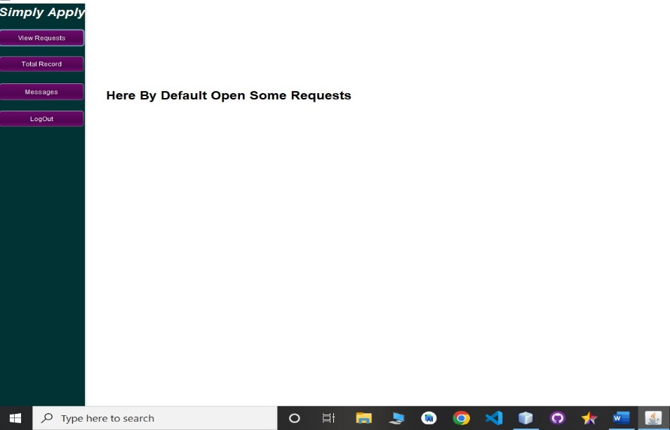

## Laiba Khan (SP21-BSE-074)

Use Case UCI: View Institute

Scope:

See the environment

Primary Actor:

Students, Parents

Stakeholders and Interests:

Teacher: Teacher check the student record, performance, and Attendance principal view student

staff performance accountant manages the student staff finance and admin will check the

environment.

Preconditions:

Check the environment.

Success Guarantee:

After checking the environment, they will satisfy.

Main Success Scenario (or Basic Flow):

• Student Satisfaction.

• Parents Satisfaction.

• Easily can appply for admisssion.

Extension(or Alternative flow):

If they do not enter correct information then it became difficult to take admission.

Special Requirement:

* Performance
* Attendance
* Technology and Data Variation List:
* Through your laptop
* Through your Smart phone.
* Through your computers.
* Open Issue:
* Board Verification

| Rahila (sp21-bse-095)Use Case UCI: Login **Scope**: Register  **Primary** **Actor**: Owner  **Stakeholders and Interests**:  **User:** user is usually the students who wish to take admission in their desired institute and through login section, they can complete the primary process and will be able to access the system and take admission in selected institute.  - **Preconditions**: need to sign in. |
| --- |

**Success Guarantee**

Students can apply sitting at home.

**Main Success Scenario (or Basic Flow):**

* Users can register in the system
* Users can Access the system
* Users can Apply for admission

**Extensions (or Alternative Flows):**

No alternative flow is present for login section.

**Special Requirements:**

* Username
* Password

**Technology and Data Variations List**:

* Smart Phone
* iPod
* Laptop
* Computer

**Open Issues:**

* Board verification

## Areeba Tanveer(SP21-BSE-079)

| Use Case UC1: Add advertisement |
| --- |
| **Scope**: Management  **Primary** **Actor**: Admin  **Stakeholders and Interests**:  **Admin:** Normally in the business model of schools, there are advertisement, offerings, discounts and other kind of scholarships etc. The system requires having a module for managing the advertisements. In this use case, the user can add advertisement to the system  - **Preconditions**: User needs to login to the system. |

**Success Guarantee**

Admin add advertisement to the system

**Main Success Scenario (or Basic Flow):**

* Any school offers an advertisement, announcement or scholarship
* The admin loads advertisements module of the system,
* Admin can add advertisement to the system by providing the following data:
* Title
* Description
* From date
* To date
* Image
* Display to: Students / Visitors page etc.
* Admin can edit any advertisement with the data added for the advertisement
* Admin can view an advertisement details here with created by and updated by activity log as well
* Admin can delete an advertisement

**Extensions (or Alternative Flows):**

* Alternate flows can be:
* Edit advertisement
* Delete advertisement
* View advertisement

**Special Requirements:**

* No special requirements need for advertisement.

**Pre - Conditions:**

* PR - 1: The user must have logged into the system
* PR - 2: The user must have access to the internet
* PR - 3: User must have knowledge about the advertisement and the system.

**Post Conditions:**

* PC - 1: People gets advertisement from the platform.

**Screen short**

**(2)**

## Mansoor Ashraf (SP21-BSE-064)

| Use Case UC1: Check Request |
| --- |
| **Scope**:  Admission  **Primary** **Actor**:  Admin  **Stakeholders and Interests**:  Institute and owner  **Admin:**  Admin is a person who handle the website |

**Success Guarantee**

Admin can add and remove institutes

**Main Success Scenario (or Basic Flow):**

* Admin logged in and Request to Manage Institutes
* System Response and Show ADD Institute, Remove Institute, Update Institute, retrieve Institute
* Admin request to Add Institutes and Perform Action
* Admin request to Remove Institutes and Perform Action
* Admin request to Update Institutes and Perform Action
* Admin request to Retrieve Institutes and Perform Action

## Shabbir Hussain (SP21-BSE-047)

**Use Case:**

Register Account

**Description:**

The use case describes how an owner can register their institute.

**Primary Actors:**

Companies, academics, and students

**Secondary Actors:**

None

**Preconditions:**

The institute registration web page is displayed to the owner. The institute is not registered

**Main success Scenario:**

* The use case starts when the user clicks the “Sign Up” tab on the navigation bar.
* The system displays the signup page that allow users to fill in their username/email address, first and last name and their password.
* The user keys in the details and clicks “Sign Up” button.
* The system displays the user’s profile page.

**Alternative Flow:**

* If the username is invalid, the owner is asked to choose another username.
* If owner enter incomplete details, system displays “please complete personal details” message.

**Post Conditions:**

Owner and institute registered .The grooming web page is displayed.

**Screenshot :**

## Tanveer Ahmad (SP21-BSE-048)

**Use Case**: **Manage Institute**

**Scope: Management**

**Primary-Actor**: **ADMIN**

**Stakeholders and Interests**:

Institutes and Owner

**Admin:**

Admin request to Manage Institute then system response to show the ADD Institute, Delete Institute, Update Institute, and Retrieve Institute Details. Admins perform one operation at time.

**Main Success Scenario (or Basic Flow):**

* Admin logged in and Request to Manage Institutes
* System Response and Show ADD Institute, Remove Institute, Update Institute, retrieve Institute
* Admin request to Add Institutes and Perform Action
* Admin request to Remove Institutes and Perform Action
* Admin request to Update Institutes and Perform Action
* Admin request to Retrieve Institutes and Perform Action

**Use Case**: ADD Institute

When Admin request to Add institute then the System Response to show add institution registration form and admin fill the form and request to submit.

**Use Case**: Delete Institute:

admin request to deleted account then system response to show deletion form in which have institute name and id to be deleted and institute will be deleted from database. In future information of institute will not be shown on SimplyApply.

**Use Case**: Update Institute:

admin request to Update account then system response to show updating institute and change will occur in Database.

**Use Case**: Retrieve Institute:

admin request to retrieve institute information and System show all information about institutes

## Syed Kashif Ali Shah (SP21-BSE-062)

| Use Case UC1: Show interestUse Case UC1: Apply |
| --- |
| **Scope**: Admission  **Primary** **Actor**: Visitor  **Stakeholders and Interests**:  **Visitor:** If visitor is a student so, they can search for their desired schools and colleges and access their information regarding the admission processes and also they can take admission in that desired institute.  - **Preconditions**: no need to login. |

**Success Guarantee**

Visitor can apply sitting at home.

**Main Success Scenario (or Basic Flow):**

* Visitor can select institute (school or college)
* Visitor can visit multiple institutes
* Visitor can watch advertisements about institute
* Visitor can watch rating of institute
* Visitor can apply

**Extensions (or Alternative Flows):**

* If visitor already known about your interested institute so, they can apply directly from home page.
* If visitor faced some problem so, they can get help from after click the help button.

**Special Requirements:**

* No special requirements need for visitor. They can view or apply any institute without login.

**Technology and Data Variations List**:

* Smart Phone
* iPod
* Laptop
* Computer

**Open Issues:**

* Board verification

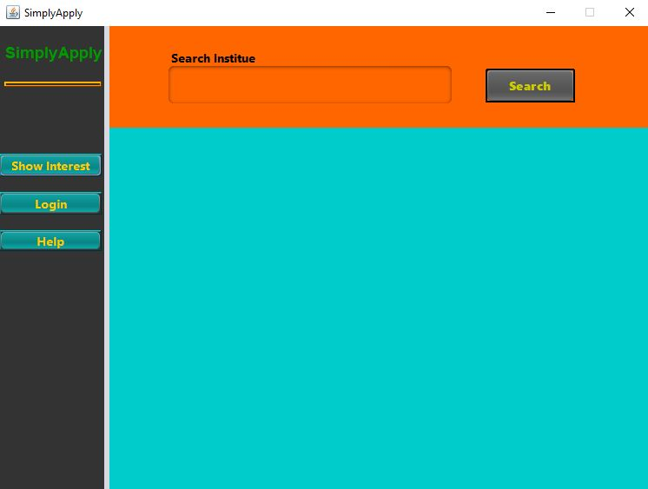**Screen Shots:**

## Laiba Naeem (sp21-bse-041)

Fully dressed:

**Scope:** Add their institute

**Primary actor:** Owner

**Stakeholders and Interests**:

Here the stakeholder is the owner of the institutes who add their institute in the website so that the students can take admission in that specific institute. As the process of admission will be online it be feasible for the students to apply in their desired institutes.

**Pre-conditions:** Login

**Success Guarantee:**  Visitor can apply sitting at home.

**Main success scenario:**

* Add their institutes
* Verify their institutes
* Admissions in their institutes

**Extensions (or Alternative Flows):**

If owner of the institute can’t add their institute the admin of the website also have the access to add the institute after getting verified by the board.

**Special Requirements:**

* Verification of institute.
* Login

**Technology and Data Variations List**:

* Smart Phone
* IPod
* Laptop
* Computer

**Open Issues:**

* Board verification

# CHAPTER 3 System Sequence Diagram

## System Sequence Diagram:

### Areeba Alam (SP21-BSE-079)

### Laiba khan (SP21-BSE-074)

### Laiba Naeem (SP21-BSE-041)

### Rahila Muqaddam (SP21-BSE-095)

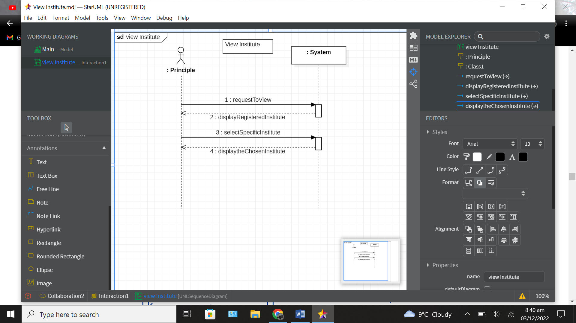

### Shabbir Hussain (SP21-BSE-048)

#### Use case: Register Institute:

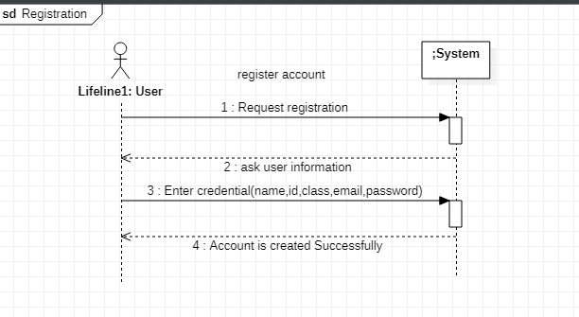

### Areeba Alam (SP21-BSE-0)

#### Use case: Add advertisement

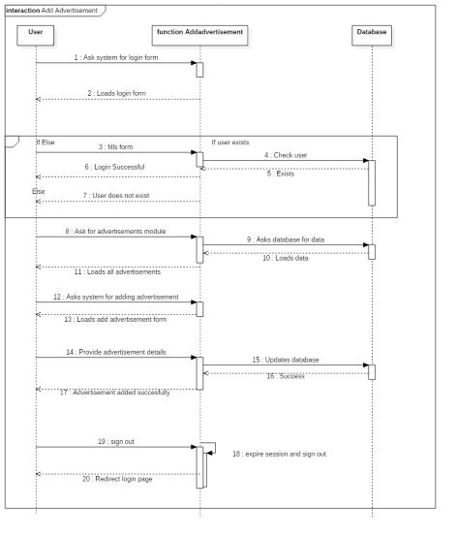

### Mansoor Ashraf (SP21-BSE-064)

#### Use case: Check Request

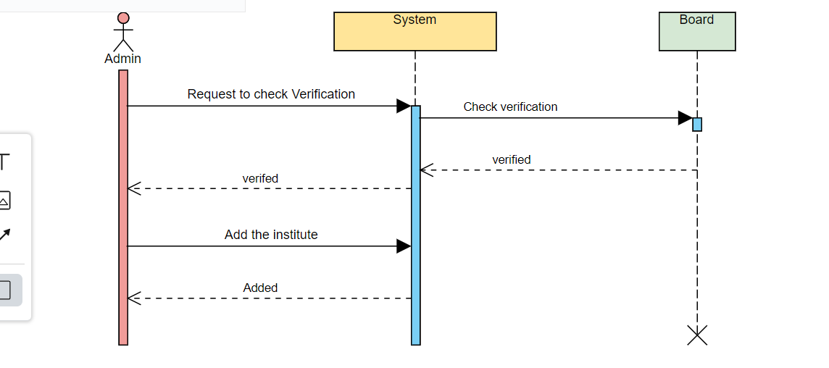

#### Use case: Sign Up

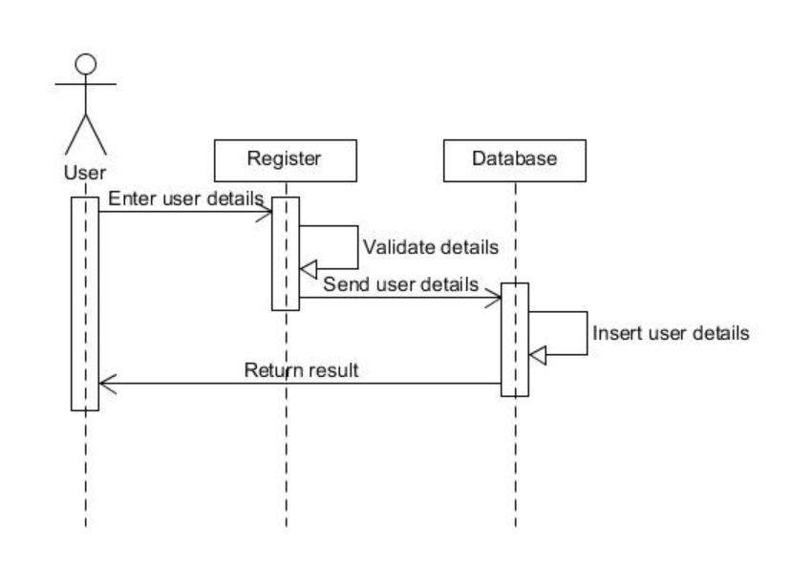

### Rahila(sp21-bse-095)

#### Login use case:

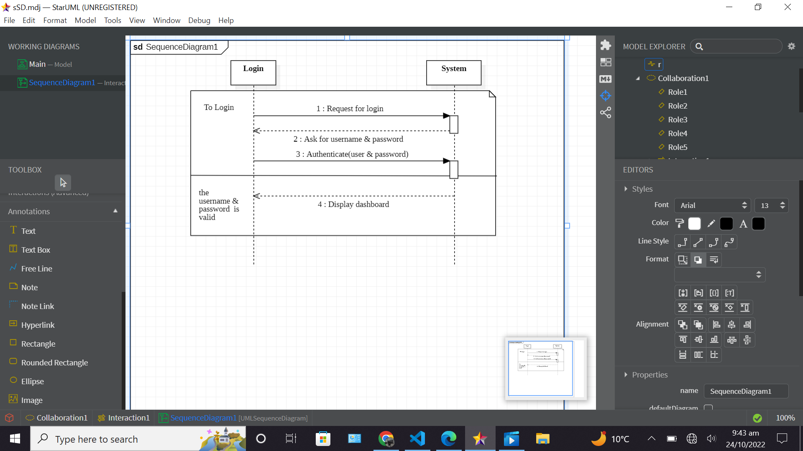

### Tanveer Ahmad (SP21-BSE-048)

#### Search Institute : use-case

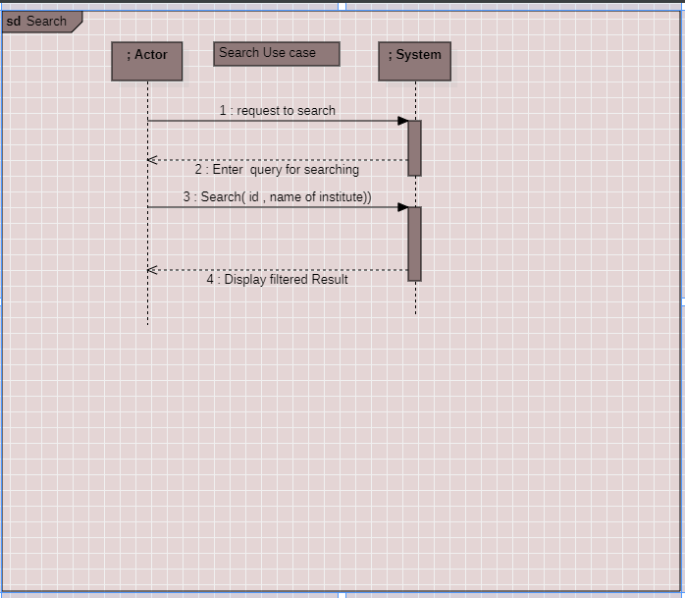

#### Remove Institute: Use case Sequence Diagram

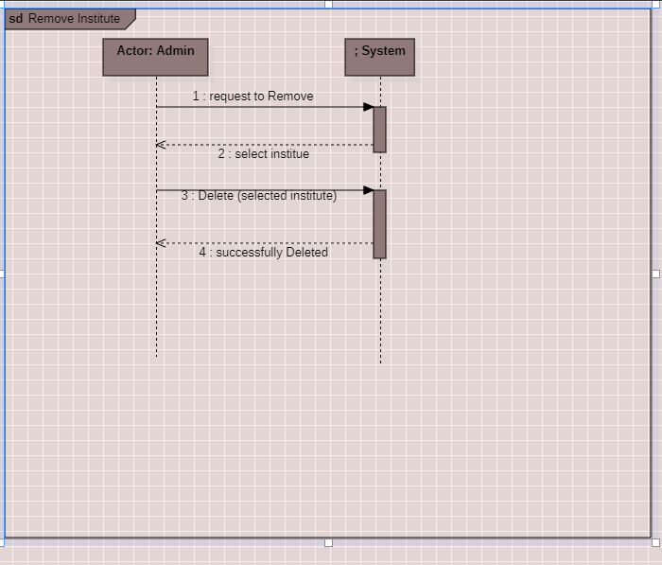

### Syed Kashif Ali Shah(sp21-bse-062)

#### Show Interest : Use case Sequence Diagram

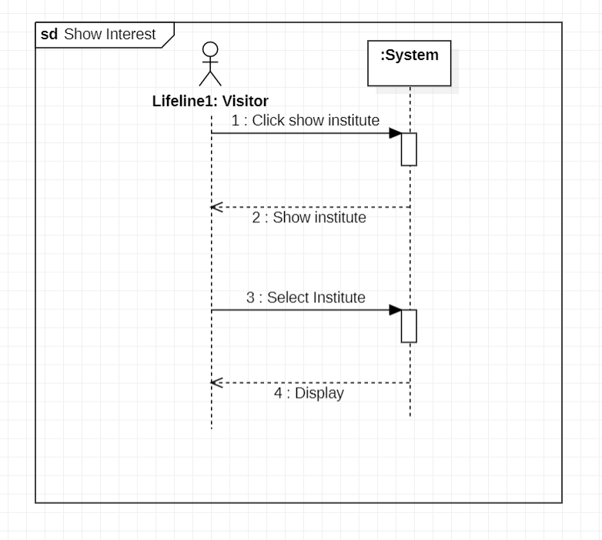

#### Apply : Use case Sequence Diagram

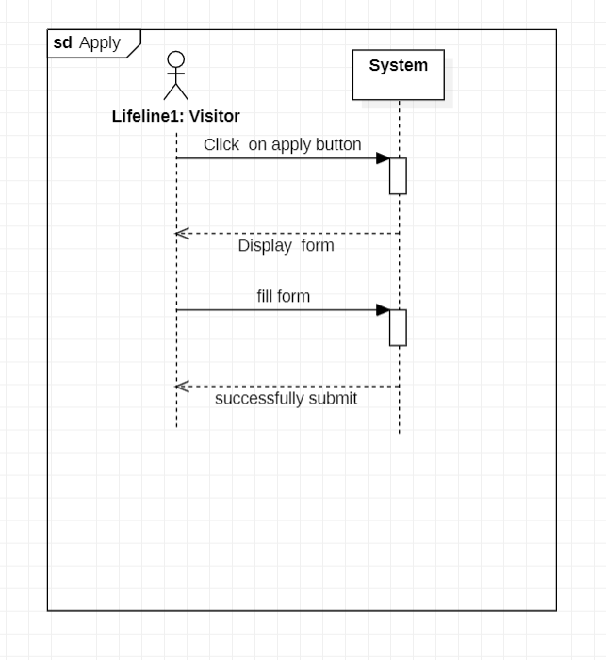

# Chapter 4 Domain Model

# Chapter 5 Operation Contracts

### Areeba Alam (SP21-BSE-79)

**Operation :** advertisement .

**Cross reference** :add advertisement.

After the success of this event:

**Preconditions**: User needs to login to the system.

**Postconditions** The admin loads advertisements module of the system.

Advertisement shall be added to the system

Audience of the advertisement shall be able to view the advertisement

**Extensions (or Alternative Flows):**

* Alternate flows can be:
* Edit advertisement
* Delete advertisement
* View advertisement

### Laiba khan (SP21-BSE-074)

**Operation Contract:**

Contract: Update Institute

Operation: Update Institute

Cross-Refrence: Process sale

Pre-Condition: Owner will update the request to system to confirm updation.

Post-Condition:

* Send the request to update the institute.
* Then display the information of the institute.
* Submit the name and information of the institute.
* Confirm Updation to update the owner institute.

### Laiba Naeem (SP21-BSE-0441)

**Operation:** Request to add institute

**Cross Reference:** Add Institute

**Pre-Conditions:** Login to the system, Registration of the institute

**Post-Conditions:** The owner of the institute will add their respective institute in the system so that the student can get admission in their institute through the system as it will be feasible for many students to apply in their institute from everywhere.

### Rahila Muqaddam (SP21-BSE-095)

**Contract CO2: Request to View**

**Operation**: requestToView (userID,integer)

**Cross Reference**: Use Case: View Institute

**Pre-Condition**: login to system

**Post-Conditions**:

* Add details of insititute instance was created. (instance creation)
* Ad was associated with verify institute. (Association format)
* Ad.userID was set to userID. (Attribute Modification)
* Ad was associated with Add Advertisement. (Association format)

## Syed Kashif Ali Shah (SP21-BSE-062)

#### Use Case UC1: Show Interest

**Contract ID**: 1

**Operation:** Click on show interest

**Cross References:** Use Case: Show interest

**Pre-condition:**

* No need to login.

**Post-condition:**

* Display all institute.

**Contract ID**: 2

**Operation:** Select institute

**Cross References:** Use Case: Show interest

**Pre-condition:**

* Must click on show institutes button.

**Post-condition:**

* Display all information about clicked institute.

#### Use Case UC2: Apply

**Contract ID**: 1

**Operation:** Click on apply button

**Cross References:** Use Case: Apply

**Pre-condition:**

* No need to login.

**Post-condition:**

* User must registered.

**Contract ID**: 2

**Operation:** Fill admission form

**Cross References:** Use Case: Apply

**Pre-condition:**

* User must registered.

**Post-condition:**

* Display admission form.
* Fill the admission form.
* Click on submit button.
* Display message (successfully uploaded or Try again).

## Shabbir Hussain (SP21-BSE-048)

#### Use Case UC1: register account

**Contract ID**: Request Registration

**Operation:** Request Registration ()

**Cross References:** Use cases: Register account

**Pre-conditions:**

* User is not registered.
* The System is running correctly.­­

**Post-conditions:­­**

* User is registered and Account is created successfully.

**Contract ID**: Enter Credential

**Operation:** Enter information ()

**Cross References:** Use cases: Register account

**Pre-conditions:**

* User is not registered.
* The System is running correctly.
* All enter information should be in proper valid form.

**Post-conditions:**

* User is registered and Account is created successfully.

## Tanveer Ahmad (SP21-BSE-048)

#### Contract CO1: request to search

**Operation:** request to search

**Cross References:** Use Case: Search

**Pre-condition:**

* Searching institute is under process

**Post-condition:**

* The System Asking for Entering query

#### Contract CO2: enter query

**Operation:** enter query (institute name, institute id)

**Cross References:** Use Case: Search

**Pre-condition:**

* Searching institute is under process

**Post-condition:**

* The System fetch all registered institute from database, display it

#### Contract CO1: request to remove institute

**Operation:** request to remove institute

**Cross References:** Use Case: Remove Institute

**Pre-condition:**

* Removing Institute is under process

**Post-condition:**

* display all registered institute for selection

#### Contract CO2: Remove

**Operation:** remove (selected institute)

**Cross References:** Use Case: Remove Institute

**Pre-condition:**

* Removing Institute is under process

**Post-condition:**

* The selected institute is removed
* The table of Institutes in Database is modified
* Display message of done operation successfully
* Object of this institute is Destroyed

# CHAPTER 6 Logical Architecture

# Chapter 7 Interaction Diagram

## SP21-BSE-048 (Remove Institute-SD)

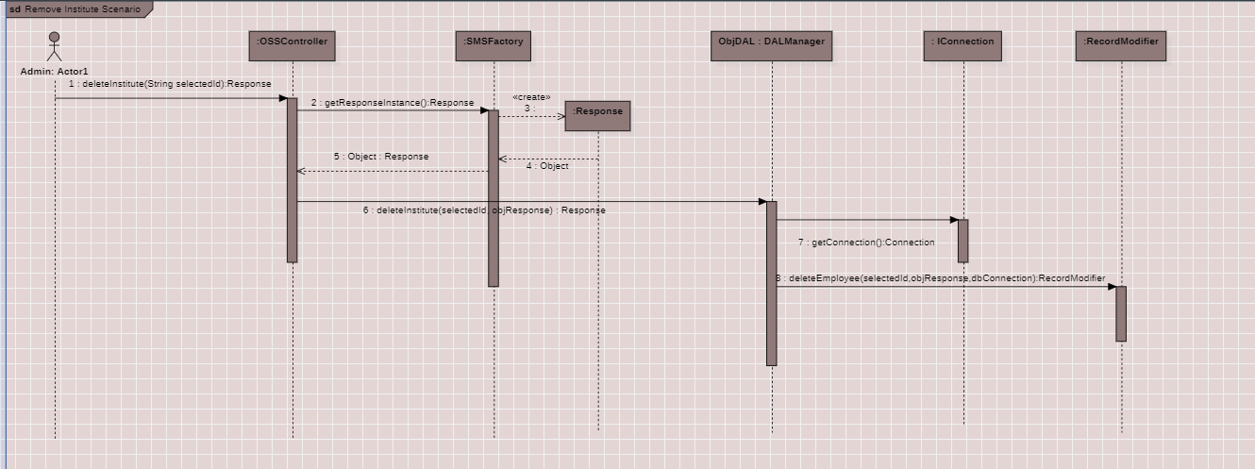

**After Reverse Engineering**

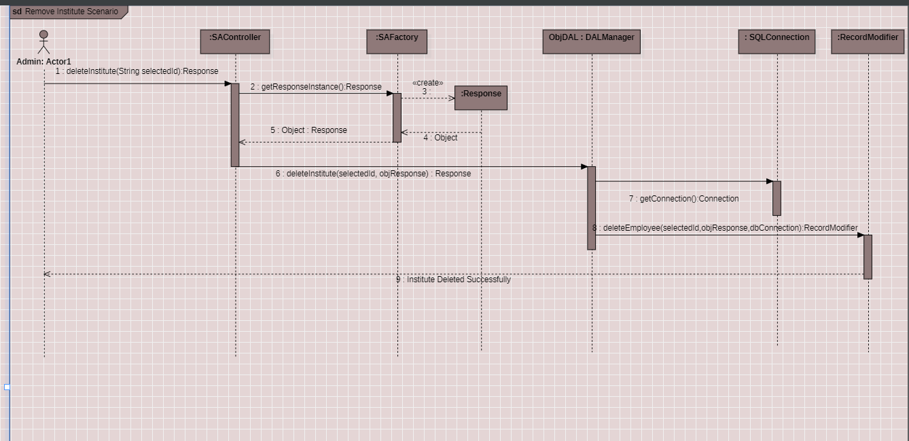

# Chapter 8 Class Diagram

## Tanveer Ahmad (SP21-BSE-048) – Delete Institute

