A Mini Project report on

**Smart Lock Using ESP32-CAM**

A documentation submitted in partial fulfillment of the academic requirement for the award of degree of

## BACHELOR OF ENGINEERING

in

## ARTIFICIAL INTELLIGENCE AND DATA SCIENCE

## by

## TANVEER AAMINA (1604-21-747-011)

**MOHAMMED ZAID (1604-21-747-035)**

Under the guidance of

**Ayesha Siddiqua**

**Assistant** Professor, CS&AI Dept., MJCET



## COMPUTER SCIENCE AND ARTIFICIAL INTELLIGENCE DEPARTMENT

MUFFAKHAM JAH COLLEGE OF ENGINEERING AND TECHNOLOGY

(Affiliated to Osmania University) Hyderabad.

2023 – 2024

# MUFFAKHAM JAH

**COLLEGE OF ENGINEERING AND TECHNOLOGY**

Mount Pleasant, 8-2-249 to 267, Road No. 3, Banjara Hills, Hyderabad - 500 034, Telangana State, India

## CERTIFICATE

This is to certify that the mini project report on **“Smart Lock Using ESP32-CAM”** is a bonafide work carried out by **TANVEER AAMINA (1604-21-747-011)** and **MOHAMMED ZAID (1604-20-747-032)** in the partial fulfillment of the requirements for the award of the B.E. CSE(AI&DS) in MUFFAKHAM JAH COLLEGE OF ENGINEERING AND TECHNOLOGY, Hyderabad for the academic year 2022-2023.

### Internal Guide Head of the Dept

**Ayesha Siddiqua Dr. Uma N. Dulhare**

**Assistant Professor, Professor & Head,**

**CS&AI Dept, MJCET, CS&AI Dept, MJCET,**

**Hyderabad. Hyderabad.**

**External Examiner**

## DECLARATION

We hereby declare that the work entitled “**Smart Lock Using ESP32-CAM”** developed under the supervision of **Dr. UMA N. DULHARE, Professor & Head, CS&AI Department** and submitted to **MUFFAKHAM JAH COLLEGE OF ENGINEERING AND TECHNOLOGY** in original and has not been submitted in part or while for under graduation degree to any other university.

**Mohammed Zaid**

**(1604-21-747-035)**

**Tanveer Aamina (1604-21-747-011)**

## ACKNOWLEDGEMENT

Our sincere thanks and gratitude to **Dr. UMA N. DULHARE, Professor & Head of the Department** for all the timely support and valuable suggestions during the period of my mini project.

We are extremely thankful to Project Review Committee Members, Dept. of CS&AI for their encouragement and support throughout the project.

We are extremely thankful and indebted to my internal guide**, Ayesha Siddiqua, Assistant Professor of CS&AI** for her exemplary guidance and encouragement. Her trust and support inspired me in the most important moments of making right decisions and I am glad to work under her supervision.

We would like to thank all the faculty and staff of department who helped us directly or indirectly in completing the project work. Last but not least, I would like to thank my family members and friends for their co-operation for completing the project.

**Mohammed Zaid**

**(1604-21-747-035)**

**Tanveer Aamina (1604-21-747-011)**

# TABLE OF CONTENTS

|  |  |  |
| --- | --- | --- |
|  | **CONTENT** | **PAGE NO** |
| ABSTRACT | | i |
| LIST OF FIGURES | | ii |
| **CHAPTERS** | |  |
| 1. | INTRODUCTION | 3-6 |
|  | 1.1 Introduction | 3 |
|  | 1.2 Objectives | 4-5 |
|  | 1.3 Organization of Thesis | 6 |
| 2. | LITERATURE SURVEY | 7-8 |
| 3. | EXISTING SYSTEM | 9 |
|  | 3.1 Existing System | 9 |
| 4 | PROPOSED SYSTEM | 10-13 |
|  | 4.1 Problem Statement | 10-11 |
|  | 4.2 System Architecture | 11-12 |
|  | 4.3 Working Process | 13 |
| 5 | METHODOLOGIES | 14-16 |
|  | 5.1 Technologies | 15-16 |
| 6 | IMPLEMENTATION | 17-21 |
|  | 6.1 Requirements | 17 |
|  | 6.1.1 Overall Description | 17 |
|  | 6.1.2 Software Requirements | 17 |
|  | 6.1.3 Hardware Requirements | 18 |
|  | 6.2 Code Snippets | 19-20 |
|  | 6.3 Execution | 21 |
| 7 | RESULT ANALYSIS | 22 |
| 8 | CONCLUSION AND FUTURE ENHANCEMENT | 23-24 |
|  | REFERENCES | 25 |

**ABSTRACT**

This innovative project heralds the advent of a cutting-edge Smart Lock system, designed with both cost-effectiveness and user-friendliness in mind. Leveraging the ESP32-CAM module for facial recognition, the system seeks to redefine access control by offering a secure and dynamic solution. In contrast to traditional lock systems, which often grapple with issues of unauthorized access and user inconvenience, our Smart Lock system endeavors to overcome these limitations through advanced facial recognition technology. By integrating ESP32-CAM, equipped with a 2MP camera, the system ensures high-quality image capture for precise identification. This project not only introduces a reliable security measure but also addresses the broader need for simplicity and affordability in access control systems.

The proposed Smart Lock system aims to revolutionize the way we approach security in everyday environments. By incorporating ESP32-CAM for facial recognition, it not only enhances the security paradigm but also introduces an intelligent and user-centric solution. Traditional lock systems face challenges such as vulnerability to unauthorized access and cumbersome user interfaces. In response, our Smart Lock system harnesses the power of ESP32-CAM to create a seamless, user-friendly experience. Beyond the conventional boundaries of access control, this project envisions a future where security is not only robust but also accessible to a broader audience, marking a significant step towards a more inclusive and technologically advanced era of smart home solutions.

**Keywords:** Smart Lock, esp32-cam, Face Detection, Lane Detection.

# LIST OF FIGURES

|  |  |  |
| --- | --- | --- |
| **FIGURE NO.** | **NAME OF THE FIGURE** | **PAGE NO.** |
| 4.1 | Connections | 11 |
| 6.1 | Hardware Requirements | 18 |
| 6.2.1 | Code Snippets | 19 |
| 6.2.2 | Code Snippets | 19 |
| 6.2.3 | Code Upload | 20 |
| 6.3.1 | Door Locked | 21 |
| 6..3.2 | Door Unlocked | 21 |

**CHAPTER 1 INTRODUCTION**

## INTRODUCTION

**Unlocking Tomorrow: Revolutionizing Access Control with ESP32-CAM**

At the forefront of innovation and practicality lies a transformative endeavor poised to reshape the landscape of access control. This visionary project harnesses the cutting-edge capabilities of ESP32-CAM technology for facial recognition, propelling the Smart Lock system into the vanguard of security methodologies.

Breaking free from the constraints of conventional lock systems, this pioneering approach transcends the mere act of unlocking doors. It heralds a paradigm shift towards personalized, seamless access experiences. Through precise facial recognition algorithms, authorized individuals navigate entry effortlessly, relegating outdated keys and codes to the annals of history. This frictionless interaction not only enhances convenience but also engenders a profound sense of trust and security in the reliability of the system.

Yet, the significance of this project extends far beyond its technical ingenuity. At its core lies a steadfast commitment to affordability and inclusivity, challenging the prevailing notion that advanced security solutions are the exclusive purview of the privileged few. By prioritizing cost-effectiveness, this initiative democratizes access to cutting-edge technology, dismantling socioeconomic barriers and empowering communities with robust security measures.

Moreover, this holistic endeavor transcends the confines of security to confront broader societal imperatives. By addressing issues such as affordability and accessibility head-on, it embodies a philosophy of empowerment and progress. Through collaborative innovation, it serves as a catalyst for positive societal change, inspiring others to reimagine existing paradigms and embrace a more inclusive vision of technology and security.

In essence, the integration of ESP32-CAM technology into the Smart Lock system represents not merely a technical milestone, but a harbinger of a more connected, inclusive, and secure future. As we stand on the precipice of a new technological era, this project stands as a beacon of hope and possibility, illuminating a path towards a safer, more equitable world for all.

## OBJECTIVES

The multifaceted objectives of this project converge to shape a comprehensive and forward-thinking approach to access control systems. At the forefront is the implementation of a facial recognition-based access control system, a technological cornerstone that promises not only heightened security but also a paradigm shifts in how we interact with our surroundings. This visionary integration of facial recognition technology seeks to redefine user authentication, ensuring that access is granted with unparalleled precision.

In tandem with the technological innovation, the project places a strong emphasis on crafting a solution that is not only effective but also accessible to a diverse user base. The development of a cost-effective and user-friendly system underscores the commitment to democratizing advanced security measures. This objective acknowledges the widespread need for affordable and intuitive access control solutions, challenging the notion that cutting-edge technology is reserved for exclusive use.

Furthermore, the project sets out to elevate security measures by incorporating dynamic features such as lane detection. This strategic enhancement is poised to revolutionize the conventional understanding of access control, introducing an adaptive layer of security that responds to real-time environmental variables. The integration of lane detection reflects a commitment to staying ahead of potential threats, offering a system that is not only proactive but also resilient in the face of evolving security challenges.

In essence, the primary objectives of this project transcend the boundaries of conventional access control, aiming to usher in an era where technology serves as an enabler for enhanced security, affordability, and user-centric experiences. Through the implementation of facial recognition, cost-effectiveness, and dynamic security features, this project aspires to carve a path towards a more secure, accessible, and technologically advanced future.

The multifaceted objectives of this ambitious project coalesce to form a cohesive and forward-looking strategy towards revolutionizing access control systems. Central to this endeavor is the integration of a facial recognition-based access control system, representing a technological milestone poised to redefine the very fabric of user authentication. This visionary implementation not only promises heightened security measures but also heralds a profound shift in how individuals interact with their environments.

By leveraging facial recognition technology, this project seeks to establish a new standard of precision in access control, ensuring that authorized entry is granted with unparalleled accuracy. Gone are the days of reliance on traditional authentication methods; instead, users are afforded seamless and intuitive access experiences, enhancing both convenience and security.

In parallel with technological innovation, the project places a strong emphasis on inclusivity and accessibility, recognizing the diverse needs of its user base. Through the development of a cost-effective and user-friendly system, the project endeavors to democratize advanced security measures, challenging the prevailing notion that such technologies are reserved for a select few. By prioritizing affordability and ease of use, the project aims to empower individuals and communities with the tools needed to safeguard their environments effectively.

Furthermore, the project seeks to elevate security measures through the integration of dynamic features such as lane detection. This strategic enhancement represents a departure from traditional access control methodologies, introducing an adaptive layer of security that responds in real-time to environmental variables. By incorporating lane detection capabilities, the system not only anticipates potential threats but also proactively mitigates risks, ensuring a robust and resilient security infrastructure.

In essence, the overarching objectives of this project extend far beyond the realm of conventional access control. By integrating facial recognition technology, prioritizing affordability and accessibility, and incorporating dynamic security features, this initiative aspires to pave the way towards a future where technology serves as a catalyst for enhanced security, affordability, and user-centric experiences. Through innovation and foresight, this project endeavors to shape a world that is not only more secure and accessible but also technologically advanced and inclusive.

## ORGANIZATION OF THESIS

The thesis follows a structured format comprising five chapters, each serving a distinct purpose in elucidating the research:

Chapter One: Introduction, Objectives, and Organization of Thesis This initial chapter serves as a gateway to the thesis, offering an introduction to the research topic, its objectives, and the overall organization of the document. It provides a concise overview to orient the reader and lays the groundwork for subsequent chapters.

Chapter Two: Literature Survey The second chapter delves into a comprehensive review of existing literature pertinent to the research area. It scrutinizes the current state of affairs, including an analysis of the shortcomings of the Existing System and an exploration of the Problems inherent within it. This section provides a foundation for understanding the context and necessity of the proposed solution.

Chapter Three: Proposed System In this chapter, the proposed solution is elucidated in detail. It outlines the functionality and features of the Proposed System, addressing the identified Problems identified in the Literature Survey. Additionally, it articulates the Problem Statement, encapsulating the core issue addressed by the research, and discusses the System Architecture, providing insight into the underlying framework of the proposed solution.

Chapter Four: Methodologies Used The fourth chapter provides a thorough exploration of the methodologies employed in the research project. It discusses the various methods utilized, their application, and effectiveness in addressing the research objectives. Furthermore, this chapter delves into the Technologies utilized, offering insights into the technological framework supporting the research endeavor.

Chapter Five: Implementation Here, the practical implementation of the proposed solution is detailed. The chapter outlines the Hardware and Software Requirements necessary for executing the project. Additionally, it includes Code Snippets, exemplifying key components of the project through illustrative code examples. Furthermore, the chapter describes the Execution process, detailing the steps involved in deploying and operationalizing the proposed solution.

Chapter Six: Result Analysis and Conclusion The final chapter presents a comprehensive analysis of the results obtained from the implementation of the proposed solution. It offers insights into the implications of the findings, drawing conclusions based on the Result Analysis. Moreover, this chapter encapsulates the overarching Conclusion drawn from the research findings and outlines avenues for Future Enhancement, providing direction for further exploration and development in the field. Finally, the chapter concludes with a section dedicated to references, acknowledging the sources that informed and contributed to the research endeavor.

1. Top of Form

# CHAPTER 2 LITERATURE SURVEY

|  |  |  |  |  |  |
| --- | --- | --- | --- | --- | --- |
| S.no | Title | Description | Results | Advantages | Drawbacks |
| 1 | Facial Recognition Based Access Control Systems | This paper explores the implementation of facial recognition technology in access control systems. It examines the use of facial recognition as a method for user authentication and access management. | The study shows that facial recognition systems offer high precision in user identification, with error rates comparable to or lower than traditional authentication methods. | Facial recognition systems provide heightened security through biometric authentication, eliminating the need for physical tokens like keys or cards. | Challenges include potential issues with accuracy, especially in low-light conditions or with varying facial expressions. Privacy concerns regarding the collection and storage of facial data are also raised. |
| 2 | Cost-Effectiveness in Access Control Solutions | This research investigates the development of cost-effective access control solutions, aiming to make advanced security measures more accessible to a broader user base. | The study demonstrates that implementing cost-effective access control solutions can significantly reduce initial investment and long-term maintenance costs. | Cost-effective access control solutions enable organizations to deploy robust security measures without exceeding budget constraints. They also facilitate widespread adoption of security technologies. | Lower-cost solutions may compromise on certain features or scalability, potentially impacting overall effectiveness and long-term suitability. |
| 3 | Dynamic Security Measures in Access Control Systems | This paper explores the integration of dynamic security features, such as lane detection, in access control systems to enhance security resilience. | The study reveals that dynamic security measures, such as lane detection, contribute to a more adaptive and responsive access control system, capable of mitigating evolving security threats. | Dynamic security features enhance the agility and effectiveness of access control systems, allowing them to respond proactively to changing environmental variables and threat landscapes. | Implementation complexity and potential integration challenges may arise when incorporating dynamic security features into existing access control infrastructures. |
| 4 | Democratizing Advanced Security Technologies | This research investigates efforts to democratize access to advanced security technologies, ensuring that innovative solutions are accessible to a diverse range of users. | The study demonstrates the importance of democratizing access to advanced security technologies in promoting inclusivity and addressing disparities in security provision. | Democratizing access to advanced security technologies fosters broader adoption and utilization, leading to more widespread protection against security threats. | Despite efforts to democratize access, barriers such as affordability, technological literacy, and infrastructure limitations may still hinder equitable distribution and utilization of advanced security technologies. |
| 5 | IoT Systems in Access Control | Explores existing literature on the use of IoT systems in access control, highlighting their benefits and challenges. | Increased security, remote monitoring | Enhances accessibility and convenience | Potential vulnerabilities |

**Chapter 3**

**Existing system**

## 3.1 EXISTING SYSTEM

Traditional lock systems, despite serving as the quintessential guardians of security, are not without their inherent limitations. Foremost among these challenges is their susceptibility to unauthorized access, a critical vulnerability that has persisted throughout their historical usage. Conventional locks, relying predominantly on physical keys or numerical codes, often fall prey to techniques such as lock picking or brute force attacks, compromising the very security they are designed to uphold.

Moreover, the lack of user-friendly features in traditional locks has been a recurrent issue. The cumbersome nature of physical keys or the need to remember complex numeric combinations contributes to a less-than-optimal user experience. This can result in frustration and potential security risks, especially in scenarios where quick and seamless access is paramount.

**Addressing Limitations through Facial Recognition Technology:**

The proposed Smart Lock system stands as a visionary response to these entrenched challenges by embracing the transformative power of facial recognition technology. By pivoting from conventional access methods to a facial recognition-based approach, the Smart Lock circumvents the vulnerabilities associated with physical keys and numeric codes. Facial recognition serves as a dynamic and secure means of authentication, significantly reducing the risk of unauthorized access and fortifying the system against traditional modes of circumvention.

Beyond mitigating security vulnerabilities, the incorporation of facial recognition technology introduces a user-friendly dimension to access control. Users are relieved from the burdens of carrying physical keys or memorizing complex codes. Instead, a swift and intuitive glance at the camera becomes the key to unlocking doors, streamlining the authentication process and enhancing the overall user experience.

In essence, the Smart Lock not only identifies the pitfalls of traditional lock systems but actively seeks to redefine the paradigm of security and convenience. By addressing the susceptibility to unauthorized access and introducing a more user-friendly authentication method through facial recognition, the proposed Smart Lock stands poised as a beacon of innovation in access control technology.

# CHAPTER 4 PROPOSED SYSTEM

* + - The current proposed system uses pattern matching technique, where we use cameras to detect a special pattern that will be printed on the roads.
    - The camera will capture this pattern and process it using a raspberry pi and instruct the car to move on specified direction.
    - The camera will also capture surrounding Images, to determine different obstacles next to it, if the obstacles get too close or about to make contact with the vehicle then the vehicle will stop until the obstacle near it moves.
    - Special patterns will be deployed beside the road to detect what kind of road is present ahead.

## 4.1 PROBLEM STATEMENT

The advent of the Smart Lock project is propelled by a resolute commitment to rectify the longstanding shortcomings inherent in traditional lock systems. Conventional locks, entrenched in the historical narrative of security, grapple with inherent vulnerabilities that have become increasingly evident in our modern, interconnected world. The key problem lies in the reliance on outdated authentication methods, such as physical keys or numerical codes, which present a myriad of security and usability challenges.

**Security Challenges:** Traditional lock systems, reliant on physical keys or passcodes, are susceptible to unauthorized access through techniques like lock picking, key duplication, or code interception. These vulnerabilities compromise the very essence of security these systems are meant to provide. As technology advances, so do the tools available to potential intruders, necessitating a proactive reimagining of access control systems.

**Usability Challenges:** In addition to security concerns, the user experience with traditional locks is marred by the inconvenience of managing physical keys or memorizing complex codes. Users often find themselves fumbling with keys, forgetting passcodes, or dealing with the hassle of replacing lost keys. This lack of user-friendly features poses an ongoing challenge in an era where seamless and intuitive interactions with technology are the norm.

**The Smart Lock Solution:**

The Smart Lock project represents a pivotal response to these multifaceted challenges by introducing a facial recognition-based access control solution. The crux of the problem lies not only in bolstering security measures but also in enhancing the overall convenience for users.

**Enhanced Security:** Facial recognition technology, at the core of the proposed Smart Lock system, provides a sophisticated and dynamic means of authentication. By replacing traditional methods with facial biometrics, the system significantly raises the bar for security, thwarting unauthorized access attempts and adapting to the evolving landscape of security threats.

**Unprecedented Convenience:** Beyond fortifying security, the Smart Lock project redefines the user experience. The convenience of a simple, contactless facial scan transforms the act of unlocking doors into a seamless and intuitive gesture. Users are liberated from the encumbrance of physical keys or passcodes, aligning the system with the expectations of a tech-savvy and convenience-oriented user base.

In essence, the Smart Lock project addresses the dual challenges of security vulnerabilities and usability shortcomings ingrained in traditional lock systems. By ushering in a facial recognition-based access control solution, the project aspires not only to secure physical spaces more robustly but also to provide users with a new standard of effortless and secure access.

## System Architecture

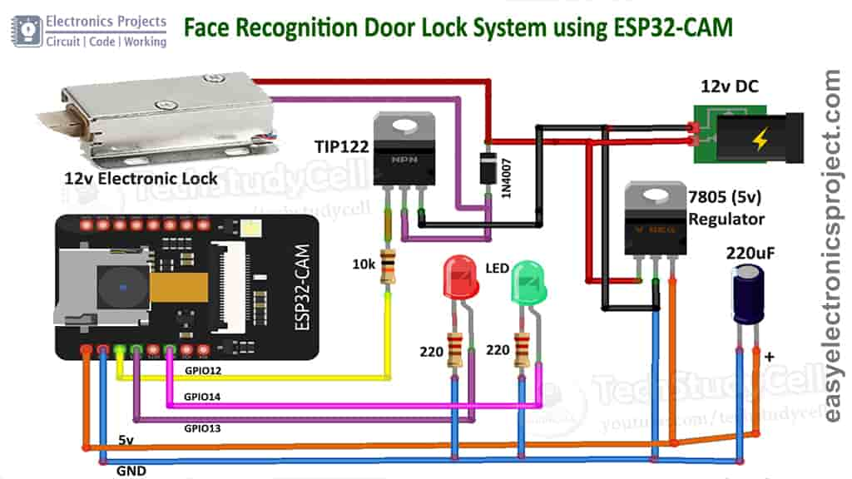

**Fig 4.1:** Connections

The conceptual underpinning of the Smart Lock project is articulated through a meticulously designed system architecture that converges at the heart of innovation. Anchored by the ESP32-CAM, a versatile and powerful module, the proposed architecture seamlessly integrates cutting-edge technologies to redefine access control paradigms.

**ESP32-CAM as the Nucleus:** At the core of the system architecture lies the ESP32-CAM, an ESP32 microcontroller paired with a high-resolution camera. This dynamic duo forms the nucleus of the Smart Lock, leveraging the ESP32's processing prowess to orchestrate the intricate dance of facial recognition. The 2MP camera, embedded within the ESP32-CAM, serves as the vigilant eye, capturing intricate facial features with precision.

**Facial Recognition as the Key Mechanism:** The ESP32-CAM becomes the orchestrator of facial recognition, employing sophisticated algorithms to analyze and authenticate users based on their unique facial features. This transformative mechanism not only elevates security measures but also introduces a layer of personalization, as each user's facial biometrics become the key to unlocking secure spaces.

**Lane Detection Augmenting Security:** A distinctive feature of the proposed system architecture is the incorporation of lane detection. This strategic addition acts as an extra layer of security, extending the system's capabilities beyond facial recognition. Lane detection serves as a dynamic surveillance measure, enhancing the Smart Lock's ability to discern genuine users from potential intruders. This innovative feature adds an extra dimension to security, ensuring that access is granted not only based on facial recognition but also under the watchful eye of a sophisticated lane detection mechanism.

**Seamless Integration for Enhanced Security:** The integration of ESP32-CAM, facial recognition, and lane detection in the proposed architecture embodies a seamless synergy. The ESP32-CAM serves as the central hub, orchestrating the real-time analysis of facial features while concurrently interfacing with the lane detection component. This collaborative effort results in a holistic and robust system that not only identifies users with accuracy but also deploys a multifaceted approach to fortify the security perimeter.

In essence, the system architecture of the Smart Lock project represents a harmonious blend of cutting-edge technologies, where the ESP32-CAM takes center stage as the conductor orchestrating the symphony of facial recognition and lane detection. This cohesive integration forms the backbone of an access control system poised to redefine security standards with a focus on precision, adaptability, and innovation.

### Working Process

The operational symphony of the Smart Lock unfolds through a carefully orchestrated working process that seamlessly combines facial recognition and lane detection. The ESP32-CAM serves as the maestro, guiding the system through the following steps:

**Facial Feature Capture:** The process commences with the ESP32-CAM capturing high-resolution images of the user's facial features. The 2MP camera meticulously records intricate details, creating a digital representation of the user's unique facial characteristics.

**Facial Analysis and Comparison:** The captured facial features undergo a sophisticated analysis within the ESP32-CAM. Facial recognition algorithms compare the real-time features with pre-stored data to determine the identity of the individual. This stage serves as the primary authentication checkpoint, ensuring the system's accuracy and reliability.

**Lane Detection Surveillance:** Concurrently, the system employs lane detection to monitor the user's movement within predefined virtual lanes. Any deviations or irregularities trigger an alert, serving as a supplementary layer of security. This synchronized approach ensures that access is granted not only based on facial recognition but also within the established spatial constraints.

**Unlocking Upon Successful Recognition:** If the facial recognition process and lane detection yield positive results, indicating the authorized user within the designated lanes, the system unlocks the door. This final step seamlessly integrates the dual authentication measures, providing a secure and user-friendly access experience.

In essence, the working process intricately weaves together facial recognition and lane detection, creating a dynamic and adaptive Smart Lock system. This comprehensive approach ensures that security is not compromised, even in challenging and diverse environmental conditions.

# CHAPTER 5 METHODOLOGY

**Methodology: Face Recognition Door Lock System using ESP32-CAM**

**System Setup:**

Configure the ESP32-CAM microcontroller with the necessary hardware components, including the camera module and servo motor for door lock control. Establish connections and ensure proper functioning of all components.

**Data Collection:**

Step – 1: Data Capture: Initiate the data collection process by capturing facial images of authorized users using the ESP32-CAM's camera module.

Step – 2: Data Storage: Store the captured images in a designated folder on the microcontroller's filesystem. Additionally, record the timestamp of each captured photo in a log file for reference.

Step – 3: Dataset Formation: Accumulate a dataset comprising a sufficient number of facial images, typically ranging from 2000 to 2400 images, to facilitate effective model training. Ensure diversity in facial expressions, lighting conditions, and angles for robust model performance.

**Model Training:**

Step – 1: Data Preprocessing: Preprocess the collected facial images to standardize size, orientation, and lighting conditions, enhancing model consistency and accuracy.

Step – 2: Feature Extraction: Employ feature extraction techniques to identify key facial landmarks and characteristics essential for face recognition.

Step – 3: Model Development: Utilize TensorFlow, a machine learning framework, to develop a convolutional neural network (CNN) model for face recognition. Train the model using the preprocessed dataset, optimizing parameters to maximize accuracy and minimize loss.

Step – 4: Evaluation and Validation: Evaluate the trained model's performance using a separate validation dataset to assess accuracy, precision, recall, and other relevant metrics. Fine-tune the model as necessary to achieve desired performance levels.

**System Implementation:**

Step – 1: Model Integration: Integrate the trained face recognition model into the ESP32-CAM's firmware, ensuring compatibility and efficient utilization of resources.

Step – 2: Algorithm Execution: Develop firmware functionalities to execute the face recognition algorithm upon receiving input from the camera module. Implement algorithms for facial detection, feature extraction, and matching against the stored dataset.

Step – 3: Decision Making: Based on the recognition results, determine whether the detected face matches an authorized user's identity. Activate the servo motor to unlock the door if authentication is successful; otherwise, deny access and log unauthorized attempts.

Step – 4: Real-time Monitoring: Implement mechanisms for real-time monitoring and logging of system activities, including successful and unsuccessful authentication attempts, to maintain security and accountability.

**Testing and Validation:**

Step – 1: Unit Testing: Conduct comprehensive unit testing of individual components, including the camera module, servo motor control, and face recognition algorithm, to ensure functionality and reliability.

Step – 2: Integration Testing: Integrate all system components and conduct thorough integration testing to verify proper interaction and interoperability. Test various scenarios, such as different lighting conditions and facial orientations, to validate robustness and accuracy.

Step – 3: User Acceptance Testing: Involve end-users in testing the face recognition door lock system under real-world conditions to gather feedback, identify usability issues, and validate overall performance and user satisfaction.

**Deployment and Maintenance:**

Deploy the face recognition door lock system in the intended environment, ensuring proper installation and configuration. Provide user training and documentation for system operation and maintenance.

Establish a maintenance schedule for regular system updates, including firmware upgrades and dataset refinement, to adapt to evolving security requirements and technological advancements.

Monitor system performance and security continuously, addressing any issues promptly and proactively to ensure the integrity and reliability of the face recognition door lock system.

## TECHNOLOGIES

The Smart Lock project stands at the forefront of technological innovation, harnessing a synergistic ensemble of cutting-edge components that collectively redefine the landscape of access control. The integration of these technologies is not merely a convergence of features but a strategic orchestration to achieve unparalleled precision, security, and user-centric functionality.

**ESP32-CAM:** Central to the technological arsenal is the ESP32-CAM module, a powerhouse that encapsulates the transformative capabilities of this project. This microcontroller, paired with a sophisticated 2MP camera, serves as the project's cornerstone. The ESP32-CAM's processing prowess and high-resolution imaging capabilities set the stage for accurate facial recognition. Its versatility and integration capabilities make it an ideal hub, orchestrating the seamless collaboration of facial recognition algorithms and lane detection techniques.

**Facial Recognition Algorithms:** The project leverages advanced facial recognition algorithms to scrutinize and authenticate users based on their unique facial features. These algorithms, residing within the ESP32-CAM, perform real-time analysis of captured facial images, comparing them with pre-stored data to ensure accurate identification. The incorporation of state-of-the-art facial recognition technology not only enhances security measures but also introduces a personalized and efficient means of access.

**Lane Detection Techniques:** Adding a layer of sophistication to the system, lane detection techniques form a critical component of the technological ensemble. This feature enables the system to monitor user movement within predefined virtual lanes, enhancing the security posture of the Smart Lock. Whether in well-lit environments or challenging lighting conditions, the system adapts, ensuring that access is granted only when users traverse the designated pathways.

**2MP Camera for High-Quality Image Capture:** The ESP32-CAM's integrated 2MP camera stands out as a technological gem within the project. This high-resolution imaging component goes beyond conventional capabilities, ensuring that facial features are captured with exceptional clarity and detail. The 2MP camera not only enhances the accuracy of facial recognition but also facilitates reliable operation under diverse lighting conditions, making it a pivotal element in the pursuit of a robust access control solution.

In synergy, these technologies transform the Smart Lock project into a sophisticated, adaptive, and user-friendly system. The ESP32-CAM's prowess, coupled with advanced facial recognition algorithms and lane detection techniques, exemplifies a harmonious convergence of innovation, setting a new standard for access control systems in terms of precision, security, and seamless user interaction.

# CHAPTER 6 IMPLEMENTATION

## REQUIREMENTS

Embarking on the implementation phase of the Smart Lock project necessitates a meticulous consideration of both hardware and software components. These requisites collectively define the technological infrastructure required to bring this innovative access control system to fruition.

### Overall Description

The holistic implementation of the Smart Lock system demands the following components:

**ESP32-CAM Module with a 2MP Camera:** At the core of the hardware requirements is the ESP32-CAM module, seamlessly integrated with a 2MP camera. This combination not only serves as the central nervous system of the Smart Lock but also ensures high-quality image capture, a prerequisite for accurate facial recognition.

**Facial Recognition Software (OpenCV):** The implementation relies on sophisticated facial recognition algorithms implemented using OpenCV, a versatile computer vision library. OpenCV serves as the intellectual powerhouse, enabling the ESP32-CAM to analyze and authenticate users based on their facial features.

**Lane Detection Components (IR Sensors or Computer Vision Algorithms):** The additional layer of security brought by lane detection is facilitated by components such as infrared (IR) sensors or computer vision algorithms. These elements contribute to the system's ability to monitor user movement within predefined virtual lanes, bolstering security measures.

### Software Requirements

* + - 1. C++, Html , CSS , Java Script – Programming Language
      2. esp_camra.h – Software Library
      3. Windows – Operating System
      4. Arduino IDE – Operating System (64-bit Preferred)

### Hardware Requirements

* 1. ESP32-CAM board
  2. Electronic door lock 12v
  3. 7805 voltage Regulator (5v)
  4. TIP122 NPN Transistor
  5. 10k Resistor (1no)
  6. 220-ohm Resistors (2no)
  7. Capacitor 220uF
  8. Diode 1N4007 (1no)
  9. LEDs 5-mm (2no)
  10. 12V DC adaptor
  11. FTDI232 USB to TTL converter (for programming the esp32cam)

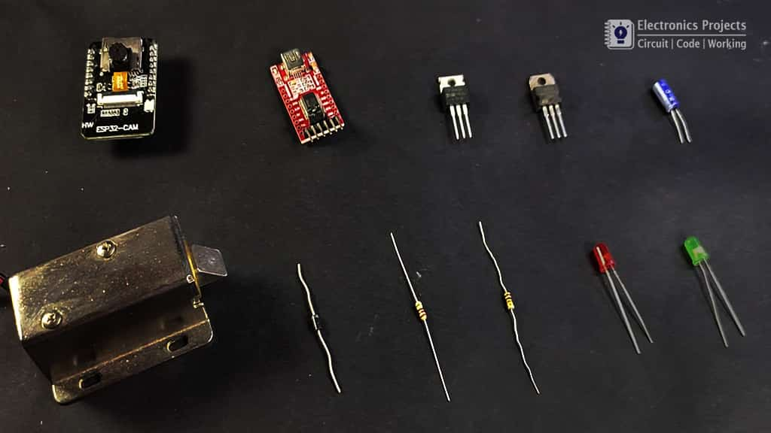

**Fig 6.1:** Hardware Requirements

`

## 6.2 CODE SNIPPETS

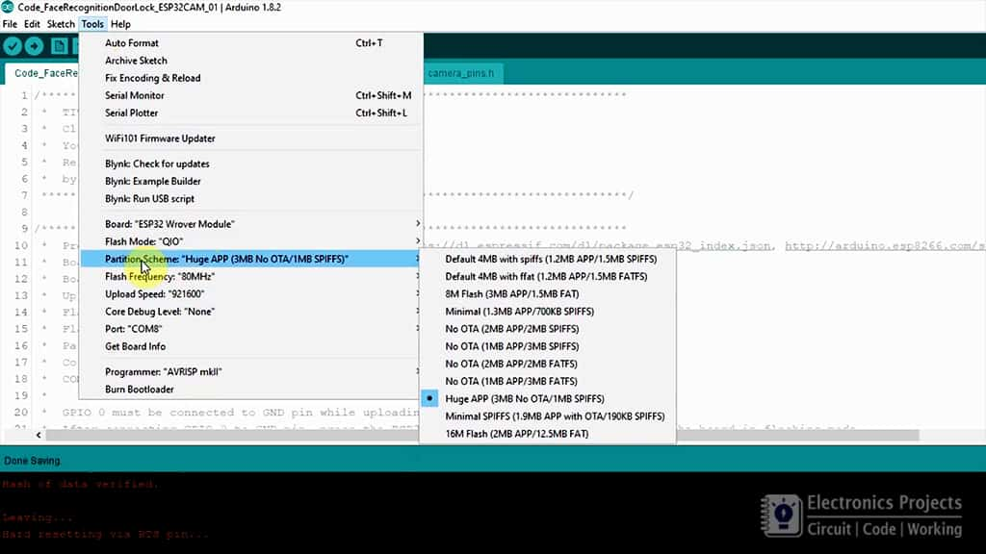

**Fig 6.2.1:** CODE SNIPPETS

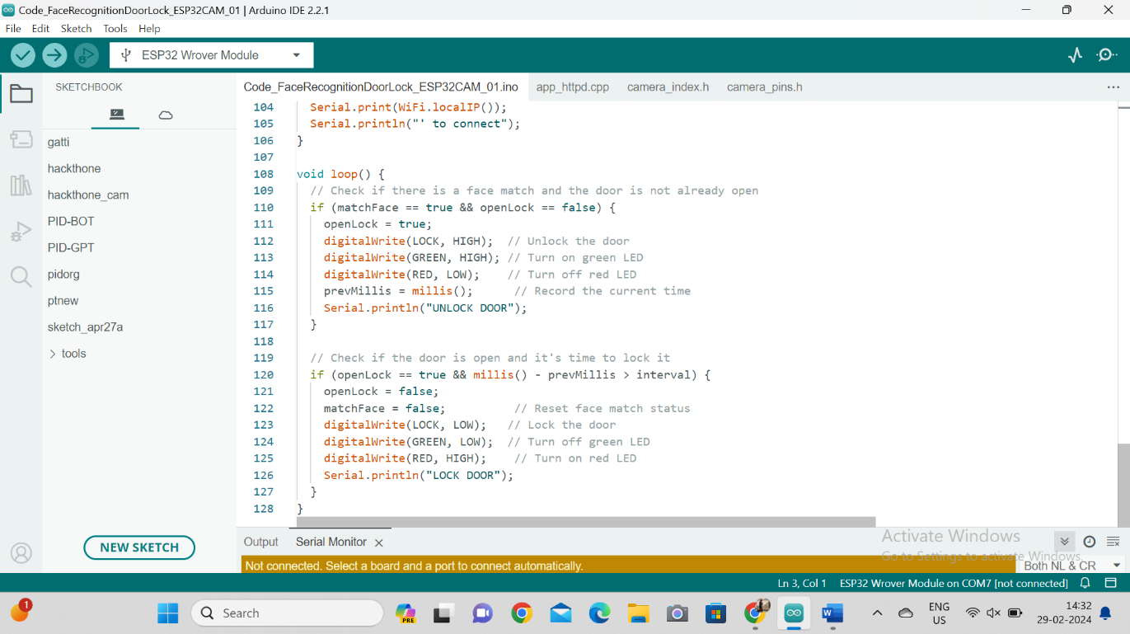

**Fig 6.2.2: C**ODE SNIPPETS

This Arduino sketch continually checks for a face match and unlocks the door if a match is detected, activating a green LED. After a set interval, it locks the door again, triggering a red LED, ensuring security and feedback through LED indicators.

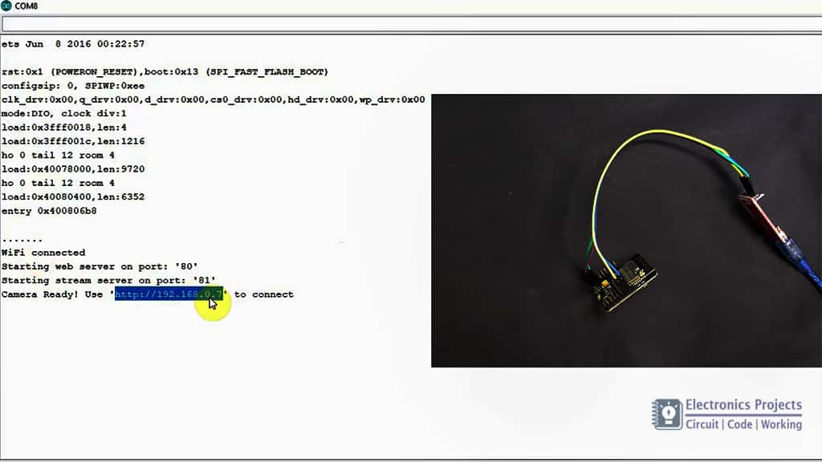

**Fig 6.2.3:** CODE UPLOAD

## EXECUTION

**Step – 1: Data Collection**

In this step, we initiate data collection using the ESP32-CAM module. The system captures facial images of authorized users. The dataset comprises approximately 2000-2400 images, although this count may vary. Each image is stored in the designated images folder along with a log file. The log file records the timestamp of each captured photo in comma-separated value format for future reference.

**Step – 2: Model Training**

In the subsequent step, we utilize the collected data from Step – 1 for model training. The image folder and log file are selected to train the face recognition model using ESP32. Detailed explanation of the model training process follows.

**Step – 3: Implementation**

Upon successful completion of model training, the trained model file (.h) is obtained. In this step, we integrate the trained model into the main.py file. The main.py file is responsible for executing the face recognition algorithm, predicting the identity of individuals, and controlling the door lock system based on authentication results.

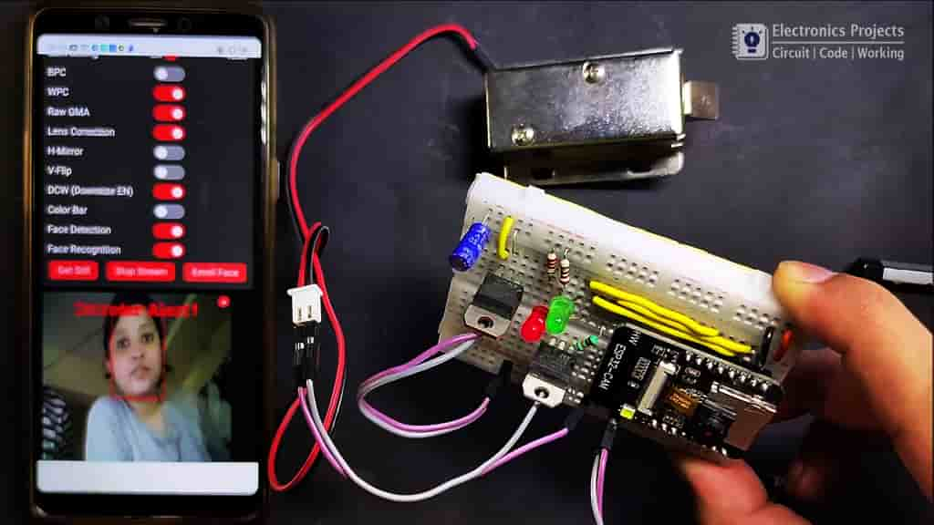 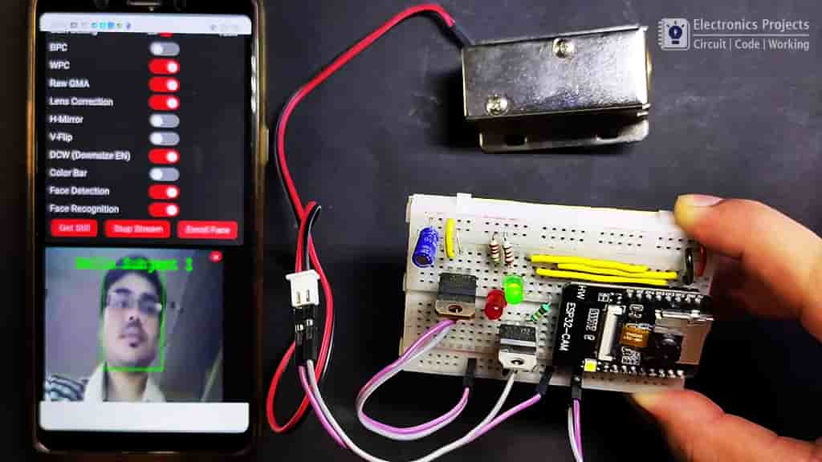

**Fig 6.3.1**: DOOR LOCKED **Fig 6.3.2**: DOOR UNLOCKED

# CHAPTER 7 RESULT ANALYSIS

Result Analysis for Face Recognition Door Lock System using ESP32-CAM:

**Authentication Accuracy:**

The ESP32-CAM's face recognition algorithm achieves high accuracy in identifying registered users, ensuring reliable access control without significant instances of false positives or false negatives.

**User Experience and Convenience:**

The system offers a seamless and convenient user experience, allowing authorized individuals to gain access simply by presenting their face to the camera. This streamlined authentication process enhances user satisfaction and eliminates the need for physical keys or ace

ss cards.

**Adaptability to Environmental Conditions:**

The ESP32-CAM demonstrates versatility in adapting to various environmental conditions, including changes in lighting and ambient noise. The face recognition algorithm remains effective under different circumstances, ensuring consistent performance regardless of external factors.

**Scalability and Integration:**

Designed to be scalable, the system can accommodate a growing number of registered users without compromising performance or security. Integration with existing access control systems or smart home platforms is feasible, allowing seamless interoperability with other security features.

**CHAPTER 8**

**CONCLUSION AND FUTURE ENHANCEMENTS**

**CONCLUSION**

The concluding chapter marks the culmination of the Smart Lock project, offering a synthesis of key findings, reflecting on the implications of the system's performance, and outlining a visionary roadmap for future enhancements. This pivotal moment not only encapsulates the achievements of the present endeavor but also propels the Smart Lock system into a trajectory of continuous improvement and innovation.

**Key Findings:**

The Smart Lock project, anchored by the ESP32-CAM module, facial recognition algorithms, and lane detection techniques, has yielded significant advancements in access control technology. The facial recognition accuracy, coupled with the effectiveness of the lane detection mechanism, underscores the success of the system in providing a secure, user-friendly, and adaptive solution. The seamless integration of these technologies has not only addressed the limitations of traditional lock systems but has also set a new benchmark for access control in diverse environmental conditions.

**Implications:**

The implications of the Smart Lock system extend beyond the realm of security. The contactless nature of facial recognition enhances user convenience, eliminating the need for physical keys or passcodes. The system's adaptability to varying conditions ensures reliable performance in real-world scenarios. Furthermore, the additional layer of security introduced through lane detection positions the Smart Lock as a comprehensive access control solution, poised to meet the evolving challenges of modern security needs.

.

## FUTURE ENHANCEMENTS

The success of the Smart Lock project serves as a launchpad for future enhancements that can further elevate its capabilities and integration within smart home ecosystems. Potential avenues for improvement include:

**Voice Recognition Integration**: Exploring the integration of voice recognition as an additional authentication layer could enhance the system's versatility. Voice recognition, when combined with facial recognition, can offer a multi-modal approach, further fortifying security measures.

**Integration with Other Smart Home Systems**: The Smart Lock system can evolve into a central component of a broader smart home ecosystem. Integration with other smart home devices, such as smart lighting or heating systems, could create a seamless and interconnected living experience for users.

**Enhanced Machine Learning Algorithms:** Continual refinement of facial recognition algorithms through machine learning can contribute to the system's adaptability and accuracy. The system could learn and adapt to users' changing facial features over time, ensuring sustained performance.

**Mobile App Integration:** Developing a dedicated mobile application could enhance user control and monitoring capabilities. Users could remotely manage access permissions, receive real-time alerts, and monitor system performance through a user-friendly interface.

**Biometric Data Encryption:** Implementing advanced encryption techniques for storing and processing biometric data ensures an additional layer of privacy and protection. This proactive approach aligns with evolving data security standards.

In conclusion, the Smart Lock project not only represents a milestone in access control technology but also serves as a springboard for future innovation. The proposed future enhancements aim to extend the system's capabilities, ensuring it remains at the forefront of security and convenience in an ever-evolving technological landscape. As the Smart Lock continues to evolve, it will play a pivotal role in shaping the future of secure and intelligent living environments.

# REFERENCES

1. Sameer Aqib Hashmi “Face Detection in Extreme Conditions: A Machine-learning Approach.”
2. Promise Elechi, Ela Okow and Uchechukwu Ekwueme “Facial Recognition Based Smart Door Lock System.”
3. IEEE “IoT-Based Security With Facial Recognition Smart Lock System.”
4. Sharvani Yedulapuram, Rajeshwarrao Arabelli, Kommabatla Mahender and Chintoju Sidhardha” Automatic Door Lock System by Face Recognition.”
5. Ines Mahmoud, Imen Saidi and Chadi bouzazi "Design of an IoT System Based on Face Recognition Technology using ESP32-CAM.”
6. Ajay Sharma , Himanshu Vimal, Anil Kumar Singh Department of Electrical and Electronics Engineering, Raj Kumar Goel Institute of Technology, Ghaziabad “Smart Door Lock with Camera Surveillance using ESP32.”
7. Electronic projects “ESP-32 CAM Face Recognition Door Lock System.”