(7344 306.456025 192.168.0.104 146.190.62.39 HTTP 510 GET / HTTP/1.1)

Frame 7344: Packet, 510 bytes on wire (4080 bits), 510 bytes captured (4080 bits) on interface \Device\NPF_{CF24EC74-6998-474F-B6FF-D63F5F3B8249}, id 0
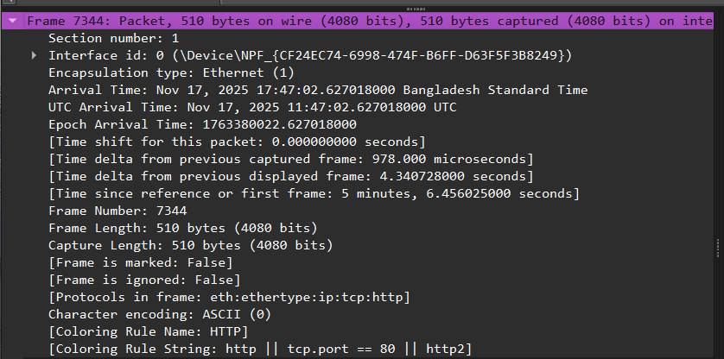

Ethernet II, Src: AzureWaveTec_9d:62:41 (80:91:33:9d:62:41), Dst: TendaTechnol_9b:f7:58 (cc:2d:21:9b:f7:58)

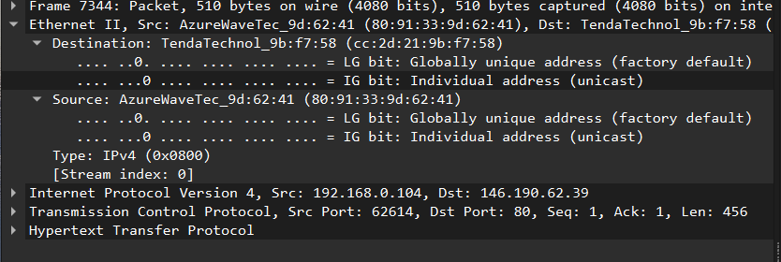

Internet Protocol Version 4, Src: 192.168.0.104, Dst: 146.190.62.39
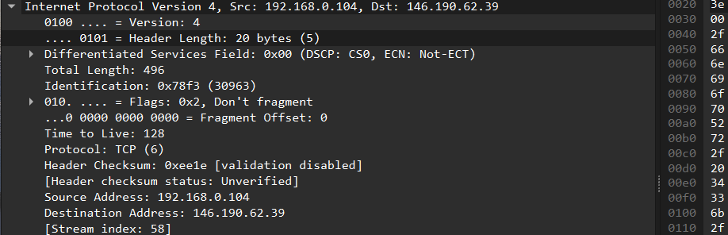

Transmission Control Protocol, Src Port: 62614, Dst Port: 80, Seq: 1, Ack: 1, Len: 456

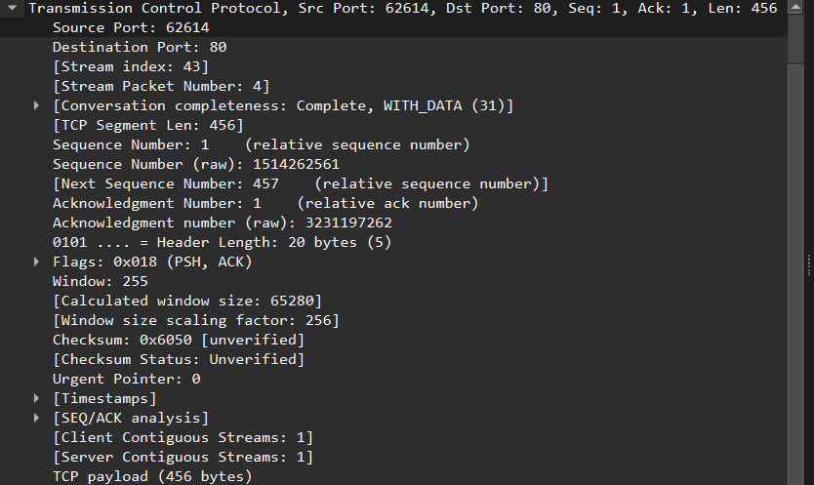

Hypertext Transfer Protocol

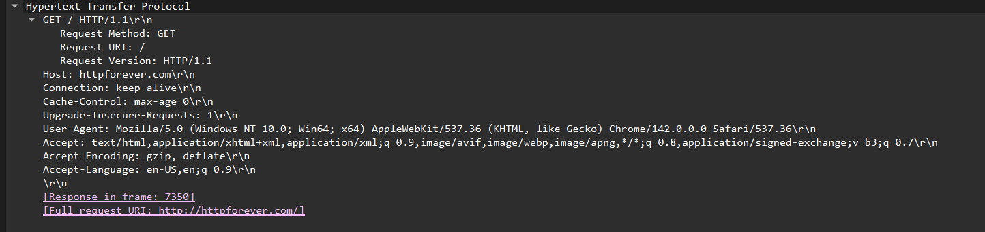

7350 306.726650 146.190.62.39 192.168.0.104 HTTP 90 HTTP/1.1 200 OK (text/html)

Frame 7350: Packet, 90 bytes on wire (720 bits), 90 bytes captured (720 bits) on interface \Device\NPF_{CF24EC74-6998-474F-B6FF-D63F5F3B8249}, id 0

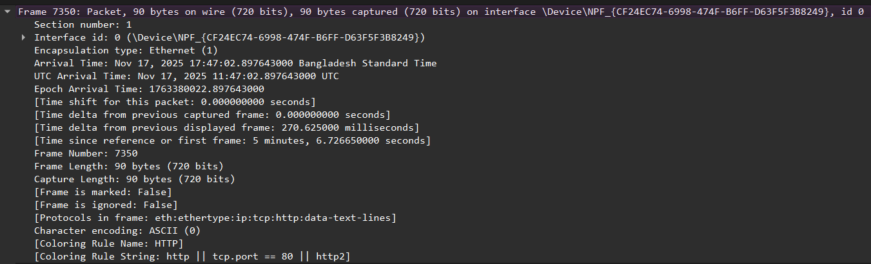

Ethernet II, Src: TendaTechnol_9b:f7:58 (cc:2d:21:9b:f7:58), Dst: AzureWaveTec_9d:62:41 (80:91:33:9d:62:41)

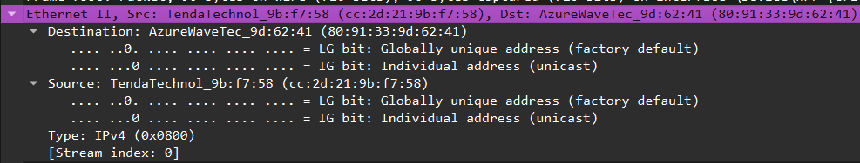

Internet Protocol Version 4, Src: 146.190.62.39, Dst: 192.168.0.104

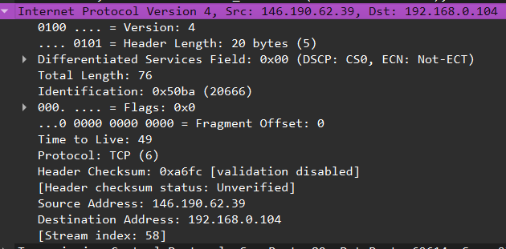

Transmission Control Protocol, Src Port: 80, Dst Port: 62614, Seq: 2721, Ack: 457, Len: 36

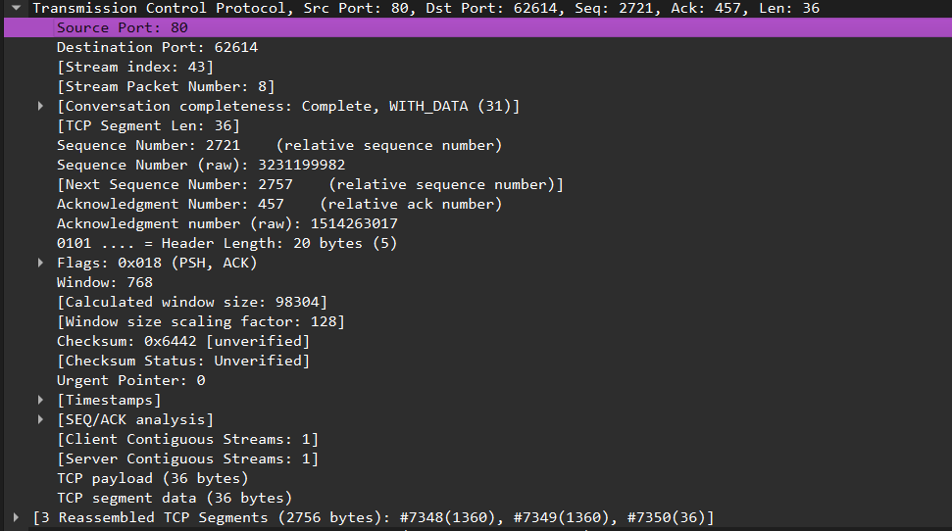

Hypertext Transfer Protocol, has 2 chunks (including last chunk)

