🚗 Adult Income Dataset (1994)

DAX Assignment
Course: DSA3050A – Business Intelligence & Data Visualization Student: Tanveer Student ID: 752
Link to DASHBOARD:
- https://app.powerbi.com/view?r=eyJrIjoiMTg3YmRhMGItNDdlMS00NjUxLTk3MDctMWRmZmMxYWVhM2E5IiwidCI6IjE2ZDgzZWU2LTI1NGEtNDY5ZC1hNmNjLTU0ZTJjYTIzMTNlNyIsImMiOjh9
Source: UC Irvine Machine Learning repository Dataset: Adult Provider: 1994 census dataset Rows: 48842
Dataset link:https://archive.ics.uci.edu/dataset/2/adult

Proof of Website
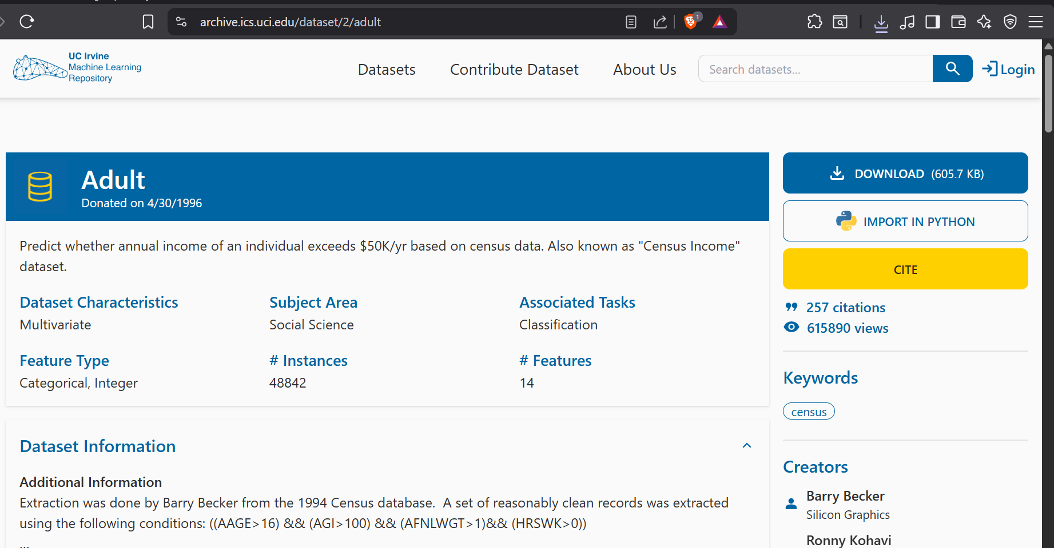
Fig. proof of Data/website

Dataset
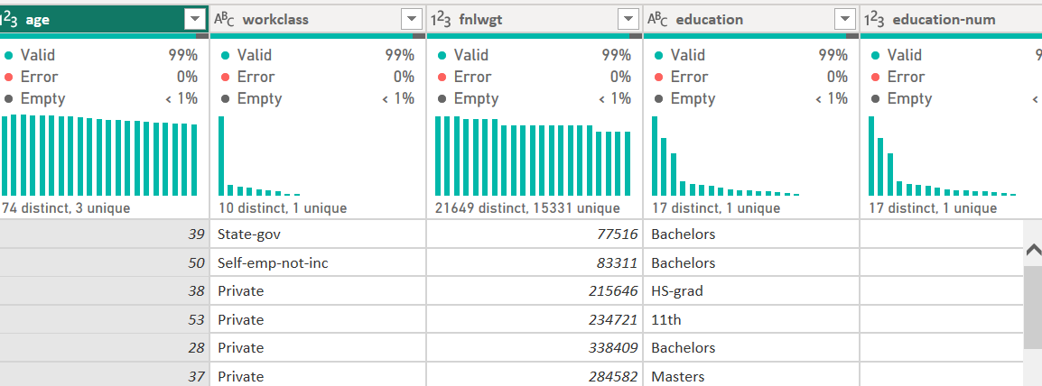
Fig. dataset_example

Creating Date Table
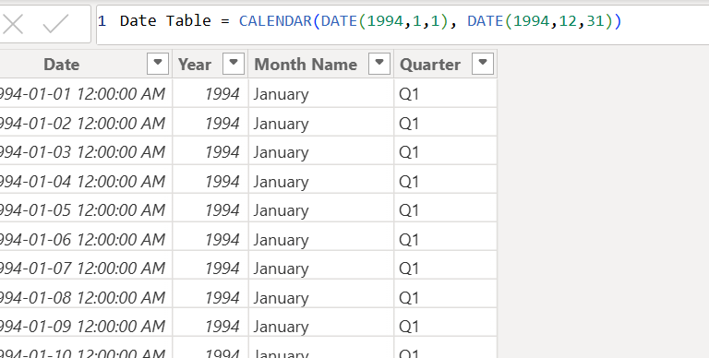
Fig. created date table dax
Fig. monthdax
Fig. quarterdax

Creating relationship
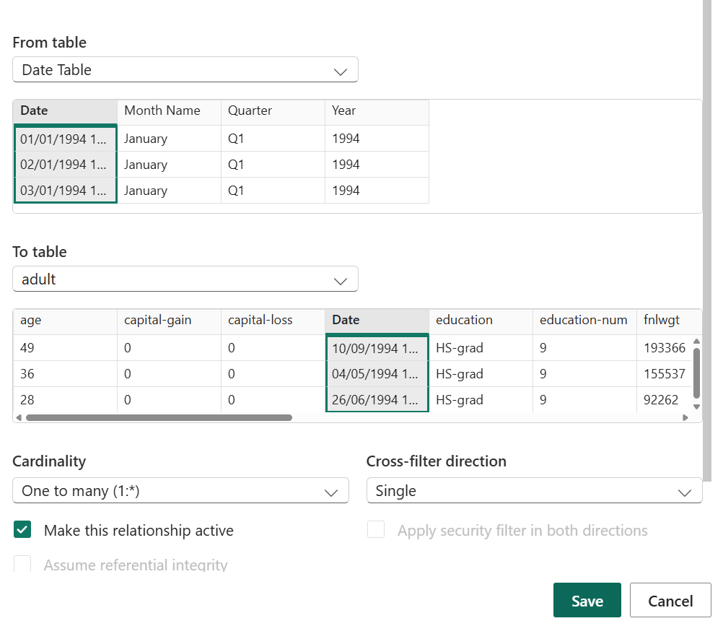
Fig. creating relationship between date table and main fact table
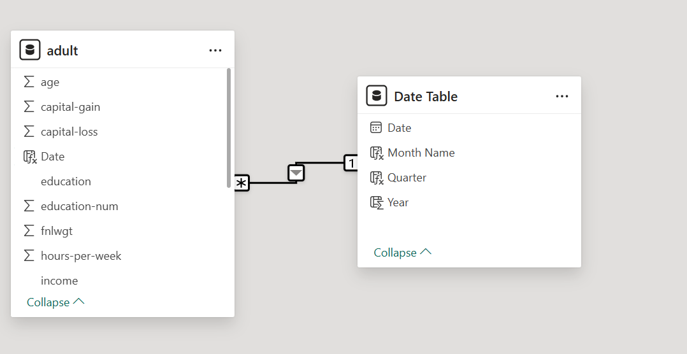
Fig. star schema
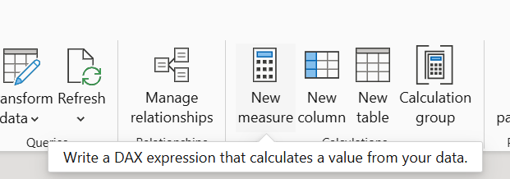
Fig. where the new measures is

Measure 1: Total individuals
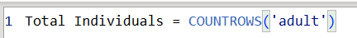
Fig. total individuals dax

Measere 2: Average worked hours
Fig. average worked hoursdax

Measure 3: High Income count
Fig. high income count dax

Measere 4: High income percentage
Fig. high income % dax

Measure 5: Low income Count
Fig. low income count dax

Column 1: Age Group Classification
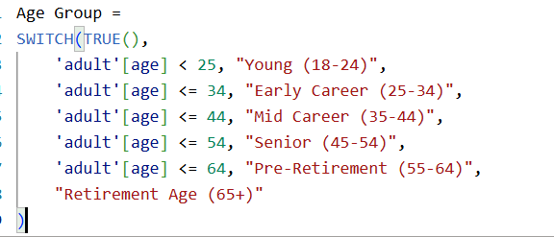
Fig. age group dax

Column 2: Work Hours Category
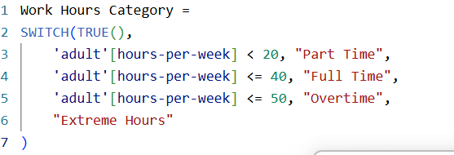
Fig. work hours category

Column 3: Education Level Group
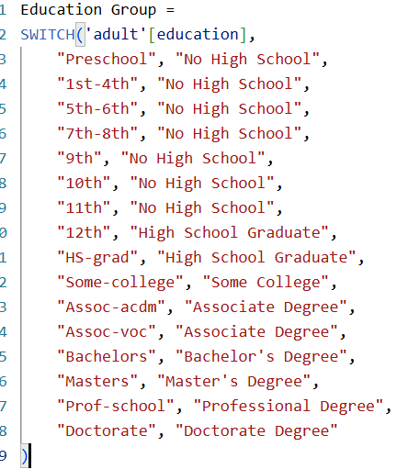
Fig. edu levl dax

Measure 1: Female High Income percentage
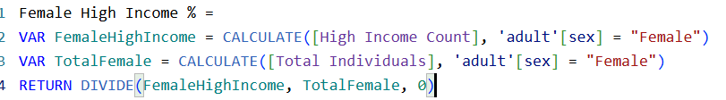
Fig. female high income percentage

Measure 2: Percentage of National Average
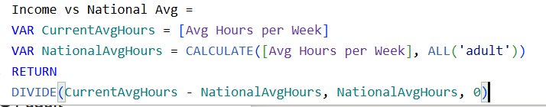
Fig. % of national income

Measure 3: Professional Contribution
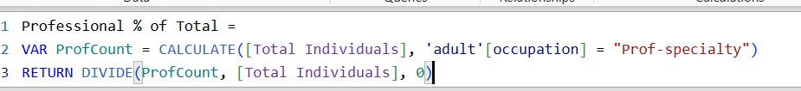
Fig. professional contribution

Measure 4: Gender Gap Analysis
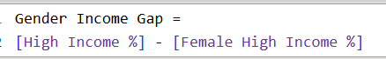
Fig. gender income gap dax

Total Estimated Income (SUMX)
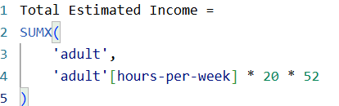
Fig. SUMX dax

Average Education Level by Occupation (AVERAGEX)
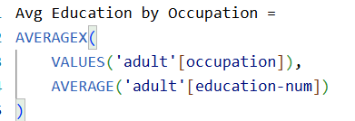
Fig. averagexdax

Total Capital Activity (SUMX with multiple columns)
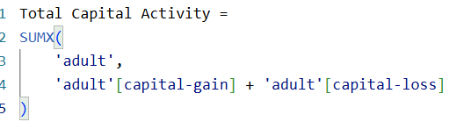
Fig. sumxMultiDAX

Measure 1: Year-to-Date Individuals
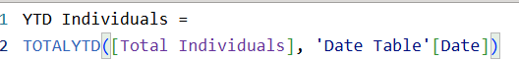
Fig. time intel dax 1

Measure 2: Previous Quarter (comparing to last period)
Fig. time intel dax 2

Measure 3: Quarter-over-Quarter Growth percentage
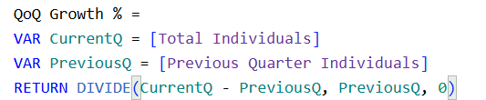
Fig. time intel dax 3

Measure 4: Same Period Last Year
Fig. time intel dax 4
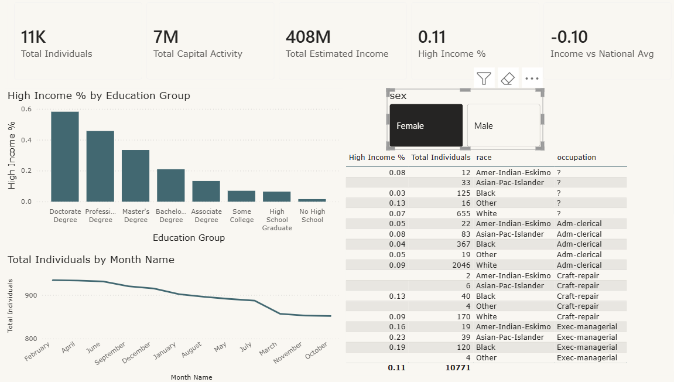
Fig. visual
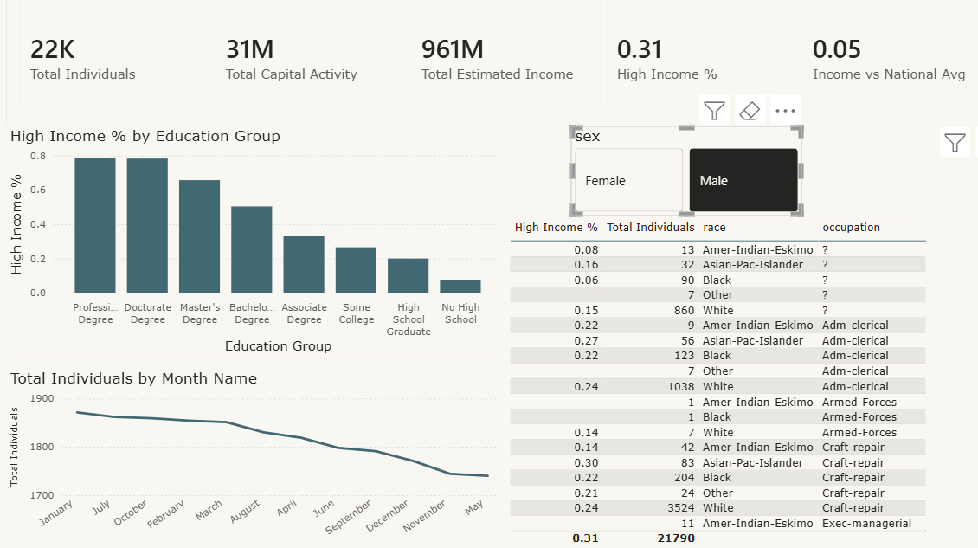
Fig. alt text

