Setting Up Firebase Storage and Database

1) We will upload the images to Firebase Storage and in the firebase database will store image URL.

2) Go to tools-> firebase

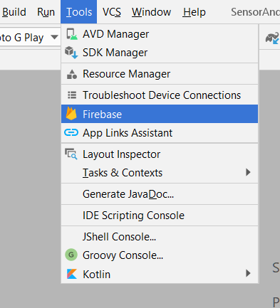

3) It will show an Assistant window for Firebase setup.

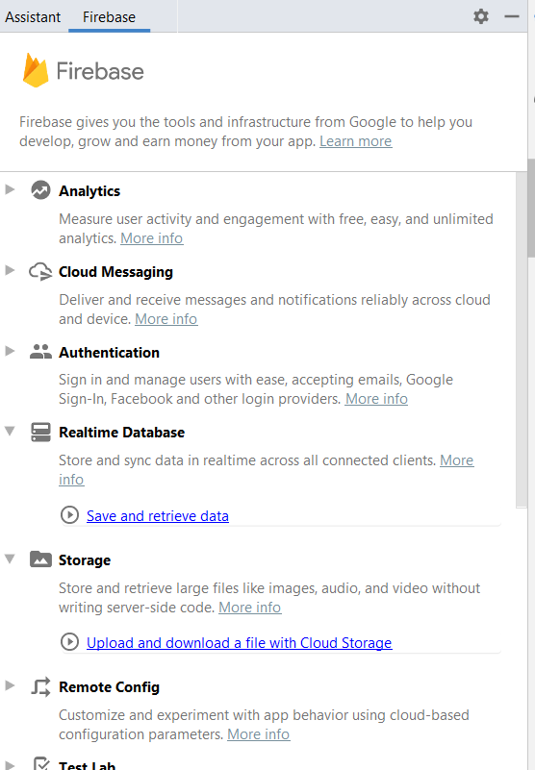

4) For Firebase Database setup

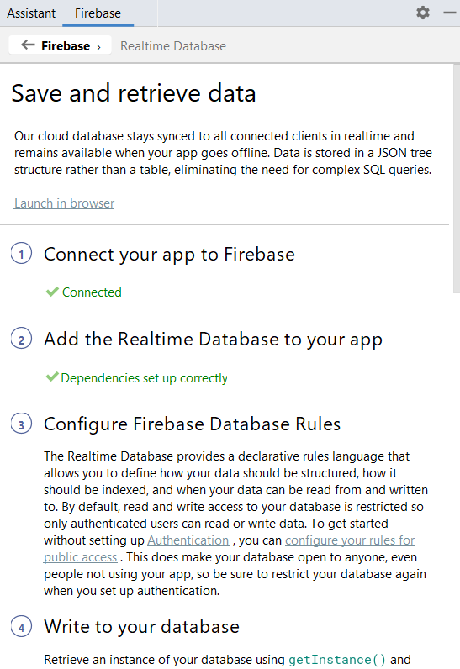

5) For Firebase Storage setup

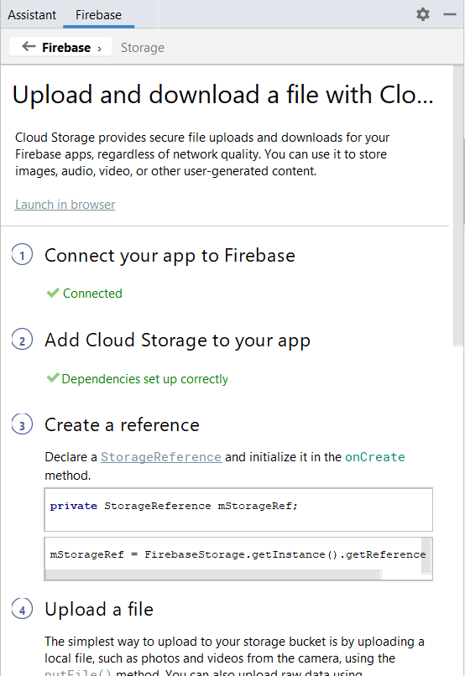

When you connect to Firebase it'll create project on Firebase console. Then add Firebase Database and Storage dependencies in your project then sync it.

6) So go to Firebase Console and open your Firebase project. Then from the left menu select Firebase Storage and go to the Rules tab.

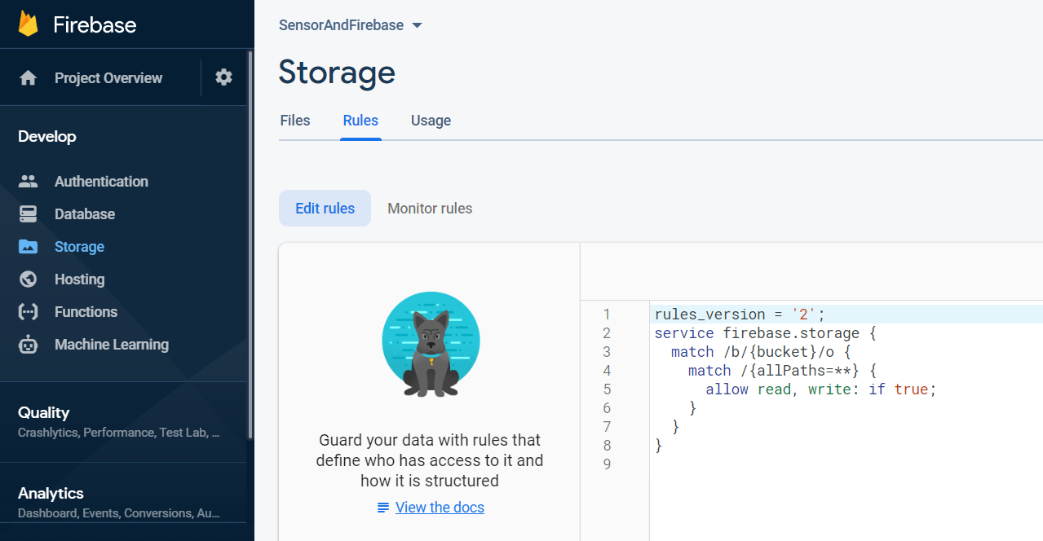

I have change the rule. Before it was **if auth != null** but I changed it to **if true**.

But you should use this only for development purpose. As for production you cannot use this way that anyone can access storage.

7) Database

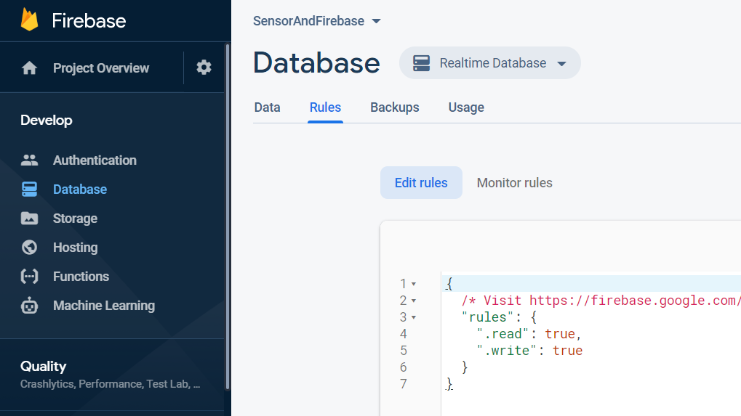

I have change the rule. Before it was **auth != null** but I changed it to **true** .

8) When you upload your photo it'll save in Firebase Storage.

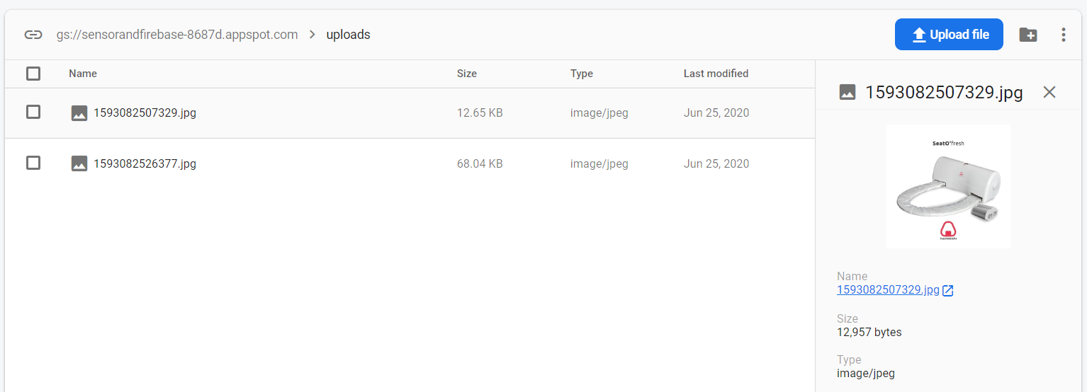

9) When you upload your photo it'll save in Firebase Database and data will retrieve here. we use URL to display images.

