BATCH:- K1
GROUP ID:- 6
MEMBERS:- Tanisha Kawale(71)
Tanvesh Deshmukh(72)
TITLE:- TripShield: A Corporate Travel Risk and Disruption Management Platform
Problem Statement
Corporate business travel is often disrupted by flight cancellations, severe weather, hotel unavailability, and transport issues. When this happens, employees and travel coordinators must manually work out which bookings are affected and search for replacements, which is slow, stressful, and error-prone. TripShield provides a centralized platform where business trips are planned and tracked, disruptions can be simulated, affected parts of the itinerary are identified automatically, and alternatives are suggested so the employee or company can choose the best option and update the itinerary quickly.
Objectives
- To provide a single platform for planning and managing corporate business trips, including destination, dates, transport, accommodation, and itinerary.
- To display trip data clearly through an interactive timeline/map.
- To simulate common disruptions such as flight cancellation, severe weather, hotel unavailability, and transport disruption.
- To automatically identify the affected parts of an itinerary and generate alternative solutions.
- To let the user select an alternative, update the itinerary, and receive a notification.
Methodology
- Trip Data Capture – The system takes in trip details like destination, dates, transport, accommodation, and itinerary through the React interface, then passes them to the backend over REST APIs, where they're checked for validity.
- Trip Data Management – Once validated, the Spring Boot backend saves the trip in MySQL through JPA/Hibernate and shows it on an interactive timeline/map.
- Disruption Simulation – To test how the system copes when things go wrong, it can trigger a predefined disruption on a trip, such as a cancelled flight, severe weather, an unavailable hotel, or a transport breakdown.
- Impact Analysis – When a disruption is triggered, the backend compares it against the saved itinerary and works out which parts of the trip are actually affected, whether that's a flight, a hotel stay, or a transport leg.
- Alternative Generation – For each affected part, the system looks through the predefined alternatives in the database and puts together workable options, like a different flight, another mode of transport, or a new place to stay.
- Alternative Presentation and Selection – The system lays these options out on screen and records whichever one the employee or company picks.
- Itinerary Update and Notification – Finally, the backend updates the itinerary with the chosen option, refreshes the timeline/map, and sends the user an alert so they know what changed.
Technology Methodology
React + TypeScript REST APIs Java Spring Boot JPA/Hibernate MySQL
- Frontend: React with TypeScript (interactive timeline/map and trip dashboard)
- API Layer: REST APIs connecting the frontend and backend
- Backend: Java Spring Boot (impact analysis, alternative generation, itinerary updates, notifications)
- Persistence: JPA/Hibernate for object-relational mapping
- Database: MySQL
The project will initially use predefined/seeded travel and disruption data for the prototype, allowing us to demonstrate the complete system without depending on live travel APIs.

Features
• Trip creation and management: enter destination, travel dates, transport, accommodation, and itinerary details for a business trip.
• Interactive timeline/map view: see the whole itinerary visually, in order, with locations plotted.
• Disruption simulation: trigger predefined events such as flight cancellation, severe weather, hotel unavailability, or transport disruption to demonstrate how the system responds.
• Automatic impact analysis: the backend identifies exactly which flights, stays, or transport legs a disruption affects.
• Alternative generation: the system suggests replacements, such as another flight, a different mode of transport, or alternative accommodation.
• Decision support: the employee or company reviews the options and chooses the most suitable one.
• Automatic itinerary update: the chosen option replaces the affected part of the trip, and the timeline/map refreshes.
• Alerts and notifications: the user is told what changed and what action was taken.
• Seeded data prototype: predefined travel and disruption data lets the full system be demonstrated without live travel APIs.
Project Flow
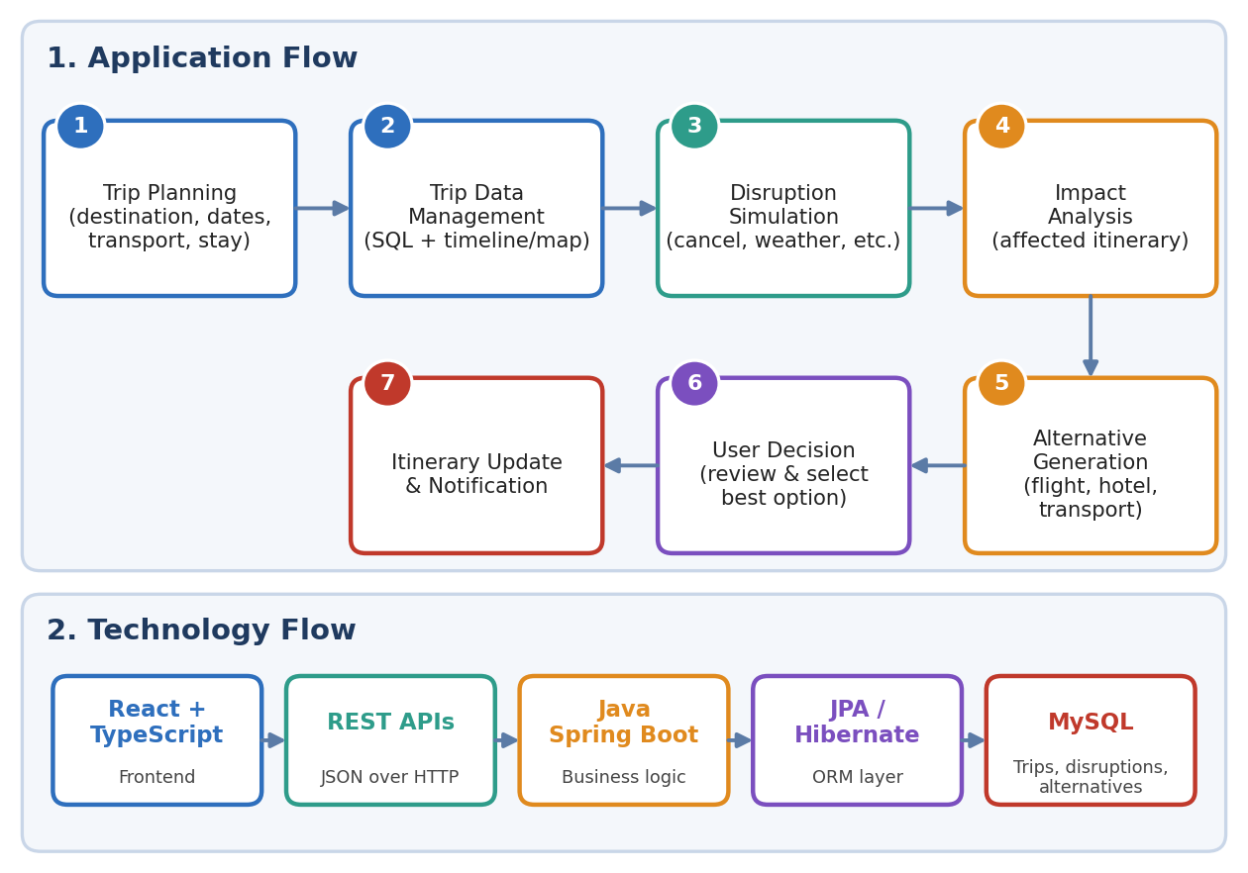
TripShield is a corporate travel risk and disruption management platform. A company or employee creates a business trip by entering the destination, dates, transport, accommodation, and itinerary, and can view everything on an interactive timeline and map. When something goes wrong, such as a flight cancellation, severe weather, or a hotel becoming unavailable, TripShield identifies exactly which parts of the itinerary are affected and generates alternatives like another flight, different transport, or a new hotel. The employee reviews the options and picks the best one, the itinerary updates automatically, and they receive a notification. It is built with React and TypeScript, Spring Boot, and MySQL, using seeded data for the prototype.
The TripShield methodology follows a step-by-step flow from planning to recovery. First, the user or company creates a business trip by entering the destination, travel dates, transport, accommodation, and itinerary details. This information is stored in an SQL database and displayed through an interactive timeline/map. The system then allows predefined disruptions, such as flight cancellation, severe weather, hotel unavailability, or transport disruption, to be simulated. When a disruption occurs, the backend identifies which parts of the employee's itinerary are affected and checks the available predefined alternatives to generate possible solutions, such as another flight, a different mode of transport, or alternative accommodation. The employee or company reviews these alternatives and selects the most suitable option. Finally, the trip itinerary is updated and the user receives the relevant alert/notification. The system is implemented using React and TypeScript on the frontend, REST APIs for communication, Java Spring Boot with JPA/Hibernate on the backend, and MySQL as the database. For the prototype, predefined/seeded travel and disruption data is used, so the complete system can be demonstrated without depending on live travel APIs.

