Tanvi Chowdhury
CS-340 Client/Server Development
Professor Scranton
10/20/2026
Grazioso Salvare Rescue Animal Dashboard
About the Project
In this project, I created an interactive dashboard for an organization that trains rescue dogs for various search and rescue missions, called Grazioso Salvare. The dashboard is based on animal data from the Austin Animal Center to assist in determining which dogs are eligible for certain rescue training requirements.
This project is based on the CRUD Python module that I developed for Project One. I didn't just use Python to connect to MongoDB, I used the same module to connect a database to a web-based dashboard.
The dashboard displays animal records, filters dogs by rescue category and visualises the results on a pie chart and an interactive map.

Motivation
The primary goal of this project was to reduce the time it takes Grazioso Salvare to find a dog that could be rescued, by eliminating the need to manually sift through a large dataset.
Certain breeds, ages and sexes are required for certain rescue operations. Using an interactive dashboard, I was able to organise the data and enable the user to filter the data by the type of rescue operation.
The dashboard also displays visual data about the animals, which helps to understand the data available and identify potential candidates.

Getting Started
This project involves using Python to connect the database to the dashboard and using MongoDB as the database.
To create the connection to MongoDB and to fetch animal records, I have used the AnimalShelter class from Project One.
The dashboard is designed according to Model-View-Controller (MVC) design pattern.

Model: MongoDB
The application's model is implemented using MongoDB. It contains the animal records and processes the queries to fetch the information.
I chose MongoDB as a NoSQL database since it is a flexible database that stores data in documents that are similar to JSON. This is suitable for the animal dataset as it has many attributes, such as breed, age, sex, and location.
A great feature of MongoDB was the ability to filter with queries, allowing the retrieval of animals that fit the criteria for each rescue category.
One benefit is that it can be used with Python via PyMongo. PyMongo is a Python library that lets you connect to MongoDB, run queries and fetch documents as dictionaries.
These records can then be transformed into pandas DataFrames to be used in the dashboard.

View: Dash
The view part of the application is implemented using Dash.
The dashboard interface, rescue filters, interactive data table, the distribution chart of the breeds and the geolocation map were designed using Dash.
With Dash, it was possible to create an interactive web application without having to write a separate HTML, CSS, and JavaScript file.

Controller: Dash Callbacks
The controller part of the application is dash callbacks.
The callbacks are called when the user interacts with the system and decide what information to show.
For instance, if a user clicks on Water Rescue, the callback fetches the dogs that satisfy the water rescue criteria from the MongoDB database.
The data is then shown in the data table and the pie chart and map are updated according to the data available.
This design allows to isolate the operations performed on the database from the user interface of the dashboard, simplifying the application's maintenance.

Installation
The project was developed using the Codio environment and Jupyter Notebook provided for the course.
The following tools and libraries were used:
Tool | Purpose
Python | Main programming language used for the application
MongoDB | Stores and retrieves animal records
PyMongo | Connects Python to MongoDB
Pandas | Organizes database records into DataFrames
Dash | Creates the interactive dashboard
JupyterDash | Runs the Dash application in the Jupyter environment
Plotly | Creates the breed distribution pie chart
Dash Leaflet | Displays animal locations on an interactive map
Jupyter Notebook | Provides the environment for developing and testing the dashboard
Codio | Provides the course development environment

Required Files
The main files used for this project are:
* ProjectTwoDashboard.ipynb – Contains the dashboard interface and callback functions.
* CRUD_Python_Module.py – Contains the AnimalShelter class used to communicate with MongoDB.
* Grazioso Salvare Logo.png – Displays the organization’s logo on the dashboard.

Setting Up the Application
To reproduce the project, MongoDB must be installed and running.
The Austin Animal Center dataset needs to be imported into the animals collection in the aac database.
The MongoDB user must also have the appropriate permissions to access the database.
The Python dependencies can be installed using:
pip install pymongo pandas dash jupyter-dash dash-leaflet plotly jupyter
After installing the required libraries, the MongoDB connection must be configured in the CRUD Python module.
The dashboard notebook and CRUD module should be placed in the same directory so the notebook can import the AnimalShelter class.
The logo image must also be available in the directory.
Once everything is configured, open ProjectTwoDashboard.ipynb in Jupyter Notebook and run the cells in order.
The application will start a Dash server, allowing the dashboard to be accessed through the address provided by the notebook.

Usage
The dashboard provides several features for interacting with the animal dataset.
Interactive Data Table
The data table displays animal records retrieved from MongoDB.
I used the Dash DataTable component to make the records easier to browse and organize.
Users can sort the records by column, apply additional table filters, and navigate through the dataset using pagination.
The table displays 10 records per page and supports selecting individual animals.
Selecting an animal also allows the user to view its location on the geolocation map.
Rescue Type Filters
I implemented four filtering options to help users find animals that meet specific rescue training requirements.
All Animals
This option displays the complete dataset without applying any rescue-specific filters.
Water Rescue
This filter retrieves dogs that meet the water rescue requirements based on breed, sex, and age.
Mountain or Wilderness Rescue
This filter retrieves dogs that meet the requirements for mountain and wilderness rescue operations.
Disaster or Individual Tracking
This filter retrieves dogs that meet the requirements for disaster response and individual tracking.
Each filter uses a MongoDB query to retrieve matching records.
When a different filter is selected, the dashboard updates the data table and its visualizations.

Breed Distribution Chart
I used Plotly to create a pie chart showing the 10 most common breeds in the currently displayed dataset.
The chart updates when a user selects a different rescue category.
This makes it easier to compare the types of dogs available for different rescue operations.

Geolocation Map
I used Dash Leaflet to create an interactive map displaying animal locations.
The map uses the latitude and longitude coordinates stored in the animal records.
When a user selects an animal from the data table, the map displays a marker at that animal’s location.
The marker also provides information about the selected animal, including its name and breed.

Setting Up the Application
The project has to be installed and running on MongoDB to be reproduced.
The Austin Animal Center dataset needs to be imported into the animals collection in the aac database.
The user of the MongoDB database also needs to have the necessary permissions to access the database.
The Python dependencies can be installed using:
pip install pymongo pandas dash jupyter-dash dash-leaflet plotly jupyter
Once the necessary libraries are installed, the connection to the MongoDB database needs to be set up in the CRUD Python module.
The dashboard notebook and CRUD module must be in the same directory so that the notebook can import the AnimalShelter class.
The logo image should also be located in the directory.
After all is set up, open the file ProjectTwoDashboard.ipynb in Jupyter Notebook and execute the cells sequentially.
The application will launch a Dash server and the dashboard will be served at the address that is given by the notebook.

Usage
The dashboard offers a number of features to interact with the animal dataset.
Interactive Data Table
The data table shows animal records from MongoDB.

To make it easier to browse and organize the records, I used the Dash DataTable component.
The user can sort the records by column, set more filters on the table and use pagination to move through the data set.
A table with 10 records per page, and individual animal selection.
By choosing an animal, the user can also see where the animal is on the geolocation map.

Rescue Type Filters
I added four filtering options for users to be able to find animals that have certain rescue training needs.
All Animals
This option shows the entire data set without any filters specific to the rescue.
Water Rescue
This filter will return the dogs that have the water rescue requirements of breed, sex and age.
Wilderness or Mountain Rescue
This filter is for dogs that are suitable for mountain and wilderness rescues.
Disaster or Individual Tracking
This filter will return dogs that have the qualifications for disaster response and individual tracking.
Every filter fetches records from a MongoDB query.
If a different filter is chosen, the dashboard will refresh the data table and visualizations.

Breed Distribution Chart
I created a pie chart using Plotly that displays the 10 most common breeds in the dataset displayed.
The chart is updated as the user changes their rescue category.
This allows for better comparison of the kinds of dogs that can be used for various rescues.

Geolocation Map
Created an interactive map of animal locations using Dash Leaflet.
The map is based on the latitude and longitude information in the animal records.
The user can choose an animal from the data table and see a marker on the map at the location of the animal.
The marker also includes details of the animal being selected, such as its name and breed.
Screenshots
The following screenshots demonstrate the functionality of the completed dashboard.
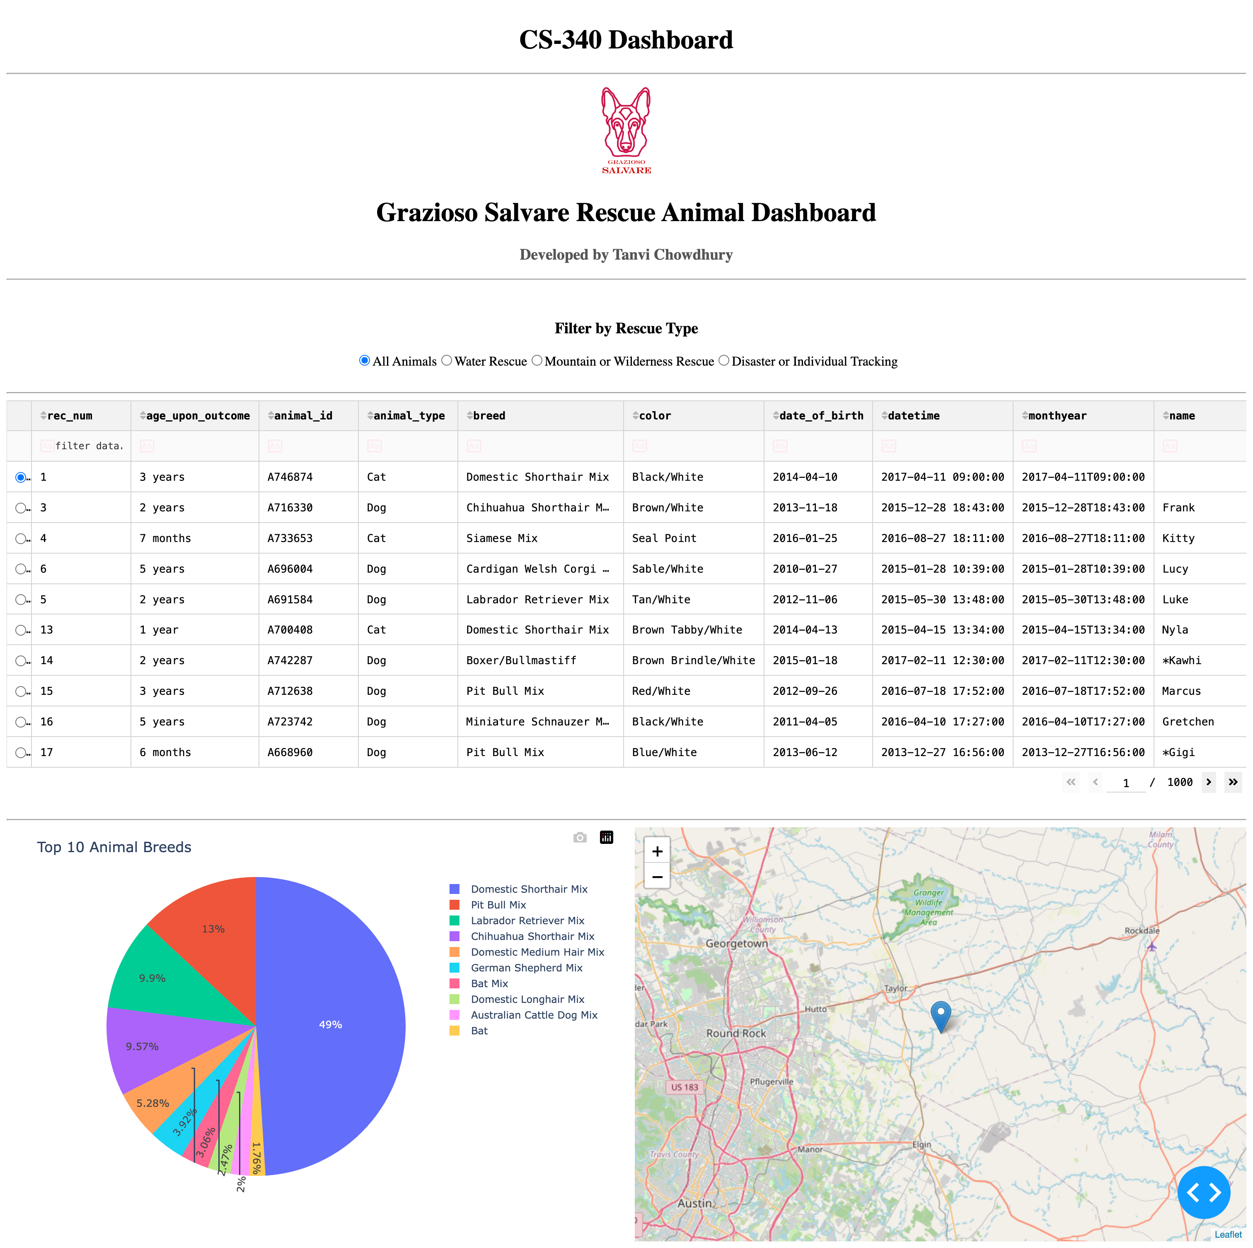
Figure 1: Default Dashboard

Figure 1: The dashboard displaying the complete animal dataset, including the interactive data table, breed distribution chart, and geolocation map.
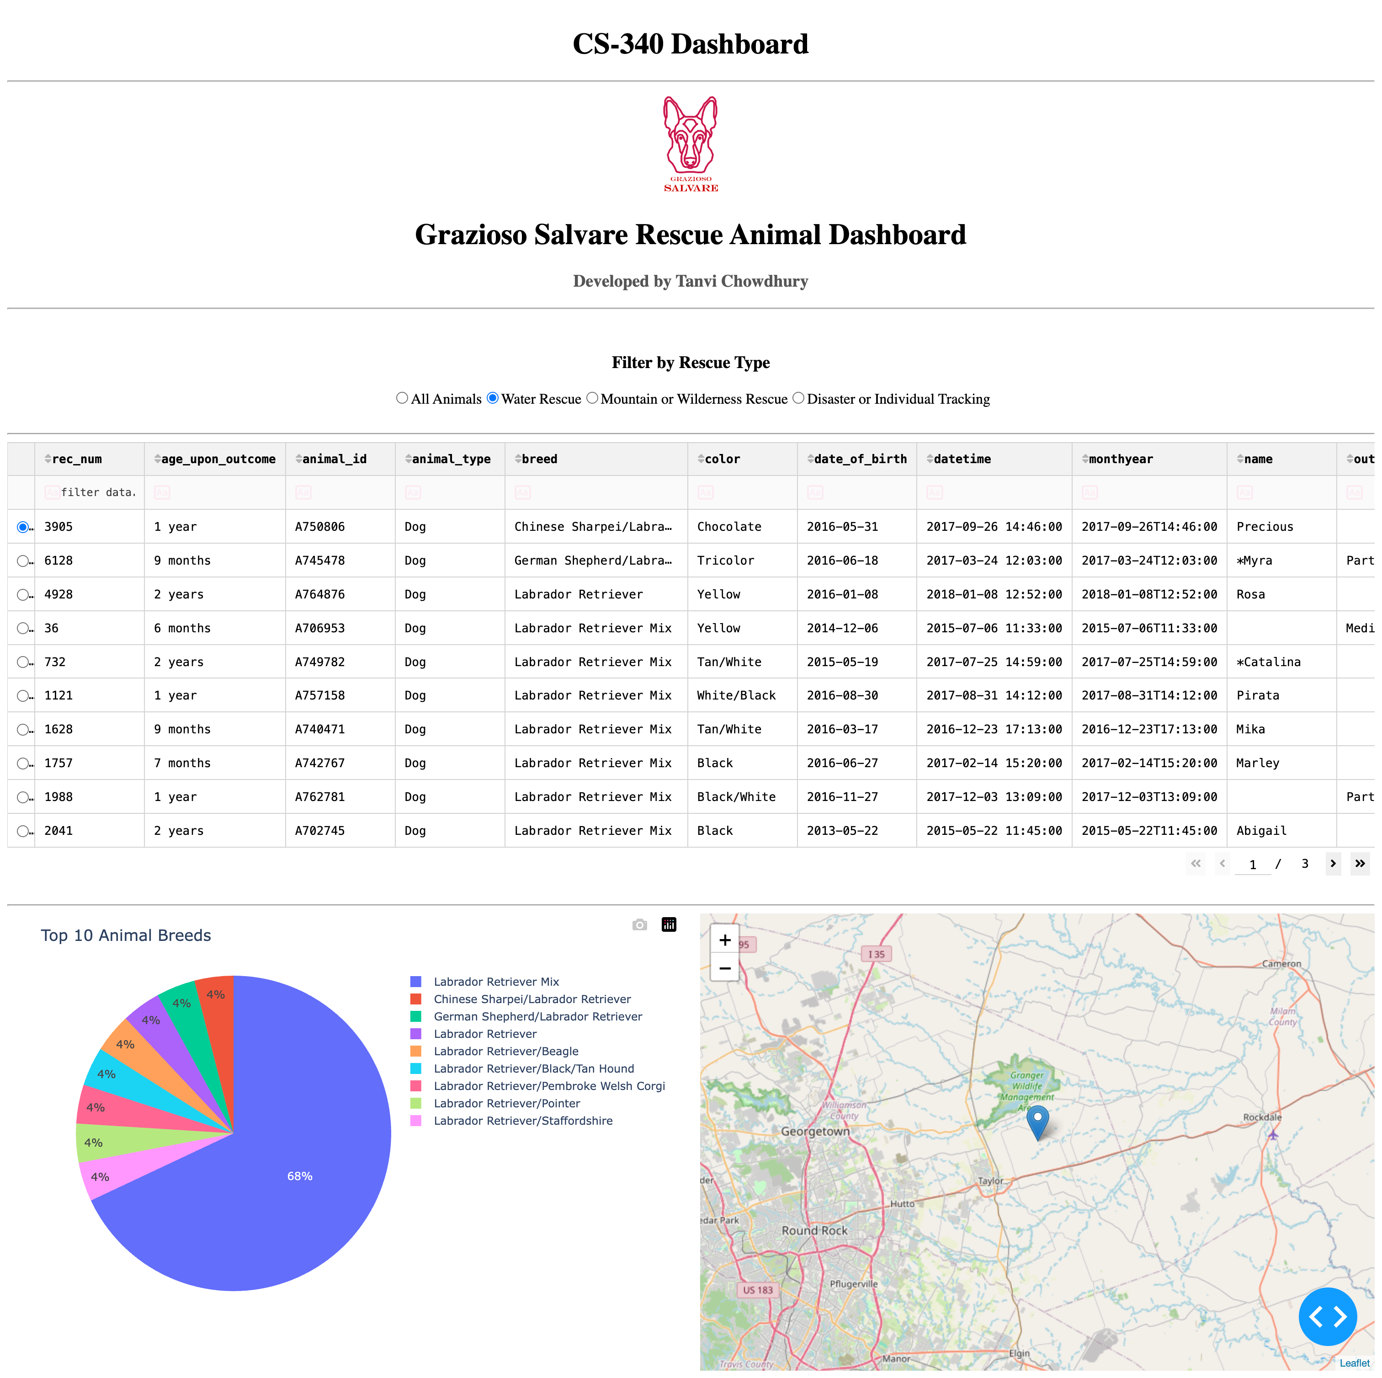
Figure 2: Water Rescue Filter
Figure 2: The dashboard displaying animal records that meet the water rescue requirements.

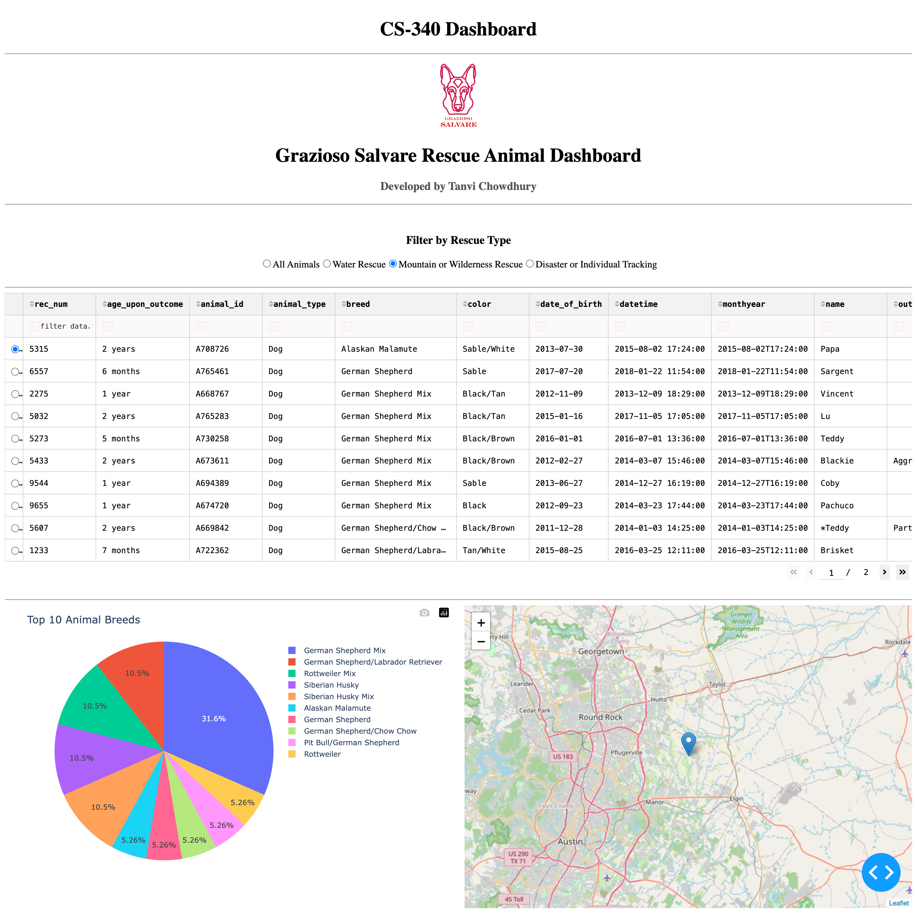
Figure 3: Mountain or Wilderness Rescue Filter
Figure 3: The dashboard displaying animal records that meet the mountain or wilderness rescue requirements.

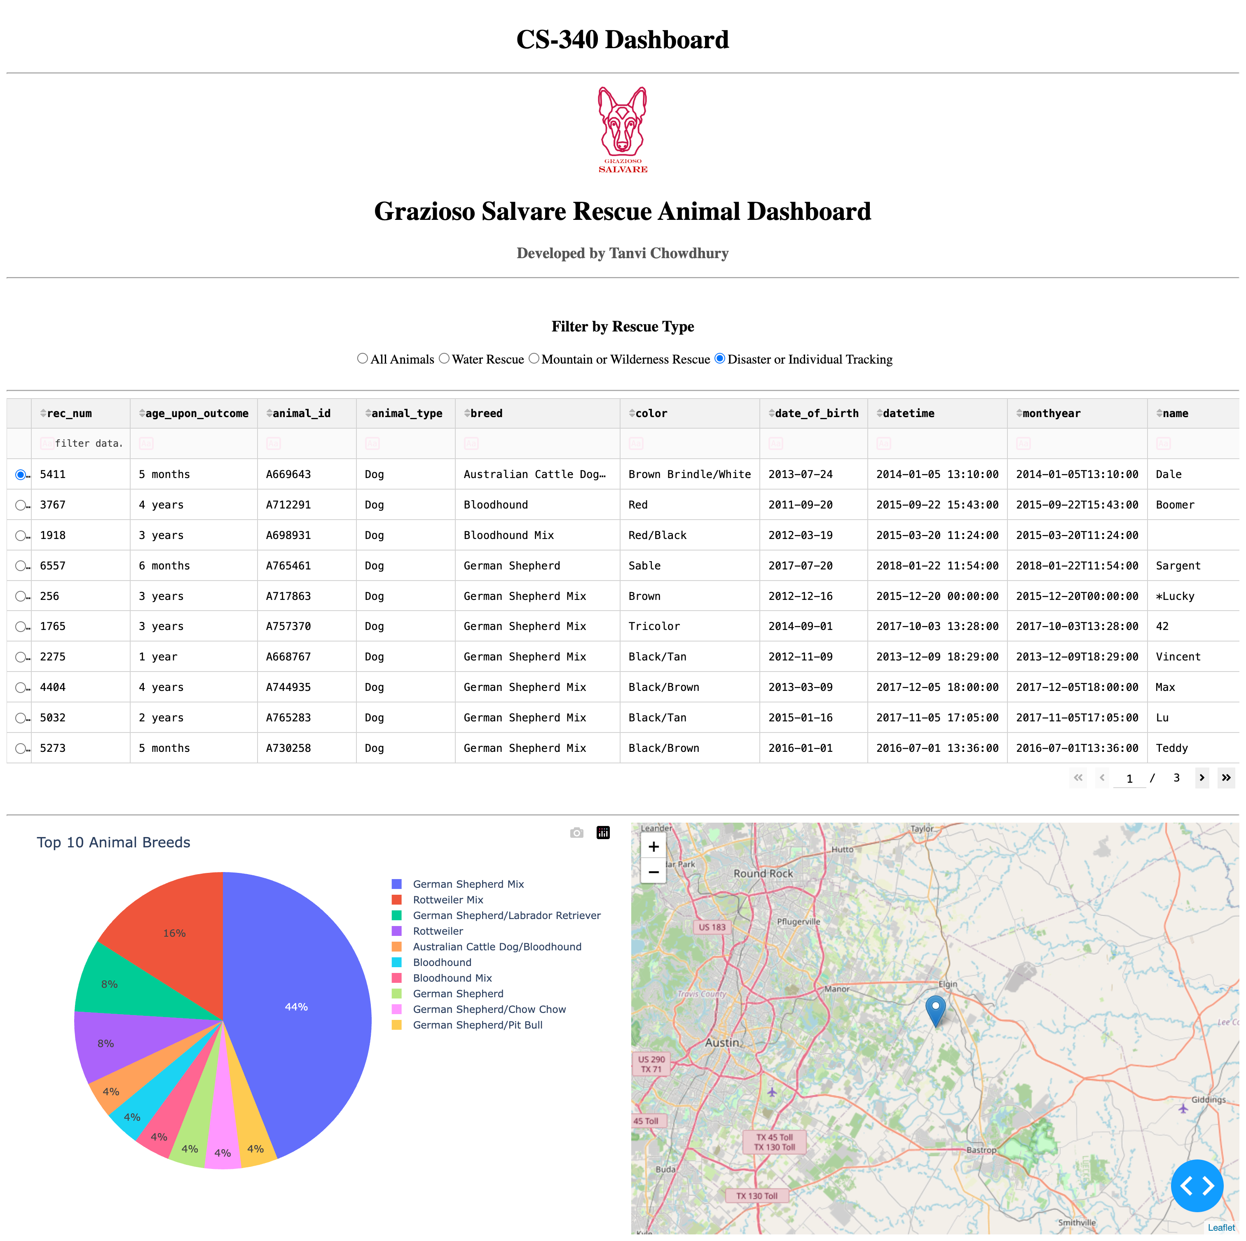
Figure 4: Disaster or Individual Tracking Filter
Figure 4: The dashboard displaying animal records that meet the disaster or individual tracking requirements.

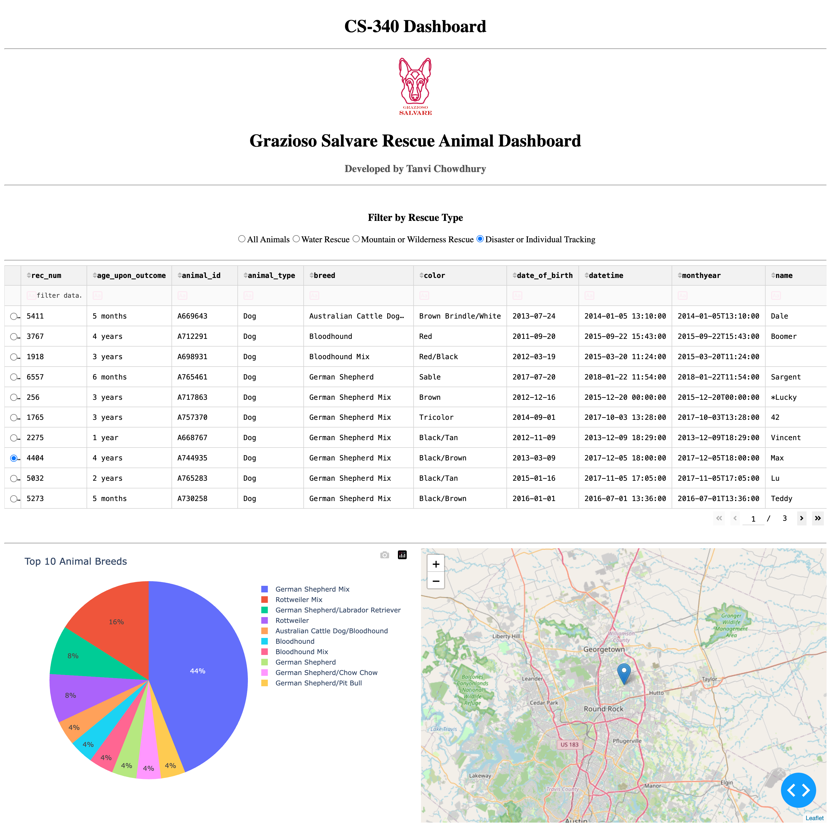
Figure 5: Interactive Geolocation Map
Figure 5: The geolocation map displaying the location of an animal selected from the data table.

Development Process
I began this project with the CRUD Python module that I created in Project One.
The first step was to link the dashboard to the database MongoDB and get the animal records by using the read() method in my AnimalShelter class.
I then transformed the records into a pandas DataFrame to be shown in the Dash DataTable.
Once the data table was working, I added the Grazioso Salvare logo, dashboard title and my name to the interface.
Then I used Dash radio buttons to create the rescue-type filters. I wrote queries for each of the rescue categories that were needed, depending on the animal attributes.
After the filtering was successful, I plotted a pie chart using Plotly to show the most common breeds in the filtered data.
Created the geolocation map with Dash Leaflet and linked it to the data table to update the map when you click on an animal.
Lastly, I tried each rescue filter and confirmed that the data table, pie chart and geolocation map refreshed properly.

Challenges and Solutions
I had a couple of issues when building the dashboard.
The first problem was to integrate Python with MongoDB. I had authentication problems with the CRUD module that prevented the application from accessing the database.
I fixed this by checking the connection settings and fixing the way the credentials were used.
One of the problems was getting the Dash callbacks to operate properly. I ran into callback errors and indentation issues while adding new functionality.
These issues have been addressed by checking the callback functions, fixing the indentation and ensuring that the component ID's were consistent with the ID's in the dashboard layout.
I also had trouble getting the geolocation map to display. The data table and pie chart were functioning at one time but the map was not showing up on the dashboard.
I looked at the layout and made some changes to the styling of the chart and map containers to make them display properly.
The last hurdle was to ensure that all the dashboard elements would update simultaneously when a rescue filter was chosen.
I solved this by binding the filtered data to the table, pie chart and geolocation map using Dash callbacks.
These challenges helped me to gain a better understanding of the interaction between the database, the dashboard components and the callback functions.

Conclusion
In general, this project gave me a better understanding of how to link a database to an interactive website.
I was able to extend the CRUD Python module from Project One and use it to create a dashboard that fetches, filters and visualizes animal records.
I also got more experience using MongoDB queries, Python libraries and Dash callbacks.
I think the most important thing I learnt from this project is that it is important to ensure that the various components of an application communicate properly. When the components were functioning individually, I had to ensure that they were updating correctly when users interacted with the dashboard.

Resources
The following resources were used during the project:
* MongoDB: https://www.mongodb.com/
* PyMongo Documentation: https://pymongo.readthedocs.io/
* Dash Documentation: https://dash.plotly.com/
* Plotly Documentation: https://plotly.com/python/
* Dash Leaflet: https://www.dash-leaflet.com/
* Pandas Documentation: https://pandas.pydata.org/
* Jupyter Notebook: https://jupyter.org/
* Codio: https://codio.com/
* Make a README: https://www.makeareadme.com/

Contact
Tanvi Chowdhury
Southern New Hampshire University
Bachelor of Science in Computer Science

