Documentation on ESP32 Web-Server for controlling multiple LEDs through Wi-Fi
-Tanvi Adivarekar
Alongside this document, the code has been attached. It uses a ESP32 for controlling Multiple LEDs using an Web server.
Apparatus required:
- Hardware:
- Microcontroller ESP32
- USB cable
- Software:
- Arduino IDE & Suitable Libraries
Features of this program:
This program connect ESP32 to an Wi-Fi network, and interacts with the Webserver and controls the LEDs remotely via a Web interface.
How to use this code and output of code:
- Have Arduino ide installed
- Tools > Manage libraries> Search for required libraries such as Wi-Fi
- Copy the code into the ide.
- Put your Wi-Fi username and password in the appropriate place.
- Connect your board and select the appropriate board and port.
- Upload the code to the microcontroller.
- Once the microcontroller connects to Wi-Fi, put the IP address it gives into the web browser. You can use your phone or laptop for this purpose, but a phone is recommended as the laptop may have a firewall preventing access to the webserver.
- Make sure the device is connected to the same wi-fi network as the microcontroller.
- The website should now be visible.
Output:
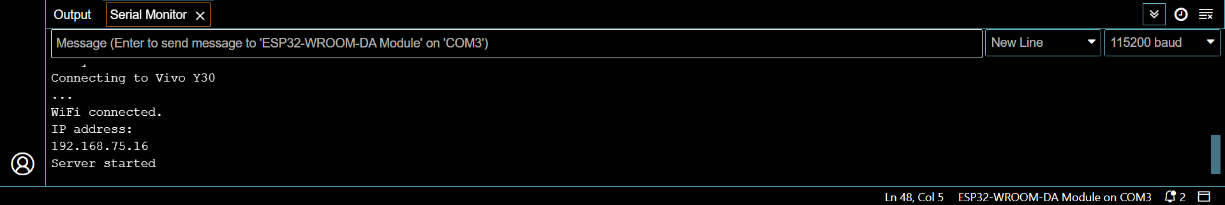
This should be displayed in your serial monitor. If it doesn’t, then press the Reset button and try again.
The following should be displayed on your device.

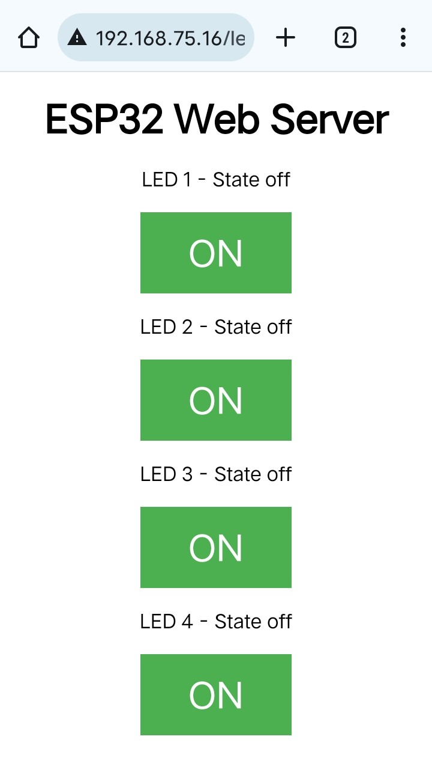
Here on this Webserver there are 4 switches available through which the LEDs are controlled.

Explanation of the code:

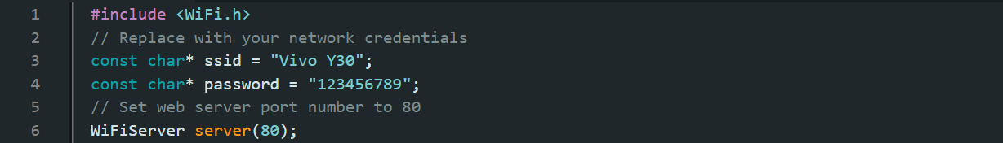
This program include Wi-Fi library to manage the Wi-Fi connection. The ssid and password are network credentials for Wi-Fi connection. This program waits for the Client at the standard port i.e. 80.

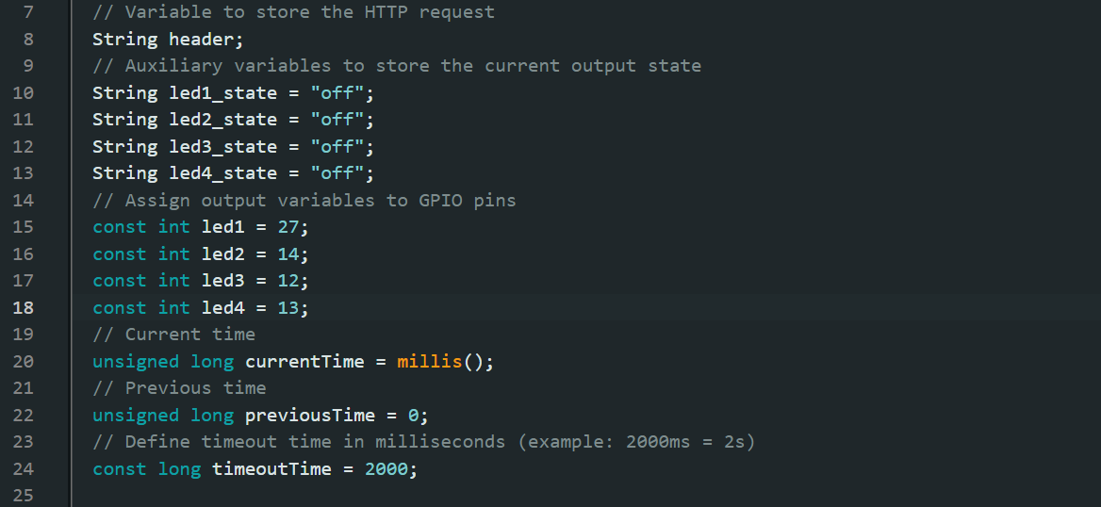
This part initializes variables to store the HTTP request and LED states, and defines the GPIO pins connected to the LEDs. It also initializes variables to track time for managing client connections.
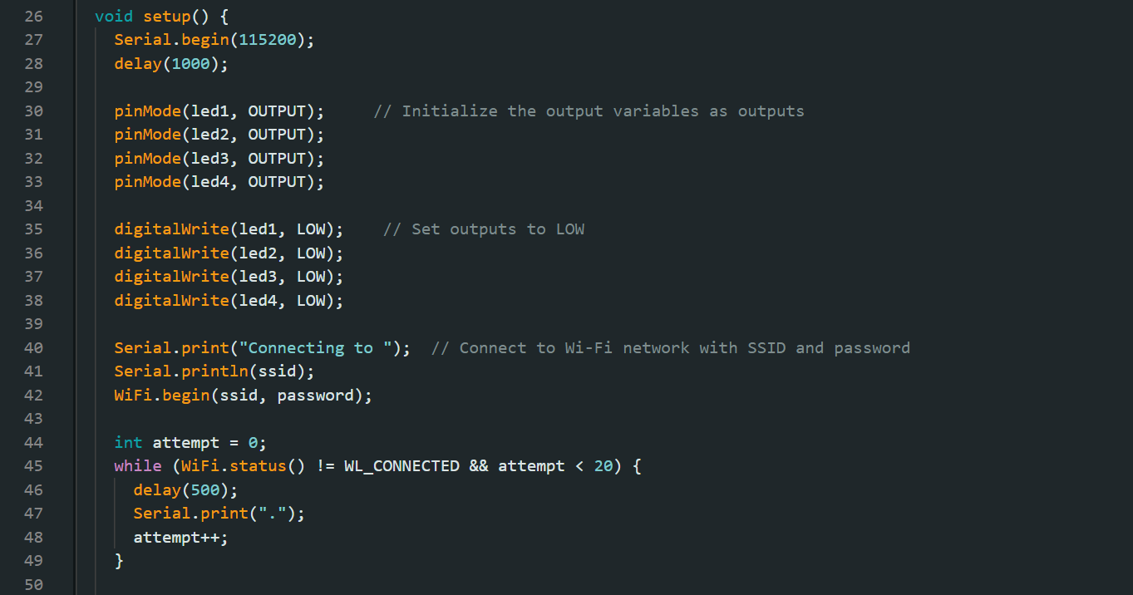
The setup function initializes the serial communication at the baud rate of 115200. Also sets the GPIO pins as outputs, and initializes them to LOW. It then attempts to connect to the specified Wi-Fi network. If successful, it starts the web server and prints the IP address to the serial monitor.
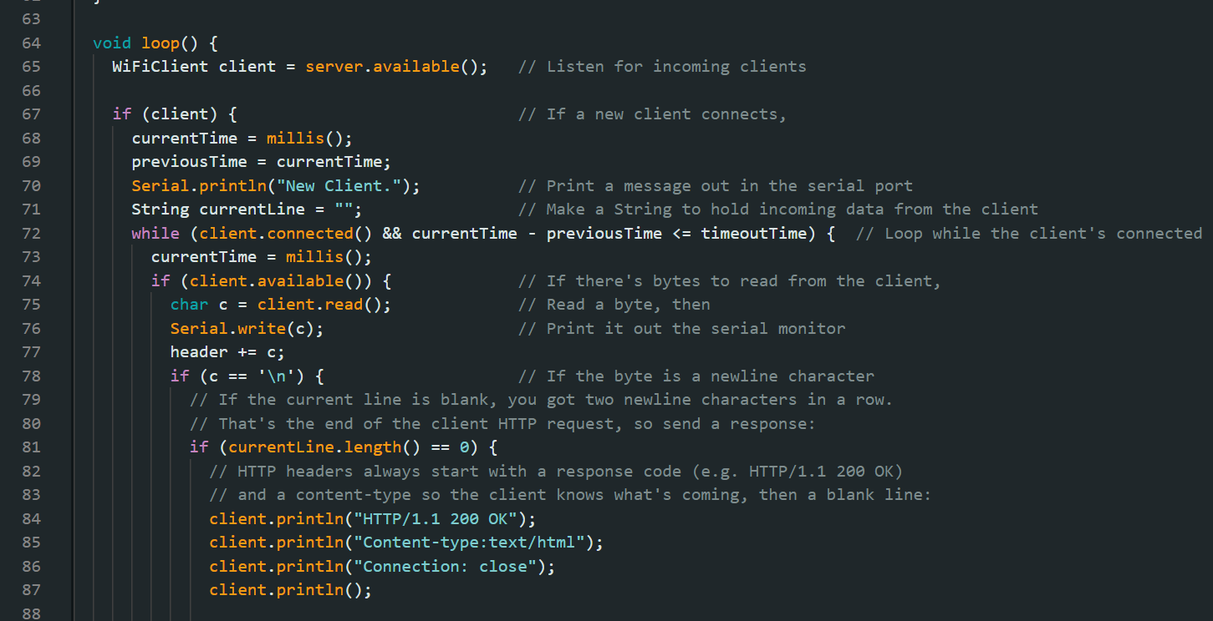
Waits for new client connections. Reads incoming data from the client. Stores the data in the header string. Detects the end of the HTTP request by checking for consecutive newline characters (\n). Sends an HTTP response header indicating a successful request.
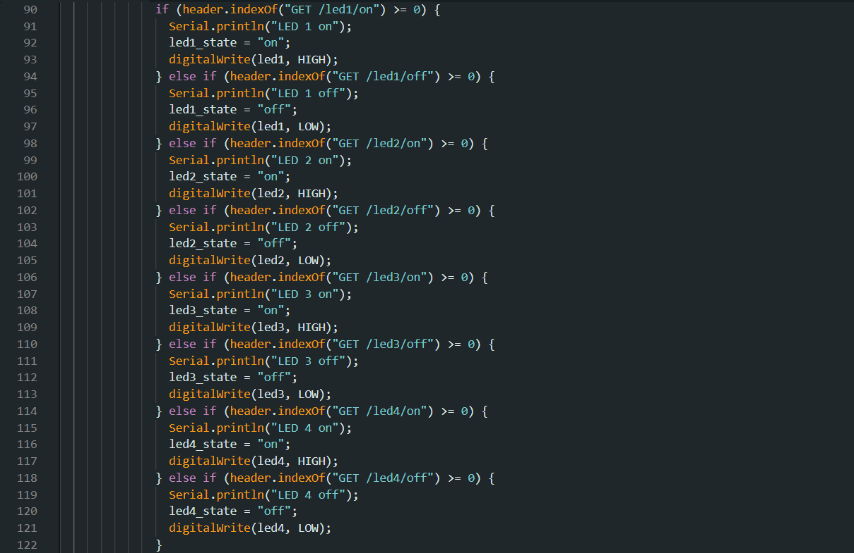
This section checks the HTTP request in the header for specific URL paths to control each LED. If a matching path is found (e.g., GET /led1/on), it updates the corresponding LED state and sets the GPIO pin HIGH or LOW.
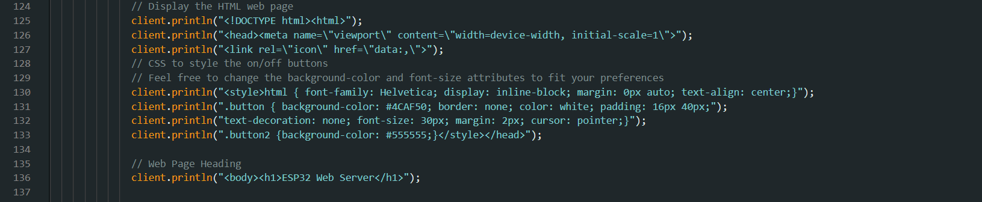
This section of the code generates and sends the HTML content of the web page to the client. This HTML code add the interactive elements (buttons) and the logic for controlling the LEDs.
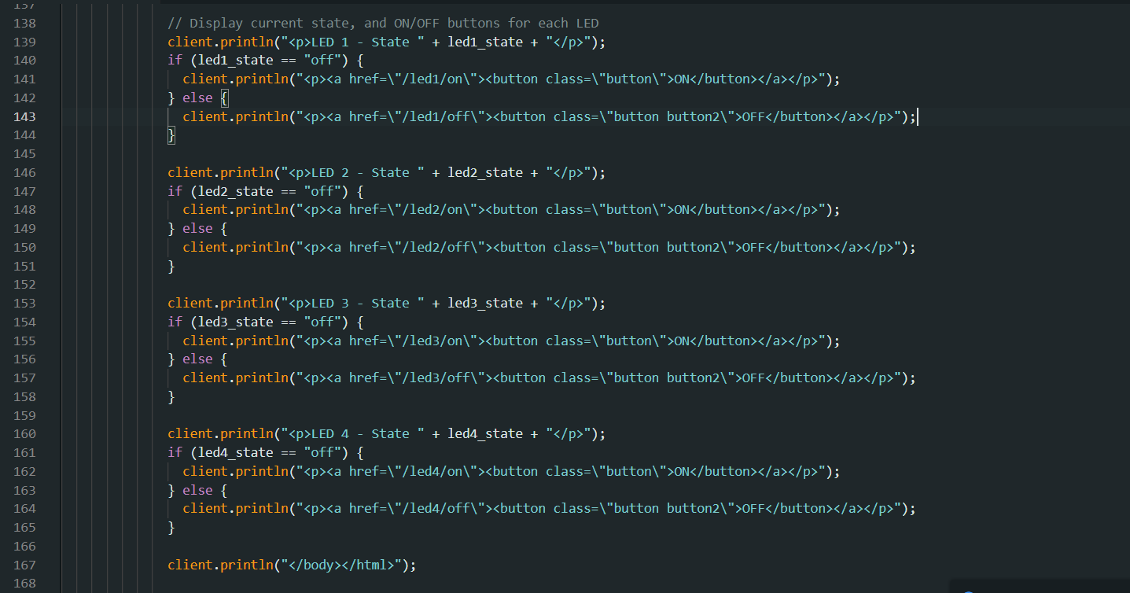
This section of the code is responsible for generating the HTML content that displays the current state of each LED and provides ON/OFF buttons to control them. This section of the code generates HTML content that displays the current state of each LED (on or off) and provides buttons to turn each LED on or off. The state of each LED is checked, and based on the state, the appropriate button is displayed:
- If the LED is off, an "ON" button is displayed.
- If the LED is on, an "OFF" button is displayed.
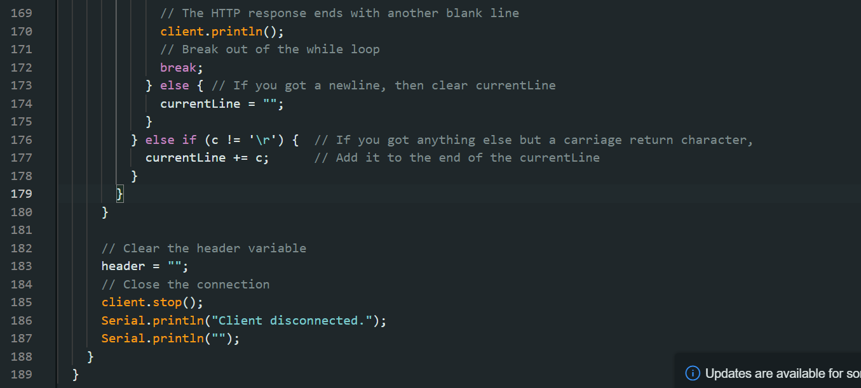
This part ensures that the HTTP request-response cycle is completed, resources are cleaned up, and the server is ready to handle new client connections.

