Documentation on ESP32 Web-based Weather station using OpenWeatherMap API
-Tanvi Adivarekar
Alongside this document, the code has been attached. It uses a ESP32 to take data from an Open Source API (OpenWeatherMap) and displays it on a web server.
Apparatus required:
- Hardware:
- Microcontroller ESP32
- USB cable
- Software:
- Arduino IDE & Suitable Libraries
Features of this program:
This program connect ESP32 to an Wi-Fi network, collect the data from OpenWeatherMap API and parses the JSON response to display on WebServer.
This program fetches and parses the JSON data from web API (here: OpenWeatherMap) using HTTPClient and ArduinoJSON libraries. It’s a practical example of IoT (Internet of Things) where an Microprocessor ESP32 retrieves data directly from the internet.
This program gives weather information such as temperature, humidity, Description, Windspeed and display it on the WebServer.
How to use this code and output of code:
- Have Arduino ide installed
- Tools > Manage libraries> Search for required libraries such as Wi-Fi, Webserver, ArduinoJson and HTTPClient.
- Copy the code into the ide.
- Put your Wi-Fi username and password in the appropriate place.
- Connect your board and select the appropriate board and port.
- Upload the code to the microcontroller.
- Once the microcontroller connects to Wi-Fi, put the IP address it gives into the web browser. You can use your phone or laptop for this purpose, but a phone is recommended as the laptop may have a firewall preventing access to the webserver.
- Make sure the device is connected to the same wi-fi network as the microcontroller.
- The website should now be visible.

Output:
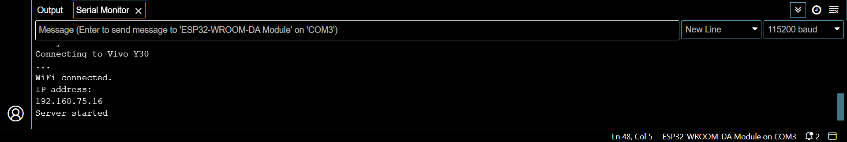
This should be displayed in your serial monitor. If it doesn’t, then press the Reset button and try again.
The following should be displayed on your device.
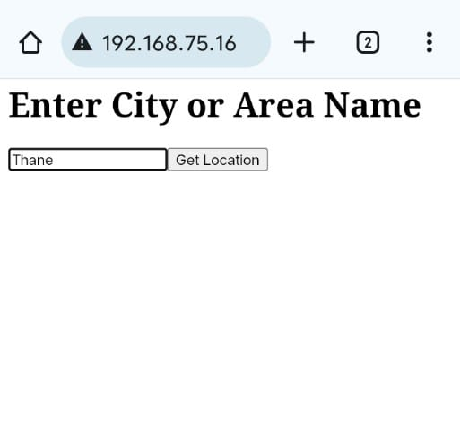
Enter the desired location in the box and click on Get Location button.
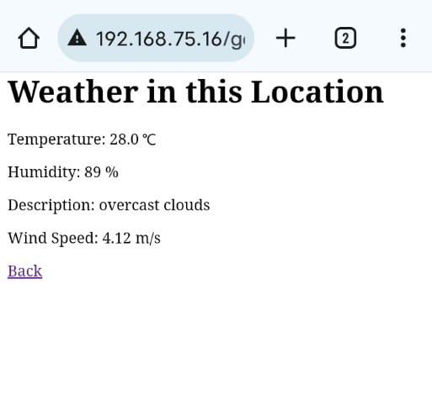

Explanation of the code:
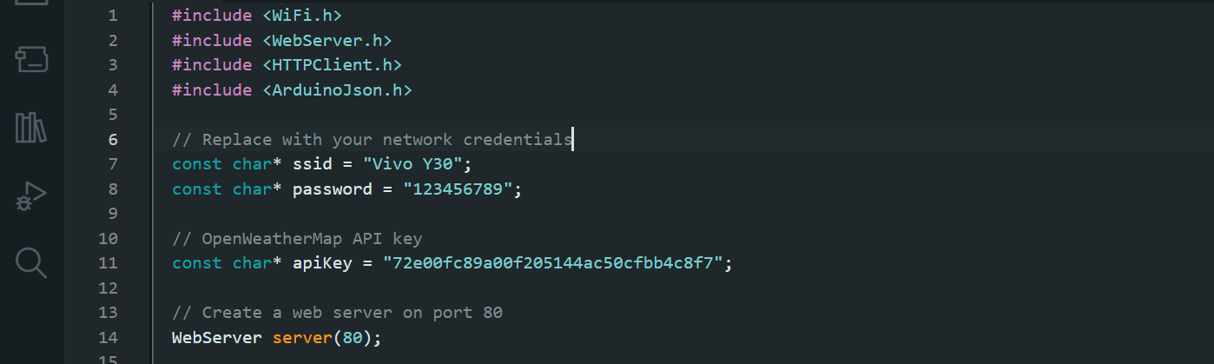
The following are the libraries included in the code along with their function.
WiFi.h: Manages the Wi-Fi connection.
WebServer.h: Creates and handles the web server.
HTTPClient.h: Makes HTTP requests.
ArduinoJson.h: Parses JSON data.
The ssid and password are network credentials for Wi-Fi connection.
The apikey is for the OpenWeatherMap API.
This program waits for the Client at the standard port i.e. 80.
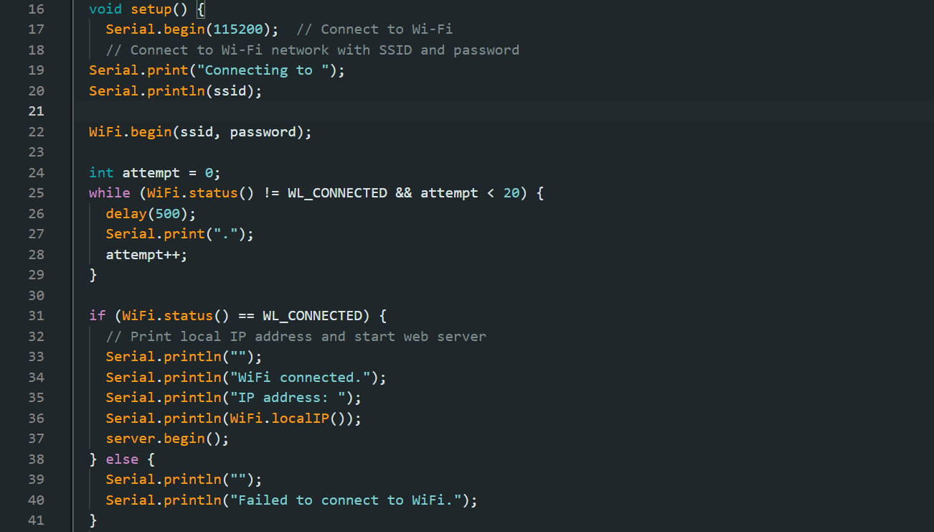
Serial.begin: Initializes serial communication at the baud rate of 115200.
Next few lines connects the ESP32 to the specified Wi-Fi network.
while (WiFi.status() != WL_CONNECTED): Waits until the device is connected to Wi-Fi.
On connecting it displays the URL on the Serial monitor and if faces any error display failed message.
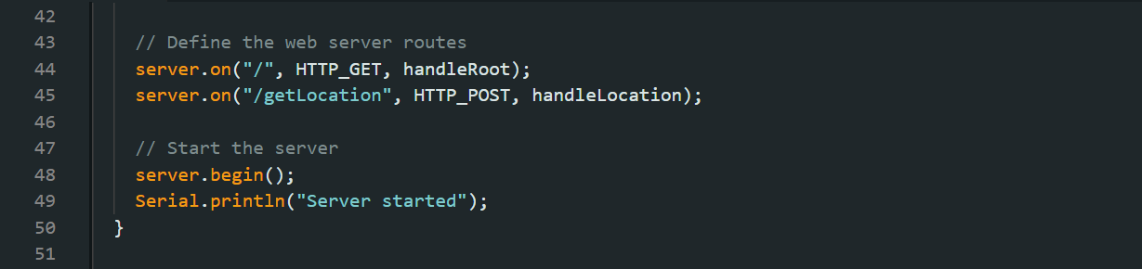
Set the route for handling GET request from the URL. Also set the route for POST request i.e. getLocation to URL. Then begins the server and display message on the Serial Monitor.
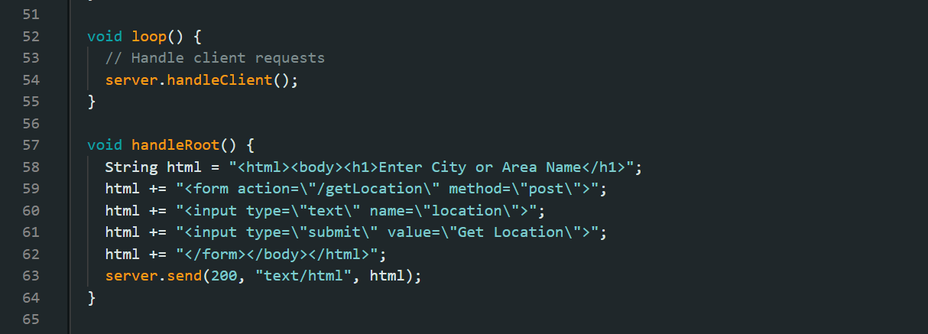
Continuously handles Clients request. Function handleRoot generates and HTML form for the user to input the location and parses it as GET request at the URL.
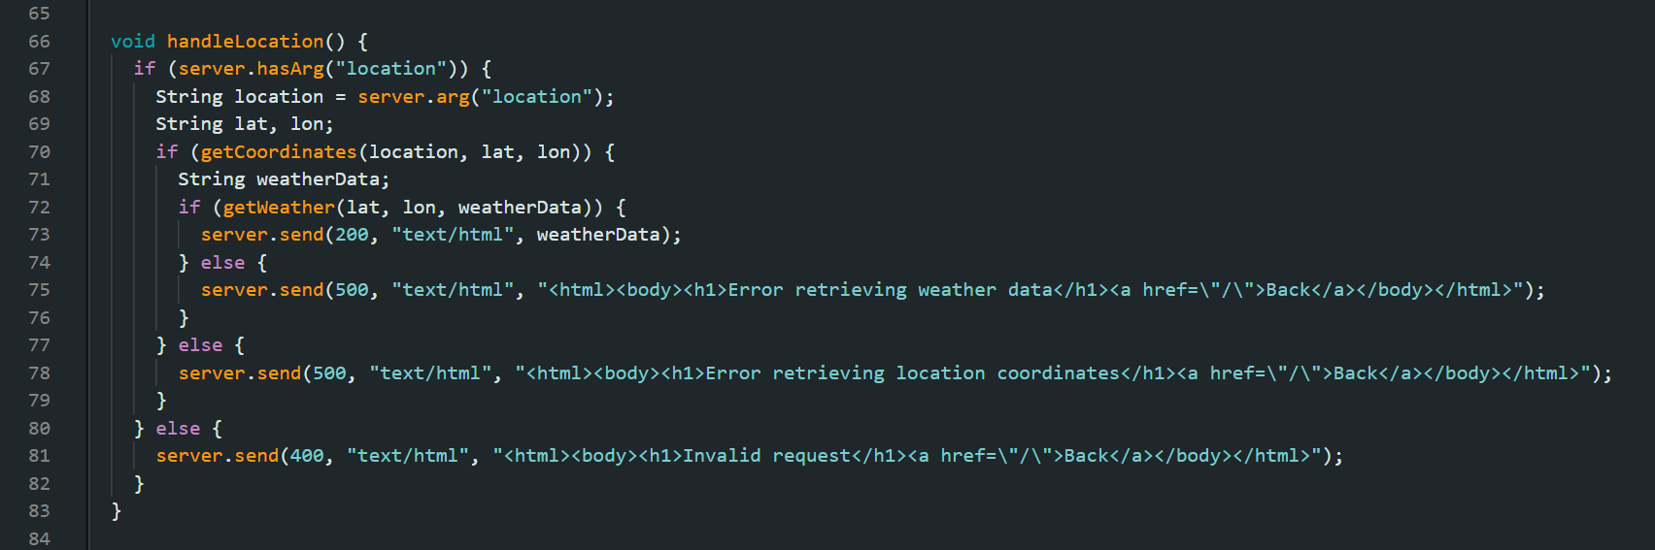
Function handleLocation initially checks that the argument location is present in the POST request. Then it fetches the coordinates (longitude and latitude) of the given location. The function then fetches the weather information from the coordinates.
Sends 200 if the weather data is successfully fetched. Sends 500 if there is an issue in retrieving data coordinates or weather related data. And sends 400 if it is an invalid request.
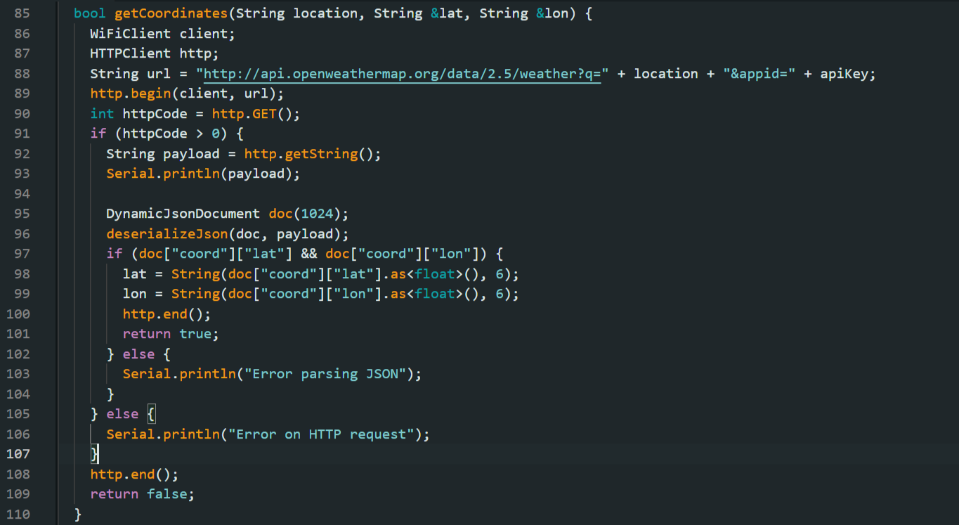
The function getCoordinates creates a Wi-Fi Client object and HTTP Client object. Then initializes the HTTP Client with an URL. Then checks if the request was successful and retrieves the response. Creates an Json document and deserializes the payload into the document. Check for the longitude and latitude. Extract and convert it into floating no. Ends the HTTP connection and returns true or false.
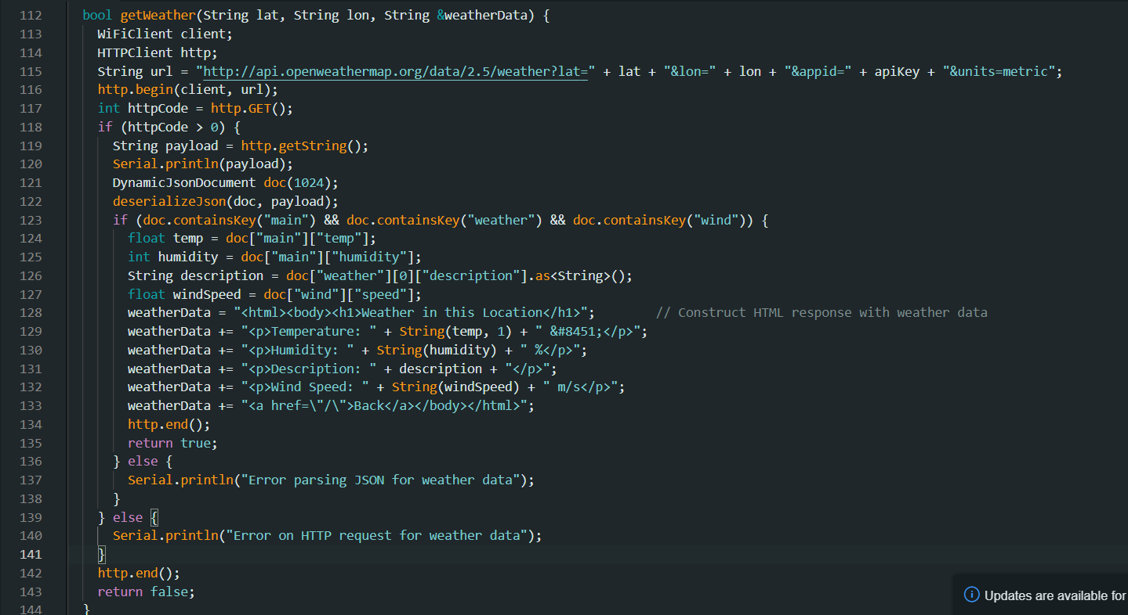
This function creates Wi-Fi Client and HTTP Client objects. Then initializes the HTTP Client with an URL. Sends a GET request to the URL and stores the response code. Then checks if the request was successful and retrieves the response. Creates an Json document and deserializes the payload into the document. Then checks for the necessary present in the JSON file. Extracts the data and constructs an HTML response containing the weather data. Ends the HTTP connection and returns true or false.

