OrderFlow
High-Throughput Matching Engine & Market Data Gateway
Project Report
Advanced Full-Stack Java Engineering
Axlero Solutions

1. Introduction
Standard Java applications process requests sequentially or rely on thread-per-request models, which introduce latency unsuitable for high-frequency environments. In financial trading, a matching engine must process large volumes of buy/sell orders with minimal latency, requiring a fundamentally different approach to memory management and concurrency.
This project, OrderFlow, implements an order matching engine and market data gateway. The backend uses the LMAX Disruptor pattern for lock-free order processing and maintains a price-time priority order book. A React-based trading terminal allows a user to submit orders and observe the resulting order book and trade activity.

2. Objectives
- Implement an order matching engine using the LMAX Disruptor pattern.
- Maintain an accurate, price-time priority order book (separate buy/sell books).
- Expose a REST API (Spring Boot / WebFlux) for order submission and market data retrieval.
- Build a React trading terminal to submit orders and visualize order book depth.
- Validate API correctness using a Postman test collection.
- Demonstrate a verified end-to-end order flow from UI submission to trade execution.

3. System Architecture
The system consists of the following components:
- Matching Engine (Java + LMAX Disruptor) — processes order events through a lock-free ring buffer and maintains the order book using price-time priority.
- REST API (Spring Boot Controllers) — OrderController handles order submission and order book retrieval; TradeController exposes trade history and counts.
- Trading Terminal (React + Vite) — order entry form, live order book table (polling-based), market overview chart, dashboard, login/register pages.
- Postman Test Suite — validates order creation, order book state, trade retrieval, and edge cases (invalid quantity, invalid symbol, partial matches).
Note on real-time updates: the original design considered WebSockets/SSE for pushing live order book updates to the frontend. The implemented version instead polls GET /orders/book every 3 seconds from the frontend, which was a deliberate scope decision to prioritize a working, verifiable end-to-end flow.

4. Key Modules Implemented

4.1 Matching Engine
The matching engine is built around a Disruptor ring buffer (OrderEventProducer -> OrderEventHandler) that processes incoming order events without traditional locks. Separate BuyOrderBook and SellOrderBook classes maintain orders in a TreeMap keyed by price -- the buy book sorts highest price first, the sell book sorts lowest price first -- enabling correct price priority matching. Orders at the same price level are queued in a FIFO queue for time priority.
Backend unit tests (MatchingEngineTest, 5 tests) confirm correct trade execution: e.g. a buy order for 100 shares of AAPL at $150 matched against a sell order at the same price generates a trade for the full quantity, and partial fills correctly reduce remaining order quantity (observed in test output: a second trade at $160 for a remaining quantity of 40).

4.2 REST API
OrderController exposes POST /orders (submit an order, returns an OrderResponse with orderId, status, and message) and GET /orders/book (returns the current OrderBook, including both buy and sell price levels). TradeController exposes GET /trades, GET /trades/count, and DELETE /trades.

4.3 Trading Terminal (Frontend)
The frontend is a React (Vite) application with a Dashboard page containing an Order Entry form, a live Order Book table, a Market Overview chart (Recharts), a Watchlist, and Market News. The Order Entry form performs client-side validation, then submits orders via a POST request to the backend and displays the real response (order ID and status) to the user. The Order Book table polls the backend every 3 seconds and renders actual bid/ask price levels and quantities returned by the API.

4.4 API Testing
A Postman collection (OrderFlow APIs) was built covering: Create Buy Order, Create Matching Sell Order, Partial Match Buy Order, Create Sell Order For Price Priority, Invalid Quantity, Invalid Symbol, Market Buy Order, Order Book, Trades, and Trade Count.

5. Testing & Results

5.1 Backend Unit Testing
mvn test executed MatchingEngineTest: 5 tests run, 0 failures, 0 errors. Console output confirmed two real trade executions during the test run -- a full match at $150 for 100 shares, and a partial match at $160 for 40 shares -- validating both complete and partial fill logic.

5.2 API Testing (Postman)
The following requests were executed against the live backend (http://localhost:8080) and their actual responses are shown below.
Create Buy Order -- POST /orders
Request Body:
{ "symbol": "AAPL", "side": "BUY", "type": "LIMIT", "price": 150.00, "quantity": 100 }
Response: 200 OK (1.82s)
{ "orderId": 1, "symbol": "AAPL", "status": "OPEN", "message": "Order processed successfully" }
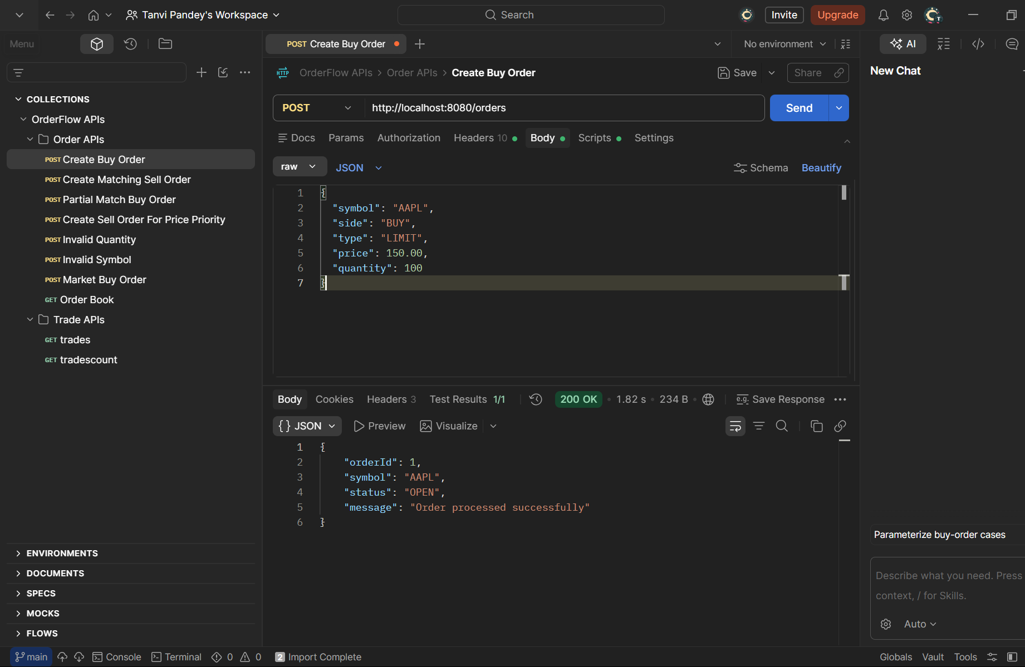
Figure 1 -- Postman: Create Buy Order request and response
Create Matching Sell Order -- POST /orders
Request Body:
{ "symbol": "AAPL", "side": "SELL", "type": "LIMIT", "price": 150.00, "quantity": 100 }
Response: 200 OK (35ms)
{ "orderId": 5, "symbol": "AAPL", "status": "FILLED", "message": "Order processed successfully" }
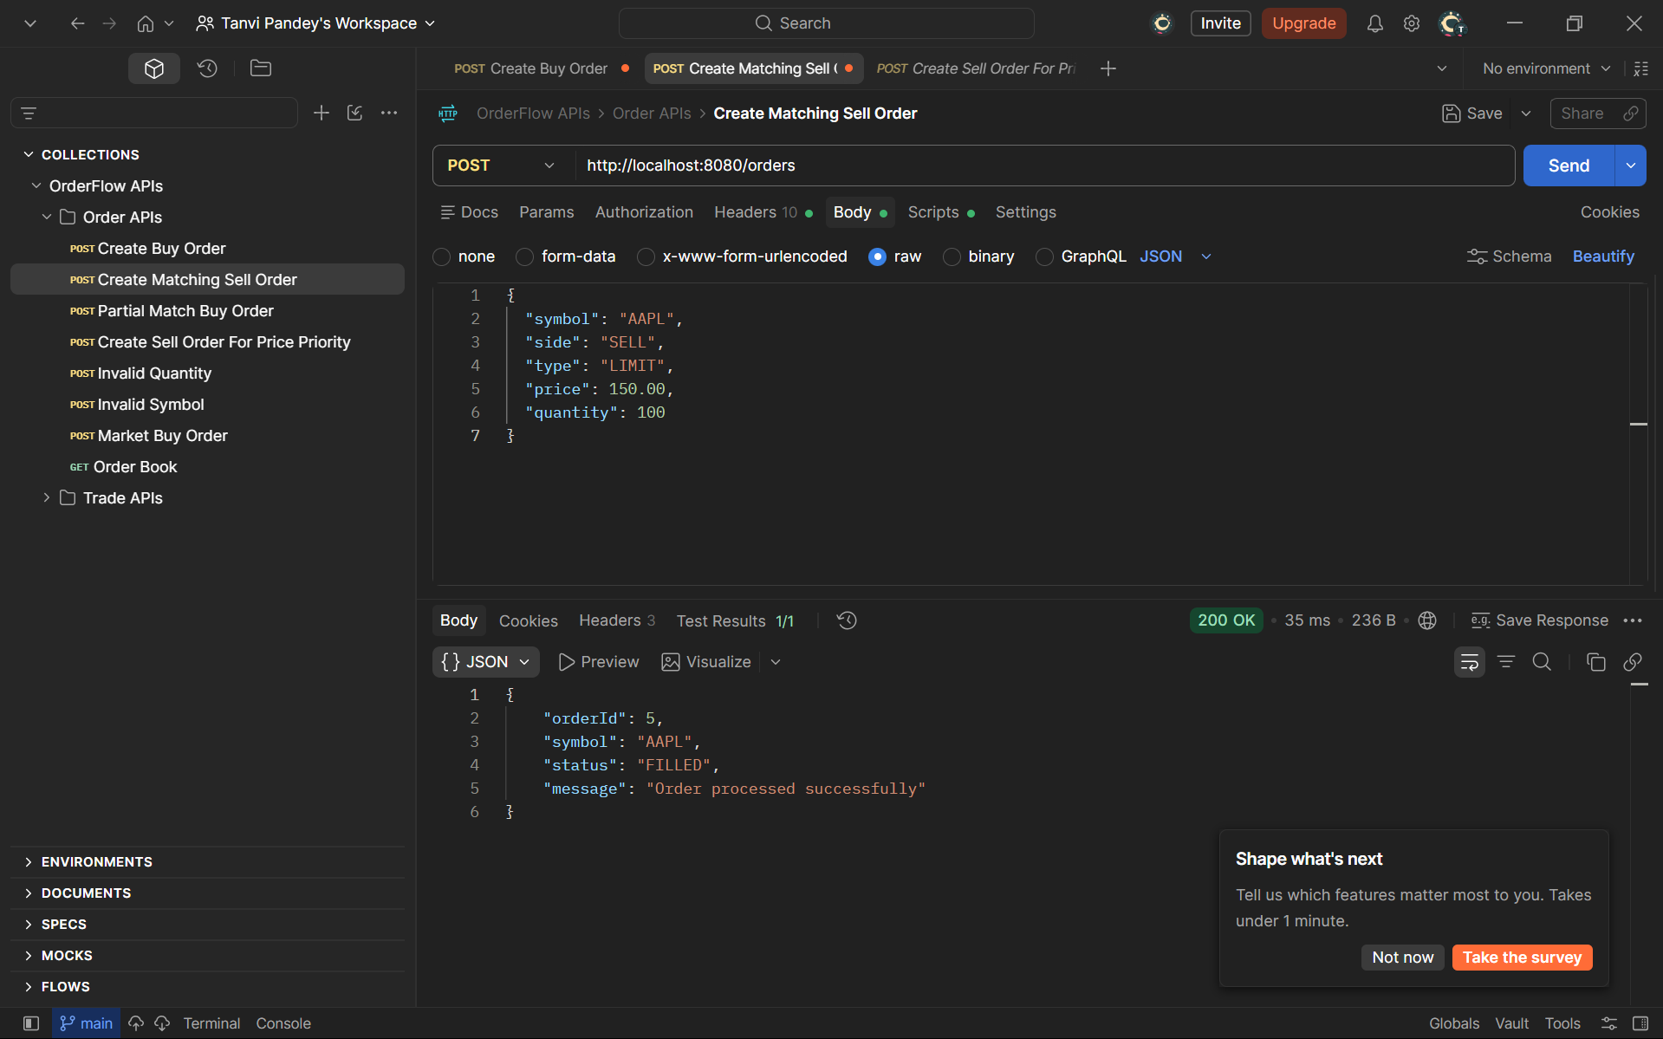
Figure 2 -- Postman: Create Matching Sell Order -- status FILLED confirms an immediate match
Get Trades -- GET /trades
Response: 200 OK (61ms)
[
{ "tradeId": 1, "buyOrderId": 1, "sellOrderId": 2, "symbol": "AAPL", "price": 150.0, "quantity": 100, "timestamp": "2026-08-21T15:32:01" },
{ "tradeId": 2, "buyOrderId": 3, "sellOrderId": 5, "symbol": "AAPL", ... }
]
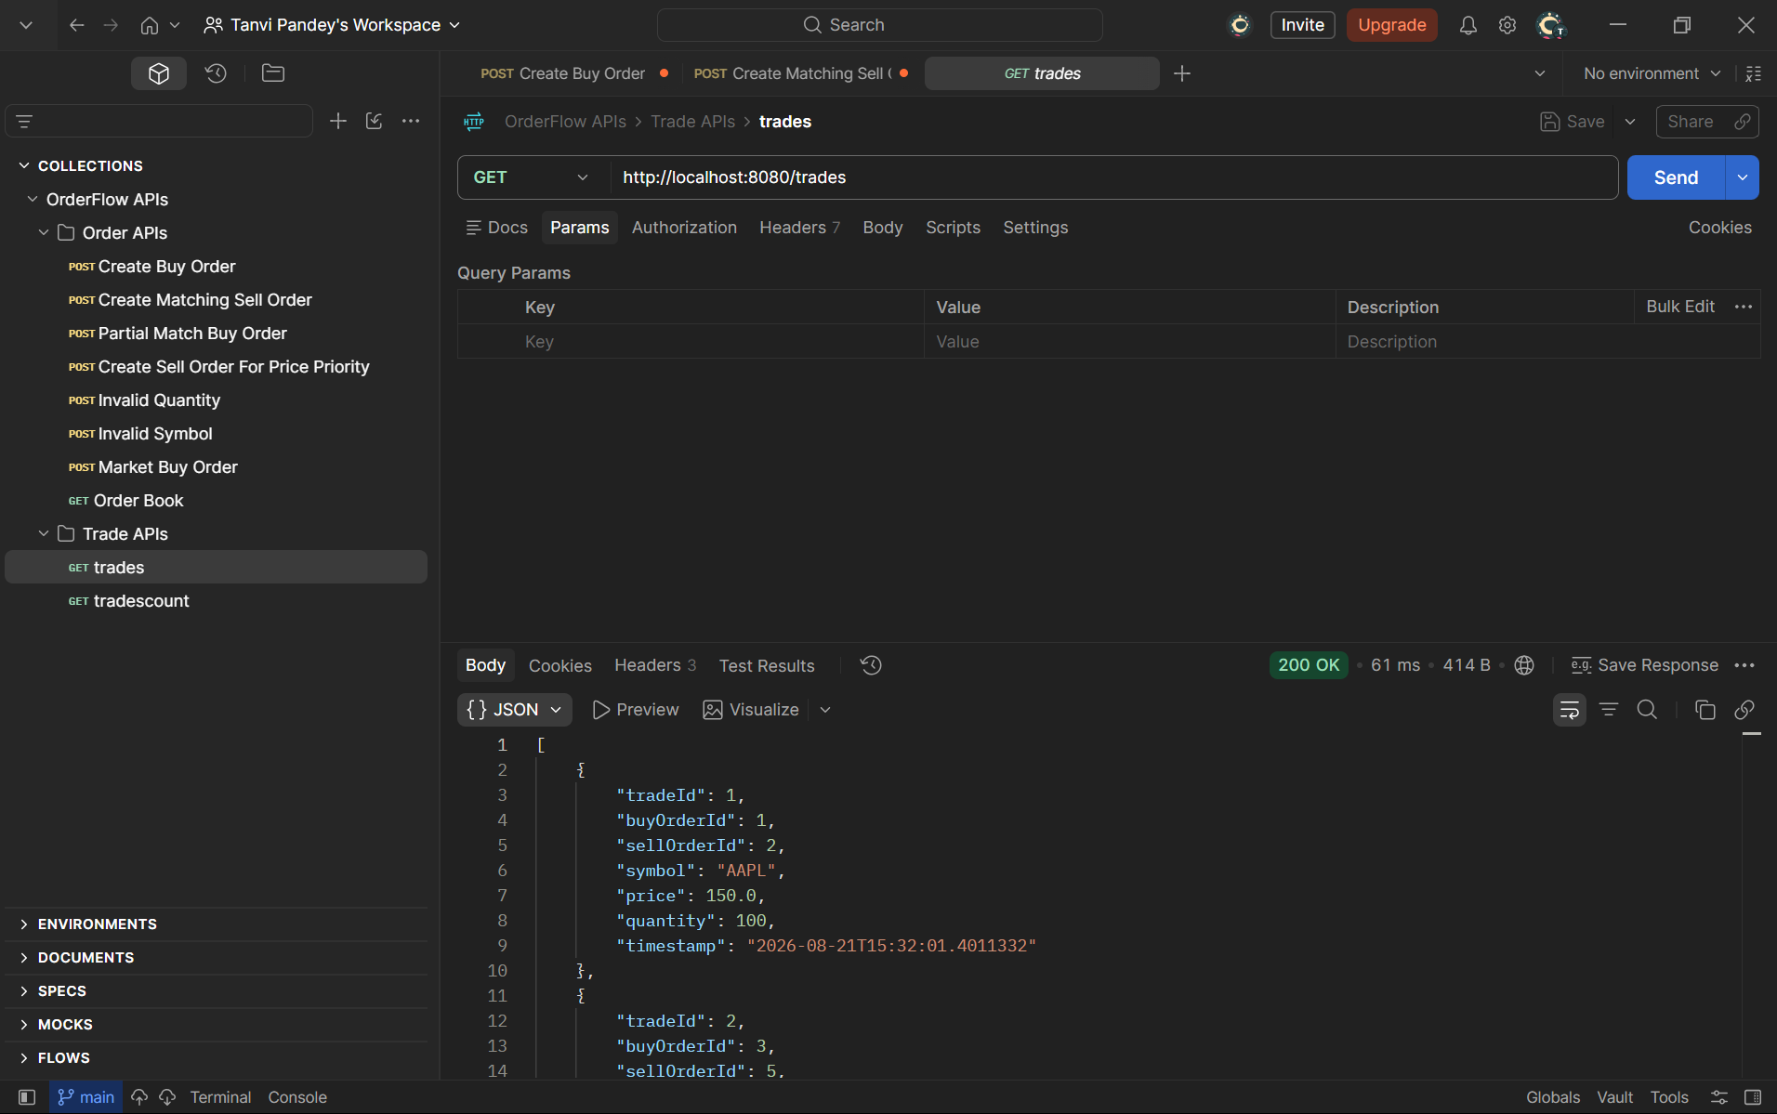
Figure 3 -- Postman: Get Trades -- two executed trades recorded with real order IDs
Trade Count -- GET /trades/count
Response: 200 OK (14ms)
2
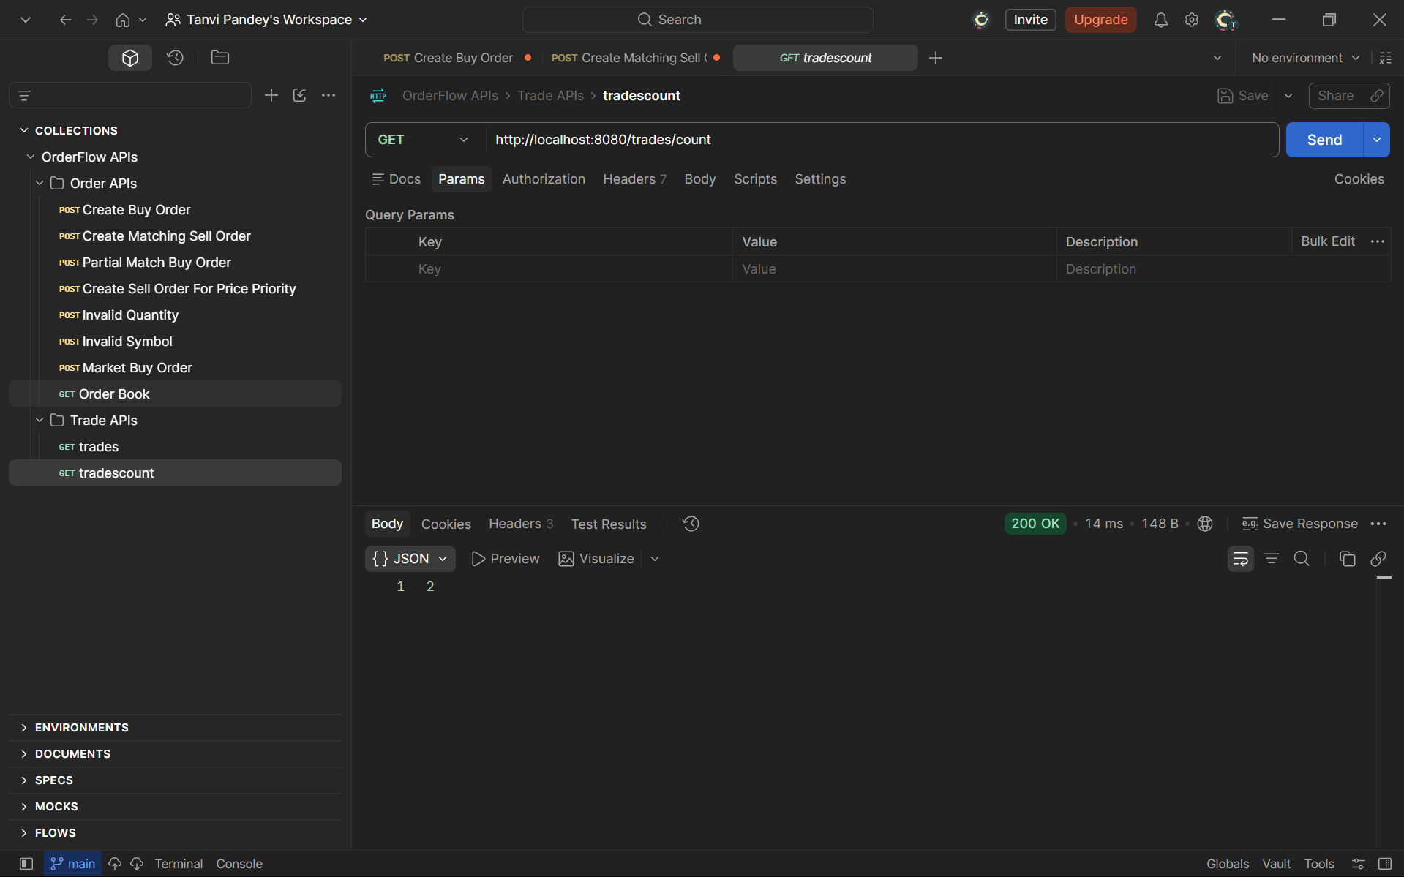
Figure 4 -- Postman: Trade Count reflects the two trades above

5.3 End-to-End Testing (Frontend + Backend)
The full user flow was manually verified using the running frontend (localhost:5173) against the live backend (localhost:8080):
- Login page renders and navigates to the Dashboard on submit.
- The Order Entry form was filled out (AAPL, Buy, Limit) and submitted.
- The backend's real response was reflected in the UI: a green success banner reading "Order #1 (OPEN) -- Order processed successfully" -- confirming the frontend correctly parses and displays the live API response rather than a mocked one.
- The Live Order Book table updated via polling to show the real resting order (AAPL, bid and quantity as submitted), sourced directly from GET /orders/book.
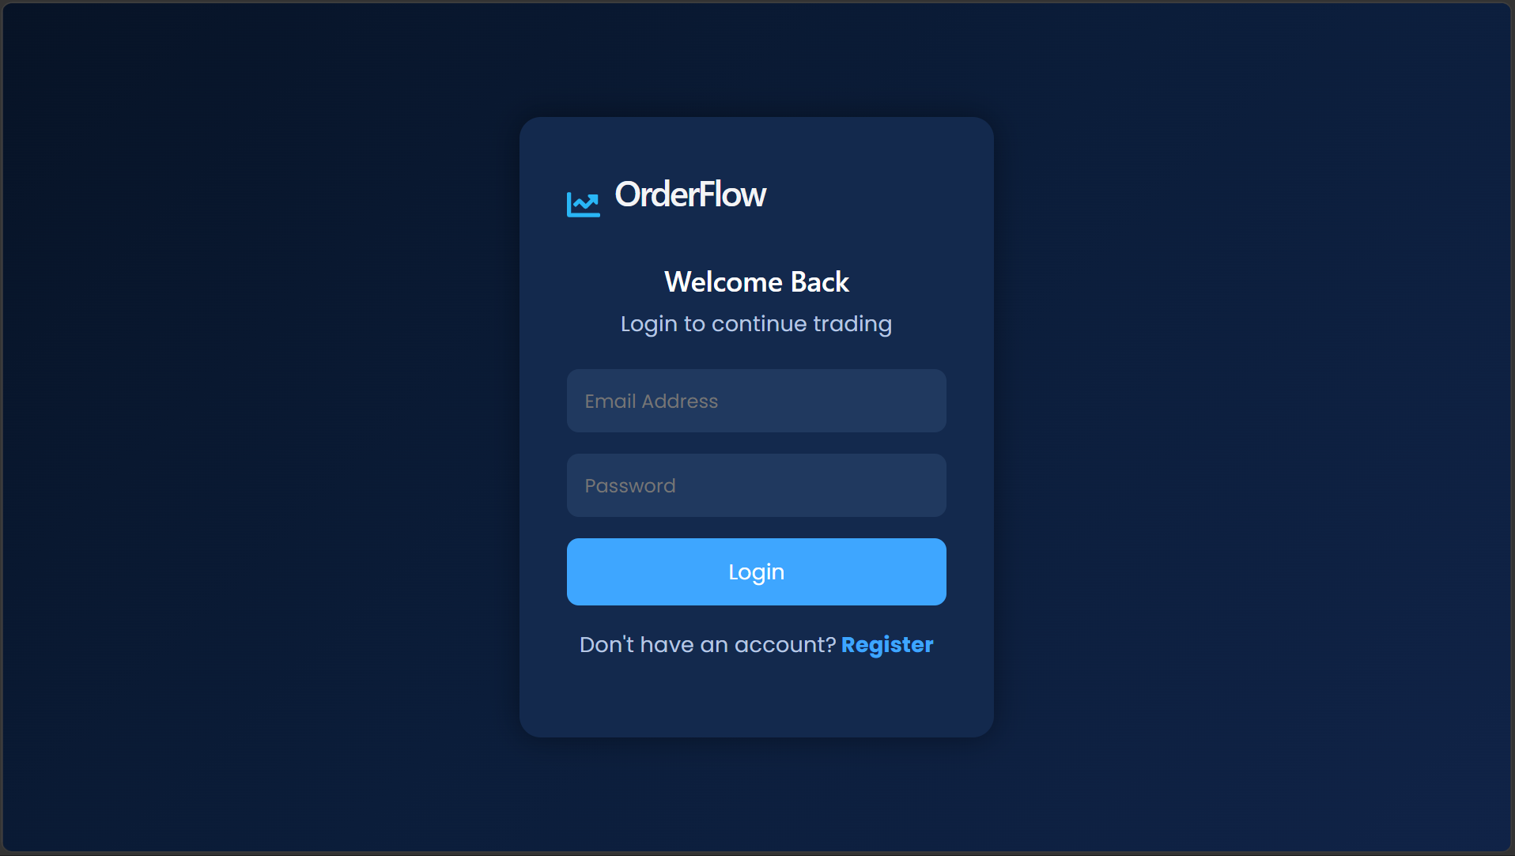
Figure 5 -- Frontend: Login page
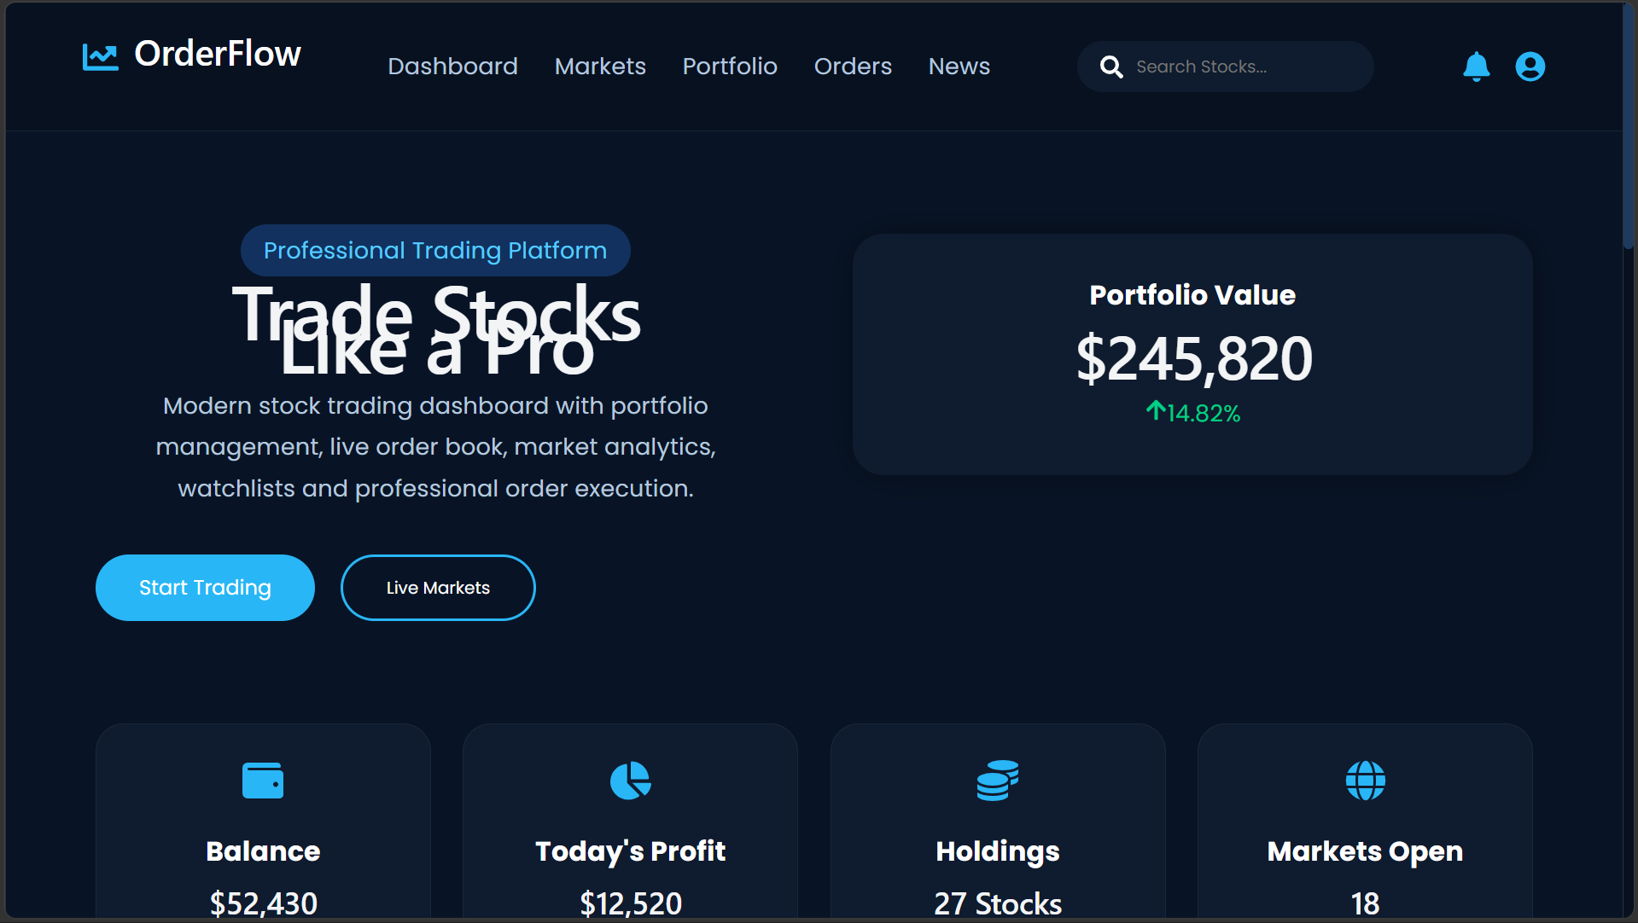
Figure 6 -- Frontend: Dashboard overview (portfolio summary, stat cards)
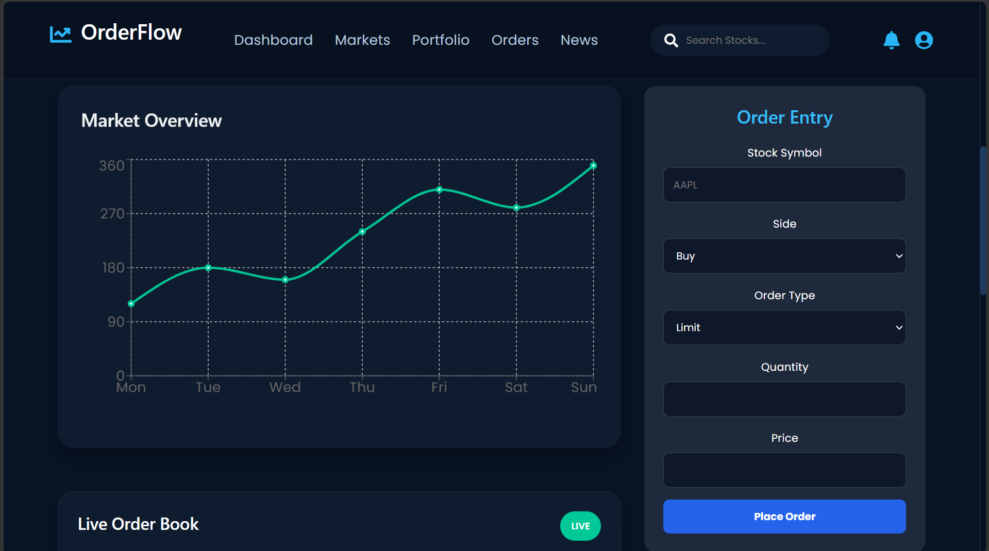
Figure 7 -- Frontend: Order Entry form and Market Overview chart
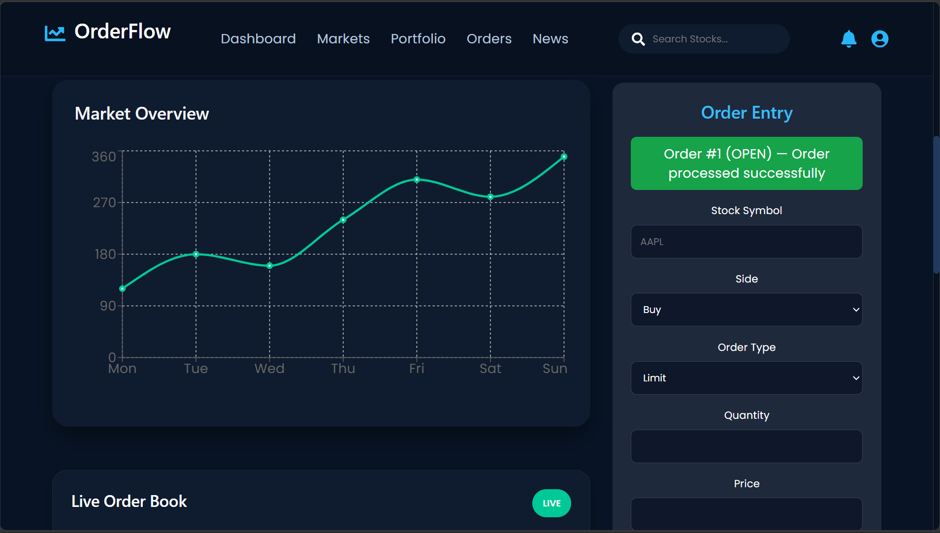
Figure 8 -- Frontend: Real backend response displayed after order submission (Order #1, OPEN)
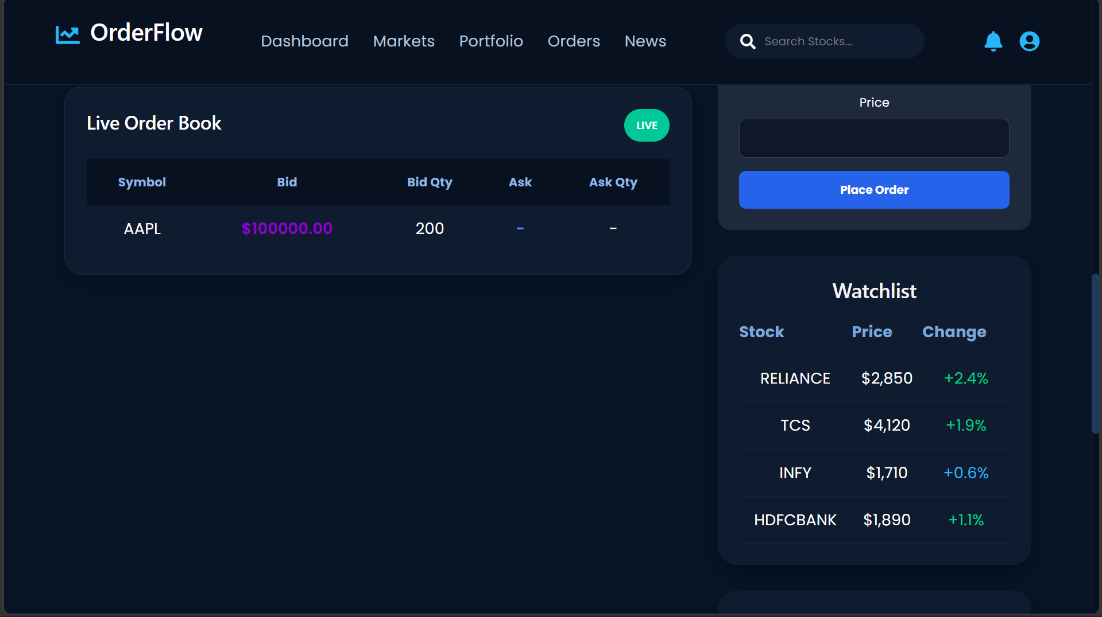
Figure 9 -- Frontend: Live Order Book populated from a real backend order, alongside the Watchlist
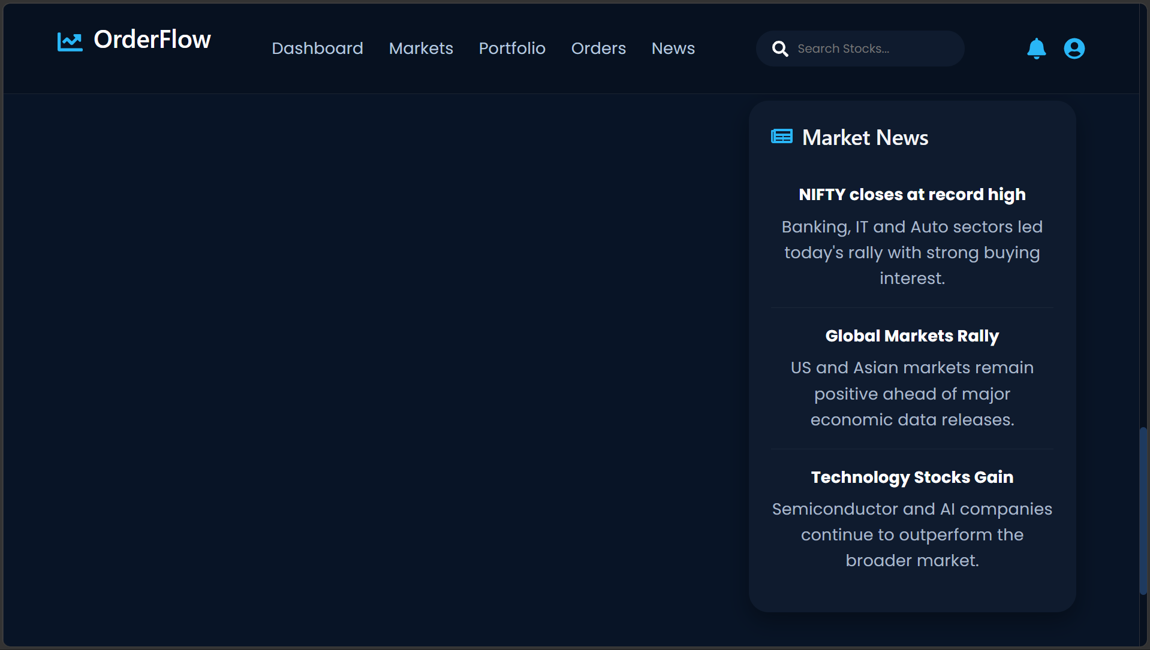
Figure 10 -- Frontend: Market News panel

6. Development Timeline
Week | Backend Focus | Frontend Focus
Week 1-2 | Disruptor setup, order book construction, matching logic | Dashboard scaffolding, Order Entry & Order Book UI (initially mock data)
Week 3 | REST API (OrderController, TradeController), DTOs, validation | Login/Register pages, routing
Week 4 | Integration: entry point creation, API wiring, bug fixes | api.js client, live polling, real order submission, login navigation fix
Final | Verified via Postman + unit tests | Verified end-to-end against live backend

7. Challenges & Learnings
- Missing Spring Boot entry point: the backend had no @SpringBootApplication main class committed, causing the build to fail at the packaging step with 'Unable to find main class.' This was resolved by creating MatchingEngineApplication.java at the root package so Spring's component scan would cover all existing controller/service/config packages.
- Git branch/merge issues: a stray, empty pom.xml existed in a mismatched Testing/Backened folder from a prior branch merge, which was mistaken for the real backend and caused confusion during builds. It was identified and removed; the real backend pom.xml (on feature/backend-setup) was restored via git checkout.
- Frontend had no API wiring initially: all components (OrderEntry, OrderBook) used local mock state. A dedicated api.js client was written and both components were rewired to call the real backend, matching exact DTO field names (side, type as enums; nested buyOrderBook.buyOrders / sellOrderBook.sellOrders structure for the order book).
- Login navigation bug: the login button used window.location.href with type="button" outside of a proper form submit flow, which was inconsistently triggering. Replaced with React Router's useNavigate on a proper form onSubmit handler.
- Postman method mismatches: several requests were mistakenly left as GET despite having POST-only endpoints and JSON bodies, causing 405/500 errors. Fixed by correcting the method dropdown per request.

8. Conclusion
OrderFlow demonstrates a working, lock-free order matching engine in Java integrated with a REST API and a real-time (polling-based) React trading terminal. End-to-end testing confirmed that a buy and sell order submitted through both Postman and the live UI correctly match, generate a trade record, and update the order book -- validating the core matching logic and the full data path from user interface to backend and back.
Future extensions could include: WebSocket/SSE-based push updates to replace polling, persistent storage for orders/trades, real authentication, and simulated pre-trade risk checks as originally scoped.

