VIVEKANAND COLLEGE FOR ADVANCED COMPUTER AND INFORMATION SCIENCE
Affiliated to
VEER NARMAD SOUTH GUJARAT UNIVERSITY, SURAT

MINI PROJECT REPORT
ON
“Global Mental Health & Lifestyle Survey”
As a partial Requirement for Degree
Of
BACHELOR OF COMPUTER APPLICATION (BCA)
GUIDED BY:
Mrs. Ankita Patel
2025-2026
SUBMITTED BY:
Patel Tanvikumari B. (9655)
Patel Visa D. (9660)

Acknowledgement
This has been the most practical and exciting part of our learning experience during the three years of our degree, and it will truly be an asset to us in our future careers.
This project marked our first professional step toward building a high-profile career in the field of Information Technology. It has been a wonderful experience that allowed us to explore, experiment, and learn many new concepts at an advanced level.
This acknowledgement would be incomplete without expressing our heartfelt gratitude to our parents and friends for being a constant source of inspiration and support in countless ways. This project is a small tribute to their hopes, encouragement, and blessings.
We are deeply thankful to our project guide Mrs. Ankita Patel for her kind cooperation, valuable guidance, and continuous support throughout the project. We also extend our sincere gratitude to our Principal, Dr. Sandip Surati, and our Campus Director, Mrs. Sumathi Shenoy, for providing us with the opportunity and facilities required to complete this project successfully.
We express our sincere thanks to everyone who helped and supported us at every stage of the project.
Thanks to All
Patel Tanvikumari Bharatbhai
Patel Visa Dipakbhai

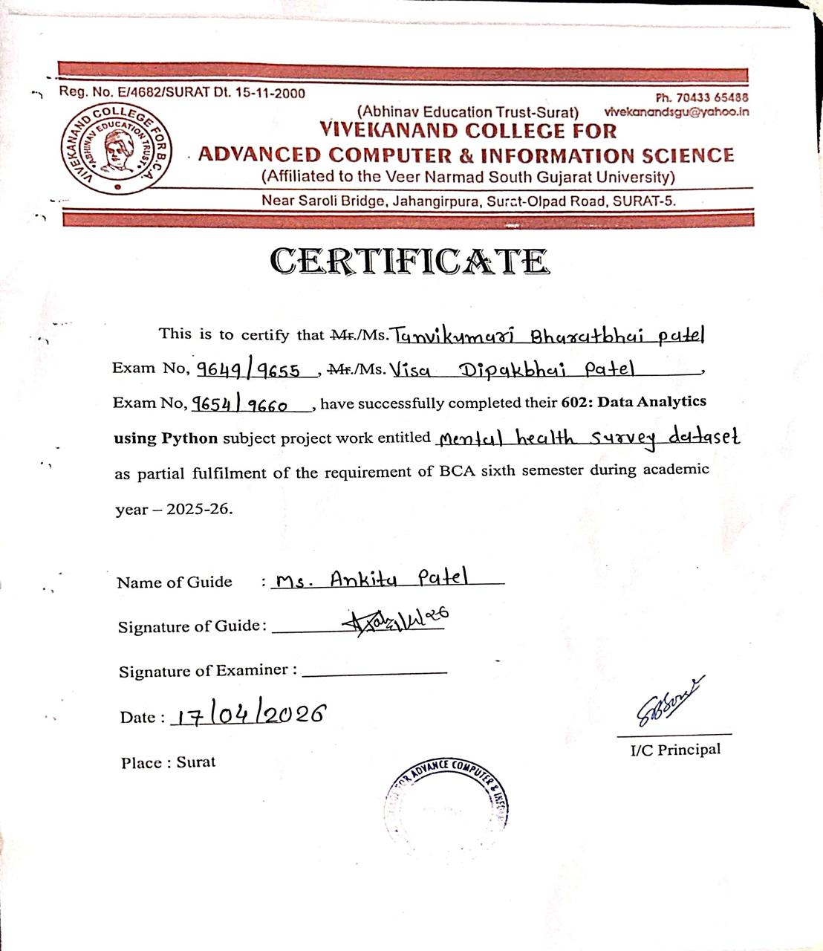
INDEX
Sr No. | Title | Page No.
1. | Project Title | 1.
2. | Data Source | 2.
3. | Project Definition | 3.
4. | Mode of Project | 4.
5. | Dataset Name | 5.
6. | Dataset Link | 5.
7. | Dataset Datatype | 6.
8. | Domain | 6.
9. | Dataset Description | 7.
 | Dataset Features / Attributes Description | 7.
10. | Project Objective | 10.
11. | Python tools & libraries to be Used | 11.
12. | Project Tasks | 14.
 | Exploratory Data Analysis | 14.
 | Simple Linear Regression Model | 14.
 | Multiple Linear Regression Model | 15.
 | Logistic Regression Model | 15.
13. | Model Evaluation | 16.
14. | Data Visualization | 20.
15. | Conclusion | 25.

1. Project Title
Project Title: “Global Mental Health & Lifestyle Survey Using Python and Machine Learning”
Nowadays, mental health has become a very important topic, especially because of busy lifestyles, work pressure, and changing daily habits. Many people experience stress, anxiety, and other mental health issues, but often don’t realize how much their lifestyle affects their mental well-being.
In this project, we have used a Global Mental Health and Lifestyle Survey dataset to understand how different lifestyle factors like sleep, physical activity, work stress, and social interaction are connected to mental health. The dataset contains responses from individuals about their daily routines and mental health conditions.
The main purpose of this project is to explore the data and find useful insights about how lifestyle choices can impact mental health. Using Python, I performed data cleaning, analysis, and visualization to better understand patterns and relationships within the data.
Overall, this project shows how data analysis helps in understanding the link between lifestyle habits and mental health. The insights highlight key factors like sleep, stress, and daily routines, which can help individuals and organizations make better decisions and promote healthier lifestyles.

2. Data Source
The dataset used in this project is taken from Kaggle, which is a widely used platform for data science and machine learning projects. The dataset is titled “Global Mental Health and Lifestyle Survey Dataset” and is based on survey responses collected from people of different backgrounds and lifestyles.
It includes detailed information about individuals’ daily habits such as sleep duration, physical activity, work pressure, and social interactions. Along with this, it also captures important mental health indicators like stress, anxiety, and depression levels. Because the data is well-organized and structured, it becomes easier to perform data cleaning, analysis, and visualization using Python.
Since this dataset is publicly available, it provides a great opportunity to work with real-world data and gain practical experience. It helps in understanding how different lifestyle factors are connected to mental health. Overall, this dataset is very useful for learning data analysis techniques and for discovering meaningful patterns that can contribute to better awareness of mental well-being.
Dataset Source:
Platform: Kaggle
Data Format: CSV
Domain: “Mental Health & Lifestyle Analysis”
Records: 999
Features: 51
3. Project definition
This project is about understanding how our daily lifestyle habits are connected to our mental health. In today’s fast-paced life, people often face stress, anxiety, and other mental health issues without realizing that their everyday routines, such as sleep patterns, work pressure, physical activity, and social life, play an important role in it.
In this project, I have used a survey-based dataset to study these factors and their impact on mental well-being. Using Python, the data is cleaned, explored, and analyzed to find patterns and relationships between different variables. The goal is not just to work with data, but to make sense of it in a way that is easy to understand.
This project also focuses on making the data easy to understand through clear visualizations and simple analysis techniques. By presenting the findings in graphs and charts, it becomes easier to identify trends and compare different factors affecting mental health. The overall aim is to turn raw data into useful information that can help people become more aware of their habits and encourage positive lifestyle changes for better mental well-being.
Overall, this project helps in gaining a better understanding of how small lifestyle changes can affect mental health. It also shows how data analysis can be used to draw meaningful insights that can spread awareness and support better decision-making for a healthier life.

4. Mode of Project
The mode of this project is a Group Project, which means the project was completed collaboratively by two members. Both team members worked together on different stages of the project, including dataset selection, data preprocessing, exploratory data analysis, machine learning model development, and result visualization using Python.
The dataset used in this project was obtained from Kaggle, and both members participated in understanding the dataset and preparing it for analysis. The project tasks were divided between the team members to ensure efficient completion of the work while maintaining collaboration throughout the development process.
Through teamwork and coordination, the project was successfully implemented using Python and machine learning techniques. Working as a group helped improve problem-solving skills, knowledge sharing, and understanding of the complete data science workflow from data collection to model evaluation and visualization.
- Work Distribution Among Members
Member Name | Role
Patel Visa Dipakbhai | Data Analysis, EDA
Patel Tanvikumari Bharatbhai | Creating Models, Visualization

5. Dataset Name
The dataset used in this project is called the “Global Mental Health and Lifestyle Survey Dataset.” As the name suggests, it focuses on understanding mental health conditions in relation to people’s daily lifestyle habits.
This dataset is based on survey responses collected from individuals, where they have shared information about their routines, stress levels, sleep patterns, and overall mental well-being. The name of the dataset clearly reflects its purpose, which is to study how lifestyle factors can influence mental health on a broader scale.
Overall, the dataset is well-suited for this project as it provides relevant and meaningful information needed to analyze and understand mental health trends.
6. Dataset Link
The dataset used in this project was obtained from Kaggle, which provides a wide range of datasets for machine learning and data analysis.
Link:
https://www.kaggle.com/datasets/dhrubangtalukdar/global-mental-health-and-lifestyle-survey-dataset?resource=download
Kaggle is widely used by students, researchers, and professionals to access real-world datasets for analysis and predictive modeling. The platform allows users to download datasets in different formats and apply various machine learning techniques to analyze them.
7. Dataset Datatype
The dataset used in this project is a Structured Dataset stored in CSV (Comma-Separated Values) format.
Structured data means that the data is organized in rows and columns, where each column represents a specific feature or attribute and each row represents a record in the dataset.
The CSV format is commonly used in data analysis because it is simple, lightweight, and easy to import into programming environments such as Python using libraries like Pandas. This format allows efficient data processing, manipulation, and analysis.
8. Domain
Domain: “Mental Health and Lifestyle Analysis”
This project falls under the domain of Mental Health and Lifestyle Analysis, which focuses on studying how daily habits and personal behaviors impact an individual’s mental well-being. It combines concepts from healthcare, psychology, and data analytics to understand issues like stress, anxiety, and depression.
The domain is important because modern lifestyles such as poor sleep, high screen time, and lack of physical activity are directly affecting mental health. By analyzing such factors, we can identify patterns and relationships that help in improving overall well-being and promoting a healthier lifestyle.
This project uses data analysis techniques to explore the connection between lifestyle factors and mental health conditions, providing insights that can be useful for awareness, prevention, and better decision-making.
9. Dataset Description
The Dataset used in this project contains multiple attributes related to individual’s lifestyle habits and mental health conditions. Each row represents a single respondent, while each column represents a specific factor that may influence mental well-being. The dataset includes a mix of lifestyle, psychological, and demographic features that help in analyzing patterns related to stress, anxiety, and overall mental health.
The data is stored in CSV format, making it easy to handle using Python libraries such as Pandas and NumPy. It includes important variables like sleep duration, physical activity, screen time, stress levels, and other daily habits. These features provide useful insights into how different lifestyle choices can impact mental health.
This dataset is suitable for data analysis and machine learning tasks such as exploratory data analysis, visualization, and predictive modeling. In this project, the data is cleaned and processed before analyzing relationships between different factors. The insights obtained help in understanding how lifestyle and behavior affect mental well-being and can support better awareness and decision-making.
Dataset Features / Attributes Description
The dataset contains 51 features that represent different aspects of an individual’s lifestyle, mental health, and demographic background. These features are useful for analyzing how daily habits and personal factors influence mental well-being.
Age: Represents the age of the individual, which helps in analyzing how mental health varies across different age groups.
Gender: Indicates the gender of the respondent, useful for comparing mental health patterns between different genders.
Occupation: Describes whether the person is a student, employed, or unemployed, which may influence stress and lifestyle.
Sleep Duration: Shows the number of hours a person sleeps daily, an important factor affecting mental and physical health.
Physical Activity: Represents how often the individual engages in exercise or physical movement, which impacts overall well-being.
Screen Time: Indicates the amount of time spent on digital devices, which can affect sleep and mental health.
Work/Study Hours: Reflects the number of hours dedicated to work or studies, influencing stress and work-life balance.
Stress Level: Measures the level of stress experienced by the individual in daily life.
Anxiety Level: Indicates the intensity of anxiety, helping in understanding emotional stability.
Depression Indicator: Shows whether the individual experiences symptoms of depression.
Mood Level: Represents the general emotional state, such as happy, neutral, or sad.
Social Interaction: Describes how frequently the person interacts with others, which affects emotional well-being.
Diet Quality: Indicates whether the individual follows a healthy or unhealthy diet.
Work-Life Balance: Reflects how well a person manages personal life and professional responsibilities.
Substance Use: Shows whether the individual consumes substances like alcohol or smoking, which may impact mental health.
Mental Health Score: Represents the overall mental well-being based on various contributing factors.

10. Project Objectives
The main objective of this project is to understand how different lifestyle habits affect a person’s mental health. It focuses on exploring how factors like sleep, physical activity, screen time, and daily routine are connected to stress, anxiety, and overall well-being.
Another important goal is to carefully examine the dataset by performing exploratory data analysis (EDA). This helps in identifying patterns, trends, and relationships between different features, making it easier to understand how various factors influence mental health.
The project also aims to clean and prepare the data properly by handling missing or incorrect values. This step ensures that the analysis is accurate and reliable. In addition, data visualization is used to present the findings in a simple and clear way through graphs and charts.
Furthermore, the project includes building machine learning models to predict mental health outcomes based on the given data. These predictions can help in understanding possible risks and improving decision-making.
Overall, the objective of this project is to generate useful insights that highlight the importance of a healthy lifestyle and help people make better choices for improving their mental well-being.

11. Python tools & libraries to be Used
The following Python tools and libraries were used in this project for performing data analysis, visualization, and building machine learning models.
1. NumPy
• NumPy is a powerful Python library used for numerical and mathematical computations.
• It supports large multi-dimensional arrays and matrices.
• It also provides various mathematical functions for fast calculations.
• In this project, NumPy was mainly used to handle numerical data and perform calculations.

2. Pandas
• Pandas is one of the most commonly used libraries for data analysis and manipulation.
• It offers data structures like DataFrame and Series to organize data efficiently.
• It makes it easy to read CSV files, clean data, and perform transformations.
• In this project, Pandas was used to load, explore, and preprocess the dataset.

3. Matplotlib
• Matplotlib is a widely used library for creating visualizations in Python.
• It is used to plot graphs such as line charts, bar graphs, histograms, and scatter plots.
• Visualization helps in understanding trends and patterns in the data.
• In this project, Matplotlib was used to visualize relationships between different variables.

4. Seaborn
• Seaborn is built on top of Matplotlib and provides more advanced and visually appealing graphs.
• It simplifies the creation of complex visualizations like heatmaps and distribution plots.
• It helps in better understanding correlations between features.
• In this project, Seaborn was used to create clear and attractive data visualizations.

5. Scikit-learn
• Scikit-learn is a popular machine learning library used for building predictive models.
• It provides tools for data preprocessing, training, testing, and evaluating models.
• It supports various algorithms like regression, classification, and clustering.
• In this project, Scikit-learn was used to build and evaluate machine learning models.

6. train_test_split
• train_test_split is a function available in the Scikit-learn library.
• It is used to divide the dataset into training and testing sets.
• The training data is used to train the model, while testing data is used to check its performance.
• This helps ensure that the model performs well on new, unseen data.

7. R² Score
• R² Score is a metric used to evaluate regression models.
• It shows how well the predicted values match the actual values.
• The value ranges from 0 to 1, where values closer to 1 indicate better performance.
• In this project, it was used to measure the accuracy of the regression models.

8. Linear Regression
• Linear Regression is a basic machine learning algorithm used for prediction.
• It finds a linear relationship between independent and dependent variables.
• It is mainly used when there is one input variable.
• In this project, it was used to analyze how individual factors affect the output.

9. Multiple Linear Regression
• Multiple Linear Regression is an advanced version of Linear Regression.
• It uses multiple input variables to predict a single output.
• It helps in understanding how different factors together influence the result.
• In this project, it was used to make predictions based on multiple features.

10. Logistic Regression
• Logistic Regression is used for classification problems.
• It predicts outcomes in categories like yes/no or true/false.
• It works based on probability to classify data.
• In this project, it was used to analyze and predict categorical outcomes.

12. Project Tasks
The project was divided into multiple tasks, and each task was implemented in separate Python files to maintain a clear and organized workflow. These files perform different operations such as exploratory data analysis and machine learning model implementation. Dividing the project into separate files makes the code easier to manage, understand, and modify.
1. Exploratory Data Analysis (EDA.ipynb)
This file is used to perform Exploratory Data Analysis (EDA) on the dataset. The main objective of this step is to understand the dataset, identify patterns, and explore relationships between different variables before applying machine learning models.
Libraries such as Pandas, NumPy, Matplotlib, and Seaborn were used in this file.
Main tasks performed:
- Load and explore the dataset
- Display dataset information and summary statistics
- Check for missing values
- Visualize relationships between variables using graphs
2. Simple Linear Regression Model
(Simple_Linear_Regression.ipynb)
This file is used to implement the Simple Linear Regression model on the dataset. The main objective of this step is to analyze the relationship between one independent variable and one dependent variable, and to predict values based on that relationship.
Main tasks performed:
• Select one independent variable and one dependent variable
• Split the dataset into training and testing sets using train_test_split
• Train the Simple Linear Regression model
3. Multiple Linear Regression Model
(Multiple_Linear_Regression.ipynb)
This file uses multiple input features to predict a target variable for better analysis.
Tasks performed:
• Select multiple features
• Train the regression model
• Predict values
• Evaluate using R² score
4. Logistic Regression Model
(Logistic_Linear_Regression.ipynb)
This file is used to perform classification and predict categorical outcomes.
Tasks performed:
• Prepare dataset for classification
• Train logistic regression model
• Make predictions
• Evaluate using accuracy score
13. Model Evaluation
After implementing the three models Simple Linear Regression, Multiple Linear Regression, and Logistic Regression, their performance was evaluated to understand how well they predict outcomes.
For the Simple Linear Regression model, the relationship between Sleep Hours and Work Stress Level was analyzed. The model attempted to capture the relationship between these variables; however, the very low R² score indicates that there is no strong linear relationship between them. The predicted values were visualized using a regression line, which helps in understanding the trend, but the model does not provide accurate predictions due to weak correlation.
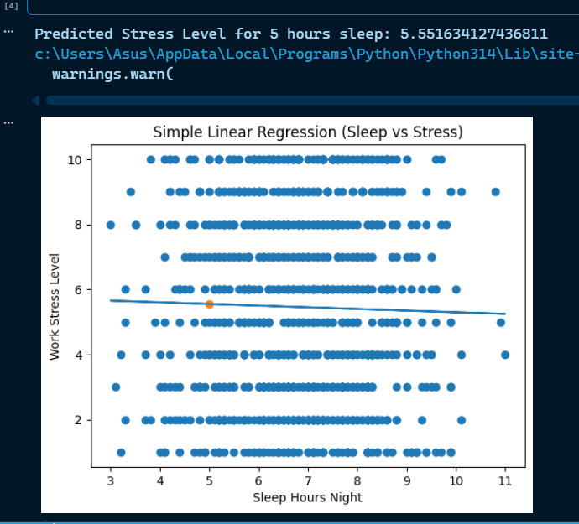
For the Multiple Linear Regression model, performance was evaluated using the R² Score. This model used multiple input features such as sleep hours, work hours, screen time, and social media usage to predict stress levels. Although multiple factors were considered, the R² score remained very low, indicating that these variables are not sufficient to explain the variation in stress levels. An Actual vs Predicted scatter plot was also created to visually compare the model’s predictions with actual values.
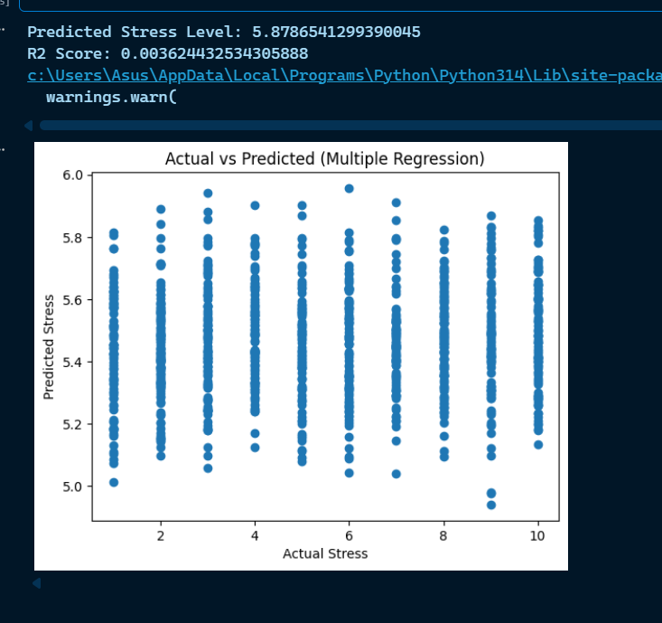
For the Logistic Regression model, evaluation was performed using accuracy score. The model was trained to classify whether a person has a mental health issue (0 or 1). After splitting the dataset into training and testing sets, predictions were made and compared with actual values. The model achieved high accuracy, indicating strong performance in classification tasks. This shows that logistic regression is more suitable for this dataset compared to regression models.
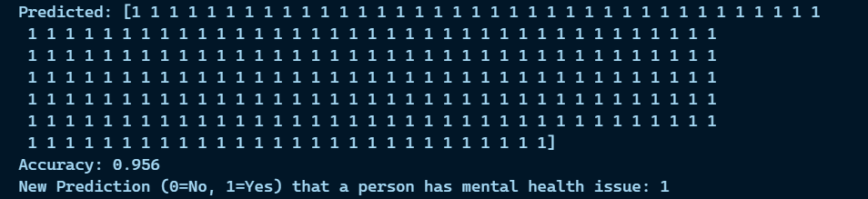
- Model Performance Table
Model | Evaluation Metric | Result | Description
Simple Linear Regression | R² Score | 0.000587(0.06%) | Very poor performance, almost no relationship between variables
Multiple Linear Regression | R² Score | 0.003624(0.36%) | Slight improvement but still very weak model performance
Logistic Regression | Accuracy | 0.956(95.6%) | Excellent performance, model classifies data very accurately

Overall, regression models showed poor performance due to weak relationships between variables, whereas logistic regression performed significantly better in classification tasks.

14. Data visualization
Data visualization is used to represent the dataset in graphical form, making it easier to understand patterns, trends, and relationships between different variables. In this project, various charts and graphs were used to analyze the data and gain meaningful insights.
- Figure: Age Distribution
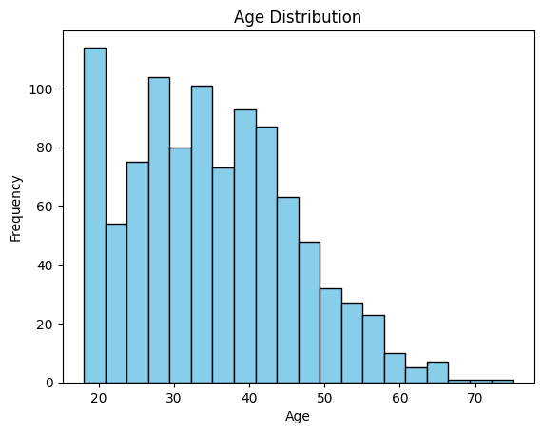
The above graph represents the distribution of age in the dataset.

- Figure: Gender Distribution
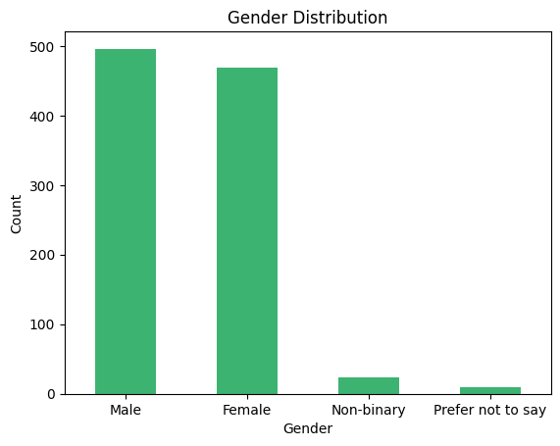
The bar chart shows the distribution of individuals across different gender categories in the dataset.

- Figure: Mental Health Issue Count
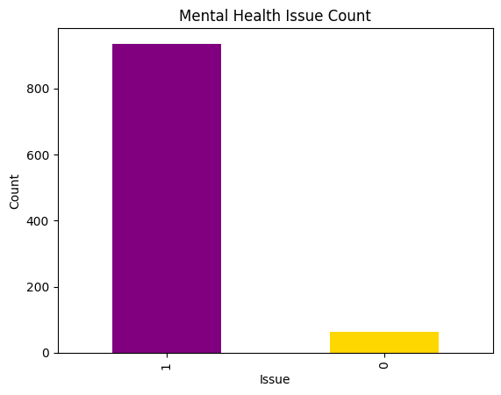
The bar chart shows the count of individuals with and without mental health issues in the dataset.

- Figure: Employee status
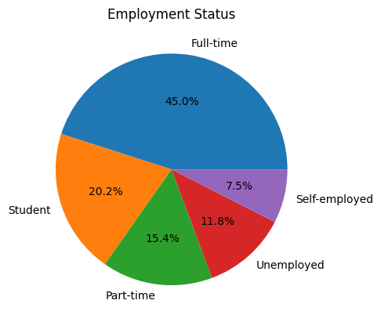
The pie chart shows the percentage distribution of individuals across different employment status categories.

- Figure: Mental health Treatment
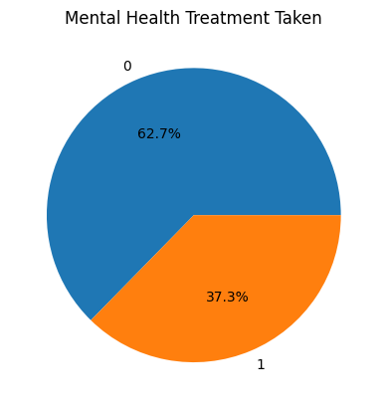
The pie chart shows the proportion of individuals who have and have not sought mental health treatment.
Various additional operations and analyses were carried out as part of the project, but only key outputs and visualizations have been included for better understanding.

Conclusion
This project helped us understand the relationship between lifestyle habits and mental health using real-world data. Through data analysis and machine learning techniques, we explored how factors such as sleep, stress, and daily routines impact mental well-being.
The results showed that regression models did not perform well due to weak relationships between variables, while logistic regression provided high accuracy in classification tasks. This highlights the importance of selecting the right model based on the type of problem.
Overall, this project enhanced our practical knowledge of Python, data analysis, and machine learning. It also increased our awareness of how small lifestyle changes can significantly affect mental health. This knowledge can be useful for individuals and organizations to make better decisions for a healthier life.

Acknowledgment / Thank You
We would like to express our heartfelt gratitude to our guide for their valuable guidance, constant support, and encouragement throughout the development of the Python project.
We are also thankful to our friends and colleagues who provided suggestions and helped us during the project implementation.
Finally, we extend our sincere thanks to our family for their motivation and support, which made the completion of this project possible.
Thank you.

