# Recorded Steps

This file contains all the steps and information that was recorded to help you describe the recorded steps to others.

Before sharing this file, you should verify the following:

* The steps below accurately describe the recording.
* There is no information below or on any screenshots that you do not want others to see.

Passwords or any other text you typed were not recorded, except for function and shortcut keys that you used.

*There were errors during recording. Some information may be missing.*

You can do the following:

* Review the recorded steps
* Review the recorded steps as a slide show
* Review the additional details

# Steps

Previous Next

**Step 1: (‎2/‎21/‎2022 9:21:36 PM)** User mouse wheel down in "Dashboard | EC2 Management Console - Google Chrome"

*No screenshots were saved for this step.*

Previous Next

**Step 2: (‎2/‎21/‎2022 9:22:08 PM)** User left click in "Launch instance wizard | EC2 Management Console - Google Chrome"

*No screenshots were saved for this step.*

Previous Next

**Step 3: (‎2/‎21/‎2022 9:22:18 PM)** User mouse wheel down in "Launch instance wizard | EC2 Management Console - Google Chrome"

*No screenshots were saved for this step.*

Previous Next

**Step 4: (‎2/‎21/‎2022 9:22:30 PM)** User left click in "Launch instance wizard | EC2 Management Console - Google Chrome"

*No screenshots were saved for this step.*

Previous Next

**Step 5: (‎2/‎21/‎2022 9:22:35 PM)** User keyboard input on "Launch instance wizard | EC2 Management Console - Google Chrome (pane)" in "Launch instance wizard | EC2 Management Console - Google Chrome" [...]

*No screenshots were saved for this step.*

Previous Next

**Step 6: (‎2/‎21/‎2022 9:22:52 PM)** User mouse wheel down in "Launch instance wizard | EC2 Management Console - Google Chrome"

*No screenshots were saved for this step.*

Previous Next

**Step 7: (‎2/‎21/‎2022 9:23:00 PM)** User left click in "Launch instance wizard | EC2 Management Console - Google Chrome"

*No screenshots were saved for this step.*

Previous Next

**Step 8: (‎2/‎21/‎2022 9:23:07 PM)** User left click in "Launch instance wizard | EC2 Management Console - Google Chrome"

*No screenshots were saved for this step.*

Previous Next

**Step 9: (‎2/‎21/‎2022 9:23:13 PM)** User mouse wheel down in "Launch instance wizard | EC2 Management Console - Google Chrome"

*No screenshots were saved for this step.*

Previous Next

**Step 10: (‎2/‎21/‎2022 9:23:13 PM)** User mouse wheel up in "Launch instance wizard | EC2 Management Console - Google Chrome"

*No screenshots were saved for this step.*

Previous Next

**Step 11: (‎2/‎21/‎2022 9:23:16 PM)** User mouse wheel down on "Launch instance wizard | EC2 Management Console (document)" in "Launch instance wizard | EC2 Management Console - Google Chrome"

*No screenshots were saved for this step.*

Previous Next

**Step 12: (‎2/‎21/‎2022 9:23:27 PM)** User left click in "Launch instance wizard | EC2 Management Console - Google Chrome"

*No screenshots were saved for this step.*

Previous Next

**Step 13: (‎2/‎21/‎2022 9:23:29 PM)** User left clicked

*No screenshots were saved for this step.*

Previous Next

**Step 14: (‎2/‎21/‎2022 9:23:38 PM)** User left click on "Move this notification to action center (button)" in "New notification"

*No screenshots were saved for this step.*

Previous Next

**Step 15: (‎2/‎21/‎2022 9:23:39 PM)** User left click in "Launch instance wizard | EC2 Management Console - Google Chrome"

*No screenshots were saved for this step.*

Previous Next

**Step 16: (‎2/‎21/‎2022 9:23:43 PM)** User keyboard input on "Launch instance wizard | EC2 Management Console - Google Chrome (pane)" in "Launch instance wizard | EC2 Management Console - Google Chrome" [... Backspace Backspace Backspace Backspace Backspace Backspace Backspace Backspace Backspace Backspace Backspace Backspace Backspace Backspace Backspace Backspace Backspace Backspace Backspace Backspace Backspace]

*No screenshots were saved for this step.*

Previous Next

**Step 17: (‎2/‎21/‎2022 9:23:59 PM)** User left clicked

*No screenshots were saved for this step.*

Previous Next

**Step 18: (‎2/‎21/‎2022 9:24:02 PM)** User left click on "Launch instance wizard | EC2 Management Console (document)" in "Launch instance wizard | EC2 Management Console - Google Chrome"

*No screenshots were saved for this step.*

Previous Next

**Step 19: (‎2/‎21/‎2022 9:24:03 PM)** User left clicked

*No screenshots were saved for this step.*

Previous Next

**Step 20: (‎2/‎21/‎2022 9:24:07 PM)** User keyboard input on "Launch instance wizard | EC2 Management Console - Google Chrome (pane)" in "Launch instance wizard | EC2 Management Console - Google Chrome" [...]

*No screenshots were saved for this step.*

Previous Next

**Step 21: (‎2/‎21/‎2022 9:24:13 PM)** User left click in "Launch instance wizard | EC2 Management Console - Google Chrome"

*No screenshots were saved for this step.*

Previous Next

**Step 22: (‎2/‎21/‎2022 9:24:16 PM)** User left click in "Launch instance wizard | EC2 Management Console - Google Chrome"

*No screenshots were saved for this step.*

Previous Next

**Step 23: (‎2/‎21/‎2022 9:24:19 PM)** User mouse wheel down in "Launch instance wizard | EC2 Management Console - Google Chrome"

*No screenshots were saved for this step.*

Previous Next

**Step 24: (‎2/‎21/‎2022 9:24:29 PM)** User left click in "Instances | EC2 Management Console - Google Chrome"

*No screenshots were saved for this step.*

Previous Next

**Step 25: (‎2/‎21/‎2022 9:24:40 PM)** User left click in "Instances | EC2 Management Console - Google Chrome"

*No screenshots were saved for this step.*

Previous Next

**Step 26: (‎2/‎21/‎2022 9:24:44 PM)** User left click in "Instances | EC2 Management Console - Google Chrome"

*No screenshots were saved for this step.*

Previous Next

**Step 27: (‎2/‎21/‎2022 9:24:51 PM)** User mouse wheel down in "Instance details | EC2 Management Console - Google Chrome"

*No screenshots were saved for this step.*

Previous Next

**Step 28: (‎2/‎21/‎2022 9:24:53 PM)** User mouse wheel up in "Instance details | EC2 Management Console - Google Chrome"

*No screenshots were saved for this step.*

Previous Next

**Step 29: (‎2/‎21/‎2022 9:25:23 PM)** User left click in "Instance details | EC2 Management Console - Google Chrome"

*No screenshots were saved for this step.*

Previous Next

**Step 30: (‎2/‎21/‎2022 9:25:35 PM)** User left click on "Search Google or type a URL (combo box)" in "New Tab - Google Chrome"

*No screenshots were saved for this step.*

Previous Next

**Step 31: (‎2/‎21/‎2022 9:25:37 PM)** User keyboard input on "New Tab - Google Chrome (pane)" in "New Tab - Google Chrome" [... Enter]

*No screenshots were saved for this step.*

Previous Next

**Step 32: (‎2/‎21/‎2022 9:25:47 PM)** User left click on "ros neotic - Google Search (document)" in "ros neotic - Google Search - Google Chrome"

*No screenshots were saved for this step.*

Previous Next

**Step 33: (‎2/‎21/‎2022 9:25:52 PM)** User mouse wheel down on "noetic - ROS Wiki (document)" in "noetic - ROS Wiki - Google Chrome"

*No screenshots were saved for this step.*

Previous Next

**Step 34: (‎2/‎21/‎2022 9:25:59 PM)** User left click on "noetic - ROS Wiki (document)" in "noetic - ROS Wiki - Google Chrome"

*No screenshots were saved for this step.*

Previous Next

**Step 35: (‎2/‎21/‎2022 9:26:03 PM)** User mouse wheel down on "ROS Noetic Ninjemys Released May, 2020 Latest LTS, supported until May, 2025 Recommended for Ubuntu 20.04 Noetic Ninjemys (item)" in "ROS/Installation - ROS Wiki - Google Chrome"

*No screenshots were saved for this step.*

Previous Next

**Step 36: (‎2/‎21/‎2022 9:26:07 PM)** User left click on "ROS/Installation - ROS Wiki (document)" in "ROS/Installation - ROS Wiki - Google Chrome"

*No screenshots were saved for this step.*

Previous Next

**Step 37: (‎2/‎21/‎2022 9:26:10 PM)** User mouse wheel down on "noetic/Installation - ROS Wiki (document)" in "noetic/Installation - ROS Wiki - Google Chrome"

*No screenshots were saved for this step.*

Previous Next

**Step 38: (‎2/‎21/‎2022 9:26:27 PM)** User mouse wheel up in "Instance details | EC2 Management Console - Google Chrome"

*No screenshots were saved for this step.*

Previous Next

**Step 39: (‎2/‎21/‎2022 9:26:48 PM)** User left click in "Instances | EC2 Management Console - Google Chrome"

*No screenshots were saved for this step.*

Previous Next

**Step 40: (‎2/‎21/‎2022 9:26:52 PM)** User mouse wheel down in "Connect to instance | EC2 Management Console - Google Chrome"

*No screenshots were saved for this step.*

Previous Next

**Step 41: (‎2/‎21/‎2022 9:27:10 PM)** User mouse drag start in "noetic/Installation/Ubuntu - ROS Wiki - Google Chrome"

*No screenshots were saved for this step.*

Previous Next

**Step 42: (‎2/‎21/‎2022 9:27:11 PM)** User mouse drag end on "noetic/Installation/Ubuntu - ROS Wiki (document)" in "noetic/Installation/Ubuntu - ROS Wiki - Google Chrome"

*No screenshots were saved for this step.*

Previous Next

**Step 43: (‎2/‎21/‎2022 9:27:12 PM)** User right click on "noetic/Installation/Ubuntu - ROS Wiki (document)" in "noetic/Installation/Ubuntu - ROS Wiki - Google Chrome"

*No screenshots were saved for this step.*

Previous Next

**Step 44: (‎2/‎21/‎2022 9:27:23 PM)** User keyboard input on "i-00586d90a58b9f27c | EC2 Instance Connect - Google Chrome (pane)" in "i-00586d90a58b9f27c | EC2 Instance Connect - Google Chrome" [... Enter]

*No screenshots were saved for this step.*

Previous Next

**Step 45: (‎2/‎21/‎2022 9:27:36 PM)** User mouse drag start on "noetic/Installation/Ubuntu - ROS Wiki (document)" in "noetic/Installation/Ubuntu - ROS Wiki - Google Chrome"

*No screenshots were saved for this step.*

Previous Next

**Step 46: (‎2/‎21/‎2022 9:27:39 PM)** User mouse drag end on "noetic/Installation/Ubuntu - ROS Wiki (document)" in "noetic/Installation/Ubuntu - ROS Wiki - Google Chrome"

*No screenshots were saved for this step.*

Previous Next

**Step 47: (‎2/‎21/‎2022 9:27:46 PM)** User keyboard input on "i-00586d90a58b9f27c | EC2 Instance Connect - Google Chrome (pane)" in "i-00586d90a58b9f27c | EC2 Instance Connect - Google Chrome" [... Ctrl-V Enter Ctrl-V Enter]

*No screenshots were saved for this step.*

Previous Next

**Step 48: (‎2/‎21/‎2022 9:28:55 PM)** User left click on "i-00586d90a58b9f27c | EC2 Instance Connect - Google Chrome (pane)" in "i-00586d90a58b9f27c | EC2 Instance Connect - Google Chrome"

*No screenshots were saved for this step.*

Previous Next

**Step 49: (‎2/‎21/‎2022 9:29:09 PM)** User mouse drag end on "noetic/Installation/Ubuntu - ROS Wiki (document)" in "noetic/Installation/Ubuntu - ROS Wiki - Google Chrome"

*No screenshots were saved for this step.*

Previous Next

**Step 50: (‎2/‎21/‎2022 9:29:14 PM)** User mouse drag end on "noetic/Installation/Ubuntu - ROS Wiki (document)" in "noetic/Installation/Ubuntu - ROS Wiki - Google Chrome"

*No screenshots were saved for this step.*

Previous Next

**Step 51: (‎2/‎21/‎2022 9:29:19 PM)** User left click on "noetic/Installation/Ubuntu - ROS Wiki - Google Chrome (pane)" in "noetic/Installation/Ubuntu - ROS Wiki - Google Chrome"

*No screenshots were saved for this step.*

Previous Next

**Step 52: (‎2/‎21/‎2022 9:29:22 PM)** User keyboard input on "i-00586d90a58b9f27c | EC2 Instance Connect - Google Chrome (pane)" in "i-00586d90a58b9f27c | EC2 Instance Connect - Google Chrome" [... Ctrl-V Enter ... Enter]

*No screenshots were saved for this step.*

Previous Next

**Step 53: (‎2/‎21/‎2022 9:34:25 PM)** User left click on "Move this notification to action center (button)" in "New notification"

*No screenshots were saved for this step.*

Previous Next

**Step 54: (‎2/‎21/‎2022 9:34:35 PM)** User left click on "somehost (document)" in "i-00586d90a58b9f27c | EC2 Instance Connect - Google Chrome"

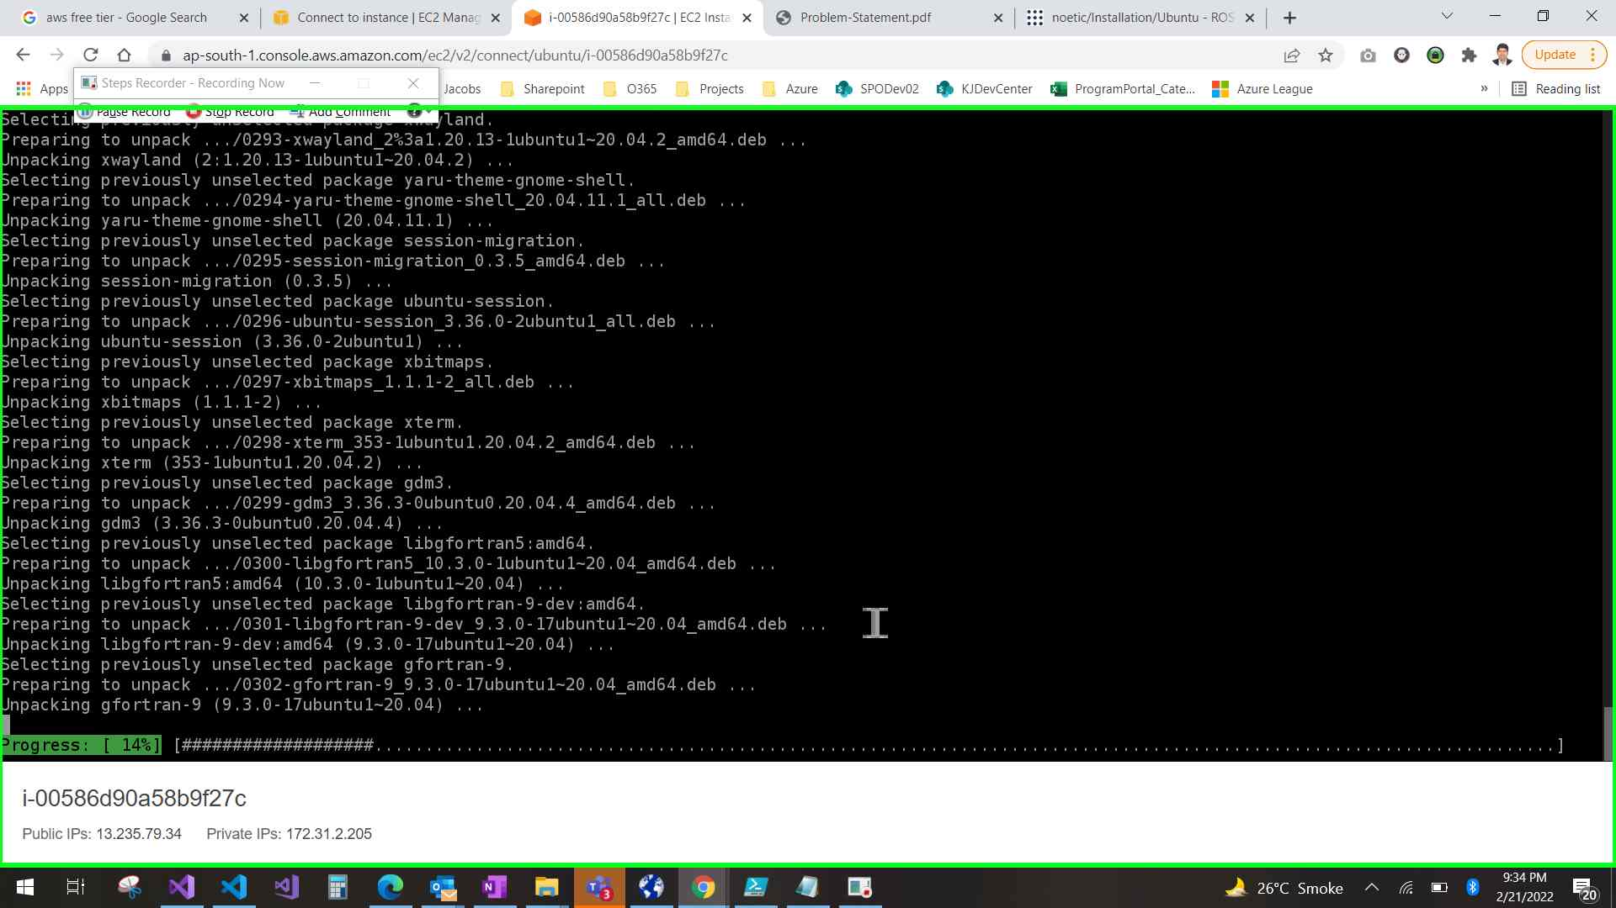Step 54 screenshot.

Previous Next

**Step 55: (‎2/‎21/‎2022 9:39:00 PM)** User left click on "somehost (document)" in "i-00586d90a58b9f27c | EC2 Instance Connect - Google Chrome"

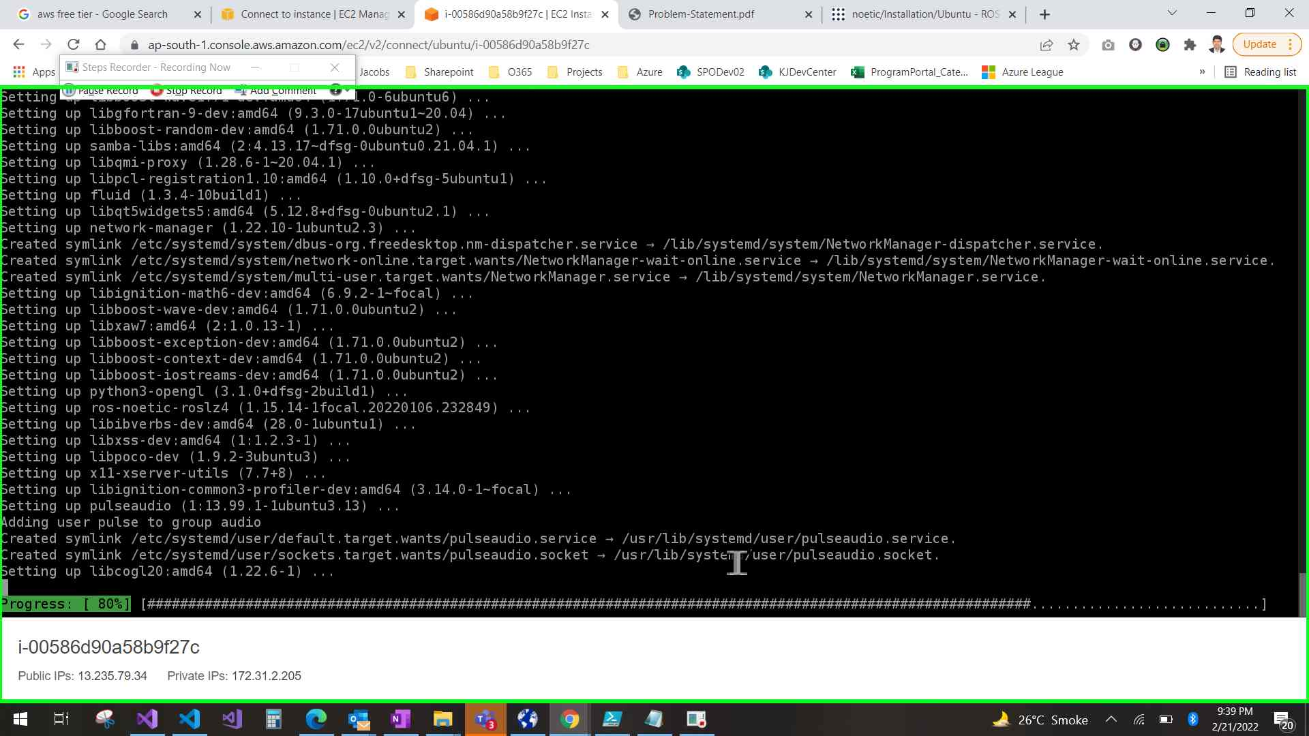Step 55 screenshot.

Previous Next

**Step 56: (‎2/‎21/‎2022 9:41:19 PM)** User left click on "i-00586d90a58b9f27c | EC2 Instance Connect - Google Chrome (pane)" in "i-00586d90a58b9f27c | EC2 Instance Connect - Google Chrome"

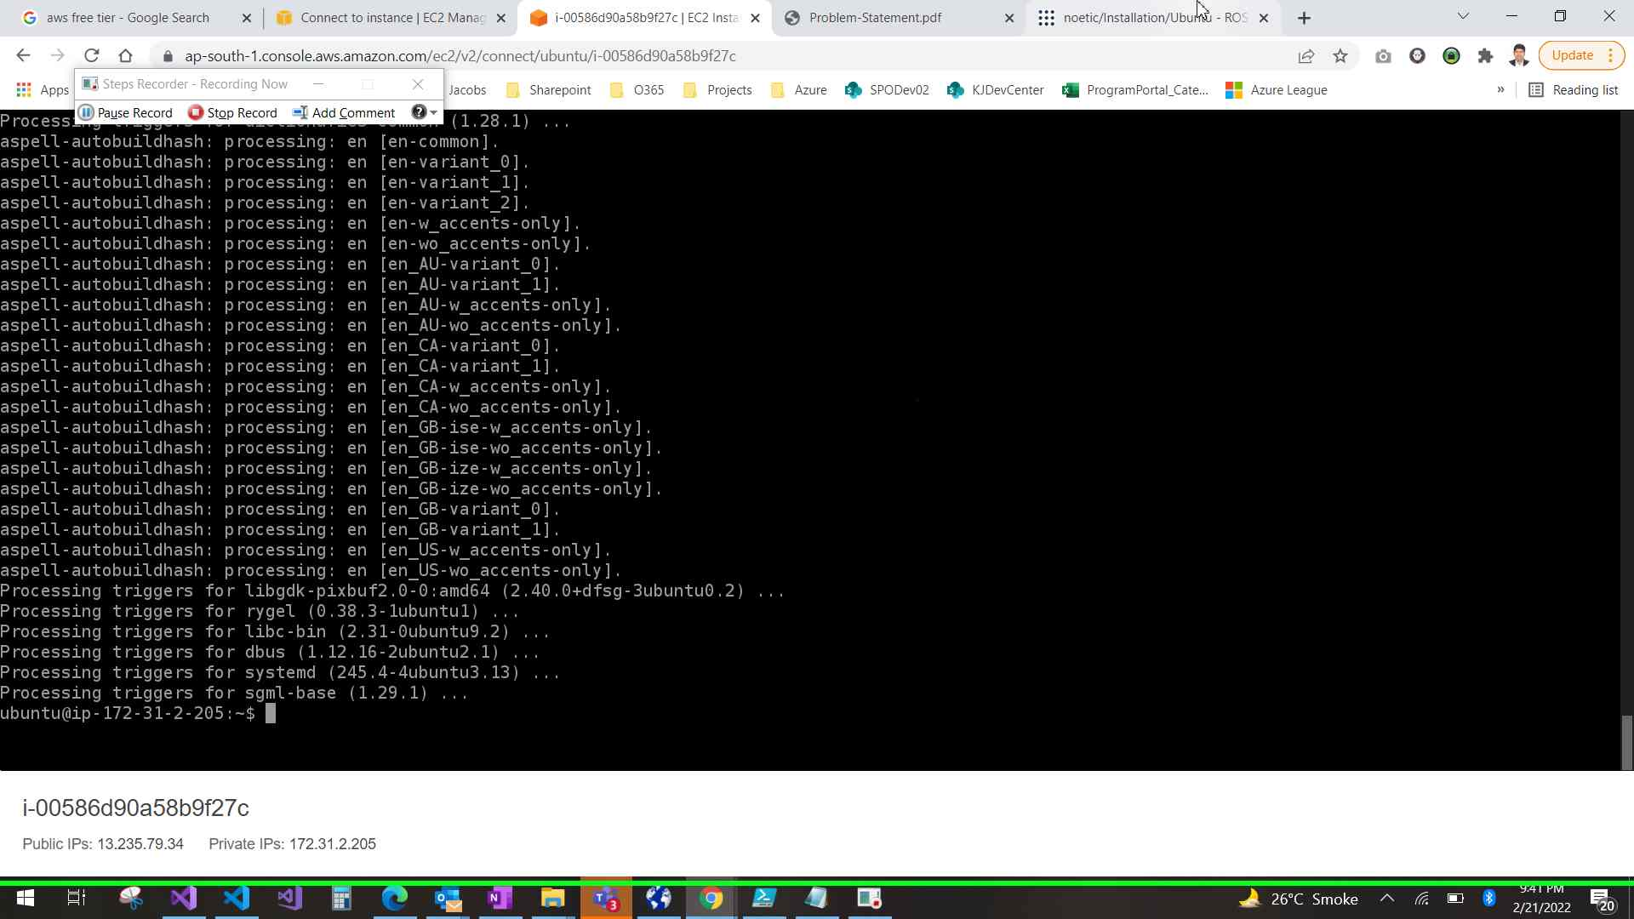Step 56 screenshot.

Previous Next

**Step 57: (‎2/‎21/‎2022 9:41:38 PM)** User left click on "noetic/Installation/Ubuntu - ROS Wiki (document)" in "noetic/Installation/Ubuntu - ROS Wiki - Google Chrome"

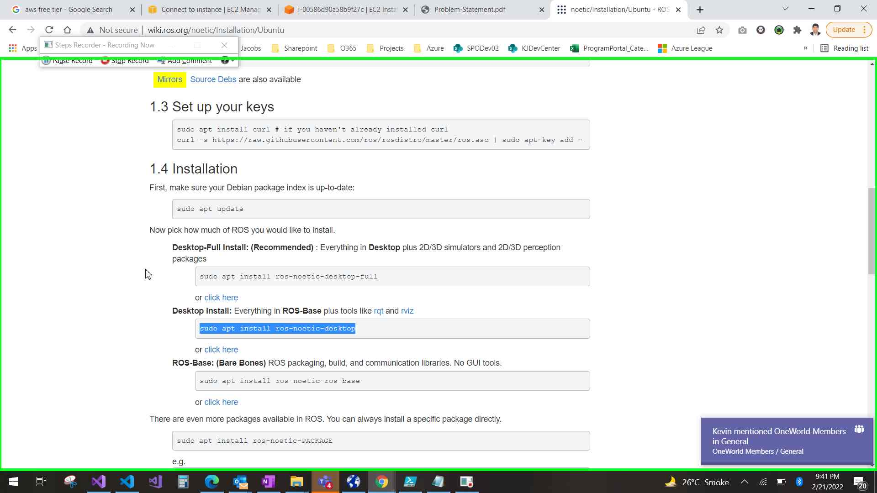Step 57 screenshot.

Previous Next

**Step 58: (‎2/‎21/‎2022 9:41:40 PM)** User mouse wheel down on "noetic/Installation/Ubuntu - ROS Wiki (document)" in "noetic/Installation/Ubuntu - ROS Wiki - Google Chrome"

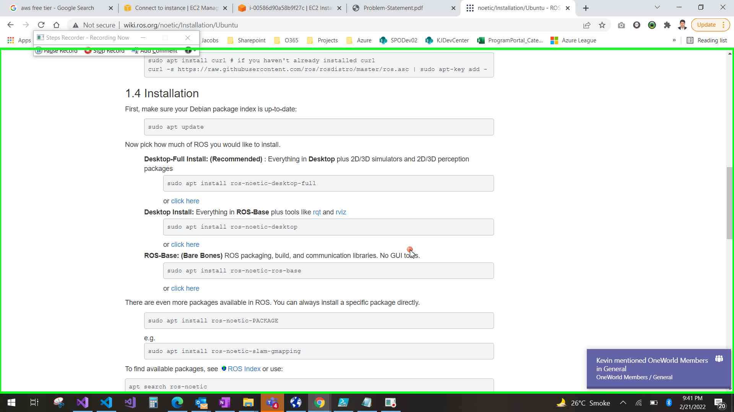Step 58 screenshot.

Previous Next

**Step 59: (‎2/‎21/‎2022 9:42:01 PM)** User mouse wheel up on "noetic/Installation/Ubuntu - ROS Wiki (document)" in "noetic/Installation/Ubuntu - ROS Wiki - Google Chrome"

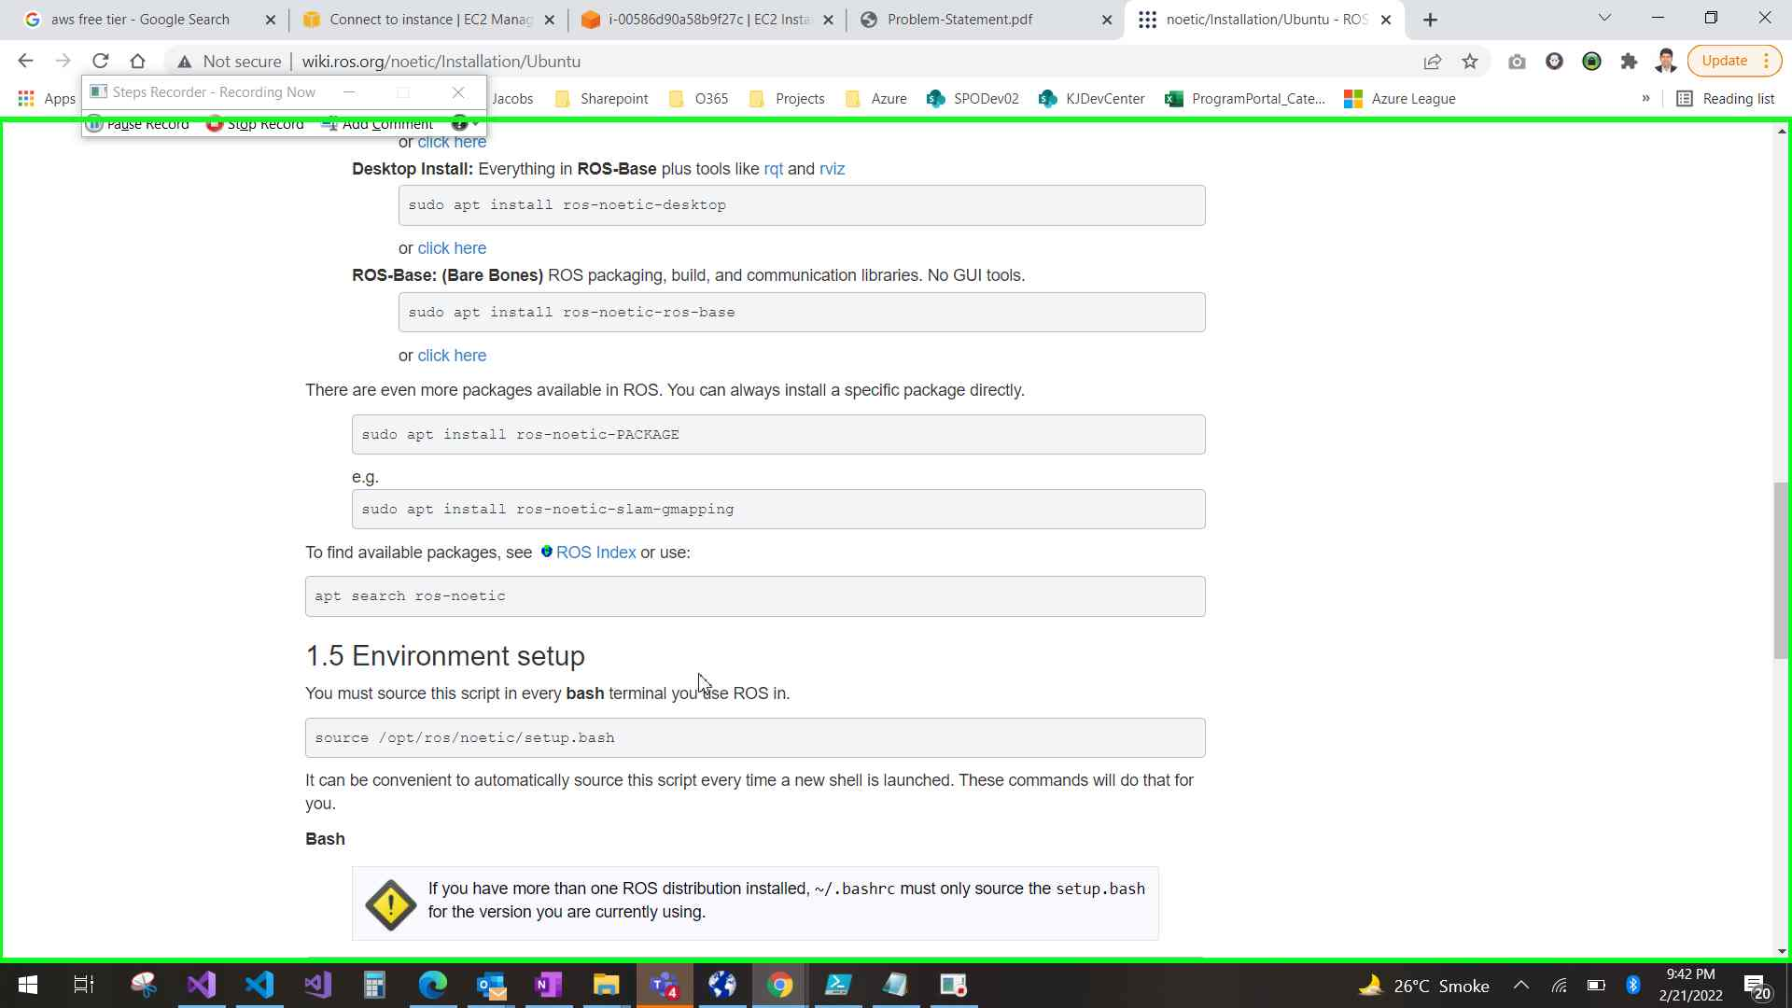Step 59 screenshot.

Previous Next

**Step 60: (‎2/‎21/‎2022 9:42:08 PM)** User left click on "somehost (document)" in "i-00586d90a58b9f27c | EC2 Instance Connect - Google Chrome"

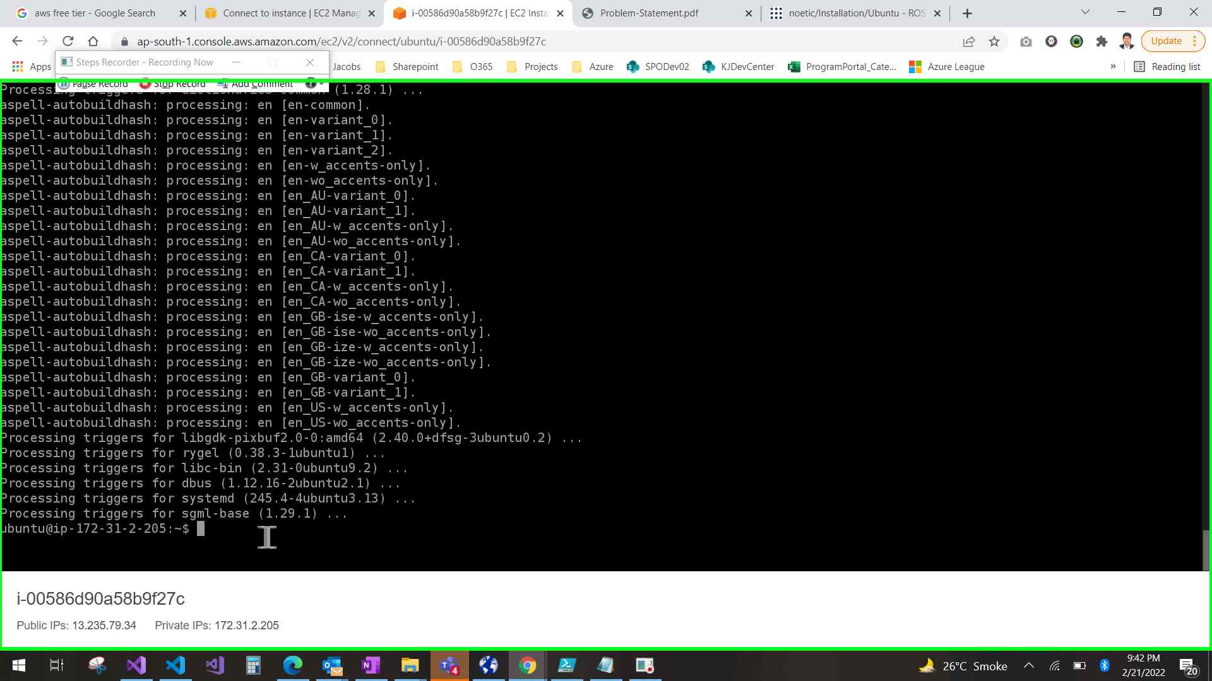Step 60 screenshot.

Previous Next

**Step 61: (‎2/‎21/‎2022 9:42:10 PM)** User keyboard input on "i-00586d90a58b9f27c | EC2 Instance Connect - Google Chrome (pane)" in "i-00586d90a58b9f27c | EC2 Instance Connect - Google Chrome" [... Enter]

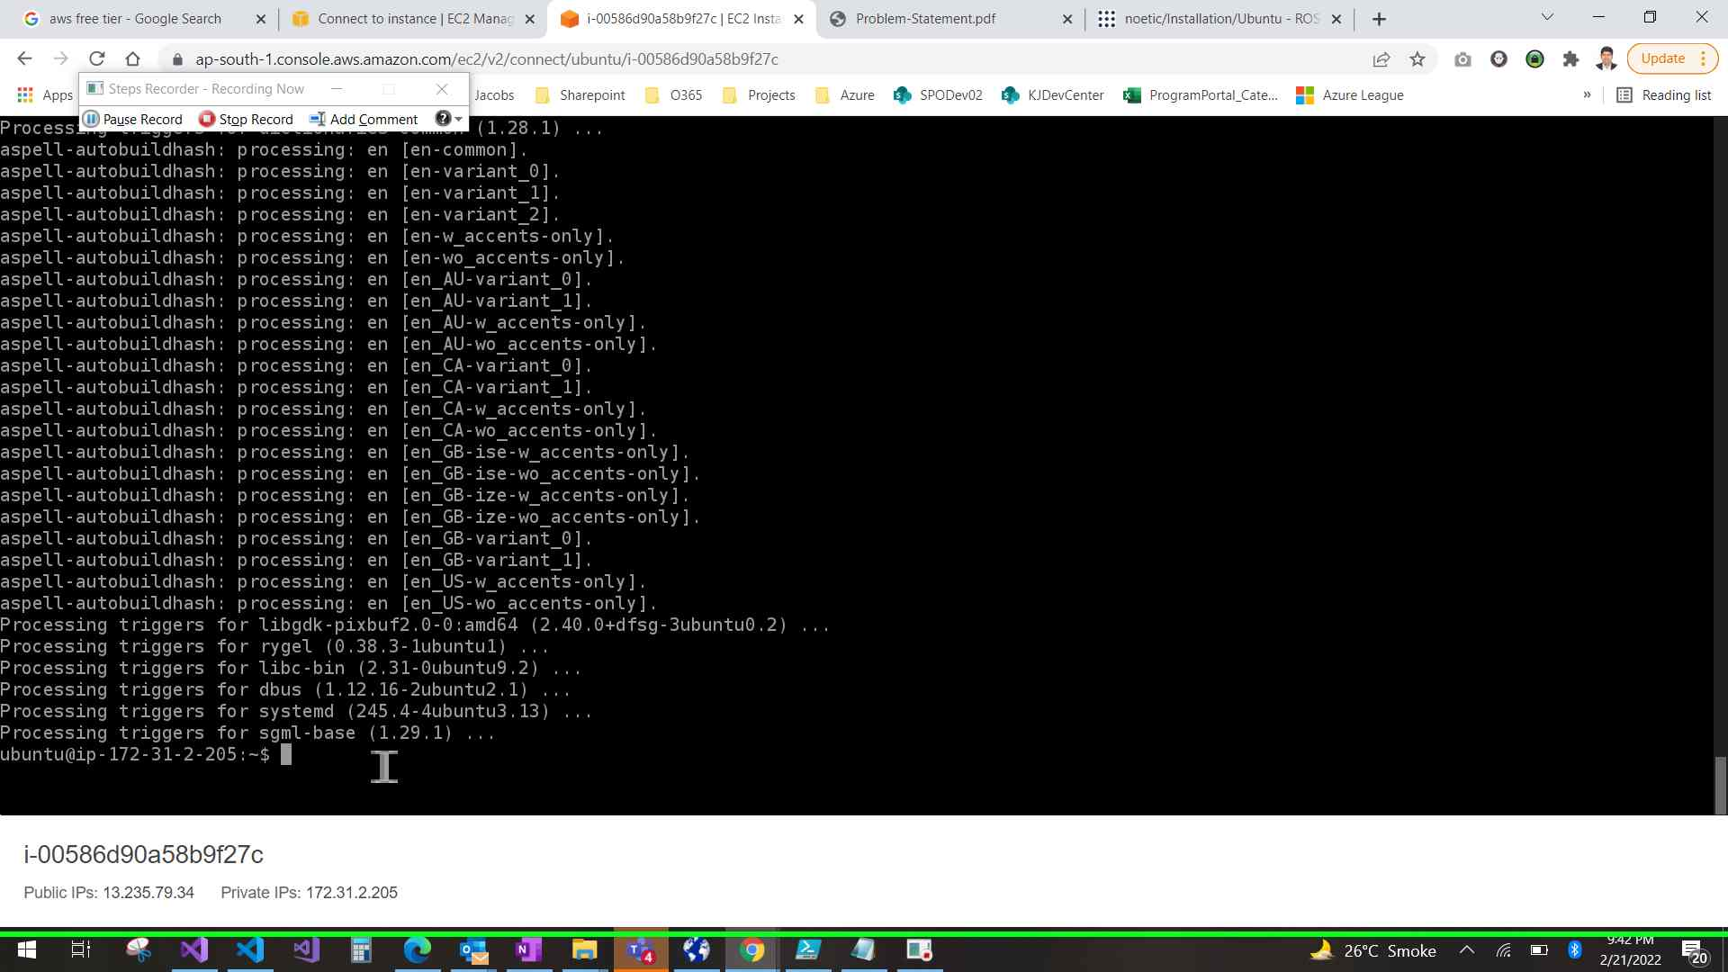Step 61 screenshot.

Previous Next

**Step 62: (‎2/‎21/‎2022 9:42:25 PM)** User left click on "i-00586d90a58b9f27c | EC2 Instance Connect - Google Chrome (pane)" in "i-00586d90a58b9f27c | EC2 Instance Connect - Google Chrome"

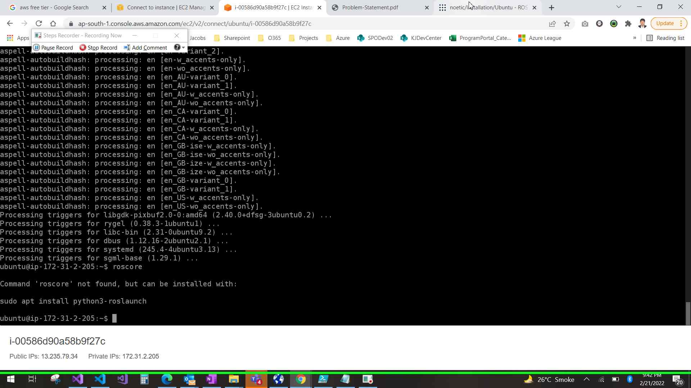Step 62 screenshot.

Previous Next

**Step 63: (‎2/‎21/‎2022 9:42:42 PM)** User mouse wheel down on "noetic/Installation/Ubuntu - ROS Wiki (document)" in "noetic/Installation/Ubuntu - ROS Wiki - Google Chrome"

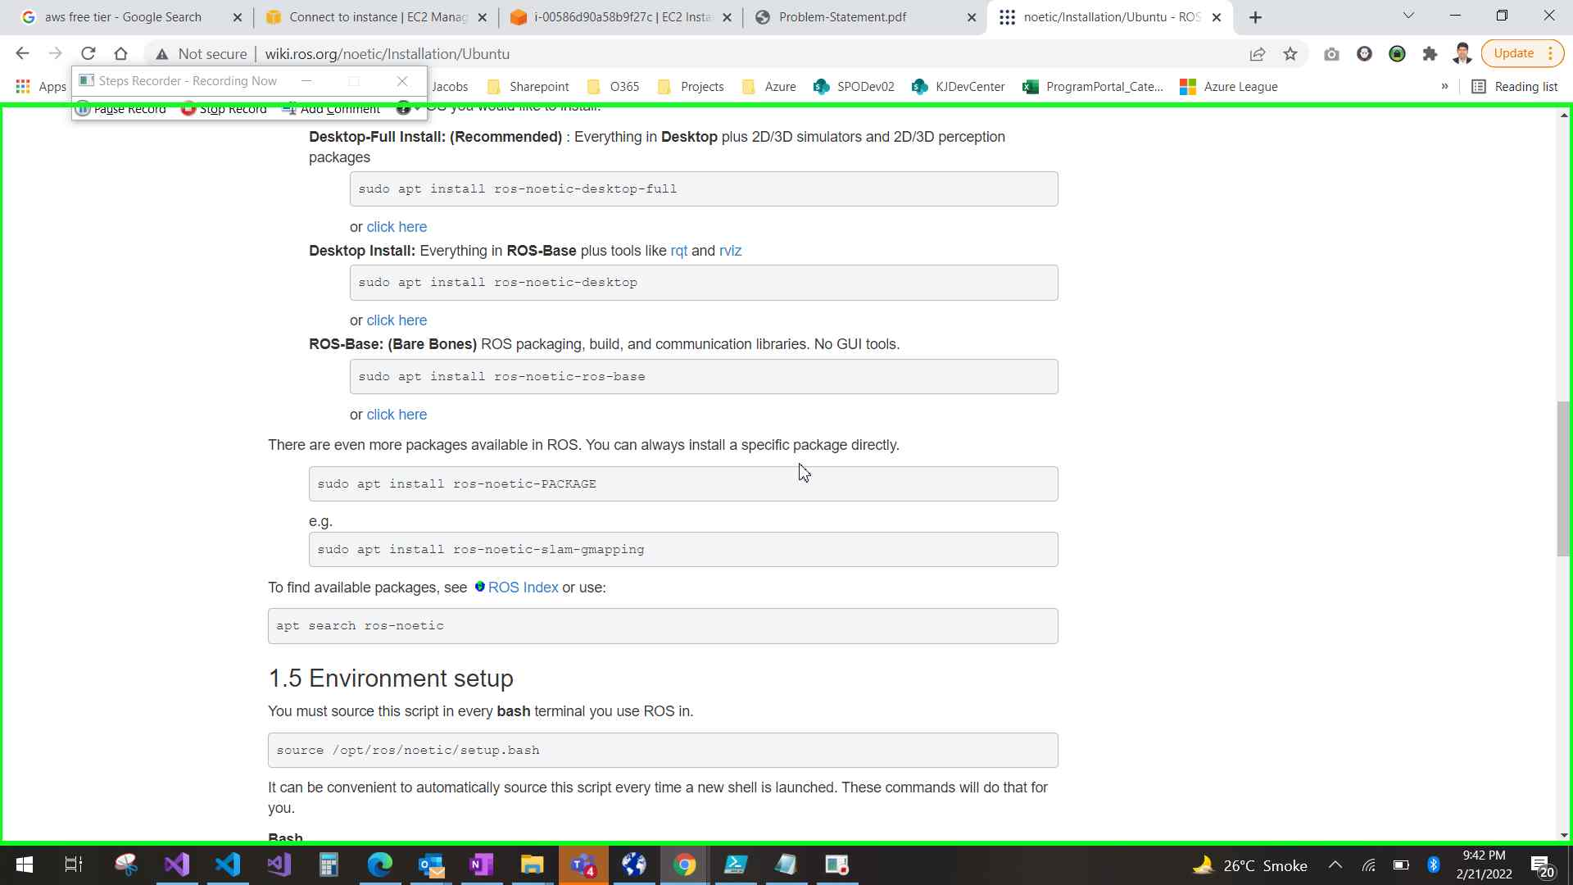Step 63 screenshot.

Previous Next

**Step 64: (‎2/‎21/‎2022 9:42:47 PM)** User mouse drag start on "noetic/Installation/Ubuntu - ROS Wiki (document)" in "noetic/Installation/Ubuntu - ROS Wiki - Google Chrome"

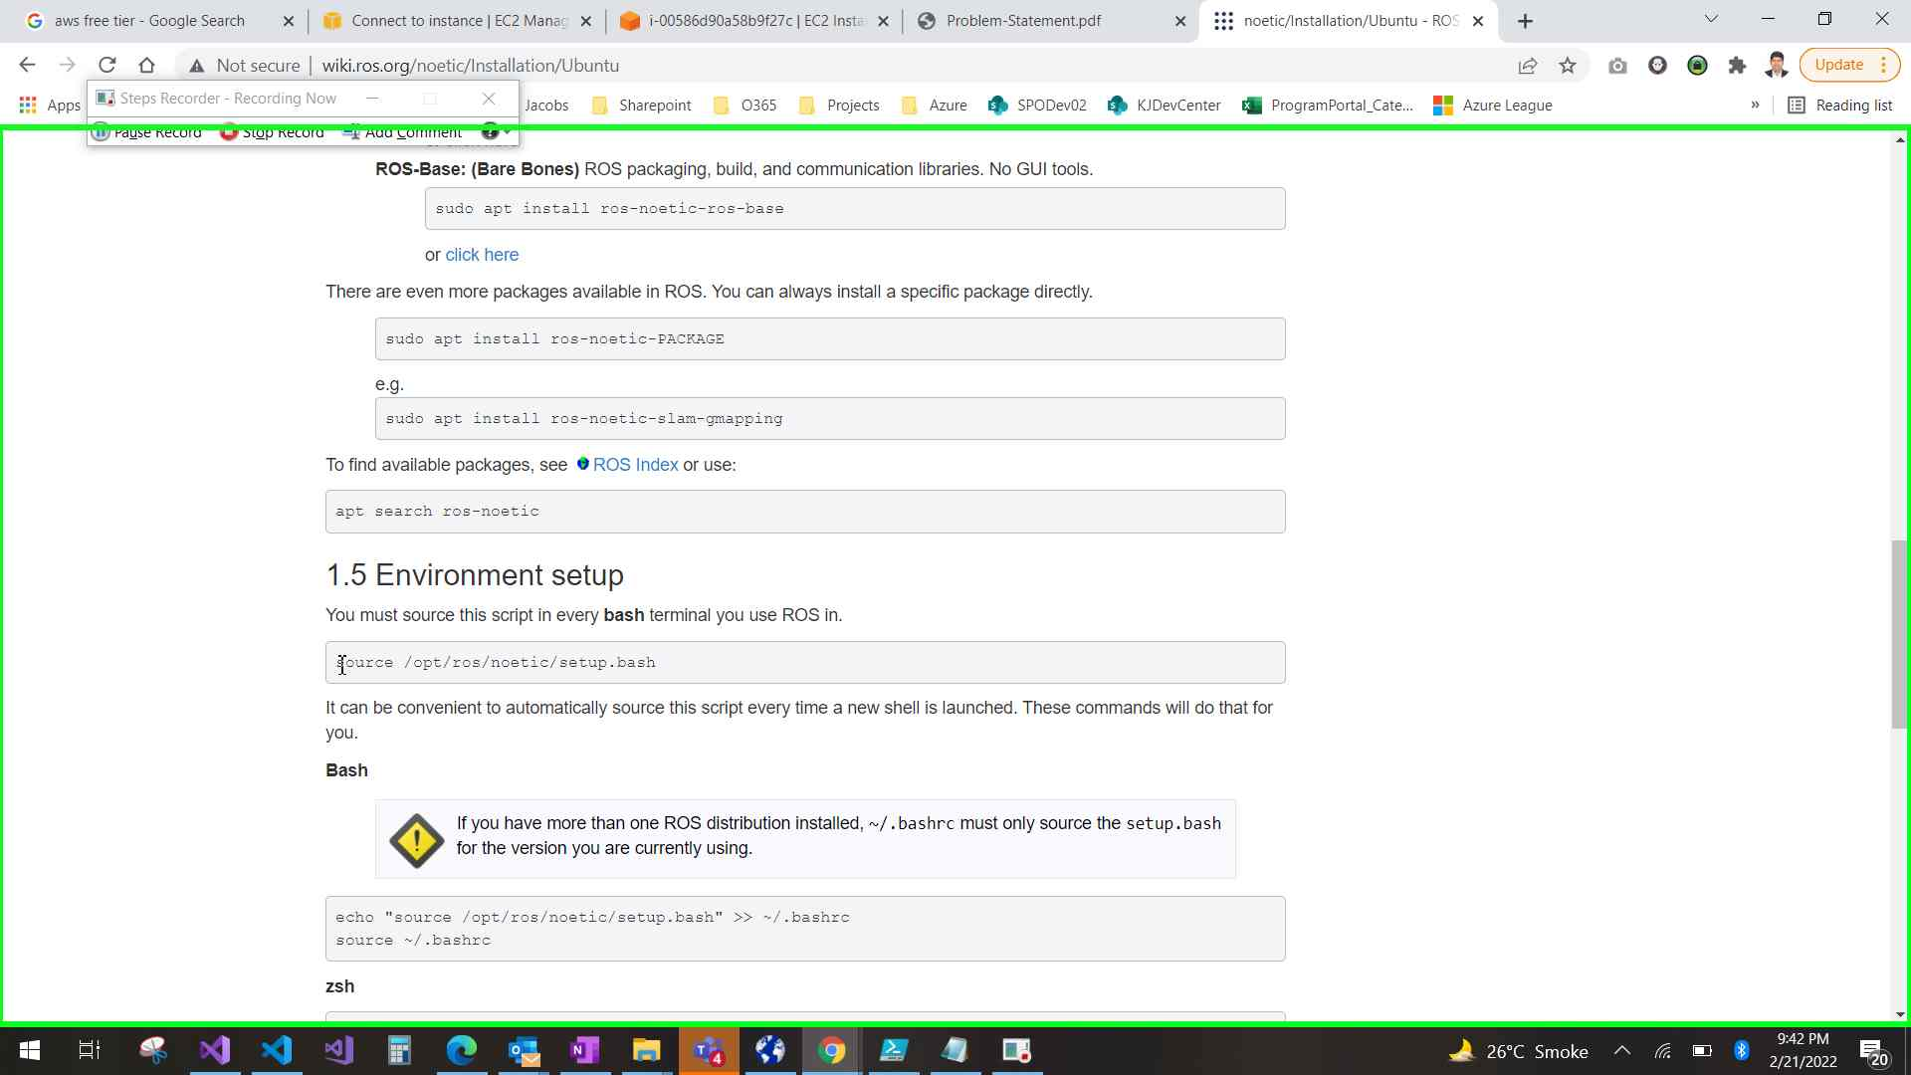Step 64 screenshot.

Previous Next

**Step 65: (‎2/‎21/‎2022 9:42:48 PM)** User mouse drag end on "noetic/Installation/Ubuntu - ROS Wiki (document)" in "noetic/Installation/Ubuntu - ROS Wiki - Google Chrome"

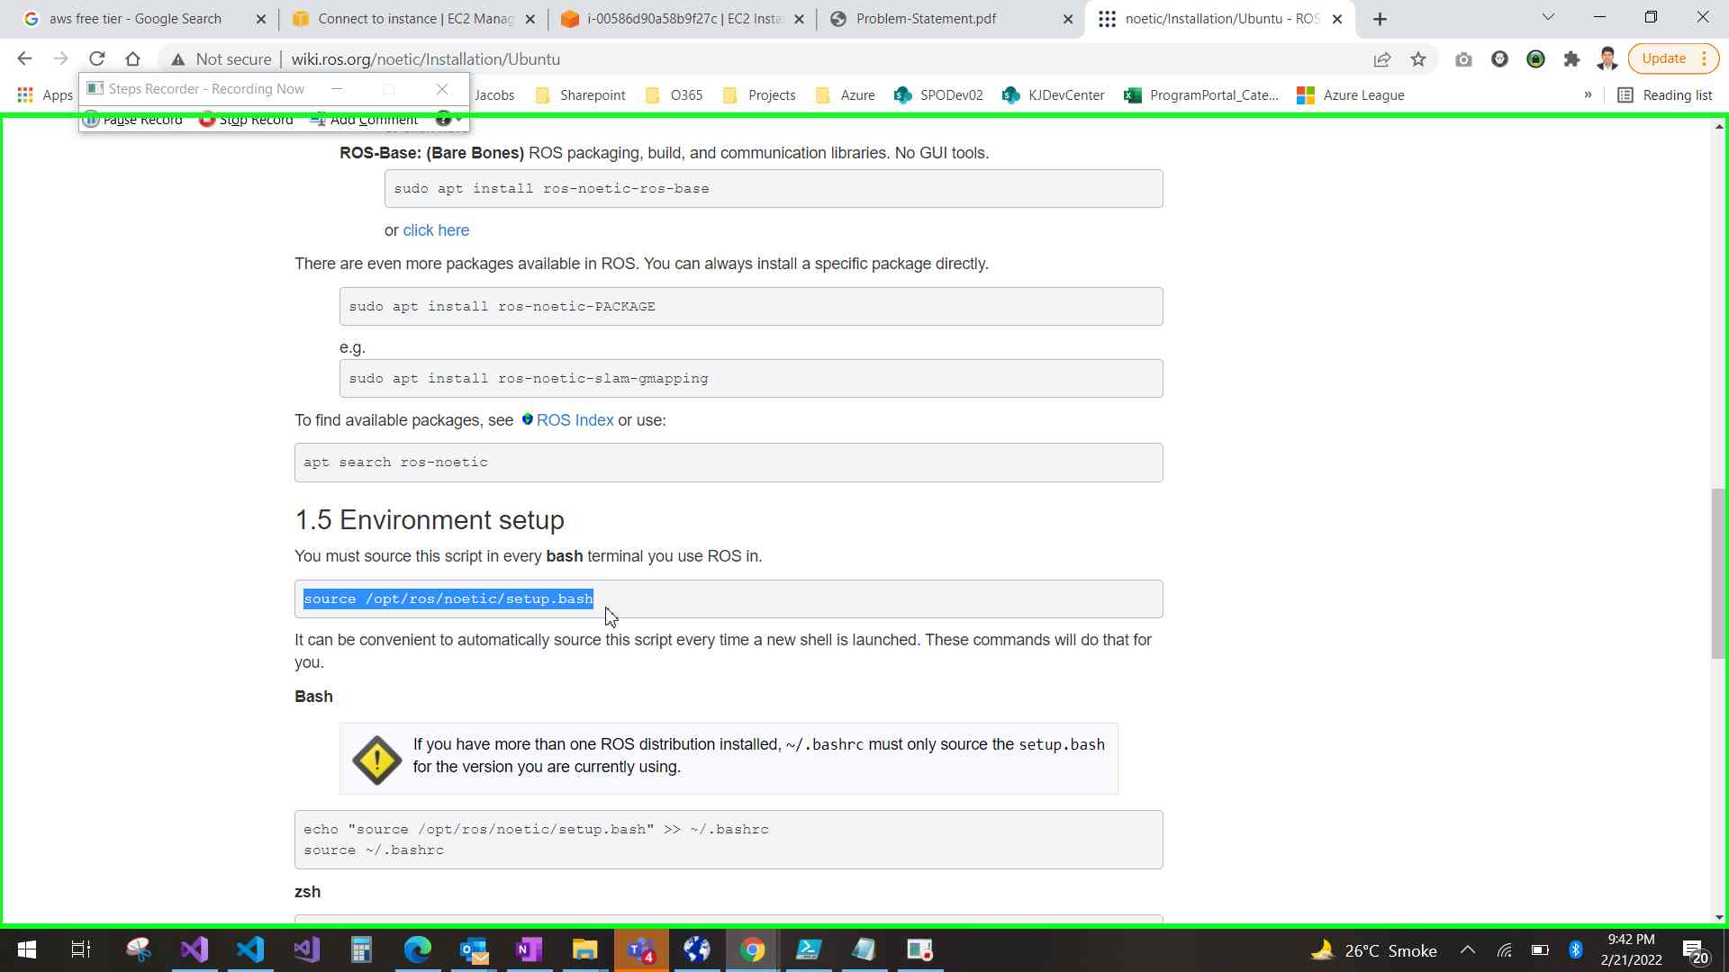Step 65 screenshot.

Previous Next

**Step 66: (‎2/‎21/‎2022 9:42:50 PM)** User left click on "Copy Ctrl+C (menu item)"

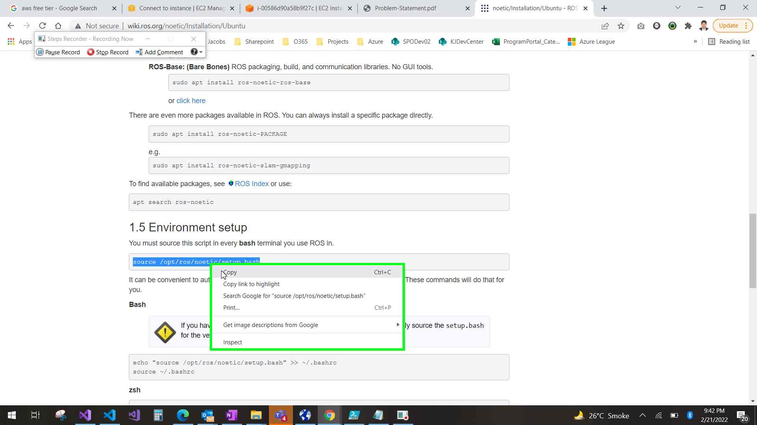Step 66 screenshot.

Previous Next

**Step 67: (‎2/‎21/‎2022 9:42:52 PM)** User left click on "noetic/Installation/Ubuntu - ROS Wiki - Google Chrome (pane)" in "noetic/Installation/Ubuntu - ROS Wiki - Google Chrome"

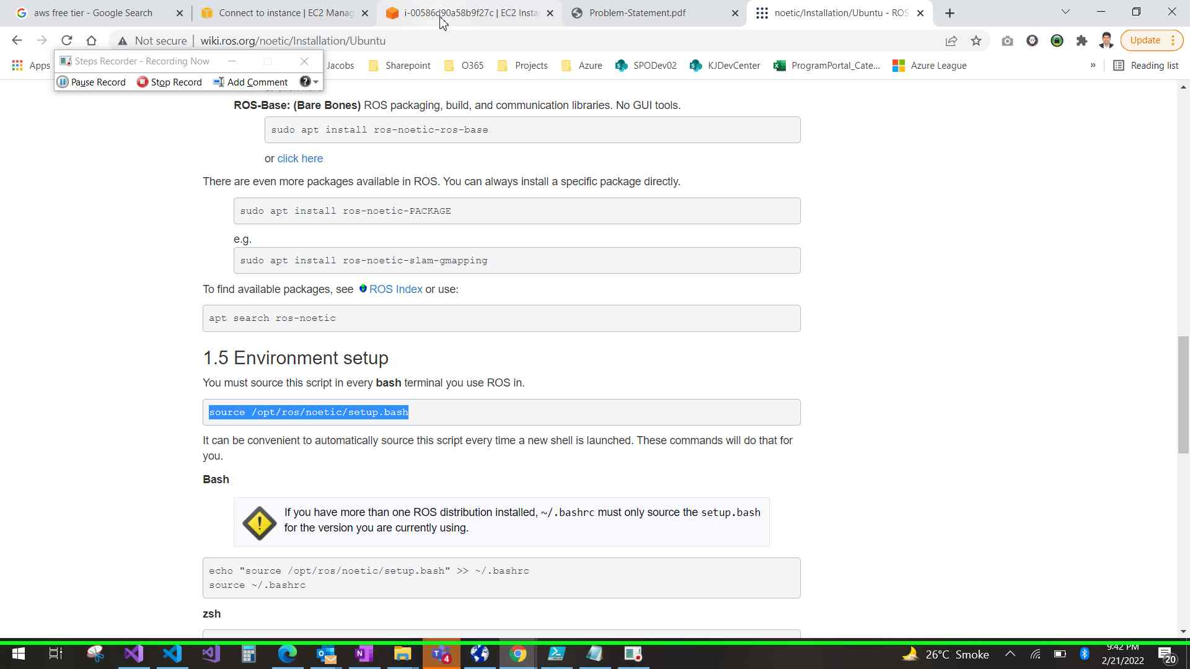Step 67 screenshot.

Previous Next

**Step 68: (‎2/‎21/‎2022 9:42:54 PM)** User keyboard input on "i-00586d90a58b9f27c | EC2 Instance Connect - Google Chrome (pane)" in "i-00586d90a58b9f27c | EC2 Instance Connect - Google Chrome" [... Ctrl-V Enter Backspace ... Enter]

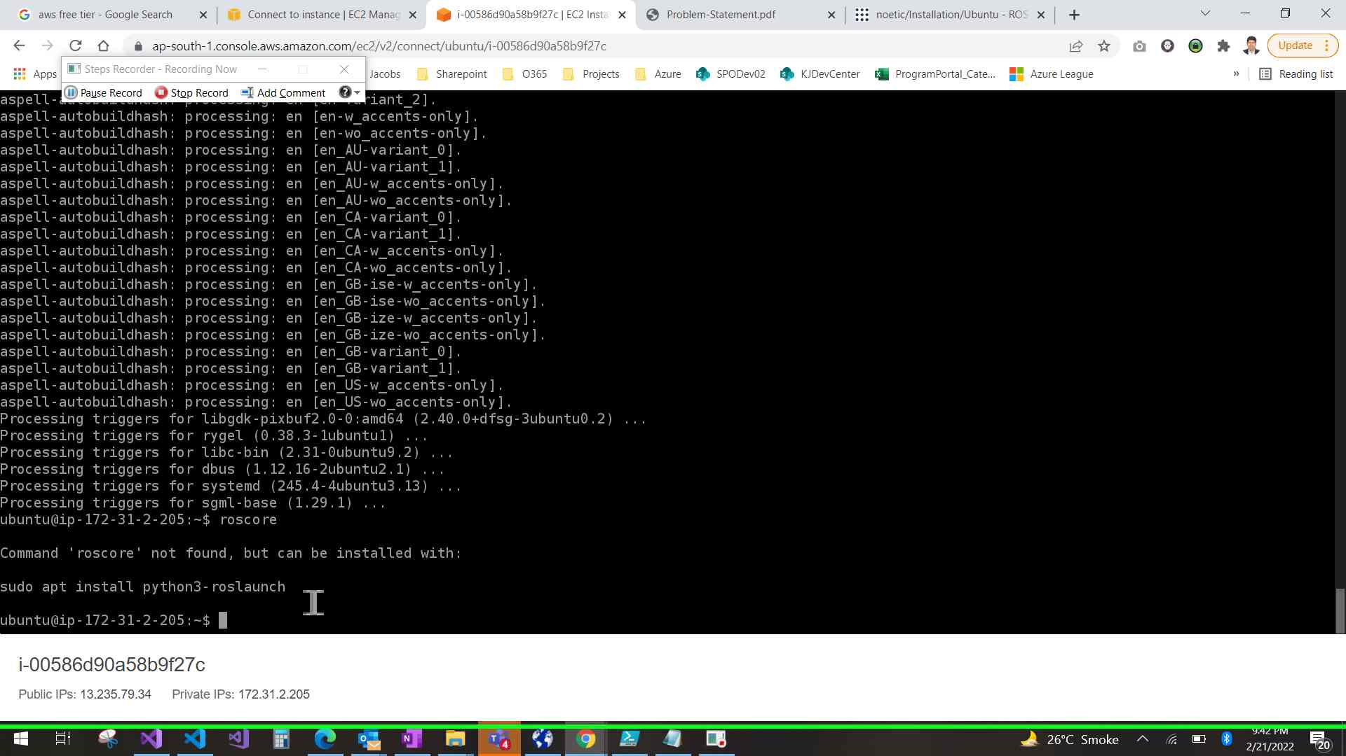Step 68 screenshot.

Previous Next

**Step 69: (‎2/‎21/‎2022 9:43:17 PM)** User left click on "somehost (document)" in "i-00586d90a58b9f27c | EC2 Instance Connect - Google Chrome"

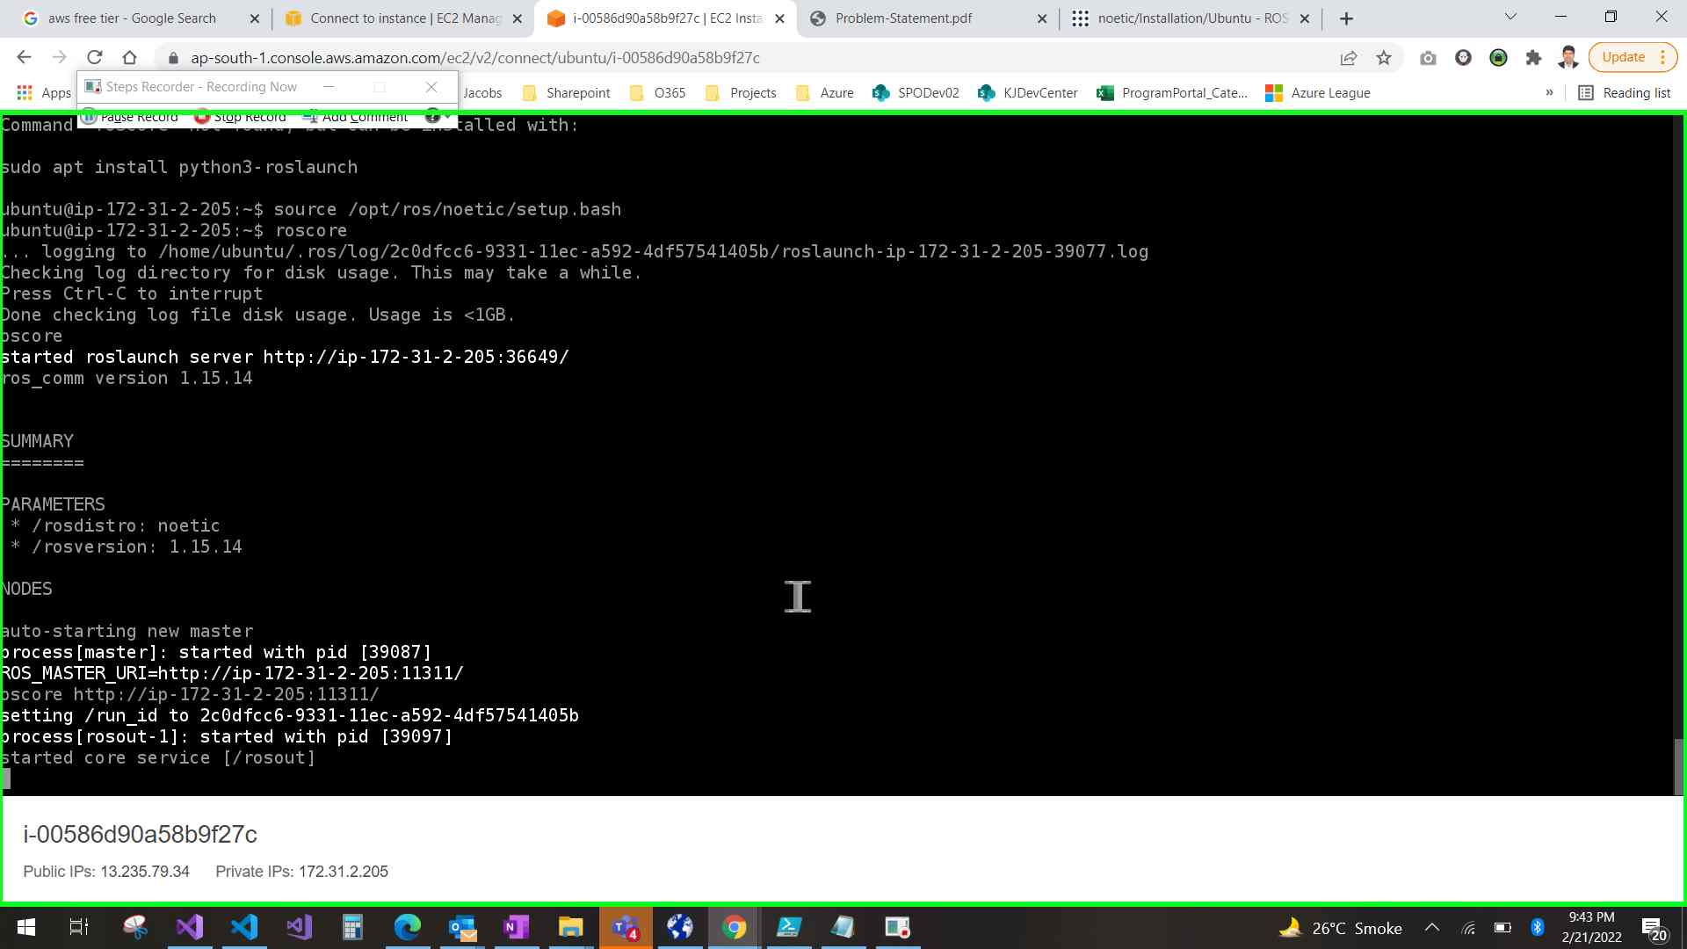Step 69 screenshot.

Previous Next

**Step 70: (‎2/‎21/‎2022 9:43:29 PM)** User mouse wheel up on "somehost (document)" in "i-00586d90a58b9f27c | EC2 Instance Connect - Google Chrome"

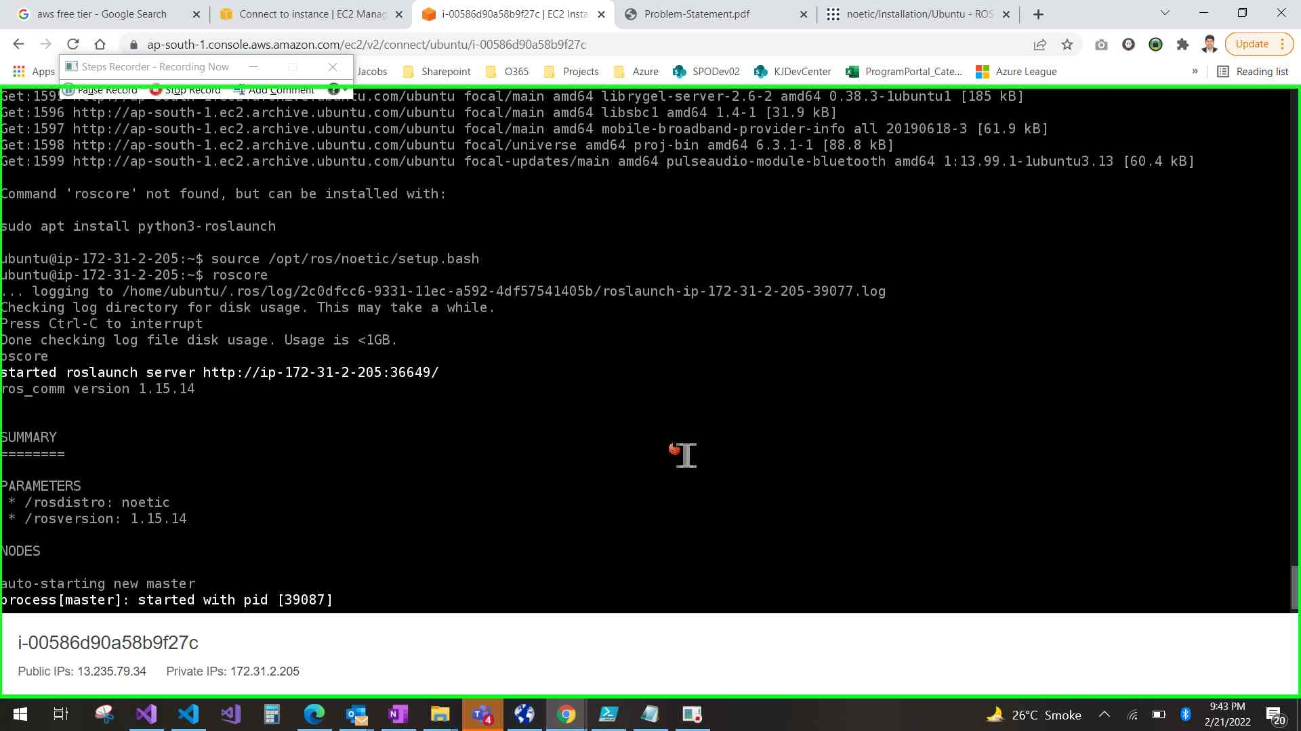Step 70 screenshot.

Previous Next

**Step 71: (‎2/‎21/‎2022 9:43:40 PM)** User mouse wheel down on "somehost (document)" in "i-00586d90a58b9f27c | EC2 Instance Connect - Google Chrome"

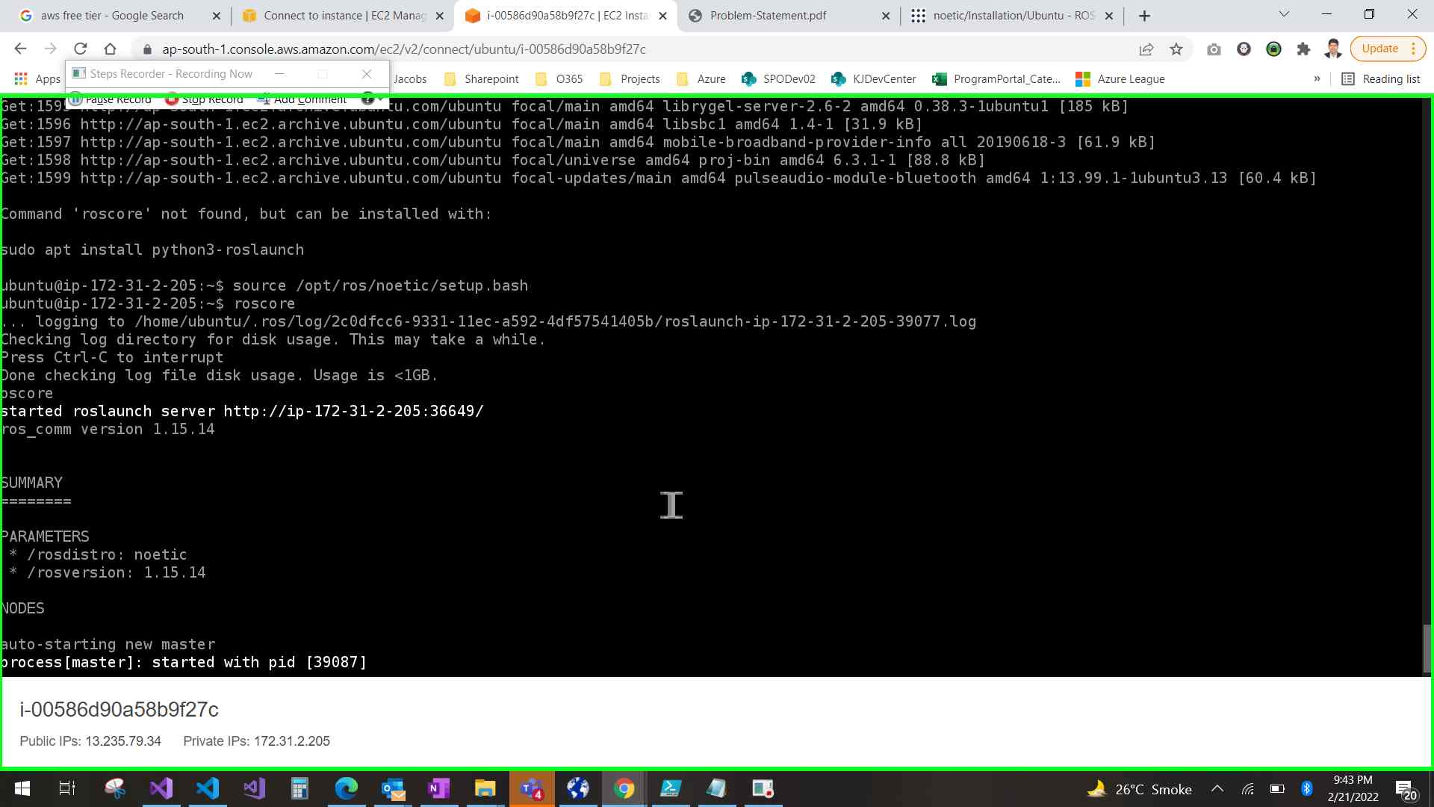Step 71 screenshot.

Previous Next

**Step 72: (‎2/‎21/‎2022 9:44:09 PM)** User left click on "i-00586d90a58b9f27c | EC2 Instance Connect - Google Chrome (pane)" in "i-00586d90a58b9f27c | EC2 Instance Connect - Google Chrome"

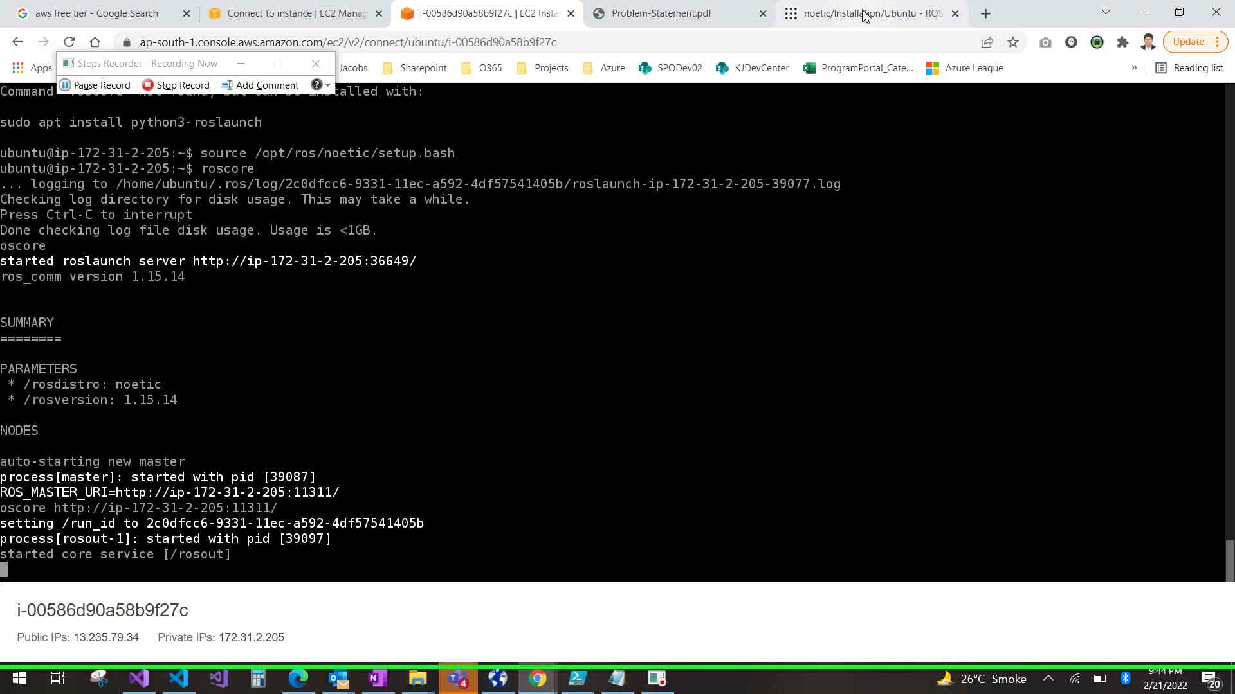Step 72 screenshot.

Previous Next

**Step 73: (‎2/‎21/‎2022 9:44:10 PM)** User mouse wheel down on "noetic/Installation/Ubuntu - ROS Wiki (document)" in "noetic/Installation/Ubuntu - ROS Wiki - Google Chrome"

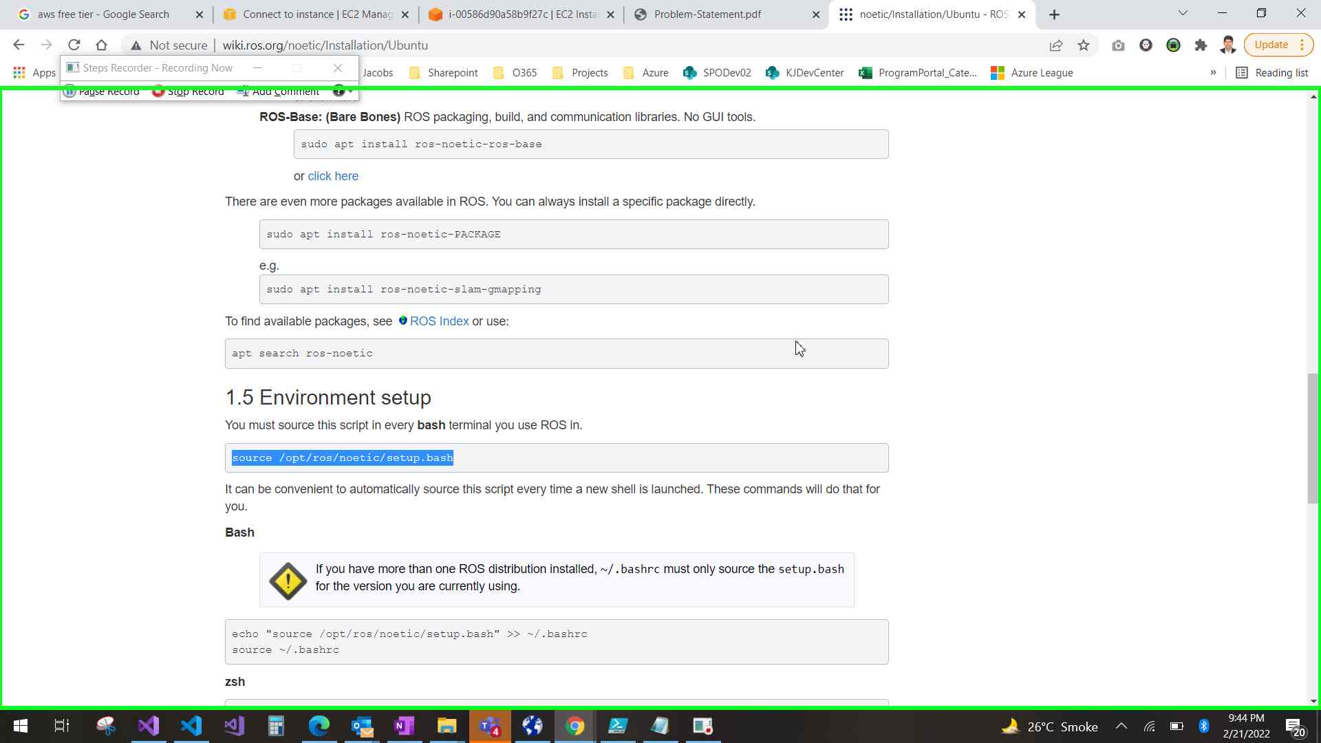Step 73 screenshot.

Previous Next

**Step 74: (‎2/‎21/‎2022 9:44:14 PM)** User mouse wheel up on "noetic/Installation/Ubuntu - ROS Wiki (document)" in "noetic/Installation/Ubuntu - ROS Wiki - Google Chrome"

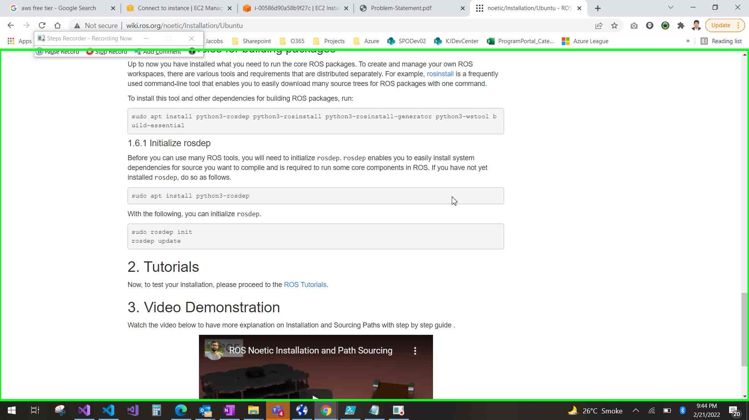Step 74 screenshot.

Previous Next

**Step 75: (‎2/‎21/‎2022 9:44:18 PM)** User mouse wheel down on "noetic/Installation/Ubuntu - ROS Wiki (document)" in "noetic/Installation/Ubuntu - ROS Wiki - Google Chrome"

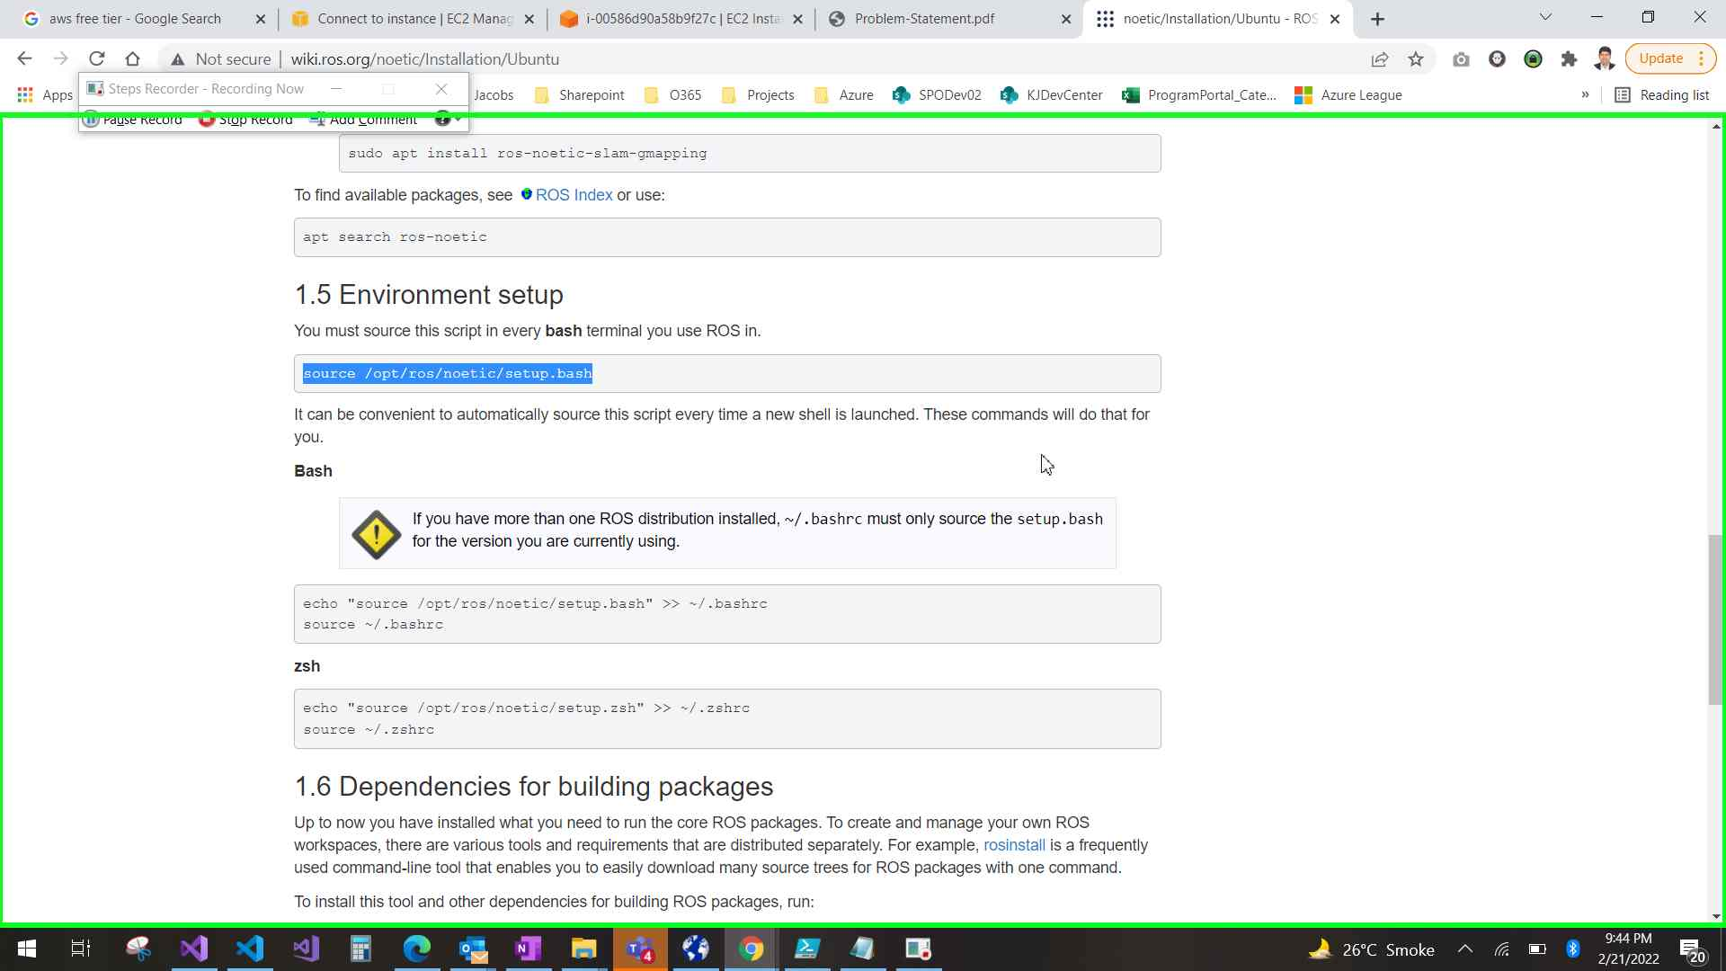Step 75 screenshot.

Previous Next

**Step 76: (‎2/‎21/‎2022 9:44:19 PM)** User mouse wheel up on "noetic/Installation/Ubuntu - ROS Wiki (document)" in "noetic/Installation/Ubuntu - ROS Wiki - Google Chrome"

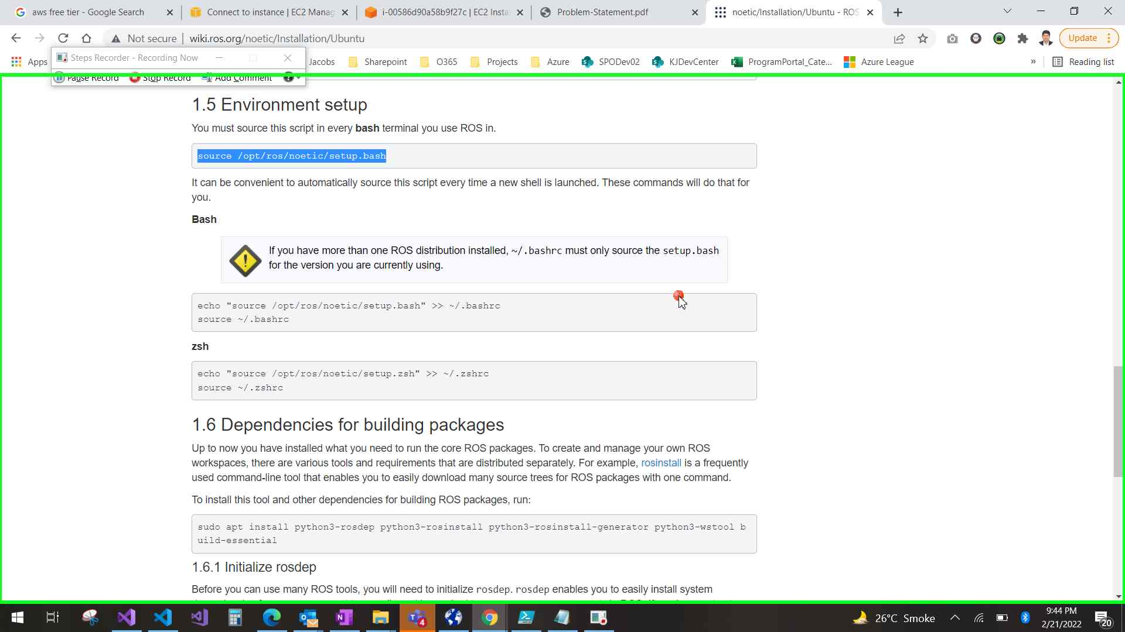Step 76 screenshot.

Previous Next

**Step 77: (‎2/‎21/‎2022 9:44:21 PM)** User left click on "noetic/Installation/Ubuntu - ROS Wiki - Google Chrome (pane)" in "noetic/Installation/Ubuntu - ROS Wiki - Google Chrome"

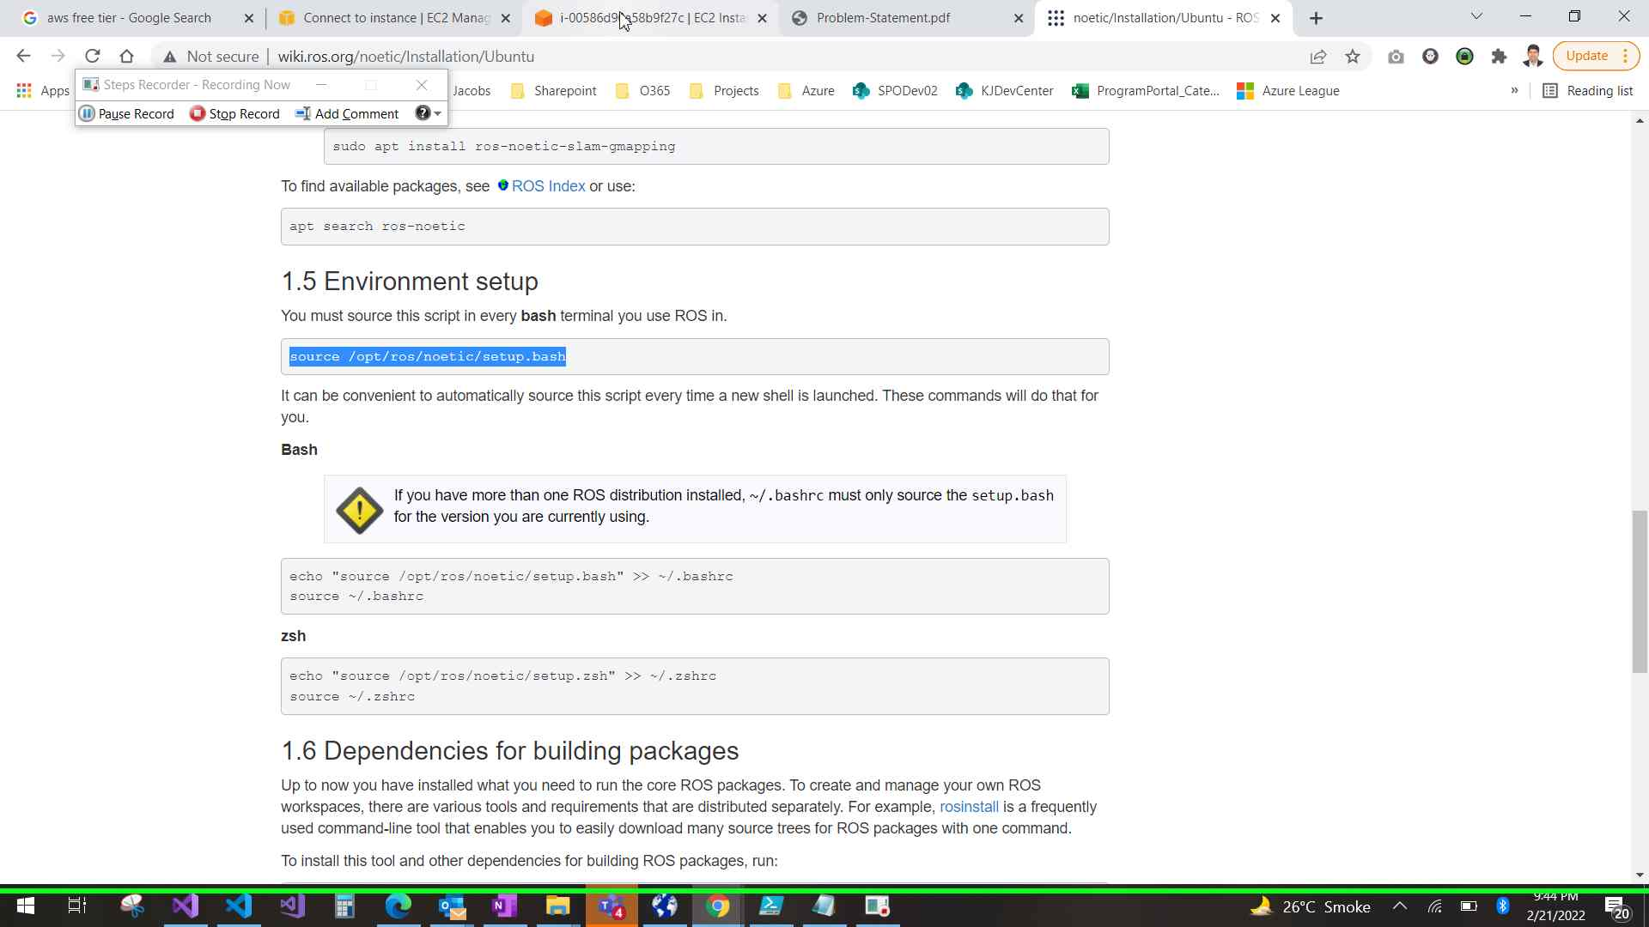Step 77 screenshot.

Previous Next

**Step 78: (‎2/‎21/‎2022 9:44:26 PM)** User keyboard input on "i-00586d90a58b9f27c | EC2 Instance Connect - Google Chrome (pane)" in "i-00586d90a58b9f27c | EC2 Instance Connect - Google Chrome" [... Enter]

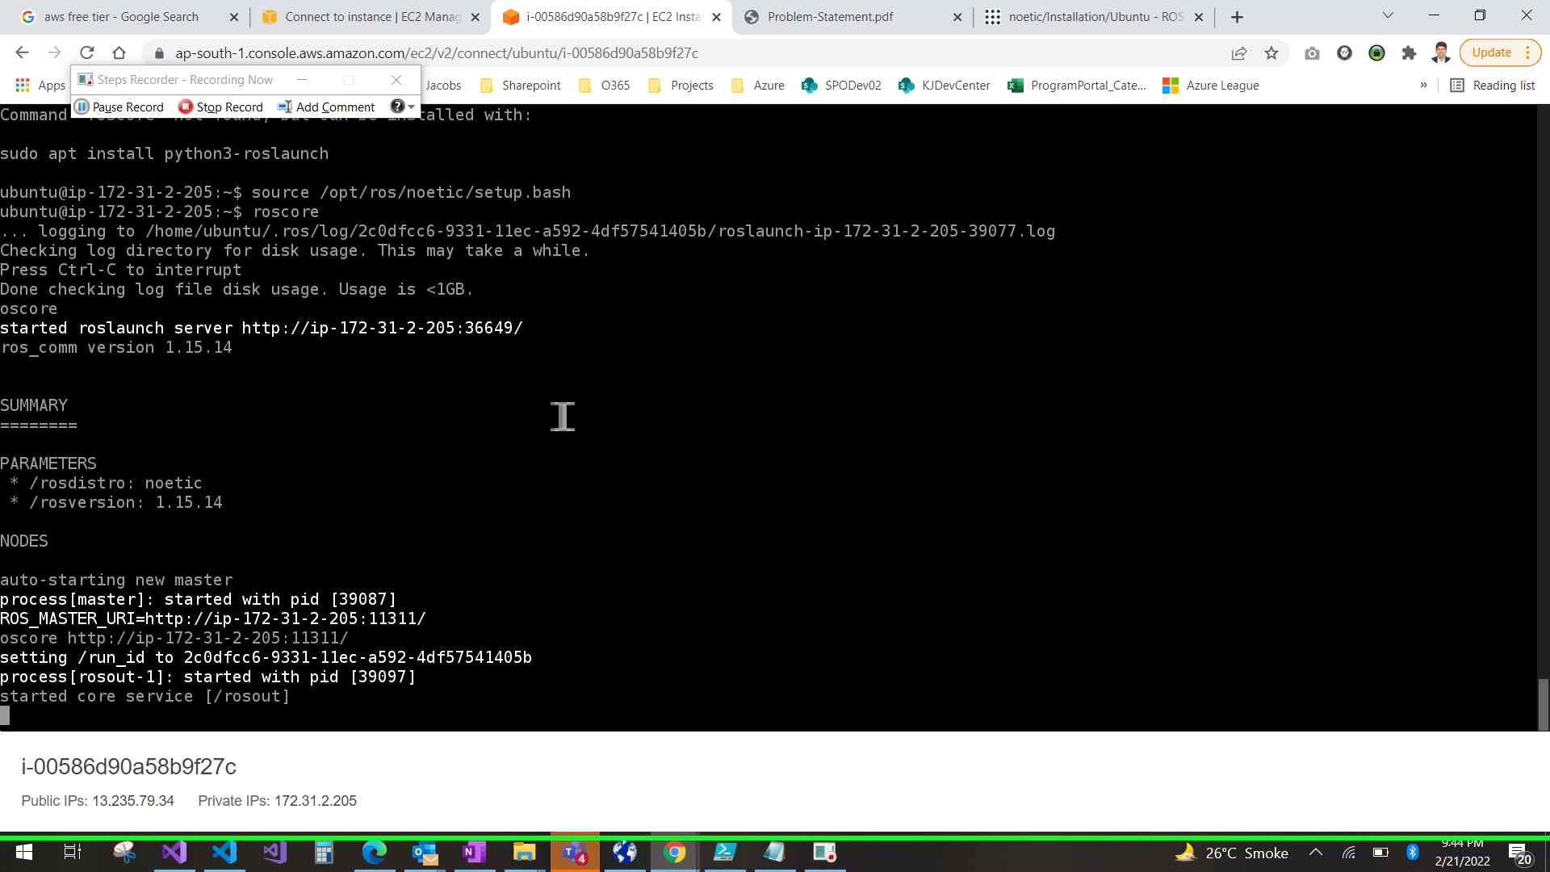Step 78 screenshot.

Return to top of page...

# Additional Details

The following section contains the additional details that were recorded.

These details help accurately identify the programs and UI you used in this recording.

This section may contain text that is internal to programs that only very advanced users or programmers may understand.

Please review these details to ensure that they do not contain any information that you would not like others to see.

*Recording Session: ‎2/‎21/‎2022 9:21:21 PM - 9:52:32 PM  
  
Recorded Steps: 78, Missed Steps: 125, Other Errors: 0  
  
Operating System: 19041.1.amd64fre.vb_release.191206-1406 10.0.0.0.2.4  
  
Step 1: User mouse wheel down in "Dashboard | EC2 Management Console - Google Chrome"  
Program: Google Chrome, 98.0.4758.82, Google LLC, CHROME.EXE --USE-SPDY=OFF --DISABLE-QUIC --FLAG-SWITCHES-BEGIN --FLAG-SWITCHES-END, CHROME.EXE  
UI Elements:   
  
Step 2: User left click in "Launch instance wizard | EC2 Management Console - Google Chrome"  
Program: Google Chrome, 98.0.4758.82, Google LLC, CHROME.EXE --USE-SPDY=OFF --DISABLE-QUIC --FLAG-SWITCHES-BEGIN --FLAG-SWITCHES-END, CHROME.EXE  
UI Elements:   
  
Step 3: User mouse wheel down in "Launch instance wizard | EC2 Management Console - Google Chrome"  
Program: Google Chrome, 98.0.4758.82, Google LLC, CHROME.EXE --USE-SPDY=OFF --DISABLE-QUIC --FLAG-SWITCHES-BEGIN --FLAG-SWITCHES-END, CHROME.EXE  
UI Elements:   
  
Step 4: User left click in "Launch instance wizard | EC2 Management Console - Google Chrome"  
Program: Google Chrome, 98.0.4758.82, Google LLC, CHROME.EXE --USE-SPDY=OFF --DISABLE-QUIC --FLAG-SWITCHES-BEGIN --FLAG-SWITCHES-END, CHROME.EXE  
UI Elements:   
  
Step 5: User keyboard input on "Launch instance wizard | EC2 Management Console - Google Chrome (pane)" in "Launch instance wizard | EC2 Management Console - Google Chrome" [...]  
Program: Google Chrome, 98.0.4758.82, Google LLC, CHROME.EXE --USE-SPDY=OFF --DISABLE-QUIC --FLAG-SWITCHES-BEGIN --FLAG-SWITCHES-END, CHROME.EXE  
UI Elements: Launch instance wizard | EC2 Management Console - Google Chrome, Chrome_WidgetWin_1  
  
Step 6: User mouse wheel down in "Launch instance wizard | EC2 Management Console - Google Chrome"  
Program: Google Chrome, 98.0.4758.82, Google LLC, CHROME.EXE --USE-SPDY=OFF --DISABLE-QUIC --FLAG-SWITCHES-BEGIN --FLAG-SWITCHES-END, CHROME.EXE  
UI Elements:   
  
Step 7: User left click in "Launch instance wizard | EC2 Management Console - Google Chrome"  
Program: Google Chrome, 98.0.4758.82, Google LLC, CHROME.EXE --USE-SPDY=OFF --DISABLE-QUIC --FLAG-SWITCHES-BEGIN --FLAG-SWITCHES-END, CHROME.EXE  
UI Elements:   
  
Step 8: User left click in "Launch instance wizard | EC2 Management Console - Google Chrome"  
Program: Google Chrome, 98.0.4758.82, Google LLC, CHROME.EXE --USE-SPDY=OFF --DISABLE-QUIC --FLAG-SWITCHES-BEGIN --FLAG-SWITCHES-END, CHROME.EXE  
UI Elements:   
  
Step 9: User mouse wheel down in "Launch instance wizard | EC2 Management Console - Google Chrome"  
Program: Google Chrome, 98.0.4758.82, Google LLC, CHROME.EXE --USE-SPDY=OFF --DISABLE-QUIC --FLAG-SWITCHES-BEGIN --FLAG-SWITCHES-END, CHROME.EXE  
UI Elements:   
  
Step 10: User mouse wheel up in "Launch instance wizard | EC2 Management Console - Google Chrome"  
Program: Google Chrome, 98.0.4758.82, Google LLC, CHROME.EXE --USE-SPDY=OFF --DISABLE-QUIC --FLAG-SWITCHES-BEGIN --FLAG-SWITCHES-END, CHROME.EXE  
UI Elements:   
  
Step 11: User mouse wheel down on "Launch instance wizard | EC2 Management Console (document)" in "Launch instance wizard | EC2 Management Console - Google Chrome"  
Program: Google Chrome, 98.0.4758.82, Google LLC, CHROME.EXE --USE-SPDY=OFF --DISABLE-QUIC --FLAG-SWITCHES-BEGIN --FLAG-SWITCHES-END, CHROME.EXE  
UI Elements: Launch instance wizard | EC2 Management Console, Chrome_RenderWidgetHostHWND, Launch instance wizard | EC2 Management Console - Google Chrome, Chrome_WidgetWin_1  
  
Step 12: User left click in "Launch instance wizard | EC2 Management Console - Google Chrome"  
Program: Google Chrome, 98.0.4758.82, Google LLC, CHROME.EXE --USE-SPDY=OFF --DISABLE-QUIC --FLAG-SWITCHES-BEGIN --FLAG-SWITCHES-END, CHROME.EXE  
UI Elements:   
  
Step 13: User left clicked  
Program: Google Chrome, 98.0.4758.82, Google LLC, CHROME.EXE --USE-SPDY=OFF --DISABLE-QUIC --FLAG-SWITCHES-BEGIN --FLAG-SWITCHES-END, CHROME.EXE  
UI Elements:   
  
Step 14: User left click on "Move this notification to action center (button)" in "New notification"  
Program: Windows Shell Experience Host, 10.0.19041.1320 (WinBuild.160101.0800), Microsoft Corporation, SHELLEXPERIENCEHOST.EXE -SERVERNAME:APP.APPXTK181TBXBCE2QSEX02S8TW7HFXA9XB3T.MCA, SHELLEXPERIENCEHOST.EXE  
UI Elements: Move this notification to action center, Button, New notification from Outlook, SPOFlowAdminJacobs, Health Attestation - Rejected (Mason ward) (Redding Office) Hello Admin, Health attesation for Mason ward is rejected. Please visit Dashboard to check more details. <end>. Picture, Placeholder image. . Actions, New notification from Outlook, SPOFlowAdminJacobs, Health Attestation - Rejected (Mason ward) (Redding Office) Hello Admin, Health attesation for Mason ward is rejected. Please visit Dashboard to check more details. <end>. Picture, Placeholder image. . Actions, New notification, Windows.UI.Core.CoreWindow  
  
Step 15: User left click in "Launch instance wizard | EC2 Management Console - Google Chrome"  
Program: Google Chrome, 98.0.4758.82, Google LLC, CHROME.EXE --USE-SPDY=OFF --DISABLE-QUIC --FLAG-SWITCHES-BEGIN --FLAG-SWITCHES-END, CHROME.EXE  
UI Elements:   
  
Step 16: User keyboard input on "Launch instance wizard | EC2 Management Console - Google Chrome (pane)" in "Launch instance wizard | EC2 Management Console - Google Chrome" [... Backspace Backspace Backspace Backspace Backspace Backspace Backspace Backspace Backspace Backspace Backspace Backspace Backspace Backspace Backspace Backspace Backspace Backspace Backspace Backspace Backspace]  
Program: Google Chrome, 98.0.4758.82, Google LLC, CHROME.EXE --USE-SPDY=OFF --DISABLE-QUIC --FLAG-SWITCHES-BEGIN --FLAG-SWITCHES-END, CHROME.EXE  
UI Elements: Launch instance wizard | EC2 Management Console - Google Chrome, Chrome_WidgetWin_1  
  
Step 17: User left clicked  
Program: Google Chrome, 98.0.4758.82, Google LLC, CHROME.EXE --USE-SPDY=OFF --DISABLE-QUIC --FLAG-SWITCHES-BEGIN --FLAG-SWITCHES-END, CHROME.EXE  
UI Elements:   
  
Step 18: User left click on "Launch instance wizard | EC2 Management Console (document)" in "Launch instance wizard | EC2 Management Console - Google Chrome"  
Program: Google Chrome, 98.0.4758.82, Google LLC, CHROME.EXE --USE-SPDY=OFF --DISABLE-QUIC --FLAG-SWITCHES-BEGIN --FLAG-SWITCHES-END, CHROME.EXE  
UI Elements: Launch instance wizard | EC2 Management Console, Chrome_RenderWidgetHostHWND, Launch instance wizard | EC2 Management Console - Google Chrome, Chrome_WidgetWin_1  
  
Step 19: User left clicked  
Program: Google Chrome, 98.0.4758.82, Google LLC, CHROME.EXE --USE-SPDY=OFF --DISABLE-QUIC --FLAG-SWITCHES-BEGIN --FLAG-SWITCHES-END, CHROME.EXE  
UI Elements:   
  
Step 20: User keyboard input on "Launch instance wizard | EC2 Management Console - Google Chrome (pane)" in "Launch instance wizard | EC2 Management Console - Google Chrome" [...]  
Program: Google Chrome, 98.0.4758.82, Google LLC, CHROME.EXE --USE-SPDY=OFF --DISABLE-QUIC --FLAG-SWITCHES-BEGIN --FLAG-SWITCHES-END, CHROME.EXE  
UI Elements: Launch instance wizard | EC2 Management Console - Google Chrome, Chrome_WidgetWin_1  
  
Step 21: User left click in "Launch instance wizard | EC2 Management Console - Google Chrome"  
Program: Google Chrome, 98.0.4758.82, Google LLC, CHROME.EXE --USE-SPDY=OFF --DISABLE-QUIC --FLAG-SWITCHES-BEGIN --FLAG-SWITCHES-END, CHROME.EXE  
UI Elements:   
  
Step 22: User left click in "Launch instance wizard | EC2 Management Console - Google Chrome"  
Program: Google Chrome, 98.0.4758.82, Google LLC, CHROME.EXE --USE-SPDY=OFF --DISABLE-QUIC --FLAG-SWITCHES-BEGIN --FLAG-SWITCHES-END, CHROME.EXE  
UI Elements:   
  
Step 23: User mouse wheel down in "Launch instance wizard | EC2 Management Console - Google Chrome"  
Program: Google Chrome, 98.0.4758.82, Google LLC, CHROME.EXE --USE-SPDY=OFF --DISABLE-QUIC --FLAG-SWITCHES-BEGIN --FLAG-SWITCHES-END, CHROME.EXE  
UI Elements:   
  
Step 24: User left click in "Instances | EC2 Management Console - Google Chrome"  
Program: Google Chrome, 98.0.4758.82, Google LLC, CHROME.EXE --USE-SPDY=OFF --DISABLE-QUIC --FLAG-SWITCHES-BEGIN --FLAG-SWITCHES-END, CHROME.EXE  
UI Elements:   
  
Step 25: User left click in "Instances | EC2 Management Console - Google Chrome"  
Program: Google Chrome, 98.0.4758.82, Google LLC, CHROME.EXE --USE-SPDY=OFF --DISABLE-QUIC --FLAG-SWITCHES-BEGIN --FLAG-SWITCHES-END, CHROME.EXE  
UI Elements:   
  
Step 26: User left click in "Instances | EC2 Management Console - Google Chrome"  
Program: Google Chrome, 98.0.4758.82, Google LLC, CHROME.EXE --USE-SPDY=OFF --DISABLE-QUIC --FLAG-SWITCHES-BEGIN --FLAG-SWITCHES-END, CHROME.EXE  
UI Elements:   
  
Step 27: User mouse wheel down in "Instance details | EC2 Management Console - Google Chrome"  
Program: Google Chrome, 98.0.4758.82, Google LLC, CHROME.EXE --USE-SPDY=OFF --DISABLE-QUIC --FLAG-SWITCHES-BEGIN --FLAG-SWITCHES-END, CHROME.EXE  
UI Elements:   
  
Step 28: User mouse wheel up in "Instance details | EC2 Management Console - Google Chrome"  
Program: Google Chrome, 98.0.4758.82, Google LLC, CHROME.EXE --USE-SPDY=OFF --DISABLE-QUIC --FLAG-SWITCHES-BEGIN --FLAG-SWITCHES-END, CHROME.EXE  
UI Elements:   
  
Step 29: User left click in "Instance details | EC2 Management Console - Google Chrome"  
Program: Google Chrome, 98.0.4758.82, Google LLC, CHROME.EXE --USE-SPDY=OFF --DISABLE-QUIC --FLAG-SWITCHES-BEGIN --FLAG-SWITCHES-END, CHROME.EXE  
UI Elements:   
  
Step 30: User left click on "Search Google or type a URL (combo box)" in "New Tab - Google Chrome"  
Program: Google Chrome, 98.0.4758.82, Google LLC, CHROME.EXE --USE-SPDY=OFF --DISABLE-QUIC --FLAG-SWITCHES-BEGIN --FLAG-SWITCHES-END, CHROME.EXE  
UI Elements: Search Google or type a URL, New Tab, Chrome_RenderWidgetHostHWND, New Tab - Google Chrome, Chrome_WidgetWin_1  
  
Step 31: User keyboard input on "New Tab - Google Chrome (pane)" in "New Tab - Google Chrome" [... Enter]  
Program: Google Chrome, 98.0.4758.82, Google LLC, CHROME.EXE --USE-SPDY=OFF --DISABLE-QUIC --FLAG-SWITCHES-BEGIN --FLAG-SWITCHES-END, CHROME.EXE  
UI Elements: New Tab - Google Chrome, Chrome_WidgetWin_1  
  
Step 32: User left click on "ros neotic - Google Search (document)" in "ros neotic - Google Search - Google Chrome"  
Program: Google Chrome, 98.0.4758.82, Google LLC, CHROME.EXE --USE-SPDY=OFF --DISABLE-QUIC --FLAG-SWITCHES-BEGIN --FLAG-SWITCHES-END, CHROME.EXE  
UI Elements: ros neotic - Google Search, Chrome_RenderWidgetHostHWND, ros neotic - Google Search - Google Chrome, Chrome_WidgetWin_1  
  
Step 33: User mouse wheel down on "noetic - ROS Wiki (document)" in "noetic - ROS Wiki - Google Chrome"  
Program: Google Chrome, 98.0.4758.82, Google LLC, CHROME.EXE --USE-SPDY=OFF --DISABLE-QUIC --FLAG-SWITCHES-BEGIN --FLAG-SWITCHES-END, CHROME.EXE  
UI Elements: noetic - ROS Wiki, Chrome_RenderWidgetHostHWND, noetic - ROS Wiki - Google Chrome, Chrome_WidgetWin_1  
  
Step 34: User left click on "noetic - ROS Wiki (document)" in "noetic - ROS Wiki - Google Chrome"  
Program: Google Chrome, 98.0.4758.82, Google LLC, CHROME.EXE --USE-SPDY=OFF --DISABLE-QUIC --FLAG-SWITCHES-BEGIN --FLAG-SWITCHES-END, CHROME.EXE  
UI Elements: noetic - ROS Wiki, Chrome_RenderWidgetHostHWND, noetic - ROS Wiki - Google Chrome, Chrome_WidgetWin_1  
  
Step 35: User mouse wheel down on "ROS Noetic Ninjemys Released May, 2020 Latest LTS, supported until May, 2025 Recommended for Ubuntu 20.04 Noetic Ninjemys (item)" in "ROS/Installation - ROS Wiki - Google Chrome"  
Program: Google Chrome, 98.0.4758.82, Google LLC, CHROME.EXE --USE-SPDY=OFF --DISABLE-QUIC --FLAG-SWITCHES-BEGIN --FLAG-SWITCHES-END, CHROME.EXE  
UI Elements: ROS Noetic Ninjemys Released May, 2020 Latest LTS, supported until May, 2025 Recommended for Ubuntu 20.04 Noetic Ninjemys, ROS/Installation - ROS Wiki, Chrome_RenderWidgetHostHWND, ROS/Installation - ROS Wiki - Google Chrome, Chrome_WidgetWin_1  
  
Step 36: User left click on "ROS/Installation - ROS Wiki (document)" in "ROS/Installation - ROS Wiki - Google Chrome"  
Program: Google Chrome, 98.0.4758.82, Google LLC, CHROME.EXE --USE-SPDY=OFF --DISABLE-QUIC --FLAG-SWITCHES-BEGIN --FLAG-SWITCHES-END, CHROME.EXE  
UI Elements: ROS/Installation - ROS Wiki, Chrome_RenderWidgetHostHWND, ROS/Installation - ROS Wiki - Google Chrome, Chrome_WidgetWin_1  
  
Step 37: User mouse wheel down on "noetic/Installation - ROS Wiki (document)" in "noetic/Installation - ROS Wiki - Google Chrome"  
Program: Google Chrome, 98.0.4758.82, Google LLC, CHROME.EXE --USE-SPDY=OFF --DISABLE-QUIC --FLAG-SWITCHES-BEGIN --FLAG-SWITCHES-END, CHROME.EXE  
UI Elements: noetic/Installation - ROS Wiki, Chrome_RenderWidgetHostHWND, noetic/Installation - ROS Wiki - Google Chrome, Chrome_WidgetWin_1  
  
Step 38: User mouse wheel up in "Instance details | EC2 Management Console - Google Chrome"  
Program: Google Chrome, 98.0.4758.82, Google LLC, CHROME.EXE --USE-SPDY=OFF --DISABLE-QUIC --FLAG-SWITCHES-BEGIN --FLAG-SWITCHES-END, CHROME.EXE  
UI Elements:   
  
Step 39: User left click in "Instances | EC2 Management Console - Google Chrome"  
Program: Google Chrome, 98.0.4758.82, Google LLC, CHROME.EXE --USE-SPDY=OFF --DISABLE-QUIC --FLAG-SWITCHES-BEGIN --FLAG-SWITCHES-END, CHROME.EXE  
UI Elements:   
  
Step 40: User mouse wheel down in "Connect to instance | EC2 Management Console - Google Chrome"  
Program: Google Chrome, 98.0.4758.82, Google LLC, CHROME.EXE --USE-SPDY=OFF --DISABLE-QUIC --FLAG-SWITCHES-BEGIN --FLAG-SWITCHES-END, CHROME.EXE  
UI Elements:   
  
Step 41: User mouse drag start in "noetic/Installation/Ubuntu - ROS Wiki - Google Chrome"  
Program: Google Chrome, 98.0.4758.82, Google LLC, CHROME.EXE --USE-SPDY=OFF --DISABLE-QUIC --FLAG-SWITCHES-BEGIN --FLAG-SWITCHES-END, CHROME.EXE  
UI Elements:   
  
Step 42: User mouse drag end on "noetic/Installation/Ubuntu - ROS Wiki (document)" in "noetic/Installation/Ubuntu - ROS Wiki - Google Chrome"  
Program: Google Chrome, 98.0.4758.82, Google LLC, CHROME.EXE --USE-SPDY=OFF --DISABLE-QUIC --FLAG-SWITCHES-BEGIN --FLAG-SWITCHES-END, CHROME.EXE  
UI Elements: noetic/Installation/Ubuntu - ROS Wiki, Chrome_RenderWidgetHostHWND, noetic/Installation/Ubuntu - ROS Wiki - Google Chrome, Chrome_WidgetWin_1  
  
Step 43: User right click on "noetic/Installation/Ubuntu - ROS Wiki (document)" in "noetic/Installation/Ubuntu - ROS Wiki - Google Chrome"  
Program: Google Chrome, 98.0.4758.82, Google LLC, CHROME.EXE --USE-SPDY=OFF --DISABLE-QUIC --FLAG-SWITCHES-BEGIN --FLAG-SWITCHES-END, CHROME.EXE  
UI Elements: noetic/Installation/Ubuntu - ROS Wiki, Chrome_RenderWidgetHostHWND, noetic/Installation/Ubuntu - ROS Wiki - Google Chrome, Chrome_WidgetWin_1  
  
Step 44: User keyboard input on "i-00586d90a58b9f27c | EC2 Instance Connect - Google Chrome (pane)" in "i-00586d90a58b9f27c | EC2 Instance Connect - Google Chrome" [... Enter]  
Program: Google Chrome, 98.0.4758.82, Google LLC, CHROME.EXE --USE-SPDY=OFF --DISABLE-QUIC --FLAG-SWITCHES-BEGIN --FLAG-SWITCHES-END, CHROME.EXE  
UI Elements: i-00586d90a58b9f27c | EC2 Instance Connect - Google Chrome, Chrome_WidgetWin_1  
  
Step 45: User mouse drag start on "noetic/Installation/Ubuntu - ROS Wiki (document)" in "noetic/Installation/Ubuntu - ROS Wiki - Google Chrome"  
Program: Google Chrome, 98.0.4758.82, Google LLC, CHROME.EXE --USE-SPDY=OFF --DISABLE-QUIC --FLAG-SWITCHES-BEGIN --FLAG-SWITCHES-END, CHROME.EXE  
UI Elements: noetic/Installation/Ubuntu - ROS Wiki, Chrome_RenderWidgetHostHWND, noetic/Installation/Ubuntu - ROS Wiki - Google Chrome, Chrome_WidgetWin_1  
  
Step 46: User mouse drag end on "noetic/Installation/Ubuntu - ROS Wiki (document)" in "noetic/Installation/Ubuntu - ROS Wiki - Google Chrome"  
Program: Google Chrome, 98.0.4758.82, Google LLC, CHROME.EXE --USE-SPDY=OFF --DISABLE-QUIC --FLAG-SWITCHES-BEGIN --FLAG-SWITCHES-END, CHROME.EXE  
UI Elements: noetic/Installation/Ubuntu - ROS Wiki, Chrome_RenderWidgetHostHWND, noetic/Installation/Ubuntu - ROS Wiki - Google Chrome, Chrome_WidgetWin_1  
  
Step 47: User keyboard input on "i-00586d90a58b9f27c | EC2 Instance Connect - Google Chrome (pane)" in "i-00586d90a58b9f27c | EC2 Instance Connect - Google Chrome" [... Ctrl-V Enter Ctrl-V Enter]  
Program: Google Chrome, 98.0.4758.82, Google LLC, CHROME.EXE --USE-SPDY=OFF --DISABLE-QUIC --FLAG-SWITCHES-BEGIN --FLAG-SWITCHES-END, CHROME.EXE  
UI Elements: i-00586d90a58b9f27c | EC2 Instance Connect - Google Chrome, Chrome_WidgetWin_1  
  
Step 48: User left click on "i-00586d90a58b9f27c | EC2 Instance Connect - Google Chrome (pane)" in "i-00586d90a58b9f27c | EC2 Instance Connect - Google Chrome"  
Program: Google Chrome, 98.0.4758.82, Google LLC, CHROME.EXE --USE-SPDY=OFF --DISABLE-QUIC --FLAG-SWITCHES-BEGIN --FLAG-SWITCHES-END, CHROME.EXE  
UI Elements: i-00586d90a58b9f27c | EC2 Instance Connect - Google Chrome, Chrome_WidgetWin_1  
  
Step 49: User mouse drag end on "noetic/Installation/Ubuntu - ROS Wiki (document)" in "noetic/Installation/Ubuntu - ROS Wiki - Google Chrome"  
Program: Google Chrome, 98.0.4758.82, Google LLC, CHROME.EXE --USE-SPDY=OFF --DISABLE-QUIC --FLAG-SWITCHES-BEGIN --FLAG-SWITCHES-END, CHROME.EXE  
UI Elements: noetic/Installation/Ubuntu - ROS Wiki, Chrome_RenderWidgetHostHWND, noetic/Installation/Ubuntu - ROS Wiki - Google Chrome, Chrome_WidgetWin_1  
  
Step 50: User mouse drag end on "noetic/Installation/Ubuntu - ROS Wiki (document)" in "noetic/Installation/Ubuntu - ROS Wiki - Google Chrome"  
Program: Google Chrome, 98.0.4758.82, Google LLC, CHROME.EXE --USE-SPDY=OFF --DISABLE-QUIC --FLAG-SWITCHES-BEGIN --FLAG-SWITCHES-END, CHROME.EXE  
UI Elements: noetic/Installation/Ubuntu - ROS Wiki, Chrome_RenderWidgetHostHWND, noetic/Installation/Ubuntu - ROS Wiki - Google Chrome, Chrome_WidgetWin_1  
  
Step 51: User left click on "noetic/Installation/Ubuntu - ROS Wiki - Google Chrome (pane)" in "noetic/Installation/Ubuntu - ROS Wiki - Google Chrome"  
Program: Google Chrome, 98.0.4758.82, Google LLC, CHROME.EXE --USE-SPDY=OFF --DISABLE-QUIC --FLAG-SWITCHES-BEGIN --FLAG-SWITCHES-END, CHROME.EXE  
UI Elements: noetic/Installation/Ubuntu - ROS Wiki - Google Chrome, Chrome_WidgetWin_1  
  
Step 52: User keyboard input on "i-00586d90a58b9f27c | EC2 Instance Connect - Google Chrome (pane)" in "i-00586d90a58b9f27c | EC2 Instance Connect - Google Chrome" [... Ctrl-V Enter ... Enter]  
Program: Google Chrome, 98.0.4758.82, Google LLC, CHROME.EXE --USE-SPDY=OFF --DISABLE-QUIC --FLAG-SWITCHES-BEGIN --FLAG-SWITCHES-END, CHROME.EXE  
UI Elements: i-00586d90a58b9f27c | EC2 Instance Connect - Google Chrome, Chrome_WidgetWin_1  
  
Step 53: User left click on "Move this notification to action center (button)" in "New notification"  
Program: Windows Shell Experience Host, 10.0.19041.1320 (WinBuild.160101.0800), Microsoft Corporation, SHELLEXPERIENCEHOST.EXE -SERVERNAME:APP.APPXTK181TBXBCE2QSEX02S8TW7HFXA9XB3T.MCA, SHELLEXPERIENCEHOST.EXE  
UI Elements: Move this notification to action center, Button, New notification from Outlook, Daily Digest, End User Digest: 1 New Message End User Digest: 1 New Message For Kalpesh Jadhav Kalpesh.Jadhav@jacobs.com The messages in your personal Digest represent emails that have been filtered and sorted into different categories, giving you an opportunity to take action on them.... Picture, Placeholder image. . Actions, New notification from Outlook, Daily Digest, End User Digest: 1 New Message End User Digest: 1 New Message For Kalpesh Jadhav Kalpesh.Jadhav@jacobs.com The messages in your personal Digest represent emails that have been filtered and sorted into different categories, giving you an opportunity to take action on them.... Picture, Placeholder image. . Actions, New notification, Windows.UI.Core.CoreWindow  
  
Step 54: User left click on "somehost (document)" in "i-00586d90a58b9f27c | EC2 Instance Connect - Google Chrome"  
Program: Google Chrome, 98.0.4758.82, Google LLC, CHROME.EXE --USE-SPDY=OFF --DISABLE-QUIC --FLAG-SWITCHES-BEGIN --FLAG-SWITCHES-END, CHROME.EXE  
UI Elements: somehost, i-00586d90a58b9f27c | EC2 Instance Connect, Chrome_RenderWidgetHostHWND, i-00586d90a58b9f27c | EC2 Instance Connect - Google Chrome, Chrome_WidgetWin_1  
  
Step 55: User left click on "somehost (document)" in "i-00586d90a58b9f27c | EC2 Instance Connect - Google Chrome"  
Program: Google Chrome, 98.0.4758.82, Google LLC, CHROME.EXE --USE-SPDY=OFF --DISABLE-QUIC --FLAG-SWITCHES-BEGIN --FLAG-SWITCHES-END, CHROME.EXE  
UI Elements: somehost, i-00586d90a58b9f27c | EC2 Instance Connect, Chrome_RenderWidgetHostHWND, i-00586d90a58b9f27c | EC2 Instance Connect - Google Chrome, Chrome_WidgetWin_1  
  
Step 56: User left click on "i-00586d90a58b9f27c | EC2 Instance Connect - Google Chrome (pane)" in "i-00586d90a58b9f27c | EC2 Instance Connect - Google Chrome"  
Program: Google Chrome, 98.0.4758.82, Google LLC, CHROME.EXE --USE-SPDY=OFF --DISABLE-QUIC --FLAG-SWITCHES-BEGIN --FLAG-SWITCHES-END, CHROME.EXE  
UI Elements: i-00586d90a58b9f27c | EC2 Instance Connect - Google Chrome, Chrome_WidgetWin_1  
  
Step 57: User left click on "noetic/Installation/Ubuntu - ROS Wiki (document)" in "noetic/Installation/Ubuntu - ROS Wiki - Google Chrome"  
Program: Google Chrome, 98.0.4758.82, Google LLC, CHROME.EXE --USE-SPDY=OFF --DISABLE-QUIC --FLAG-SWITCHES-BEGIN --FLAG-SWITCHES-END, CHROME.EXE  
UI Elements: noetic/Installation/Ubuntu - ROS Wiki, Chrome_RenderWidgetHostHWND, noetic/Installation/Ubuntu - ROS Wiki - Google Chrome, Chrome_WidgetWin_1  
  
Step 58: User mouse wheel down on "noetic/Installation/Ubuntu - ROS Wiki (document)" in "noetic/Installation/Ubuntu - ROS Wiki - Google Chrome"  
Program: Google Chrome, 98.0.4758.82, Google LLC, CHROME.EXE --USE-SPDY=OFF --DISABLE-QUIC --FLAG-SWITCHES-BEGIN --FLAG-SWITCHES-END, CHROME.EXE  
UI Elements: noetic/Installation/Ubuntu - ROS Wiki, Chrome_RenderWidgetHostHWND, noetic/Installation/Ubuntu - ROS Wiki - Google Chrome, Chrome_WidgetWin_1  
  
Step 59: User mouse wheel up on "noetic/Installation/Ubuntu - ROS Wiki (document)" in "noetic/Installation/Ubuntu - ROS Wiki - Google Chrome"  
Program: Google Chrome, 98.0.4758.82, Google LLC, CHROME.EXE --USE-SPDY=OFF --DISABLE-QUIC --FLAG-SWITCHES-BEGIN --FLAG-SWITCHES-END, CHROME.EXE  
UI Elements: noetic/Installation/Ubuntu - ROS Wiki, Chrome_RenderWidgetHostHWND, noetic/Installation/Ubuntu - ROS Wiki - Google Chrome, Chrome_WidgetWin_1  
  
Step 60: User left click on "somehost (document)" in "i-00586d90a58b9f27c | EC2 Instance Connect - Google Chrome"  
Program: Google Chrome, 98.0.4758.82, Google LLC, CHROME.EXE --USE-SPDY=OFF --DISABLE-QUIC --FLAG-SWITCHES-BEGIN --FLAG-SWITCHES-END, CHROME.EXE  
UI Elements: somehost, i-00586d90a58b9f27c | EC2 Instance Connect, Chrome_RenderWidgetHostHWND, i-00586d90a58b9f27c | EC2 Instance Connect - Google Chrome, Chrome_WidgetWin_1  
  
Step 61: User keyboard input on "i-00586d90a58b9f27c | EC2 Instance Connect - Google Chrome (pane)" in "i-00586d90a58b9f27c | EC2 Instance Connect - Google Chrome" [... Enter]  
Program: Google Chrome, 98.0.4758.82, Google LLC, CHROME.EXE --USE-SPDY=OFF --DISABLE-QUIC --FLAG-SWITCHES-BEGIN --FLAG-SWITCHES-END, CHROME.EXE  
UI Elements: i-00586d90a58b9f27c | EC2 Instance Connect - Google Chrome, Chrome_WidgetWin_1  
  
Step 62: User left click on "i-00586d90a58b9f27c | EC2 Instance Connect - Google Chrome (pane)" in "i-00586d90a58b9f27c | EC2 Instance Connect - Google Chrome"  
Program: Google Chrome, 98.0.4758.82, Google LLC, CHROME.EXE --USE-SPDY=OFF --DISABLE-QUIC --FLAG-SWITCHES-BEGIN --FLAG-SWITCHES-END, CHROME.EXE  
UI Elements: i-00586d90a58b9f27c | EC2 Instance Connect - Google Chrome, Chrome_WidgetWin_1  
  
Step 63: User mouse wheel down on "noetic/Installation/Ubuntu - ROS Wiki (document)" in "noetic/Installation/Ubuntu - ROS Wiki - Google Chrome"  
Program: Google Chrome, 98.0.4758.82, Google LLC, CHROME.EXE --USE-SPDY=OFF --DISABLE-QUIC --FLAG-SWITCHES-BEGIN --FLAG-SWITCHES-END, CHROME.EXE  
UI Elements: noetic/Installation/Ubuntu - ROS Wiki, Chrome_RenderWidgetHostHWND, noetic/Installation/Ubuntu - ROS Wiki - Google Chrome, Chrome_WidgetWin_1  
  
Step 64: User mouse drag start on "noetic/Installation/Ubuntu - ROS Wiki (document)" in "noetic/Installation/Ubuntu - ROS Wiki - Google Chrome"  
Program: Google Chrome, 98.0.4758.82, Google LLC, CHROME.EXE --USE-SPDY=OFF --DISABLE-QUIC --FLAG-SWITCHES-BEGIN --FLAG-SWITCHES-END, CHROME.EXE  
UI Elements: noetic/Installation/Ubuntu - ROS Wiki, Chrome_RenderWidgetHostHWND, noetic/Installation/Ubuntu - ROS Wiki - Google Chrome, Chrome_WidgetWin_1  
  
Step 65: User mouse drag end on "noetic/Installation/Ubuntu - ROS Wiki (document)" in "noetic/Installation/Ubuntu - ROS Wiki - Google Chrome"  
Program: Google Chrome, 98.0.4758.82, Google LLC, CHROME.EXE --USE-SPDY=OFF --DISABLE-QUIC --FLAG-SWITCHES-BEGIN --FLAG-SWITCHES-END, CHROME.EXE  
UI Elements: noetic/Installation/Ubuntu - ROS Wiki, Chrome_RenderWidgetHostHWND, noetic/Installation/Ubuntu - ROS Wiki - Google Chrome, Chrome_WidgetWin_1  
  
Step 66: User left click on "Copy Ctrl+C (menu item)"  
Program: Google Chrome, 98.0.4758.82, Google LLC, CHROME.EXE --USE-SPDY=OFF --DISABLE-QUIC --FLAG-SWITCHES-BEGIN --FLAG-SWITCHES-END, CHROME.EXE  
UI Elements: Copy Ctrl+C, Chrome_WidgetWin_2, noetic/Installation/Ubuntu - ROS Wiki - Google Chrome, Chrome_WidgetWin_1  
  
Step 67: User left click on "noetic/Installation/Ubuntu - ROS Wiki - Google Chrome (pane)" in "noetic/Installation/Ubuntu - ROS Wiki - Google Chrome"  
Program: Google Chrome, 98.0.4758.82, Google LLC, CHROME.EXE --USE-SPDY=OFF --DISABLE-QUIC --FLAG-SWITCHES-BEGIN --FLAG-SWITCHES-END, CHROME.EXE  
UI Elements: noetic/Installation/Ubuntu - ROS Wiki - Google Chrome, Chrome_WidgetWin_1  
  
Step 68: User keyboard input on "i-00586d90a58b9f27c | EC2 Instance Connect - Google Chrome (pane)" in "i-00586d90a58b9f27c | EC2 Instance Connect - Google Chrome" [... Ctrl-V Enter Backspace ... Enter]  
Program: Google Chrome, 98.0.4758.82, Google LLC, CHROME.EXE --USE-SPDY=OFF --DISABLE-QUIC --FLAG-SWITCHES-BEGIN --FLAG-SWITCHES-END, CHROME.EXE  
UI Elements: i-00586d90a58b9f27c | EC2 Instance Connect - Google Chrome, Chrome_WidgetWin_1  
  
Step 69: User left click on "somehost (document)" in "i-00586d90a58b9f27c | EC2 Instance Connect - Google Chrome"  
Program: Google Chrome, 98.0.4758.82, Google LLC, CHROME.EXE --USE-SPDY=OFF --DISABLE-QUIC --FLAG-SWITCHES-BEGIN --FLAG-SWITCHES-END, CHROME.EXE  
UI Elements: somehost, i-00586d90a58b9f27c | EC2 Instance Connect, Chrome_RenderWidgetHostHWND, i-00586d90a58b9f27c | EC2 Instance Connect - Google Chrome, Chrome_WidgetWin_1  
  
Step 70: User mouse wheel up on "somehost (document)" in "i-00586d90a58b9f27c | EC2 Instance Connect - Google Chrome"  
Program: Google Chrome, 98.0.4758.82, Google LLC, CHROME.EXE --USE-SPDY=OFF --DISABLE-QUIC --FLAG-SWITCHES-BEGIN --FLAG-SWITCHES-END, CHROME.EXE  
UI Elements: somehost, i-00586d90a58b9f27c | EC2 Instance Connect, Chrome_RenderWidgetHostHWND, i-00586d90a58b9f27c | EC2 Instance Connect - Google Chrome, Chrome_WidgetWin_1  
  
Step 71: User mouse wheel down on "somehost (document)" in "i-00586d90a58b9f27c | EC2 Instance Connect - Google Chrome"  
Program: Google Chrome, 98.0.4758.82, Google LLC, CHROME.EXE --USE-SPDY=OFF --DISABLE-QUIC --FLAG-SWITCHES-BEGIN --FLAG-SWITCHES-END, CHROME.EXE  
UI Elements: somehost, i-00586d90a58b9f27c | EC2 Instance Connect, Chrome_RenderWidgetHostHWND, i-00586d90a58b9f27c | EC2 Instance Connect - Google Chrome, Chrome_WidgetWin_1  
  
Step 72: User left click on "i-00586d90a58b9f27c | EC2 Instance Connect - Google Chrome (pane)" in "i-00586d90a58b9f27c | EC2 Instance Connect - Google Chrome"  
Program: Google Chrome, 98.0.4758.82, Google LLC, CHROME.EXE --USE-SPDY=OFF --DISABLE-QUIC --FLAG-SWITCHES-BEGIN --FLAG-SWITCHES-END, CHROME.EXE  
UI Elements: i-00586d90a58b9f27c | EC2 Instance Connect - Google Chrome, Chrome_WidgetWin_1  
  
Step 73: User mouse wheel down on "noetic/Installation/Ubuntu - ROS Wiki (document)" in "noetic/Installation/Ubuntu - ROS Wiki - Google Chrome"  
Program: Google Chrome, 98.0.4758.82, Google LLC, CHROME.EXE --USE-SPDY=OFF --DISABLE-QUIC --FLAG-SWITCHES-BEGIN --FLAG-SWITCHES-END, CHROME.EXE  
UI Elements: noetic/Installation/Ubuntu - ROS Wiki, Chrome_RenderWidgetHostHWND, noetic/Installation/Ubuntu - ROS Wiki - Google Chrome, Chrome_WidgetWin_1  
  
Step 74: User mouse wheel up on "noetic/Installation/Ubuntu - ROS Wiki (document)" in "noetic/Installation/Ubuntu - ROS Wiki - Google Chrome"  
Program: Google Chrome, 98.0.4758.82, Google LLC, CHROME.EXE --USE-SPDY=OFF --DISABLE-QUIC --FLAG-SWITCHES-BEGIN --FLAG-SWITCHES-END, CHROME.EXE  
UI Elements: noetic/Installation/Ubuntu - ROS Wiki, Chrome_RenderWidgetHostHWND, noetic/Installation/Ubuntu - ROS Wiki - Google Chrome, Chrome_WidgetWin_1  
  
Step 75: User mouse wheel down on "noetic/Installation/Ubuntu - ROS Wiki (document)" in "noetic/Installation/Ubuntu - ROS Wiki - Google Chrome"  
Program: Google Chrome, 98.0.4758.82, Google LLC, CHROME.EXE --USE-SPDY=OFF --DISABLE-QUIC --FLAG-SWITCHES-BEGIN --FLAG-SWITCHES-END, CHROME.EXE  
UI Elements: noetic/Installation/Ubuntu - ROS Wiki, Chrome_RenderWidgetHostHWND, noetic/Installation/Ubuntu - ROS Wiki - Google Chrome, Chrome_WidgetWin_1  
  
Step 76: User mouse wheel up on "noetic/Installation/Ubuntu - ROS Wiki (document)" in "noetic/Installation/Ubuntu - ROS Wiki - Google Chrome"  
Program: Google Chrome, 98.0.4758.82, Google LLC, CHROME.EXE --USE-SPDY=OFF --DISABLE-QUIC --FLAG-SWITCHES-BEGIN --FLAG-SWITCHES-END, CHROME.EXE  
UI Elements: noetic/Installation/Ubuntu - ROS Wiki, Chrome_RenderWidgetHostHWND, noetic/Installation/Ubuntu - ROS Wiki - Google Chrome, Chrome_WidgetWin_1  
  
Step 77: User left click on "noetic/Installation/Ubuntu - ROS Wiki - Google Chrome (pane)" in "noetic/Installation/Ubuntu - ROS Wiki - Google Chrome"  
Program: Google Chrome, 98.0.4758.82, Google LLC, CHROME.EXE --USE-SPDY=OFF --DISABLE-QUIC --FLAG-SWITCHES-BEGIN --FLAG-SWITCHES-END, CHROME.EXE  
UI Elements: noetic/Installation/Ubuntu - ROS Wiki - Google Chrome, Chrome_WidgetWin_1  
  
Step 78: User keyboard input on "i-00586d90a58b9f27c | EC2 Instance Connect - Google Chrome (pane)" in "i-00586d90a58b9f27c | EC2 Instance Connect - Google Chrome" [... Enter]  
Program: Google Chrome, 98.0.4758.82, Google LLC, CHROME.EXE --USE-SPDY=OFF --DISABLE-QUIC --FLAG-SWITCHES-BEGIN --FLAG-SWITCHES-END, CHROME.EXE  
UI Elements: i-00586d90a58b9f27c | EC2 Instance Connect - Google Chrome, Chrome_WidgetWin_1*

Return to top of page...