V.I.M.A.

**Variable Insurance and Mediclaim Application**

**By:**

**Tanvi K. Modi**

**Ravi J. Patel**

**Dhrumil A. Shah**

**Vatsal I. Prajapati**

**Priyanshi S. Pansara**

**Vainavi S. Gangvekar**

**Email ids:**

[**Tanvi.mce19@sot.pdpu.ac.in**](mailto:Tanvi.mce19@sot.pdpu.ac.in)

[**Ravi.pce19@sot.pdpu.ac.in**](mailto:Ravi.pce19@sot.pdpu.ac.in)

[**Dhrumil.sce19@sot.pdpu.ac.in**](mailto:Dhrumil.sce19@sot.pdpu.ac.in)

[**Vatsal.pce19@sot.pdpu.ac.in**](mailto:Vatsal.pce19@sot.pdpu.ac.in)

[**Priyanshi.pce19@sot.pdpu.ac.in**](mailto:Priyanshi.pce19@sot.pdpu.ac.in)

[**Vainavi.gce19@sot.pdpu.ac.in**](mailto:Vainavi.gce19@sot.pdpu.ac.in)

**Abstract:**

This database provides details about the Insurance taken by clients, along with that it also provides details regarding the company and the hospital from where the client has taken Insurance. This database contains basic information about client, hospital, policies, companies, and so on. As mentioned above, it stores client’s detail like from where the client issues the Mediclaim, when the client and for how long the client issued a particular Mediclaim and it also shows the previous records of client’s mediclaim policies. The database also gives basic information related to the hospitals as well as the doctors who work in that particular hospital. Different Companies and their policy details are shown in the database along with the employees that work in the company. This database also provides records about which employees have accessed the data from the database for the security purpose. Basically if we say, it is a centralized Data that contains all the details related to Insurance.

**Keywords:**

Hippa, Mediclaim, Policy Comparison, Nearby Locator, Security policy.

.

1. Introduction:

This online Insurance application is used to keep record and track the details regarding the insurance policy, client details and company details. This project is useful for any kind of insurance company to manage the insurance details, to sanction the insurance for clients, process the insurance policy details and all kind of insurance process using online mode.

In this we have provided login and sign up module from where the clients can enter their details and choose the insurance policy easily. Once the client has done sign up, then he/she can easily login using id and password to view their policy details.

The existing systems were the manual systems which are prone to errors and time consuming. So, online systems were taken into picture. The primary aim of this new system was to speedup transactions. It comes up with no surprise to one that when everything is being taken online; client no more aims the local market as they get all things with just a click of button. Dozens of companies are in the race to convince the clients to join their business on the Internet. In this fast race of business and moneymaking, no country, no company and no individual want to fall back. Hence, everyone is trying to make the best use of Internet.

Along with the use of Internet for all the things, it is also necessary to provide security to the client details. Client always demands for a secure way to achieve their work.

* 1. Our Contributions:

We have added a new feature to the existing system, which is ‘HIPPA’. In this feature, the confidentialities between patients and the doctor are not compromised. Hippa is a Law in which the disease or any problem of the patient should not be exposed to anyone other than the doctor and the patient itself. Also no one can make fun of a patient’s disease. So, the privacy of the patient is important and in order to secure the client’s information, we have focused more on the security part in our project. We have added some columns like Client_ID, Company_ID, Hospital_ID, Doctor_ID which shows the ids of the respective client, company, hospital, doctor and then the Law_Violation field shows that if the law is any how violated or not.

* 1. Paper organization:

In the first section, we have given an overview of the project title. In second section, we gave information about the existing systems and their drawbacks. In third section, we introduced our project and gave the solutions to the problems in the existing systems. We also showed how our system works by using the relational and ER models. In the fourth section, we described the tools that we used for the project and also compared the project with other existing systems. In the fifth section we gave conclusion and showed the future work of the system.

1. Literature Survey:

The existing systems were the manual systems which are prone to errors and time consuming. Usage of papers in the payment process leads to less efficiency, less accuracy and less productivity.

* Increasing expenditure for papers shuffling and storage.
* Increasing labors and hence errors.
* Less control of Amounts.
* Time delay between the payment and its receipt.
* Persons who are present in different part of the world cannot transact efficiently.

Therefore, online systems were brought into picture. These new systems focused more on the speedy transactions. As the world is growing at a very high speed and its necessary that we also speed up in order to catch the goal. But not everything comes at a price of speed, also not everywhere user demands for speed. Having speedy transactions doesn’t mean one can compromise with the user privacy and security. At times what user needs is the privacy and proper security policy in order to perform their tasks safely.

Privacy and security is one of the biggest problems in this new electronic age. Users are sometimes not willing to go for online mode because of the security and privacy policies. People think that what if their personal data gets leaked anywhere.

If we talk about our system, which is regarding the mediclaim wherein also we need to provide privacy and security to the user at the highest level possible. In mediclaim or insurance policy, users or clients share their diseases which they don’t want to get revealed. Even it is a crime to leak a person’s diseases or make fun of anyone for having any disease. In this scenario, it was necessary that along with speedy transaction facility we also needed to provide security and privacy policies to the user.

1. Proposed System:

The proposed system is designed to eliminate the drawbacks of the existing system. It is designed by keeping in mind the drawbacks of the present system and provides a permanent solution to the problems. The primary aim of the new system is to provide security and privacy policy to the clients.

In the Proposed system we have provided features like Policy Comparison, Centralized Data, Nearby Locator, Security policy. In Policy Comparison we can compare two company’s policies and choose best of them. Centralized data means that it helps the companies to access the data from a single source rather than looking for other different source every time the data changes. As per Current location of the user, nearby locator is used to find our network locators. It will find nearby hospitals, pharmacy, and our Mediclaim company branches near them. Security policy is provided to the clients were no unknown person can access the data of the clients. Along with the mentioned features, we have added one more unique feature that is Hippa. In this feature, hippa is a law in which the disease of a patient cannot be exposed to other, or no person can tease or make fun of any patients disease. We have added some columns like Client_ID, Company_ID, Hospital_ID, Doctor_ID which shows the ids of the respective client, company, hospital, doctor and then the Law_Violation field shows that if the law is any how violated or not.

* 1. Framework:

First of all, this database is useful for the users as they can easily compare the policies and select the one that best suits them. It is also beneficial to the companies to maintain their records. Due to the entries in the record it is useful for the hospitals and the doctors as client is most likely to contact them in case they need any help.

3.2 Relational Model:

This is the Relational model for our system in which we have shown all the tables required for the database and linked them to each other as required.

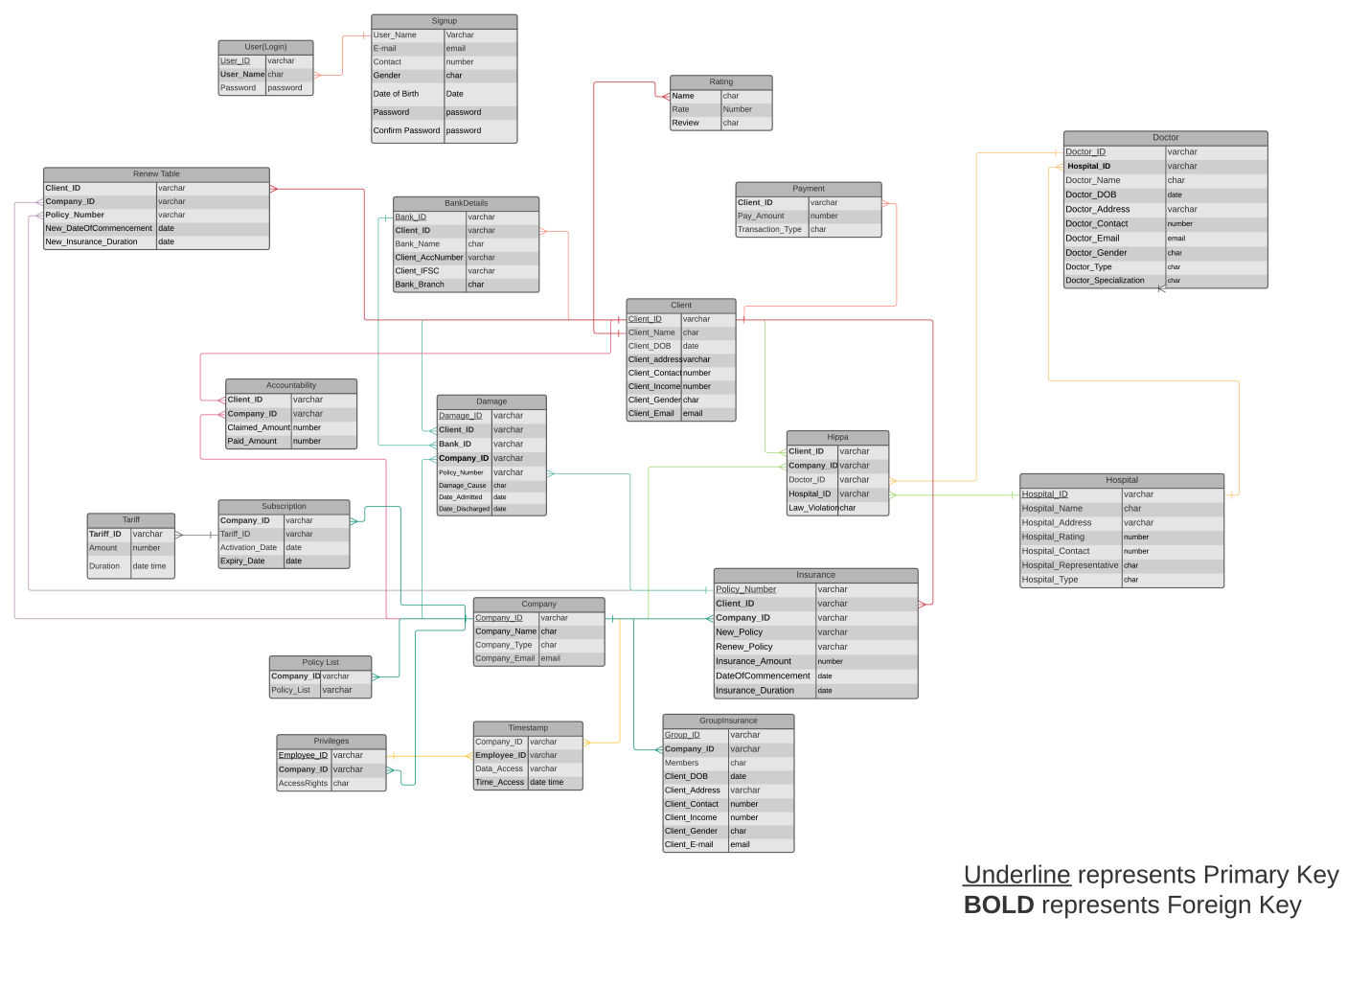

Figure 1: Relational Model

* 1. Entity Relationship Model:

This is the ER model of our system in which we have shown all the entities and their attributes and then connected all of them as required.

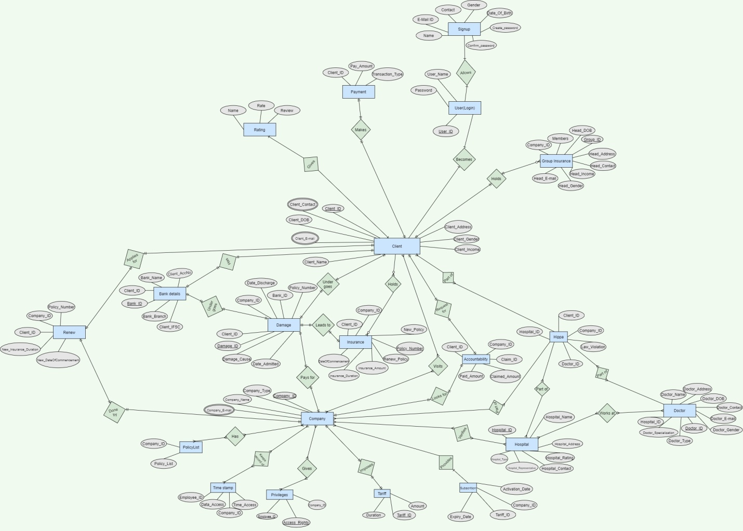

Figure 2: ER Model

1. Experimental Analysis:

For the database purpose, we use the phpMyAdmin as a server.

phpMyAdmin:

* It is a free and open-source administration tool and one of the most famous tools for the database purpose.
* The reason behind the using this software is it is managing centrally so that all the members from our team can do the query and perform their particular tasks.
* It is very easy to do a complex query and run that on the server.

Requirement to Run the phpMyAdmin:

1. Xampp server. (we use version-3.2.4)

Below query show the unique feature of our project:

This will SELECT the ID of the Client that are present in the Client Table as well as the Clients that have violated the Hippa Law.

SELECT Client_ID FROM Client UNION

SELECT Client_ID FROM Hippa;

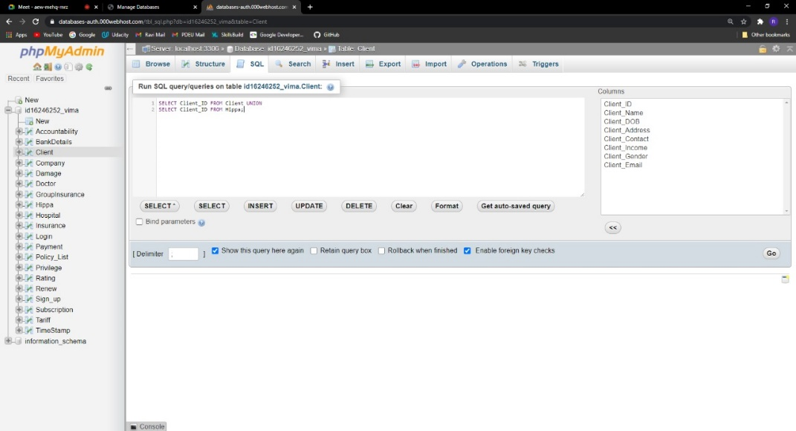

Figure 3.1: Query

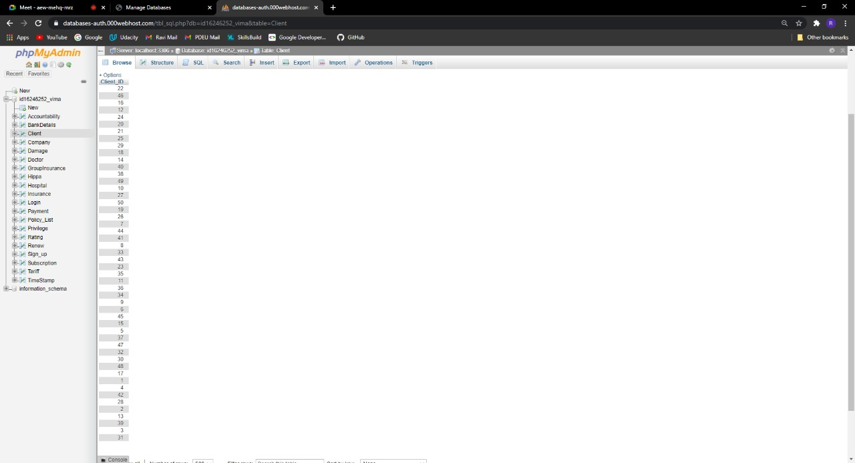

Figure 3.2: Output

Table 1.1: Comparison

|  |  |  |  |  |  |
| --- | --- | --- | --- | --- | --- |
|  | Hippa | Policy Comparison | Centralized Data | Nearby Locator | Security policy |
| Online Insurance | NO | NO | YES | NO | YES |
| OnlineMediclaim Management system | NO | YES | NO | NO | NO |
| Insurance company | NO | YES | NO | YES | YES |
| Insurance Policy database | NO | YES | YES | NO | NO |
| Our system | YES | YES | YES | YES | YES |

Table 1.2: Features

|  |  |
| --- | --- |
| Feature | Meaning |
| Hippa | In this feature, the confidentialities between patients and the doctor are not compromised. |
| Policy Comparison | In Policy Comparison we can compare two company’s policies and choose best of them. |
| Centralized Data | Centralized data means that it helps the companies to access the data from a single source rather than looking for other different source every time the data changes. |
| Nearby Locator | As per Current location of the user, nearby locator is used to find our network locators. It will find nearby hospitals, pharmacy, and our Mediclaim company branches near them. |
| Security policy | Security policy is provided to the clients were no unknown person can access the data of the clients. |

1. Conclusion and Future Work:

In the present situation where the technology is the buzzword and has revolutionized the way we work and live, we would be the left behind if we do not keep up with the changing world. Moreover, it makes a world of difference and a whole of sense to break-up from the age old work culture and embrace the effective, cost, and time saving ways of looking and working at things.

This is precisely where the V.I.M.A. Variable Insurance and Mediclaim Application comes in picture which supports and improves many of the core functionality of the insurance organization i.e. this mediclaim project helps to provide security and privacy along with the speedy transactions. Using such a system helps the organization in providing security to client’s data, minimizing the time consumed in fulfilling the day-to-day functionality’s and cutting down the expenses incurred on the same. In future, such systems which provide features for user’s privacy and security along with all other features of speedy transaction, nearby locator, etc will be in more demand. This is because user always wants such systems where both the good features and security is provided. We can also add more features to this in future like showing the route in nearby locator, adding emergency contact details of hospitals and much more.

**Acknowledgment**

I would like to express my special thanks of gratitude to my faculty Dr. Nishant Doshi as well as our HOD Dr. Samir Patel who gave me the golden opportunity to do this wonderful project on the topic Variable Insurance and Mediclaim Application (VIMA), which also helped me in doing a lot of Research.

References

1. David M. Dror. Reinsurance of Health Insurance for the informal Sector. 2001 (Date Not Mentioned).
2. Dennis P. Scanlon, Michael Chernew, Judith R. Lave. Consumer Health Plan Choice: Current Knowledge and Future Directions. 1997.
3. Dileep Mavalankar Ramesh Bhat. Health Insurance in India Opportunities, Challenges and Concerns. November 2000.
4. Dr. Pranam Dhar, Sudipta Halder. Financial Protection in Health Insurance Schemes: A Comparative Analysis of Mediclaim Policy and Chat Scheme in India. August 2015.
5. Jay Pan, Sen Tian, Qin Zhou And Wei Han. Benefit Distribution of Social Health Insurance: Evidence from China’s Urban Resident Basic Medical Insurance. 1 March 2016.
6. Jemima A Frimpong, Ste´Phane Helleringer, John Koku Awoonor-Williams, Thomas Aguilar, James F Phillips And Francis Yeji. The Complex Association of Health Insurance and Maternal Health Services in The Context of a Premium Exemption for Pregnant Women: A Case Study in Northern Ghana. 2014.
7. M. Kent Ranson. Community-Based Health Insurance Schemes in India: A Review. 2003.
8. Mushtaq Ahmed. Marketing Strategies of Life Insurance in Public and Private Sector: A Comparative Study of Lic And Icici Prudential. 2016.
9. N Devadasan, Kent Ranson, Wim Van Damme, Bart Criel. Community Health Insurance in India.July 10, 2004.
10. Olanrewaju A. Olaniyan, Saheed O. Olayiwola. The Impact of Micro-Health Insurance on The Access to Health Care Services Among the Informal Sector Employees In Urban Areas Of Nigeria. (Date Not Mentioned)
11. Rajesh Srivastava, Dr. Preeti Sharma. Effective Customer Support System of Life Insurance Companies. 2, Dec 2014
12. Ramesh Bhat, Dileep Mavalankar. District health Account of Sindhudurg District in Maharashtra developing health Financing Options. June 2001
13. Ramesh Bhat, Elan Benjamin Reuben. Analysis of Claim and Reimbursement Made Under Mediclaim Policy If the General Insurance Corporation of India. August 2001.
14. Ramesh Bhat, Elan Benjamin Reuben. Analysis of Claim Made Under Mediclaim Policy. 02-08-2001.
15. Ramesh Bhat, Elan Benjamin Reuben. Management of Claims and Reimbursementsthe Case of Mediclaim Insurance Policy. October-December 2002
16. Rao Chen, Ning-Xiu Li And Xiang Liu. Study on The Equity of Medical Services Utilization for Elderly Enrolled in Different Basic Social Medical Insurance Systems In An Underdeveloped City Of Southwest China. 2018.
17. Siripen Supakankunti. Future Prospects of Voluntary Health Insurance in Thailand. (Date Not Mentioned).
18. Sukumar Vellakkal. Adverse Selection and Private Healthinsurance Coverage in India. February 2009.
19. Thiptaiya Sydavong, Daisaku Goto, Household Risk Preferences and Community-Based Health Insurance. 2019.
20. Xiaolei Xiong, Zhiguo Zhang, Jing Ren, Jie Zhang, Xiaoyun Pan, Liang Zhang,Shiwei Gong, Si Jin. Impact of Universal Medical Insurance System on The Accessibility of Medical Service Supply and Affordability of Patients In China. March 7, 2018