Tanvi Modi

tanvimodi297@gmail.com

Abstract

INFOVIRTECH CYBERSECURITY INTERNSHIP FINAL REPORT

Advanced Keylogger

INFOVIRTECH Private Limited

INTERNSHIP PROJECT

At the end of the internship, we have to submit one project that is related to the cyber security domain.

So, I choose the **ADVANCED KEYLOGGER USING PYTHON**.

**What is Keylogger**

* A keylogger, sometimes called a keystroke logger or keyboard capture, is a type of surveillance technology used to monitor and record each keystroke on a specific computer. Keylogger software is also available for use on smartphones, such as the Apple iPhone and Android devices.
* They aren’t always illegal
* They do have legitimate, useful applications. For example, keyloggers are often used by IT departments to troubleshoot problems and systems.

**Types of Keylogger**

* Kernel-Based Keyloggers
* Hardware Keyloggers
* Software Keyloggers
* Acoustic Keyloggers

**Implementation of Keylogger**

* In the project, I implement the keylogger in such a way that we can save the all information in the text files and also, we can send that text files via email to anyone.
* In the text files we have different type of information like
* Keylogging Information
* System Information
* Clipboard information
* Screenshot
* After Getting all the information that are listed above, we have to encrypt the file and send to the email address that are provides in the Keylogger.py file.
* In code, I have implemented keylogger which is execute for 15 minutes and its exe capture key pressed by user, screen shot of working screen, system information and clipboard information.
* That information is sent by the mail for continues time periods. For sending mail I use SMTP library to implement it.
* Let’s see all function’s code for understanding.

**This function call all function and make attachments for the mail and send mail.**

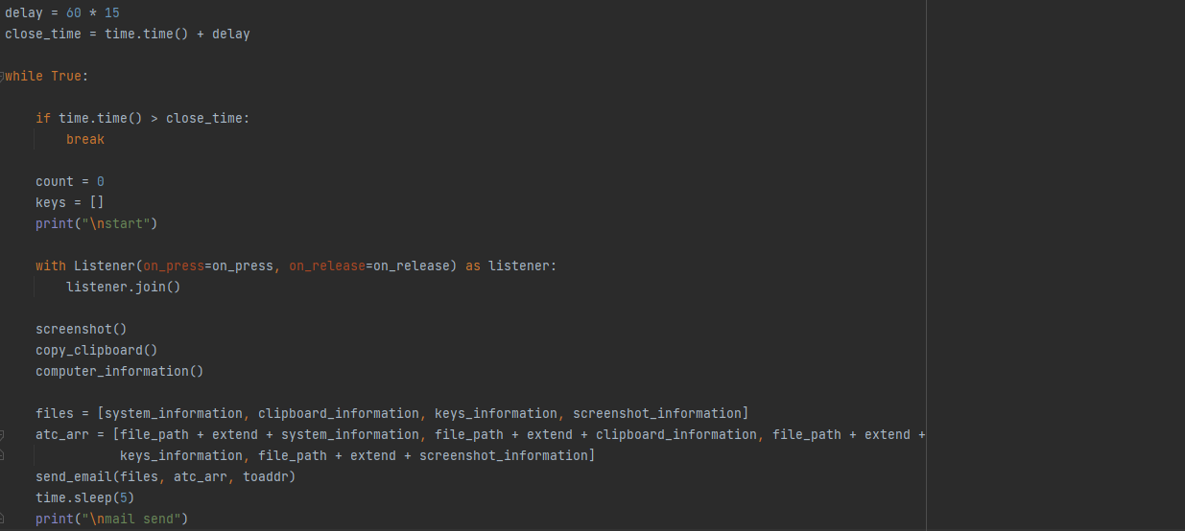

**Function for Computer information**

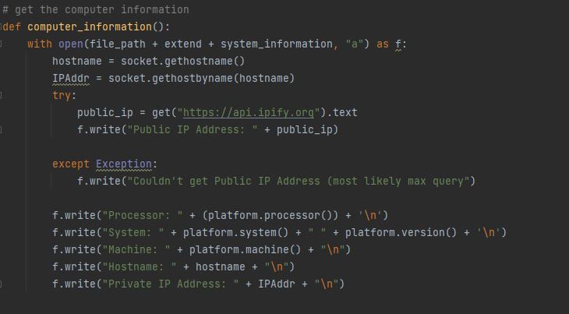

**Function for sending mail**

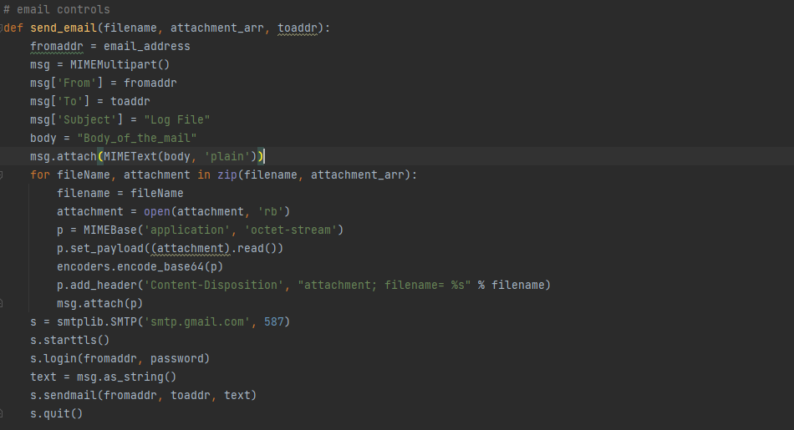

After the code implementation, I make the EXE file of this python program.

**Python to .exe**

To make exe file we have to install auto-py-to-exe library. After installation, we have to open it using command line.

* pip install auto-py-to-exe
* auto-py-to-exe

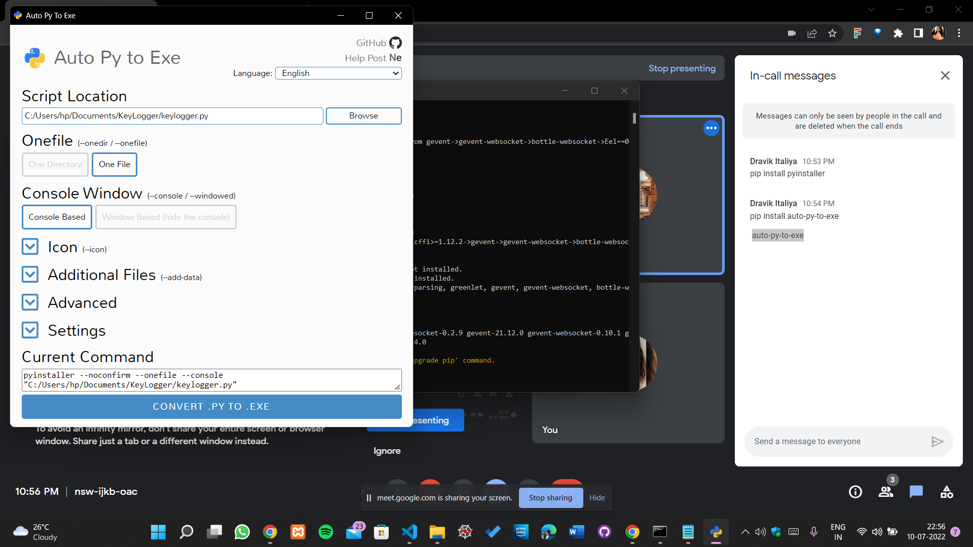

Fulfil the requirements that are shown in the prompt.

We can modify name, icon, OS version etc.

You can see the exe file that I have created.

