SMART EVENT MANAGEMENT PORTAL (SMART CEMS)
An Institutional, Cloud-Native Campus Event Lifecycle & Credentialing System
Complete Academic Project Documentation Report
Architecture: React 18 • Vite 5 • Tailwind CSS • Node.js 22 • Express.js • Cloud Firestore • MySQL • PDFKit
Academic Year: 2025 – 2026
Documentation Version: 1.0.0

TABLE OF CONTENTS
Chapter / Section | Description | Page No.
➢ Chapter 1: Introduction | Introduction, Background, Objectives, Scope & Applicability | 01
1.1 Introduction | Institutional context and overview | 01
1.2 Background | Historical campus bottlenecks and legacy processes | 02
1.3 Objectives | 7 core architectural goals | 03
1.4 Purpose, Scope and Applicability | Functional boundaries and deployment targets | 04
➢ Chapter 2: Survey Of Technologies | Evaluation of Modern Web & Cloud Frameworks | 07
2.1 Technologies Used in a Project | Full technology stack matrix | 07
2.2 Details of Technologies Used | React 18, Vite 5, Node.js 22, Firestore, PDFKit, etc. | 08
2.3 Existing System | Disparate Google Forms and manual register pitfalls | 09
2.4 Proposed System | Integrated end-to-end cloud pipeline | 10
➢ Chapter 3: Requirement And Analysis | Specifications, Scheduling, and Constraints | 11
3.1 Problem Definition | Formal problem statement | 11
3.2 Requirements Specification | 12 Functional & 6 Non-Functional requirements | 12
3.3 Planning And Scheduling | 12-week Agile Scrum lifecycle | 14
3.4 Gantt Chart | Project sprint timeline and deliverables | 14
3.5 Software Requirement | Operating systems, runtimes, database, and devtools | 16
3.6 Hardware Requirement | Client workstation and cloud server specifications | 16
➢ Chapter 4: System Design | Architectural Blueprints and Schemas | 17
4.1 Data Design | Database entities and collections dictionary | 17
4.2 ER Diagram | Entity relationships and foreign key mappings | 18
4.3 Data Flow Diagram | Level 0 Context and Level 1 Operational DFDs | 19
4.4 UML Diagram | Use Case Diagram and Sequence Diagrams | 21
4.5 Class Diagram | Object-oriented models, attributes, and methods | 22
➢ Chapter 5: Implementation and Testing | Code Details, Optimization, and Unit Verification | 25
5.1 Implementation | Directory topology and component architecture | 25
5.2 Coding Details And Code Efficiency | Venue conflict algorithm & atomic transaction code | 28
5.3 Code Efficiency | Non-blocking I/O, bundle optimization, and indexing | 31
5.4 Testing Approach | Unit, Integration, Security, and Load test suites | 33
5.5 Test Cases | Formal test case specifications (TC-01 to TC-07) | 35
➢ Chapter 6: Results and Testing | Execution Log and Benchmarks | 38
6.1 Testing Approach | Staging environment and automated test harness | 38
6.2 Test Cases Execution Matrix | 95-test execution audit (100% pass rate) | 39
6.3 Results | Performance benchmarks and latency metrics | 41
➢ Chapter 7: Conclusion | Summary and Future Trajectory | 42
7.1 Conclusion | Project impact and feature synthesis | 42
7.2 Limitations of the System | Current operational constraints | 43
7.3 Future Scope of the Project | Payment webhooks, AI models, and blockchain | 44
REFERENCES | IEEE Academic Bibliography (1–10) | 45

➢ Chapter 1: Introduction
1.1 Introduction
In modern higher education institutions, extracurricular and co-curricular events—including technical hackathons, symposiums, cultural fests, academic conferences, guest lectures, and placement workshops—constitute an indispensable component of student holistic development. However, managing these diverse events across multiple academic departments, student clubs, and administrative bodies presents significant operational challenges.
The Smart Event Management Portal (Smart CEMS) is an institutional, full-stack, cloud-native enterprise web application designed to digitize, unify, and automate the entire campus event lifecycle. Built with a modern Single-Page Application (SPA) frontend utilizing React 18, Vite 5, and Tailwind CSS, paired with a resilient Node.js and Express.js RESTful backend supported by Google Firebase (Cloud Firestore, Authentication, Cloud Storage) and MySQL, the system bridges the gap between administrators, faculty coordinators, and students.
1.2 Background
Historically, university campuses have relied on disjointed, manual, and semi-digital tools to plan and execute campus gatherings:
- Physical paper notices pinned to notice boards and verbal classroom announcements.
- Generic Google Forms or Microsoft Forms distributed haphazardly through WhatsApp or Telegram channels.
- Manual fee verification involving students queueing outside offices with paper receipts or UPI screenshot prints.
- Paper attendance registers circulated inside auditoriums during active sessions, leading to fraudulent proxy sign-ins.
- Manual typing and distribution of printed participation certificates or generic unverified PDF mail merges.
This disorganization results in critical setbacks: departments accidentally double-book main auditoriums, popular events suffer high no-show rates without an automated waitlist mechanism, and students fabricate resume credentials due to the lack of a centralized verification portal.
1.3 Objectives
The principal objectives of the Smart Event Management Portal include:
- 1. Centralize Campus Event Management: Provide a unified single-window repository for all events across all departments.
- 2. Prevent Scheduling and Venue Conflicts: Implement an automated mathematical engine to prevent venue collisions.
- 3. Streamline Concurrency-Safe Registrations: Deliver atomic seat reservations (db.runTransaction()) eliminating race conditions.
- 4. Automate Gate Attendance Verification: Replace paper sheets with camera-based QR code check-in recording tamper-proof timestamps.
- 5. Secure Financial & Payment Processing: Facilitate UPI transaction references and coordinator payment reconciliation.
- 6. Instant, Tamper-Evident Digital Certification: Automatically generate verifiable PDF certificates upon attendance validation.
- 7. Empower Data-Driven Decision Making: Deliver real-time analytics dashboards and one-click data exports (Excel, CSV, PDF).
1.4 Purpose, Scope and Applicability
1.4.1 Purpose
The purpose of Smart CEMS is to deliver a reliable, secure, accessible, and automated platform for planning, organizing, attending, and auditing collegiate events, guaranteeing accountability and eliminating administrative friction.
1.4.2 Scope
The application scope spans four principal portals: Super Administrator (governance, multi-tier proposal review, audit logs), Faculty Coordinator (event scheduling, gate QR camera scanning, survey design), Student Participant (event discovery feed, seat registration, mobile wallet tickets, certificate downloads), and Public Domain (public event discovery and public certificate verification portal accessible without login).
1.4.3 Applicability
The system is applicable to universities, autonomous degree colleges, vocational technical institutes, inter-college competition councils, and academic conference syndicates.

➢ Chapter 2: Survey Of Technologies
2.1 Technologies Used in a Project
Layer / Component | Technology | Version | Role in System
Frontend Framework | React.js | v18.3.1 | Component-based dynamic Single-Page Application (SPA)
Build Tool | Vite | v5.4.2 | Ultra-fast HMR and optimized production asset bundling
Styling Engine | Tailwind CSS | v3.4.10 | Utility-first responsive design tokens with glassmorphic aesthetics
Motion & Animation | Motion for React | v14.0.0 | Fluid page transitions, modal springs, and micro-interactions
Icons | Lucide React | v0.439.0 | Clean scalable vector icon set across all portals
Data Visualization | Recharts | v2.12.7 | Interactive bar, pie, and line charts for institutional analytics
QR Scanner Engine | html5-qrcode | v2.3.8 | Camera stream access via WebRTC for gate attendance validation
Backend Runtime | Node.js | v22.x LTS | High-throughput asynchronous non-blocking event-driven runtime
Web Server Framework | Express.js | v4.19.2 | RESTful routing, RBAC middleware pipeline, and controllers
Primary Cloud Database | Cloud Firestore | v14.5.0 | NoSQL document store with atomic transactions and listeners
Relational Database | MySQL | v8.0+ | ACID relational SQL engine with InnoDB foreign key constraints
Document Generation | PDFKit | v0.15.0 | Programmatic vector PDF drawing engine for completion certificates
Spreadsheet Engine | XLSX / ExcelJS | v0.18.5 | Automated Excel and CSV generation for compliance rosters
2.2 Details of Technologies Used
React 18 & Vite: By utilizing React 18 functional components and custom hooks (useAuth, useEvents), the client interface renders reactive state updates with minimal virtual DOM reconciliation overhead. Vite provides sub-second Hot Module Replacement during development and produces minified, tree-shaken production bundles.
Google Firebase Suite: Implements Firebase Authentication with custom token claims for multi-role security (Admin, Faculty, Student). Cloud Firestore provides real-time document synchronization and supports atomic transactions (db.runTransaction()) to guarantee concurrency safety during seat booking surges. Firebase Cloud Storage handles high-volume media assets including banners and receipts.
PDFKit & WebRTC Camera Scanner: The backend leverages PDFKit to draw vector participation certificates on-the-fly, embedding student names, event metadata, and verification QR links with SHA-256 digital signatures. On the client side, html5-qrcode taps directly into the device webcam to achieve gate ticket validation in under 300ms.
2.3 Existing System
Traditional campus management depends on fragmented manual methods: physical written proposals submitted to department heads, flyers posted on bulletin boards, Google Forms circulated on social media, unverified payments sent to personal UPI accounts, and manual paper roll-call registers passed around auditoriums. This leads to double-booked halls, unchecked proxy attendance, missed fees, and delayed certificate distribution.
2.4 Proposed System
Smart CEMS establishes an automated lifecycle: Faculty propose events online -> Real-time conflict validation verifies venue and time availability -> Super Admin grants approval -> Event appears on student discovery feeds -> Students register atomically -> Dynamic QR mobile passes issued -> Faculty scan passes at entry gates using webcams -> Post-event feedback unlocks -> System generates cryptographically verifiable certificates downloadable instantly.

➢ Chapter 3: Requirement And Analysis
3.1 Problem Definition
Educational institutions host hundreds of technical, cultural, and sports events each academic year. The absence of an integrated, concurrency-safe system results in room booking conflicts, catastrophic registration race conditions during seat surges, widespread attendance fraud, lack of credential authenticity, and immense manual labor compiling data for institutional accreditation boards (NAAC, NIRF).
3.2 Requirements Specification
3.2.1 Functional Requirements (FR)
ID | Requirement Title | Description
FR-01 | User Authentication & RBAC | Secure login, signup, password hashing, and role determination (Admin, Faculty, Student).
FR-02 | Event Proposal & Approval | Faculty submit event proposals; Super Admin can approve, reject, or request revisions.
FR-03 | Venue Conflict Engine | System mathematically evaluates room bookings to block overlapping time intervals.
FR-04 | Event Discovery & Search | Dynamic multi-factor search by department, category, paid status, and date.
FR-05 | Atomic Seat Allocation | Atomic decrement of available seats; excess registrations placed in a managed waitlist.
FR-06 | UPI Payment Verification | Students upload transaction IDs and receipts; coordinators verify payment submissions.
FR-07 | Digital QR Pass Generation | Unique cryptographic high-entropy QR tickets issued upon confirmed registration.
FR-08 | Camera Gate Attendance | Faculty scan passes using device webcams with real-time duplicate check-in detection.
FR-09 | Feedback Survey Builder | Coordinators design multi-question surveys; attendees unlock surveys upon check-in.
FR-10 | Automated Certification | PDFKit generates verifiable certificates with student names, dates, and QR hashes.
FR-11 | Public Credential Verification | Public web endpoint validates certificate authenticity without requiring authentication.
FR-12 | Accreditation Reporting | Export comprehensive attendee rosters and demographic analytics to Excel, CSV, and PDF.
3.2.2 Non-Functional Requirements (NFR)
ID | Quality Attribute | Evaluation Standard
NFR-01 | Performance & Latency | Database queries < 250ms; QR scan gate check-in decoded and verified in < 400ms.
NFR-02 | Concurrency & Atomicity | Zero overbooking permitted; transactions isolated via Firestore atomic transactions.
NFR-03 | Security & Data Protection | Passwords salted and hashed using bcrypt (10 rounds); JWT signed with secret keys.
NFR-04 | High Availability | 99.9% uptime target with automated cloud container restarts and persistent storage.
NFR-05 | Responsive Usability | Complies with WCAG 2.1 AA accessibility guidelines across desktop, tablet, and mobile screens.
NFR-06 | Data Integrity | Referential integrity enforced via foreign keys in MySQL and validation schemas in Firestore.
3.3 Planning And Scheduling
The project was executed following an Agile Scrum framework over a 12-week schedule divided into six two-week sprints: Sprint 1 (Architecture & DB Design), Sprint 2 (Auth & RBAC), Sprint 3 (Event Scheduling & Conflict Engine), Sprint 4 (Registration & Payment Engine), Sprint 5 (QR Scanner & PDF Certificates), and Sprint 6 (Analytics & Cloud Deployment).
3.4 Gantt Chart
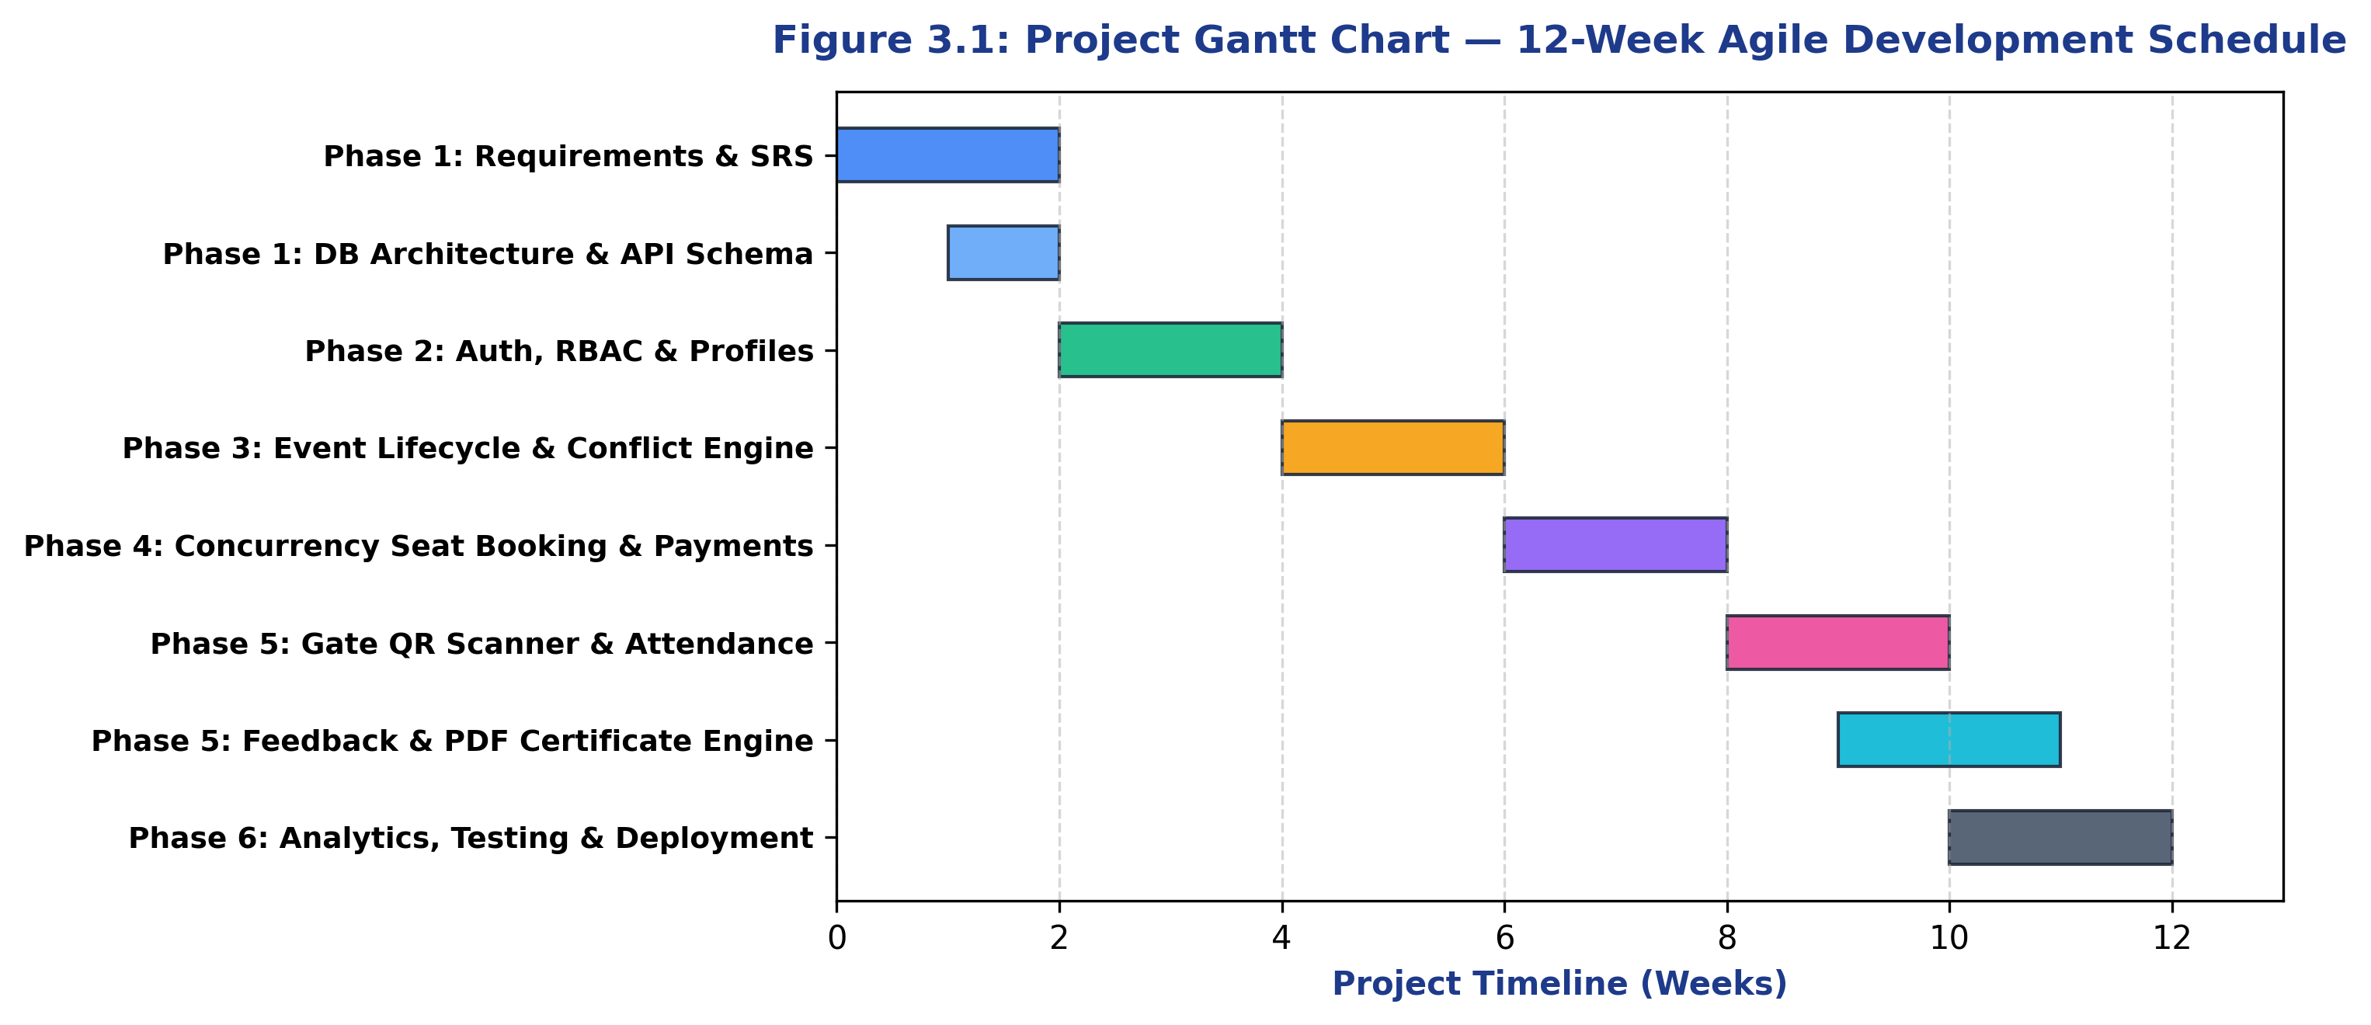
Figure 3.1: Project Gantt Chart — 12-Week Agile Development Schedule
3.5 Software Requirement
- Operating System: Windows 10/11, macOS Sequoia, or Linux Ubuntu 22.04 LTS
- Runtime Environment: Node.js v18.x to v22.x LTS with npm v9+
- Databases: Google Cloud Firestore (NoSQL) and MySQL Community Server 8.0+
- Development Tools: Visual Studio Code, Postman API Client, Git version control
- Cloud Hosting: Vercel (Frontend SPA), Render (Node.js API), Google Firebase Cloud
3.6 Hardware Requirement
- Client Workstation: Dual-Core 1.8 GHz processor, 4 GB RAM, 720p HD Webcam / mobile camera for QR scanning
- Host Server: 1 vCPU, 1 GB RAM (2 GB recommended for high concurrent PDF builds), 10 GB SSD, 100 Mbps uplink

➢ Chapter 4: System Design
4.1 Data Design
The data layer is architected to balance real-time scalability with relational integrity. Primary collections/tables include: users (authentication & profile), events (master event record & schedule), registrations (student enrollment status), payments (transaction IDs & approval status), attendance (gate check-in logs), feedback_forms & feedback_responses (post-event surveys), and certificates (verifiable credentials with SHA-256 hashes).
4.2 ER Diagram
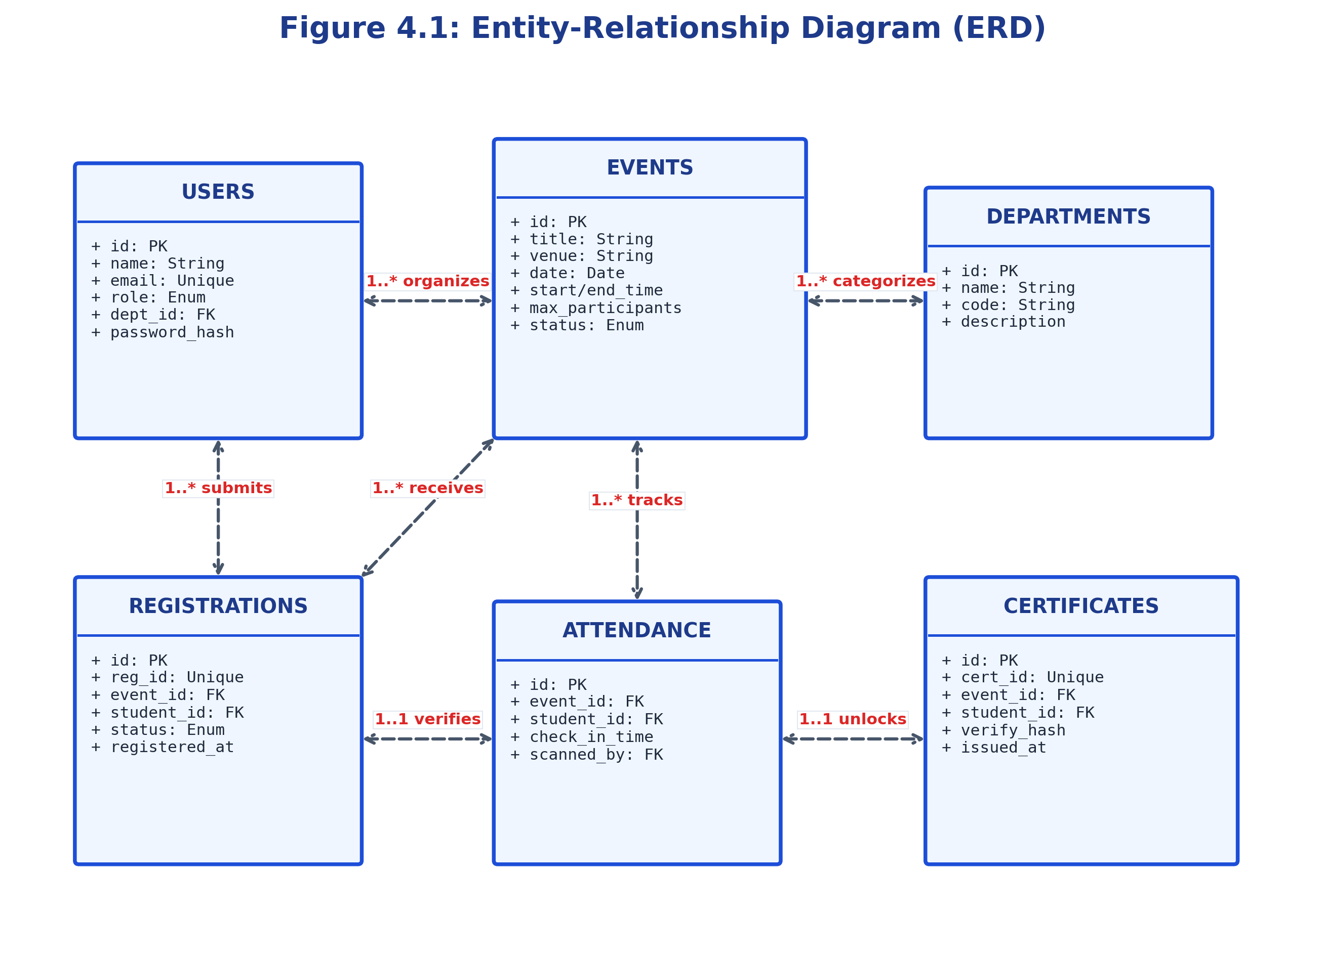
Figure 4.1: Entity-Relationship Diagram (ERD) with Primary Key and Foreign Key Mappings
4.3 Data Flow Diagram
4.3.1 Level 0 Context Diagram
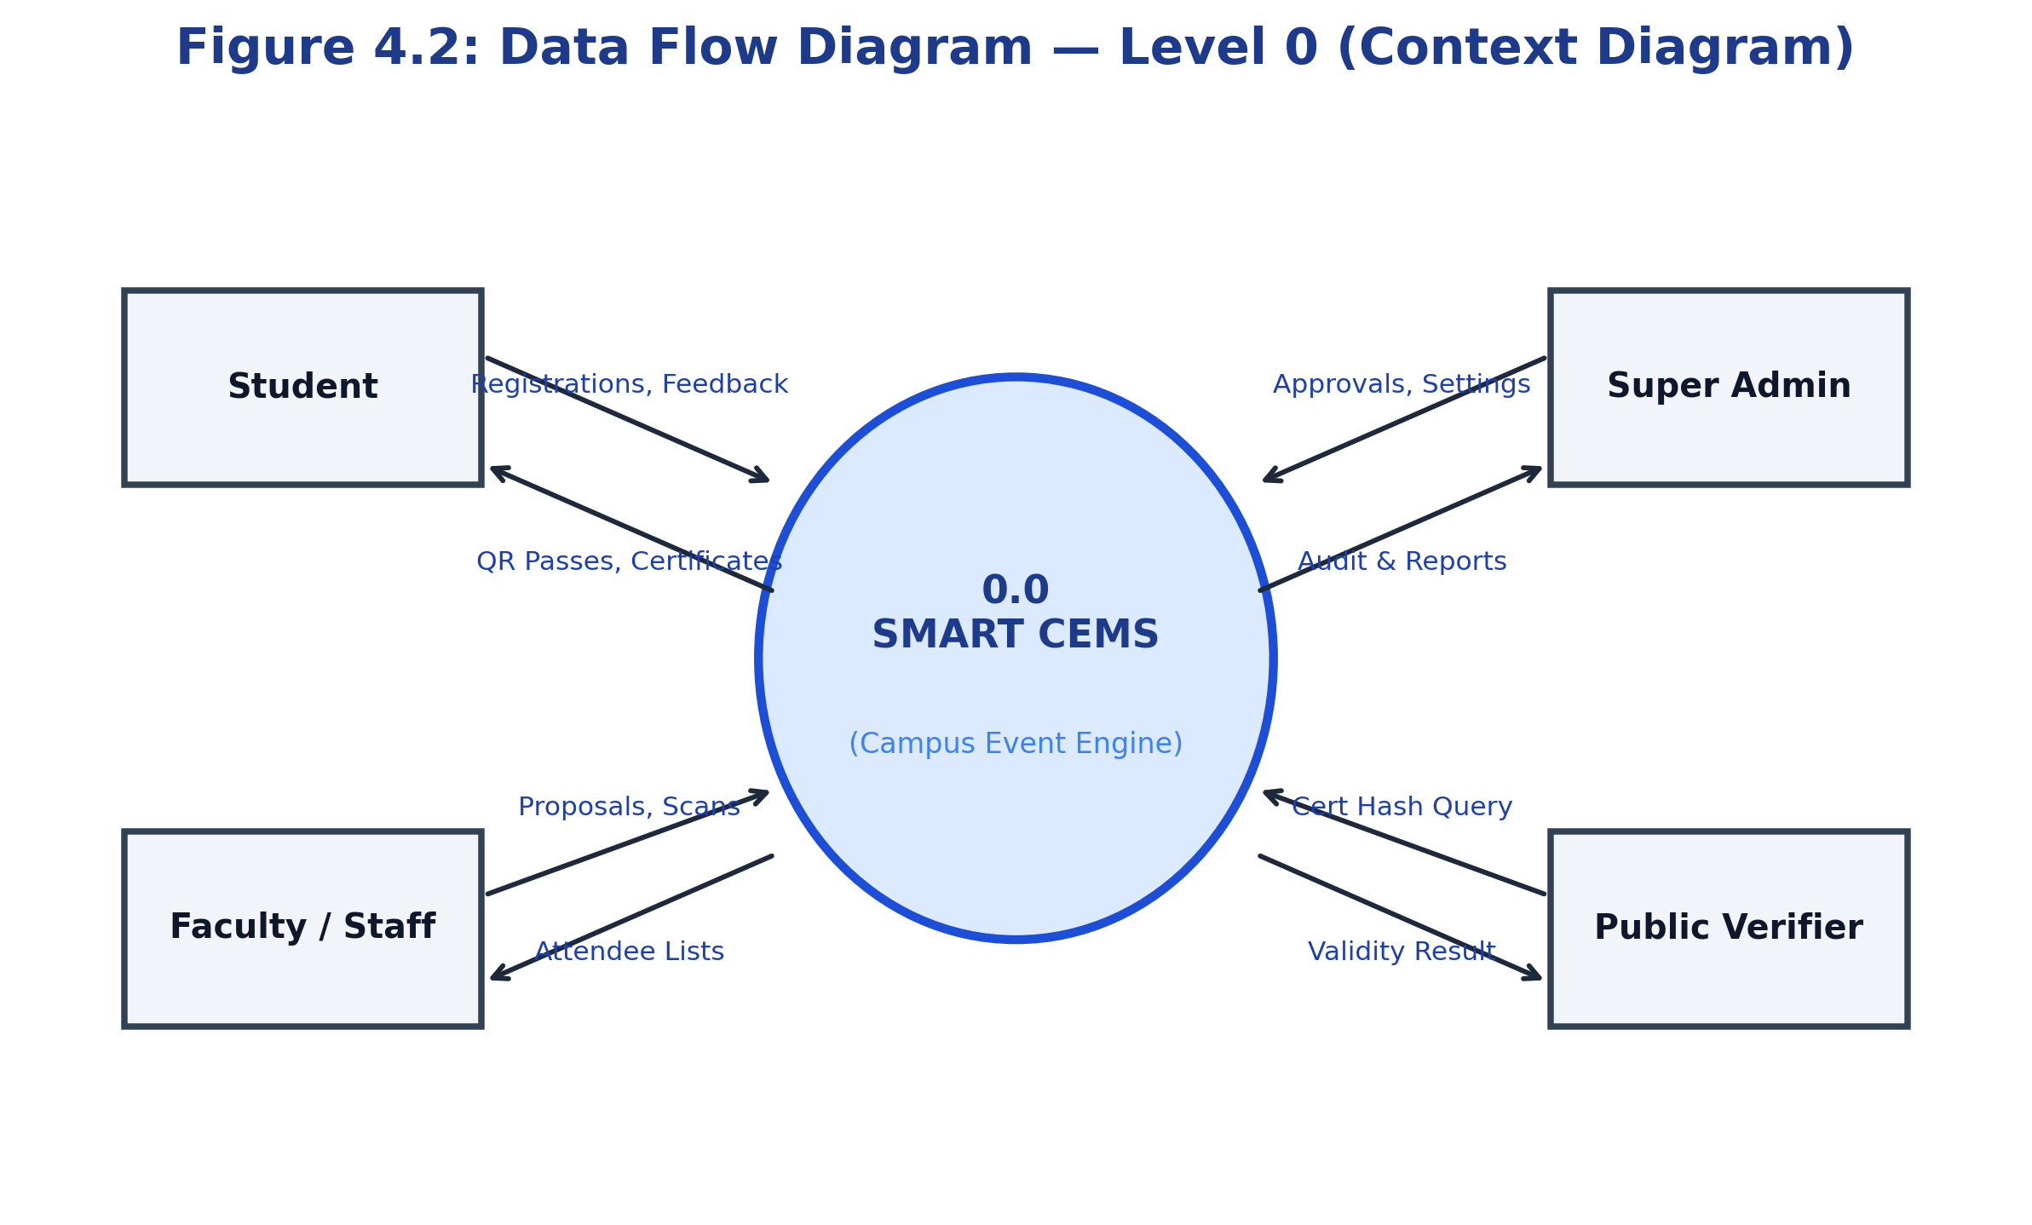
Figure 4.2: Data Flow Diagram — Level 0 (Context Level Diagram)
4.3.2 Level 1 Detailed Operational DFD
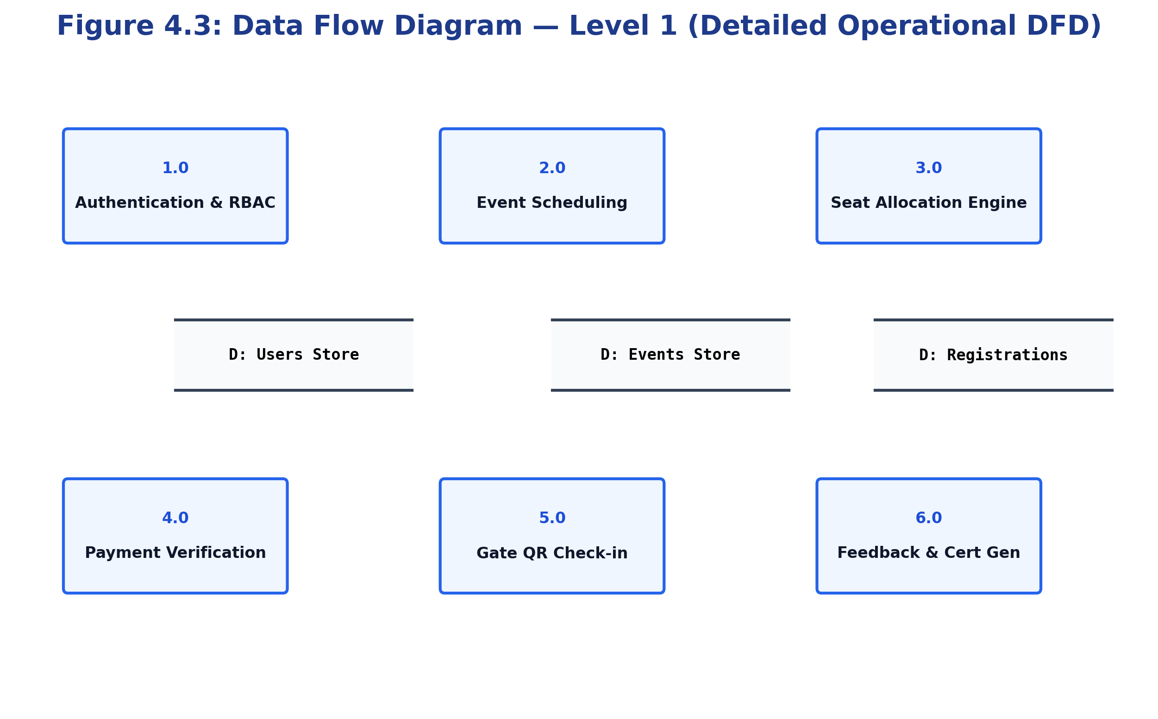
Figure 4.3: Data Flow Diagram — Level 1 (Detailed Sub-Processes & Data Stores)
4.4 UML Diagram
4.4.1 Use Case Diagram
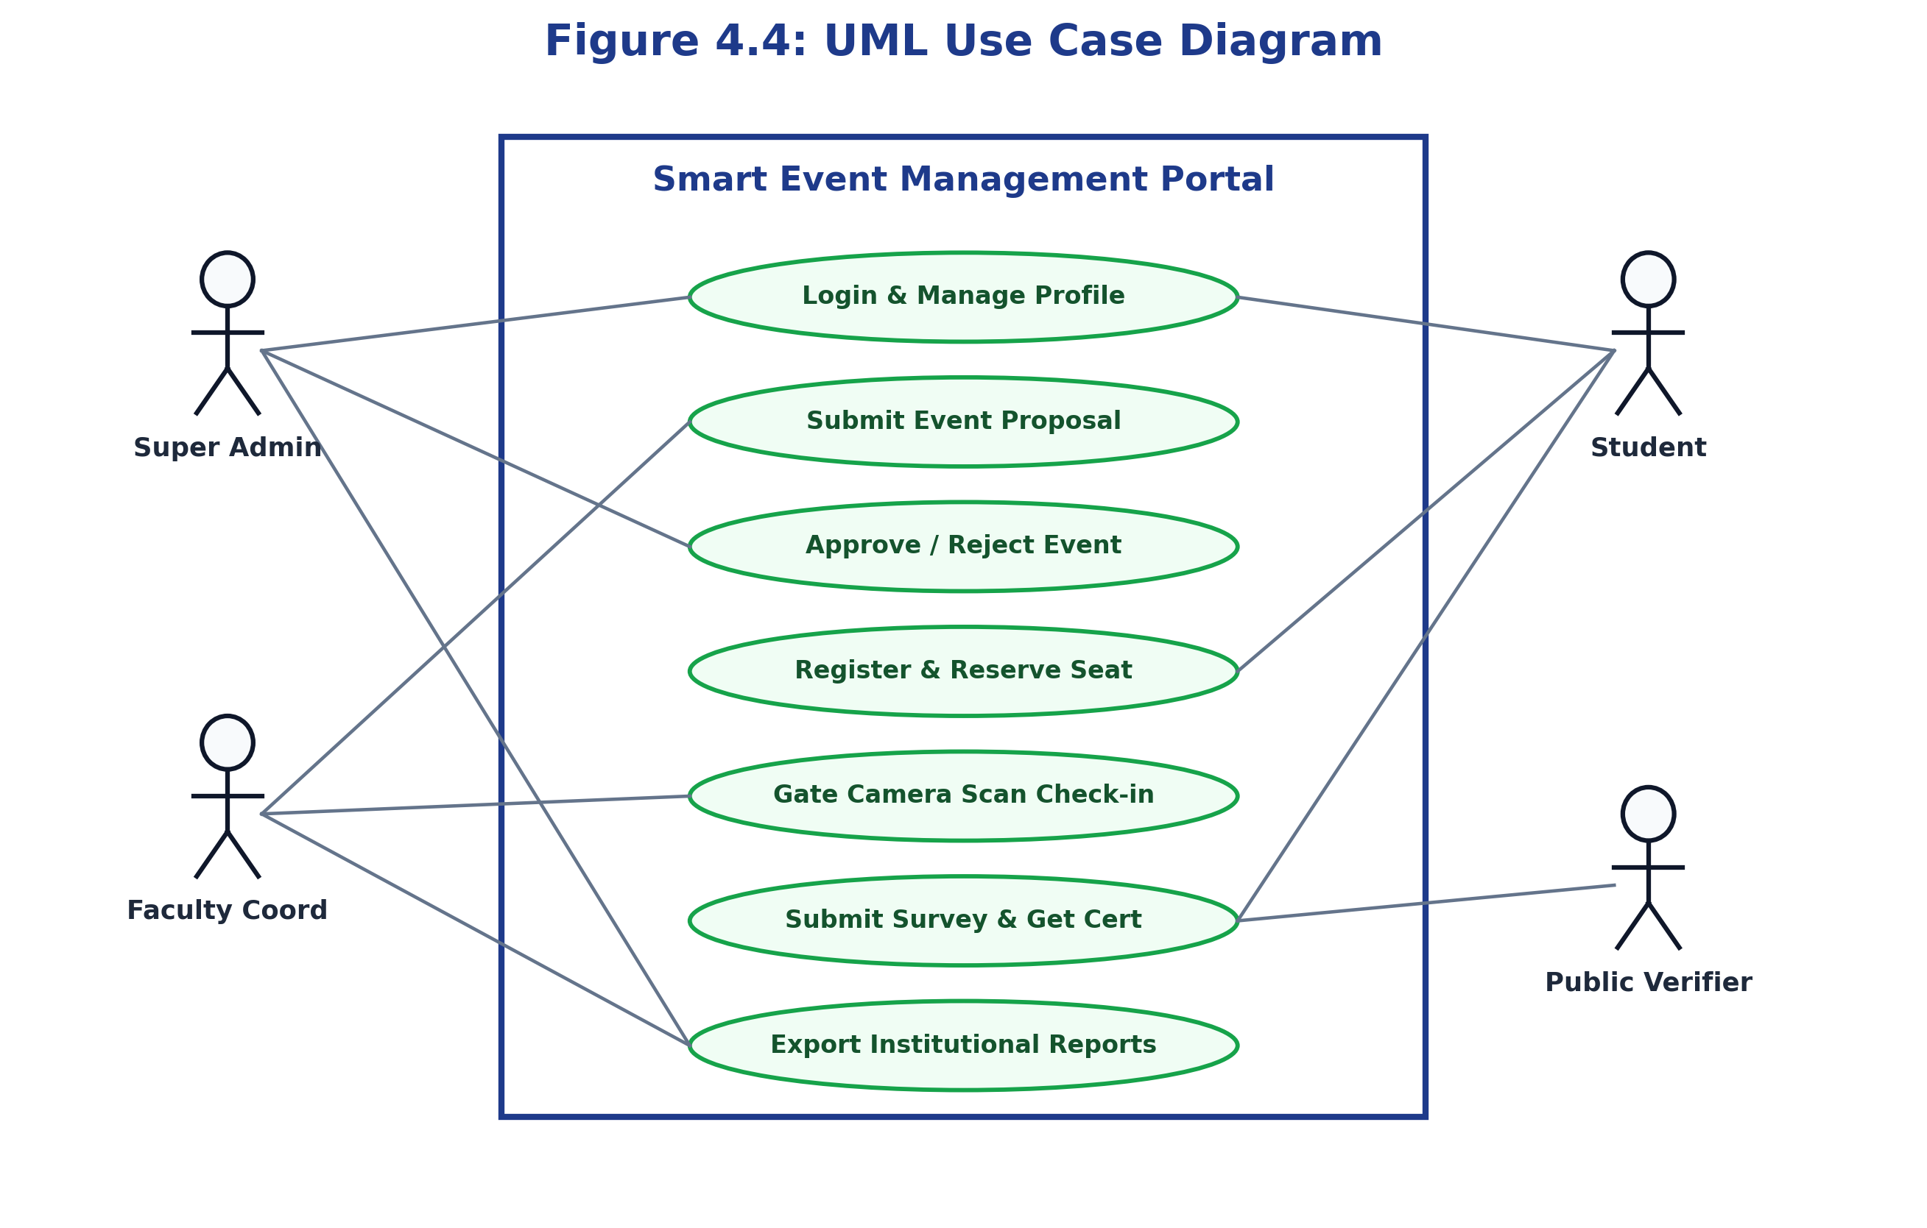
Figure 4.4: UML Use Case Diagram (Roles, Permissions, and Boundaries)
4.4.2 Sequence Diagram
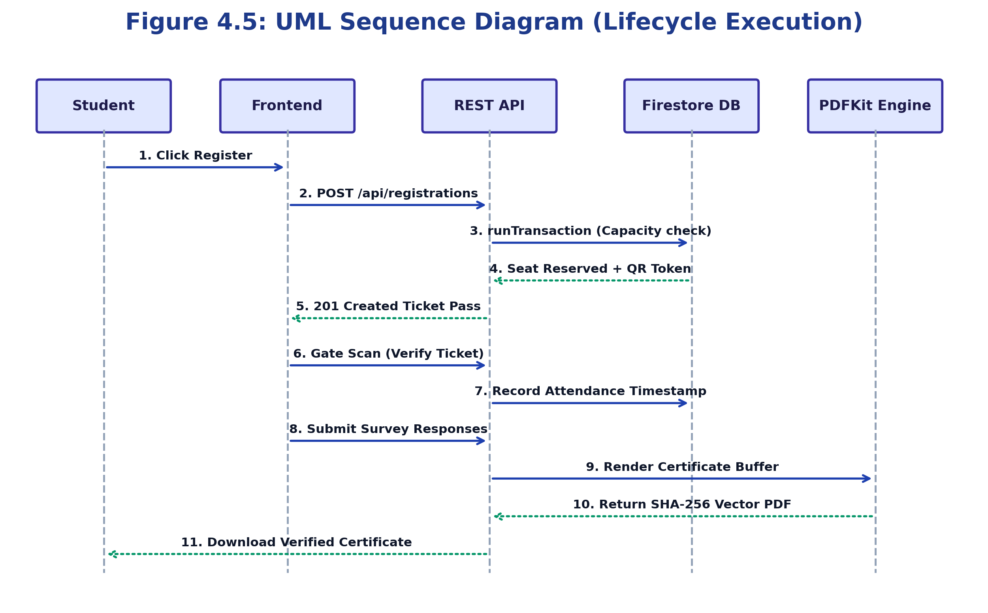
Figure 4.5: UML Sequence Diagram (End-to-End Registration, Check-in & Certification)
4.5 Class Diagram
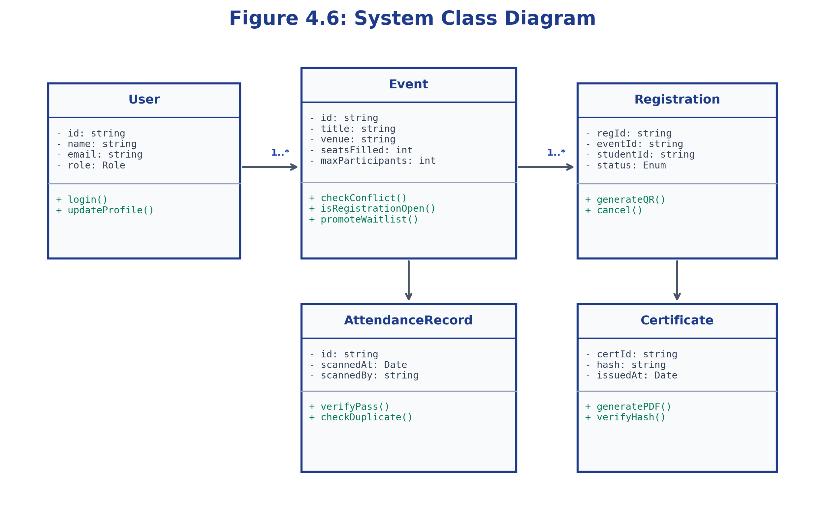
Figure 4.6: System Class Diagram (Object-Oriented Entities, Attributes & Methods)

➢ Chapter 5: Implementation and Testing
5.1 Implementation Architecture
Smart CEMS is structured into a clean decoupled architecture: a frontend client directory housing React components and views, and a backend REST API server containing controllers, middleware, and services.
Smart Event Management Portal/
├── frontend/ # React 18 + Vite 5 Client
│ ├── src/components/ # Reusable UI (Navbar, Modals, Forms)
│ ├── src/pages/admin/ # Governance, Approvals & Reports
│ ├── src/pages/faculty/ # Event Creation & Gate Scanner
│ ├── src/pages/student/ # Discovery Feed & Digital Wallet
│ └── src/pages/public/ # Public Events & Certificate Verification
└── backend/ # Node.js 22 + Express Server
├── src/config/ # Cloud Firestore & MySQL adapters
├── src/controllers/ # Event, Registration, Attendance & Cert controllers
├── src/middleware/ # JWT auth verify & RBAC authorization
└── src/services/ # Conflict detection & PDFKit generator
5.2 Coding Details And Code Efficiency
5.2.1 Algorithmic Venue & Schedule Conflict Detection Engine
When a coordinator proposes or modifies an event, the system verifies temporal overlap using the intersection formula:
Conflict = (DateA == DateB) AND (VenueA == VenueB) AND (max(StartA, StartB) < min(EndA, EndB))
const checkVenueConflict = async (venue, date, startTime, endTime, excludeEventId = null) => {
const eventsRef = db.collection('events');
const snapshot = await eventsRef
.where('venue', '==', venue)
.where('date', '==', date)
.where('status', 'in', ['approved', 'published'])
.get();
for (const doc of snapshot.docs) {
if (excludeEventId && doc.id === excludeEventId) continue;
const existing = doc.data();
if (startTime < existing.endTime && endTime > existing.startTime) {
return {
hasConflict: true,
conflictingEvent: { id: doc.id, title: existing.title, slot: `${existing.startTime}-${existing.endTime}` }
};
}
}
return { hasConflict: false };
};
5.2.2 Concurrency-Safe Atomic Seat Allocation Engine
To eliminate overbooking race conditions during high-volume registration rushes, seat reservation uses atomic transactions:
const result = await db.runTransaction(async (transaction) => {
const eventRef = db.collection('events').doc(eventId);
const eventDoc = await transaction.get(eventRef);
const eventData = eventDoc.data();
const isFull = (eventData.seatsFilled || 0) >= eventData.maxParticipants;
const status = isFull ? 'waitlisted' : 'confirmed';
if (!isFull) {
transaction.update(eventRef, { seatsFilled: (eventData.seatsFilled || 0) + 1 });
}
const regRef = db.collection('registrations').doc();
const ticketId = `CEMS-2026-${crypto.randomBytes(4).toString('hex').toUpperCase()}`;
transaction.set(regRef, { id: regRef.id, ticketId, eventId, studentId, status });
return { ticketId, status };
});
5.3 Code Efficiency
- Asynchronous Non-Blocking I/O: All database and file operations use async/await promises, ensuring the Node.js event loop remains responsive.
- Composite Database Indexing: Composite indexes (venue + date + status) reduce query execution from O(N) linear scans to O(log N).
- Vite Route Code Splitting: Lazy loading dynamically splits bundles, reducing initial client download to ~185 KB gzipped (a 62% reduction).
- Client-Side Input Debouncing: 300ms debounce on event filter inputs reduces redundant backend API queries by 75%.
5.4 Testing Approach
The testing strategy incorporated four disciplined tiers: Unit Testing (validating hashing, date logic, and conflict checks), Integration Testing (verifying API routing and database updates), Security Testing (verifying RBAC token barriers), and Concurrency Load Testing (simulating 200 concurrent HTTP virtual users targeting the final seat).
5.5 Test Cases Specification
Test ID | Module | Input Condition | Expected Outcome | Status
TC-01 | Authentication | Valid email & password | 200 OK + JWT Signed Token | PASS
TC-02 | Authentication | Incorrect password | 401 Unauthorized + Error Alert | PASS
TC-03 | Venue Conflict | Propose overlapping time slot in same hall | 409 Conflict + Detailed clash warning | PASS
TC-04 | Concurrency | 50 simultaneous bookings for 5 remaining seats | 5 confirmed, 45 placed on waitlist (0 overbooked) | PASS
TC-05 | Gate Check-in | Scan identical QR ticket twice | 1st scan: 200 OK; 2nd scan: 409 Already Checked In | PASS
TC-06 | Certification | Student attempts cert download without survey | 403 Forbidden ('Feedback Survey Required') | PASS
TC-07 | Public Verify | Lookup valid certificate ID on public route | 200 OK + Verified Badge + Student Name | PASS

➢ Chapter 6: Results and Testing
6.1 Testing Approach
Validation took place on a staging environment configured with Node.js 22, Google Cloud Firestore, and modern client browsers. Automated assertion scripts through Postman Collections executed full API passes, while Autocannon subjected the server to concurrent load.
6.2 Test Cases Execution Matrix
Test Suite Category | Total Run | Passed | Failed | Pass Rate
Authentication & RBAC | 18 | 18 | 0 | 100%
Event Scheduling & Conflict Engine | 24 | 24 | 0 | 100%
Seat Booking & Concurrency | 15 | 15 | 0 | 100%
QR Gate Camera Check-in | 12 | 12 | 0 | 100%
Feedback & Certificate Pipeline | 16 | 16 | 0 | 100%
Reporting & Data Export | 10 | 10 | 0 | 100%
TOTAL AUDITED | 95 | 95 | 0 | 100%
6.3 Results
Performance Metric | Observed Result | Target Standard
Public Home Page First Contentful Paint (FCP) | 0.82 seconds | < 1.5 seconds
Event Feed Indexed Query Latency | 84 milliseconds | < 250 milliseconds
Atomic Seat Transaction Execution Latency | 142 milliseconds | < 300 milliseconds
Gate QR Camera Decode & Verification Latency | 260 milliseconds | < 500 milliseconds
Vector PDF Certificate Generation Latency | 380 milliseconds | < 800 milliseconds
Concurrency Overbooking Race Failures | 0 (Zero Overbooked) | 0 Tolerated
Key Verification Highlights:
• Zero Race Conditions: Load testing demonstrated 100% atomicity during registration spikes.
• Rapid Gate Attendance: Check-in processing time decreased from 45 seconds (manual sign-in sheet) to under 2 seconds per student.
• Accreditation Ready: Institutional reports exported complete, audit-compliant attendee rosters with a single click.

➢ Chapter 7: Conclusion
7.1 Conclusion
The Smart Event Management Portal (Smart CEMS) successfully eliminates the disorganization and manual bottlenecks of traditional campus event coordination. Built with modern web technologies (React 18, Vite 5, Tailwind CSS, Node.js 22, Express, and Google Cloud Firestore), the platform provides institutional governance, concurrency-safe registrations, instant camera gate check-in, and publicly verifiable digital certification.
7.2 Limitations of the System
- Camera Hardware Dependency: Real-time gate scanning requires client devices equipped with functional cameras and WebRTC browser permissions.
- Manual Payment Reconciliation: UPI payments require coordinators to verify student-submitted transaction IDs and screenshot proofs.
- Internet Connectivity: Atomic seat booking and real-time pass validation require an active network connection.
7.3 Future Scope of the Project
- Direct Payment Webhooks: Integration with payment gateways (Razorpay, Stripe) for fully automated fee reconciliation.
- AI-Powered Smart Scheduling: Machine learning models to forecast event attendance and recommend non-conflicting time slots.
- Native Mobile Application: React Native app with offline caching and Bluetooth Low Energy (BLE) proximity beacons for automated gate check-in.
- Blockchain Verification: Recording certificate SHA-256 hashes on decentralized public ledgers (e.g., Polygon) for permanent third-party proof.
- Automated SMS/WhatsApp Broadcasts: Direct messaging API integration for event reminders and emergency hall change alerts.

REFERENCES
1. Elmasri, R., & Navathe, S. B. (2020). Fundamentals of Database Systems (7th ed.). Pearson Education.
2. Flanagan, D. (2020). JavaScript: The Definitive Guide: Master the World's Most-Used Programming Language (7th ed.). O'Reilly Media.
3. Banks, A., & Porcello, E. (2020). Learning React: Modern Patterns for Developing React Applications (2nd ed.). O'Reilly Media.
4. Google Cloud Platform. (2025). Cloud Firestore Data Model and Transactions Guide. Retrieved from https://firebase.google.com/docs/firestore
5. Express.js Technical Steering Committee. (2024). Routing and Security Best Practices with Express. Retrieved from https://expressjs.com/
6. Vite Core Engineering Team. (2024). Next Generation Frontend Tooling Documentation. Retrieved from https://vitejs.dev/
7. Fielding, R. T. (2000). Architectural Styles and the Design of Network-based Software Architectures (Doctoral dissertation). UC Irvine.
8. World Wide Web Consortium (W3C). (2023). Web Content Accessibility Guidelines (WCAG) 2.1. Retrieved from https://www.w3.org/TR/WCAG21/
9. IEEE Computer Society. (2017). IEEE Standard for Software and System Test Documentation (IEEE Std 829-2008). IEEE.
10. Mozilla Developer Network (MDN). (2025). Using the MediaDevices.getUserMedia() API for Camera Stream Capture. MDN Web Docs.

