Task 1 - Sample Chatbot
Name: Tanvi Khicchi
1. Register Page
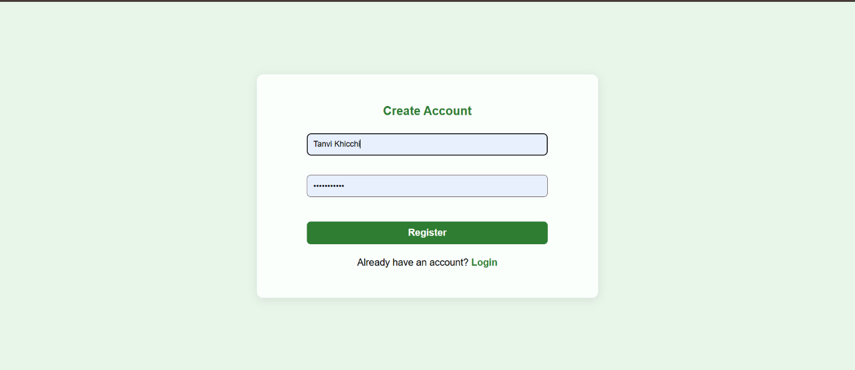
User registration interface for new users.
2. Login Page
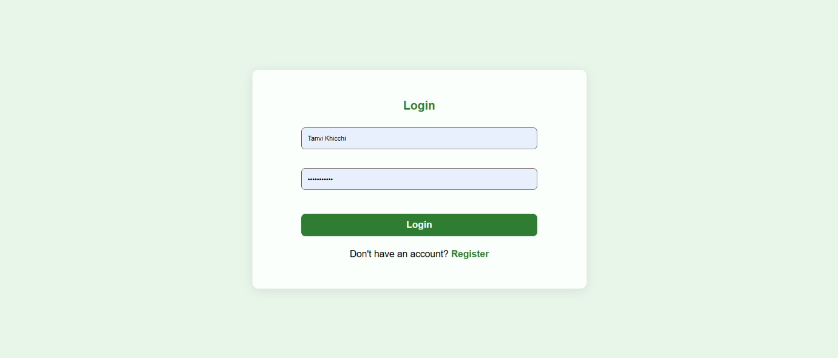
Secure login for existing users.

3. Chatbot Interface
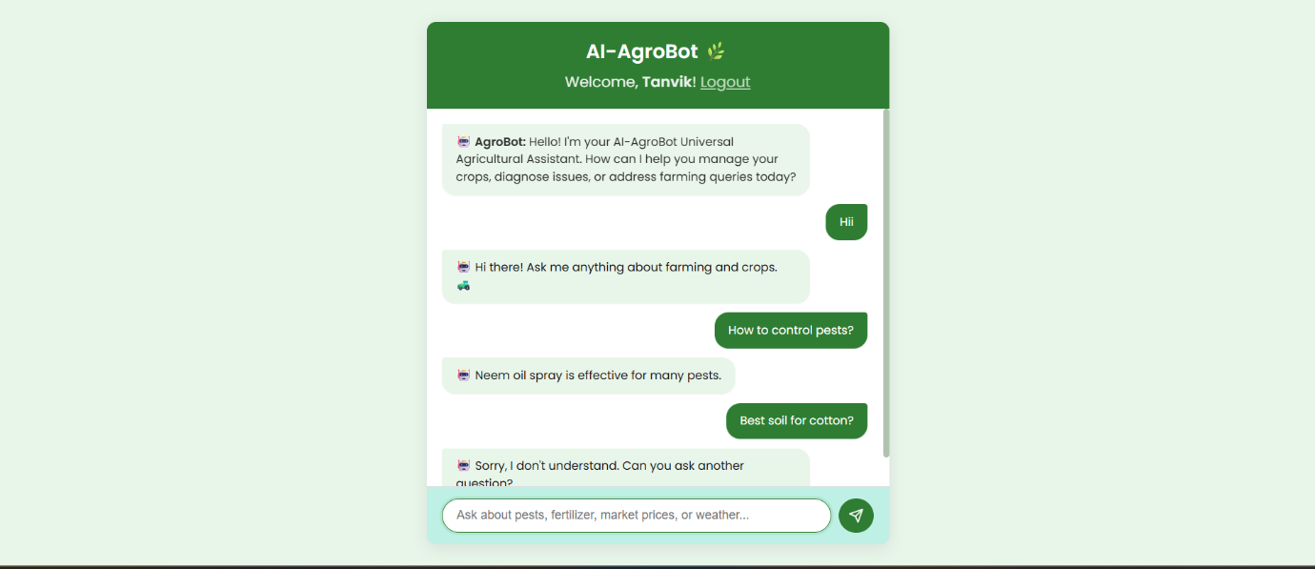
AI chatbot providing smart farming assistance.

