Assignment of BINARY TREE 1

Q1)Product of all Nodes

Code :

Solution:

#include <iostream>

using namespace std;

class Node{ // This is a TreeNode

public:

int val;

Node\* left;

Node\* right;

Node(int val){

this->val = val;

this->left = NULL;

this->right = NULL;

}

};

int product(Node\* root){

if(root==NULL) return 1;

return root->val \* product(root->left) \* product(root->right);

}

int main(){

Node\* root = new Node(1);

root->left = new Node(2);

root->right = new Node(3);

root->left->left = new Node(4);

root->left->right = new Node(5);

root->right->left = new Node(6);

root->right->right = new Node(7);

root->right->left->right = new Node(8);

int prod = product(root);

cout << "Product of all the nodes is: " << prod << endl;

return 0;

}

Output :

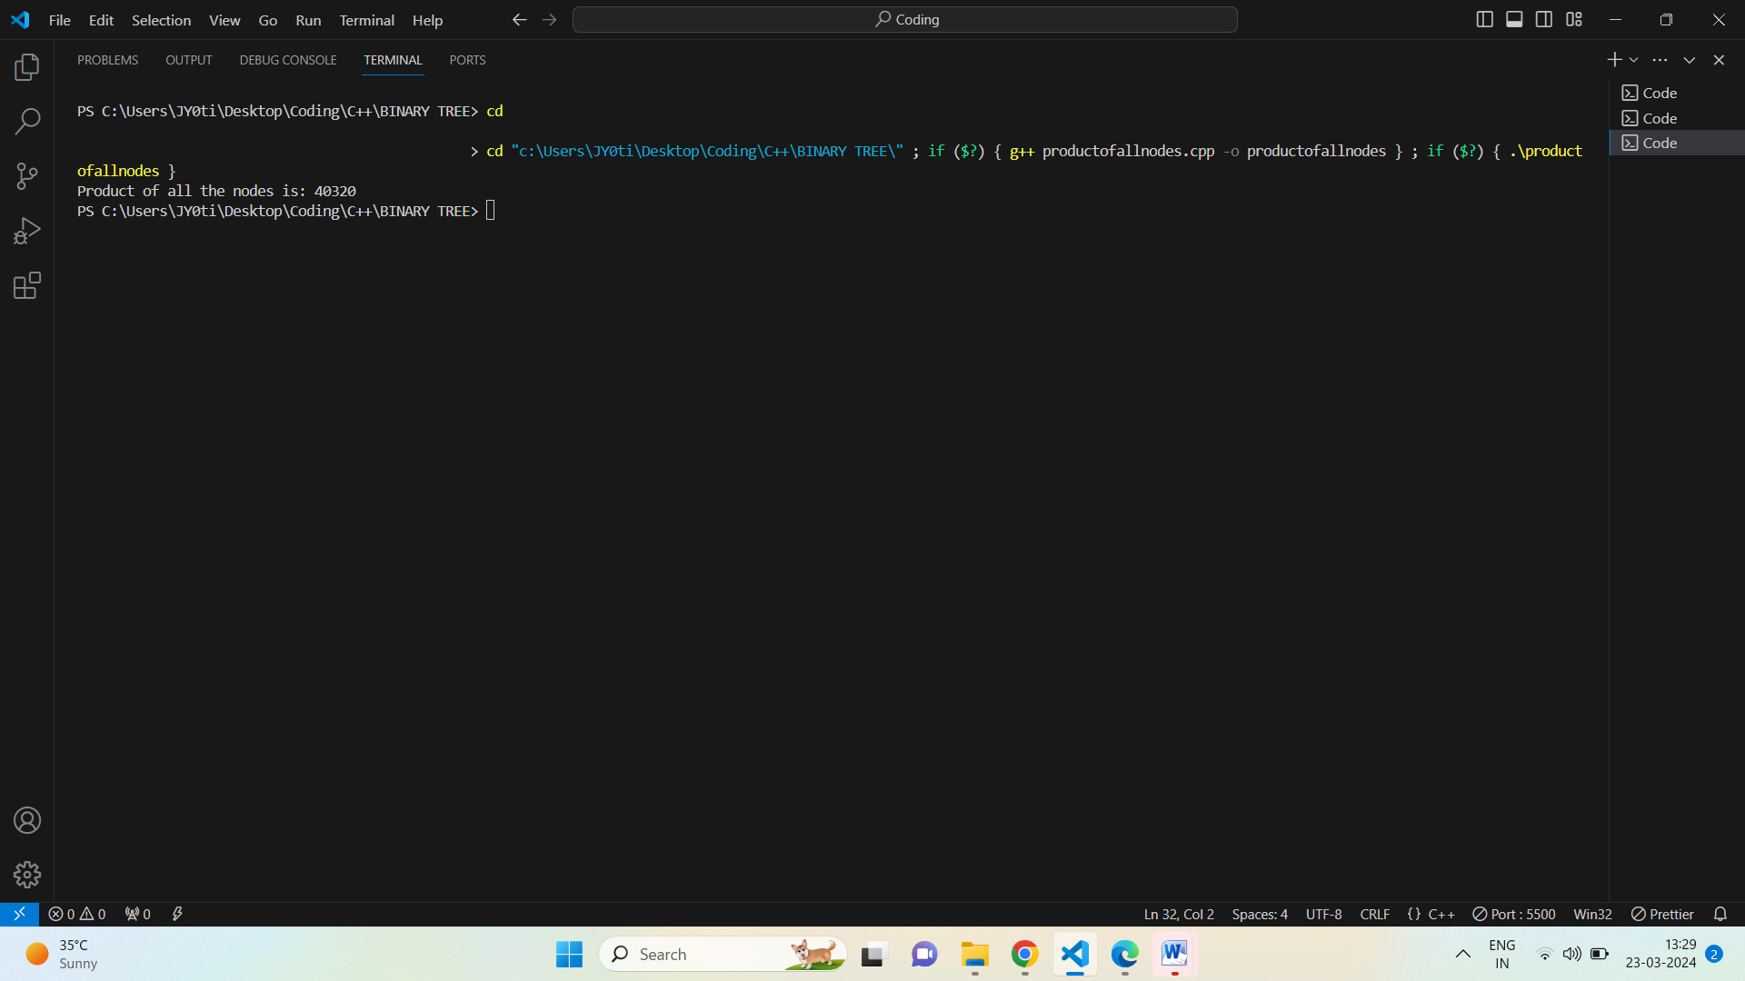

Q2)Minimum element in the binary tree

Code :

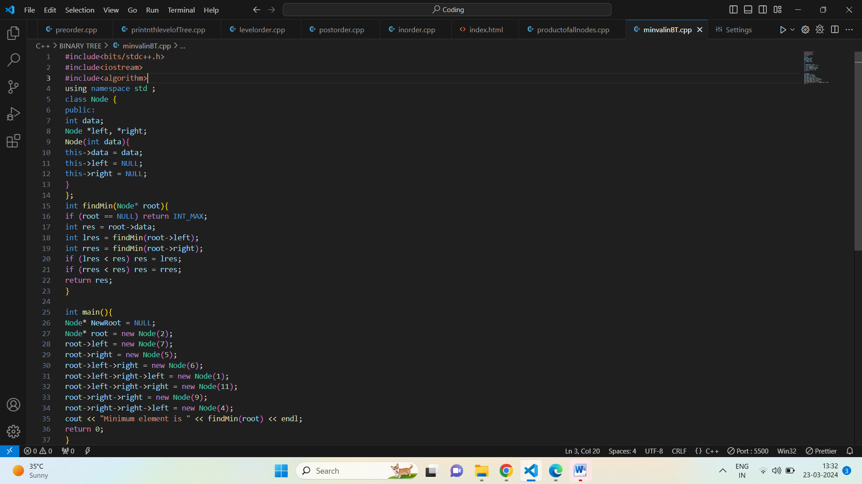

Output :

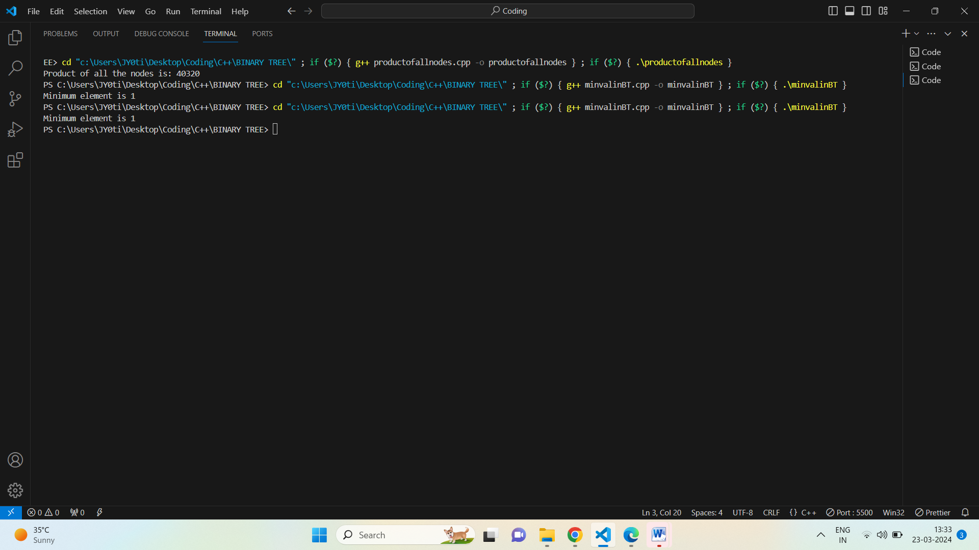

Q3)

Code :

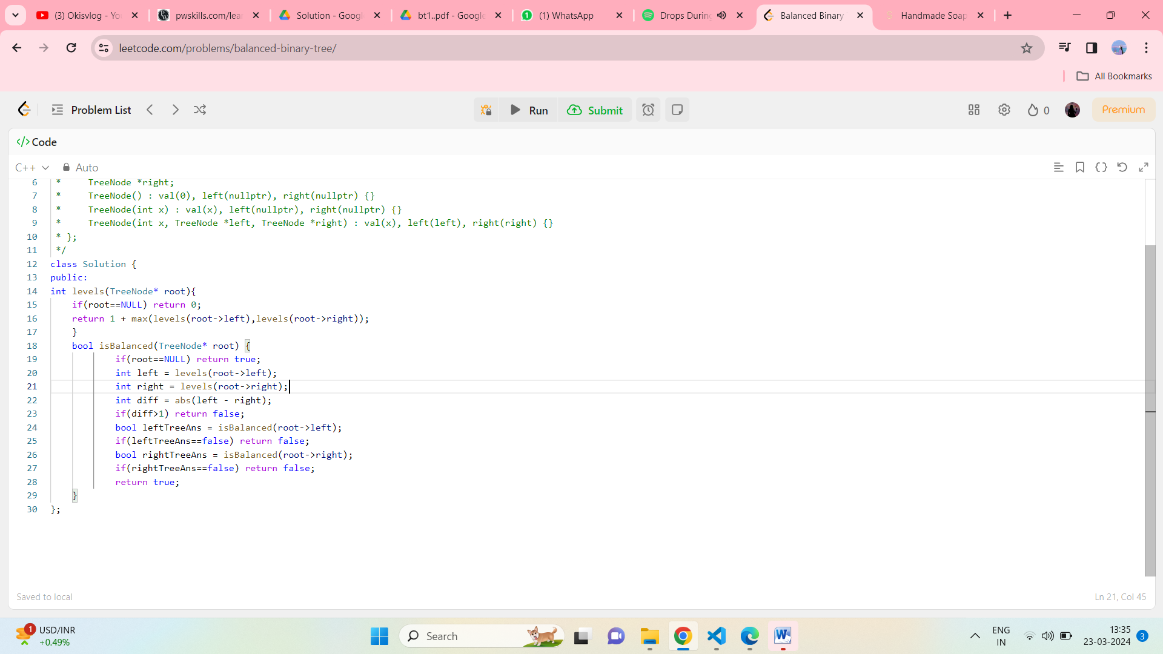

Output :

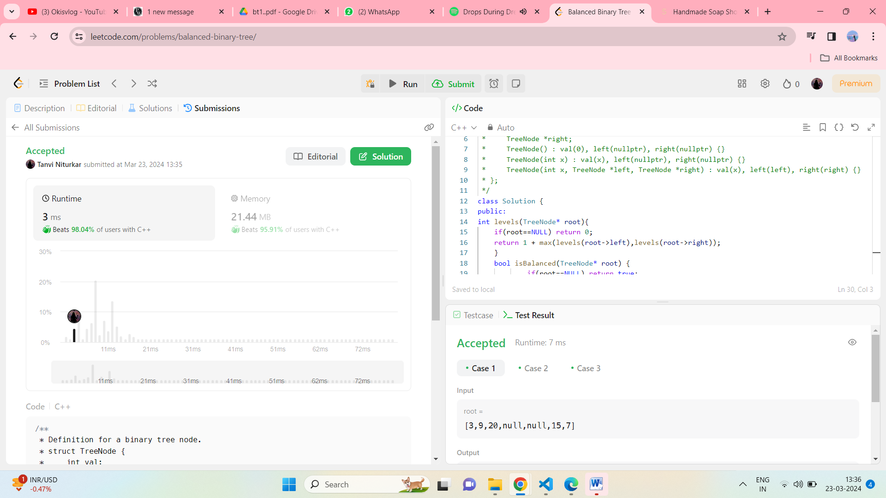

Q4)

Code :

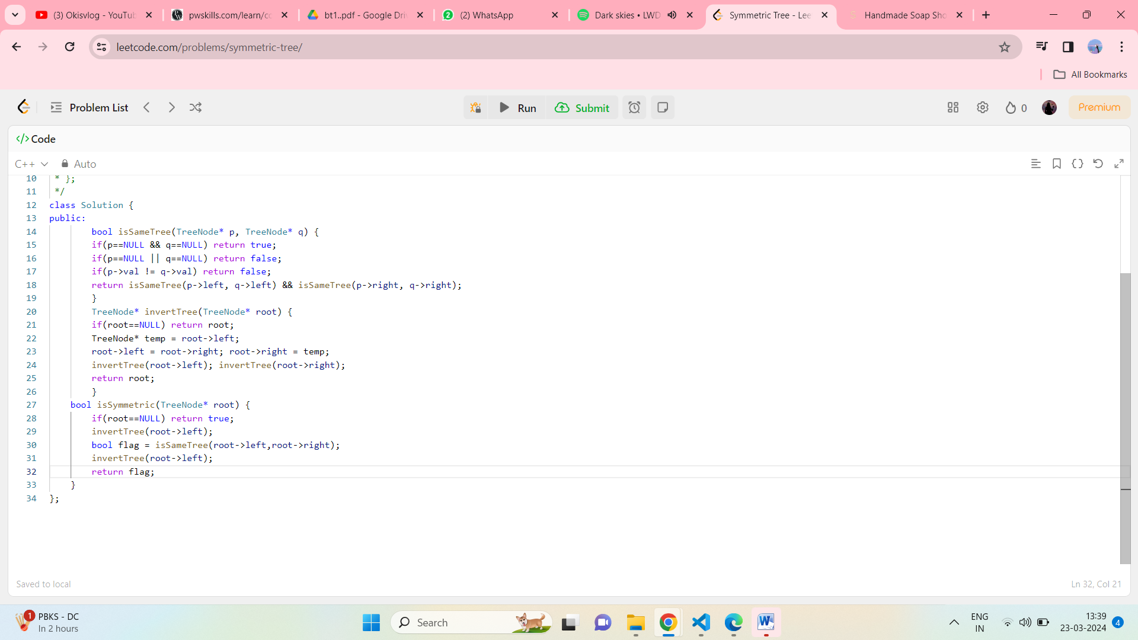

Output :

