Assignment solution binary tree 3

Q1)code :

class Solution {

public:

void helper(TreeNode *root, int level, vector<int> &ans){

if(root==NULL) return ;

if(ans.size()==level) ans.push_back(root->val);

helper(root->left, level+1, ans);

helper(root->right, level+1, ans);

}

vector<int> leftSideView(TreeNode *root) {

vector<int> ans;

helper(root, 0, ans);

return ans;

}

};

Q2)leetcode 112

Code ;

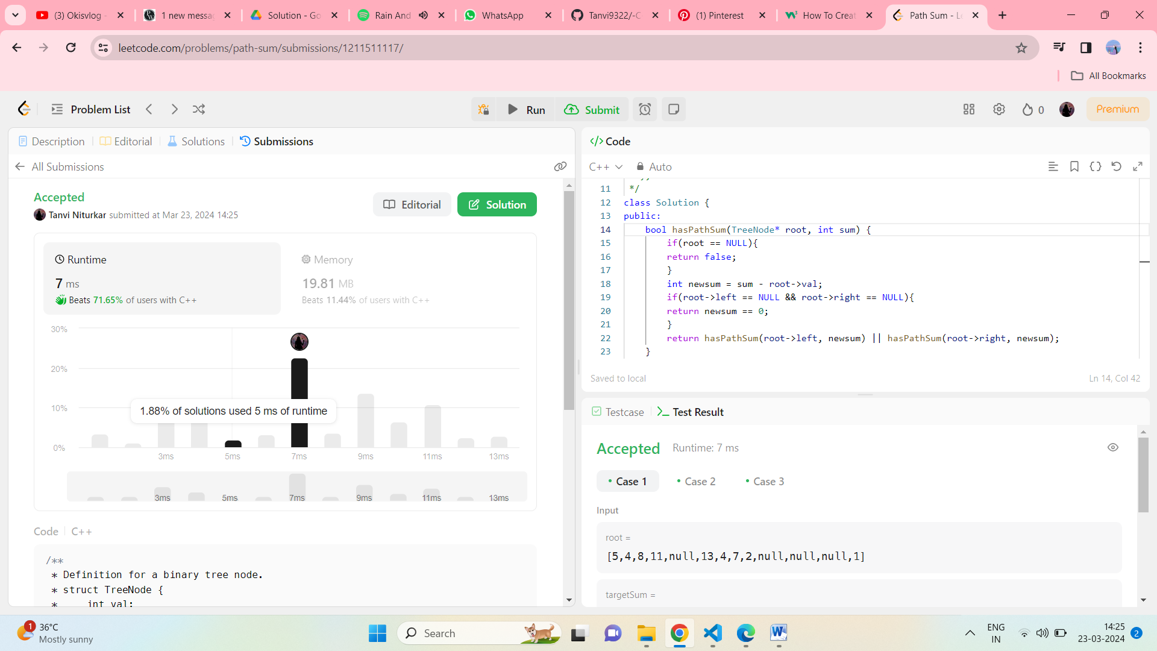

Q3)

Code :

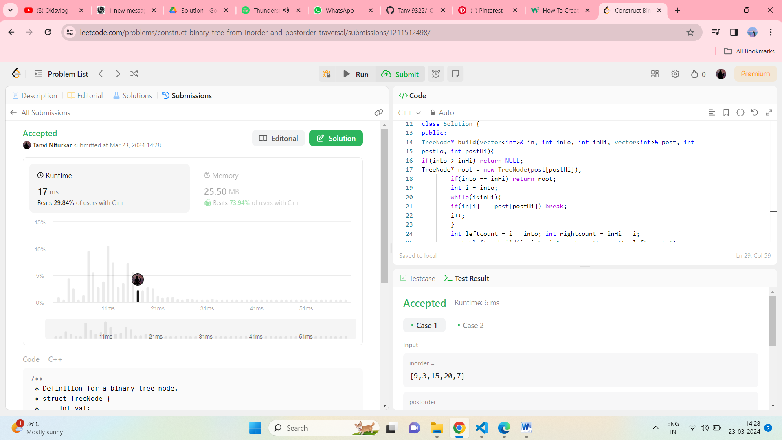

Q4) output :

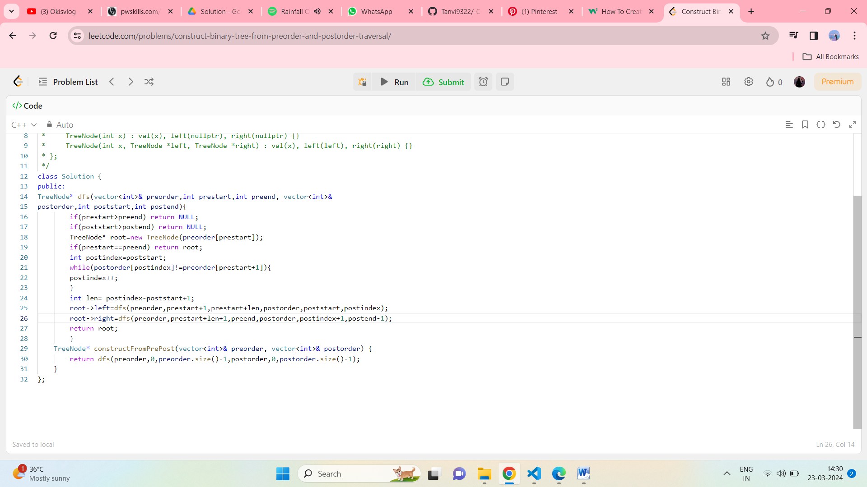

Output :

