Please book below flight and train for me ( Sawan Desai ) and Gaumishbhai ( Gaumish Patel)
Travel date : out bound journey date : 21/04/2026
In bound journey date : 22/04//2026

flight lhr – madrid £650
train madrid to Barcelona £95.00
hotel stay between 265-290 - £275
total expense : £1020
airport car park booking required for vehicle reg : RA08 HLG

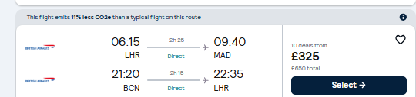

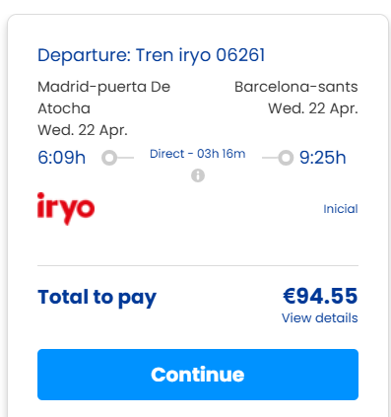

Below are the link for the hotel. Find the hotel near to the train station in Madrid. 4 start hotel require with one twin sharing base room as one of the director is traveling with me.

https://www.booking.com/searchresults.en-gb.html?label=atocha-vnFar8lvfp_XEPxvBHJtxwS388465683828%3Apl%3Ata%3Ap1%3Ap2%3Aac%3Aap%3Aneg%3Afi%3Atikwd-301368937182%3Alp9194102%3Ali%3Adec%3Adm%3Appccp%3DUmFuZG9tSVYkc2RlIyh9YfOICo1LOVmejEBpLq7NOGI&sid=e8c039a1002804c96bdbac21aeb1efcc&aid=314919&checkin=2026-04-21&checkout=2026-04-22&dest_id=-390625&dest_type=city&srpvid=483d3d316bf604c6&nflt=tdb%3D2%3Bprice%3DGBP-min-300-1%3Bht_id%3D204%3Bmealplan%3D1%3Broomfacility%3D11%3Bdistance%3D1610&order=price

please share all details before final booking.
Feel free to reach out to me on sawan.desai@astutehealthcare.co.uk
Call : +447533510881

