**Developing an Aggregator Platform for B&B Units**

**By**

**Tanvi Dhupkar - 10508427**

**Nikhil Aasnikar - 10360623**

Table of Contents

1. Introduction 3

1.1 Industry background and potential 3

1.2 Related business case studies 4

2. Approach 4

3. Development Process 5

3.1.1 Requirement Validation 5

3.1.2 Requirement analysis 6

3.1..3 Development Platform 6

3.1.4 Web API 6

3.1.5 Mail forms 7

3.1.6 Database design 7

3.1.7 Landing Page 8

3.1.8 Login/Registration 10

3.1.9 Query Widget 12

4. Conclusion and future prospects 12

5. References 13

6. Appendix 14

6.1 Application Screenshots 14

6.2 List of cities supported by Openweathermap 17

List of Figures

Figure 1 ER diagram 7

Figure 2 Weather widget controller segment 8

Figure 3 Weather widget view structure 9

Figure 4 B&B Listing view section 9

Figure 5 List of functions and description relating to B&B listing, reviewing and commenting 10

Figure 6 Login controller code snippet 10

Figure 7 Registration and logout controller snippet 11

Figure 8 Code snippet for Google OAuth 11

Figure 9 Climate information widget 14

Figure 10 B&B Listing 14

Figure 11 Login section 15

Figure 12 Signup section 15

Figure 13 Detailed B&B view 16

Figure 14 B&B review section 16

Figure 15 List of first 105 cities listed in supported city list of Openweathermap. 17

# 1. Introduction

## 1.1 Industry background and potential

The Irish Bed and Breakfast business is one of the most important secondary sources of income for Irish citizens. With overnight stays at Irish BBs clocking as high as an estimated eight million in 1999 (The Irish Times, 2019), the Irish B&B business has the potential to contribute and play a major role in Irish tourism GDP. Furthermore, the reports from Central Statistics Office, Ireland, shows a constant and steady rise in non-resident tourists with 4.3 million trips in 2016, 4.7 million in 2017 and 5.2 million in 2018, with an average length of stay of 6.4 nights (Central Statistics Office, 2019). A comparative study in non-resident tourists footfall in Ireland for the first Quarter shows a rise in 5.5%, as compared with Q1 of 2018 (Central Statistics Office, 2019). Kate Burns, the chairperson of the Town Country Homes Association, a marketing group for B&B owners, in an interview with Irish Times stated that the majority of North American and European visitors to Ireland choose B&B (The Irish Times, 2019). This is a clear indicator of the contribution potential a traditional B&B business can have.

## 1.2 Related business case studies

Family Homes of Ireland, BandB Ireland, and B&B owners association are three major B&B business associations that provided booking options of all of Ireland B&Bs and played a major part in Ireland tourism industry until the Great Recession of 2007 (HISTORY, 2019). However, a sharp decline in the closure of B&B enterprises followed the Great Recession as revenue dropped. Many of the B&Bs that retained business lost up to 50% of their margin as OTAs began dominating the market (Bnbowners.com, 2019). By 2012 BandB Ireland and B&B Owners Association adapted to the market, by making use of collective marketing and low-cost online bookings by removing middlemen. Creation of this common platform having access and details to association enrolled B&B properties, increased the revenue. However significant progress was not made, because of lack in high user interaction and footfall creation.

Airbnb Inc. is a classic case study on how to improve the footfall in B&B business. Airbnb Inc. a multinational B&B facilitation portal incorporates B&B properties in their portal and allows for online booking and other management functions. The main reason for the success of the company which is worth 38 billion US Dollars according to Forbes (Forbes.com, 2019), is the QoS they offer. Unlike the traditional B&B units which function independently and has its own standards of maintenance, Airbnb has standardization requirements that every enrolled vendor needs to follow. This effectively increased the standard of enrolled B&B units increasing the footfall and booking frequency.

# 2. Approach

Direct approach of integration of services are enabled in the development process of this project. Due to its non-transactional nature and strictly minimal business intend or nature, the project requires minimum third party validation. Basic integration of services will be web based application designed and developed to be compatible with most of the commonly available Linux servers. The application may be hosted on free shared hosting servers or available free student version servers.

Although validations from third party vendors or users are not mandatory due to stated reasons, the applications includes third party API integrators –

1. Open Weather Map – for climatic data presentation and
2. Google developer API for Oauth services – open authorization from google services are utilized due to the common availability of the Google service users.

All the third party service integrations are carried as per norms and guidelines suggested/mandated by the API provider.

**3. Development Process**

### 3.1.1 Requirement Validation

Based on the research following factors/data were observed (validation assumes Ireland as the sole market for project deployment):

1. Majority of North American and European visitors still prefer B&B’s (The Irish Times, 2019)
2. There is a consistent rise in tourists at an average rate of 5.5% (Central Statistics Office, 2019)
3. 35% of accommodation properties in Ireland and registered B&B’s (Fáilte Ireland, 2018) and additional estimated 15000 unregistered B&B’s operate all throughout the country (The Irish Times, 2019).
4. Airbnb, and OYO in European market (as OYO is yet to launch services in Ireland), promote and approve only B&B’s and rooms that act in a franchise model of operation and do not entertain the traditional B&B’s.
5. Booking.com, a possible portal with similar working model, acts as a platform for booking of B&B’s and Hotel rooms, and they require the B&B owners to list their property in their portal and charges in commission per booking basis. Hence they does not address the base problem that this project is trying to solve.
6. Trivago is the perhaps the closest working model to the proposed working model, wherein features like rate comparison and user star rating are displayed helping tourists select the best possible rates and B&Bs. However Trivago pulls up information from other portals and does not list B&B’s that are either not listed or very low in popularity due to their lower booking rates in other booking portals. They also do not list or share information on any unregistered B&B’s.

Based on these initial market analysis it was concluded that an information portal on B&B’s, both registered and unregistered, which are listed by the administrators and reviewed by the users are essential to inform the possible B&B customers on the accommodation rates, the quality of service and its registration status. This creates an awareness among the users on availability of various B&B’s which are not listed otherwise in any portals and also at the same time give the users unbiased feedback reviews from previous users of the corresponding B&B service.

### 3.1.2 Requirement analysis

The basic requirements for this project are:

1. Administrator section for addition/modification of B&B’s
2. Weather indication of selected places in Ireland
3. Provision for B&B rating and comments for registered users
4. Provision for registered users to send queries to B&B owners

**3.1.3 Development Platform**

The base programming language selected for the development of the application is PHP. Since the application is a simple operational platform with minimal security aspect and does not contain any transactional aspects or such modules which requires extensive security measures, development of this application in programming languages such as .Net, Python and Angular etc. had less significance. The selection also considered the learning curve for development in such platforms and had significantly higher learning curve than PHP. However, PHP does not explicitly use Secure By Design concept unlike other considered languages. Owing to the same, chances of security vulnerabilities such as XML injection attacks, cross-site scripting, stream injection attacks, and SSL/TLS misconfiguration issues etc. are high when compared along with personal programming expertise. This is overcome by using platforms/frameworks for development in PHP (similar platforms based on other languages may also be found), such as CakePHP, Laravel, and Codeignitor etc. Since the comparative learning curve for Laravel is high and the CakePHP framework is now obsolete, Codeignitor is considered for the development of the application.

The database considered for application data management is MySQL. With intend on deploying the application to free, shared linux servers, MySQL, Postgre SQL and MongoDB were initially considered for usage. The detailed study of requirement revealed the maximum B&B entities in Ireland (which is the considered case for region of interest), will be less than 25,000. This ensured the satisfactory performance of MySQL, as it has performance issues in massive databases and that the project’s database is small in size. Postgre SQL on other hand has advantages of NoSQL and MongoDB is entirely a NoSQL database; these databases are commonly used where the database size is very large and requires faster operational speeds. As these parameters do not fit to our requirements, both MongoDB and Postgre SQL were avoided and MySQL was selected for the development purposes.

### 3.1.4 Web API

Weather information on select places in Ireland is added along with the base requirements to serve as a value addition to the project. This information was added after few face-face interview with some tourists, who were concerned with sporadic rains they have experienced during their stay in Ireland. Free weather API is used for the displaying this information atop the landing page of the application.

* Weather API Provider: Open Weather Map
* API Link: http://api.openweathermap.org/data/2.5/weather
* API Key: d828bc57d263d11b348eba143fa7c5c8

Secure practices as suggested by the API provider has been utilized for this widget development.

### 3.1.5 Mail forms

Web forms are utilized to collect query data to be send to a specific listed B&B and based on the mailing information of the B&B retrieved from the database, these queries are transferred to the recipient as email, using SMTP on TCP in port 587. To restrict anonymity of queries only logged in users are allowed to sent queries and the details of users (Name, email ID and contact number), are shared via email to preserve the integrity of the queries.

### 3.1.6 Database design

The application has simple requirement of storing destinations and its relational entities and users and its relational entities. It hence requires two tables namely “comments table” (tbl_comments), for holding the destination details and comments, rating and the user contributing the reviews, and “user’s table” (tbl_user) for holding user credentials such as id, name email, phone, username, and password etc. The ER diagram of the database is given below.

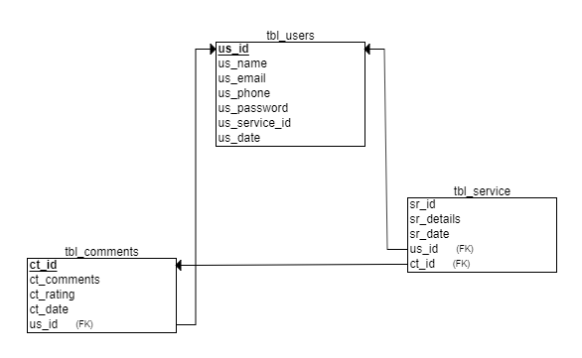

Figure ER diagram

### 3.1.7 Landing Page

The landing page consists of three essential parts:

#### User Login link

The user login link is linked to Login.php and login_view.php representing the controller and the view section respectively, and are discussed in detailed in section 3.3.2

#### Weather widget

The weather widget as discussed in elaboration phase was the value added service added to the original design to facilitate the tourist information on general weather condition. The API provided by Open Weather Map is used to display the same. The widget controller file is placed inside the /application/controllers/Home.php. The screenshot of the same along with its corresponding widget display section inside the view structure are attached below.

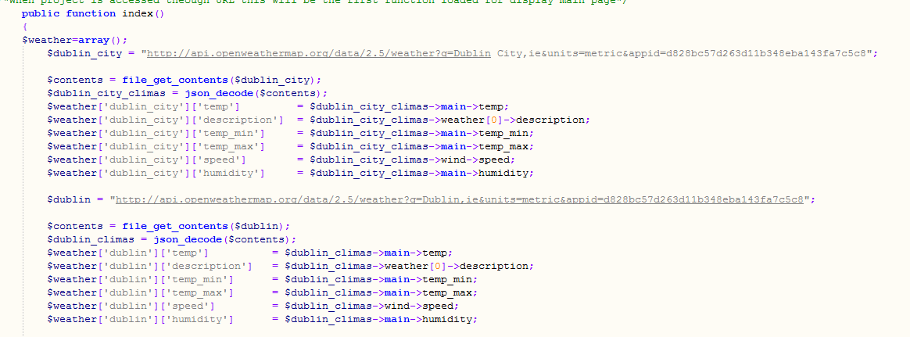

Figure Weather widget controller segment

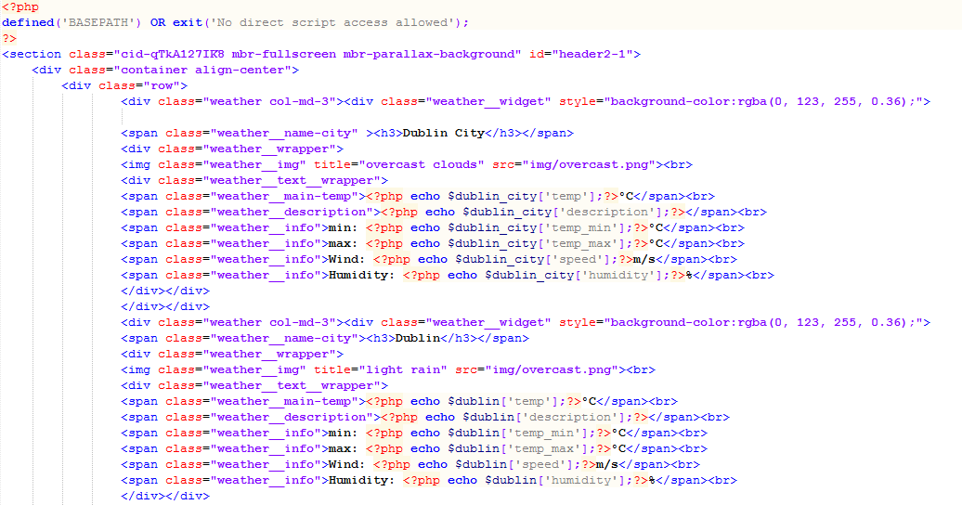

Figure Weather widget view structure

The data fetched from weather API is real time and can be used to access climatic data from 116,506 cities worldwide and are listed in “city.list.json” file documented by the API provider (included in the appendix).

#### B&B listing

The listing of B&B in the landing page is static in nature and is given detaileddestination.php inside the views structure of the application folder. However the comments and reviews are dynamically fetched from the database and displayed in the detailed view. The code snippet of one of the listing is shown in the figure below.

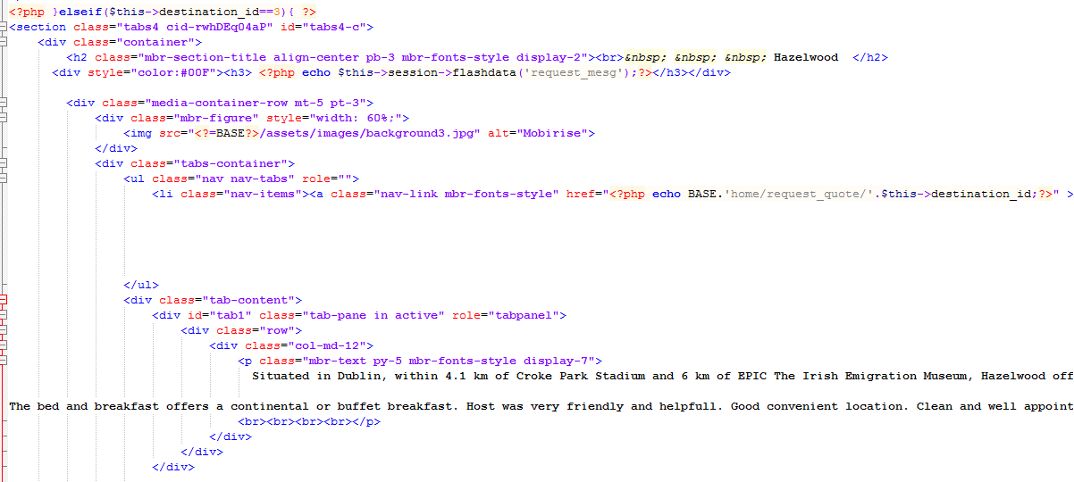

Figure B&B Listing view section

Each of the listing when clicked opens in different page having detailed description and provision to leave rating and comments and also ask queries directly to the B&B owner. The rating and commenting are controlled by Destination.php in the controller segment of the application directory and functions in Destination_model.php (contained in the model structure) contains functions for adding and retrieving data from database.

The following are listed are the major functions associated with the destination listing, review and commenting.

|  |  |
| --- | --- |
| destination_detail($destin_id='') | display detail view of destination |
| add_comment($data='') | add new entry to tbl_comments (table) when user add review comment |
| update_comment($data='',$comment_id='') | Update tbl_comments entry when user add review comment |
| get_user_comment($user_id='',$destination_id='') | Get user updated comment |
| get_desination_comment($destination_id='') | Get all comments for the displayed destination |
| get_desination_total($destination_id='') | Get the total star reviews for displayed destination |

Figure List of functions and description relating to B&B listing, reviewing and commenting

### 3.1.8 Login/Registration

Login and registration processes are handled in 3 separate ways.

1. Users having preregistered accounts can login directly using their username (essentially the email id given during sign up) and password. The view section of the same is handled by the login_view.php file inside the view structure. The controller script is written in the Login.php file inside the controller structure (\application\controllers\Login.php).
2. Legacy registration are controlled by the same script as of login in controller section (i.e. Login.php), and the view section is executed by the script signup_view.php. The registration allows the users registering to upload profile pictures using the FTP protocol
3. The application supports Google Oauth for registrations and are controlled by using Oauth 2.0 protocol for authentication and authorization as per API provider mandate. For initializing client ID and client secret are obtained from the Google API console. This is configured using PHP usage templates provided by googleapis github repository (GitHub, 2019) to include google oauth in the application.

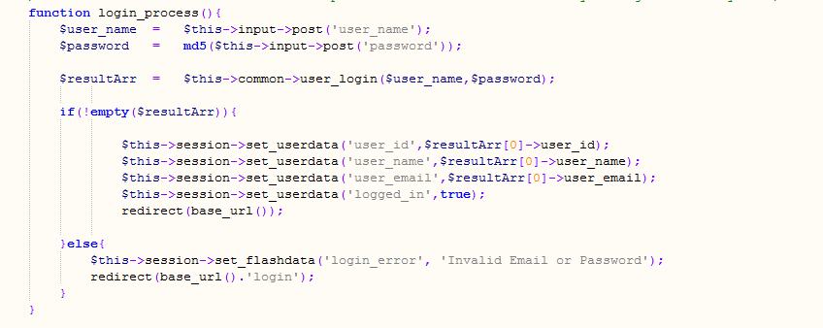

Figure Login controller code snippet

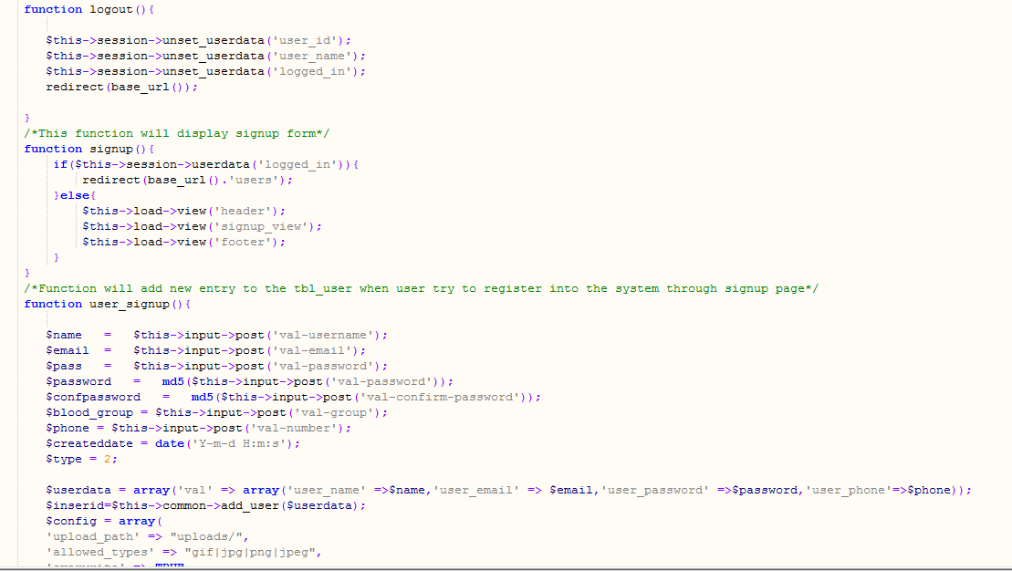

Figure Registration and logout controller snippet

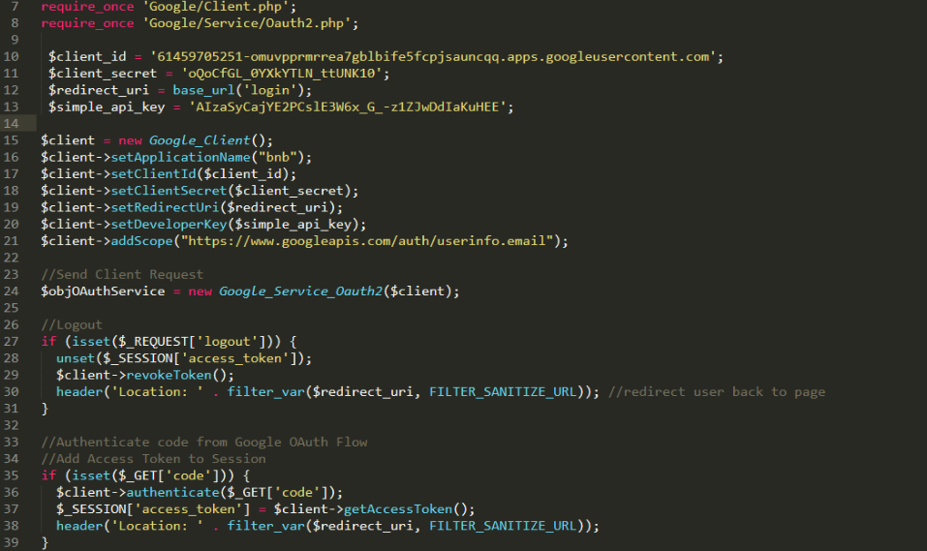

Figure Code snippet for Google OAuth

### 3.1.9 Query Widget

The query sending widget is placed inside the detailed view of the B&B listing, which also houses the widgets for commenting and star rating review provisions. The query segment requires authenticated users to preserve the integrity of the user and the data for the query mail is collected using a text box. Since the users are pre-authenticated, the user details are automatically attached along with the mail body and send to the B&B owner. PHP mailer is used to achieve this functionality and its dependency files are included inside the third_party directory inside the application folder.

# 4. Conclusion and future prospects

With a consistent tourism growth rate marked at an average of 5.5%, the Ireland tourism industry has significantly grown from the great recession of 2007. However due to rising numbers in hoteliers and web platforms promoting and attracting customers to their segment of business, and the division in major B&B associations, B&B business has failed to create a unified promotional approach where unbiased opinions are available for the tourists to decide on their choice of accommodation.

The application developed addresses this void which has been long standing, and gained importance since the start of high closure rates of traditional B&Bs. The application creates an interactive platform where users are free to select and are provided with unbiased user reviews and comments from other users who had experienced the comfort of the B&Bs being reviewed upon. Also being a third party application the portal also includes all B&B’s registered/unregistered and provides users with transparent information.

The application can in future host commission based booking facilities, and can include customized activity packages by including existing service providers along with B&B’s. Such an inclusion will ensure higher rate of customer flow through the application and can then be a sustainable tourism project which promotes traditional B&Bs and activities which otherwise are monopoly to huge resort segments.

# 5. References

1. Investopedia. (2019). *Amazon Effect*. [online] Available at: https://www.investopedia.com/terms/a/amazon-effect.asp.
2. Forbes.com. (2019). *As A Rare Profitable Unicorn, Airbnb Appears To Be Worth At Least $38 Billion*. [online] Available at: https://www.forbes.com/sites/greatspeculations/2018/05/11/as-a-rare-profitable-unicorn-airbnb-appears-to-be-worth-at-least-38-billion/#112ad1b62741.
3. Bnbowners.com. (2019). *About the Irish B&B Owners Association*. [online] Bnbowners.com. Available at: https://bnbowners.com/about.php.
4. Fáilte Ireland (2018). *National Accommodation Capacity*. [online] Fáilte Ireland. Available at: http://www.failteireland.ie/FailteIreland/media/WebsiteStructure/Documents/3_Research_Insights/3_General_SurveysReports/Accommodation-Capacity-in-Ireland-2018.pdf?ext=.pdf.
5. HISTORY. (2019). *Great Recession*. [online] Available at: https://www.history.com/topics/21st-century/recession.
6. Budget Your Trip. (2019). *Ireland Travel Costs & Prices - Pub Crawls, the Cliffs of Moher & Blarney Castle | BudgetYourTrip.com*. [online] Available at: https://www.budgetyourtrip.com/ireland.
7. The Irish Times. (2019). *Ireland's cottage industry*. [online] Available at: https://www.irishtimes.com/life-and-style/travel/ireland-s-cottage-industry-1.
8. Bandbireland.com. (2019). *B&B Star Rating and Classification | B&B Ireland*. [online] Bandbireland.com. Available at: https://www.bandbireland.com/feature/accommodation/b-b-star-rating-and-classification.
9. Central Statistics Office. (2019). *TMA08: Overseas Trips to and from Ireland by Reason for Journey, Year and Statistic*. [online] Available at: https://www.cso.ie/px/pxeirestat/Statire/SelectVarVal/saveselections.asp.
10. Central Statistics Office. (2019). *Tourism and Travel*. [online] Available at: https://www.cso.ie/en/statistics/tourismandtravel/tourismandtravel/.
11. The Irish Times. (2019). *Unregistered B&Bs cited as major problem*. [online] Available at: https://www.irishtimes.com/news/unregistered-b-bs-cited-as-major-problem-1.657138.
12. Techterms.com. (2019). *RUP (Rational Unified Process) Definition*. [online] Available at: https://techterms.com/definition/rup.
13. GitHub. (2019). *googleapis/google-api-php-client*. [online] Available at: https://github.com/googleapis/google-api-php-client.

# 6. Appendix

## 6.1 Application Screenshots

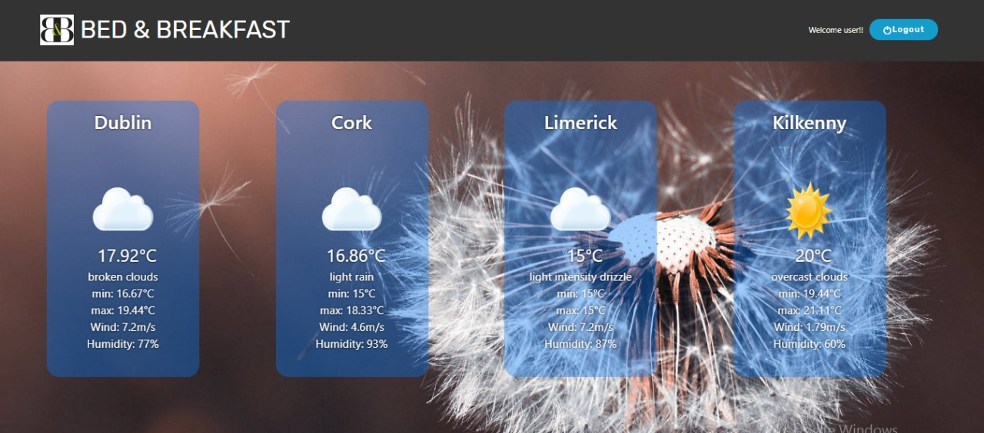

Figure Climate information widget

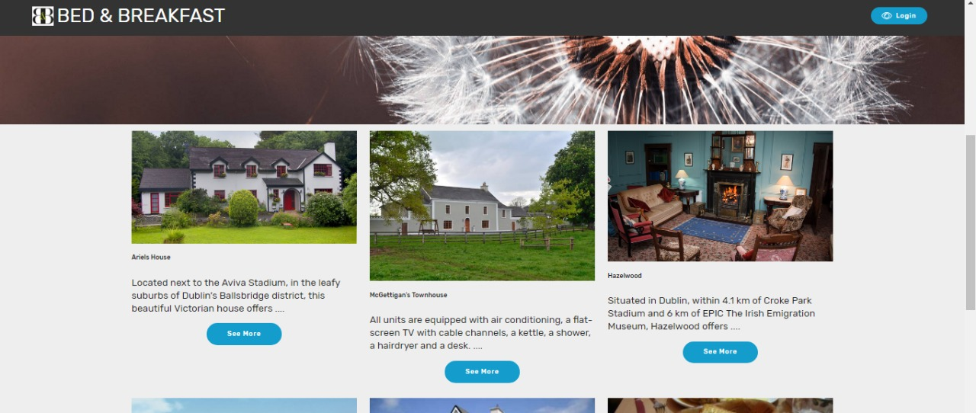

Figure B&B Listing

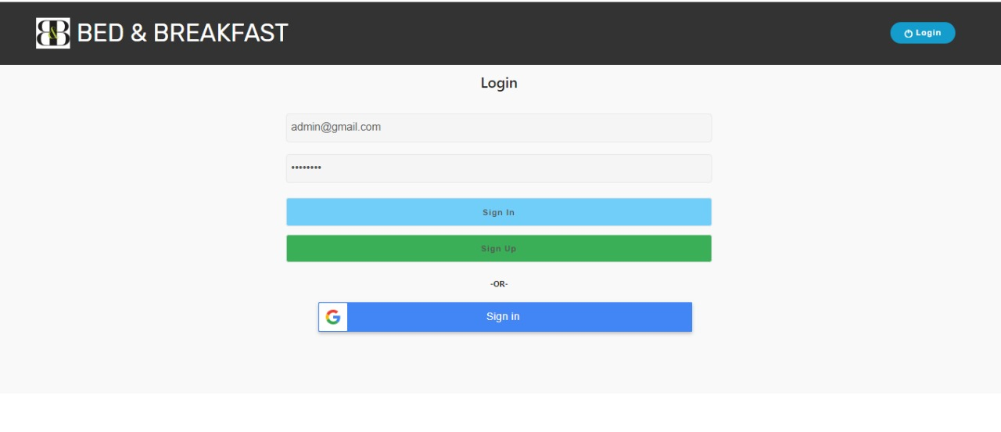

Figure Login section

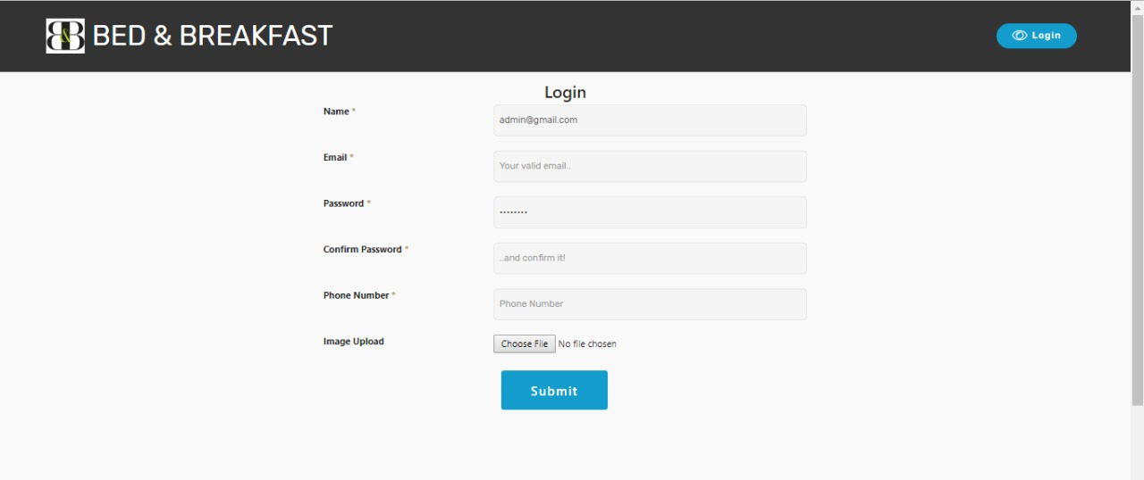

Figure Signup section

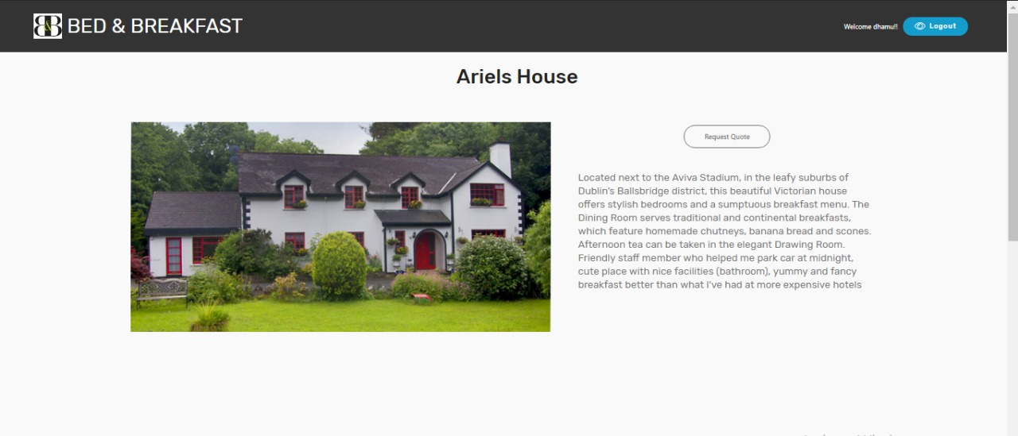

Figure Detailed B&B view

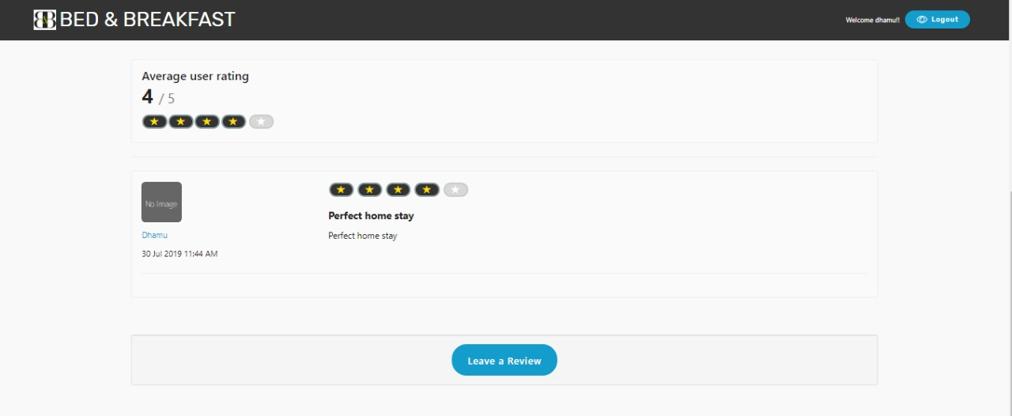

Figure B&B review section

## 6.2 List of cities supported by Openweathermap

Only first 105 out of 116,506 cities listed in the json file provided by the openweathermap “city.list” is listed as a table below

|  |  |  |
| --- | --- | --- |
| Hurzuf | Lhasa | Bee House |
| Novinki | İstanbul | Morden |
| Gorkhā | Mao | Nasirotu |
| State of Haryāna | Russian Federation | Sisali |
| Holubynka | De-Friz | Puntan |
| Bāgmatī Zone | Rumbak | Tsiémé-Mandiélé |
| Mar’ina Roshcha | Vavibet | Masama |
| Republic of India | Surtagān Chib | Purukcahu |
| Kathmandu | Rīgas Rajons | Néméyong II |
| Laspi | Verkhneye Shchekotikhino | Pondok Genteng |
| Merida | Bucha | Mbongoté |
| Vinogradovo | Republic of Poland | Amiling |
| Qarah Gawl al ‘Ulyā | Kuchary | Kélkoto |
| Cherkizovo | North America | Angetu |
| Alupka | Brumaire | Massa |
| Lichtenrade | Ishikawa-ken | Tumko |
| Zavety Il’icha | Matoba | Moskva |
| ‘Azriqam | Pya | Japan |
| Ghūra | Kalanac | Hokkaidō |
| Tyuzler | Federal Republic of Germany | Sanggrahan |
| Zaponor’ye | Land Nordrhein-Westfalen | Karangmangle |
| Il’ichëvka | Mutaykutan | Sheremetyevskiy |
| Partyzans’ke | Nalchik | Yershovo |
| Yurevichi | Kolganov | Znamenka |
| Gumist’a | Rybatskiy | Lisbon |
| Ptitsefabrika | Bellara | Walbrzych |
| Orekhovo | Bartlett | Naklo nad Notecia |
| Birim | Rietfontein | Zhengzhou |
| Priiskovyy | Hardap | Tonyrefail |
| Dzhaga | Botswana | Bankra |
| Tret’ya Rota | El Destierro | Europe |
| Ruislip | Jones Crossroads | Moskovskaya Oblast’ |
| Karow | Vernon Parish | Provo |
| Gatow | Pennick | Tejon |
| Mkuze | Black Bear Spring | Guliston |

Figure List of first 105 cities listed in supported city list of Openweathermap.