**Aim : You are required to apply five different regression techniques on the dataset assigned to you. Each student has been given a unique dataset to ensure individual analysis.**

**Perform the following tasks: Data Understanding & Preprocessing, Model Implementation, Performance Evaluation, Analysis & Insights.**

**Data Understanding**

**Code:**

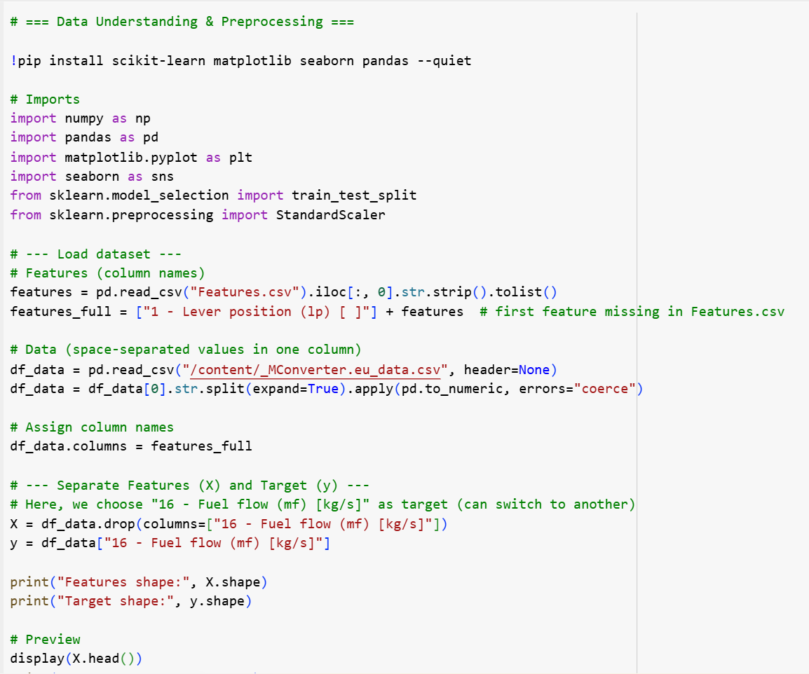

**Output:**

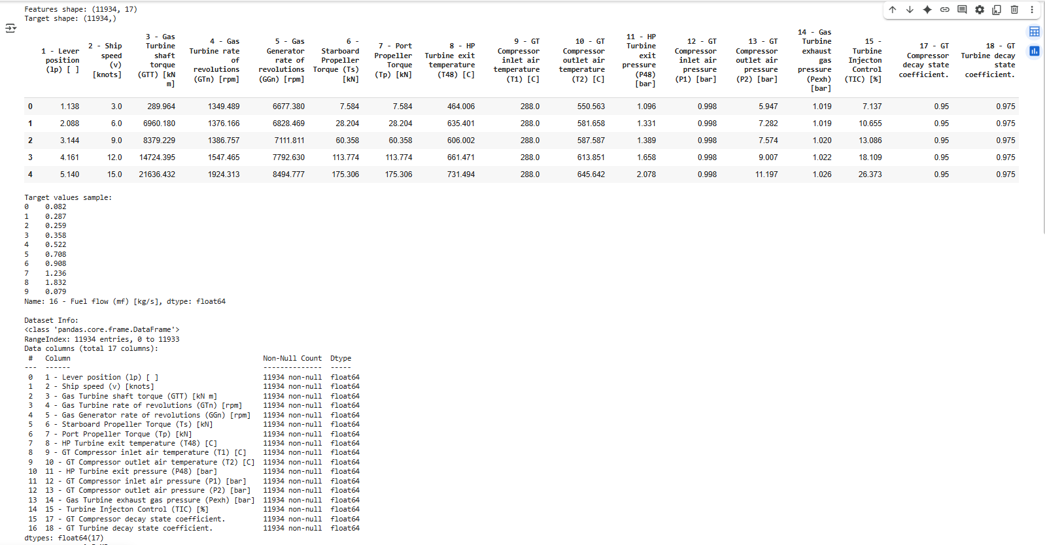

**Model Implementation**

**Performance Evaluation**

**Analysis & Insights**

