

**School of Computer Engineering & Technology**

**Capstone Project Synopsis**

**Group No**: Group 2

**Team Member Details:**

| **Name** | **PRN** | **Email** | **Mobile Number** |
| --- | --- | --- | --- |
| Joella Susan Jacob | 1032200637 | 1032200637@mitwpu.edu.in | +917020509156 |
| Urvi Bhavesh Desai | 1032200434 | 1032200434@mitwup.edu.in | +919167727909 |
| Tanvi Sachin Kulkarni | 1032200891 | 1032200891@mitwpu.edu.in | +919960336548 |
| Nupur Patil | 1032202206 | 1032202206@mitwpu.edu.in | +918806517919 |

**Project Title:**  Design and Implementation of a Digital Twin for Subsea Air Compressor

**Project Domain:** Machine Learning

**InHouse Project:** Yes

**Abstract:**

Subsea laboratories are essential for the research and testing of different systems and equipment used in offshore oil and gas production. Compressor systems are essential for gas compression and transportation in subsea environments. However, ensuring the reliability and efficiency of these systems presents significant challenges due to the harsh subsea conditions and the need for continuous monitoring and maintenance. Conventional maintenance methods are frequently reactive, increasing operational risks and resulting in expensive downtime. To address these challenges, we propose creating a "Digital Twin of a Subsea Air Compressor".

The project encompasses a 3D compressor system model tailored to the distinct architecture and components found in the subsea laboratory environments. The data collected was used for predicting factors such as air pressure, temperature, etc. The predictions will then be integrated into the 3D model to form a Unidirectional Digital Twin. Machine learning algorithms analyze compressor data and detect potential faults or anomalies. Based on the insights generated by the algorithms, we assess their effectiveness through simulations. This would thereby minimize the risk of failures and their associated cost. The goal of the project is to improve the reliability, efficiency, and safety of the double reciprocating compressor system at the MIT-WPU Subsea Engineering Laboratory, ultimately contributing to the advancement of offshore energy research and development.

**Project Objectives:**

* To create a Detailed 3D Model: Build a three-dimensional (3D) model of the double reciprocating compressor system used in subsea laboratories, accurately representing its architecture and subsea-specific components.
* To create a Digital Twin: Integrate the data into the 3D model to create a digital twin of the double reciprocating compressor system, providing a virtual representation of the actual system, capable of running simulations on hypothetical values.
* To apply Machine Learning Algorithms: Use advanced machine learning algorithms to analyze data, make predictions and detect potential failures in the operation of the double reciprocating compressor system.
* To indicate if simulation values exceed acceptable limits:Create a system capable of raising an alarm or giving indications in case acceptable thresholds for normal execution are exceeded.

**Individual Contribution:**

1. **Joella Jacob**
   1. Implementation of ML Models such as Polynomial Regression and Random Forest for Air Flow Rate.
   2. Implementation of ML Models such as Polynomial Regression, Random Forest and Long Short-Term Memory (LSTM) for Outlet Temperature and Outlet Pressure.
   3. Implementation of the digital twin (3D model) using Blender for demonstrating simulations for detecting potential faults or anomalies.
   4. Integration of ML models with the digital twin for raising alerts for predicted values exceeding the given threshold.
2. **Urvi Desai**
   1. Implementation of ML Models such as XGBoost, Support Vector Regressor (SVR) for Air Flow Rate.
   2. Implementation of ML Models such as XGBoost, SVR, Multi Linear Regression (MLR) for Outlet Temperature and Outlet Pressure.
   3. Implementation of the digital twin (3D model) using Blender for demonstrating simulations for detecting potential faults or anomalies.
   4. Integration of ML models with the digital twin for raising alerts for predicted values exceeding the given threshold.
3. **Tanvi Kulkarni**
   1. Preprocessing of the dataset.
   2. Implementation of ML Models such as LSTM, Adaptive Boosting (AdaBoost), Gradient Boosting (GradBoost) and KNN for Air Flow Rate.
   3. Implementation of ML Models such as AdaBoost, GradBoost and K- Nearest Neighbour (KNN) for Outlet Temperature and Outlet Pressure.
   4. Implementation of the digital twin (3D model) using Blender for demonstrating simulations for detecting potential faults or anomalies.
   5. Integration of ML models with the digital twin for raising alerts for predicted values exceeding the given threshold.
4. **Nupur Patil**
   1. Implementation of the digital twin (3D model) using Blender for demonstrating simulations for detecting potential faults or anomalies.
   2. Integration of ML models with the digital twin for raising alerts for predicted value exceeding the given threshold.

**H/w & S/w Requirements:**

1. Blender
2. Python
3. AutoCAD

**High-Level Design:**

1. Use case Diagram:

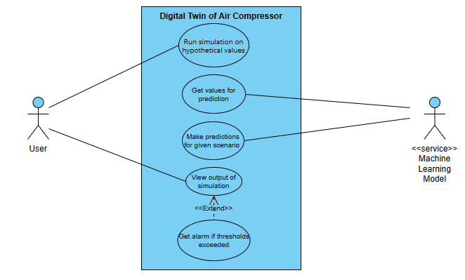

1. Activity Diagram:

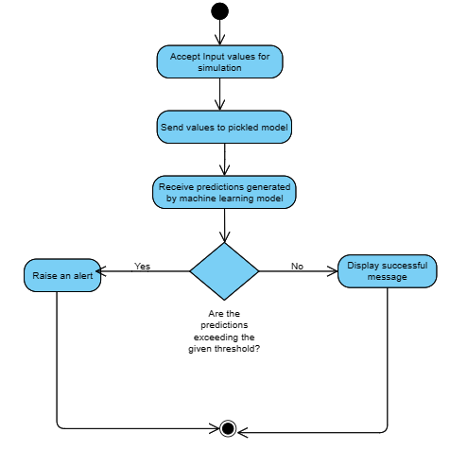

**Low-Level Design:**

1. Class Diagram:

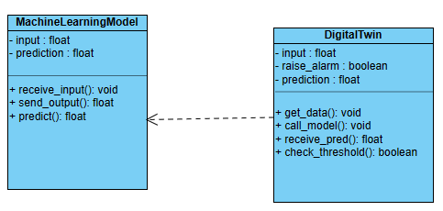

**Project Guide:** Dr. Mangesh Bedekar

**Signature:**

**Date:** 12.03.2024