**Aim:** To implement DDA algorithms for drawing a line segment between two given end points.

**Objective:** Draw the line using (vector) generation algorithms which determine the pixels that should be turned ON are called as digital differential analyzer (DDA).It is one of the techniques for obtaining a rasterized straight line. This algorithm can be used to draw the line in all the quadrants.

**Theory:**

DDA algorithm is an incremental scan conversion method. Here we perform calculations at each step using the results from the preceding step. The characteristic of the DDA algorithm is to take unit steps along one coordinate and compute the corresponding values along the other coordinate. Digital Differential Analyzer (DDA) algorithm is the simple line generation algorithm which is explained step by step here.

**Algorithm:**

**{**

**dx=x2-x1;**

**dy=y2-y1;**

**if(abs(dx) &gt; abs(dy)) {**

**step = dx;**

**} else {**

**step = dy;**

**}**

**Xn = dx/step;**

**Yn = dy/step;**

**for(i=0;i&lt;=step;i++)**

**{**

**putpixel(x1,y1,RED);**

**x1 = x1 + Xn;**

**y1 = y1 + Yn;**

**}**

**}**

**Program:**

**#include<stdio.h>**

**#include<conio.h>**

**#include<graphics.h>**

**#include<math.h>**

**void main()**

**{**

**int gd=DETECT,gm;**

**int x1,x2,y1,y2,xn,yn,dx,dy,step,i;**

**initgraph(&gd,&gm,"C:\\TURBOC3\\BGI");**

**clrscr();**

**printf("Enter x1,y1");**

**scanf("%d%d",&x1,&y1);**

**printf("Enter x2,y2");**

**scanf("%d%d",&x2,&y2);**

**dx=x2-x1;**

**dy=y2-y1;**

**if(abs(dx)>abs(dy))**

**{**

**step=dx;**

**}**

**else**

**{**

**step=dy;**

**}**

**xn=dx/step;**

**step=dy;**

**}**

**xn=dx/step;**

**yn=dy/step;**

**for(i=0;i<=step;i++)**

**{**

**putpixel(x1,y1,BLUE);**

**x1=x1+xn;**

**y1=y1+yn;**

**}**

**getch();**

**closegraph();**

**}**

**Output:**

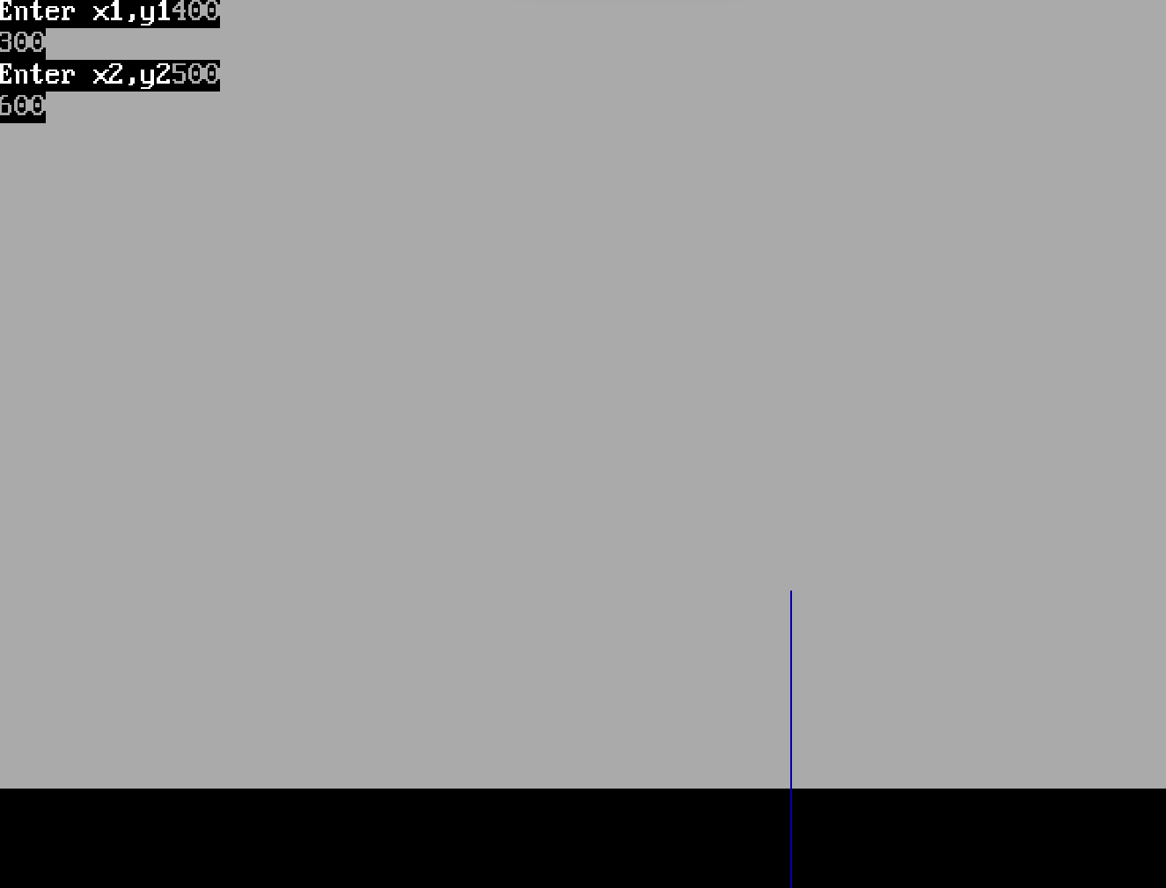

**Conclusion:** Comment on -

1. Pixel :-In computer graphics, the display or screen is composed

of a grid of individual picture elements, commonly known as

pixels. Each pixel can be independently controlled to display a

specific color, creating the overall image.

2. Equation for line:- ((y - y1) = m(x - x1)) or (y = mx + b)

3. Need of line drawing algorithm:-Line drawing algorithms are

essential in computer graphics to render lines between specified

points. Without a line drawing algorithm, displaying a straight

line on a pixel grid would require individually setting each pixel

position along the line, which is impractical and inefficient. The

DDA algorithm provides a simple and efficient way to

approximate lines on the pixel grid.

4. Slow or fast :-The DDA algorithm is relatively fast and suitable for

real-time rendering on most systems.