Explainable AI-Based Sinus Disease Detection Using Deep Learning and Transfer Learning

Tanvi Sharma
Department of Computer Engineering
Marwadi University, Rajkot, Gujarat, India ms.tanvisharma.132874@marwadiuersity.ac.in

Abstract— This paper presents an explainable artificial intelligence (XAI) framework for healthy-versus-unhealthy sinus CT image classification. A dataset of 137 labeled CT images, comprising 37 Healthy and 100 Unhealthy images, was analyzed using duplicate detection, related-image grouping, and leakage-aware group-stratified splitting. ResNet50 and EfficientNet-B0 were evaluated using transfer learning, while 2048-dimensional ResNet50 embeddings were classified using Logistic Regression, Random Forest, SVM, XGBoost, and LightGBM. Models were evaluated using accuracy, precision, recall, specificity, F1-score, ROC-AUC, PR-AUC, and confusion matrices. SHAP and LIME were used for model interpretation. On the 12-image test set, ResNet50 and SVM achieved 91.67% accuracy, while SVM achieved a ROC-AUC of 0.909. However, the test set contained only one Healthy image and the majority-class baseline also achieved 91.67% accuracy. Therefore, the results represent a proof-of-concept evaluation rather than clinical validation. The proposed framework combines leakage-aware evaluation with predictive modeling and explainability for sinus CT image classification.
Keywords— Explainable artificial intelligence, sinus CT, deep learning, transfer learning, SHAP, LIME
INTRODUCTION
Artificial intelligence (AI) and machine learning are increasingly being explored for automated analysis of chronic rhinosinusitis (CRS) and sinonasal imaging. Recent studies have investigated machine learning for disease prediction, recurrence prediction, treatment outcomes, and CT-based assessment [1]–[5]. Deep learning and radiomics-based approaches have also shown potential for extracting useful information from sinus CT images [6], [7].
However, predictive performance alone does not explain why a model produces a particular prediction. This is particularly important in healthcare applications, where model interpretability can support model analysis and increase confidence in automated predictions. Explainable AI (XAI) methods such as SHAP and LIME provide global and local explanations of machine learning predictions [8], [9].
In this work, we develop an explainable framework for healthy-versus-unhealthy sinus CT image classification. The framework combines leakage-aware dataset processing, ResNet50 and EfficientNet-B0 transfer learning, ResNet50 feature extraction, classical machine learning, feature-selection experiments, and SHAP/LIME-based interpretation. The models are evaluated using multiple performance metrics rather than accuracy alone.
The dataset contains 137 labeled CT images, with 37 Healthy and 100 Unhealthy images. Because subject identifiers were unavailable, duplicate and related-image grouping was incorporated into the splitting process. The final test set contains only 12 images; therefore, the results are considered a proof-of-concept evaluation rather than clinical validation.
The main contributions are:
- A leakage-aware pipeline for sinus CT image classification.
- Comparison of deep transfer-learning and classical machine-learning approaches.
- Multi-metric evaluation of model performance.
- SHAP and LIME-based interpretation of model predictions.

LITERATURE REVIEW
Recent studies have increasingly applied machine learning (ML) and artificial intelligence (AI) to chronic rhinosinusitis (CRS), particularly for disease prediction, classification, recurrence prediction, and treatment outcomes. Liu et al. developed an ML model using clinical parameters for eosinophilic CRS, while Raghavan et al. investigated patient-generated health data for predicting CRS symptoms and sinonasal inflammation [1], [3]. Ishikawa et al. used ML to identify important features associated with CRS and its comorbidities [4], [5]. Jiang et al. developed an explainable model for postoperative recurrence in pediatric CRS, while Xiong et al. compared multiple ML approaches for eosinophilic CRS prediction [6], [7]. Chowdhury et al. further investigated ML for predicting outcomes of sinus surgery [2].
Deep learning has also been explored for sinus imaging. He et al. investigated deep-learning radiomics for preoperative prediction of CRS recurrence, demonstrating the potential of imaging-derived representations in CRS research [8]. Reviews by Pereira et al. and S. H. and D. G. summarized the growing applications of AI in CRS and rhinology, including diagnostic and imaging-related tasks [9], [10].
Explainability is increasingly important for healthcare AI. Alkhanbouli et al. reviewed the role of explainable AI (XAI) in disease prediction and emphasized the importance of interpretable and trustworthy predictive systems [11]. Related work has also explored personalized healthcare using explainable AI [20]. In this study, SHAP and LIME are used to examine global and local model behavior.
Active feature acquisition has been investigated for selecting informative features under cost, availability, and time-varying constraints [12]–[15]. Although relevant to clinical ML, these methods are not directly implemented here because the present study focuses on CT image representations. Similarly, environmental studies have examined relationships between air pollution and CRS occurrence, severity, and related respiratory conditions [16]–[19], providing clinical context but falling outside the scope of this image-based framework.
Overall, existing research demonstrates significant progress in clinical ML, deep learning, and XAI for CRS. However, fewer studies combine sinus CT image classification, leakage-aware data handling, comparative deep and classical ML, and post-hoc explainability in a single framework. This study addresses this gap by evaluating transfer-learning models and ResNet50-derived embeddings with multiple classical classifiers, followed by SHAP and LIME-based interpretation.
PROPOSED METHODOLOGY
The proposed framework performs healthy-versus-unhealthy classification of sinus CT images using transfer learning, deep feature extraction, classical machine learning, and post-hoc explainability. The overall workflow is shown in Fig. 1.
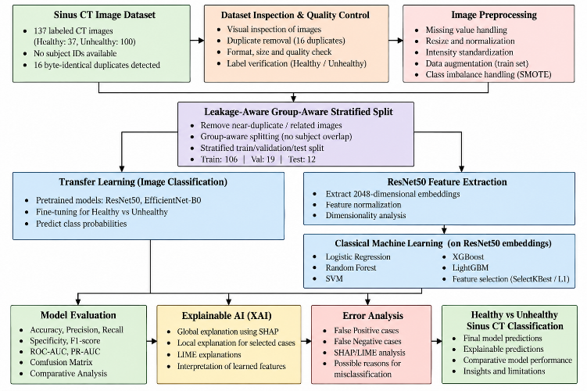
Fig. 1. Overall workflow of the proposed explainable sinus CT classification framework.
- Dataset and Preprocessing
The dataset contains 137 labeled sinus CT images, including 37 Healthy and 100 Unhealthy images. Images were inspected for format, size, color mode, duplicate files, and related-image groups. Since subject identifiers were unavailable, byte-identical duplicates and visually related images were grouped before splitting to reduce possible data leakage. A group-aware stratified split was used to create training, validation, and test sets.

Transfer LearningTwo pretrained convolutional neural networks, ResNet50 and EfficientNet-B0, were evaluated for image classification. The pretrained models were adapted to the binary classification task and trained using the prepared training data. Validation performance was monitored during training, followed by evaluation on the held-out test set.
- Deep Feature Extraction and Classical Classification
The 2048-dimensional feature representation extracted from ResNet50 was also used as input to classical machine learning models. Logistic Regression, Random Forest, Support Vector Machine (SVM), XGBoost, and LightGBM were evaluated. Feature-selection approaches including SelectKBest, L1-based selection, tree-based importance, XGBoost importance, and PCA were additionally investigated to examine whether reduced representations could improve classification performance.
D. Explainability
To improve model interpretability, SHAP and LIME were applied to the trained classifiers. SHAP was used to analyze global feature importance and individual predictions, while LIME was used to provide local explanations for selected CT images. These explanations help identify which learned image features contributed to predictions, including true-positive, false-positive, and false-negative cases. The extracted embedding features are treated as learned representations rather than direct anatomical or clinical biomarkers.

Experimental Setup
The experiments were conducted using a Python-based machine learning environment with PyTorch, torchvision, scikit-learn, XGBoost, LightGBM, SHAP, and LIME. The implementation was executed on a CPU-based system.
The dataset was divided using a group-aware stratified split with random seed 42, resulting in 106 training images, 19 validation images, and 12 test images. The training set contained 34 Healthy and 72 Unhealthy images, while the validation and test sets were highly imbalanced. In particular, the test set contained only one Healthy image and 11 Unhealthy images. Therefore, accuracy alone was not considered sufficient for evaluating the models.
ResNet50 and EfficientNet-B0 were evaluated using transfer learning. In addition, 2048-dimensional ResNet50 embeddings were used for the classical machine learning models. Different feature-selection strategies were evaluated to investigate their effect on classification performance.
For model evaluation, accuracy, precision, recall, specificity, F1-score, ROC-AUC, and PR-AUC were calculated. Confusion matrices, ROC curves, and precision-recall curves were generated for comparative analysis.
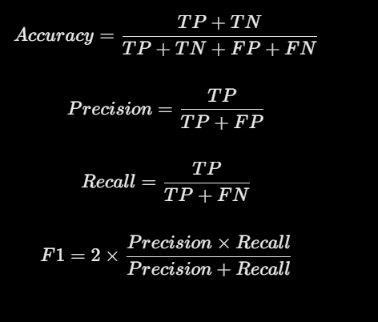SHAP and LIME were used after model training to provide global and local explanations of model predictions.

RESULTS AND DISCUSSION
A. Model Performance
The performance of the evaluated models on the held-out test set is presented in Table I. ResNet50, Random Forest, and SVM achieved the highest accuracy of 91.67%, correctly classifying 11 out of 12 test images. EfficientNet-B0, Logistic Regression, XGBoost, and LightGBM achieved 83.33% accuracy.
TableI
Performance Comparison of Evaluated Models:-
Model | Accuracy | Precision | Recall | Specificity | F1-Score | ROC-AUC | PR-AUC
ResNet50 | 91.67 | 91.67 | 100.00 | 0.00 | 95.65 | 0.818 | 0.984
EfficientNet-B0 | 83.33 | 90.91 | 90.91 | 0.00 | 90.91 | 0.909 | 0.992
Logistic Regression | 83.33 | 90.91 | 90.91 | 0.00 | 90.91 | 0.909 | 0.992
Random Forest | 91.67 | 91.67 | 100.00 | 0.00 | 95.65 | 0.545 | 0.955
SVM | 91.67 | 91.67 | 100.00 | 0.00 | 95.65 | 0.909 | 0.992
XGBoost | 83.33 | 90.91 | 90.91 | 0.00 | 90.91 | 0.364 | 0.927
LightGBM | 83.33 | 90.91 | 90.91 | 0.00 | 90.91 | 0.364 | 0.927

The accuracy values should be interpreted together with the other evaluation metrics. SVM provided a strong overall balance, achieving 91.67% accuracy with a ROC-AUC of 0.909 and PR-AUC of 0.992. EfficientNet-B0 and Logistic Regression also obtained ROC-AUC values of 0.909. ResNet50 achieved the same accuracy as SVM but showed a slightly lower ROC-AUC of 0.818. Random Forest also achieved 91.67% accuracy; however, its ROC-AUC was considerably lower at 0.545.
The ROC curves in Fig. 2 provide a threshold-based comparison of the models. The results show that accuracy alone does not adequately represent model discrimination, particularly for the imbalanced test set.
Fig. 2. ROC curves of the evaluated models on the test set.
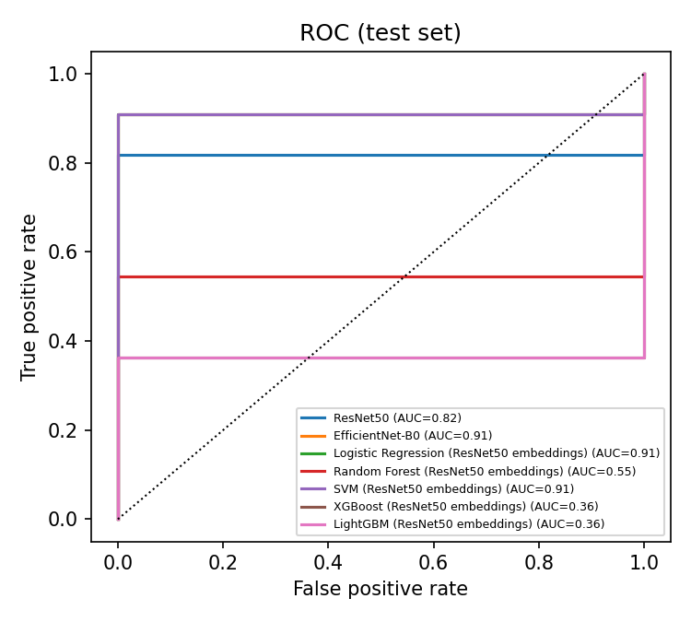
The precision-recall curves shown in Fig. 3 provide additional information because the test set contains substantially more Unhealthy than Healthy images. SVM, EfficientNet-B0, and Logistic Regression achieved PR-AUC values close to 0.99, while ResNet50 achieved 0.984. XGBoost and LightGBM produced lower PR-AUC values of 0.927.
Fig. 3. Precision-recall curves of the evaluated models on the test set.
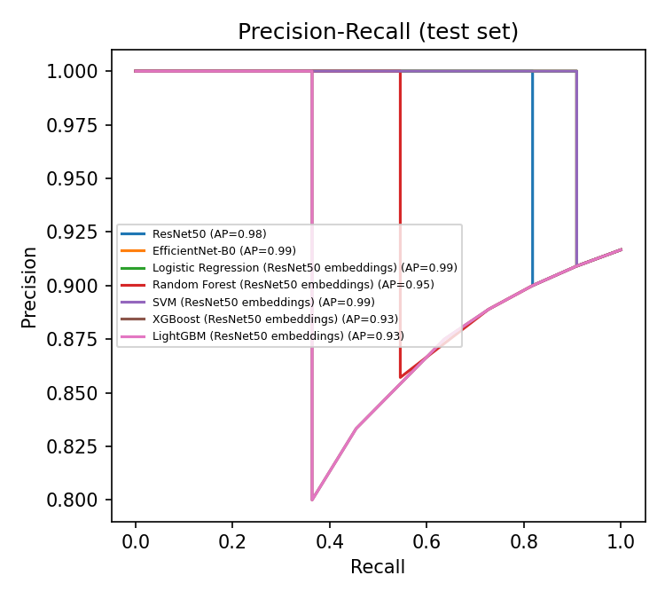

B. Confusion Matrix Analysis
The confusion matrix provides a direct view of the classification errors. The LightGBM classifier correctly classified 10 Unhealthy images but incorrectly classified one Unhealthy image as Healthy and one Healthy image as Unhealthy. Similar behavior was observed across several models.
Fig. 4. Confusion matrix of the LightGBM classifier on the test set.
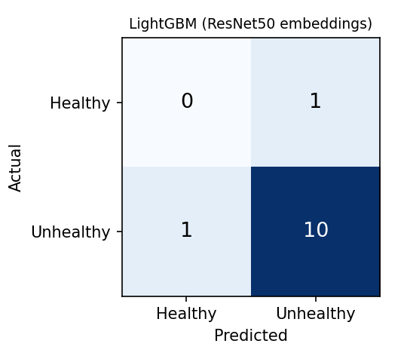
A particularly important observation is that the test set contained only one Healthy image. Consequently, the specificity was 0% for the evaluated models, and a single prediction involving the Healthy class has a large effect on the reported metrics. Therefore, the numerical results should not be interpreted as evidence of clinical diagnostic capability. Instead, they demonstrate the feasibility of the proposed experimental framework on the available dataset.

C. Explainability Analysis
To investigate the reasoning of the classical classifiers, SHAP was applied to the learned ResNet50 embedding features. The global SHAP analysis for LightGBM identified several embedding dimensions as influential in the model predictions, as illustrated in Fig. 5. These dimensions represent learned features generated by the neural network and should not be interpreted directly as specific anatomical structures or clinical biomarkers.
Fig. 5. Global SHAP feature importance for the LightGBM classifier. 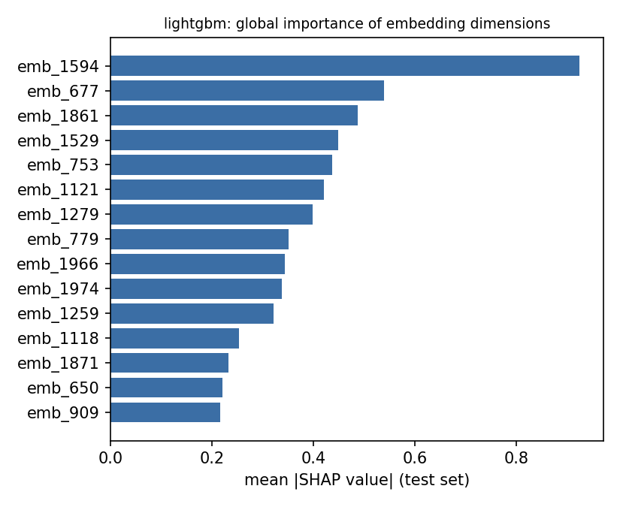
Local explanations were further examined to understand individual predictions. Fig. 6 presents a false-negative case in which the LightGBM model assigned a disease probability of approximately 0.22. The SHAP contributions indicate which learned representation features pushed the prediction toward the opposite class.
Fig. 6. Local SHAP explanation for a false-negative prediction.
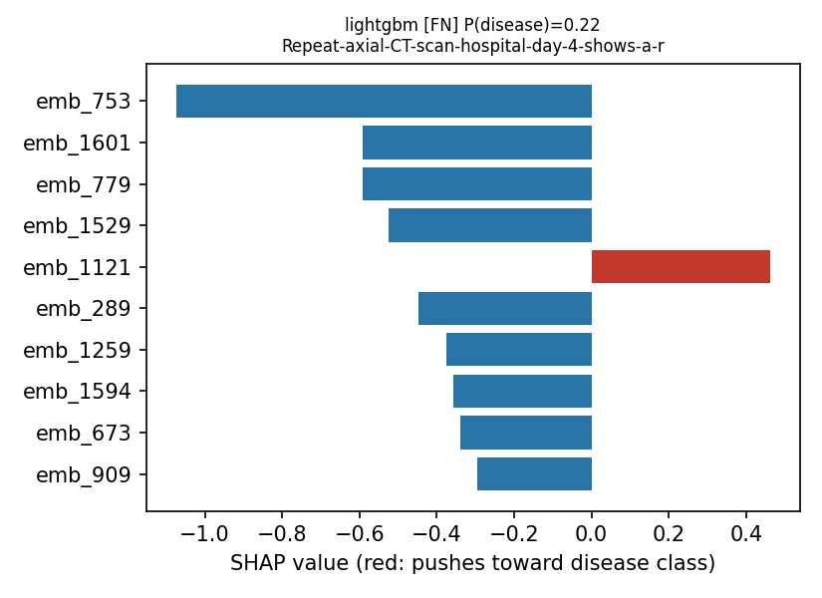
In contrast, Fig. 7 shows a false-positive case with a predicted disease probability of approximately 0.99. This example demonstrates that the model can assign a high disease probability even when the corresponding sample belongs to the Healthy class. Such cases are particularly important for understanding model limitations and potential sources of incorrect predictions.
Fig. 7. Local SHAP explanation for a false-positive prediction.
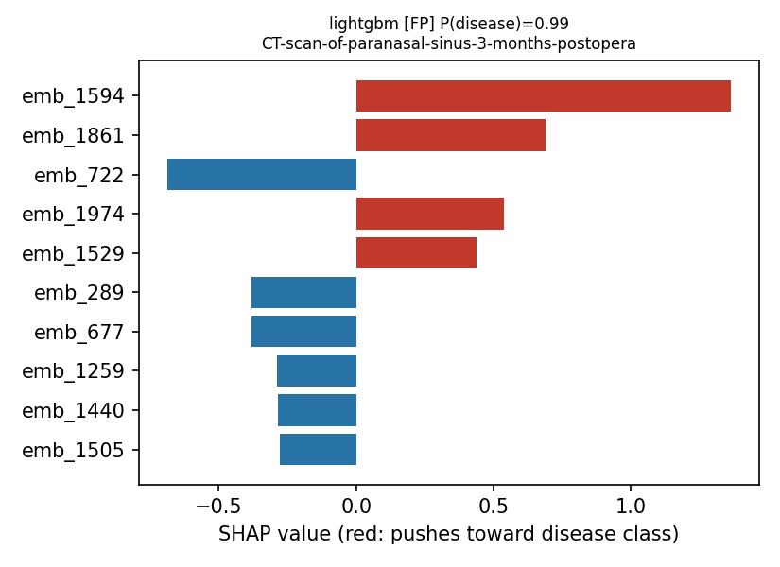
LIME was additionally used to provide local explanations for selected predictions. These explanations complement SHAP by providing an alternative local interpretation of model behavior. Together, SHAP and LIME demonstrate how post-hoc explainability can be incorporated into an image-classification pipeline to investigate both correct and incorrect predictions.
D. Overall Discussion
Overall, the experiments demonstrate the feasibility of combining transfer learning, deep feature representations, classical machine learning, and explainability for sinus CT image classification. SVM and ResNet50 achieved the highest test accuracy, while SVM, EfficientNet-B0, and Logistic Regression showed strong ROC-AUC and PR-AUC values. However, the small and highly imbalanced test set limits the reliability of these metrics. The SHAP and LIME analyses further demonstrate how model predictions can be examined beyond conventional performance measures. Therefore, the results support the proposed framework as an experimental and explainable approach, while larger and more diverse datasets with independent validation are required before drawing clinical conclusions.

Limitations and Future Work
This study has several limitations. First, the dataset contains only 137 labeled CT images, with an imbalanced distribution between Healthy and Unhealthy classes. In addition, subject identifiers were unavailable, and the held-out test set contained only 12 images. Therefore, the reported performance metrics may have high uncertainty and should not be interpreted as clinical validation.
Second, the study focuses on image-based healthy-versus-unhealthy classification and does not incorporate additional clinical information such as patient history, laboratory measurements, or other diagnostic variables. The learned embedding features used for classical classifiers also cannot be directly interpreted as specific anatomical or clinical biomarkers.
Future work should evaluate the framework using larger, more balanced, and independently collected sinus CT datasets with reliable subject-level information. External validation can provide a stronger assessment of generalization. Future experiments can also investigate more advanced transfer-learning and attention-based architectures, improved image-level interpretability such as Grad-CAM, and multimodal approaches that combine imaging with relevant clinical information. These extensions could improve both predictive reliability and clinical interpretability while reducing the limitations caused by the current dataset size.

CONCLUSION
This study presented an explainable deep learning framework for healthy-versus-unhealthy sinus CT image classification. Transfer learning with ResNet50 and EfficientNet-B0 was combined with ResNet50-based deep feature extraction and multiple classical machine learning classifiers. The framework also incorporated SHAP and LIME to provide global and local explanations of model predictions.
Among the evaluated models, ResNet50, Random Forest, and SVM achieved 91.67% test accuracy, while SVM provided a strong combination of accuracy, ROC-AUC, and PR-AUC. The explainability analysis further demonstrated how learned feature representations contributed to individual predictions and helped examine incorrect classifications.
However, the small and imbalanced test set significantly limits the reliability and generalizability of the reported results. Therefore, the proposed framework should be considered an experimental research framework rather than a clinically validated diagnostic system. Larger datasets, external validation, and clinically meaningful interpretability are required in future work to establish its practical applicability.
REFERENCES
- [1] L. Liu et al., “Development and Interpretation of a Machine Learning-Based Predictive Model Using Clinical Parameters for Eosinophilic Chronic Rhinosinusitis With Nasal Polyps,” 2026, doi: 10.1177/19458924261425834.
- [2] S. S. Chowdhury et al., “Who Benefits From Sinus Surgery? Comparing Generative AI and Supervised Machine Learning for Predicting Surgical Outcomes in Chronic Rhinosinusitis,” 2026, doi: 10.48550/arXiv.2601.13710.
- [3] A. M. Raghavan et al., “Using Machine Learning Models to Diagnose Chronic Rhinosinusitis: Analysis of Pre-Treatment Patient-Generated Health Data to Predict Cardinal Symptoms and Sinonasal Inflammation,” 2025, doi: 10.1177/19458924251322081.
- [4] M. Ishikawa et al., “Clinical Key Features Uncovered by Blood Eosinophilia-Based Machine Learning Classification of Chronic Rhinosinusitis,” 2025, doi: 10.1002/alr.70077.
- [5] M. Ishikawa et al., “Uncovering Key Features for Predicting Comorbid Chronic Eosinophilic Pneumonia in Chronic Rhinosinusitis via Machine Learning,” 2025, doi: 10.1002/alr.23613.
- [6] S. Jiang et al., “Development and Validation of an Explainable Prediction Model for Postoperative Recurrence in Pediatric Chronic Rhinosinusitis,” 2024, doi: 10.1002/ohn.1092.
- [7] P. Xiong et al., “Predictive modeling for eosinophilic chronic rhinosinusitis: Nomogram and four machine learning approaches,” iScience, 2024, doi: 10.1016/j.isci.2024.108928.
- [8] S. He et al., “Deep learning radiomics-based preoperative prediction of recurrence in chronic rhinosinusitis,” iScience, 2023, doi: 10.1016/j.isci.2023.106527.
- [9] N. M. Pereira et al., “The Role of Artificial Intelligence in Chronic Rhinosinusitis: A Scoping Review,” 2025, doi: 10.1002/alr.70078.
- [10] S. H. and D. G., “The Application and Diagnostic Accuracy of Artificial Intelligence in Rhinology: A Review,” 2025, doi: 10.7759/cureus.87966.
- [11] R. Alkhanbouli et al., “The role of explainable artificial intelligence in disease prediction: a systematic literature review and future research directions,” 2025, doi: 10.1186/s12911-025-02944-6.
- [12] J. C. Bingham and N. Arussy, “Cost-Aware Active Feature Acquisition for Differential Diagnosis under Realistic Clinical Availability Constraints,” 2026, doi: 10.64898/2026.08.30.26361745.
- [13] Y. Kobayashi et al., “Learning-To-Measure: In-context Active Feature Acquisition,” 2025, doi: 10.48550/arXiv.2510.12624.
- [14] O. B. Güney et al., “Active Feature Acquisition Via Explainability-driven Ranking,” 2025.
- [15] H. von Kleist et al., “Evaluation of Active Feature Acquisition Methods for Time-varying Feature Settings,” 2023, doi: 10.48550/arXiv.2312.01530.
- [16] Z.-Q. Zhang et al., “Association between air pollution and allergic upper respiratory diseases: a meta-analysis,” 2025, doi: 10.1183/16000617.0266-2024.
- [17] Q. Zhou et al., “Air pollution, genetic factors, and chronic rhinosinusitis: A prospective study in the UK Biobank,” 2024, doi: 10.1016/j.scitotenv.2024.173526.
- [18] E. Leland et al., “Environmental air pollution and chronic rhinosinusitis: A systematic review,” 2022, doi: 10.1002/lio2.774.
- [19] X.-Z. Yang et al., “Air Pollution Exposure Affects Severity and Cellular Endotype of Chronic Rhinosinusitis With Nasal Polyps,” 2021, doi: 10.1002/lary.29974.
- [20] M. Vani et al., “Personalized health monitoring using explainable AI: bridging trust in predictive healthcare,” 2025, doi: 10.1038/s41598-025-15867-z.

