Lab 2 Worksheet: CNN Training on CIFAR-10
Name: Uttla Tanvi Kumari
Roll Number: B23BB1044
Date: 01 Feb 2026

1. Introduction
The objective of this lab was to implement a custom Convolutional Neural Network (CNN) on the CIFAR-10 dataset. The experiment focused on designing a custom Data Loader, analyzing computational complexity (FLOPs), and visualizing the internal training dynamics (Gradient Flow and Weight Updates) using Weights & Biases (W&B).
2. Model Architecture & Complexity
A custom CNN architecture was implemented with the following structure:
- Input: 3 * 32 * 32 image
- Architecture: 3 Convolutional Blocks (Conv + ReLU + MaxPool) followed by 2 Fully Connected layers.
- Computational Cost: The model complexity was profiled using the thop library.
  - Total FLOPs: ~63.5 Million
  - Parameters: ~0.60 Million
This low FLOP count indicates the model is lightweight and suitable for efficient inference on standard hardware.
3. Training Performance
The model was trained for 30 epochs using the Adam optimizer with a learning rate of 0.001.
Performance Metrics:
- Final Training Accuracy: 86.01%
- Final Loss: 0.3972
The training curves below demonstrate a smooth convergence. The loss decreased rapidly in the first 5 epochs, followed by a steady decline, while accuracy improved consistently without major fluctuations.
Figure 1: Training Loss and Accuracy
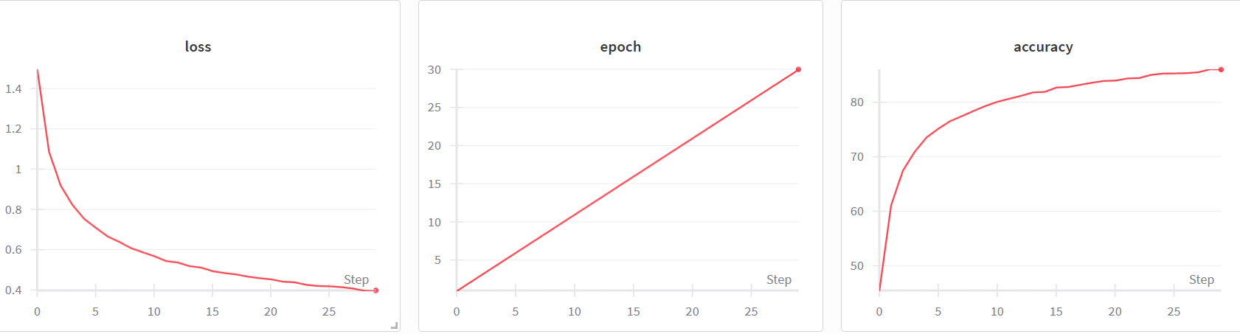
Figure 1: The loss curve (left) shows a smooth exponential decay, while accuracy (right) reaches 86.01% by epoch 30.

4. Gradient Flow Analysis
To verify that the network was training effectively, we monitored the gradients of the loss with respect to the weights and biases.
Observations:
- Non-Vanishing Gradients: The gradient histograms for the early layers, specifically conv1 and conv2, show a healthy spread centered around zero. The magnitudes are significant (ranging between -0.5 and 0.5 for conv1), confirming that the gradient signal is propagating back to the input layers without vanishing.
- Stability: The gradients for the deeper fully connected layers (fc1, fc2) remain stable and centered, indicating that the optimizer was receiving consistent signals throughout the 30 epochs.
Figure 2: Gradient Flow (Early Layers)
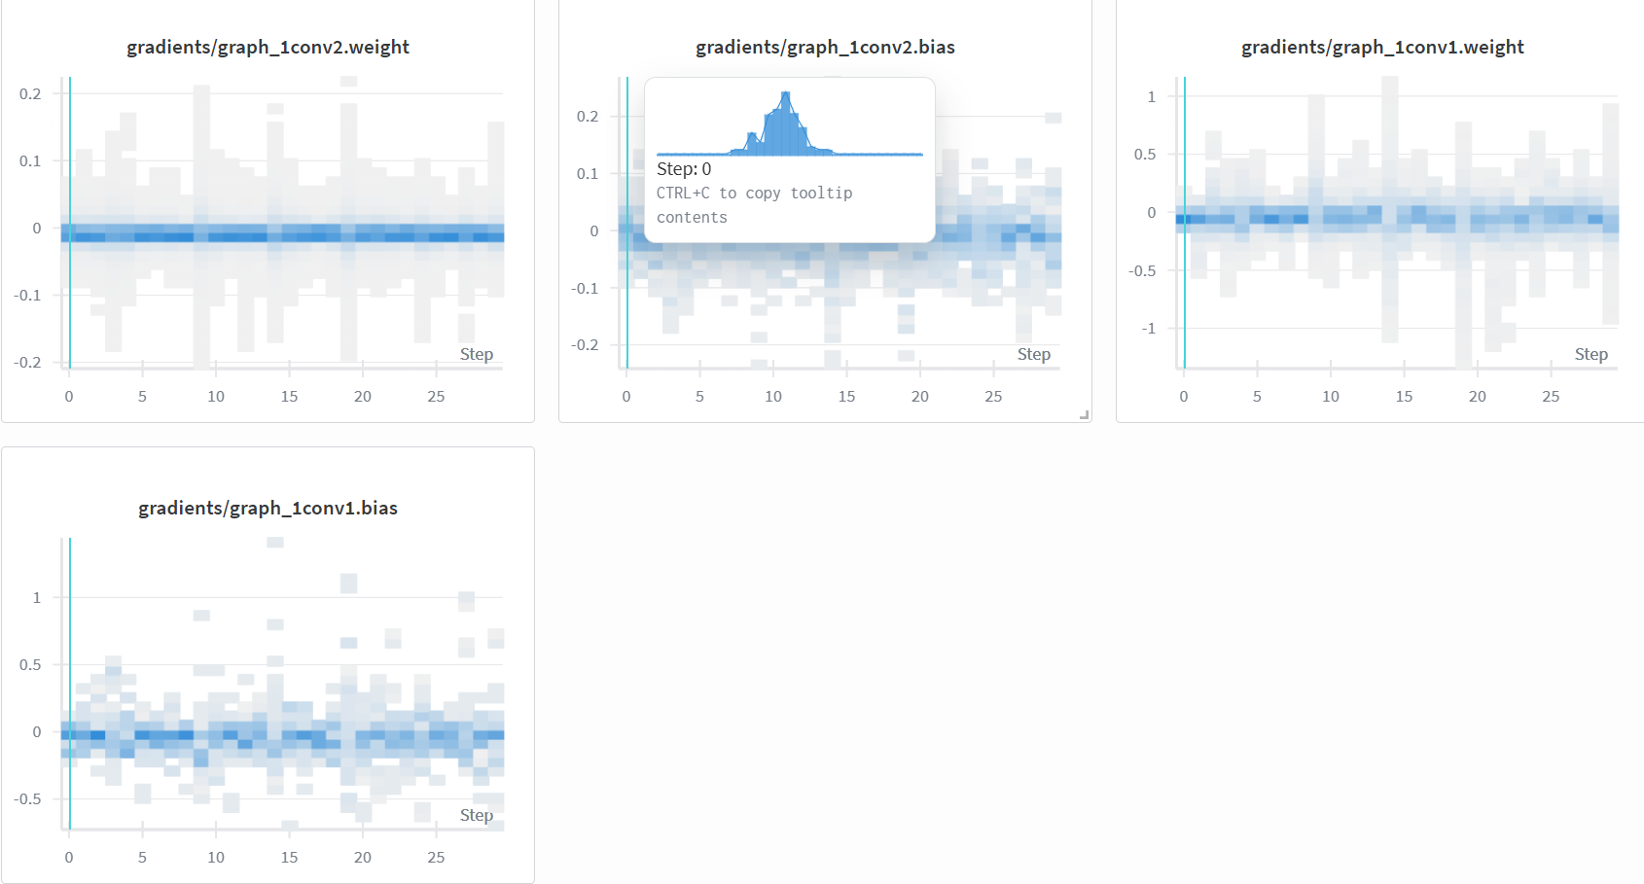
Figure 2: Gradients for Conv1 and Conv2. The distributions are well-formed bell curves, indicating active learning in the initial feature extractors.
Figure 3: Gradient Flow (Deep Layers)
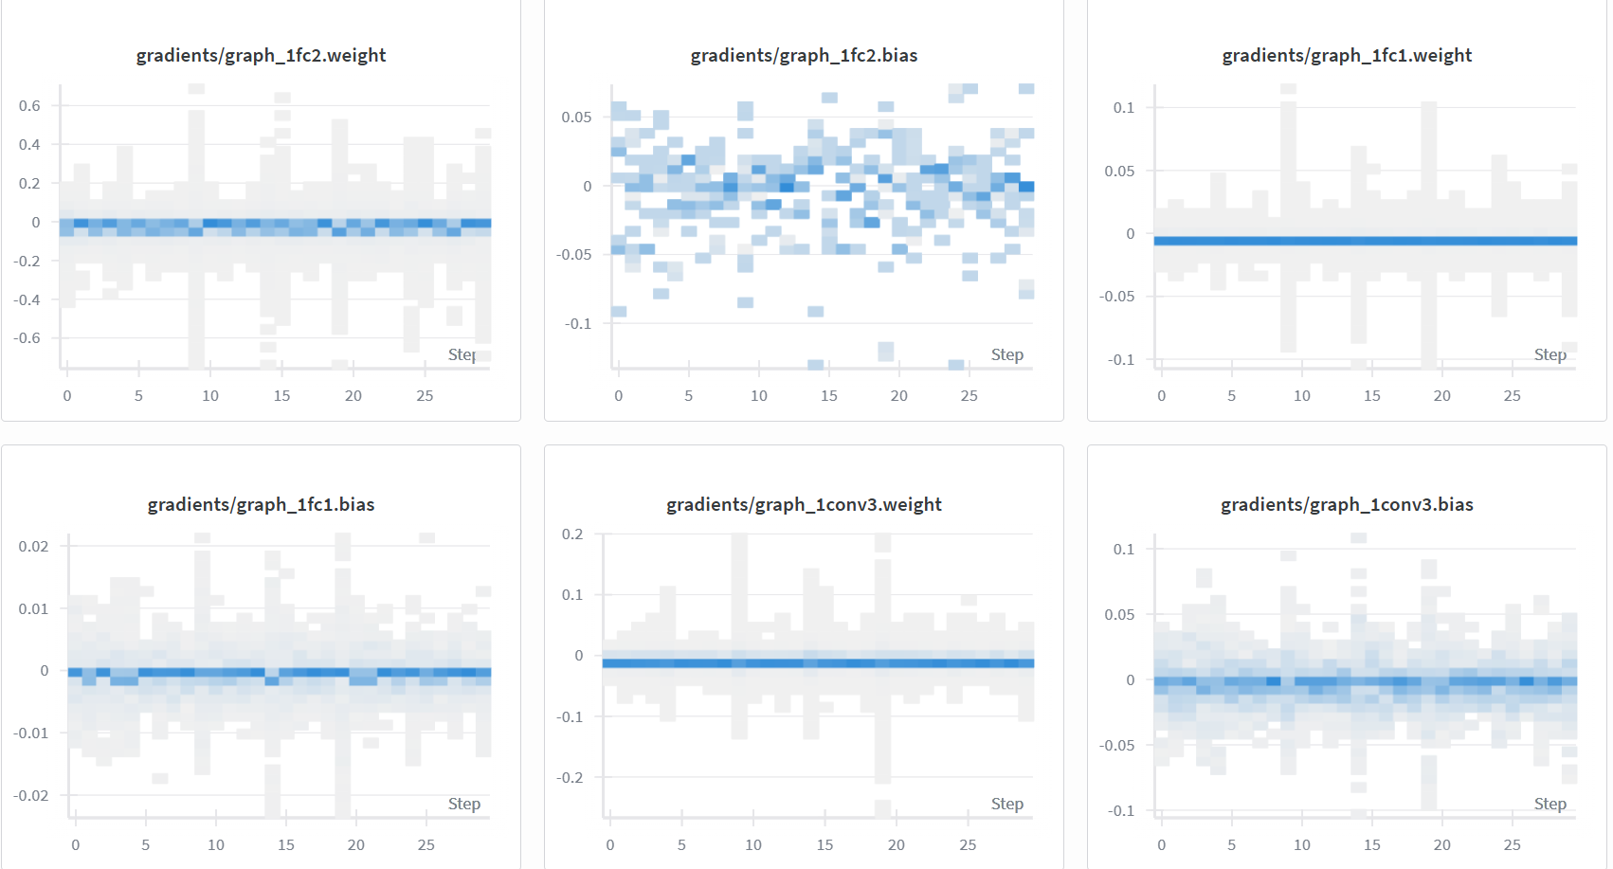Figure 3: Gradients for FC1 and FC2. The distributions remain stable, preventing exploding gradient issues.

5. Weight Update Flow
We visualized the evolution of the model parameters (weights and biases) to understand how the network learned features over time.
Observations:
- Feature Discovery (0-15 Epochs): The weight histograms for conv1 and conv2 show a distinct "fanning out" pattern. Starting from a narrow initialization, the weights spread out significantly as the model learned to recognize edges, textures, and shapes.
- Bias Adaptation: The bias parameters, particularly in conv1.bias and fc2.bias, show distinct directional shifts. In fc2.bias, we observe diverging streams, suggesting that neurons in the final layer adapted specific thresholds to differentiate between the 10 classes.
- Convergence: By epoch 30, the rate of change in the weight distributions slowed down, confirming that the model had converged to an optimal state.
Figure 4: Weight Evolution (Early Layers)
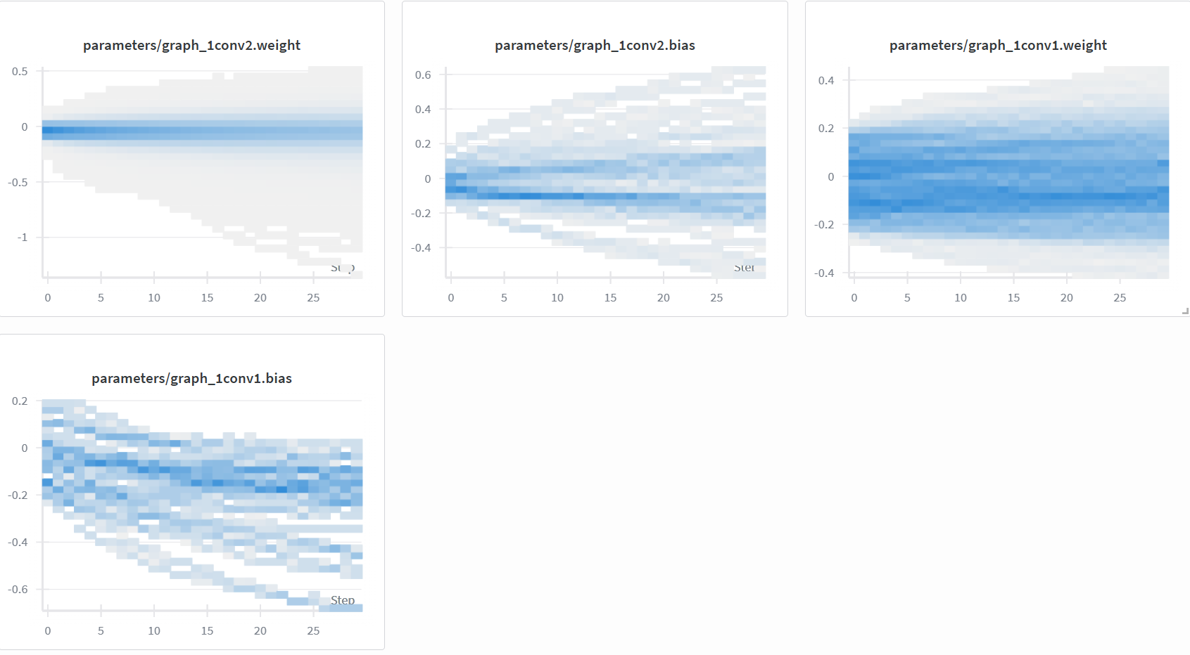Figure 4: Evolution of Conv1 and Conv2 weights. Note the significant spreading of conv1.weight as filters are learned.
Figure 5: Weight Evolution (Deep Layers)
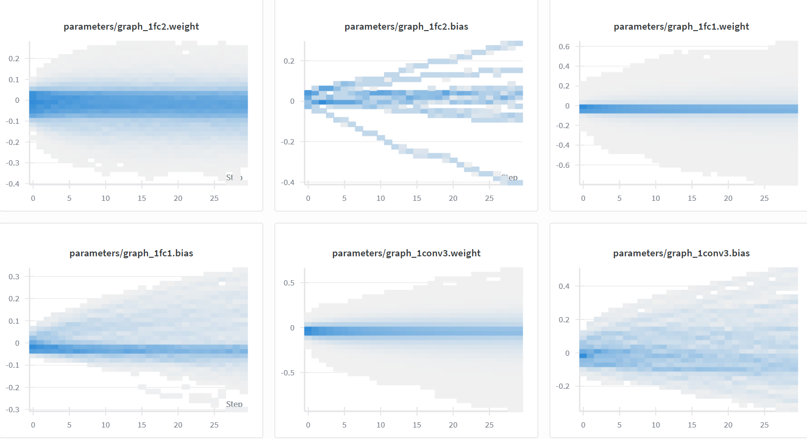Figure 5: Evolution of FC1 and FC2 weights. The fc2.bias (center top) clearly shows neurons diverging to learn class-specific biases.

6. Conclusion
The custom CNN successfully learned the CIFAR-10 dataset, achieving 86% accuracy with a computationally efficient footprint of 63.5M FLOPs. Visualization of the gradient flow confirmed that the network did not suffer from vanishing gradients, and the weight update plots demonstrated clear phases of feature learning and refinement. The custom data loader and WandB integration facilitated a transparent and effective training pipeline.

