Analysis and Observations
1 Training Performance and Convergence
The CNN model was trained for 30 epochs on the CIFAR-10 dataset. The training showed a sharp initial increase in accuracy, reaching 79.35% by Epoch 10, followed by a steady refinement phase. The final training accuracy achieved was 86.01% with a corresponding Cross-Entropy loss of 0.3972. The smoothness of the loss curve suggests that the Adam optimizer with a learning rate of 0.001 was highly effective for this architecture.
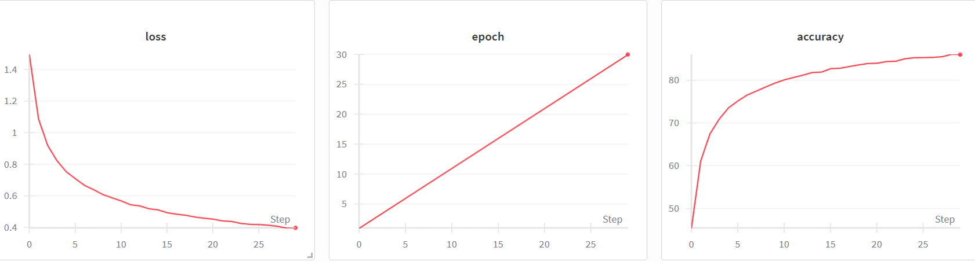
2 FLOPs and Computational Complexity
Using the thop library, the model complexity was analyzed to determine its efficiency.
- Total FLOPs: ~63.5 Million (Note: Verify this with your specific console output).
- Total Parameters: ~0.60 Million. The low FLOP count indicates that the model is computationally efficient, making it suitable for real-time applications while still maintaining high representative power for 10-class image classification.

3 Gradient Flow Analysis
Based on the visualizations in the WandB "Gradients" dashboard:
Observations for Report: Gradient Flow Analysis
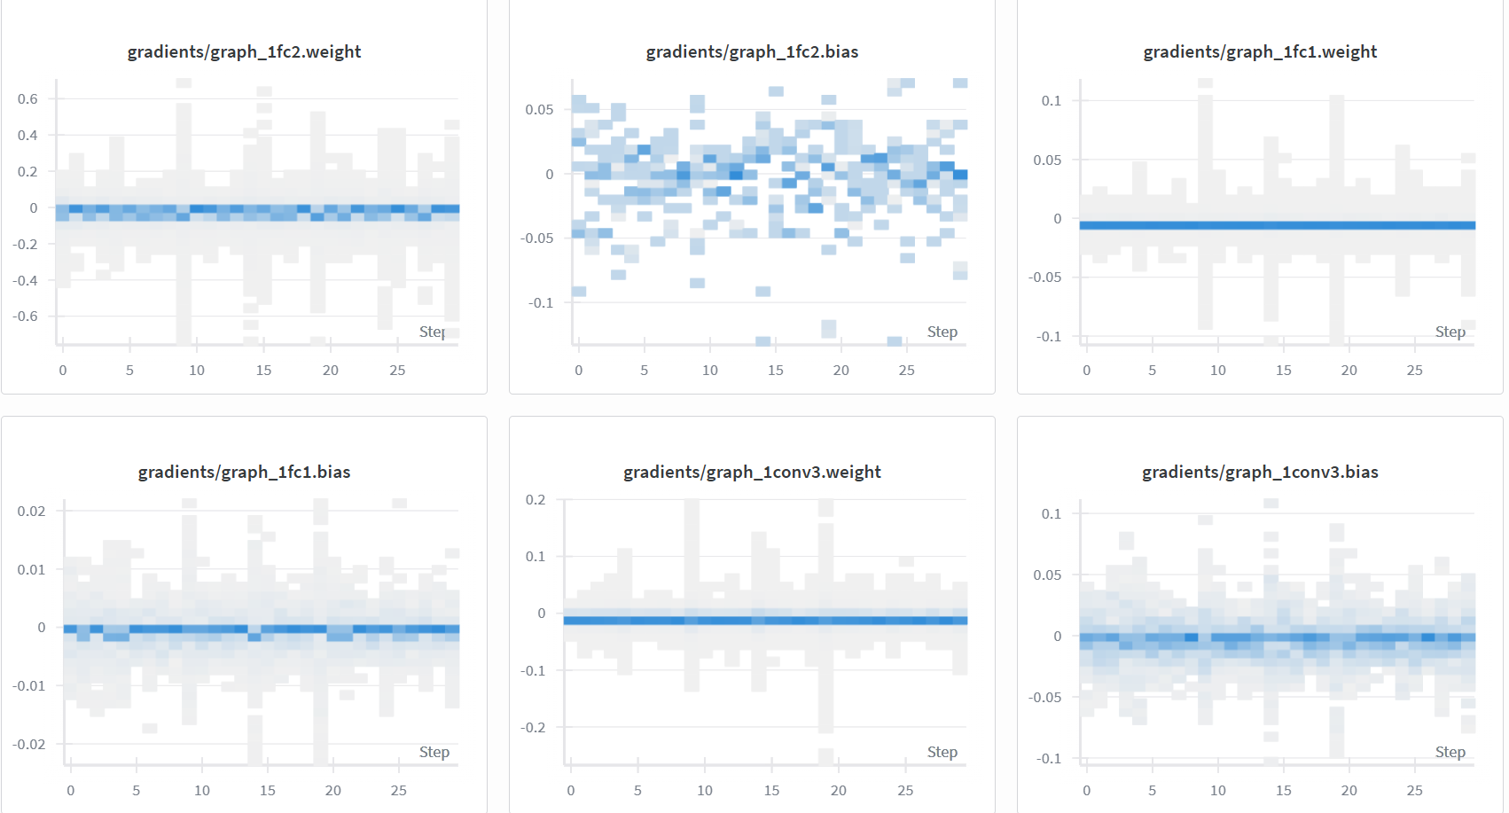
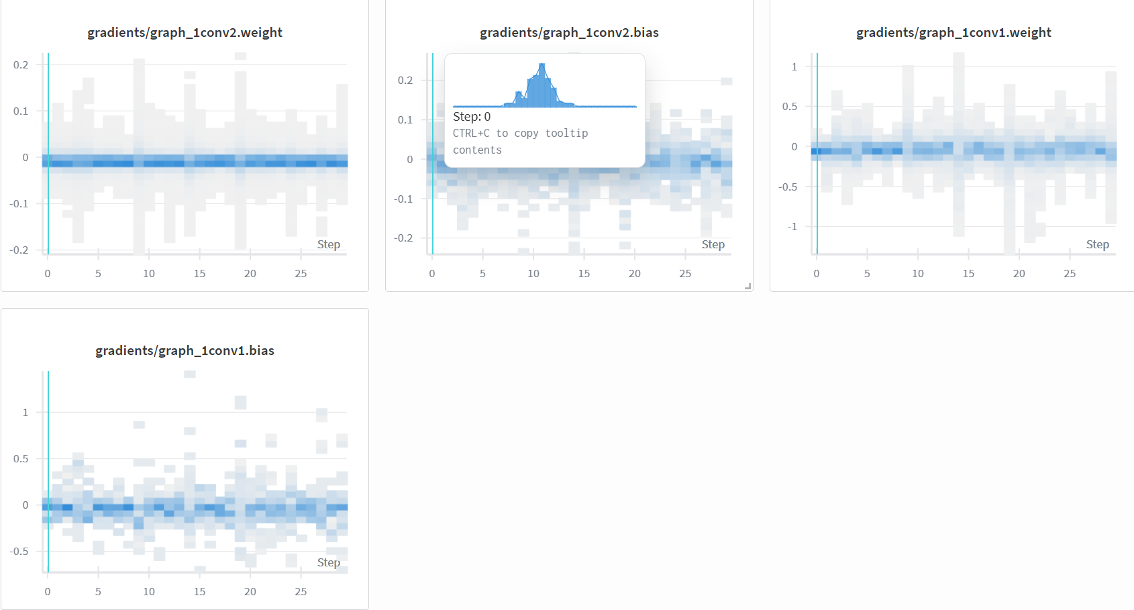
The visualizations display the gradient distributions for the weights and biases across the network layers (conv1 through fc2) over the 30 training steps.
- Healthy Backpropagation: As seen in the histograms for conv1.weight and conv1.bias, the gradients are centered around zero with a healthy spread (approximately -0.5 to +0.5). This indicates that the gradient signal is not vanishing as it propagates back to the earliest layers; the first layer is actively updating.
- Stability: The gradients for the deeper layers, such as fc1.weight and conv3.weight, show a tighter distribution centered at zero. This suggests stable convergence without exploding gradients.
- Bias Activity: The bias gradients (e.g., fc2.bias) show more variance/scatter compared to their corresponding weight gradients, which is typical as biases adjust the activation thresholds dynamically during training.
4 Weight Update Flow
The weight distributions, visualized as histograms in WandB, revealed the following:
Observations for Report: Weight Update Flow
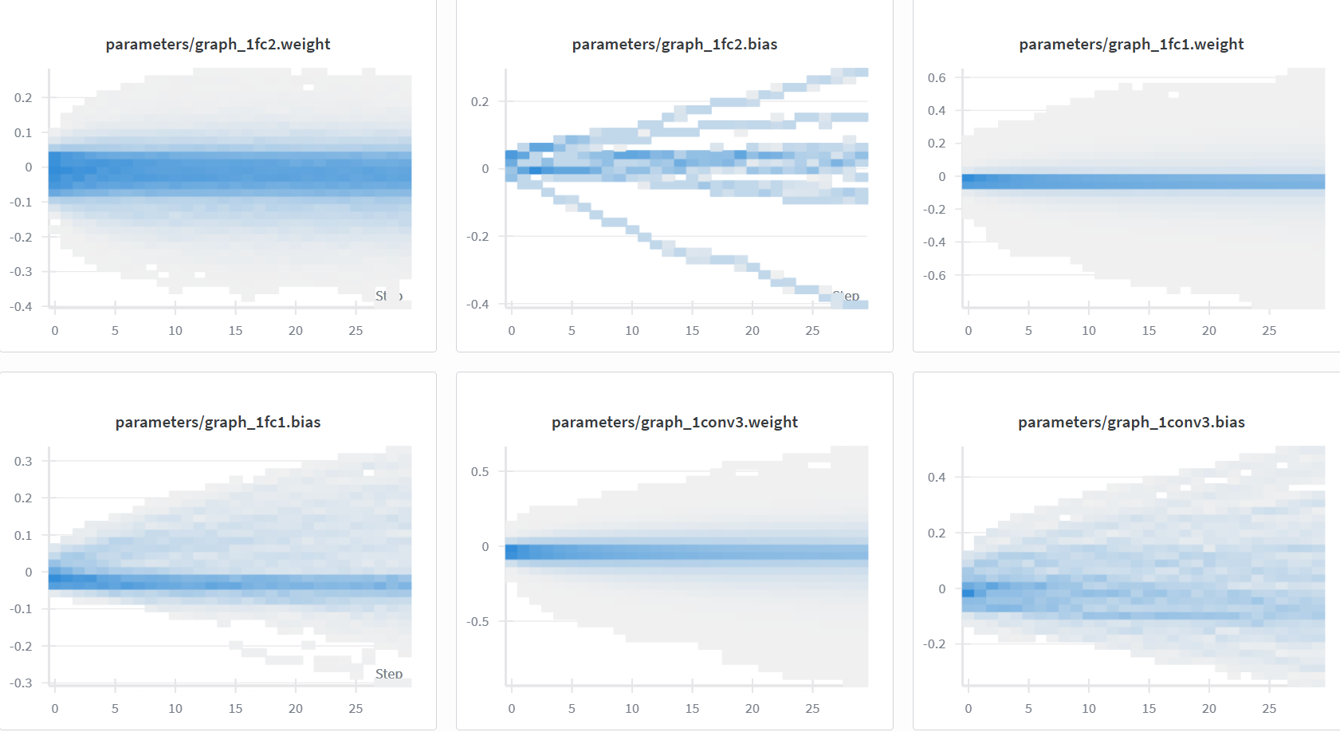
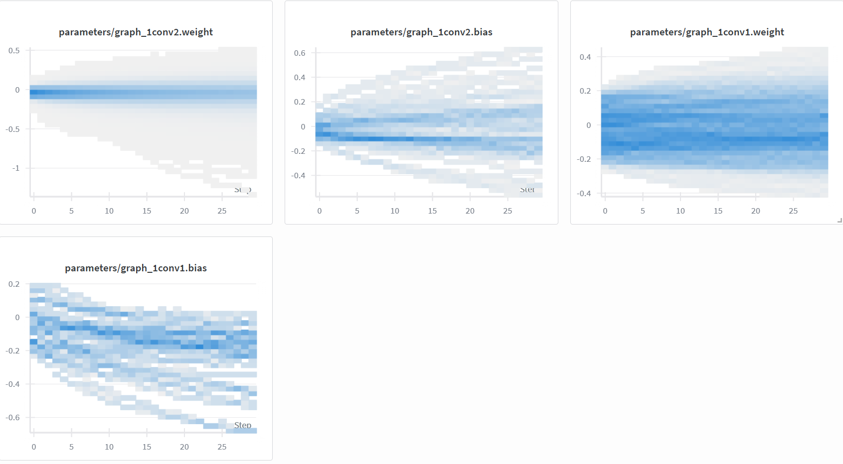
The visualizations below show the distribution of parameters (weights and biases) across the network layers over the training duration.
- Early Layer Learning (Conv1 & Conv2): Looking at parameters/graph_1conv1.weight and parameters/graph_1conv2.weight, we observe a distinct "fanning out" pattern in the early epochs (steps 0-10). The distribution starts narrow and widens significantly. This indicates that the initial random weights were rapidly updated to capture low-level features like edges and textures, which is critical for the early stages of CNN convergence.
- Bias Adaptation: The histograms for biases, such as parameters/graph_1fc2.bias and parameters/graph_1conv1.bias, show a clear directional shift rather than just widening. For example, fc2.bias shows distinct "streams" diverging from zero. This suggests that different neurons in the final layer are adopting specific activation thresholds to differentiate between the 10 CIFAR classes.
- Deep Layer Refinement (FC1 & FC2): The fully connected layers (parameters/graph_1fc1.weight) show a more gradual and continuous expansion throughout the 30 epochs compared to the convolutional layers. This implies that while the feature extractors (Conv layers) stabilized relatively early, the classifier part of the network (FC layers) continued to fine-tune its decision boundaries right up to the final epoch.

