Explainable Multi Label Classification of Cardiac Abnormalities from Electrocardiograms Using Lightweight Deep Learning
Tanvi Bandebuche and Maheen Meshram
Department of Computer Science and Engineering
Symbiosis Institute Of Technology, Nagpur, India
tanvi.bandebuche.btech2023@sitnagpur.siu.edu.in
maheen.meshram.btech2023@sitnagpur.siu.edu.in

Abstract—This study evaluates lightweight deep learning for multi-label classification of cardiac abnormalities in twelve-lead electrocardiograms. We used 21,388 eligible PTB-XL recordings and the official patient-separated folds. A compact convolutional network, a residual network, and an InceptionTime variant were trained with three random seeds. A logistic regression baseline and an unweighted-loss ablation supplied additional comparisons. Across seeds, the weighted compact network achieved macro AUROC of 0.920±0.0016 and macro F1 of 0.737±0.0025 on 2,158 held-out recordings. Its mean median forward latency was 0.639 milliseconds on the recorded CPU. The unweighted network achieved slightly higher mean scores, showing that class weighting did not improve aggregate performance here. Patient-level bootstrap intervals, category-specific errors, and measured lead and temporal occlusion responses support the analysis. These internal results do not establish external clinical validity.
Keywords—electrocardiogram, multi-label classification, convolutional neural network, PTB-XL, model interpretation

Introduction
An electrocardiogram (ECG) records cardiac electrical activity over time. PTB-XL provides a public collection of annotated clinical ECGs for the development of classification models [1]. Its benchmark established residual and inception-based networks as useful comparison families [2]. Because abnormalities can co-occur, a recording can require several diagnostic labels rather than one exclusive class.
Our question was whether a compact convolutional neural network (CNN) could provide a useful balance of predictive performance and computational cost under a controlled evaluation. We also examined the effects of class weighting and category-specific decision thresholds. The study evaluated held-out patients, measured inference time, and retained the predictions needed to reproduce its metrics.

Related Work
Self-supervised representation learning from twelve-lead ECGs reduces dependence on labeled examples [3]. Explainable ECG decision models connect classification to post hoc feature analysis [4]. Gradient-based visualization has been applied to myocardial infarction classification [5], while variational auto-encoders offer another route to interpretable ECG representations [6]. These methods motivate examining both predictive performance and the limits of model explanations.
Few-shot learning on PTB-XL explores classification with limited labeled data [7]. PTB-XL+ provides engineered features and comparisons between feature-based and waveform-based models [8]. State-space modeling, self-supervision, and metadata can improve ECG analysis [9]. These findings show that network complexity alone does not explain performance differences.
Cross-distribution representation learning highlights generalization concerns [10]. Single-lead versus twelve-lead studies examine the value of lead information [11]. ECGencode addresses computational efficiency [12]. Masked autoencoder pretraining [13] and spatiotemporal masked modeling [14] learn signal structure beyond conventional supervised fitting.
MERL aligns ECGs and clinical reports for zero-shot classification [15]. METS uses a frozen language model in multimodal pretraining [16]. K-MERL incorporates structured knowledge and arbitrary lead combinations [17]. Our experiment uses supervised waveform inputs only. It does not reproduce these large-scale pretraining systems or equate their results with our narrower task.
Our contribution is a reproducible comparison with fixed partitions and settings, three-seed measurements, a loss ablation, and perturbation analyses. We report unsuccessful assumptions as well as favorable results. In particular, weighting the loss did not improve the compact model’s mean test scores.

Dataset and Cohort Construction
PTB-XL version 1.0.3 contains 21,799 ten-second clinical ECGs with twelve leads [18]. We downloaded its 100 Hz waveform files from the public S3 mirror documented by PhysioNet. Every downloaded waveform was checked against the release SHA-256 manifest. Each input contained twelve channels and one thousand time samples in the supplied physical units.
Diagnostic code keys were mapped through the release statement table to five superclasses: normal ECG (NORM), myocardial infarction (MI), ST/T change (STTC), conduction disturbance (CD), and hypertrophy (HYP). Likelihood zero denotes unknown certainty in the source annotations; code presence, rather than a likelihood threshold, defined the primary mapping. We excluded 411 recordings without a mapped diagnostic category, leaving 21,388 recordings.
TABLE I. OBSERVED PATIENT-SEPARATED COHORT
Partition | Folds | ECGs | Patients
Training | 1–8 | 17,084 | 14,823
Validation | 9 | 2,146 | 1,917
Test | 10 | 2,158 | 1,877
We retained the official folds and found no patient overlap across partitions. SHA-256 checks of decoded waveforms also found no exact waveform duplicates across partitions. Record identifiers, exclusions, class co-occurrence counts, normalization statistics, and array hashes are saved with the experiment. No test score guided eligibility decisions.
The retained cohort contained 9,514 NORM, 5,469 MI, 5,235 STTC, 4,898 CD, and 2,649 HYP label occurrences. These counts overlap. For example, 1,794 recordings carried both MI and CD labels. Fig. 1 summarizes the workflow; model selection and threshold selection preceded test inference.
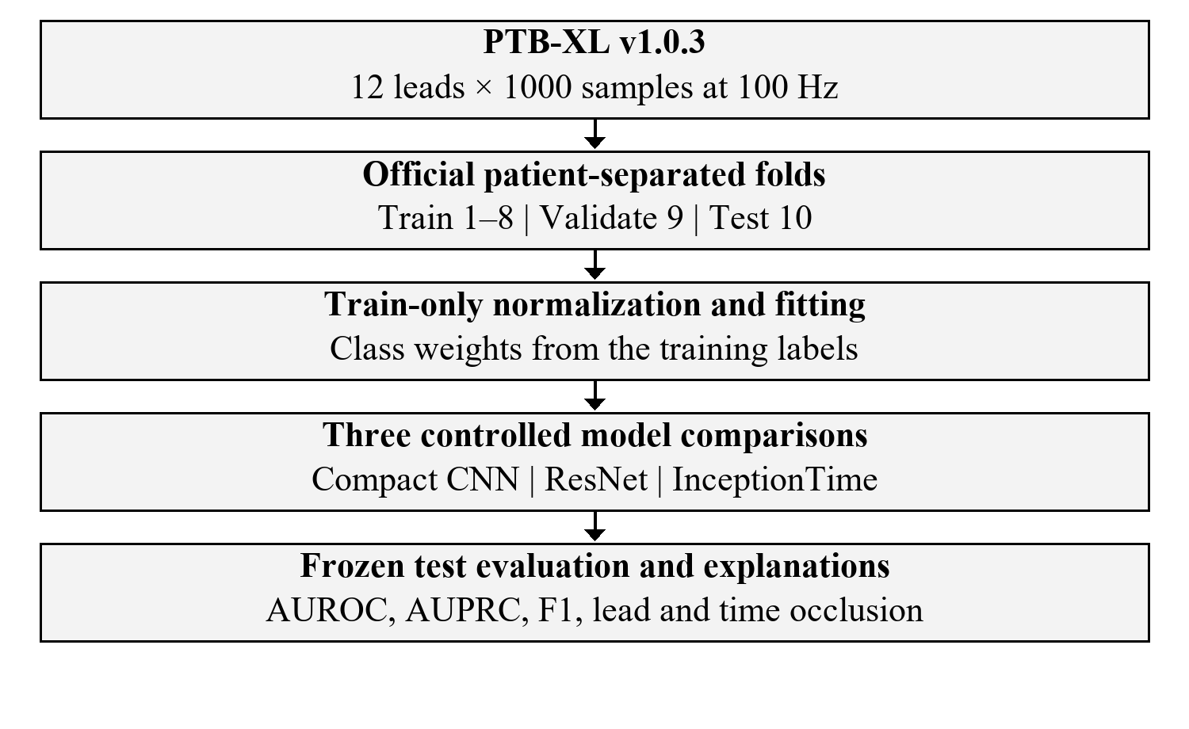
Fig. 1. Executed workflow using the official folds. Frozen checkpoints and thresholds preceded all test inference.

Compared Model Architectures
The compact CNN used three convolution blocks with 64, 128, and 192 output channels. Their kernels were 15, 9, and 5, with stride two and symmetric padding. Each block used batch normalization and rectified linear activation. Global average pooling produced a 192-element vector. The head contained a 64-unit dense layer, activation, dropout, and five output logits. The measured trainable parameter count was 221,573.
The residual baseline used a 16-channel, kernel-seven, stride-two stem and max pooling. Four stages had widths 16, 32, 64, and 128, with two basic residual blocks per stage. Each block contained two kernel-three convolutions. Stage transitions used stride two and projected shortcuts. Global pooling, dropout, and a five-unit head completed the 244,005-parameter model.
The CPU InceptionTime variant used a learned depthwise kernel-fifteen, stride-four stem. Six inception modules followed, with 16 filters per branch and kernels 9, 19, and 39. A pooling-and-projection branch supplied the fourth branch. Residual connections spanned groups of three modules. Global pooling, dropout, and a five-unit head completed the 115,729-parameter model.
These are architecture-family comparisons, not exact reproductions of published checkpoints. Widths and the strided stem were fixed using generated-input CPU timing before fitting real ECGs. The same waveform input, label mapping, partitions, optimizer settings, stopping rule, and seeds applied to all neural models. The compact model was smaller than the residual baseline but larger than the InceptionTime variant.
The classical baseline used logistic regression on 96 waveform summary features: per-lead mean, standard deviation, minimum, maximum, root mean square, mean absolute first difference, and fifth and ninety-fifth percentiles. Feature scaling used training data only. One binary classifier per category used balanced class weights. Validation AUROC selected C = 0.1 from 0.1, 1, and 10; all selected classifiers converged before 1,000 iterations.

Methodology and Experimental Setup

Normalization and model outputs
Each lead was normalized with its mean and standard deviation computed from training recordings only. The same frozen statistics transformed validation and test recordings. Equation (1) defines the normalized amplitude, where l identifies a lead, t a sample, and ε is one millionth.
$z_{l,t}=\frac{xₗ,ₜ − μₗ}{σₗ \text{+} ε}$ (1)
We used no extra filtering or augmentation. Nonfinite values, unexpected dimensions, sampling rates, or lead orders would stop preparation; all retained waveforms passed these checks. Fig. 2 shows the compact model’s executed signal path.
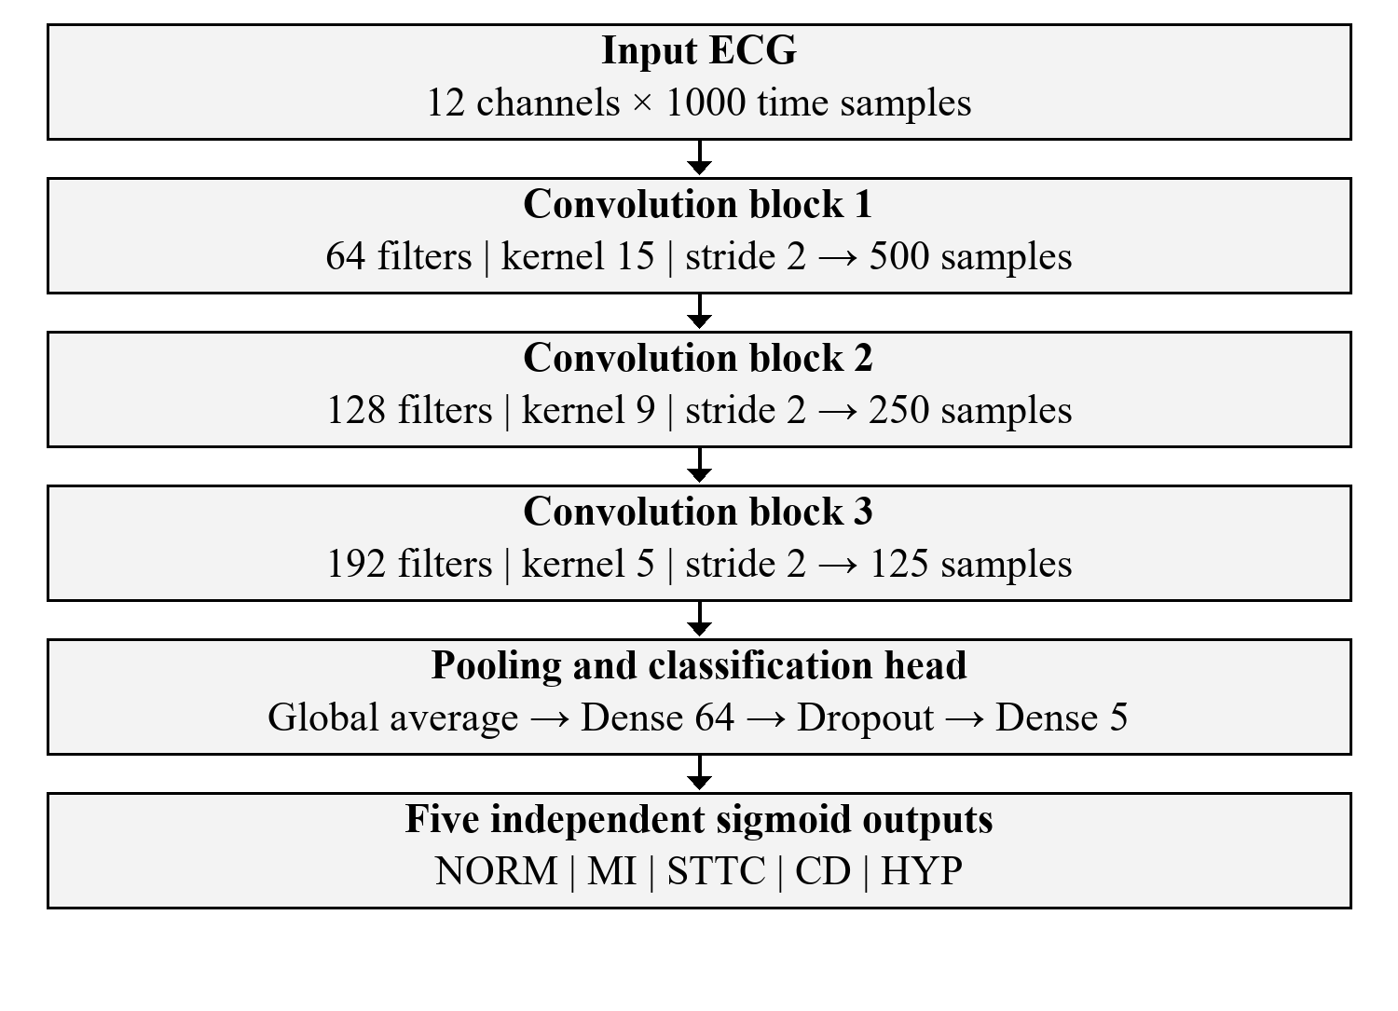
Fig. 2. Executed compact CNN. Each convolution block contains batch normalization and rectified linear activation.
Independent sigmoid scores permit overlapping predictions. Equation (2) relates logit a to score p for recording i and category c. These uncalibrated scores must not be interpreted as validated clinical probabilities.
$p_{i,c}=\frac{1}{1 \text{+} exp(−aᵢ,c)}$ (2)

Loss and optimization
The primary models minimized weighted binary cross-entropy over N training recordings and C = 5 categories. In (3) and (4), y is the binary target, and w is the training negative-to-positive count ratio for a category.
$L \text{=}\frac{1}{NC}∑ᵢ ∑cℓ_{i,c}$ (3)
$\begin{aligned}ℓ_{i,c}\text{=} −w_{c}y_{i,c}logp_{i,c} \\ −(1 −y_{i,c}) log(1 −p_{i,c})\end{aligned}$ (4)
The observed positive weights were 1.249, 2.901, 3.081, 3.373, and 7.062 in the stated output order. Training used the stable logits implementation. The unweighted compact model used the same architecture and settings, with all positive weights equal to one.
TABLE II. EXECUTED TRAINING CONFIGURATION
Item | Value
Optimizer / learning rate | AdamW / 0.001
Weight decay / dropout | 0.0001 / 0.2
Batch size / maximum epochs | 64 / 25
Early stopping | 5 epochs; improvement 0.0001
Checkpoint | Highest validation macro AUROC
Seeds | 42, 123, 2026
Hardware | Intel Core Ultra 5 245K; 32 GB RAM
Software | Windows; Python 3.12.14; PyTorch 2.14.1+cpu
CPU execution | 4 threads per process; up to 3 processes
Neural hyperparameters were fixed in advance; no neural grid search was performed. All twelve neural runs stopped early after 12–18 epochs. The checkpoint always retained the highest observed validation AUROC, while the minimum improvement controlled stopping patience. Source hashes and exact package versions were locked before training.
For each category, validation F1 selected a threshold on the grid 0.05–0.95 in steps of 0.01, with ties favoring the larger threshold. We also evaluated a fixed threshold of 0.5. Every checkpoint and threshold was frozen before test inference. No test metric triggered retraining or threshold changes.

Measured Results and Comparative Analysis
Table III reports test measurements. Neural values are mean ± sample standard deviation across seeds 42, 123, and 2026; logistic regression is a single fitted baseline. AP denotes scikit-learn average precision, our stated precision–recall summary. Macro scores weight the five categories equally. The test set contained 2,158 recordings from 1,877 patients.
TABLE III. HELD-OUT TEST PERFORMANCE
Model | AUROC | AP | F1
Compact CNN | 0.920±0.0016 | 0.802±0.0045 | 0.737±0.0025
1D ResNet | 0.914±0.0018 | 0.793±0.0028 | 0.722±0.0022
InceptionTime variant | 0.914±0.0004 | 0.795±0.0023 | 0.726±0.0024
CNN unweighted | 0.920±0.0029 | 0.807±0.0043 | 0.740±0.0088
Logistic features | 0.817 | 0.613 | 0.600
The weighted compact CNN achieved macro AUROC 0.9195, AP 0.8018, and F1 0.7369. The corresponding residual AUROC was 0.9140, and the InceptionTime variant achieved 0.9142. These descriptive differences do not establish statistical superiority.
The unweighted compact model achieved AUROC 0.9198 and F1 0.7398. Thus class weighting did not improve the aggregate result. Its effect varied by seed; a favorable individual run cannot justify a general improvement claim. The logistic baseline reached AUROC 0.8173, showing the value of learned waveform representations under this feature comparison.
Fig. 3 shows validation trajectories, with bold seed-42 traces and faint traces for the other seeds. Curves terminate at each run’s actual stopping epoch. Rising training complexity did not guarantee higher validation discrimination. Final predictions came from the saved best checkpoints, not necessarily the final epoch.
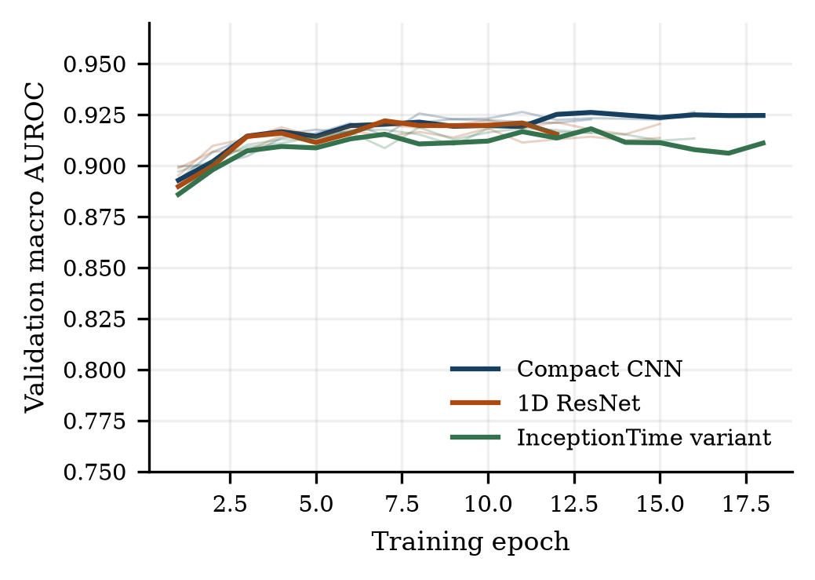
Fig. 3. Observed validation AUROC during training. No test values enter these curves.

Uncertainty and decision thresholds
The weighted compact seed-42 checkpoint achieved test AUROC 0.9178. Its 95% interval was [0.9099, 0.9253], using 1,000 patient-level bootstrap resamples. Each sampled patient contributed all associated recordings. All 1,000 resamples had defined metrics. This interval describes sampling uncertainty for one checkpoint, while the standard deviation in Table III describes variation across training seeds.
For that checkpoint, validation-selected thresholds produced macro F1 0.7360; the fixed threshold 0.5 produced 0.7199. Threshold selection changed binary decisions but left the score-based AUROC unchanged. The selected thresholds were 0.61, 0.45, 0.66, 0.59, 0.69 for NORM, MI, STTC, CD, and HYP, respectively.
$F1 \text{=}\frac{2TP}{2TP \text{+} FP \text{+} FN}$ (5)
In (5), TP, FP, and FN denote true positives, false positives, and false negatives for one category. Macro F1 averages the five category F1 scores. A single multiclass confusion matrix would discard co-occurring labels; we saved five binary matrices and their counts instead.

Measured efficiency and literature context
TABLE IV. CPU FORWARD LATENCY AND MODEL SIZE
Model | Parameters | Median ms
Compact CNN | 221,573 | 0.639
1D ResNet | 244,005 | 0.887
InceptionTime variant | 115,729 | 1.573
Latency used batch size one, four CPU threads, fifty warm-up inferences, and five hundred timed inferences per checkpoint. Table IV averages checkpoint medians across seeds. Timing excludes disk access, normalization, and occlusion. Training wall times also include validation and checkpoint work under concurrent execution, so they are not isolated hardware benchmarks.
PTB-XL+ reports superclass macro AUROC of 0.928 for its raw-waveform CNN reference, 0.921 for random forests with Uni-G features, 0.924 with 12SL features, and 0.899 with ECGDeli features [8]. These provide published context rather than a matched reproduction. Dataset versions, cohort rules, architectures, and features differ. Our compact model did not establish a new literature benchmark.

Error Analysis and Interpretability
The weighted compact seed-42 model supplied the prespecified detailed analysis because it had the highest validation AUROC among the weighted seed-42 candidates. This choice preceded test evaluation. Table V reports its category metrics; these are single-checkpoint values, not seed averages. Fig. 4 gives the corresponding precision–recall curves.
TABLE V. CATEGORY METRICS FOR THE SELECTED CHECKPOINT
Label | AUROC | AP | Recall | F1
NORM | 0.942 | 0.920 | 0.933 | 0.862
MI | 0.903 | 0.780 | 0.720 | 0.702
STTC | 0.930 | 0.821 | 0.798 | 0.766
CD | 0.917 | 0.833 | 0.736 | 0.758
HYP | 0.896 | 0.637 | 0.615 | 0.592
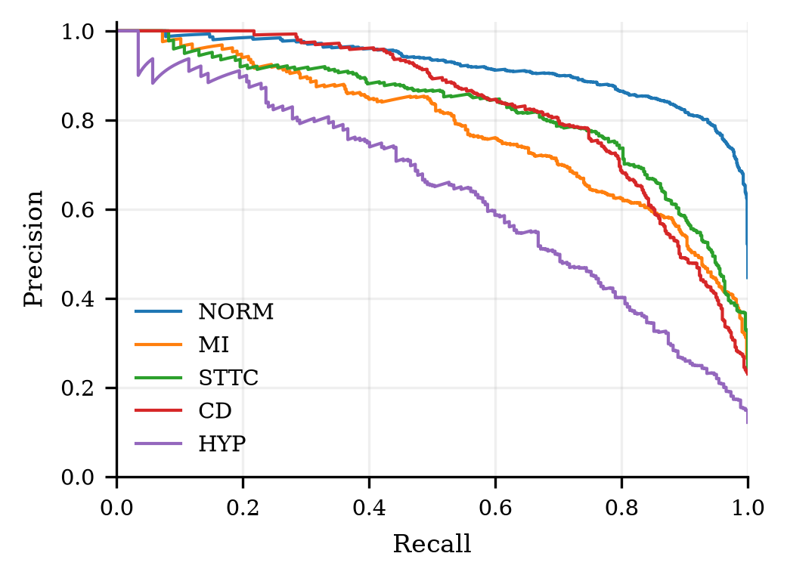
Fig. 4. Test precision–recall curves for the weighted compact seed-42 checkpoint.
NORM had AP 0.920 and F1 0.862. HYP was more difficult: AP was 0.637, recall 0.615, and F1 0.592. Its 262 positive test labels represented 12.1% of the test cohort. This pattern makes the category error analysis necessary even when the macro AUROC appears strong.
The prediction files retain ECG identifiers, patient identifiers, targets, scores, and frozen thresholds. Five confusion matrices and category-wise CSV files accompany the report. No examples or categories were removed because their predictions were unfavorable.

Measured occlusion responses
We replaced individual normalized leads, or all leads within a 200 ms window, and recorded the change in a category score. Temporal windows advanced by 100 ms. Equation (6) compares the original score with its value after masking region S. Positive change means removal reduced the score.
$Δ_{c,S}=p_{c}(x) −p_{c}(mask(x, S))$ (6)
For each category, the lowest eligible ECG identifier selected one true positive and one false negative. All ten examples were available. We repeated masking with the per-record lead median as an alternate replacement. The original predictions reproduced within the recorded numerical tolerance. Fig. 5 shows one prespecified MI true positive.
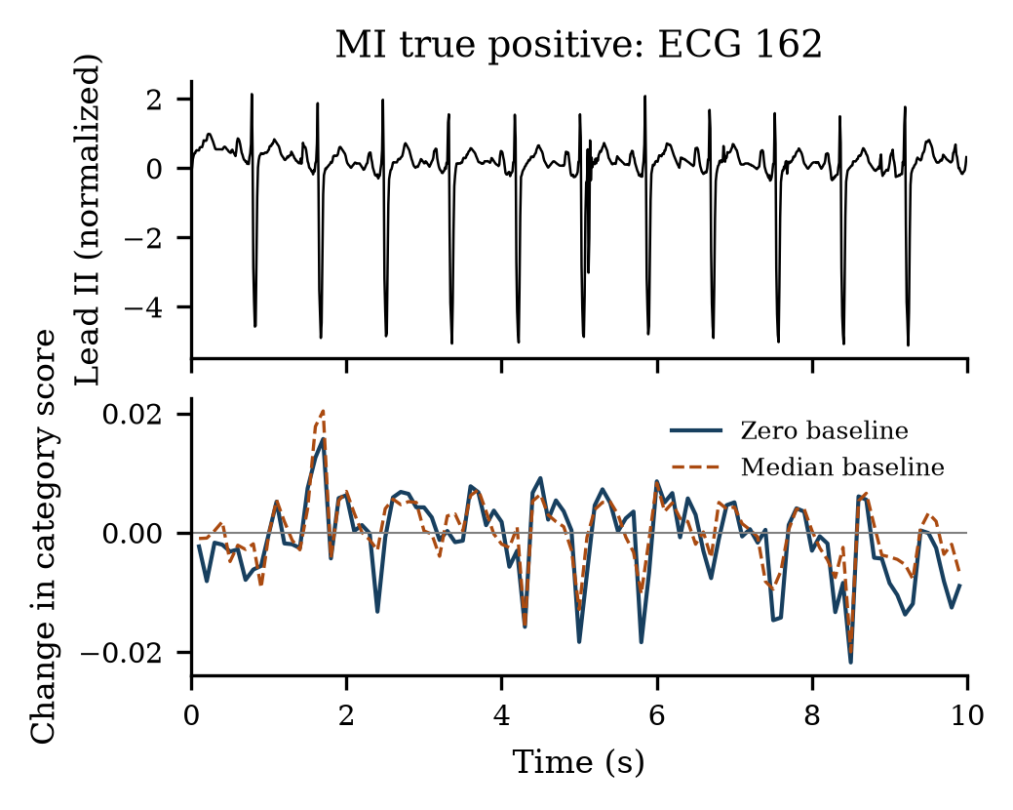
Fig. 5. Measured temporal occlusion responses for MI example 162. Zero and median refer to replacement baselines.
ECG 162 had MI score 0.860 against threshold 0.45. Zero- versus median-baseline temporal responses had Spearman correlation 0.834. The saved MI false negative, ECG 63, scored 0.294 below the same threshold. Attribution sensitivity is not physiological causality, and no clinician validated these locations.

Limitations and conclusion
This study used one historical dataset and an internal test fold. It included no external hospital, prospective evaluation, probability calibration, subgroup fairness study, or clinical expert review. The narrow CPU variants and fixed hyperparameters limit architecture-level conclusions. Three seeds do not establish broad optimization robustness, and individual perturbation examples do not prove clinical interpretability.
The executed experiment supports a useful compact-model baseline with reproducible test predictions and low measured CPU latency. It also shows that loss weighting and larger parameter counts did not guarantee better aggregate results. Further work requires external validation, calibration, and clinically reviewed explanations before any care-related application.

References
[1] P. Wagner et al., “PTB-XL, a large publicly available electrocardiography dataset,” Scientific Data, vol. 7, art. 154, 2020. doi: 10.1038/s41597-020-0495-6.
[2] N. Strodthoff, P. Wagner, T. Schaeffter, and W. Samek, “Deep learning for ECG analysis: Benchmarks and insights from PTB-XL,” IEEE J. Biomed. Health Inform., vol. 25, no. 5, pp. 1519–1528, 2021. doi: 10.1109/JBHI.2020.3022989.
[3] T. Mehari and N. Strodthoff, “Self-supervised representation learning from 12-lead ECG data,” Computers in Biology and Medicine, vol. 141, art. 105114, 2022. doi: 10.1016/j.compbiomed.2021.105114.
[4] A. Anand, T. Kadian, M. K. Shetty, and A. Gupta, “Explainable AI decision model for ECG data of cardiac disorders,” Biomedical Signal Processing and Control, vol. 75, art. 103584, 2022. doi: 10.1016/j.bspc.2022.103584.
[5] V. Jahmunah, E. Y. K. Ng, R.-S. Tan, S. L. Oh, and U. R. Acharya, “Explainable detection of myocardial infarction using deep learning models with Grad-CAM technique on ECG signals,” Computers in Biology and Medicine, vol. 146, art. 105550, 2022. doi: 10.1016/j.compbiomed.2022.105550.
[6] R. R. van de Leur et al., “Improving explainability of deep neural network-based electrocardiogram interpretation using variational auto-encoders,” European Heart Journal – Digital Health, vol. 3, no. 3, pp. 390–404, 2022. doi: 10.1093/ehjdh/ztac038.
[7] K. Pałczyński, S. Śmigiel, D. Ledziński, and S. Bujnowski, “Study of the few-shot learning for ECG classification based on the PTB-XL dataset,” Sensors, vol. 22, no. 3, art. 904, 2022. doi: 10.3390/s22030904.
[8] N. Strodthoff et al., “PTB-XL+, a comprehensive electrocardiographic feature dataset,” Scientific Data, vol. 10, art. 279, 2023. doi: 10.1038/s41597-023-02153-8.
[9] T. Mehari and N. Strodthoff, “Towards quantitative precision for ECG analysis: Leveraging state space models, self-supervision and patient metadata,” IEEE J. Biomed. Health Inform., vol. 27, no. 11, pp. 5326–5334, 2023. doi: 10.1109/JBHI.2023.3310989.

[10] S. Soltanieh, J. Hashemi, and A. Etemad, “In-distribution and out-of-distribution self-supervised ECG representation learning for arrhythmia detection,” IEEE J. Biomed. Health Inform., vol. 28, no. 2, pp. 789–800, 2024. doi: 10.1109/JBHI.2023.3331626.
[11] A. Saglietto et al., “Convolutional neural network (CNN)-enabled electrocardiogram (ECG) analysis: A comparison between standard twelve-lead and single-lead setups,” Frontiers in Cardiovascular Medicine, vol. 11, art. 1327179, 2024. doi: 10.3389/fcvm.2024.1327179.
[12] L. Bontinck, K. Fonteyn, T. Dhaene, and D. Deschrijver, “ECGencode: Compact and computationally efficient deep learning feature encoder for ECG signals,” Expert Systems with Applications, vol. 255, art. 124775, 2024. doi: 10.1016/j.eswa.2024.124775.
[13] S. Sawano et al., “Applying masked autoencoder-based self-supervised learning for high-capability vision transformers of electrocardiographies,” PLOS ONE, vol. 19, no. 8, art. e0307978, 2024. doi: 10.1371/journal.pone.0307978.
[14] Y. Na, M. Park, Y. Tae, and S. Joo, “Guiding masked representation learning to capture spatio-temporal relationship of electrocardiogram,” in Proc. International Conference on Learning Representations, 2024. [Online]. Available: https://arxiv.org/abs/2402.09450.
[15] C. Liu et al., “Zero-shot ECG classification with multimodal learning and test-time clinical knowledge enhancement,” in Proc. International Conference on Machine Learning, PMLR, vol. 235, pp. 31949–31963, 2024. [Online]. Available: https://proceedings.mlr.press/v235/liu24bg.html.
[16] J. Li, C. Liu, S. Cheng, R. Arcucci, and S. Hong, “Frozen language model helps ECG zero-shot learning,” in Medical Imaging with Deep Learning, PMLR, vol. 227, pp. 402–415, 2024. [Online]. Available: https://proceedings.mlr.press/v227/li24a.html.
[17] C. Liu et al., “Knowledge-enhanced multimodal ECG representation learning with arbitrary-lead inputs,” in Findings of the Association for Computational Linguistics: EMNLP 2025, pp. 7298–7316, 2025. doi: 10.18653/v1/2025.findings-emnlp.385.
[18] P. Wagner, N. Strodthoff, R.-D. Bousseljot, W. Samek, and T. Schaeffter, “PTB-XL, a large publicly available electrocardiography dataset,” version 1.0.3, PhysioNet, 2022. doi: 10.13026/kfzx-aw45. [Dataset release].

