SHRI SHAMBHUBHAI V. PATEL COLLEGE OF COMPUTER SCIENCE & BUSINESS MANAGEMENT, SURAT.

VEER NARMAD SOUTH GUJARAT UNIVERSITY, SURAT.

PROJECT REPORT ON

“RUHH BLOGS”

AS A PARTIAL REQUIREMENT FOR THE DEGREE

OF BACHELOR OF COMPUTER APPLICATION

[B.C.A]YEAR:2023-24

SUBMITTED BY : GUIDED BY:

PAL MANSI ANILBHAI PROF.PRATIKSHA PATEL

**PREFACE**

• Before Tasking the Project Work for Foundation, It Is Quite Necessary to Have an Exact Idea the Work “Project”. The Project Consist of Seven Letters Each Letter Has Its Own Significance as Follow.

‘P’ For Planning

‘R’ For Resource

‘O’ For Operation

‘J’ For Joints Efforts

‘E’ For Engineering Function

‘C’ Communication

‘T’ Task of Working

• We Happy to Hand-Over This Project to **The Shri Shambhubhai V. Patel College of Computer Science & Business Management.**

I’m doing my project on **“RUHH BLOG”** .

• Here I’m Presenting a Project on the Different Concept. I Have Tried my Level best to do proper justification in this project.

**Acknowledgement**

• My Self Ms. Mansi Pal have opportunity to express my knowledge. We would like to express my gratitude to all those who gave me the possibility to complete my project. I want to thanks to Signature Infosys for giving me permission to Do Project Work in their Organization.

• Prof. Pratiksha Patel – Our professor and project coordinates has been very prudent to me threw out the Collage Studies. They are the Person who has giving this Direction to My Work and The shape to my Imagination.

• I also like to thanks our all the professor who are always ready to give best guide. They are the person who give solution whenever needed.

• I would also like to acknowledge all the Friends and Colleagues, Team member for the help and encouragement by them for Time to Time. The constant Support and Encouragement of my Friend is deeply appreciates. The Project indeed gave Challenging and Exhilarating experience in Designing and Developing the Required System.

**INDEX**

Certificate………………………………………………………………………………………………………..2

PREFACE………………………………………………………………………………………………………….3

Acknowledge………………………………………………………………………………………………………….4

Introduction……………………………………………………………………………………………………….…….6

MINOR PROJECT………………………………………………………………………………………………………….7

1.SPECIFICATIONS : (SRS Documentation) …………………………………………………………………………7

2.OBJECTIVES………………………………………………………………………………………………………….7

3.Flow chart………………………………………………………………………………………………………….8

4.DFD………………………………………………………………………………………………………….9

ZERO level………………………………………………………………………………………………………….9

First level………………………………………………………………………………………………………….10

Second level………………………………………………………………………………………………………….11

5.ER-diagram………………………………………………………………………………………………………….12

6.Screenshots………………………………………………………………………………………………………….13

Home…………………………………………………………………………………………………………………….13

Blog page……………………………………………………………………………………………………………..14

Posted blog page………………………………………………………………………………………………………….14

About us page………………………………………………………………………………………………………..16

Contact us page……………………………………………………………………………………………….…….17

Admin login page………………………………………………………………………………………………………….17

Admin Dashboard page……………………………………………………………………………………………………………..18

Add category page…………………………………………………………………………………………………….….18

Manage category page……………………………………………………………………………………………………………..19

Add Sub-category page………………………………………………………………………………………………….….19

Manage Sub-category page ……………………………………………………………………………………………………….…….20

Add Post Page…………………………………………………………………………………………………….20

Manage Post Page ……………………………………………………………………………………………………..21

Unapproved Commet page………………………………………………………………………………………………….22

Approved Comment page………………………………………………………………….………………………….22

7.BIBLIOGRAPHY……………………………………………………………………………………….23

INTRODUCTION

Project profile

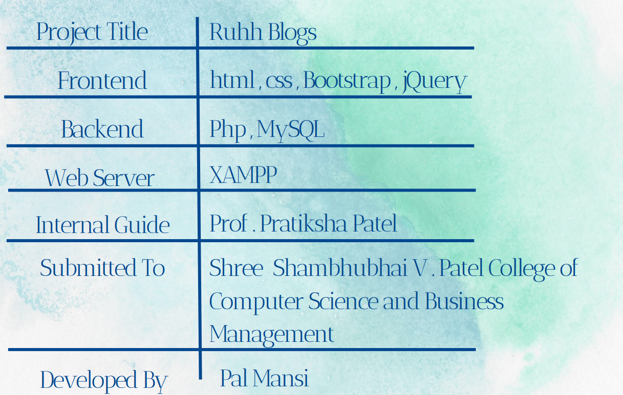

**MINOR PROJECT**

1. **SPECIFICATIONS : (SRS Documentation)**

Overall descriptions:

1: Blog perspective [Product details]

2: Blog Features [ER diagram]

3: Operating environment [Database details]

**2. OBJECTIVES :**

1. Provides the searching facilities based on various factors. Such as Blog ,Idea.

2. Manage the Information of Topic.

3. It tracks all the information of Topic ,Views , Content, etc.

4. Manage the Information of Blogs.

5. Manage the Information of Content.

6. Editing , adding and updating of records is improved which results in proper resource management of Blog data

**3.FLOW Chart:**

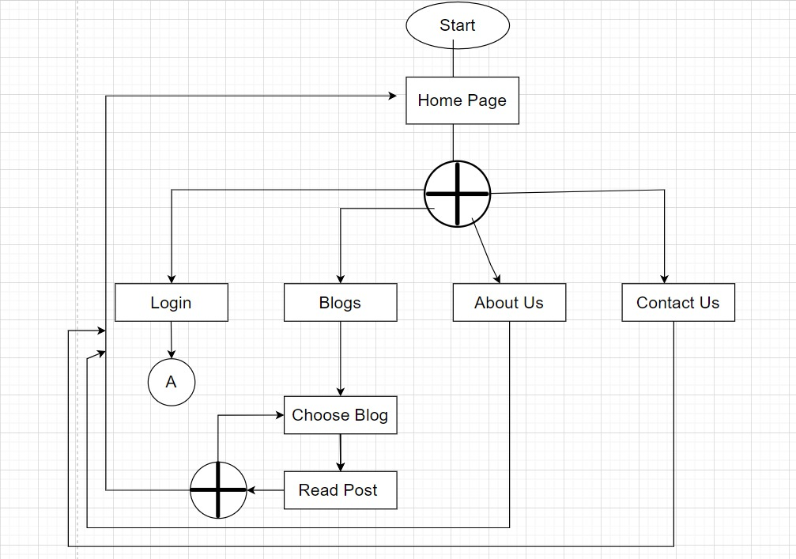

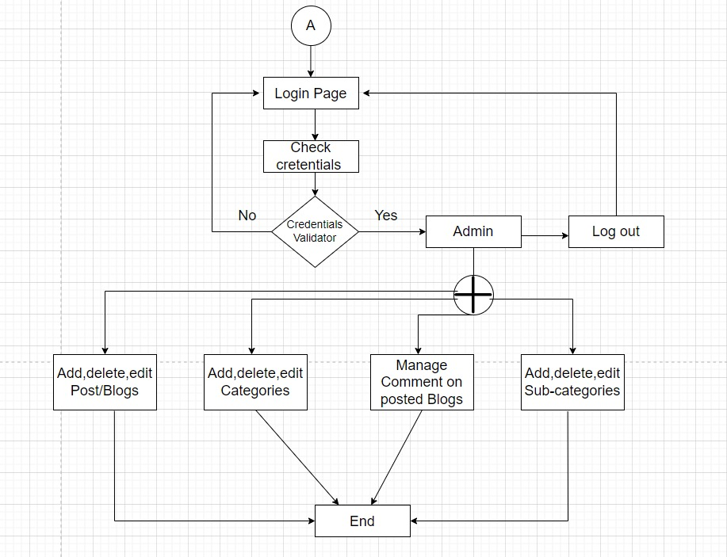

**4. DFD:**

**• Zero Level :-**

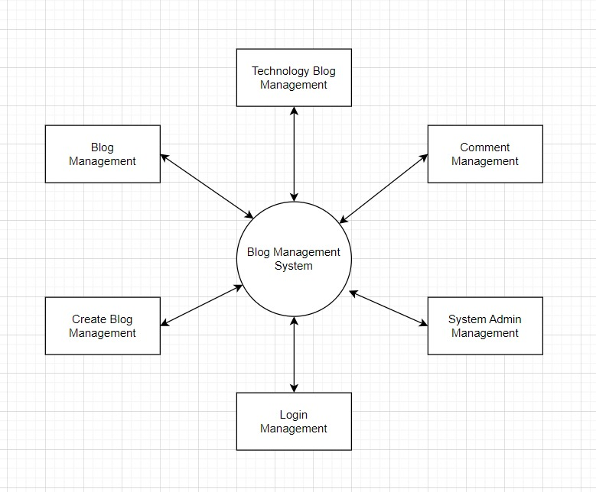

**• First Level :-**

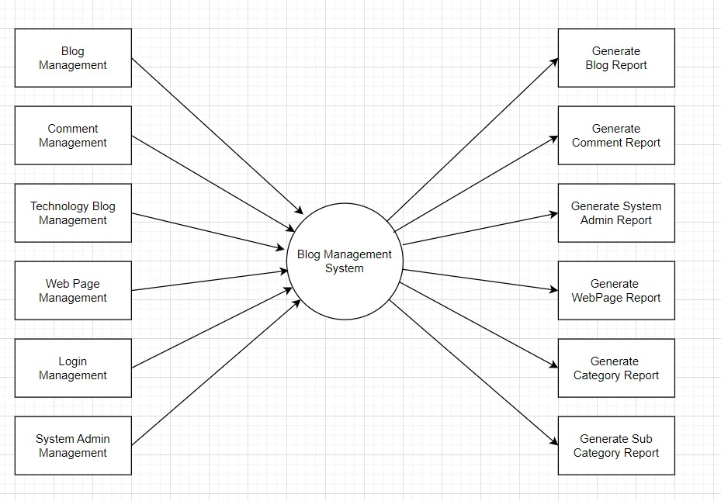

**• Second Level :-**

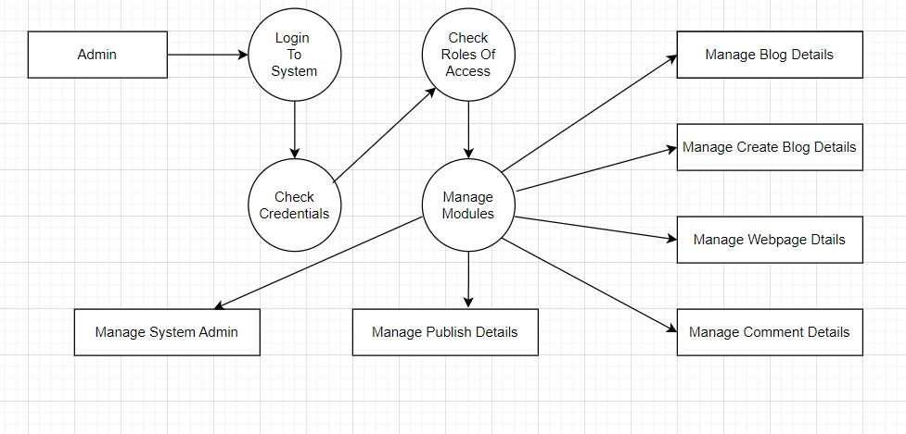

**5.ER-Diagram:**

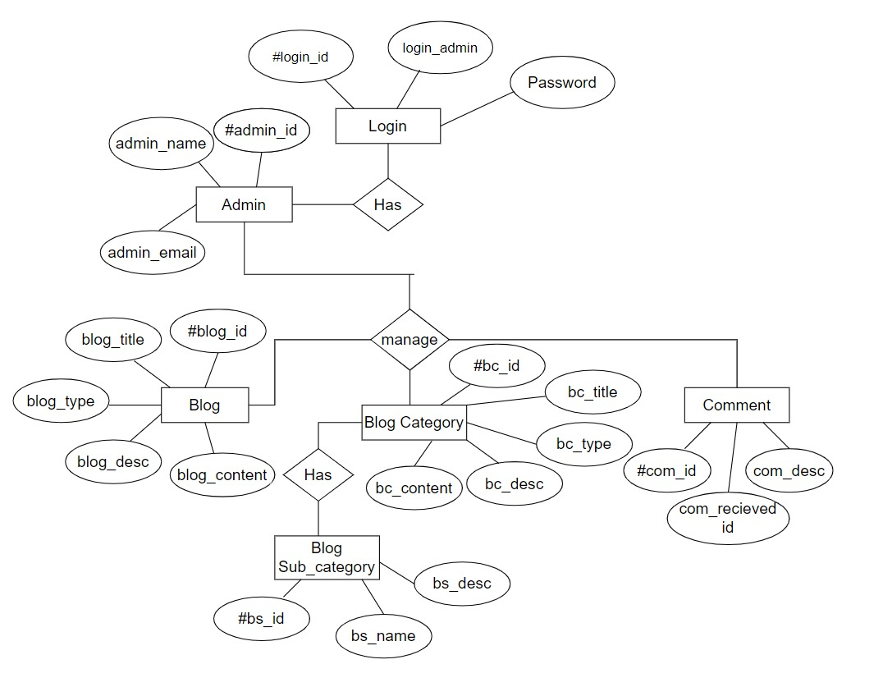

**6. Screen Shots:**

**• Home Page:**



**• Blog Page:**



**Posted BLog page:**

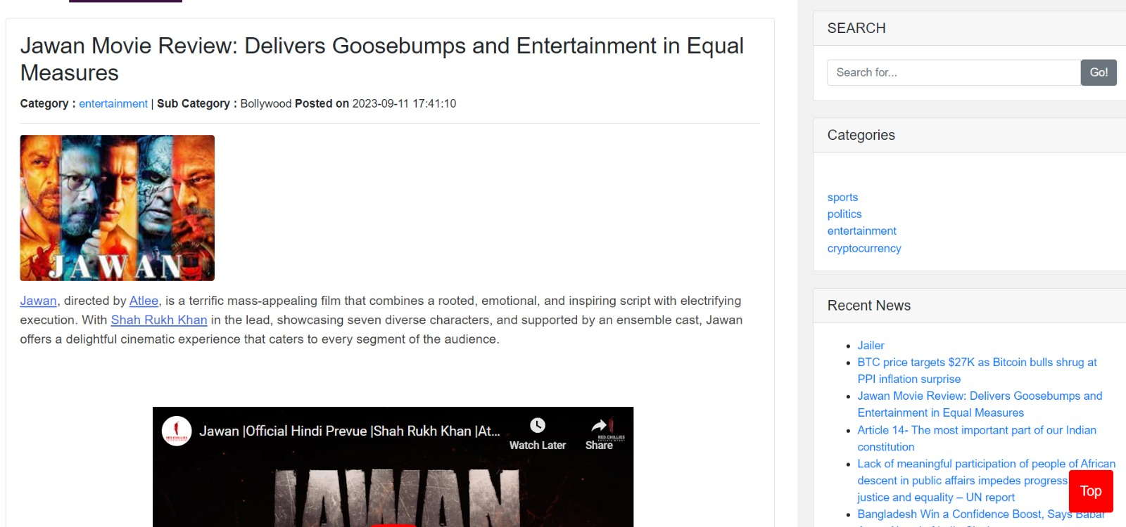

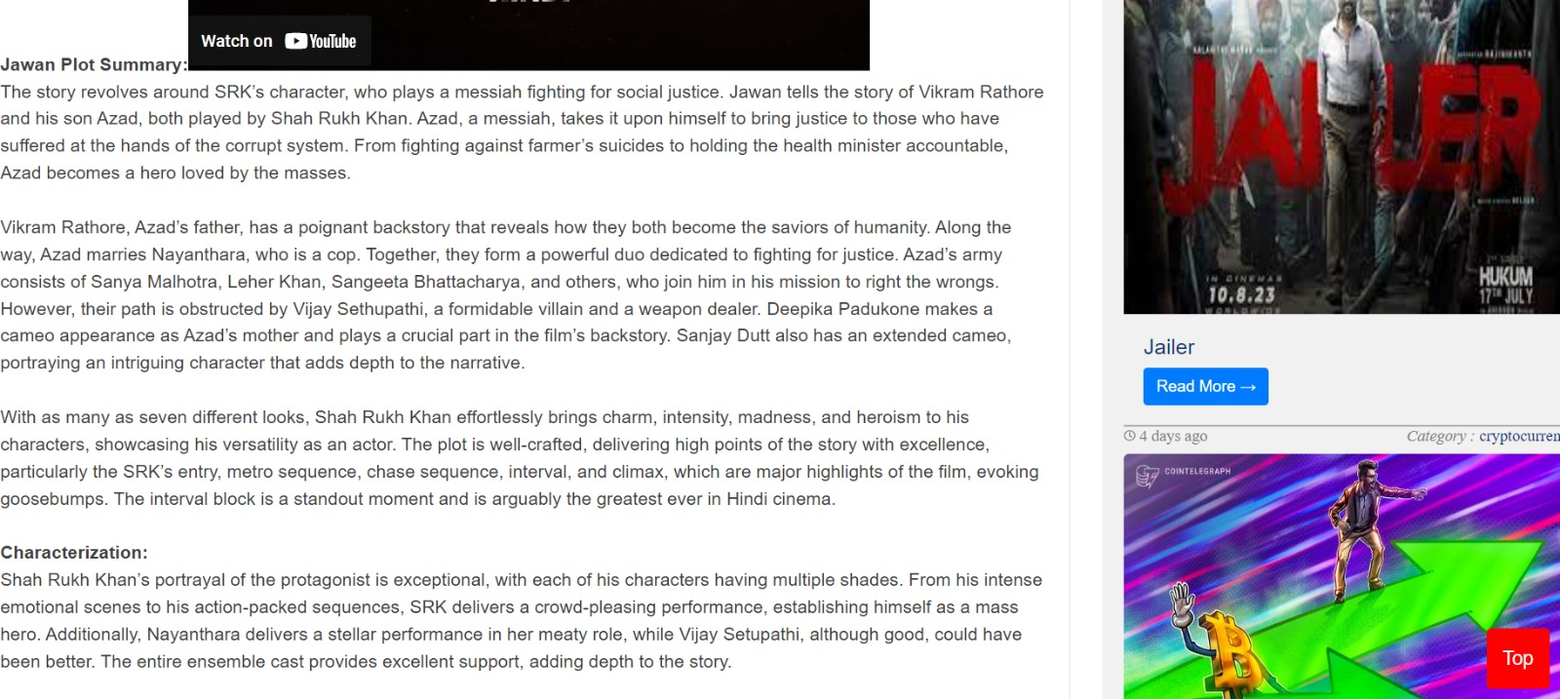

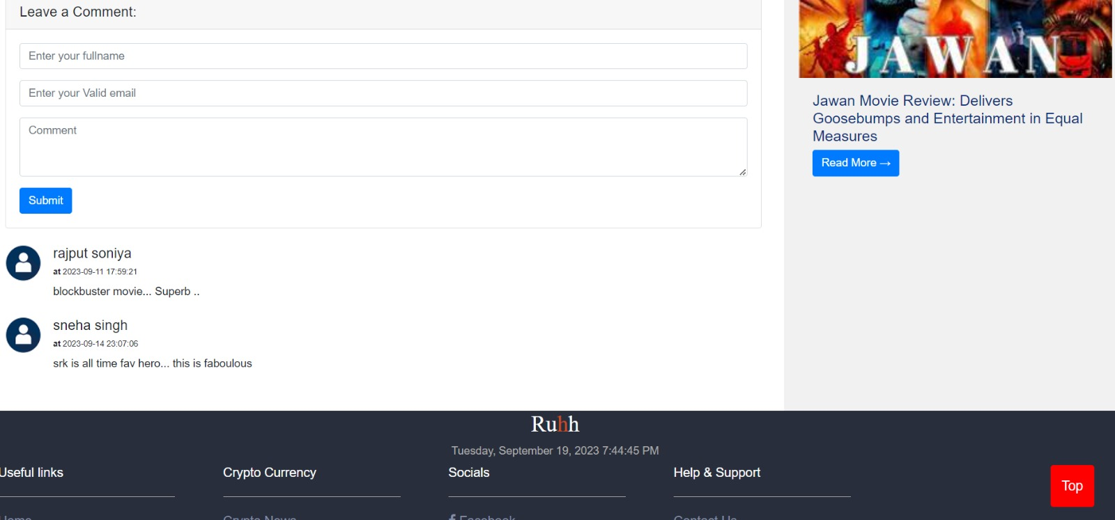

**About us:**





**Contact us page:**



**Admin Login page:**



**Admin Dashboard page:**

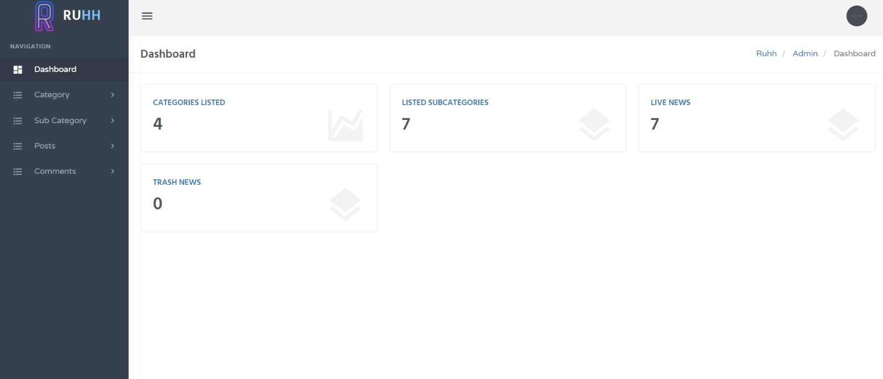

**Add Category page:**

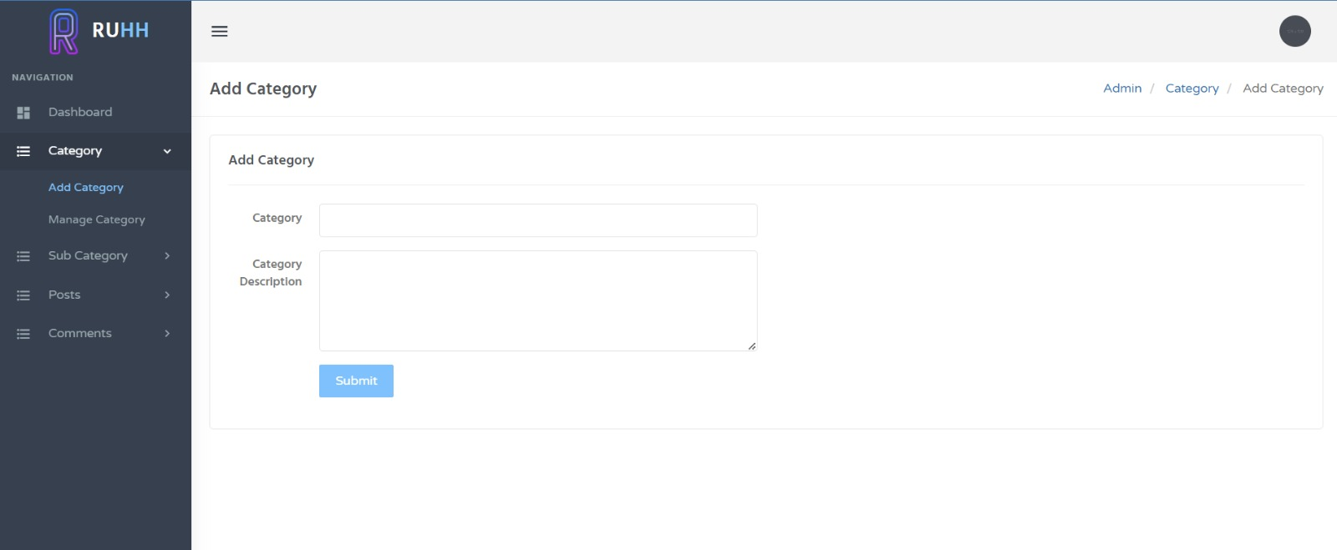

**Manage Category page:-**

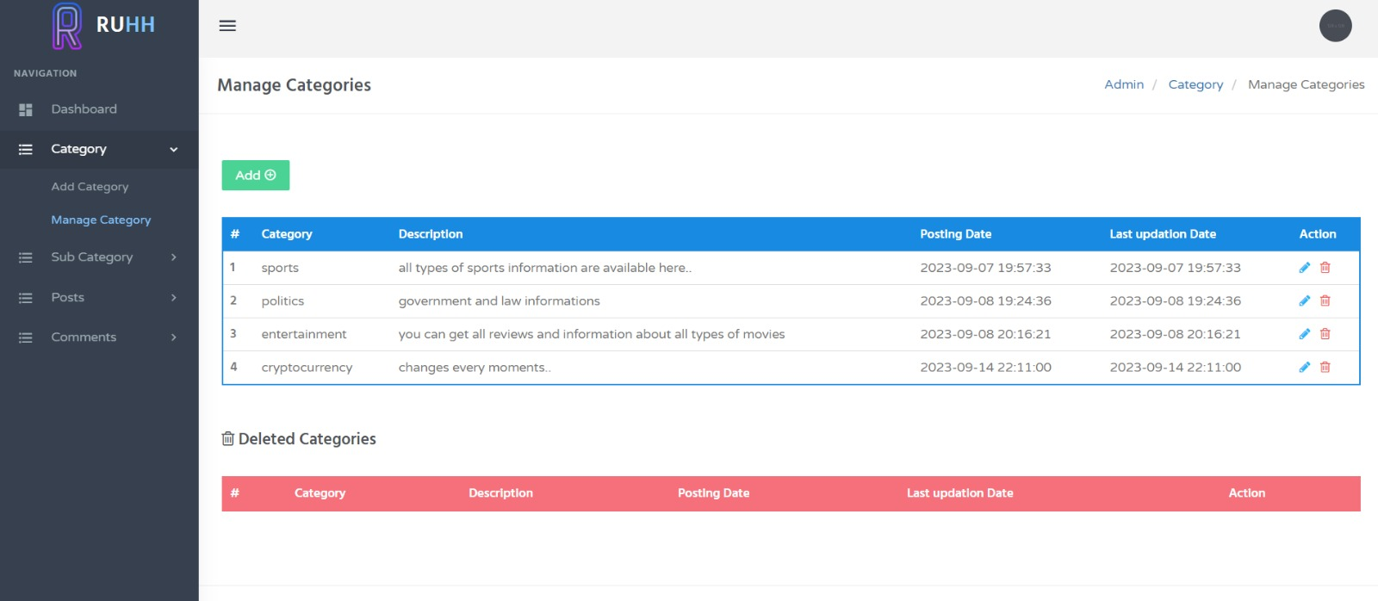

**Add Sub-category page:**

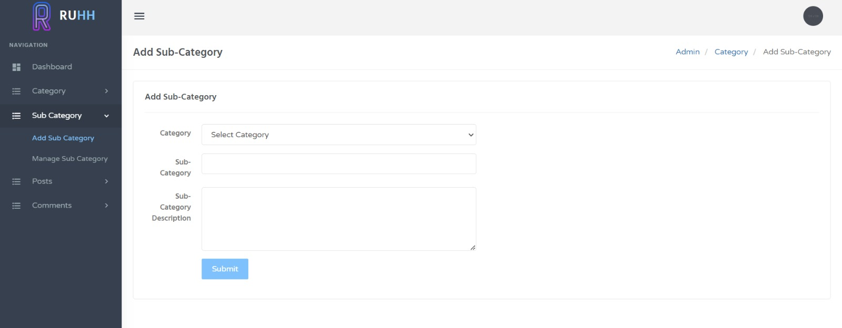

**Manage Sub-category page:**

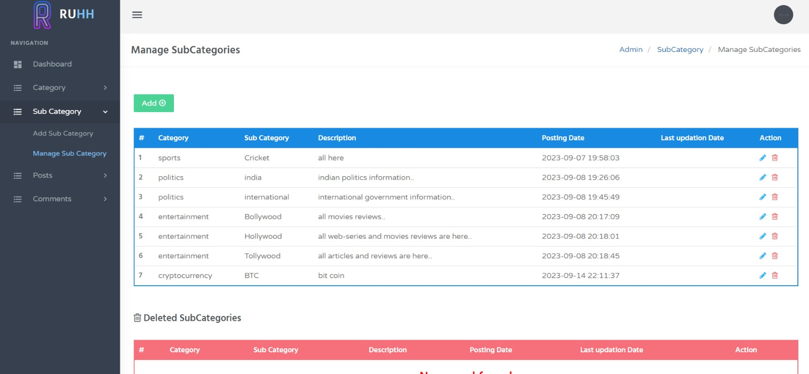

**Add Post Page:**

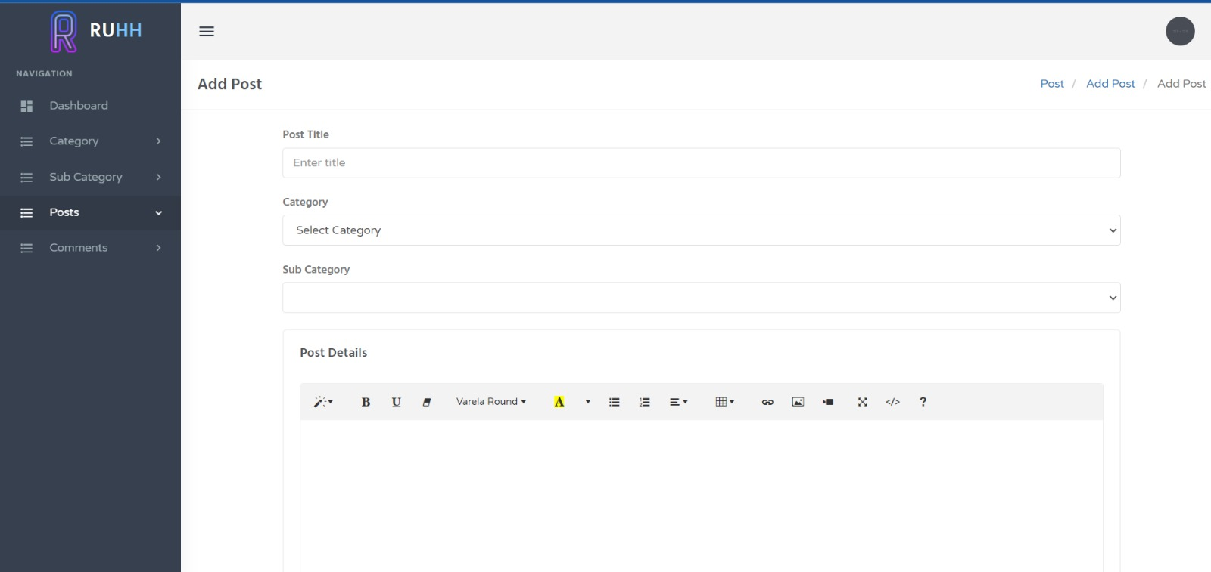

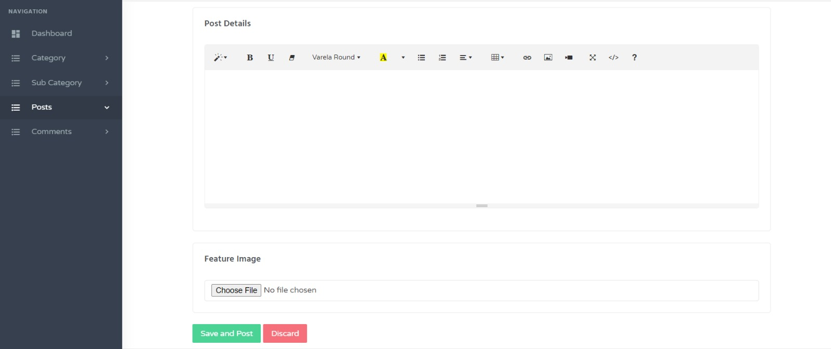

**Manage Post page:**

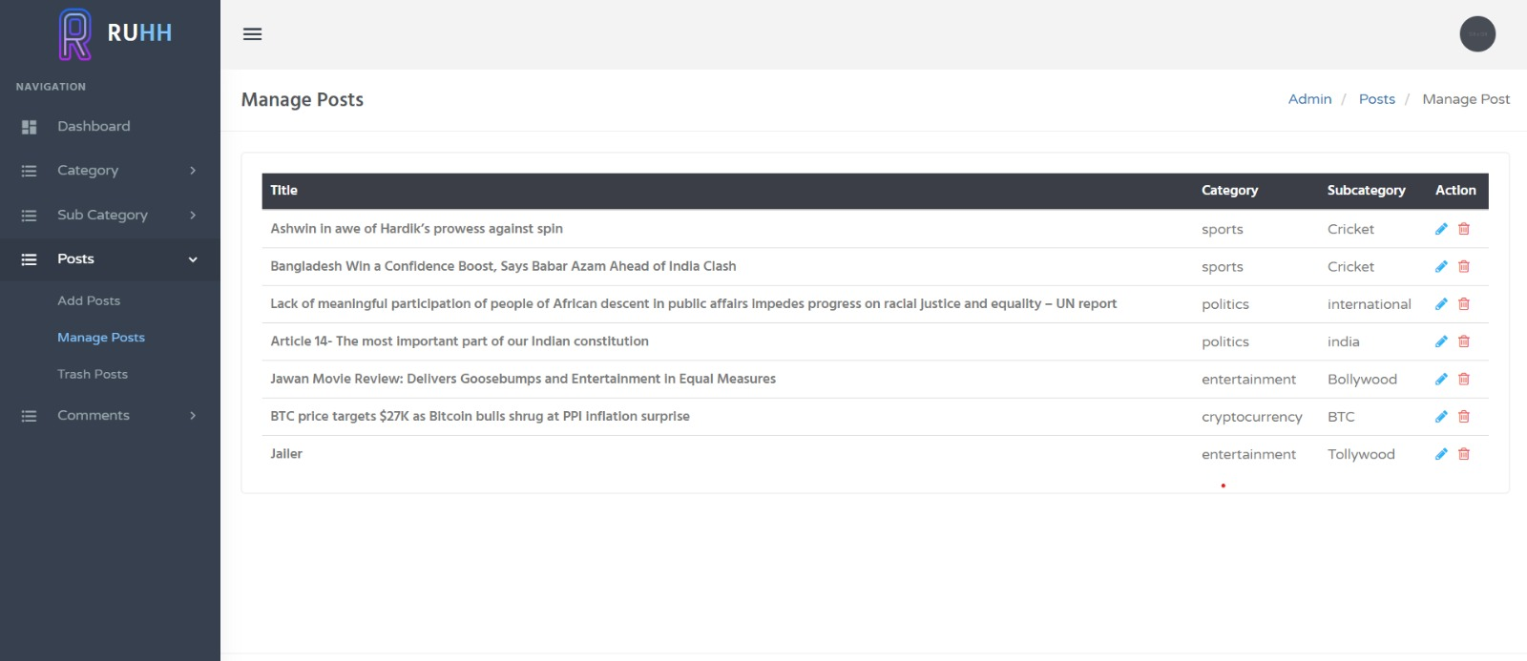

**Unapproved Comment Page:**

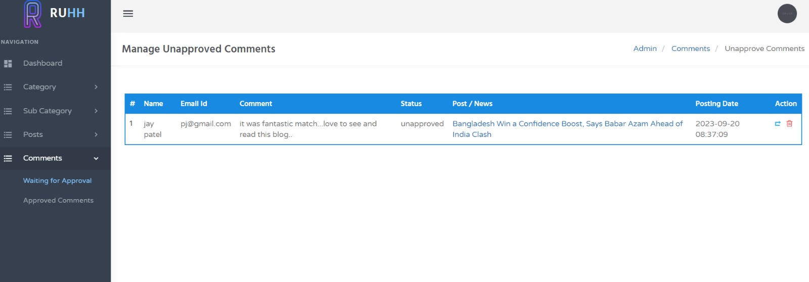

**Approved Comment Page:**

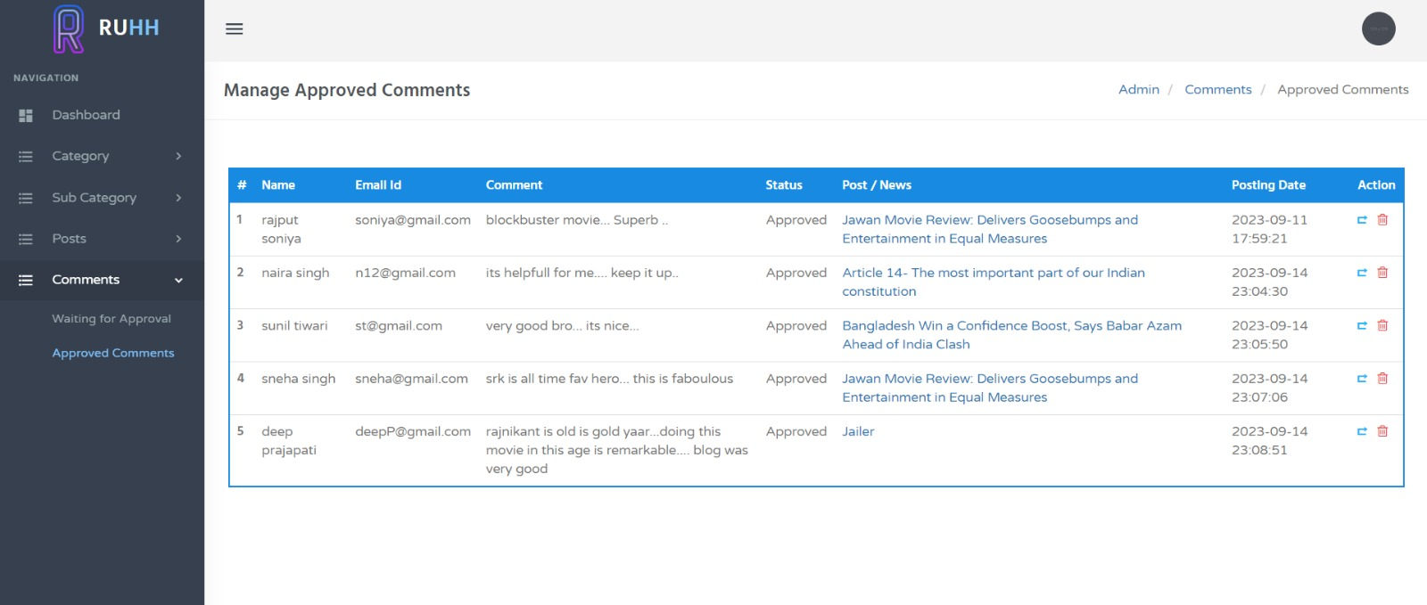

7. BIBLIOGRAPHY

• References

➢ Figure:

✓ (Source: <https://www.geeksforgeeks.org/architecture-of-mysql/>)

➢ WEBSITES: 1. <http://www.phptutorial.com>

2. <http://www.easyphpwebsites.com>

3. <http://www.bestphpwebsites.com>

➢ BOOK:

1. PHP 5 Power programming.

2. PHP MySQL bible. 3. PHP Manual