RESUME
STATEMENT OF PURPOSE:
I would like to put my best effort in learning practical aspects of mechanical & operation & maintenance engineering and would directly lead to the growth and development of the company, my aim would be to make a mark in the company with the help of my hard efforts and toil put in together with patience and passion to do work.

SPECIALIZATION:

B.E: maintenance Engineering

CONTACT INFORMATION:

Name: Dadga Bhumitkumar Jayantilal.
Mobile: +91-9727212797
E-Mail : patelbhumit65@gmail.com

CONTACT ADDRESS
AREAS OF INTREST:
- Maintenance
- Production Planning and Control
- Operation
- Quality Control & Quality Assurance.
- Machine shop/Production (machining).

PROFESSIONAL STRENGTHS:
- In any type of condition I do my best and try to held work without tension.
- Good team management, communication skills and leadership qualities.
- Proactive problem solver.
- Adaptable to new work places and environment very easily.
- Proactive, self-motivated and Honest.
- Keenly interested in learning new technologies to become technically Sound.

ACADEMIC RECORD:

To.: Pitruchhaya palace,ukani nagar Bidada-mandvi.
Mandvi–Kutch-370435 PERSONAL DETAILS:
ENGINEERING | CPI-6.53
HIGHSCHOOL | Mar-  2011
HIGHSCHOOL | Mar- 2009

Date of birth : 26/08/1993 Sex : Male
Height : 172 cm
Weight : 49 kg Nationality : Indian
Maritalstatus :Married Cast : Hindu

LANGUAGES KNOWN:

- 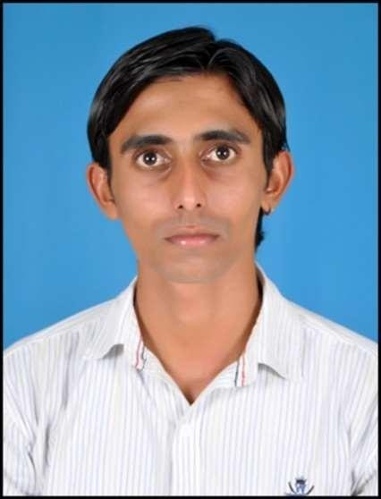English
- Hindi
- Gujarati

HOBBIES:
Driving Car, Reading News Paper, Net Surfing, Listening music, Play indoor Game

Collage/institute: H.J.D. Institute & Technical research, Kera-Kutch University : Gujarat technological university, Ahmedabad.

WORK EXPERIENCE:
  - Experience in HARSHAL ELECTRICAL PVT. LTD. at adani port and sez ltd. mundra-kutch from 26-april-2016 to 31-jan-2019(2 years and 9 months) as a mechanical technician for maintenance of port equipments.
  - From 05-feb-2019 to 10-aug-2019 work in LAND MARINE ENGINEERING AND PORT
SOLUTION. at NSICT, Mumbai. As a mechanical engineer for maintenance of port equipments.
  - From 29-sep-2019 to till date work in ABU DHABI TERMINALS. at ABU DHABI, UAE. as a mechanical supervisor to handle the technical maintenance team for straddle carriers and mobile equipments preventive and corrective maintenance.
    - Maintenance of RTG and STS spreader.
    - Service Maintenance, Overhauling and troubleshooting of CATERPILLERC13, CUMMINS QSB6.7, SCANIA,VOLVO PENTA, DEUTZ L04,YANMAR 4TNE92 engines
    - Service maintenance, Overhauling and troubleshooting of DANA and ALLISON transmission work done
    - Breakdown attends of RTG and STS spreader.
    - Private maintenance RTG,STS,RMG,SUTTLE CARRIER,ASC,RICH STRACKER,FORKLIFT,ECH,TT,TR.
    - Breakdowns attends of RTG,STS,RMG and mobile equipment cranes.
    - Hydraulics systems related breakdown attending & rectification.
    - Trolley wheel of RTG and STS replacement work.
    - All tyre BREAK maintenance.
    - Wire rope preparation and replacement work.
    - Heavy hydraulics cylinder replacement work.

Good Team Player
    - Quick Learner
    - Good Communication Skills
    - Good at time management
    - Ability to meet deadlines

PROJECT – INDUSTRIAl DEFINE PROBLEM (IDP):

I have prepared Industrial Defined Problem (IDP) based on “Failureanalsis & modification of vibratory strip used in thresher machine . ” in my training at Ashapura industries, bhuj- kutch.

TRAINING:

    - Ashapura industries, India

Work Affiliation:
Company name : Ashapura industries, India Location : BhujG.I.D.C. Bhuj(India)
Duration : From 1st June 2015 to 13thJune 2015
Position : Trainee

    - Study area –Manufacturing And Machine Shop

EXTRACURRICULAR ACTIVITIES
.
-Attended Seminar on “LEAN MANUFACTURING” organized by Bombardier Pvt.Ltd.

COMPUTER SKILL
- Operating system, windows xp, windows 7
- MS offices 2007

DECLARATION:

I confirm that the information provided by me is true and correct to the best of my knowledge and belief. I assure you that if I am given a chance to serve in your organization than I will work honestly, sincerely and enthusiastically towards the achievement of yours organizational goals and objectives.

Date: / / Bhumit J. Dadga

