

**INFO 2301  
GROUP PROJECT**

School Management System

**SECTION - 02**

**Hasan MD Tanvir 1716763**

**MD Abu Sayed Chowdhury 1711237**

**Hussain K M Tansir 1638331**

**Abstract:**

This project is about School Management System which we developed with SQL and PL/Sql. There are 6 tables in it – Student, Teacher, Staff, Class, Family and Result. These tables are interrelated with one another. We also connect our database with the web using PHP coding and XAMPP. The user interface is functional, people can insert, delete, search and edit the data.

drop table Family cascade constraints;

drop table Staff cascade constraints;

drop table Teacher cascade constraints;

drop table Class cascade constraints;

drop table Result cascade constraints;

drop table Student cascade constraints;

create table Family

(FamilyID number primary key,

Father_Name varchar2(20),

Mother_Name varchar2(20),

Father_Phone number,

Mother_Phone number,

Home_Address varchar2(20));

create table Staff

( Staff_ID number primary key,

First_Name varchar2(20),

Last_Name varchar2(20),

Phone_Number number,

Address varchar2(20),

Salary number);

create table Teacher

(Teacher_ID number,

Staff_ID number,

Room_No varchar2(20),

Subject varchar2(20),

primary key (Teacher_ID),

foreign key (Staff_ID) references Staff( Staff_ID));

create table Class

( Class_ID varchar2(20),

Class_Subject varchar2(20),

Teacher_ID number,

Lesson_Time varchar2(20),

primary key( Class_ID),

foreign key( Teacher_ID) references Teacher(Teacher_ID));

create table Student

(Student_ID number,

First_Name varchar2(20),

Last_Name varchar2(20),

Birthdate varchar2(20),

Phone number,

FamilyID number,

Class varchar2(20),

primary key (Student_ID),

foreign key (FamilyID) references Family(FamilyID));

create table Result

(Exam varchar2(20),

Student_ID number,

Class_ID varchar2(20),

Exam_date date,

Mark number,

foreign key (Student_ID) references Student(Student_ID),

foreign key (Class_ID) references Class(Class_ID));

insert into Family values ( 1000, 'MR. Mokles', 'MRS. Sokles', 01029273, 01927382,' 29-Jalan-Gombak');

insert into Family values ( 1001, 'MR. Mula', 'MRS. Gula', 01024573, 01923482,' 29-Sri-Gombak');

insert into Family values ( 1002, 'MR. Gajor', 'MRS. Fojor', 01664573, 09923482,' 9-Sri-Kedah');

insert into Family values ( 1003, 'MR. Amm', 'MRS. Jamm', 44664573,77923482,' 91-Sr-Muda');

insert into Family values ( 1004, 'MR. Kola', 'MRS. Dola', 44664873,77923002,' 91-Sri-Huda');

insert into Family values ( 1005, 'MR. Bye', 'MRS. Hii', 44004873,77926602,' 21-Sri-Sylhet');

insert into Family values ( 1006, 'MR. Khai', 'MRS. Jai', 44004343,77924302,' 21-7-Noyakhali');

insert into Family values ( 1007, 'MR. Bari', 'MRS. Curry', 00004343,09924302,' 21-0-Potuakhali');

insert into Family values ( 1008, 'MR. Bari', 'MRS. Curry', 00004343,09924302,' 21-0-Hotuakhali');

insert into Family values ( 1009, 'MR. Huda', 'MRS. Nuda', 21004343,98924302,' 24-Jalan-Idaman');

insert into Family values ( 1010, 'MR. Akkas', 'MRS. Sakkas', 21009343,98924002,' 2-Jalan-Idaman');

insert into Family values ( 1011, 'MR. Jula', 'MRS. Juli', 21009343,98924002,' 12-D-Idaman');

insert into Family values ( 1012, 'MR. Kadia', 'MRS. Nadia', 21009763,98724002,' 22-E-Idaman');

insert into Family values ( 1013, 'MR. Kadia', 'MRS. Chadia', 210097667,98724002,' 45-A-Idaman');

insert into Family values ( 1014, 'MR. Dhongso', 'MRS. Bongsho', 98763453,98755502,' 45-P-KL');

insert into Family values ( 1015, 'MR. Hotasha', 'MRS. Natasha', 98763411,00755502,' 45-Putra-KL');

insert into Family values ( 1016, 'MR. Kosto', 'MRS. Nosto', 98763411,00755502,' D1-Putra-KL');

insert into Family values ( 1017, 'MR. Happy', 'MRS. Papi', 98763441,00711502,' D1-Putra-HKL');

insert into Family values ( 1018, 'MR. Chaiya', 'MRS. ChaiyaChaiya', 98763455,00711565,' 78-Putra-HKL');

insert into Family values ( 1019, 'MR. Khadok', 'MRS. Khaddo', 98769955,00710065,' 99-Putra-KL');

insert into Family values ( 1020, 'MR. Cafe', 'MRS. Bufe', 98761115,88887653,' 99-Sungai-KL');

insert into Family values ( 1021, 'MR. Bilai', 'MRS. Kilai', 98761115,88887653,' 99-Sungai-Chilling');

insert into Family values ( 1022, 'MR. Kutta', 'MRS. Vorta', 98765415,88887003,' 9-Sungai-Chilling');

insert into Family values ( 1023, 'MR. Cheyar', 'MRS. Beyar', 9870976,88887097,' D8-Sungai-Chilling');

insert into Family values ( 1024, 'MR. Dhisiya', 'MRS. Dhishum', 9811976,11887097,' D0-Sungai-Chilli');

insert into Family values ( 1025, 'MR. Ghushi', 'MRS. Thushi', 9811998,1188707,' D0-Sungai-Chilli');

insert into Family values ( 1026, 'MR. Latthi', 'MRS. Patti', 9811998,1188707,' 76-Damai');

insert into Family values ( 1027, 'MR. Thaba', 'MRS. Thabra', 9811008,1100707,' 7-Damai');

insert into Family values ( 1028, 'MR. Akash', 'MRS. Batash', 9800008,1100007,' 0-Kedah');

insert into Family values ( 1029, 'MR. Dasbin', 'MRS. Baskett', 9809878,1212007,' 89-Kedah');

insert into Family values ( 1030, 'MR. Fua', 'MRS. Furi', 9229878,1209007,' 89-Sylhet');

insert into Family values ( 1031, 'MR. Gua', 'MRS. Guri', 9229878,1209007,' 19-Sylhet');

insert into Family values ( 1032, 'MR. Kombokt', 'MRS. Bekkol', 9221178,1209807,' 16-Sylhet');

insert into Family values ( 1033, 'MR. Kagoj', 'MRS. Kholom', 0021178,1278807,' 16-Borishal');

insert into Family values ( 1034, 'MR. Mogoj', 'MRS. Mostiskko', 1121178,1270907,' 15-Borishal');

insert into Family values ( 1035, 'MR. Dhisumai', 'MRS. Dhisumaimai', 1121178,1270907,' 11-2-Borishal');

insert into Family values ( 1036, 'MR. Jama', 'MRS. Jamai', 1121178,1270907,' 11-2-Noyakhali');

insert into Family values ( 1037, 'MR. Gadha', 'MRS. Hiyal', 1121178,1270907,' 11-2-Takjasdb');

insert into Family values ( 1038, 'MR. Alu', 'MRS. Khalu', 1121008,1270707,' 11-T-Tarkov');

insert into Family values ( 1039, 'MR. Potol', 'MRS. Petla', 1101008,1670707,' 1-U-Tarkov');

insert into Family values ( 1040, 'MR. Gajor', 'MRS. Halua', 1101008,1670707,' 1-O-Wonderland');

insert into Family values ( 1041, 'MR. Murgi', 'MRS. Roast', 1101908,1600707,' 1-D-Wonderland');

insert into Family values ( 1042, 'MR. Rui', 'MRS. Murighonto', 19932400,16007071,' 1-D-Dhaka');

insert into Family values ( 1043, 'MR. Khashi', 'MRS. Kacchi', 19902400,16807071,' 1-D-PuranDhaka');

insert into Family values ( 1044, 'MR. Mash', 'MRS. Vaji', 19977400,16803371,' 1-4-PuranDhaka');

insert into Family values ( 1045, 'MR. Vat', 'MRS. Polau', 09977400,06803371,' 1-D-Damai');

insert into Staff values ( 500, 'Korola', 'Vaji', 09977400,' 1-D-Damai',5000);

insert into Staff values ( 501, 'Begun', 'Vaji', 09877400,' 1-3-Sungai',5000);

insert into Staff values ( 502, 'Morich', 'Vorta', 09877411,' D-4-Sungai',4000);

insert into Staff values ( 503, 'Chanachur', 'Muri', 09870011,' D-4-Ramai',4500);

insert into Staff values ( 504, 'Fucka', 'Chotpoti', 09330011,'1-Sungaibuloh',3500);

insert into Staff values ( 505, 'Alur', 'Chips', 09390011,'D2-Sungaibuloh',5500);

insert into Staff values ( 506, 'Lebur', 'Shorbot', 09397711,'D2-Sungai',4500);

insert into Staff values ( 507, 'Vapa', 'Pitha', 09397711,'D2-Keluar',5000);

insert into Staff values ( 508, 'Hutki', 'Shira', 09307711,'D2-Sylhet',4000);

insert into Staff values ( 509, 'Lacchi', 'Shemai', 1307711,'D2-Bonoful',4500);

insert into Staff values ( 510, 'Porota', 'Mangsho', 1307711,'2-Llakhal',4500);

insert into Teacher values ( 100, 500, '2-D-12', 'English');

insert into Teacher values ( 101, 501, '2-E-2', 'Math');

insert into Teacher values ( 102, 502, '1-A-4', 'Biology');

insert into Teacher values ( 103, 503, '1-B-2', 'Science');

insert into Teacher values ( 104, 504, '3-E-3', 'Geography');

insert into Teacher values ( 105, 505, '3-E-9', 'Islam');

insert into Teacher values ( 106, 506, '3-E-1', 'Histroy');

insert into Teacher values ( 107, 507, '3-C-4', 'Math');

insert into Teacher values ( 108, 508, '3-C-9', 'Science');

insert into Teacher values ( 109, 509, '1-D-9', 'English_2');

insert into Teacher values ( 110, 510, '1-D-2', 'Religion');

insert into Class values ( '3-A-S', 'Islam', 105, '10.30');

insert into Class values ( '4-A-S', 'Biology', 102, '11.30');

insert into Class values ( '5-A-S', 'Geography', 104, '1.00');

insert into Class values ( '6-A-S', 'Science', 103, '2.00');

insert into Class values ( '7-A-S', 'History', 106, '3.00');

insert into Class values ( '8-A-S', 'English', 100, '4.00');

insert into Class values ( '1-B-S', 'Islam', 105, '9.00');

insert into Class values ( '2-B-S', 'English_2', 109, '10.00');

insert into Class values ( '3-B-S', 'Math', 107, '11.00');

insert into Class values ( '4-B-S', 'Religion', 110, '12.00');

insert into Class values ( '5-B-S', 'Science', 110, '2.30');

insert into Class values ( '6-B-S', 'Geography', 104, '3.30');

insert into Student values ( 001, 'Jibon', 'Moron',to_date('20-DEC-2000'), 01987653,1000,8);

insert into Student values ( 002, 'Prem', 'Valobasha',to_date('23-FEB-2001'), 01980653,1001,5);

insert into Student values ( 003, 'Thash', 'Thus',to_date('23-JAN-2003'), 01980653,1002,2);

insert into Student values ( 004, 'Uri', 'Babare',to_date('12-JUN-2000'), 01980053,1003,8);

insert into Student values ( 005, 'Bapre', 'Bap',to_date('30-JUN-2002'), 01989053,1004,6);

insert into Student values ( 006, 'Vavago', 'Vava',to_date('30-SEP-2005'), 01980053,1005,1);

insert into Student values ( 007, 'Khida', 'Lagse',to_date('12-OCT-1999'), 06380053,1006,8);

insert into Student values ( 008, 'Khaite', 'Ja',to_date('12-APR-2001'), 01380053,1006,7);

insert into Student values ( 009, 'Prem', 'Korum',to_date('12-MAR-2002'), 01380053,1006,6);

insert into Student values ( 010, 'Hasaili', 'Mama',to_date('19-SEP-2003'), 01389953,1007,5);

insert into Student values ( 011, 'Iss', 'KotoShokh',to_date('21-DEC-2005'), 01389953,1008,3);

insert into Student values ( 012, 'Vallage', 'Na',to_date('22-JUL-2004'), 01311993,1010,1);

insert into Student values ( 013, 'Mori', 'Jamu',to_date('03-FEB-2001'), 01311993,1010,6);

insert into Student values ( 014, 'Fifa', 'Khelbi',to_date('02-JAN-2004'), 01311993,1010,4);

insert into Student values ( 015, 'Chol', 'Hoyejak',to_date('02-JUN-2003'), 01311993,1015,4);

insert into Student values ( 016, 'Chol', 'Hoyejak',to_date('02-JUN-2003'), 01311993,1015,4);

insert into Student values ( 017, 'Shala', 'Nub',to_date('02-JUN-2001'), 01311293,1020,6);

insert into Student values ( 018, 'Vora', 'Khabi',to_date('09-OCT-2001'), 13311293,1023,7);

insert into Student values ( 019, 'Tui', 'Nuub',to_date('19-OCT-2003'), 13311293,1025,3);

insert into Student values ( 020, 'Lojja', 'Nai',to_date('23-JAN-2002'), 1331293,1027,1);

insert into Student values ( 021, 'Hehe', 'Hala',to_date('22-FEB-2005'), 1331883,1029,2);

insert into Student values ( 022, 'Emne', 'VoraKhaisos',to_date('22-MAY-1998'), 1300883,1032,8);

insert into Student values ( 023, 'Bal', 'Sal',to_date('22-MAY-2000'), 1303483,1033,7);

insert into Student values ( 024, 'Chol', 'Khamu',to_date('10-JUN-2006'), 1303483,1033,1);

insert into Student values ( 025, 'Eto', 'Khaikhai',to_date('10-JUL-2005'), 1345483,1038,2);

insert into Student values ( 026, 'Thabra', 'Dia',to_date('12-DEC-2006'), 1345483,1038,3);

insert into Student values ( 027, 'Dat', 'Falaidimu',to_date('30-May-2001'), 1345483,1041,6);

insert into Student values ( 028, 'Bujhsos', 'Ni',to_date('31-MAR-2002'), 1342283,1031,4);

insert into Student values ( 029, 'Bujhsos', 'Ni',to_date('05-APR-2002'), 1342993,1042,2);

insert into Student values ( 030, 'Ki', 'Vabos',to_date('08-SEP-2001'), 0042993,1044,1);

insert into Student values ( 031, 'Tar', 'Chokh',to_date('02-FEB-2004'), 0042211,1035,7);

insert into Student values ( 032, 'Totlas', 'Ken',to_date('12-DEC-2001'), 0042111,1037,1);

insert into Student values ( 033, 'Koitesi', 'Beta',to_date('12-JUN-2006'), 0042111,1031,2);

insert into Student values ( 034, 'Dekhe', 'Dioyana',to_date('15-JUN-2005'), 9942111,1024,3);

insert into Student values ( 035, 'Muri', 'Kha',to_date('11-JUN-2001'), 9942111,1024,8);

insert into Student values ( 036, 'Uri', 'Mama',to_date('02-DEC-2004'), 01311993,1013,3);

insert into Student values ( 037, 'Maf', 'Kor',to_date('19-SEP-2003'), 01389953,1008,5);

insert into Student values ( 038, 'Vaglam', 'Ami',to_date('30-JUN-2002'), 01989053,1004,6);

insert into Result values ('Final',001,'4-A-S',to_date('30-JUN-2019'),75);

insert into Result values ('Final',002,'4-A-S',to_date('30-JUN-2019'),70);

insert into Result values ('Final',003,'4-A-S',to_date('30-JUN-2019'),66);

insert into Result values ('Final',004,'4-A-S',to_date('30-JUN-2019'),96);

insert into Result values ('Final',005,'4-A-S',to_date('30-JUN-2019'),89);

insert into Result values ('Final',006,'4-A-S',to_date('30-JUN-2019'),66);

insert into Result values ('Final',007,'4-A-S',to_date('30-JUN-2019'),69);

insert into Result values ('Final',008,'4-A-S',to_date('30-JUN-2019'),71);

insert into Result values ('Final',009,'4-A-S',to_date('30-JUN-2019'),75);

insert into Result values ('Final',010,'6-A-S',to_date('30-JUN-2019'),59);

insert into Result values ('Final',011,'6-A-S',to_date('30-JUN-2019'),54);

insert into Result values ('Final',012,'6-A-S',to_date('30-JUN-2019'),49);

insert into Result values ('Final',013,'6-A-S',to_date('30-JUN-2019'),91);

insert into Result values ('Final',013,'3-B-S',to_date('29-JUN-2019'),80);

insert into Result values ('Final',014,'3-B-S',to_date('29-JUN-2019'),74);

insert into Result values ('Final',015,'3-B-S',to_date('29-JUN-2019'),61);

insert into Result values ('Final',016,'3-B-S',to_date('29-JUN-2019'),69);

insert into Result values ('Final',017,'3-B-S',to_date('29-JUN-2019'),74);

insert into Result values ('Final',018,'3-B-S',to_date('29-JUN-2019'),66);

insert into Result values ('Final',019,'3-B-S',to_date('29-JUN-2019'),99);

insert into Result values ('Final',020,'3-B-S',to_date('29-JUN-2019'),30);

insert into Result values ('Final',021,'6-A-S',to_date('29-JUN-2019'),75);

insert into Result values ('Final',022,'6-A-S',to_date('29-JUN-2019'),80);

insert into Result values ('Final',023,'6-A-S',to_date('29-JUN-2019'),70);

insert into Result values ('Final',024,'6-A-S',to_date('29-JUN-2019'),53);

insert into Result values ('Final',023,'6-A-S',to_date('29-JUN-2019'),56);

insert into Result values ('Final',030,'6-A-S',to_date('29-JUN-2019'),71);

insert into Result values ('Final',030,'3-A-S',to_date('28-JUN-2019'),72);

insert into Result values ('Final',030,'4-A-S',to_date('27-JUN-2019'),90);

insert into Result values ('Final',030,'8-A-S',to_date('28-JUN-2019'),81);

insert into Result values ('Final',030,'3-B-S',to_date('30-JUN-2019'),86);

insert into Result values ('Final',030,'5-B-S',to_date('25-JUN-2019'),69);

insert into Result values ('Final',030,'2-B-S',to_date('26-JUN-2019'),83);

**ER Diagram:**

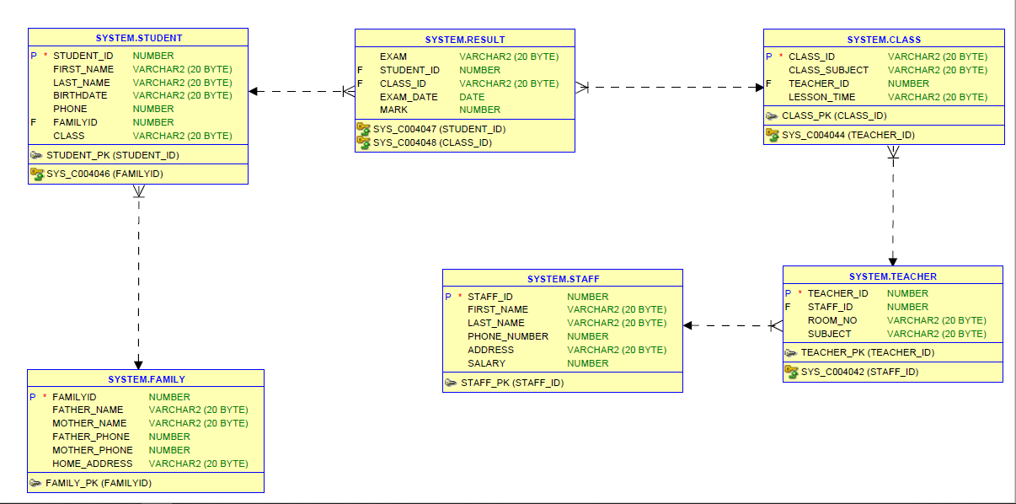

select * from Family;

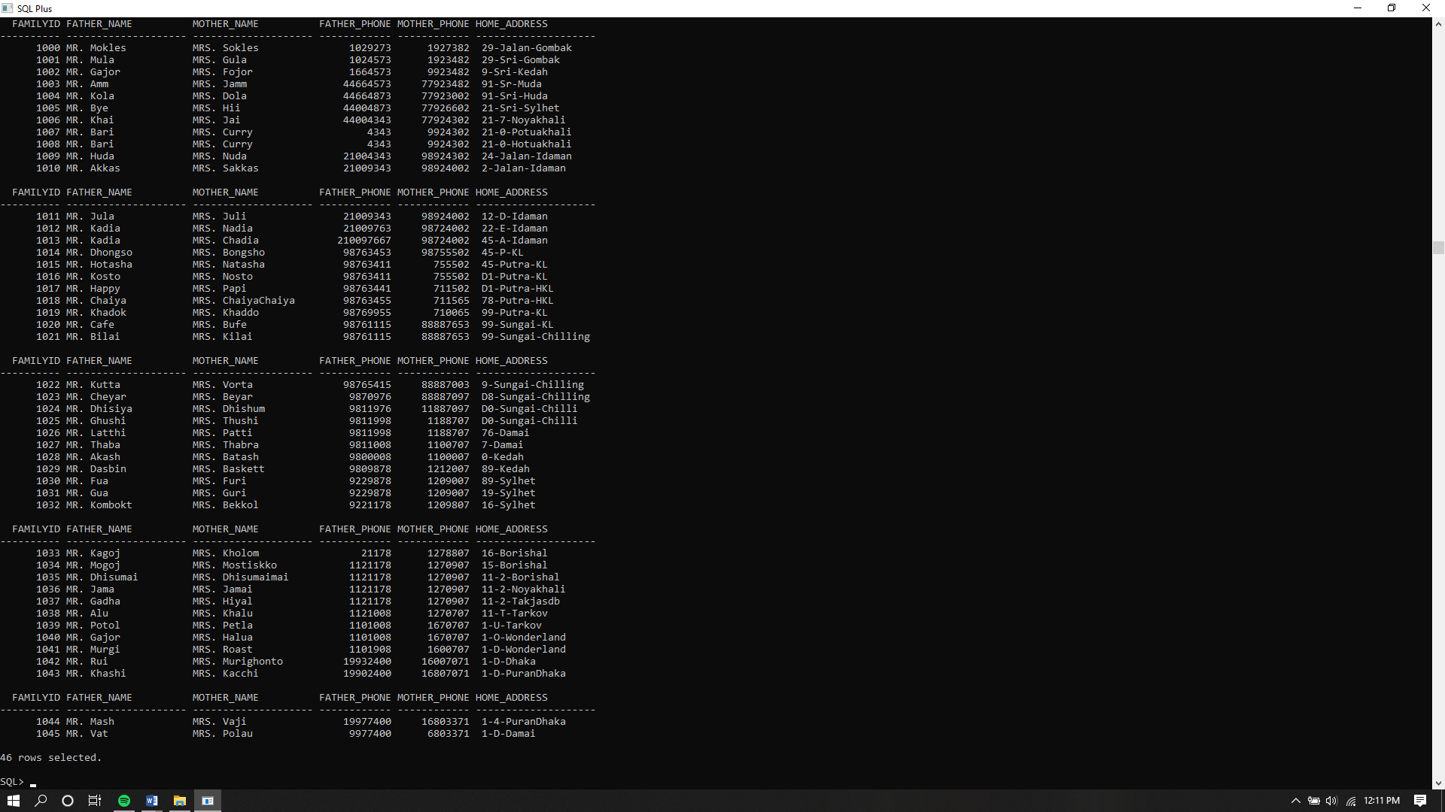

Select * from Staff;

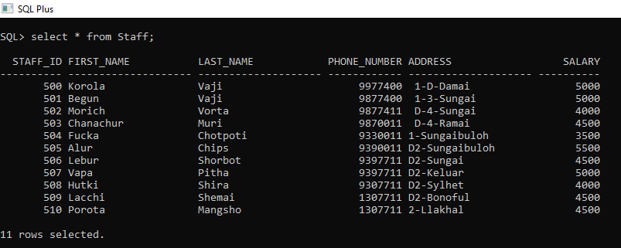

Select * from Teacher;

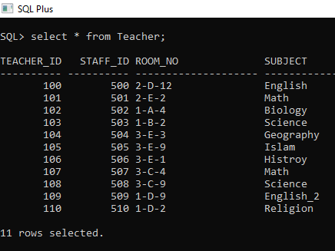

Select * from Class:

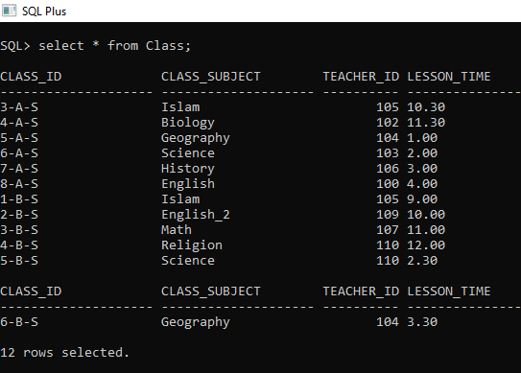

Select * from Student;

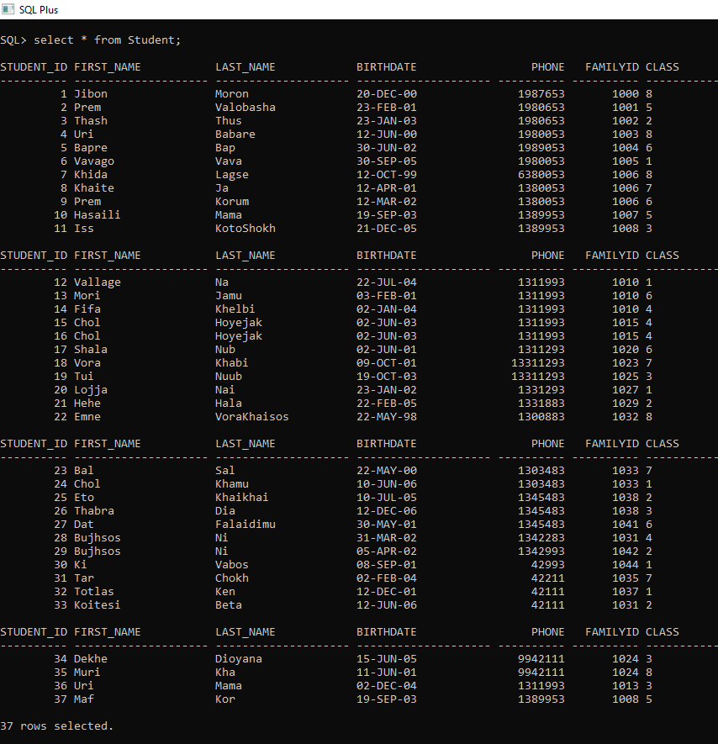

Select * from Result;

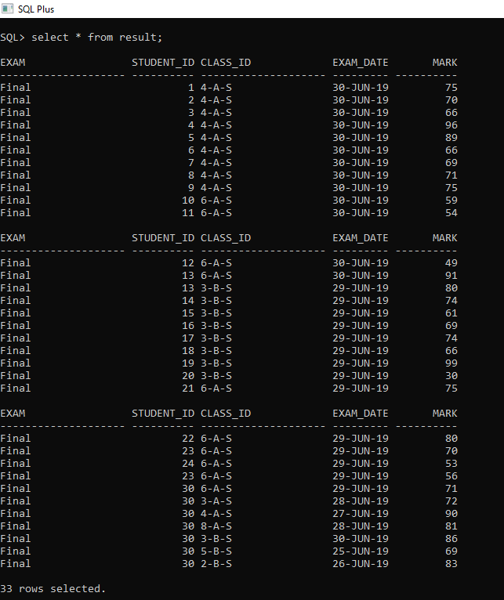

**Query:**

**Insert:**

insert into Student values ( 040, 'Hayre', 'Kopal',to_date('22-FEB-2001'), 019876853,1023,6);



**Select Statement :**

select First_name,Last_name,class from Student where First_name = 'Shala';

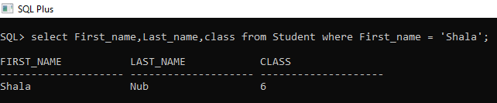

**Update:**

update Result set Mark = 70 where Student_ID = 15 and Class_ID = '3-B-S';

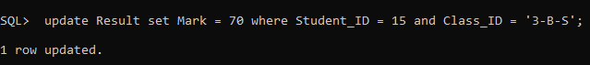

**Delete:**

delete from result where Mark>98;



**Join:**

Show which student is under which subject and teacher id and that teacher’s salary:

select teacher_id,subject,first_name,last_name,phone_number,salary

from teacher t, staff s

where t.staff_id=s.staff_id;

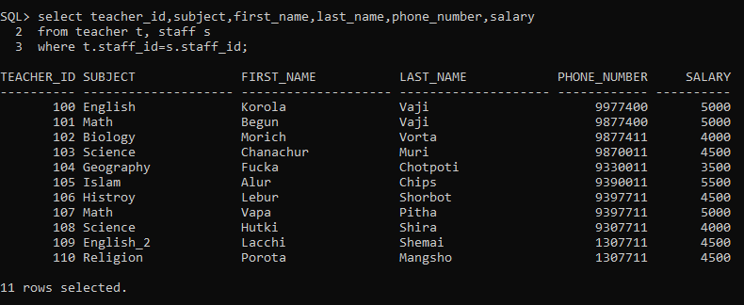

Show student details with their marks and classes:

select first_name,last_name,student.student_id,result.class_id,mark

from result,class,student

where result.class_id=class.class_id

AND student.student_id=result.student_id;

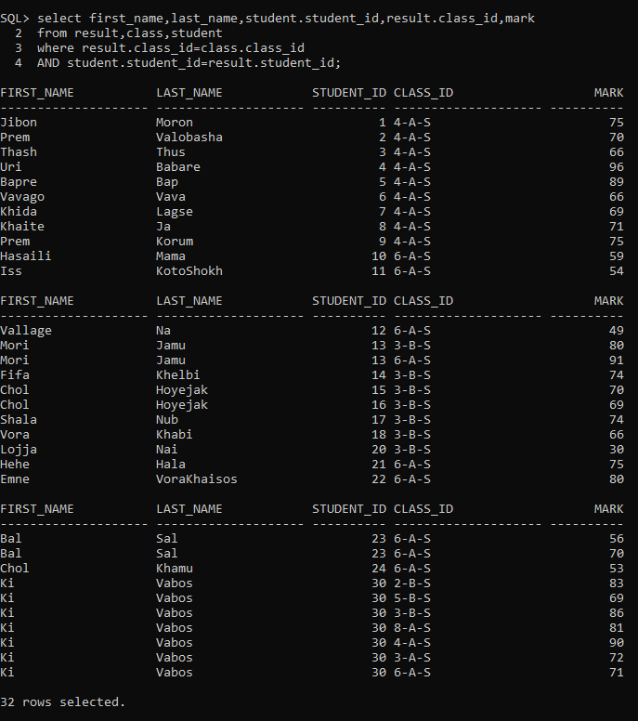

**View:**

drop view info;

create view info

as select staff_id,first_name,last_name,phone_number from staff

order by staff_id desc;

select * from ( select

teacher_id,t.staff_id,subject,first_name,last_name,phone_number

from teacher t,info s

where t.staff_id=s.staff_id);

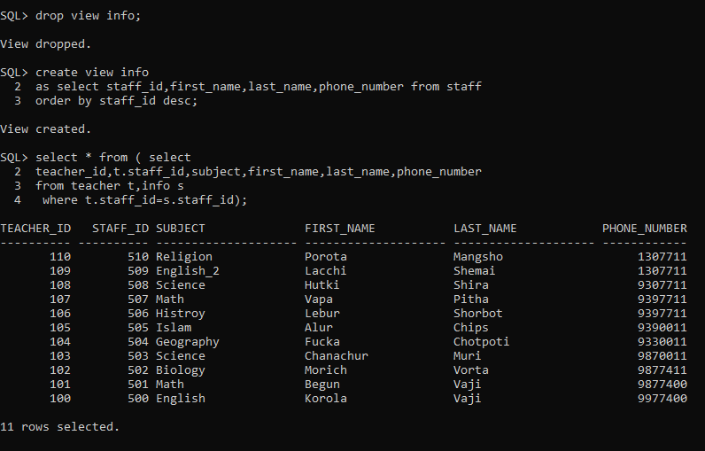

**Subquery:**

Get students name who get more than 80 marks:

select first_name, last_name, class from Student where student_id = any ( select student_id from Result where mark>80);

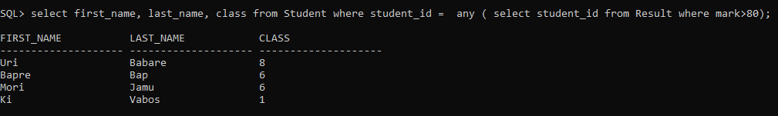

Get specific students family info:

select Father_Name,Mother_Name,Home_Address from Family where FamilyID = ( select FamilyID from Student where First_name = 'Khida' and last_name = 'Lagse');



**PROOCEDURES**

To get students father’s and mother’s name by inserting family id:

create or replace procedure pro1(c_family_ID family.familyid%TYPE) IS

fathername varchar2(20);

mothername varchar2(20);

phone number;

home_add varchar2(20);

BEGIN

select father_name,mother_name,father_phone,home_address into fathername,mothername,phone,home_add

from family

where c_family_ID=familyid;

dbms_output.put_line('Father Name: '||fathername);

dbms_output.put_line('Mother Name: '||mothername);

dbms_output.put_line('Phone Number: '||phone);

dbms_output.put_line('Address: '||home_add);

end;

/

--ANONYMOUS BLOCK

--===========================

ACCEPT famID PROMPT 'Enter the family ID: '

begin

pro1('&famID');

dbms_output.put_line('THe data is successfully entered.');

end;

/

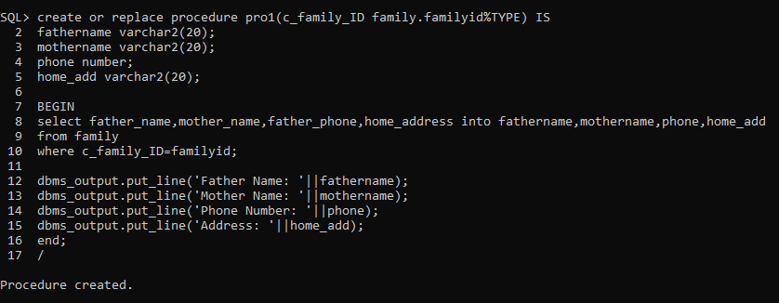

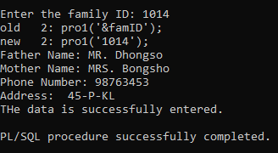

Inserting a new row in staff table:

create or replace procedure newval

(s_staff_id staff.staff_id%TYPE,

s_first_name staff.first_name%TYPE,

s_last_name staff.last_name%TYPE,

s_staff_phone staff.phone_number%TYPE,

s_address staff.address%TYPE,

s_salary staff.salary%TYPE

) IS

BEGIN

INSERT INTO staff (staff.staff_id,staff.first_name,staff.last_name,staff.phone_number,staff.address,staff.salary)

VALUES (s_staff_id,s_first_name,s_last_name,s_staff_phone,s_address,s_salary);

DBMS_OUTPUT.PUT_LINE('Data successfully added');

END;

/

--ANONYMOUS BLOCK

--===========================

ACCEPT s_staff_id prompt 'ENTER Staff ID: '

ACCEPT s_first_name prompt 'ENTER FIRST NAME: '

ACCEPT s_last_name prompt 'ENTER LAST NAME: '

ACCEPT s_staff_phone prompt 'ENTER PHONE NO: '

ACCEPT s_address prompt 'ENTER ADDRESS: '

ACCEPT s_salary prompt 'ENTER SALARY: '

BEGIN

newval('&s_staff_id','&s_first_name','&s_last_name','&s_staff_phone','&s_address','&s_salary');

END;

/

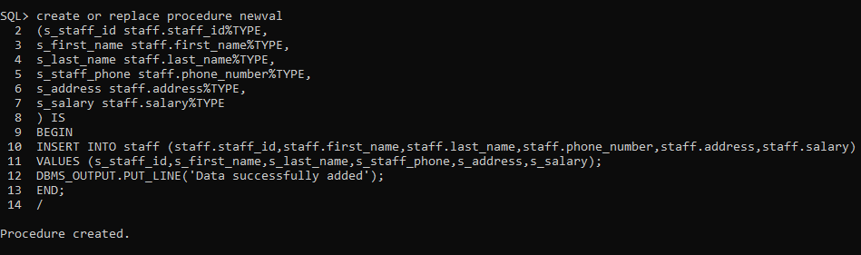 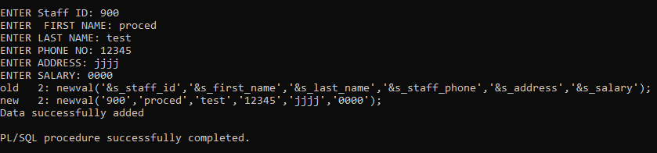

After updating Staff table:

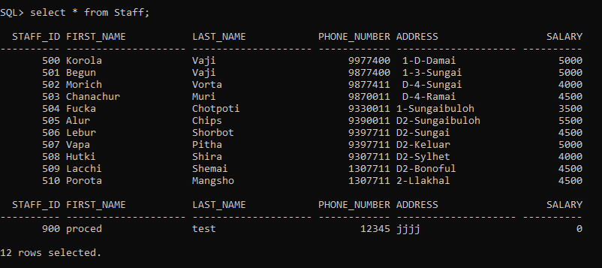

**FUNCTIONS:**

Giving students result by inserting student id and class id:

CREATE OR REPLACE FUNCTION grading

(stud_id in number,c_id in varchar2)

return varchar2

is

m_mark number;

grade varchar2(2);

BEGIN

select mark into m_mark

from result

where stud_id=result.student_id

AND c_id=result.class_id;

if m_mark>0 AND m_mark<49 then grade:='F';

elsif m_mark>=50 AND m_mark<=59 then grade:='C';

elsif m_mark>=60 AND m_mark<=69 then grade:='B';

elsif m_mark>=70 AND m_mark<=79 then grade:='A-';

elsif m_mark>=80 AND m_mark<=100 then grade:='A';

end if;

return(grade);

end;

/

--ANONYMOUS BLOCK

--===========================

ACCEPT stud_id prompt 'Enter Student ID:'

ACCEPT c_id prompt 'Enter c_id ID:'

declare

stud_id number;

c_id varchar2(20);

BEGIN

stud_id:=&stud_id;

c_id:=&c_id;

DBMS_OUTPUT.put_line('The grade is '||grading(stud_id,c_id));

END;

/

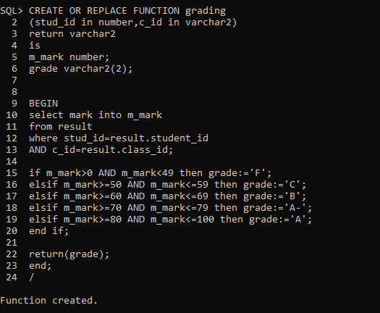

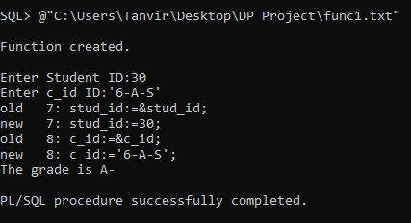

Get how many students in a class by giving class id:

CREATE OR REPLACE FUNCTION tota_stud

(cls_id in varchar2)

return number

is

s_id number;

BEGIN

select count(student_id) into s_id

from result

where cls_id=result.class_id;

return(s_id);

end;

/

--ANONYMOUS BLOCK

--===========================

ACCEPT cls_id prompt 'Enter Class ID:'

declare

cls_id varchar2(20);

BEGIN

cls_id:=&cls_id;

DBMS_OUTPUT.put_line('Total students in this course are '||tota_stud(cls_id));

END;

/

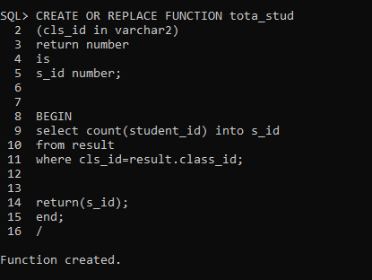

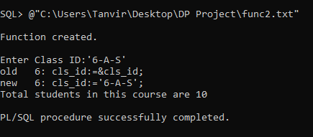

**IMPLICIT CURSOR:**

To delete specific student details by giving student id:

BEGIN

DELETE FROM result

where student_id=030;

IF SQL%NOTFOUND THEN

DBMS_OUTPUT.PUT_LINE('No maching record');

ELSIF SQL%FOUND then DBMS_OUTPUT.PUT_LINE('DATA Successfully deleted');

END IF;

END;

/

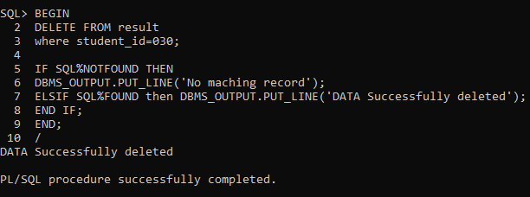

**EXPLICIT CURSOR:**

Get specific students exam results by giving student id:

Declare

r_student_id result.student_id%TYPE;

r_class_id result.class_id%TYPE;

r_exam_date result.exam_date%TYPE;

r_mark result.mark%TYPE;

CURSOR result_cursor IS

select student_id,class_id,exam_date,mark

from result;

BEGIN

OPEN result_cursor;

LOOP

FETCH result_cursor into r_student_id,r_class_id,r_exam_date,r_mark;

EXIT WHEN result_cursor%ROWCOUNT >5 OR

result_cursor%NOTFOUND;

DBMS_OUTPUT.PUT_LINE

(to_char(r_student_id)||' '||r_class_id||' '||r_exam_date||' '||r_mark);

END LOOP;

CLOSE result_cursor;

END;

/

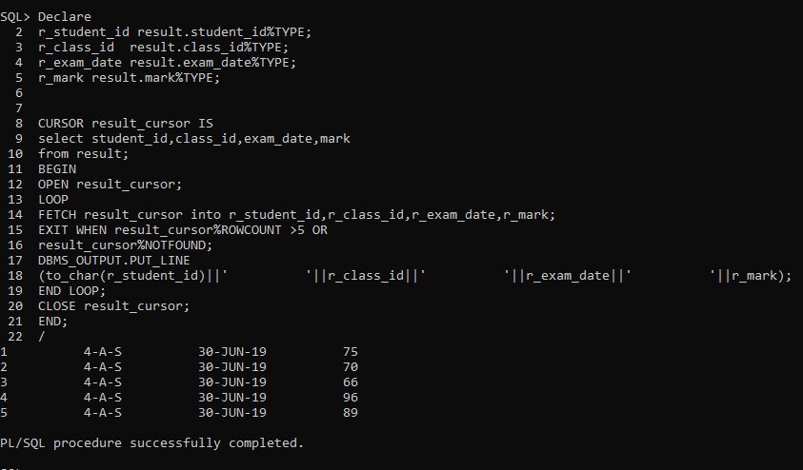

**Task – 9 Web implementation:**

Connection in XAMPP:

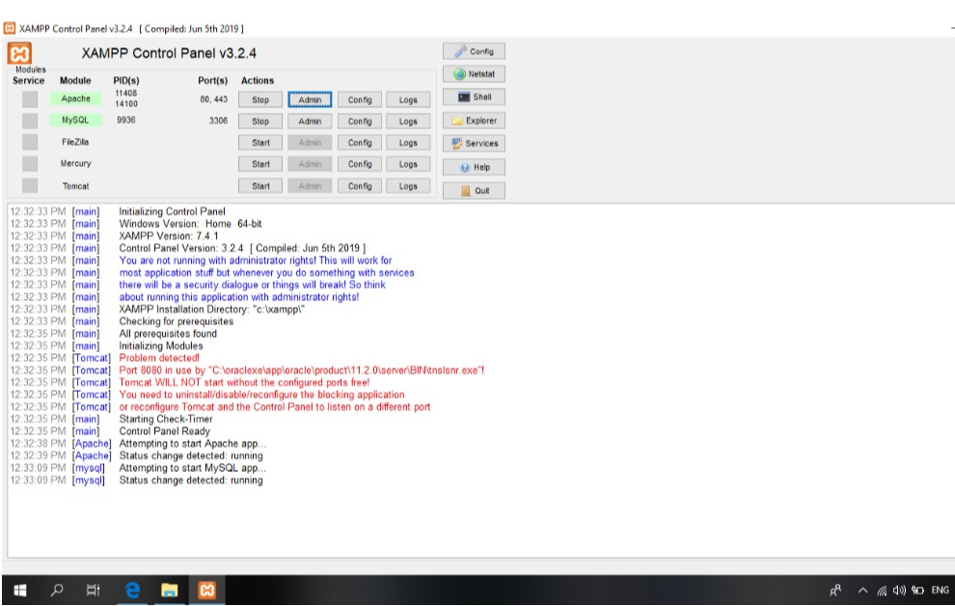

Tables in XAMPP:

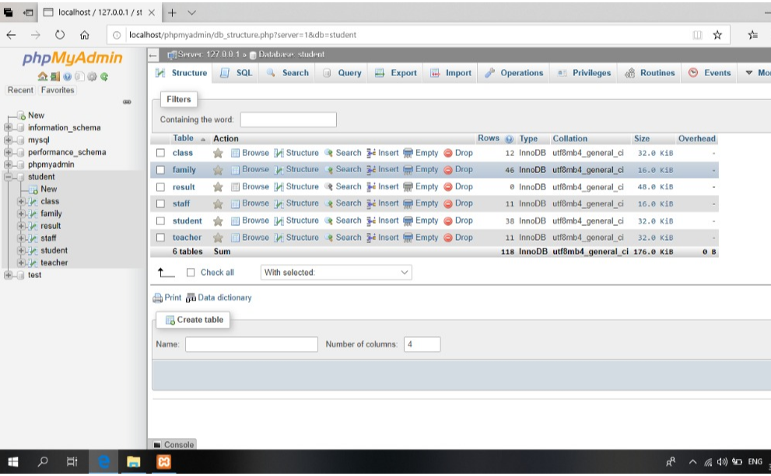

Student table:

Search by student id:

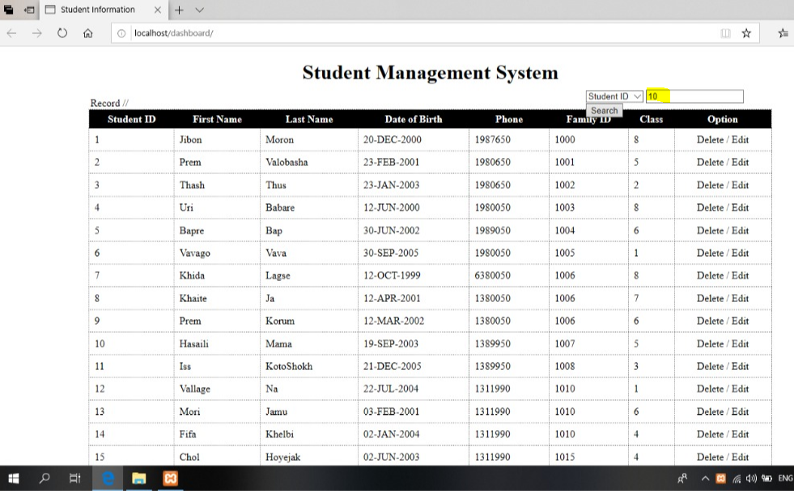

Result:

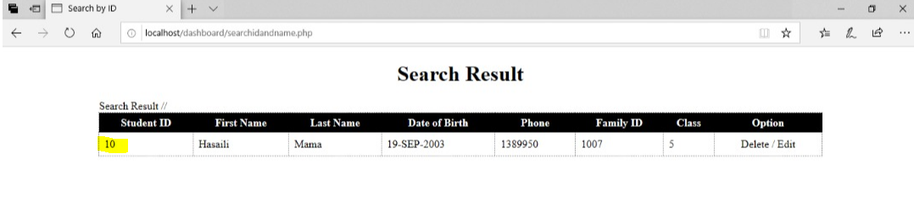

Search by student name:

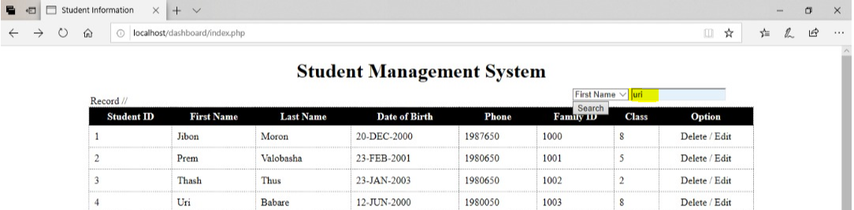

Result:

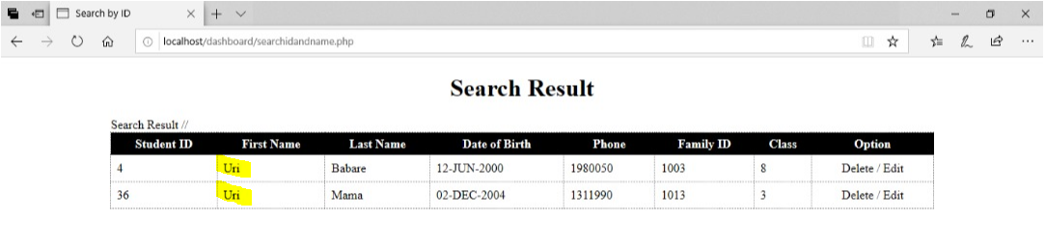

Insert new student:

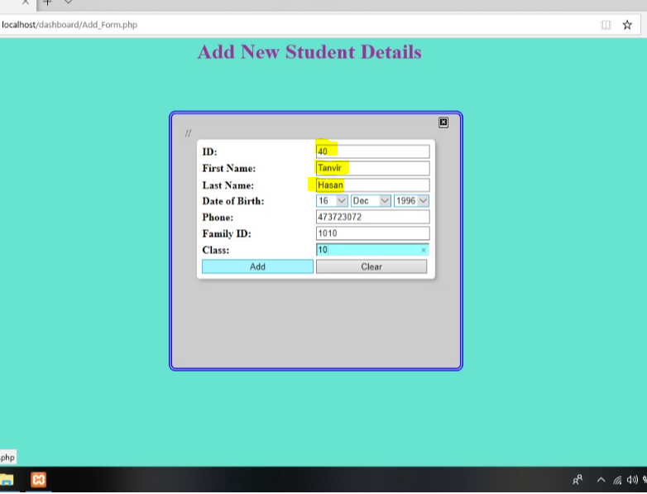

Result:

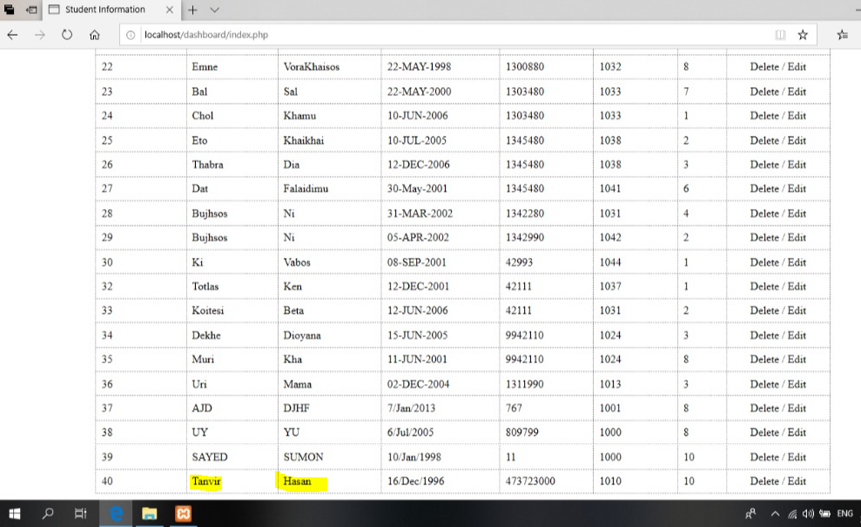

Edit student details:

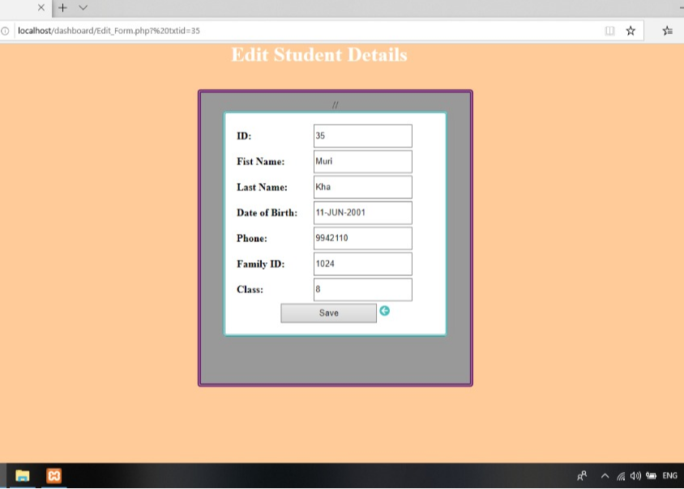

Delete student:

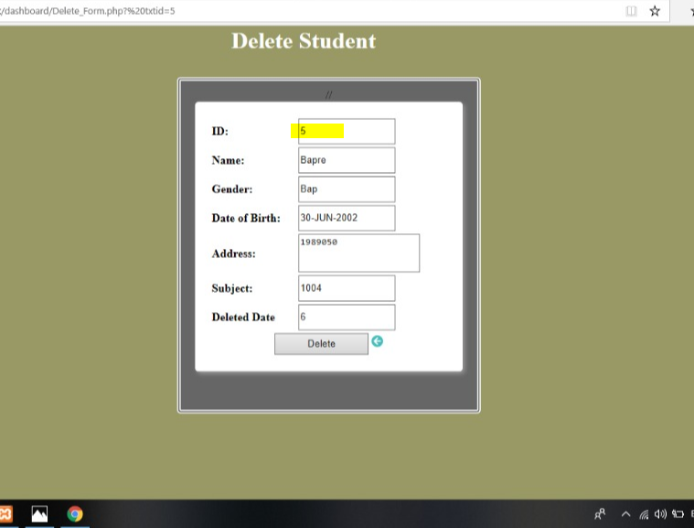

Result:

