Data Flow Diagram (DFD)
A Data Flow Diagram (DFD) is a graphical technique used during requirements analysis to model how data enters a system, moves between processes and data stores, is transformed, and leaves the system. It focuses on the logical movement and transformation of data rather than the internal implementation of the software.
***A DFD answers the question, “Where does data come from, how is it transformed and stored, and where does it go?”**

1. What is a Data Flow Diagram?
A Data Flow Diagram represents the logical flow of information within a system. It identifies the external entities that exchange information with the system, the processes that transform information, the data stores that hold information, and the data flows that carry information.
A DFD is particularly useful for analyzing functional requirements related to information processing.
DFD Element | Main purpose | What it represents
External Entity | Identify the source or destination of data | People, organizations, devices, or external systems
Process | Transform incoming data into outgoing data | A business activity or system function
Data Flow | Show movement of data | Information moving between entities, processes, and stores
Data Store | Represent stored information | Files, databases, records, or repositories

2. Why Use a DFD?
- Provides a high-level view of how information moves through a system.
- Helps analysts understand and communicate functional requirements.
- Shows the relationship between inputs, processes, outputs, and stored information.
- Helps identify missing inputs, outputs, processes, or data stores.
- Supports decomposition of a complex system into smaller processes.
- Provides a logical model that can be discussed with users and stakeholders before implementation.

3. DFD and Requirements Analysis
In requirements analysis, a DFD concentrates on the “what” of information processing: what data is received, what processing occurs, where information is stored, and what information is produced. It does not prescribe programming language, database product, user-interface design, or implementation architecture.

4. Main Components of a DFD

4.1 External Entity
An external entity is a person, organization, device, or another system that is outside the boundary of the system but sends data to the system or receives data from it.
- Usually named using a noun or noun phrase.
- Can be a human user, department, organization, external system, or device.
- Acts as a source and/or destination of data.
- It is outside the system being modeled.
Examples:
- Student
- Librarian
- Customer
- Bank
- Payment Gateway
- Supplier

4.2 Process
A process represents an activity or function that transforms incoming data into outgoing data. The transformation may involve calculation, validation, updating, searching, registering, or generating information.
- Usually named using a verb + noun or a short action phrase.
- A process must have at least one meaningful input and at least one meaningful output.
- A process can be decomposed into smaller processes at a lower DFD level.
Examples:
- Validate Student
- Process Order
- Borrow Book
- Generate Report
- Update Customer Record

4.3 Data Flow
A data flow represents data moving from one component to another. It is normally shown using a directed arrow and should be labeled with the name of the data being transferred.
- The arrow indicates the direction of data movement.
- The label should describe the data, not the action.
- Examples include Student Details, Book Request, Payment Information, Order Details, and Report.

4.4 Data Store
A data store represents a place where data is held for later use. It may represent a database, file, register, record collection, or logical repository.
- Usually named as a noun or noun phrase.
- A process reads data from or writes data to a data store.
- A data store exchanges data only through a process; do not connect a data store directly to an external entity or directly to another data store.
Examples:
- D1 Student File
- D2 Book Database
- D3 Loan Records
- Customer Database

5. DFD Notation
Notation | Description | Typical representation
External Entity | Source or destination of data outside the system | Rectangle
Process | Transforms input data into output data | Circle / bubble (Yourdon–DeMarco) or rounded rectangle (Gane–Sarson)
Data Flow | Carries data from one component to another | Directed arrow
Data Store | Stores data for later access | Parallel-line store (Yourdon–DeMarco) or open-ended store (Gane–Sarson)
Notation note: Two classic notation families are commonly used. Yourdon–DeMarco typically uses a circle/bubble for a process and parallel lines for a data store; Gane–Sarson uses a rounded process box and an open-ended data-store symbol. The meaning is the same. Choose one style and use it consistently in a diagram set.

6. Context Diagram
A Context Diagram is the highest-level view of a system. It represents the entire system as a single process and shows only the major external entities and the major data flows between those entities and the system.

- The whole system is represented as one process.
- External entities are shown outside the system.
- Major input and output data flows are shown.
- Internal processes and internal data stores are not shown in a Context Diagram.
- It establishes the system boundary and scope.
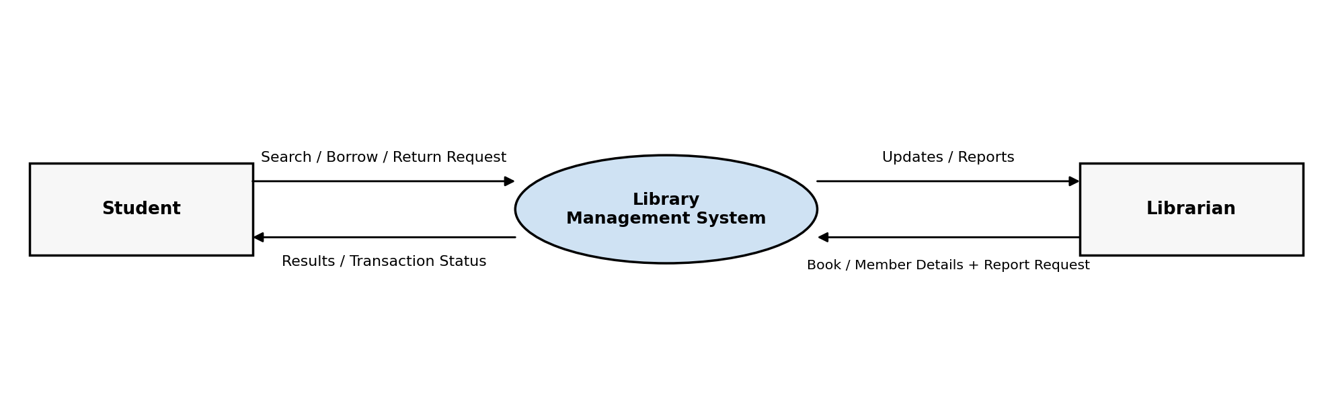
Figure 1. Context diagram for a Library Management System.

7. Level 0 DFD
A Level 0 DFD is the first decomposition of the Context Diagram. It breaks the single system process into the major processes of the system and normally shows major external entities, data stores, and data flows. Terminology varies across textbooks: some sources call the Context Diagram “Level 0” and call this first decomposition “Level 1.” Use one convention consistently throughout a model.
For a Library Management System, major processes could include:
- 1.0 Manage Members
- 2.0 Search / Manage Books
- 3.0 Borrow / Return Books
- 4.0 Generate Reports
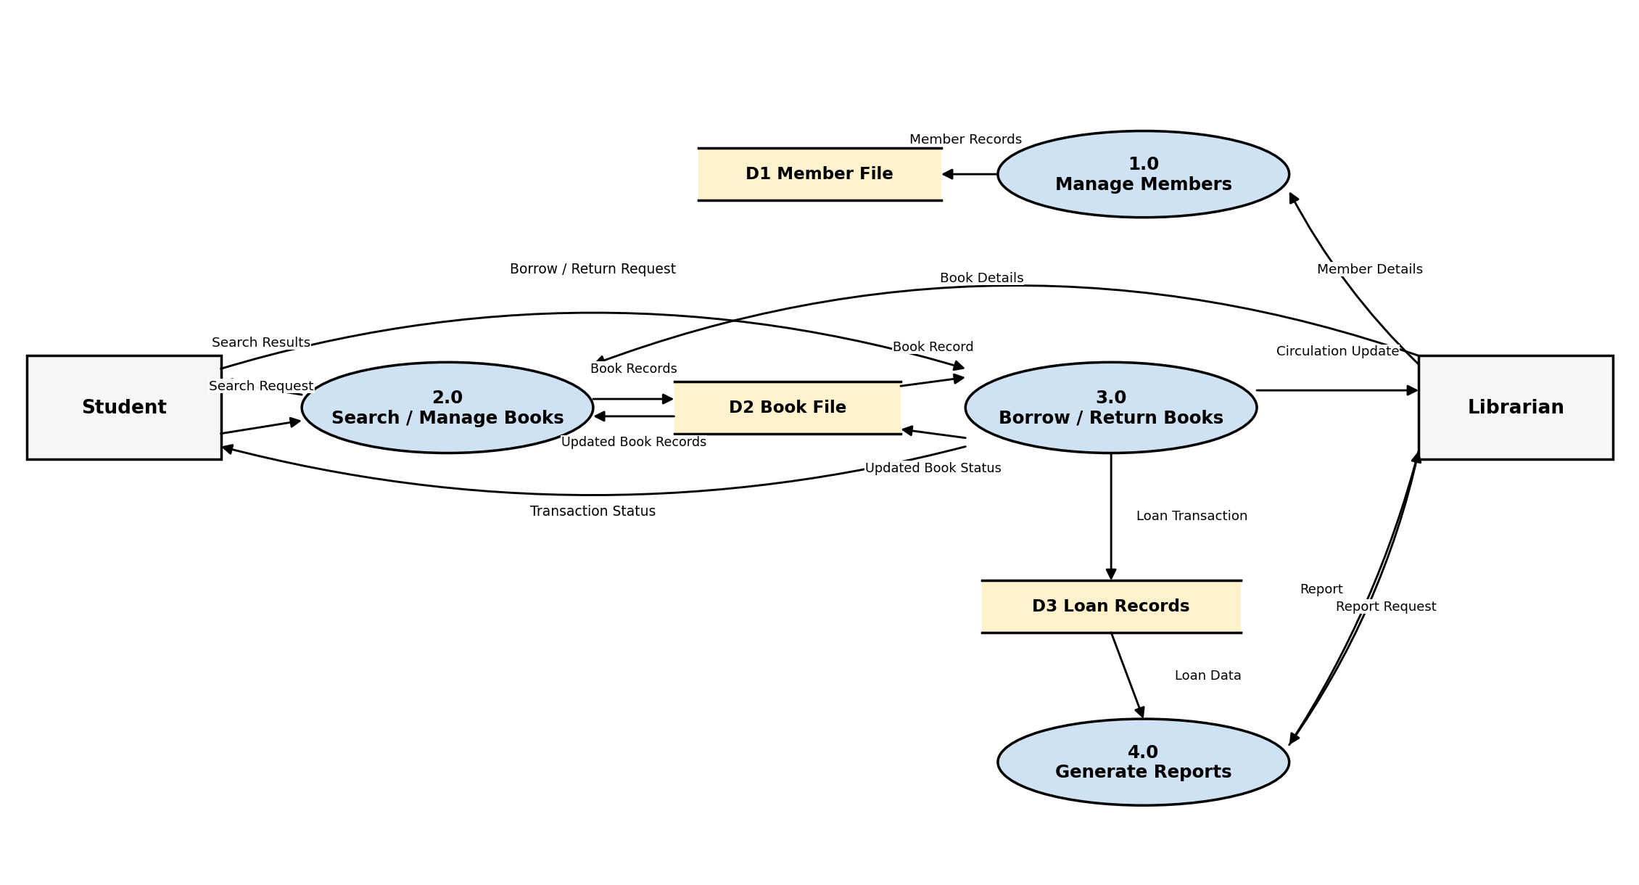
Figure 2. Example Level 0 DFD for a Library Management System.

8. Level 1 DFD
A Level 1 DFD provides more detail by decomposing one Level 0 process into smaller subprocesses. For example, process 3.0 Borrow / Return Books can be decomposed into receiving the request, checking availability, recording the transaction, and updating book status. The child diagram must preserve the parent process inputs and outputs through balancing.
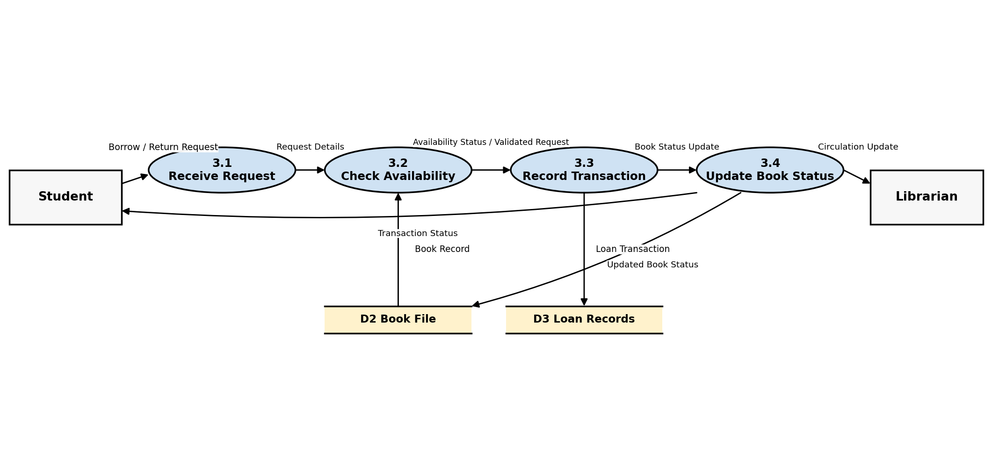
Figure 3. Level 1 decomposition of process 3.0 Borrow / Return Books.

9. Level 2 and Further Decomposition
If a Level 1 process is still too complex, it can be decomposed again into Level 2 processes. Further levels may be used, when necessary, but excessive decomposition should be avoided when the additional detail does not improve understanding.
- Level 0: major system processes.
- Level 1: decomposition of one Level 0 process.
- Level 2: further decomposition of one Level 1 process.
- Continue only while additional detail is useful for requirements understanding.

10. Data Flow Rules
- Every data flow should have a meaningful data-oriented label.
- Each data flow arrow shows one clear direction. If data moves in both directions, draw two separate arrows and label each direction.
- Every process should have at least one meaningful input and at least one meaningful output, and its output should be reasonably derivable from its inputs.
- Do not connect an external entity directly to a data store; the data must pass through a process.
- Do not connect one data store directly to another data store; the data must pass through a process.
- Do not show direct external-entity-to-external-entity communication as part of the system DFD; such communication is outside the modeled system boundary.
- Data stores are passive: they hold and provide data but do not transform it. Only processes transform data.
- Avoid representing control flow, program execution sequence, decision logic, or physical network connections as data flows.

11. Data Flow Naming
A common source of confusion is the difference between naming a process and naming a data flow.
Element | Recommended naming style | Examples
Process | Verb + noun / action | Validate Payment; Register Student; Generate Report
Data Flow | Noun / data description | Payment Details; Student Record; Report Data
Data Store | Noun / repository | Student File; Loan Database; Product Records
External Entity | Noun / role | Student; Customer; Bank; Administrator
Quick process-quality check: A black hole has inputs but no meaningful outputs; a miracle has outputs without sufficient inputs; a gray hole produces outputs that are not reasonably supported by its inputs.

12. Balancing Between DFD Levels
Balancing means that all data flows crossing the boundary of a parent process must remain logically consistent in its child DFD. A child diagram may split a parent flow into more detailed data flows, but it must not add or remove net external inputs or outputs. Connections to data stores that cross the parent-process boundary should also remain consistent.
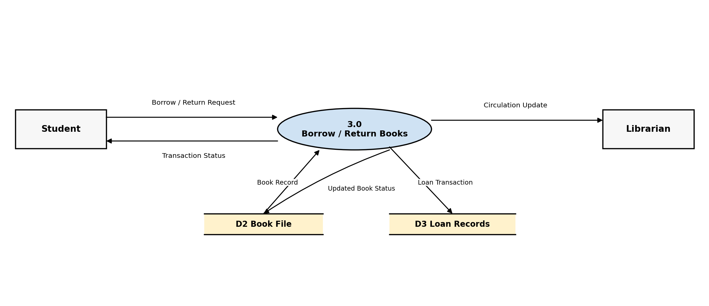
Figure 4. Parent-process interface for process 3.0. These boundary flows must be preserved when the process is decomposed.

13. Example: Library Management System
Suppose the requirements state:
“A student submits a borrow or return request. The system checks the relevant book record, records the loan transaction, updates the book status, provides the transaction status to the student, and sends a circulation update to the librarian.”
From this requirement we can identify:
Requirement item | DFD element
Student | External Entity
Librarian | External Entity
Borrow / Return Books | Process
Borrow / Return Request | Data Flow
Book File | Data Store
Loan Records | Data Store
Transaction Status | Data Flow
Circulation Update | Data Flow

14. How to Identify DFD Components
Start the analysis by asking structured questions, similar to the actor and use-case identification approach.
- Who or what provides information to the system?
- Who or what receives information from the system?
- What major information enters the system?
- What major information leaves the system?
- What processes transform the incoming information?
- What information must be stored for later use?
- Which processes read from the stored information?
- Which processes update or create stored information?
- Are there external systems that exchange data with the system?

15. How to Identify Processes
Once external entities and major data flows are identified, look for the business activities that transform the data.
- Convert user goals and functional requirements into major information-processing activities.
- Combine closely related low-level actions into a meaningful higher-level process.
- Use process names that describe what the system does.
- Avoid implementation-level activities such as opening a database connection or clicking a button.

16. How to Identify Data Stores
- Look for information that must persist after a process finishes.
- Identify records that are created, read, updated, or deleted.
- Consider databases, files, registers, and logical repositories.
- Give each major store a clear identifier such as D1, D2, or D3 when using numbered DFD notation.

17. DFD Levels of Detail
DFD granularity refers to how much detail is represented at each level. A useful DFD starts with a simple high-level view and is refined only when more detail is necessary. Process numbering should preserve the parent-child relationship, for example 3.0 → 3.1, 3.2, 3.3, and so on.
Level | Purpose | Typical contents
Context Diagram | Define overall scope (called Level 0 in some texts) | One system process, external entities, major data flows
Level 0 | Show major system functions (first decomposition in this lecture) | Major processes, external entities, major data stores, and flows
Level 1 | Explain one major process | Subprocesses, relevant stores, detailed flows
Level 2+ | Provide further detail where needed | More detailed subprocesses and flows

18. DFD vs Use Case Diagram
Use Case Diagram | Data Flow Diagram
Focuses on actors and their goals | Focuses on movement and transformation of data
Shows who interacts with the system | Shows where data comes from, where it goes, and how it is processed
Uses actors and use cases | Uses external entities, processes, data stores, and data flows
Useful for identifying functional requirements from the user perspective | Useful for analyzing information-processing requirements
Emphasizes system functionality | Emphasizes information flow

19. Common Mistakes in DFD
- Using arrows without meaningful data labels.
- Using action or control wording as a data-flow label instead of naming the data being transferred.
- Connecting an external entity directly to a data store.
- Connecting two data stores directly without a process.
- Mixing physical implementation details with a logical DFD.
- Mixing different DFD notation styles within the same diagram without explanation.
- Creating a black-hole process (inputs but no outputs) or a miracle process (outputs but no meaningful inputs).
- Creating a gray-hole process whose outputs are not reasonably supported by its inputs, or failing to balance parent and child DFDs.
- Using arrows to represent control flow or execution sequence rather than data movement.

20. DFD Tips
- Start with the context diagram and establish the system boundary.
- Keep the highest-level DFD simple and understandable.
- Focus on the logical movement of information rather than implementation technology.
- Use meaningful and consistent names for processes, flows, stores, and external entities, and use one notation family consistently within a diagram set.
- Decompose a process only when the additional detail is useful.
- Check that every important requirement is reflected in the data flow model.
- Check balancing whenever a process is decomposed.
- Review the DFD with stakeholders to verify that the modeled information flows match the real business process.

21. Summary
Concept | Remember
External Entity | Source or destination of data outside the system
Process | Transforms input data into output data
Data Flow | Shows movement of data
Data Store | Stores data for later use
Context Diagram | Entire system represented as one process; some texts call this Level 0
Level 0 | Major processes of the system; first decomposition in this lecture
Level 1 | Detailed decomposition of one Level 0 process
Balancing | Parent and child DFDs preserve consistent major inputs and outputs

22. Quick Identification Technique
Ask four questions: Who or what is outside the system? → External Entity | What processing transforms data? → Process | What information moves? → Data Flow | What information is stored? → Data Store
Core idea: A DFD models the logical flow of information through a system. It shows where data comes from, how processes transform it, where it is stored, and where it goes.

