Data Analytics Boot Camp

Assignment – VBA-Challenge

Tanvir Khan

March 14, 2020

# **Alphabetical Testing Outcome**

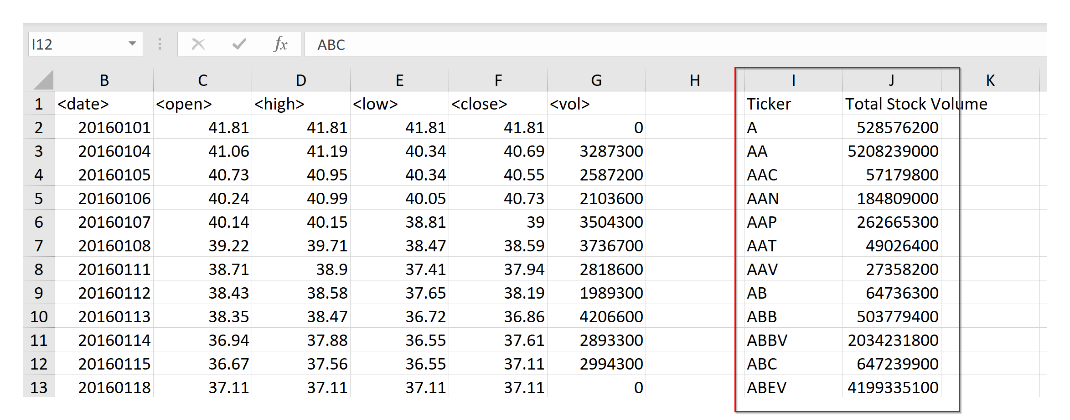

**VBA HW2 - Alphabetical Testing Easy Outcome**

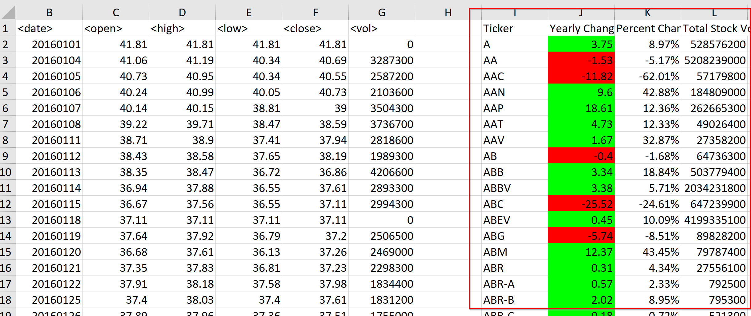

**VBA HW2 - Alphabetical Testing Moderate Outcome**

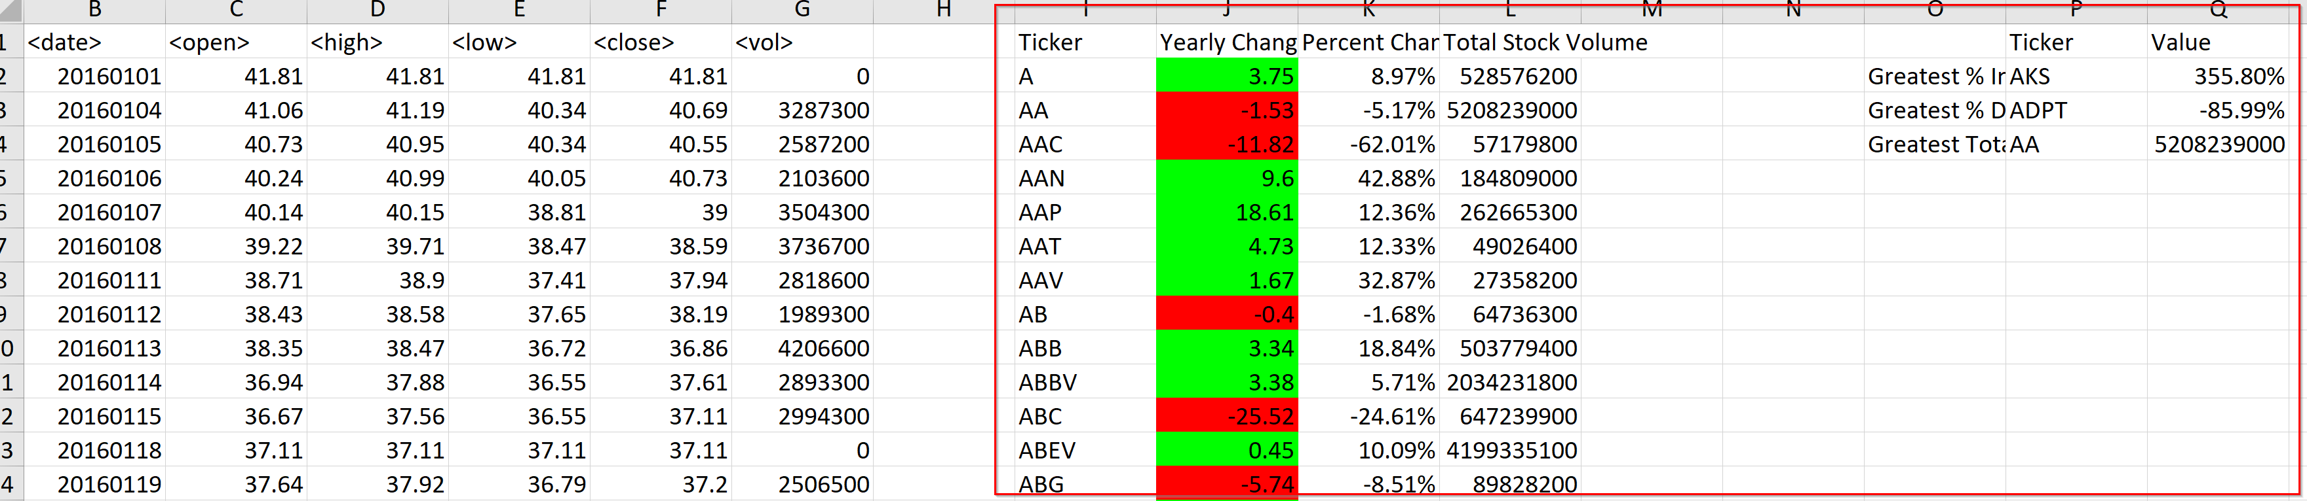

**VBA HW2 - Alphabetical Testing Challenge Outcome**

# **Stock Analysis Outcome**

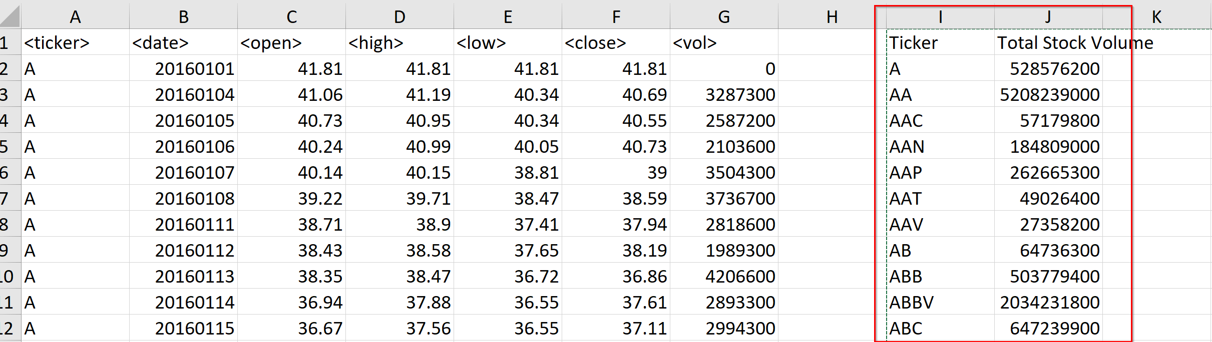

**VBA HW2 – Multi Year Stock Data Easy Outcome**

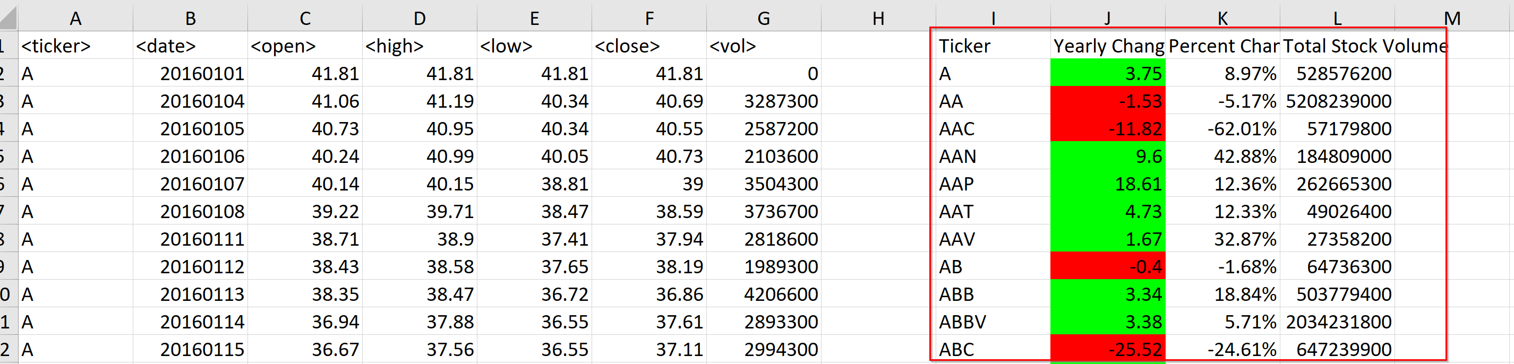

**VBA HW2 – Multi Year Stock Data Moderate Outcome**

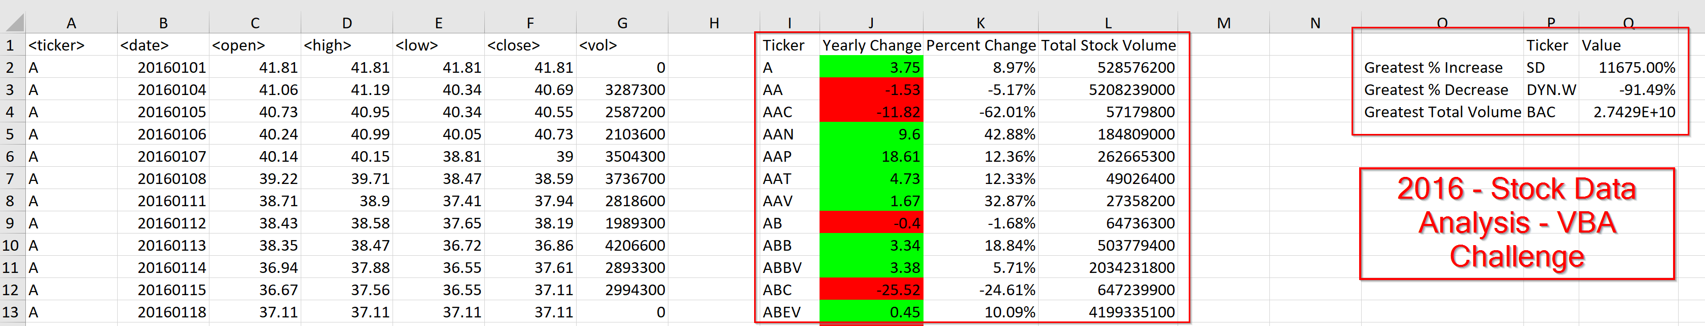

**VBA HW2 – 2016- Multi Year Stock Data - Challenge Outcome**

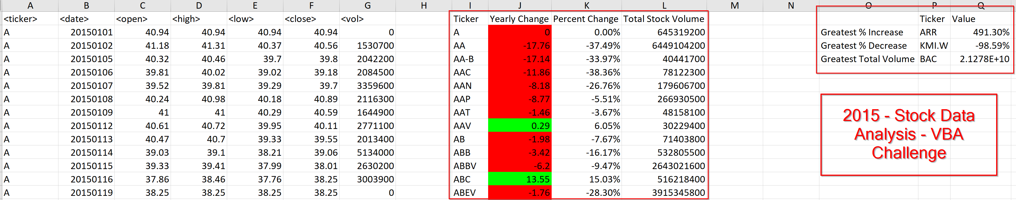

**VBA HW2 – 2015- Multi Year Stock Data - Challenge Outcome**

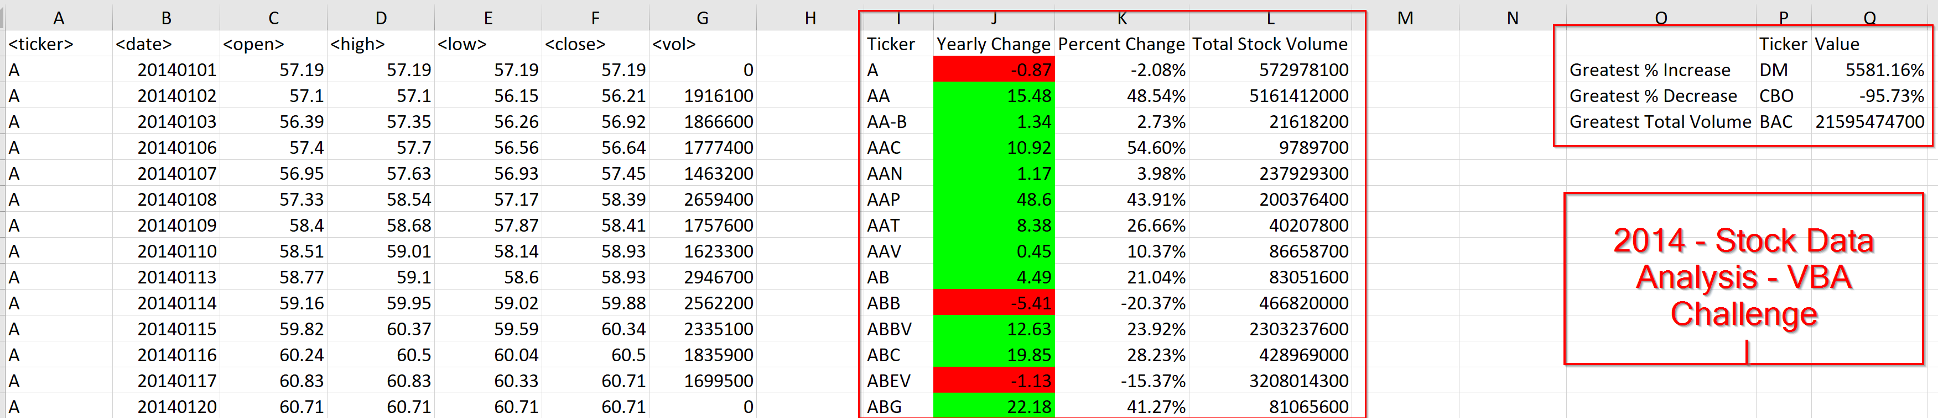

**VBA HW2 – 2014 - Multi Year Stock Data - Challenge Outcome**