5CS019 Project Report — Digital Voting System
Student Name: Shahrier Ahammed Tanvir
Student ID: 2442655
Submission: Individual

1. Introduction
This report documents the design, implementation and evaluation of a Digital Voting System developed using Java (Spring Boot) and MySQL. The system supports voter registration, election creation, candidate management, vote casting, and automated results generation through RESTful APIs. The project demonstrates object-oriented design (inheritance, abstraction, relationships), SOLID principles, database integration (CRUD) and testing using JUnit.

2. Background / Context
University elections are commonly managed using manual or semi-digital approaches that can be slow, error-prone and difficult to audit. A digital voting system provides faster election administration, improves accessibility, and enables consistent enforcement of voting rules. This project models a student council election scenario where administrators create elections with positions and candidates, and registered voters cast votes during the election window. Results are calculated automatically from stored votes.

3. Requirements

3.1 Functional Requirements
FR1: Register voters (unique username).
FR2: Create elections with start/end dates.
FR3: Add positions and candidates to elections.
FR4: Cast votes for candidates in an election.
FR5: Prevent duplicate votes (database constraint + service rules).
FR6: Retrieve election results (vote counts per candidate).
FR7: Retrieve all elections and election details (REST GET).
FR8: Delete elections (REST DELETE).

3.2 Non-Functional Requirements
NFR1: Maintainability via layered architecture and SOLID principles.
NFR2: Security via parameterised persistence (Spring Data JPA) and constraints.
NFR3: Usability via clear REST endpoints and JSON payloads.
NFR4: Reliability via validation and exception handling.
NFR5: Testability via JUnit/Mockito tests for service logic.

4. System Design

4.1 System Architecture Overview
The system follows a 3-layer architecture: (1) Presentation Layer (REST controllers), (2) Business Layer (services implementing domain logic), and (3) Data Layer (repositories interacting with MySQL using Spring Data JPA). This separation supports SRP, testability and future extensibility.

4.2 UML Class Diagram
The UML class diagram shows core domain entities and their relationships: User is an abstract superclass inherited by Voter and Admin (inheritance/polymorphism). Election composes Positions (composition with cascading). Position aggregates Candidates. Vote associates Voter, Election and Candidate. Service and repository layers are also shown to reflect DIP/ISP (controllers depend on service interfaces; services use repositories).
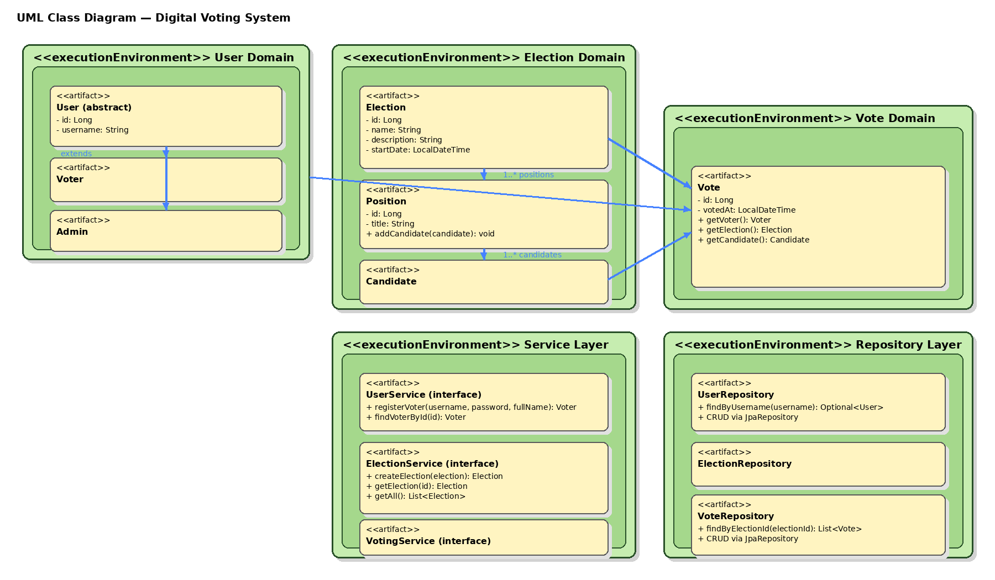

4.3 ERD Diagram
The ERD represents the database schema supporting the application. Tables include users, elections, positions, candidates and votes. Foreign keys enforce referential integrity and ON DELETE CASCADE ensures dependent records are removed when an election or position is deleted. A unique constraint on votes prevents duplicate votes for the same voter/election/candidate combination.
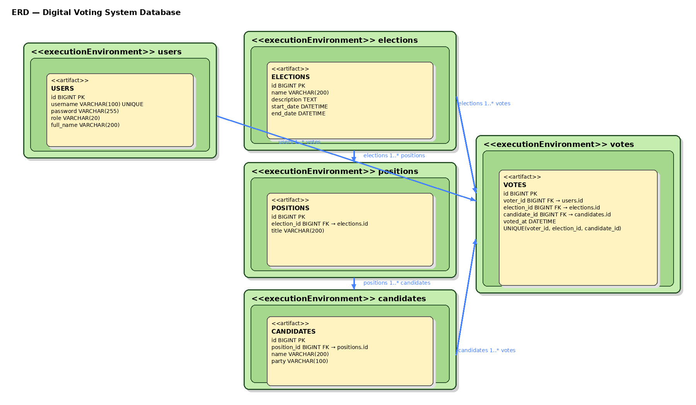

5. System Implementation

5.1 Object-Oriented Design Decisions
Encapsulation is applied through private/protected fields with public getters/setters. Inheritance is used via the abstract User superclass with Voter/Admin subclasses. Abstraction and polymorphism are achieved using service interfaces (UserService, ElectionService, VotingService) with concrete implementations injected by Spring. Relationships include composition (Election→Position), aggregation (Position→Candidate) and association (Vote ties Voter, Election and Candidate).

5.2 SOLID Principles
SRP: Controllers handle HTTP; services handle business logic; repositories handle persistence.
OCP: New election types/validation rules can be added by extending services without modifying controllers.
LSP: Voter and Admin can be treated as User without breaking behaviour.
ISP: Separate service interfaces avoid forcing unused methods on clients.
DIP: Controllers depend on interfaces; implementations are injected, improving testability.

5.3 Database Implementation
The MySQL schema is implemented in the university database digital_voting_db. Tables and relationships match the ERD. Spring Boot is configured using application.properties to connect to the university host with the student credentials. Hibernate is configured with ddl-auto=update to keep schema aligned during development.
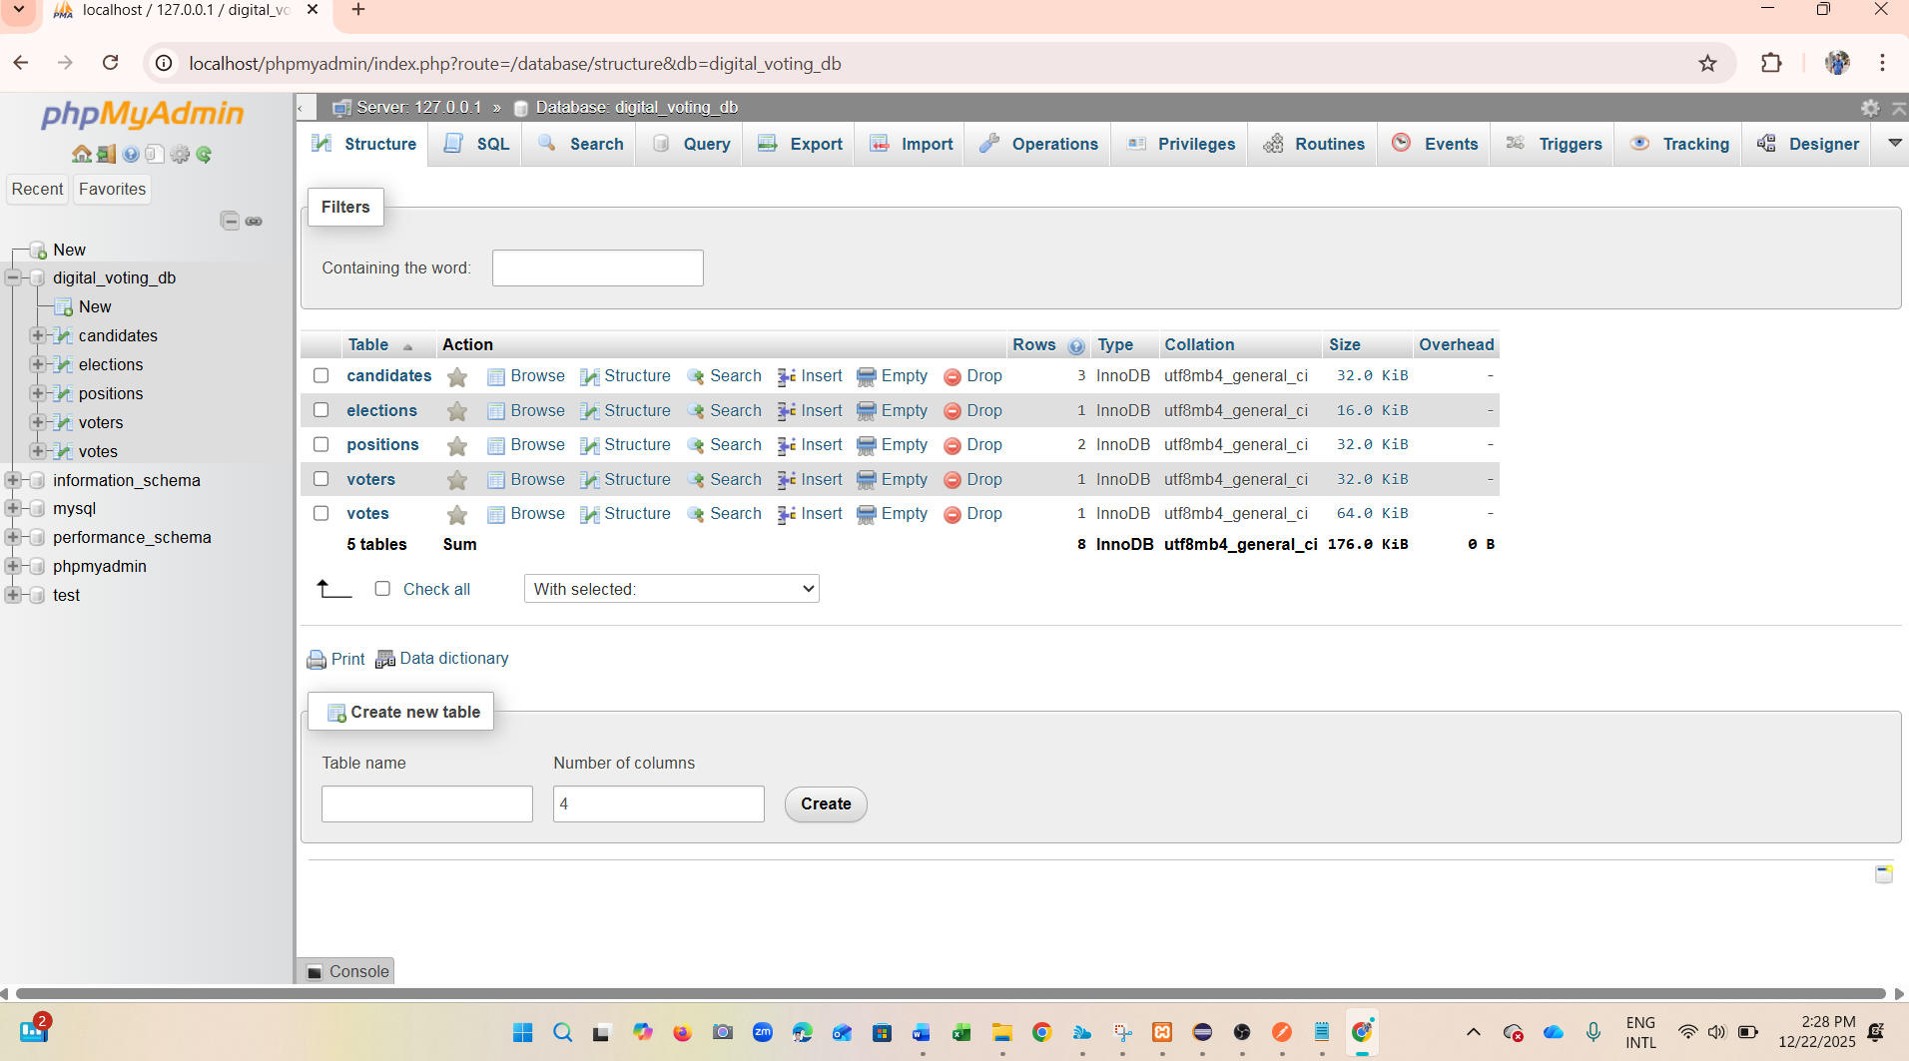
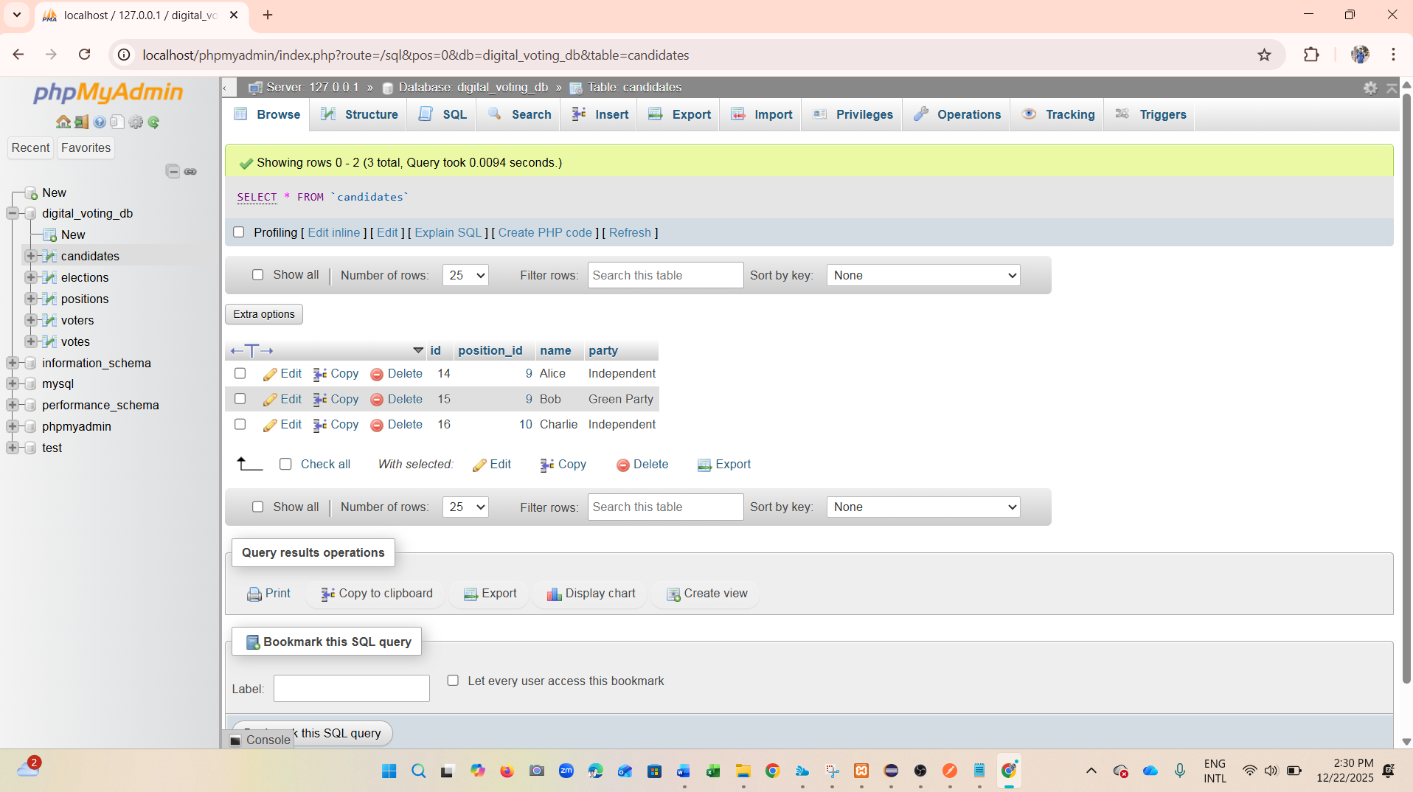
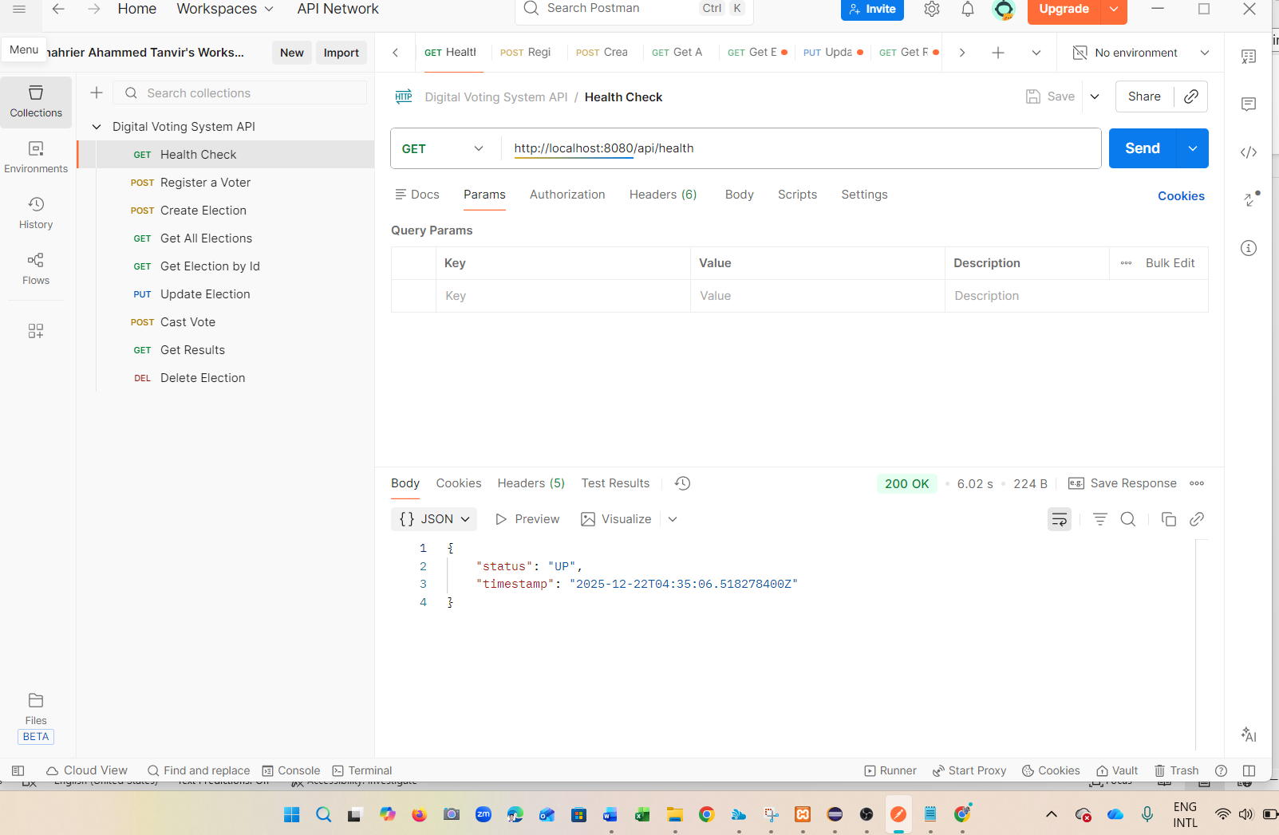
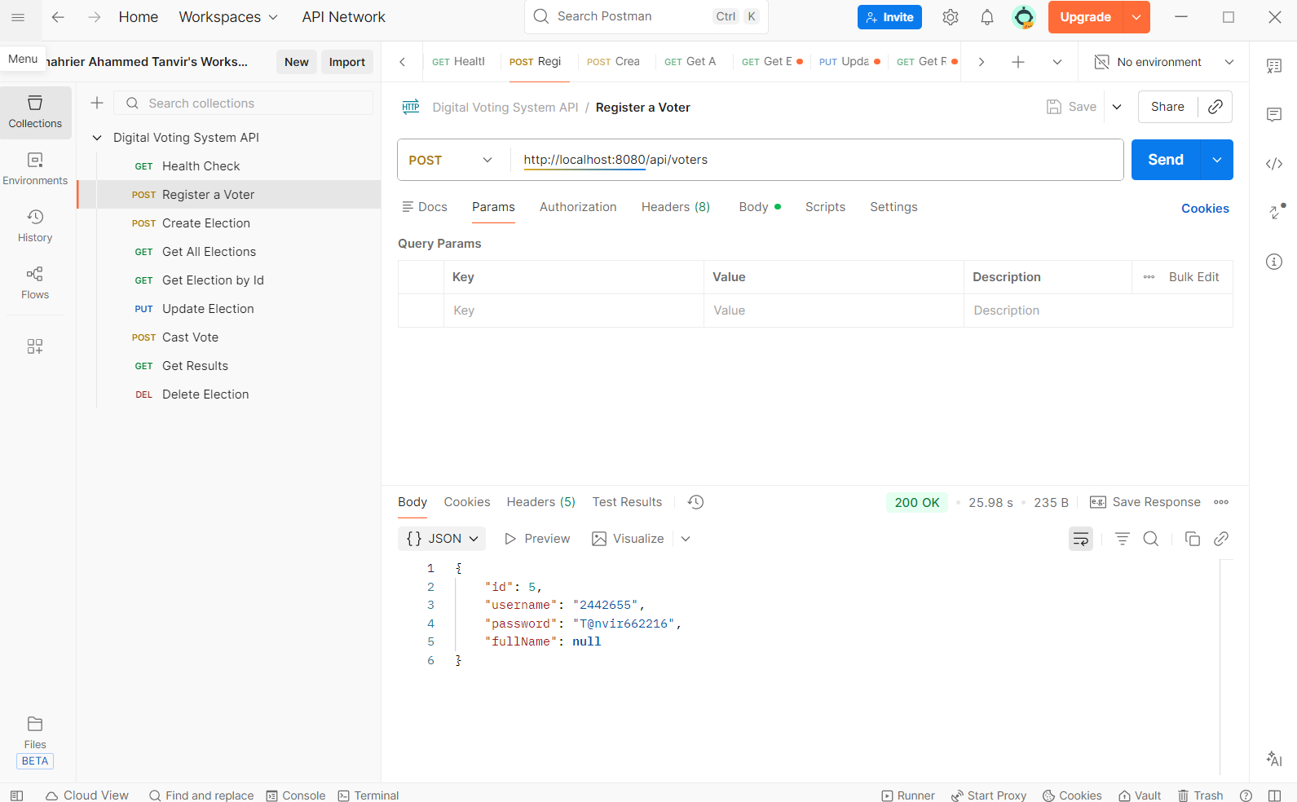
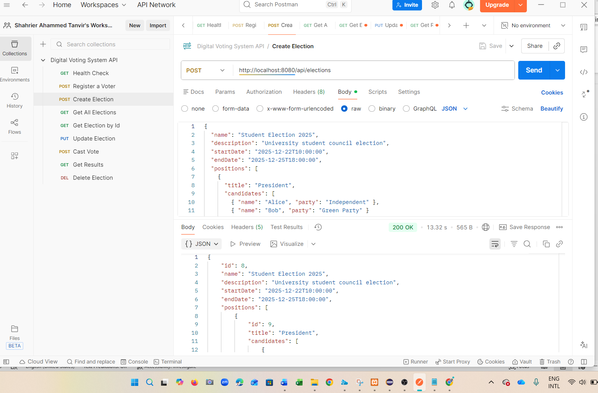
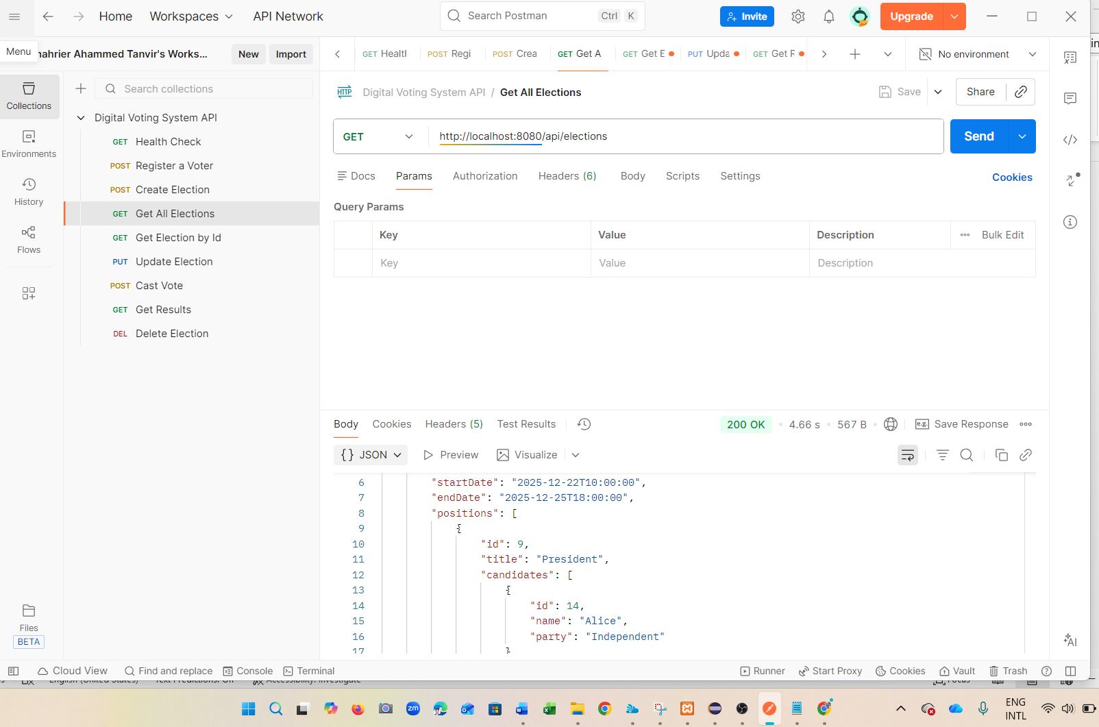
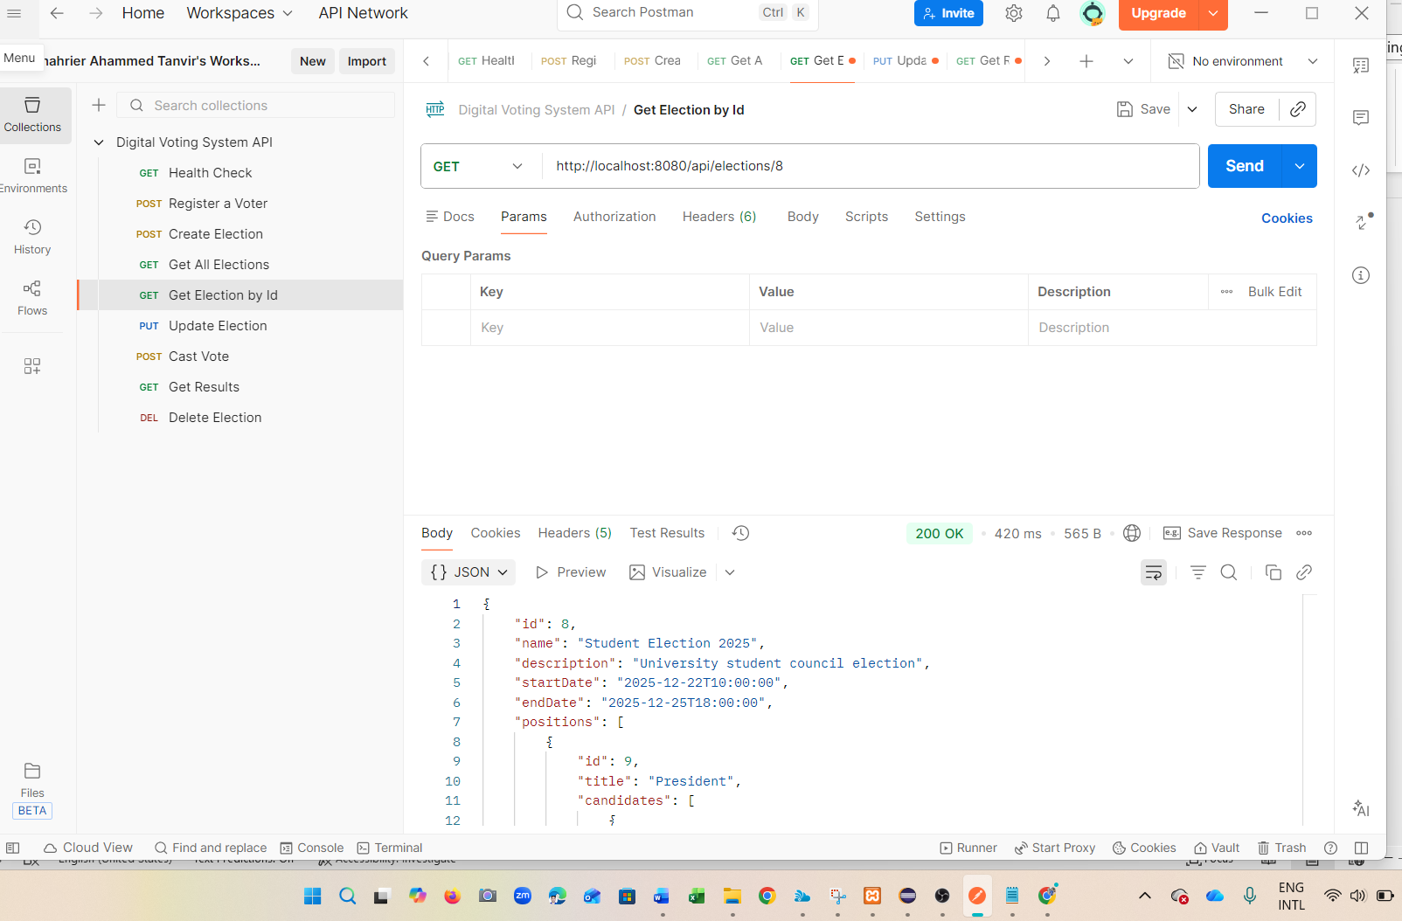
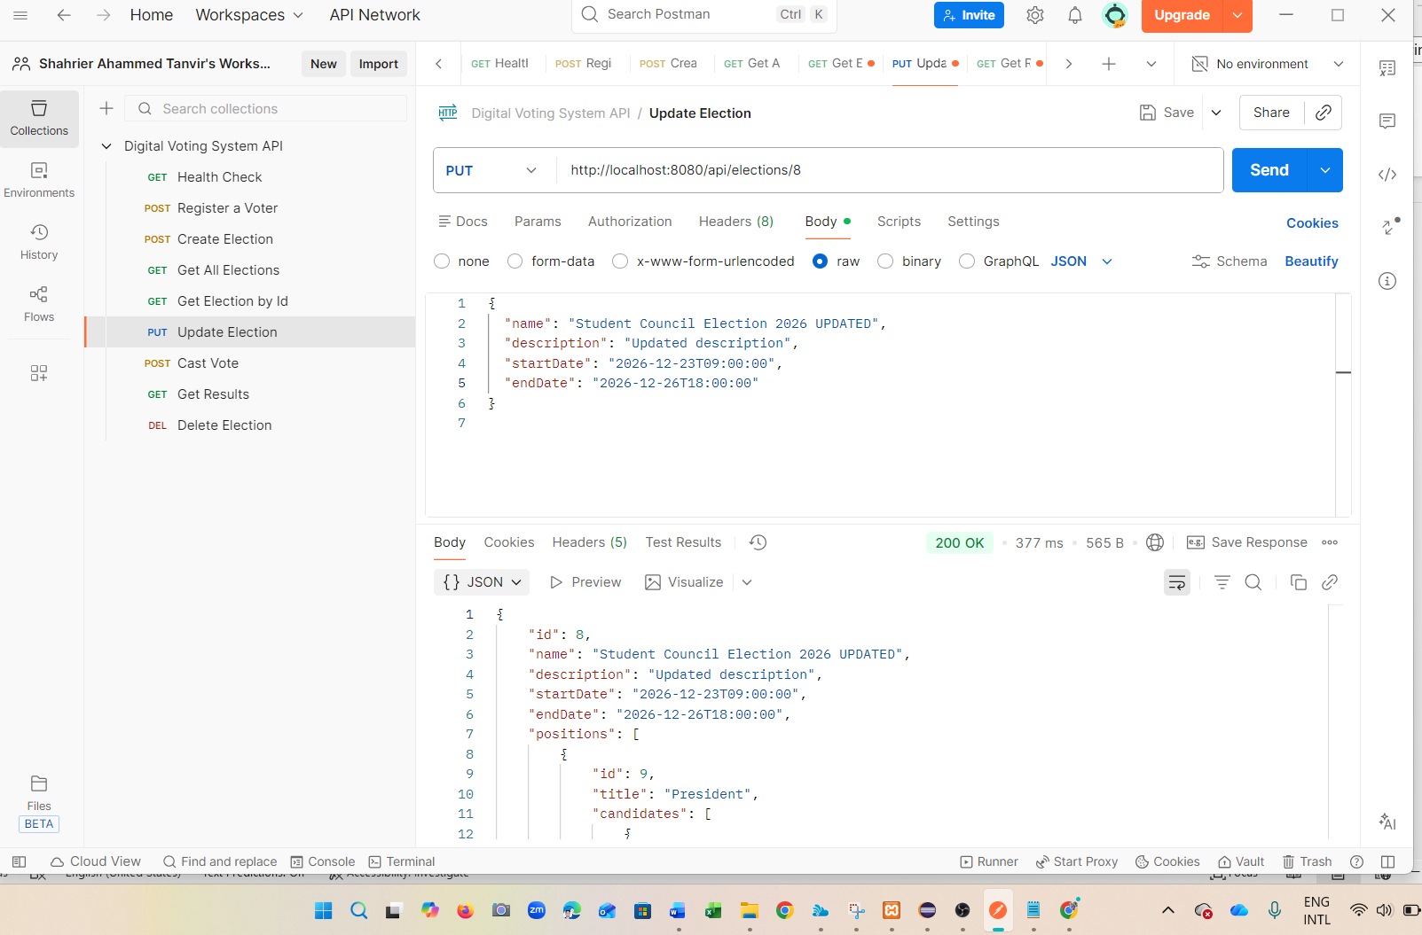
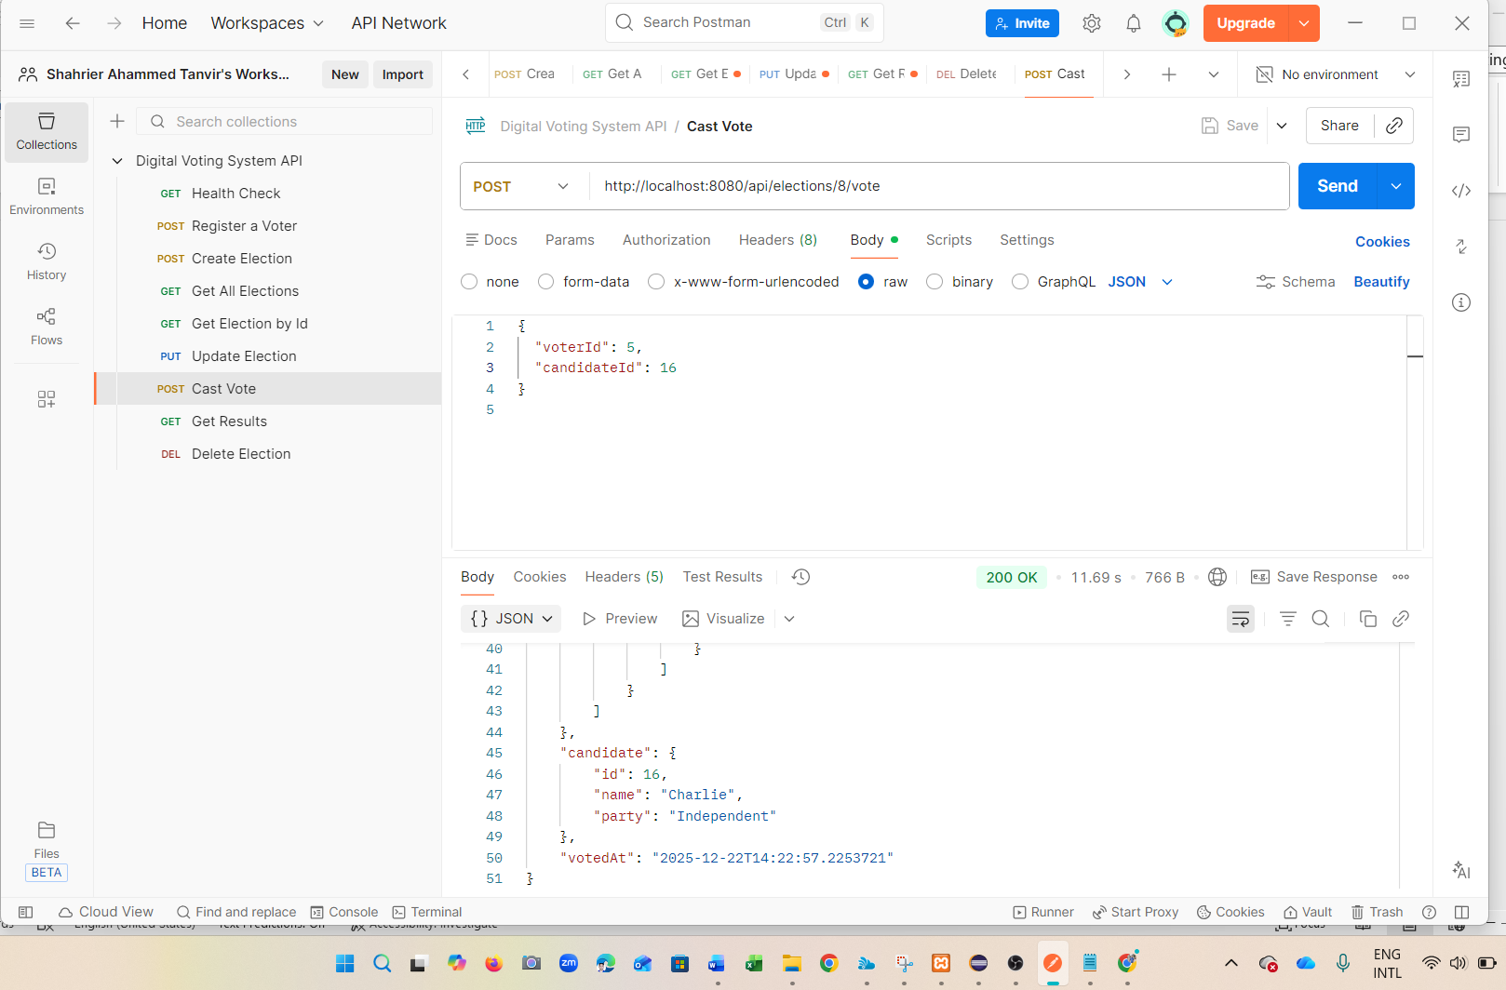
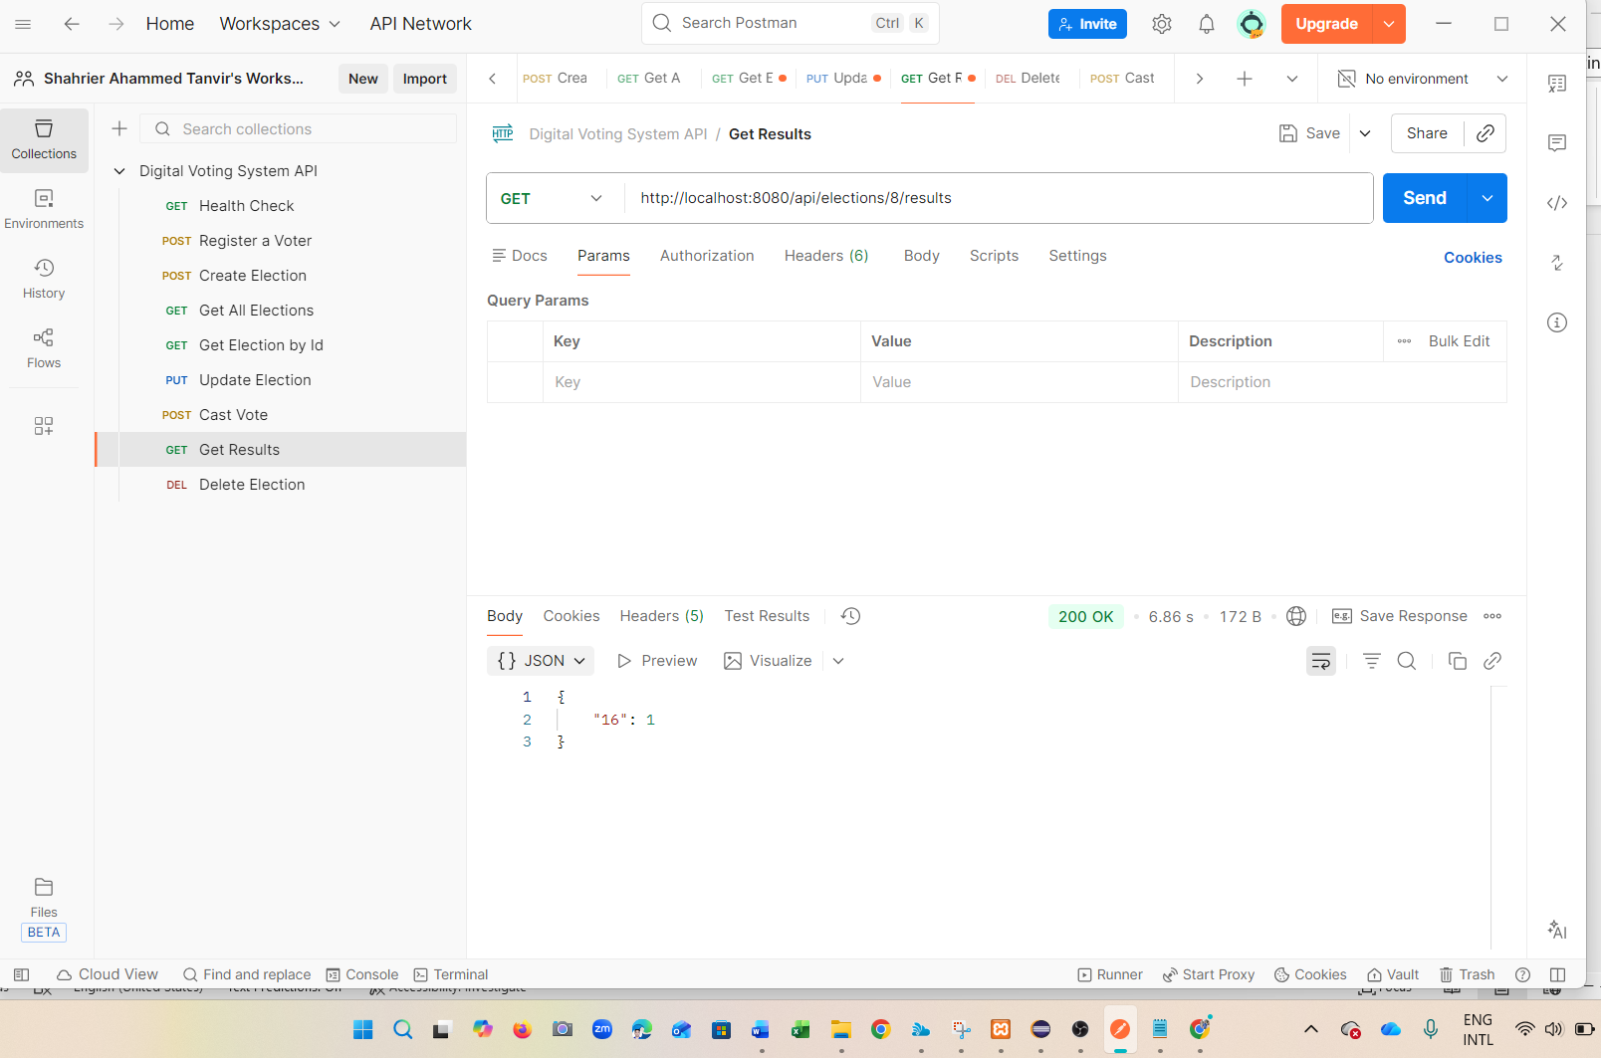
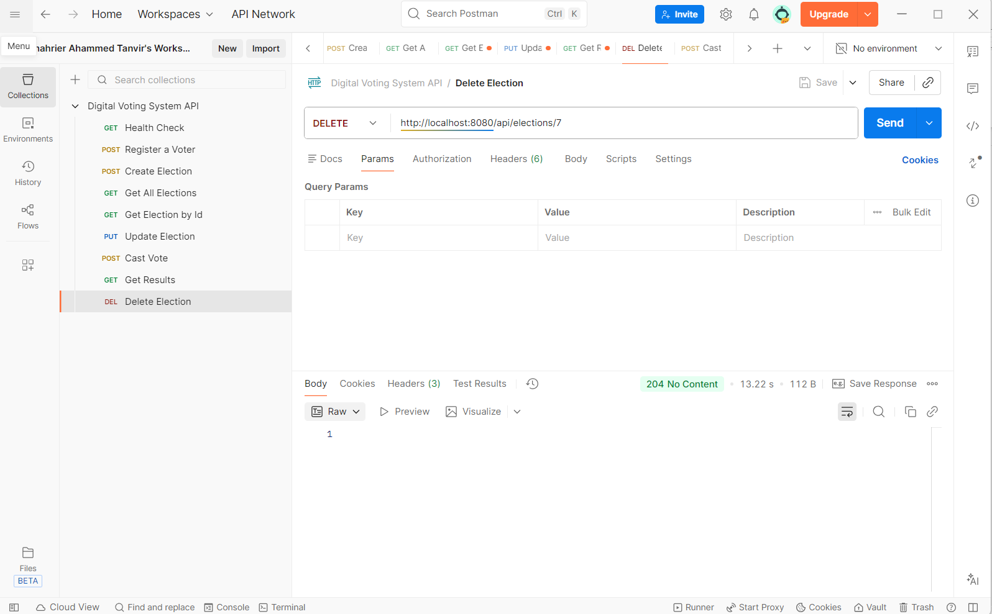

5.4 REST API Endpoints
POST /api/voters — register a new voter.
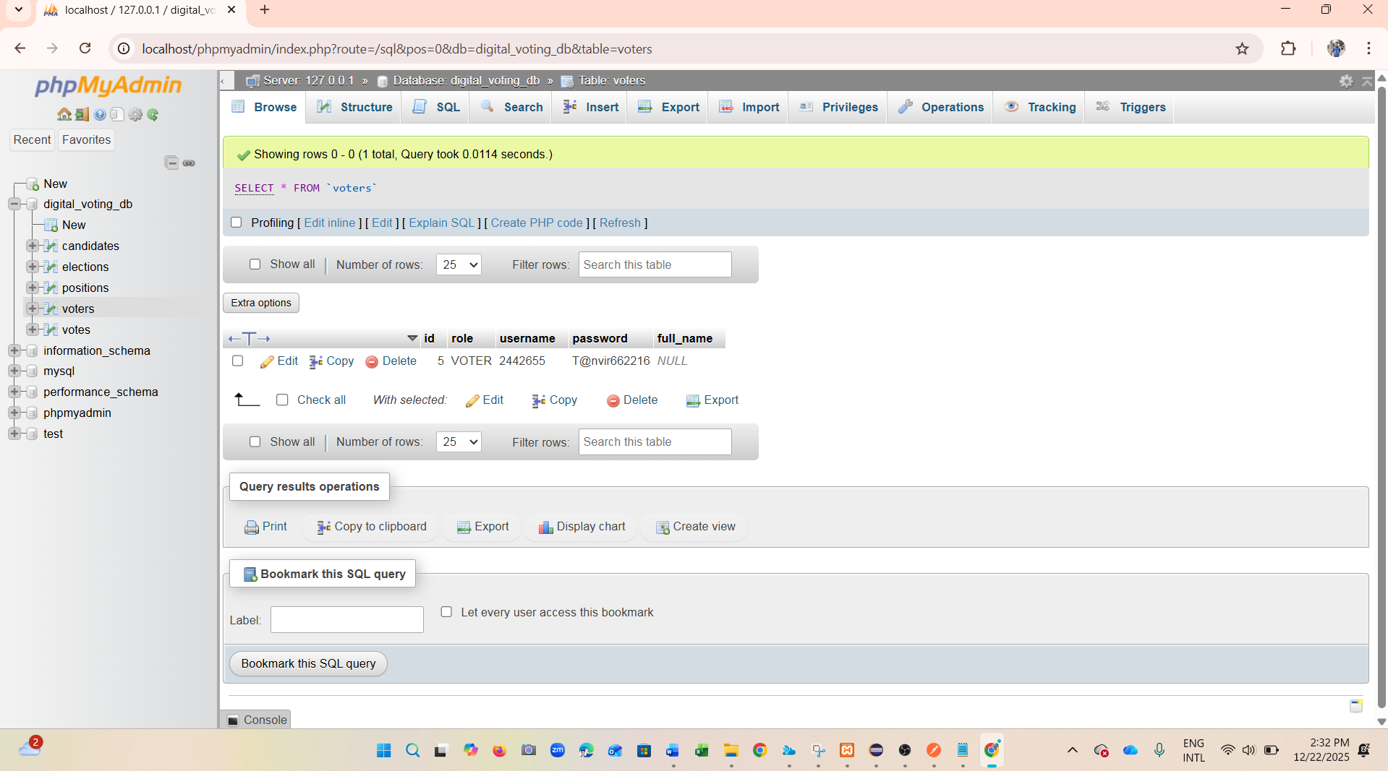
POST /api/elections — create a new election with positions/candidates.
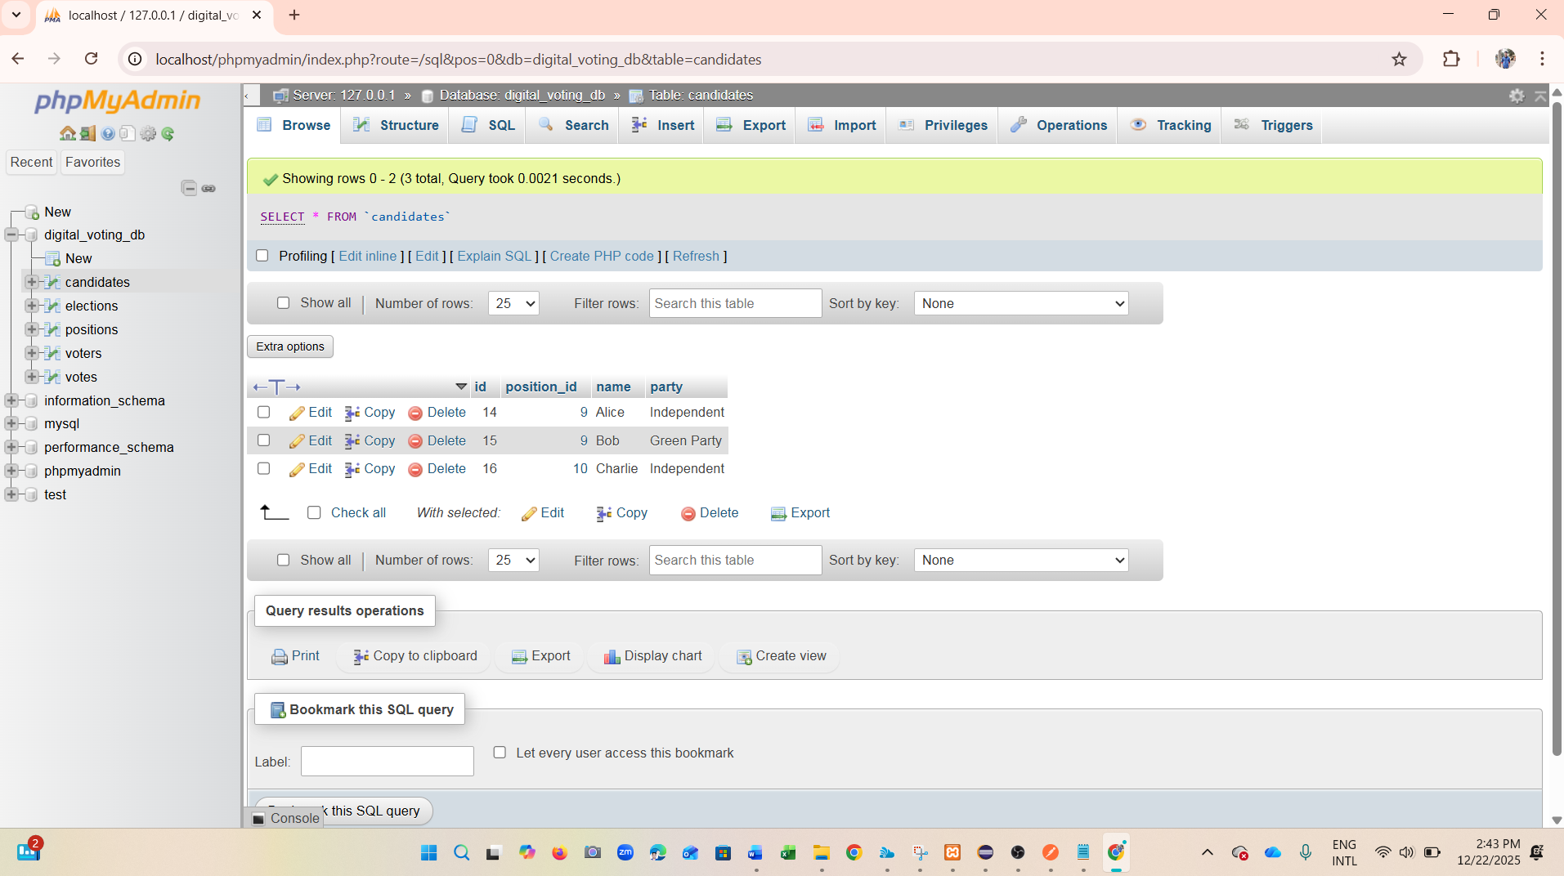
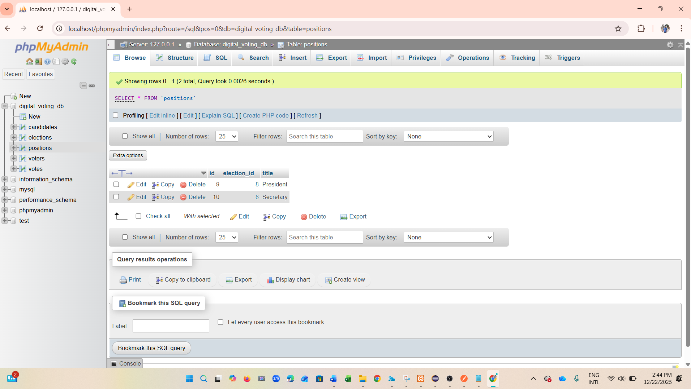
GET /api/elections — list elections.
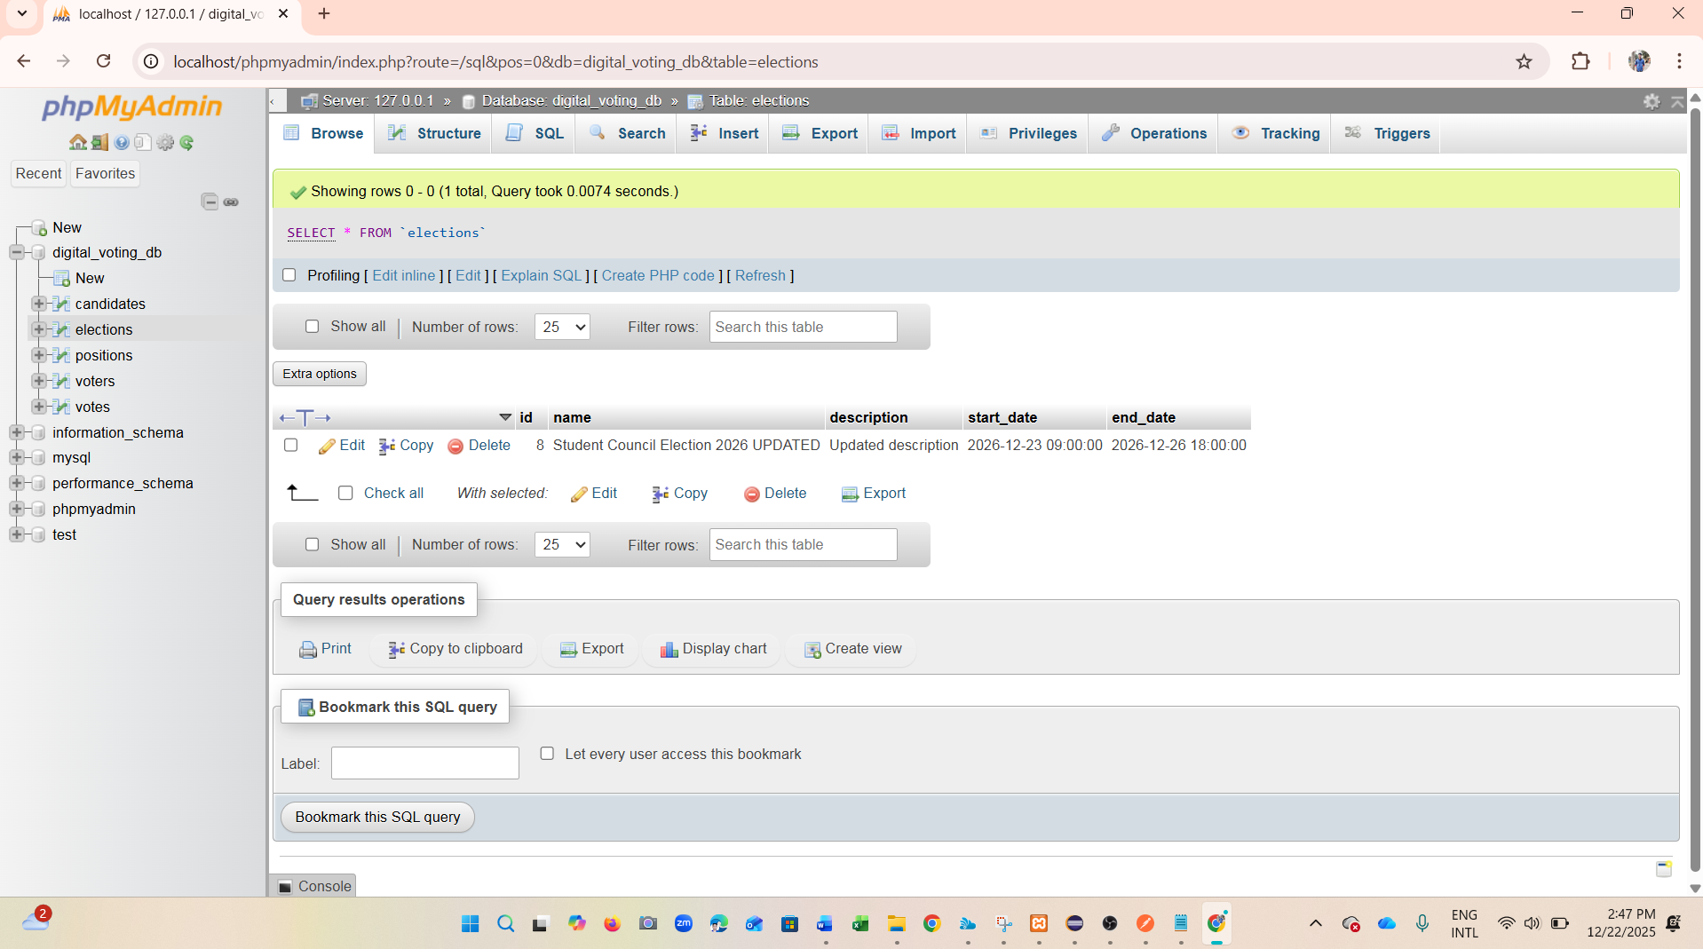
GET /api/elections/{id} — get election details.
PUT /api/elections/{id} — Update Election.

DELETE /api/elections/{id} — delete an election.
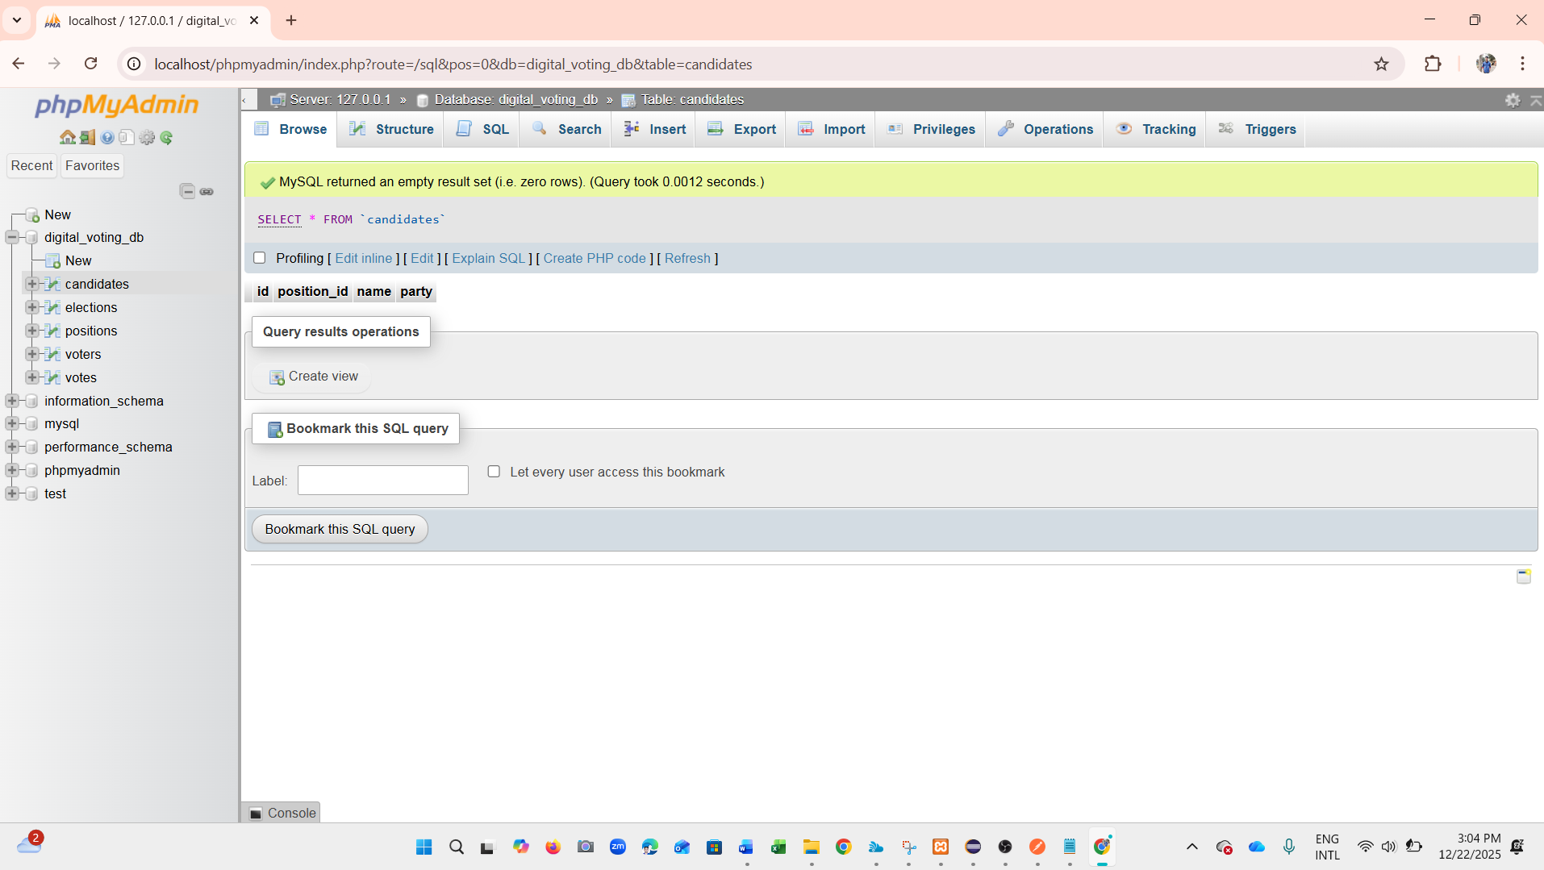

POST /api/elections/{id}/vote — cast a vote.
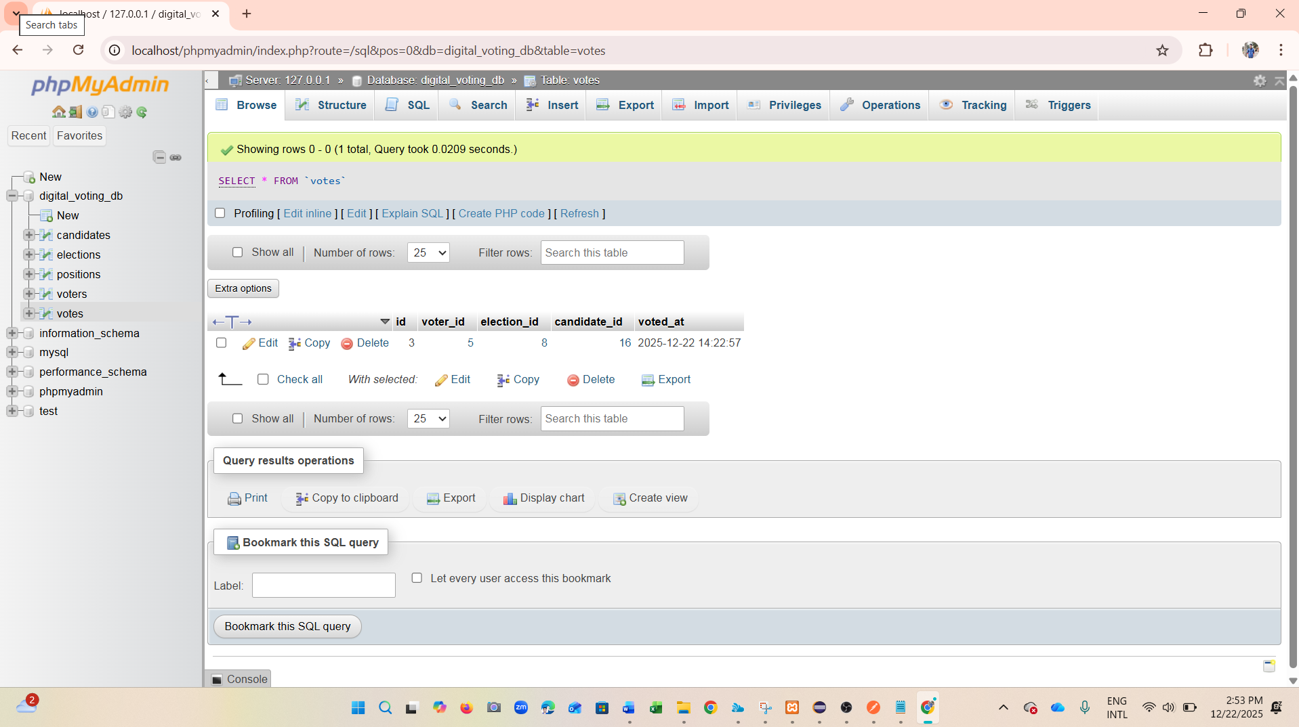
GET /api/elections/{id}/results — vote counts per candidate.

6. Testing
Testing includes unit tests for service-layer business logic using JUnit. Key scenarios tested include successful vote casting and validation failures (e.g., missing voter/election/candidate). API endpoints were also manually tested using Postman to confirm correct HTTP status codes and JSON responses. A global exception handler returns consistent error payloads for invalid requests.
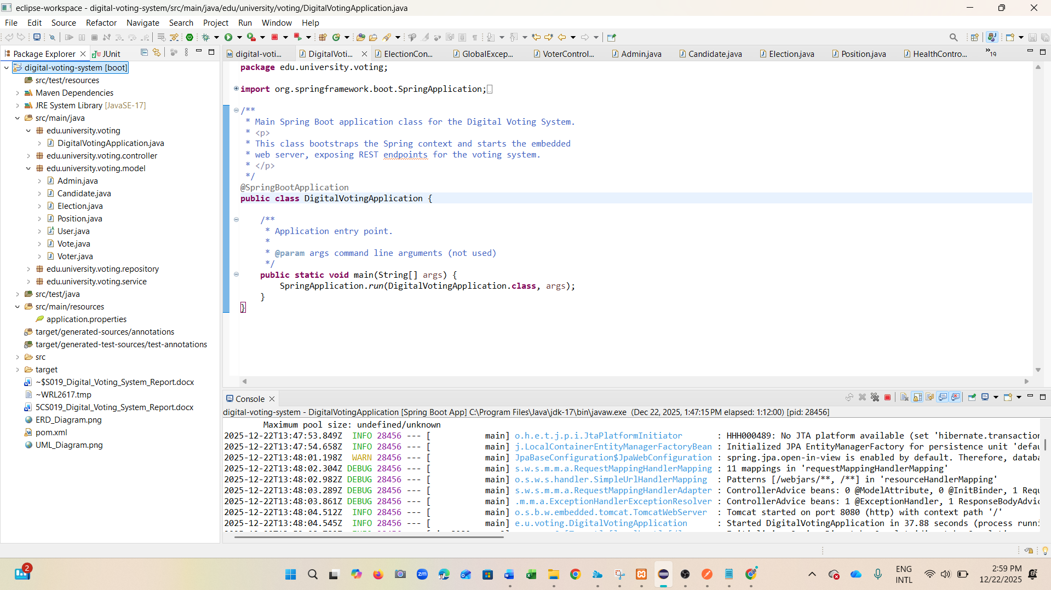
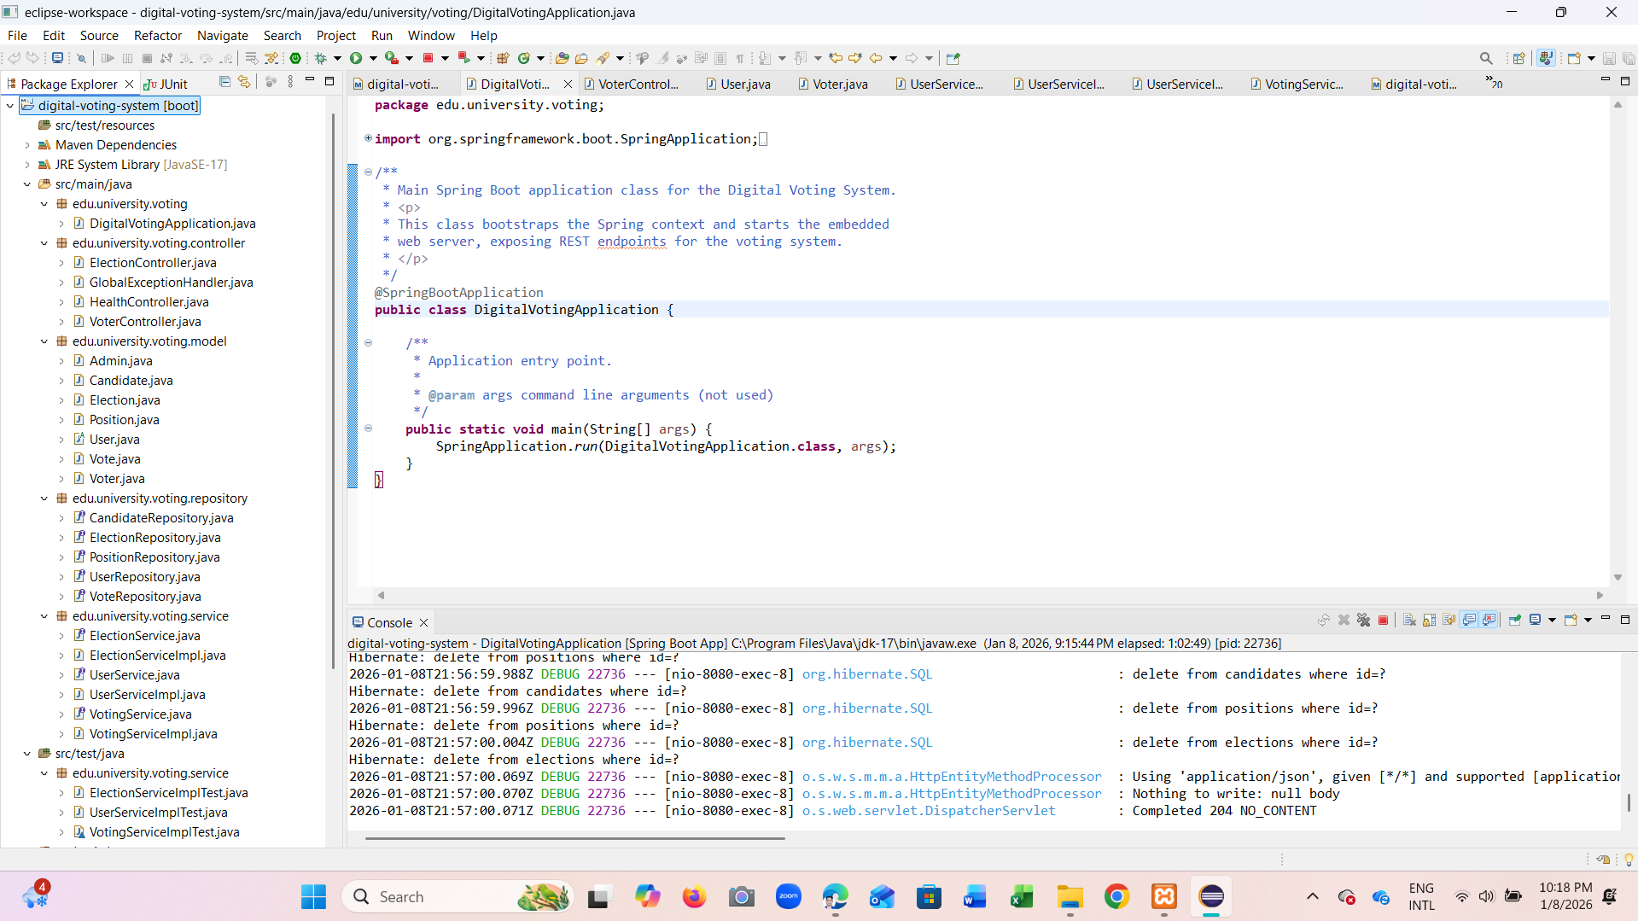
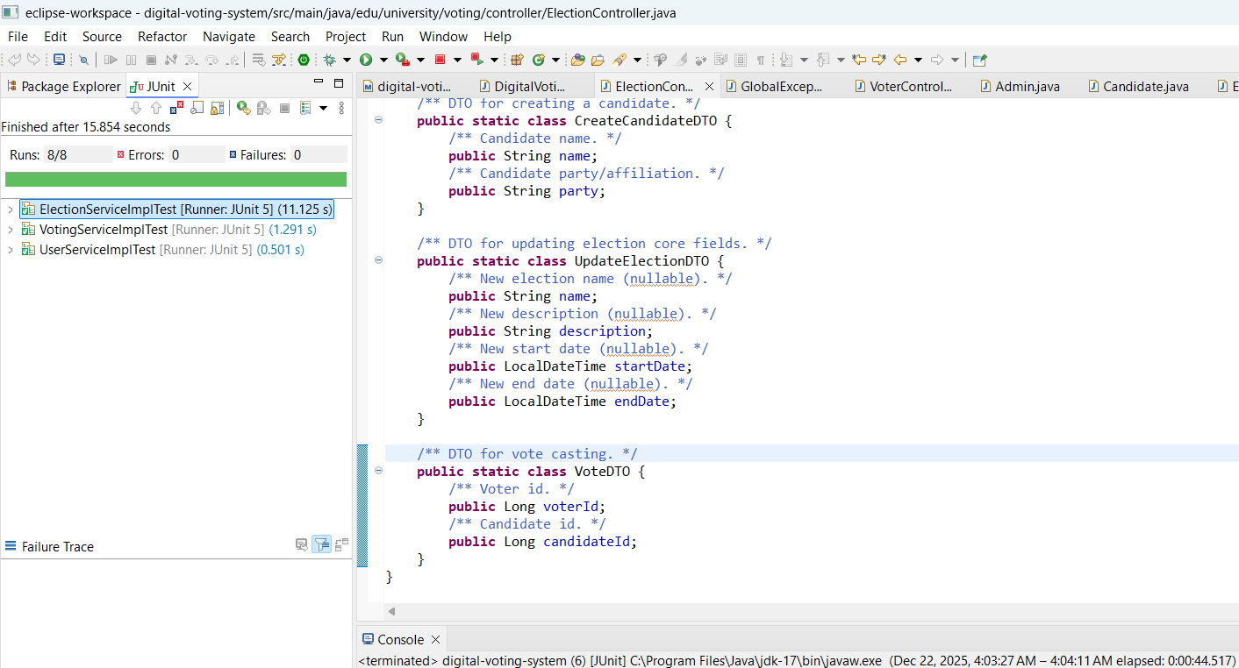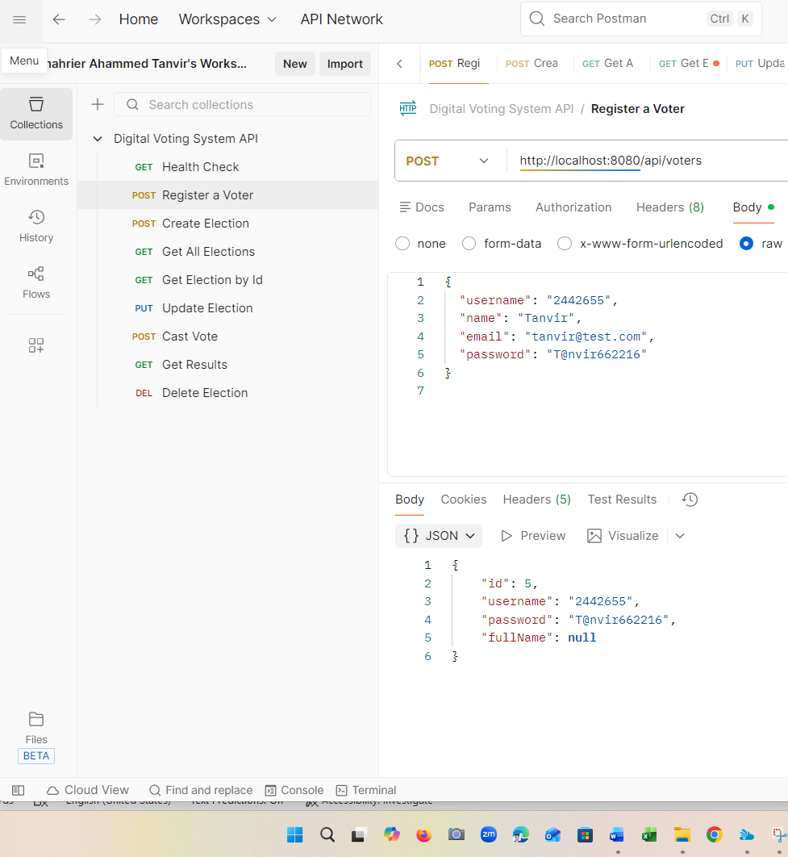

7. Reflection
This project strengthened understanding of layered architecture in Spring Boot, REST API design, and mapping object-oriented models to relational database schemas using JPA. The most valuable learning outcomes were applying SOLID principles in practice, implementing entity relationships, and writing meaningful unit tests. Future improvements would include authentication/authorisation (Spring Security), password hashing (BCrypt), audit logs, and UI integration.

8. Conclusion
The Digital Voting System satisfies the project objectives by providing a functional voting platform with clear OOP design, database-backed persistence, RESTful endpoints and testing. The system is maintainable and extensible due to SOLID-aligned services and repository abstraction. The included UML and ERD diagrams provide evidence of design work, and placeholders indicate where runtime screenshots should be inserted for assessment.

9. References
Spring Boot Documentation; Spring Data JPA Documentation; MySQL Documentation; Oracle Java Documentation; UML modelling standards.

10. Appendices

Appendix A — UML Class Diagram

Appendix B — ERD Diagram

Appendix C — Screenshot Checklist
1) phpMyAdmin tables in digital_voting_db
2) phpMyAdmin rows after CRUD operations
3) Spring Boot console run output
4) JUnit tests passing

