Task 2: Movie Review Web App Evidence
Name: Shahrier Ahammmed Tanvir
Student ID: 2442655
__________________________________________________

Evidence 1: Google Firestore Database (Backend)
This screenshot shows the 'movies' collection in the Firestore console, confirming the data is stored in the NoSQL database.
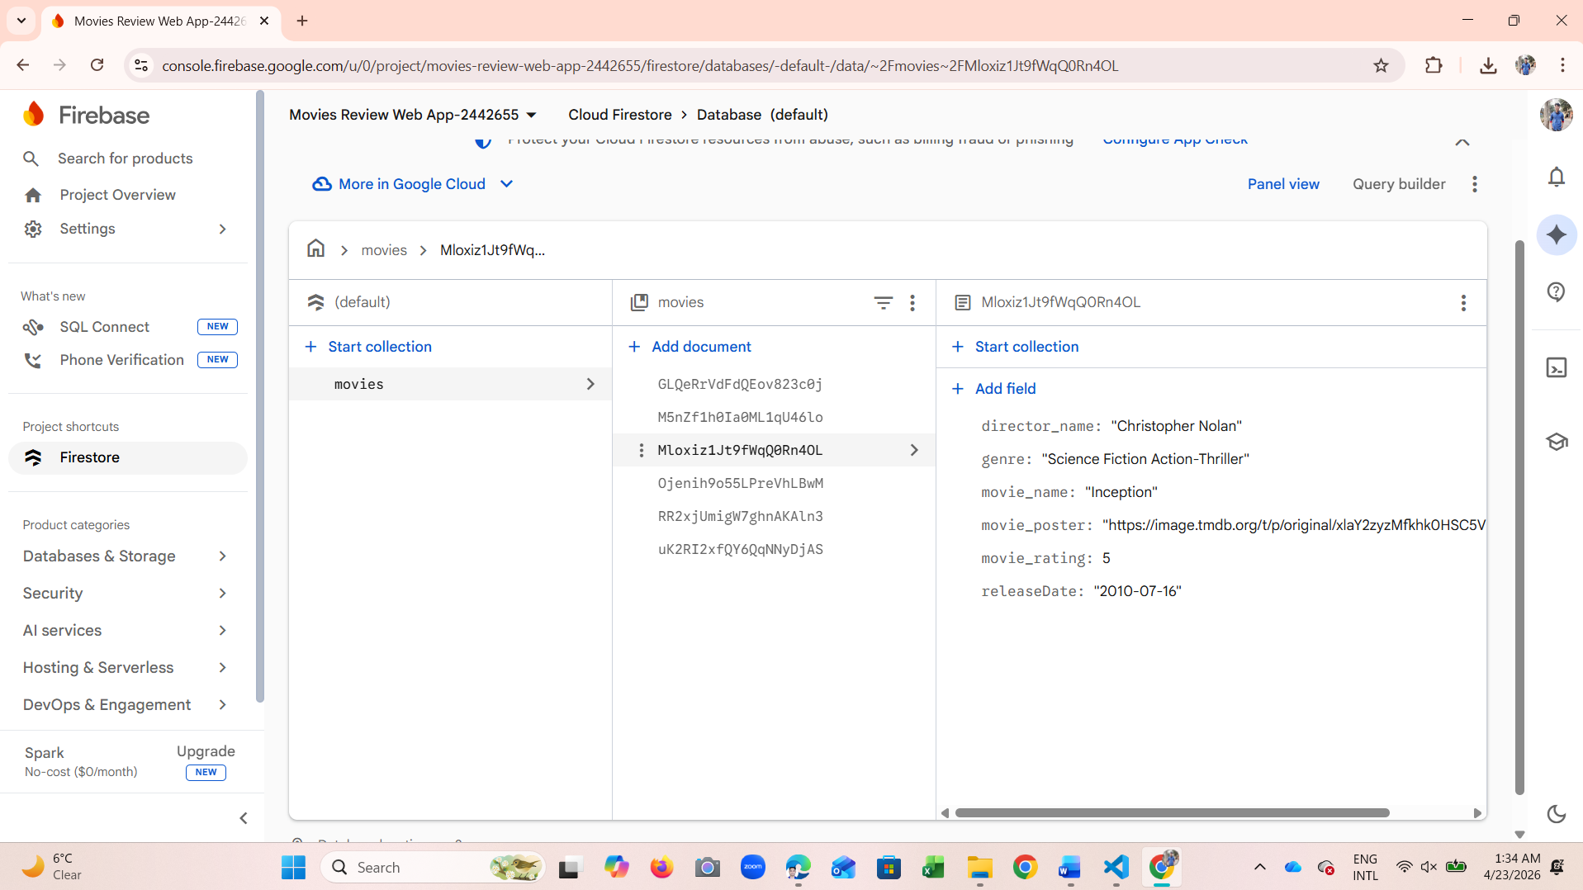
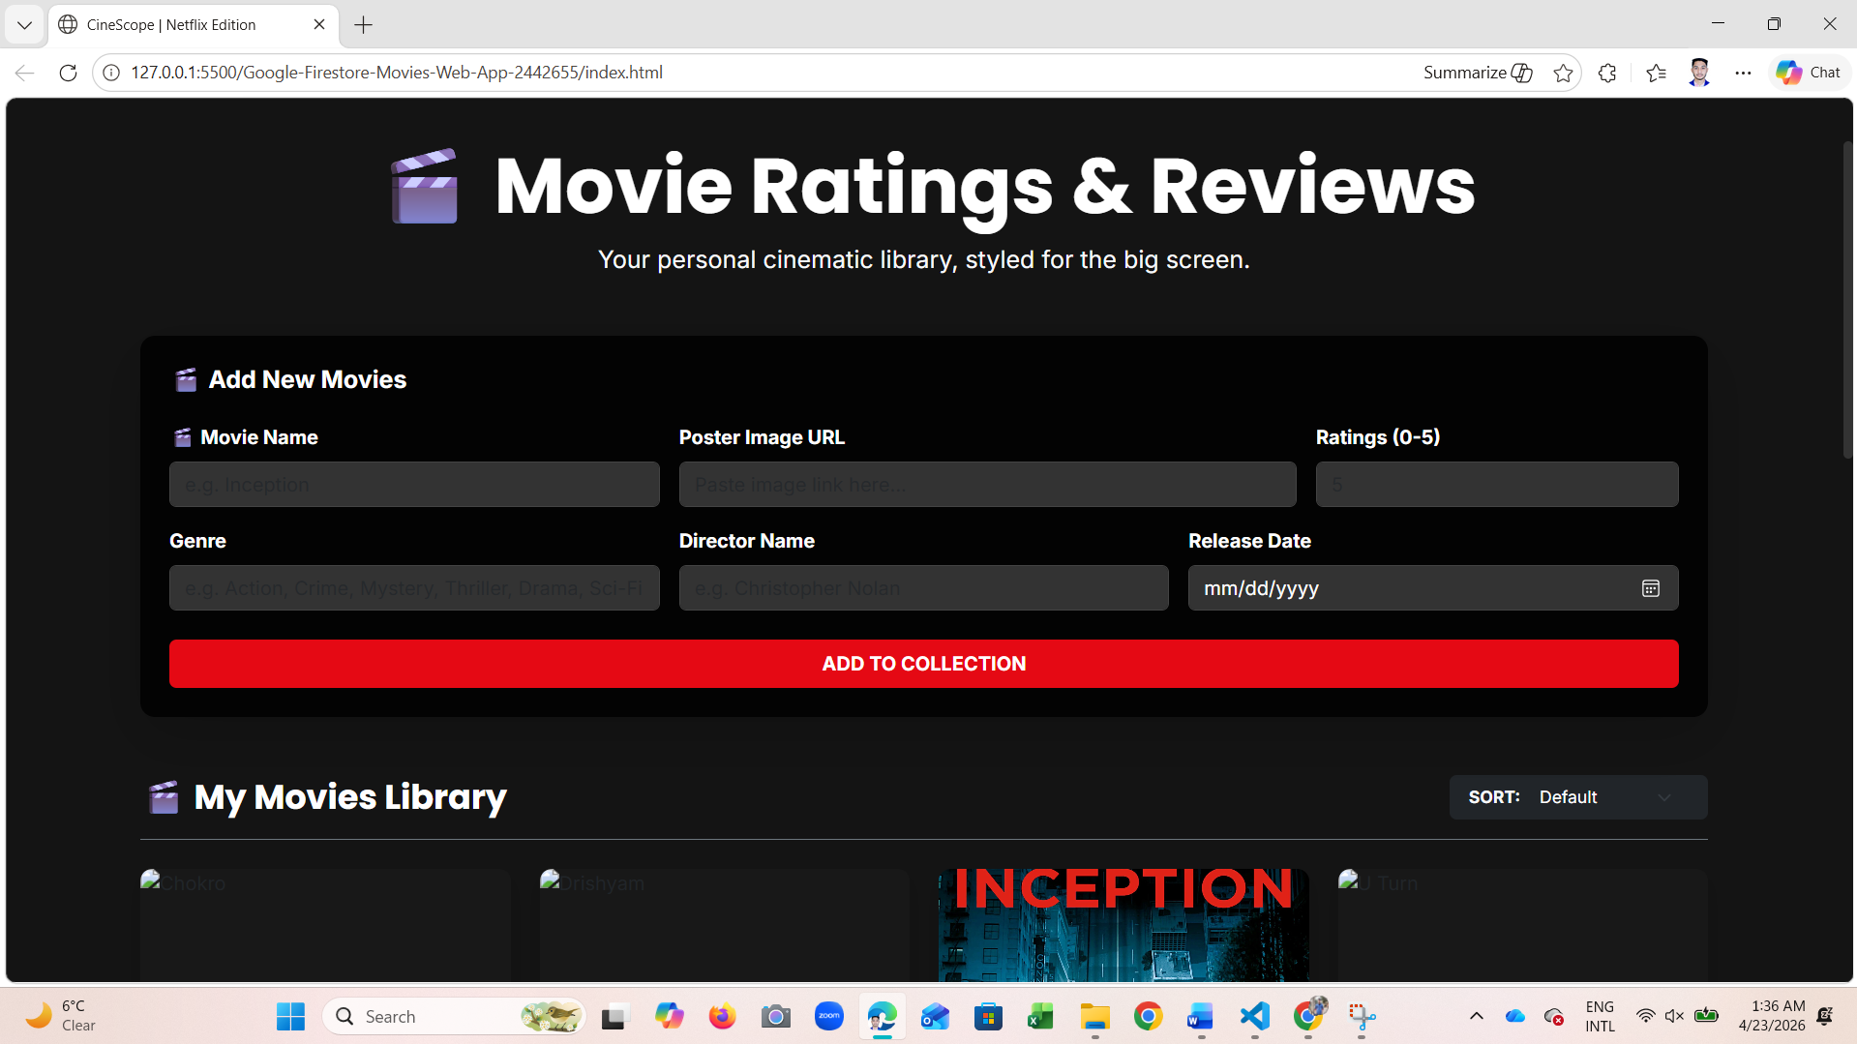
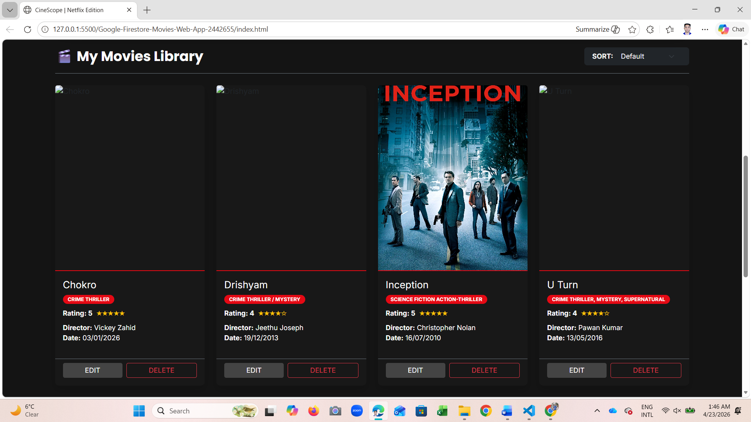

Evidence 2: Adding a Movie (Create Function)
A screenshot of the web browser showing the form filled out and the movie being successfully added to the library.
Before My Movies Library
After Adding Movie Then My Movies Library
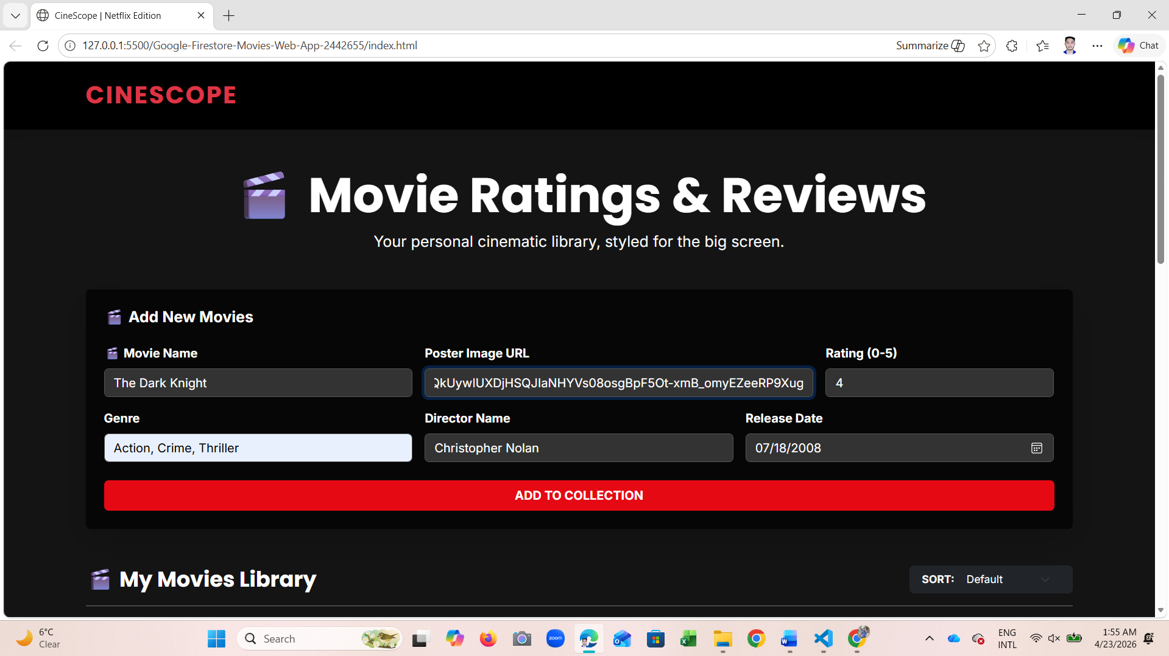
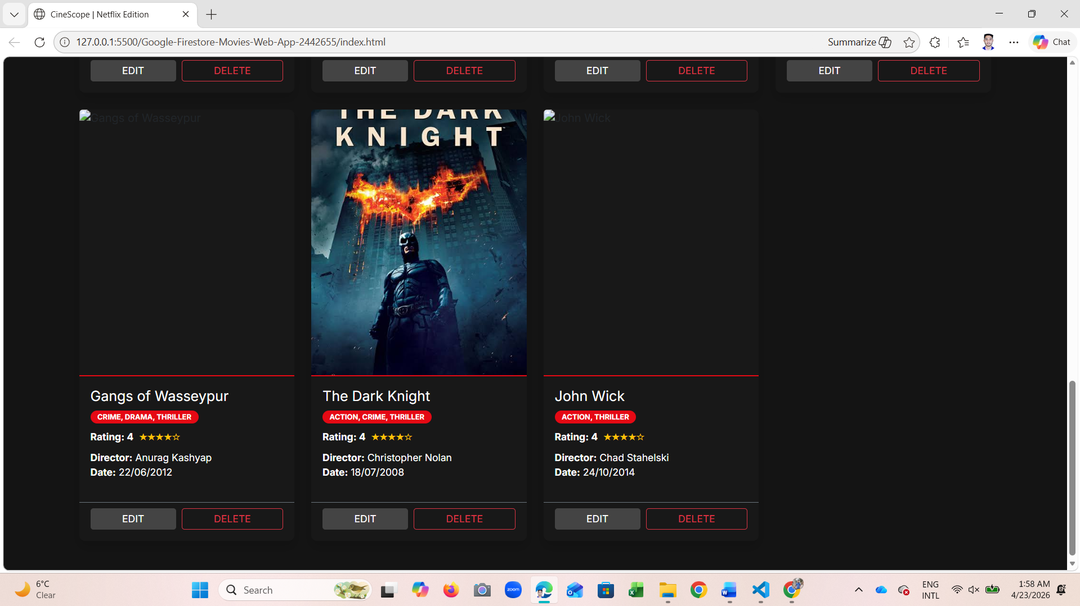
Also Added in the Cloud Firestore Database
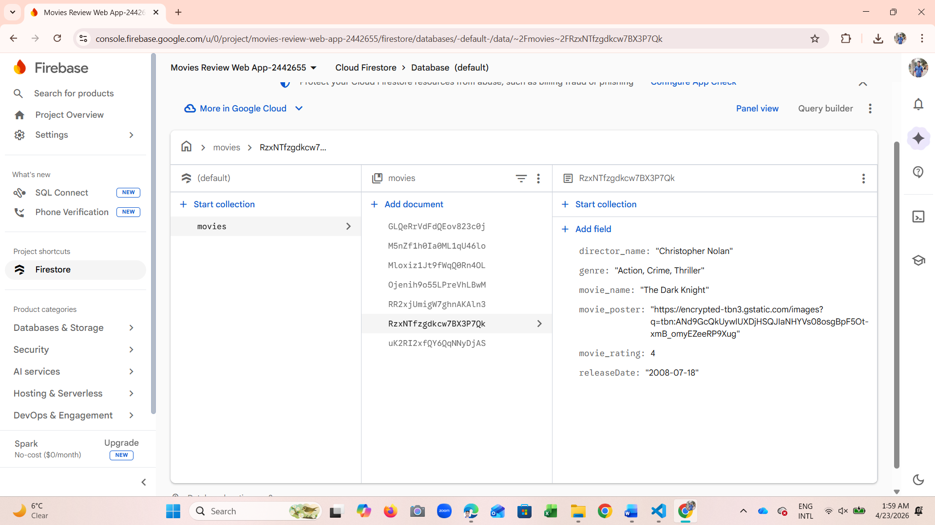

Evidence 3: Displaying Movies (Read Function)
A screenshot of the web browser showing the list of movie reviews being fetched and displayed on the HTML page.
Web browser showing the list of movie reviews being fetched
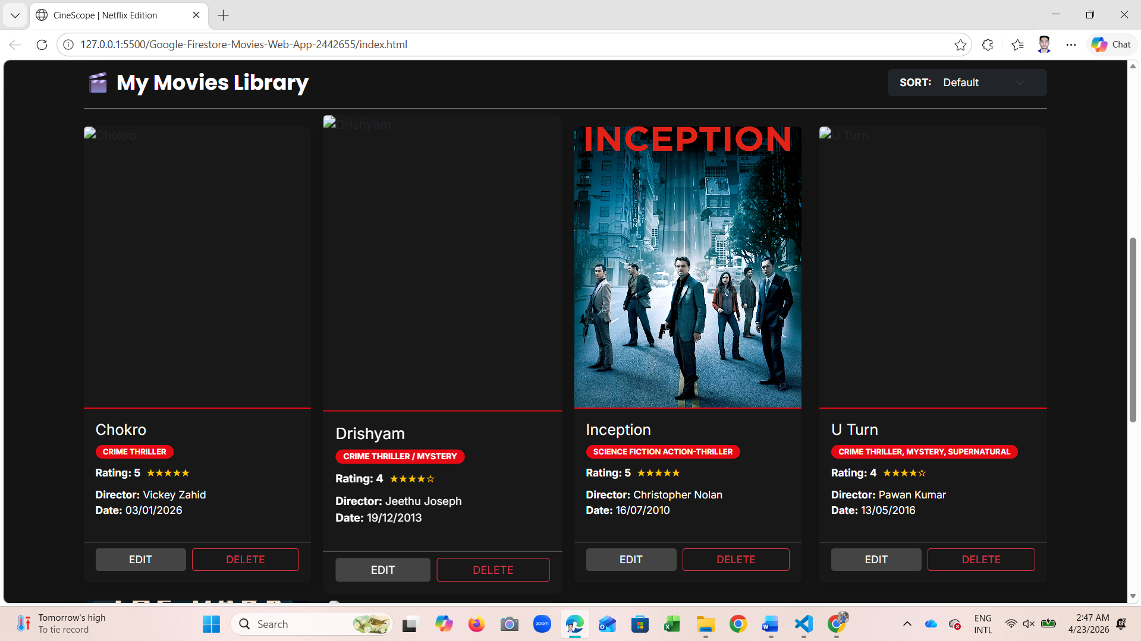
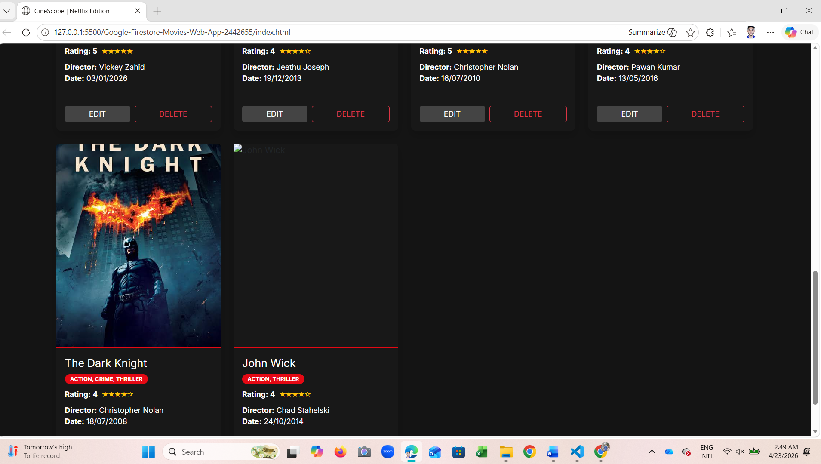

Movie reviews being fetched and displayed on the HTML page
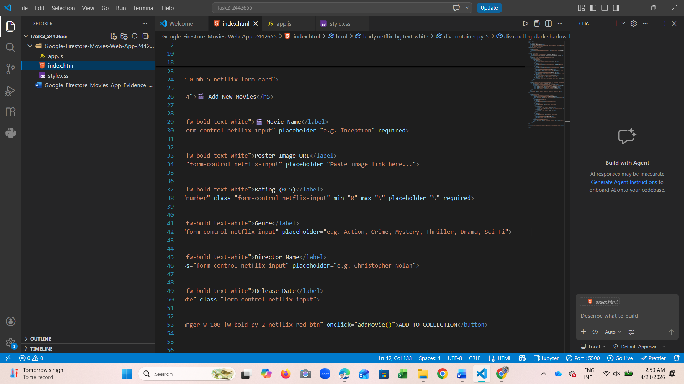
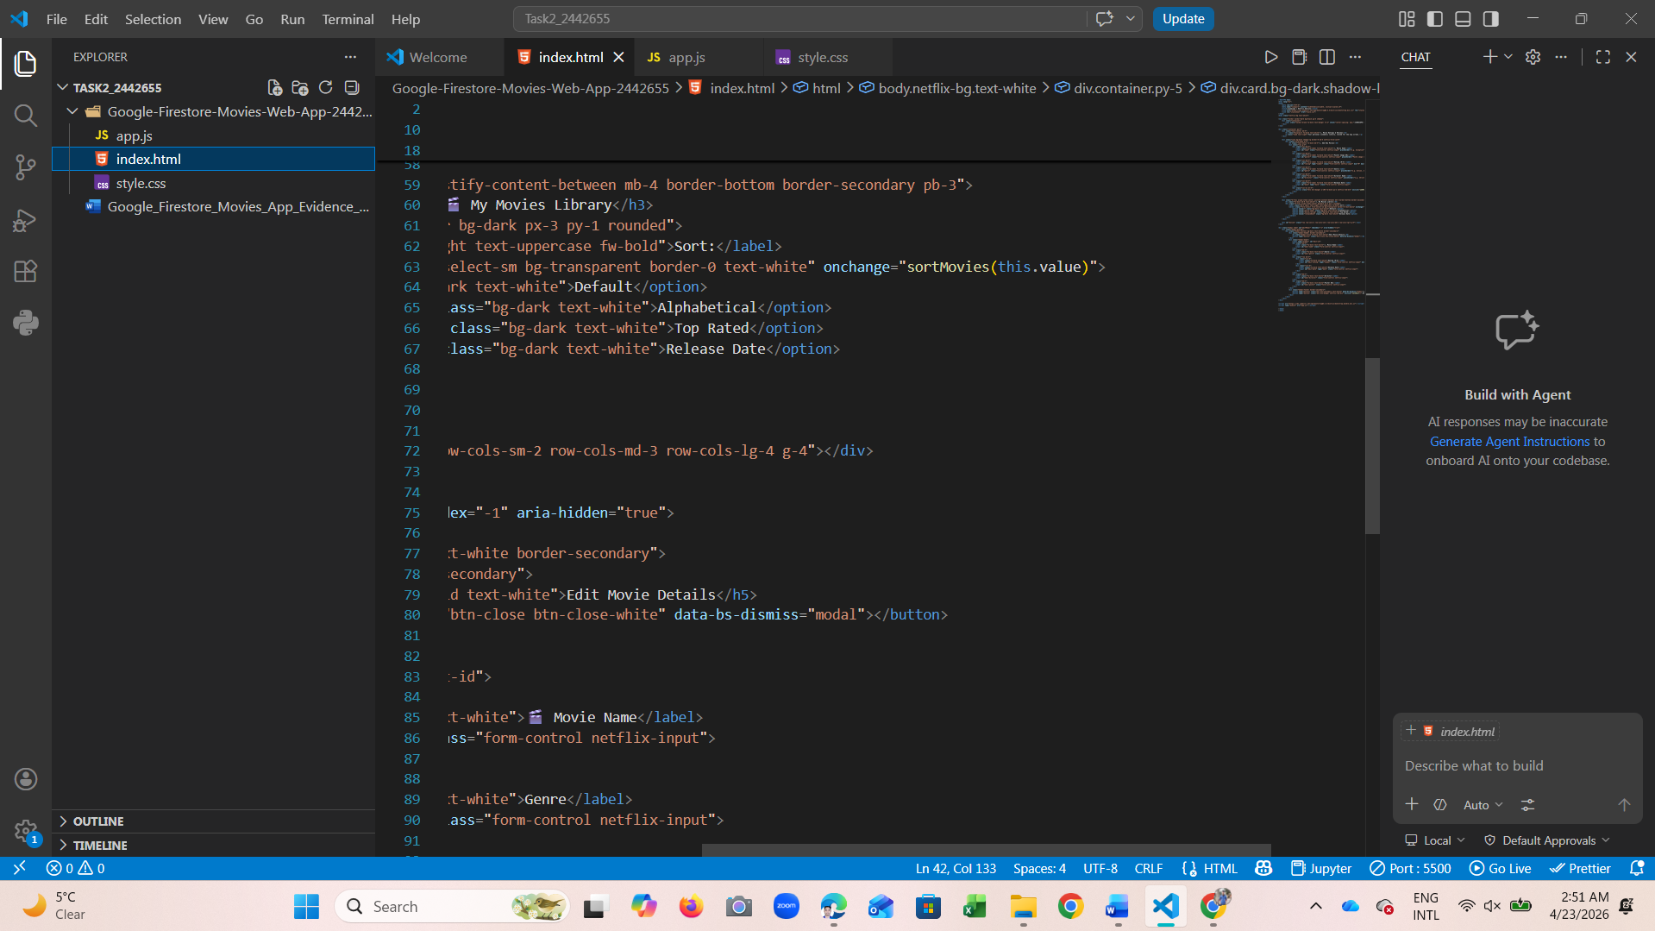
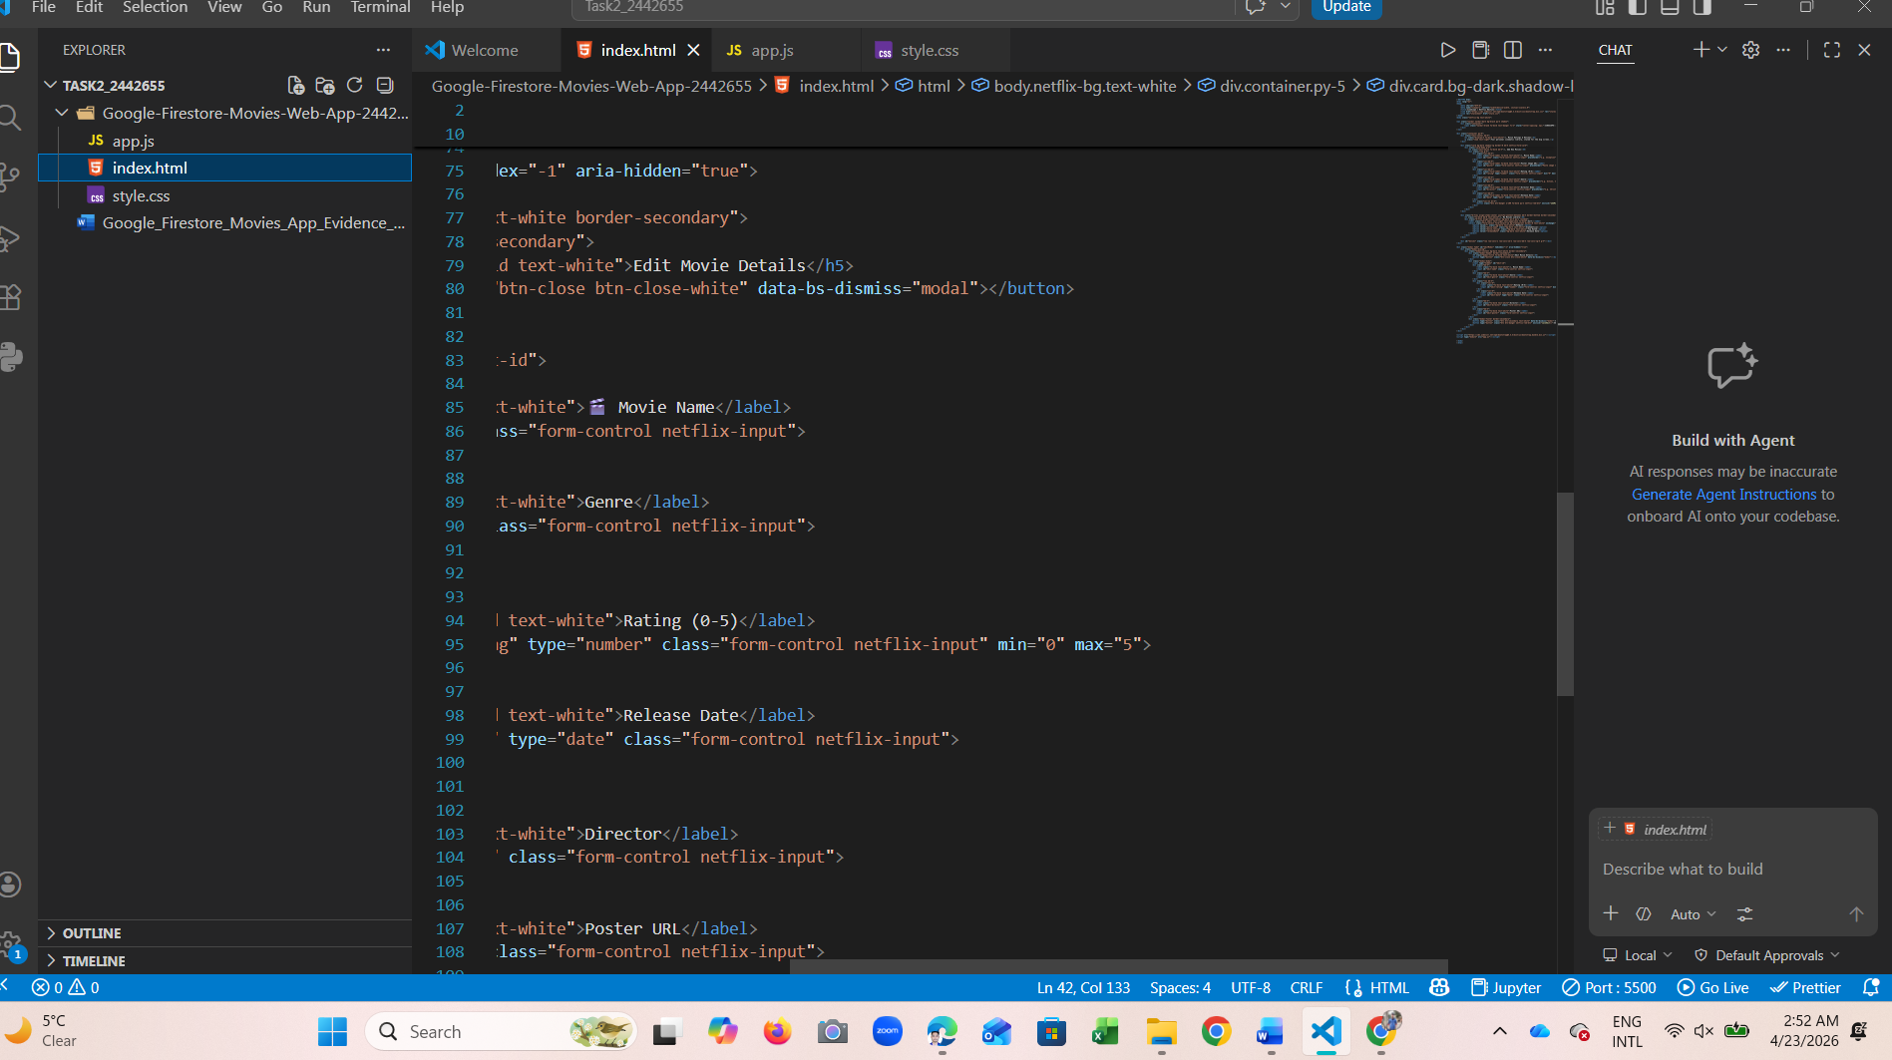

Evidence 4: Editing a Movie (Update Function)
A screenshot showing the 'Edit' modal/popup with updated details before and after saving the changes.
Before Editing the movie named “Gangs of Wasseypur”
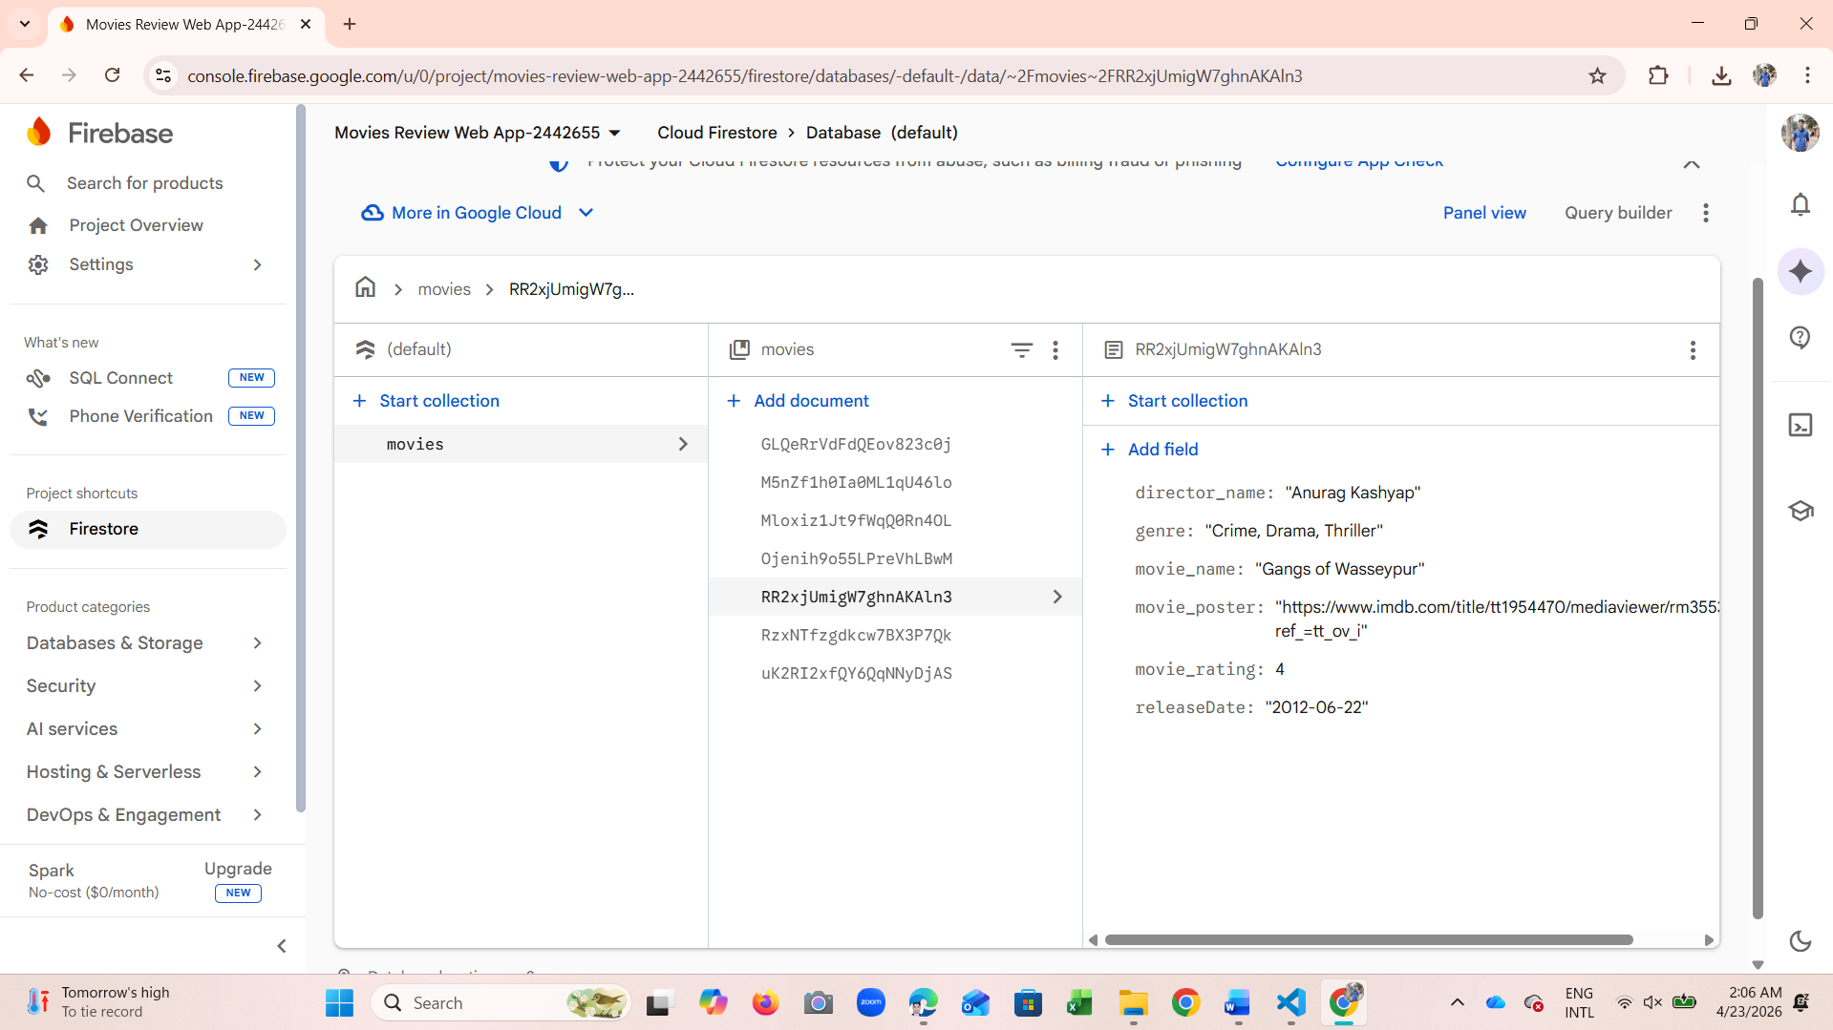
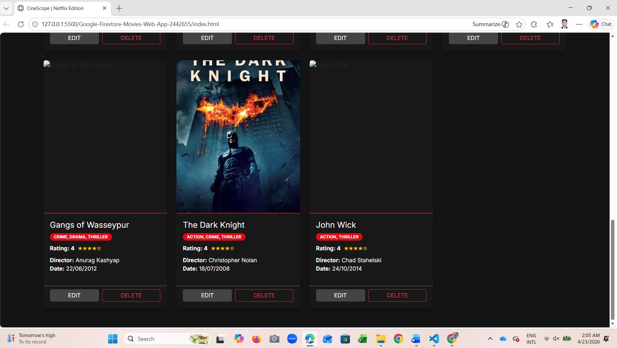

After Editing Genre, Rating, Date, Director Name of the movie named “Gangs of Wasseypur”
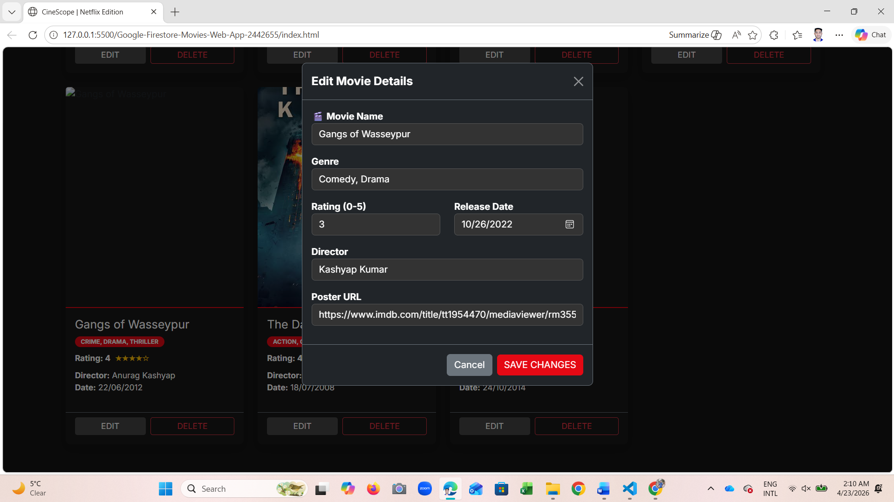
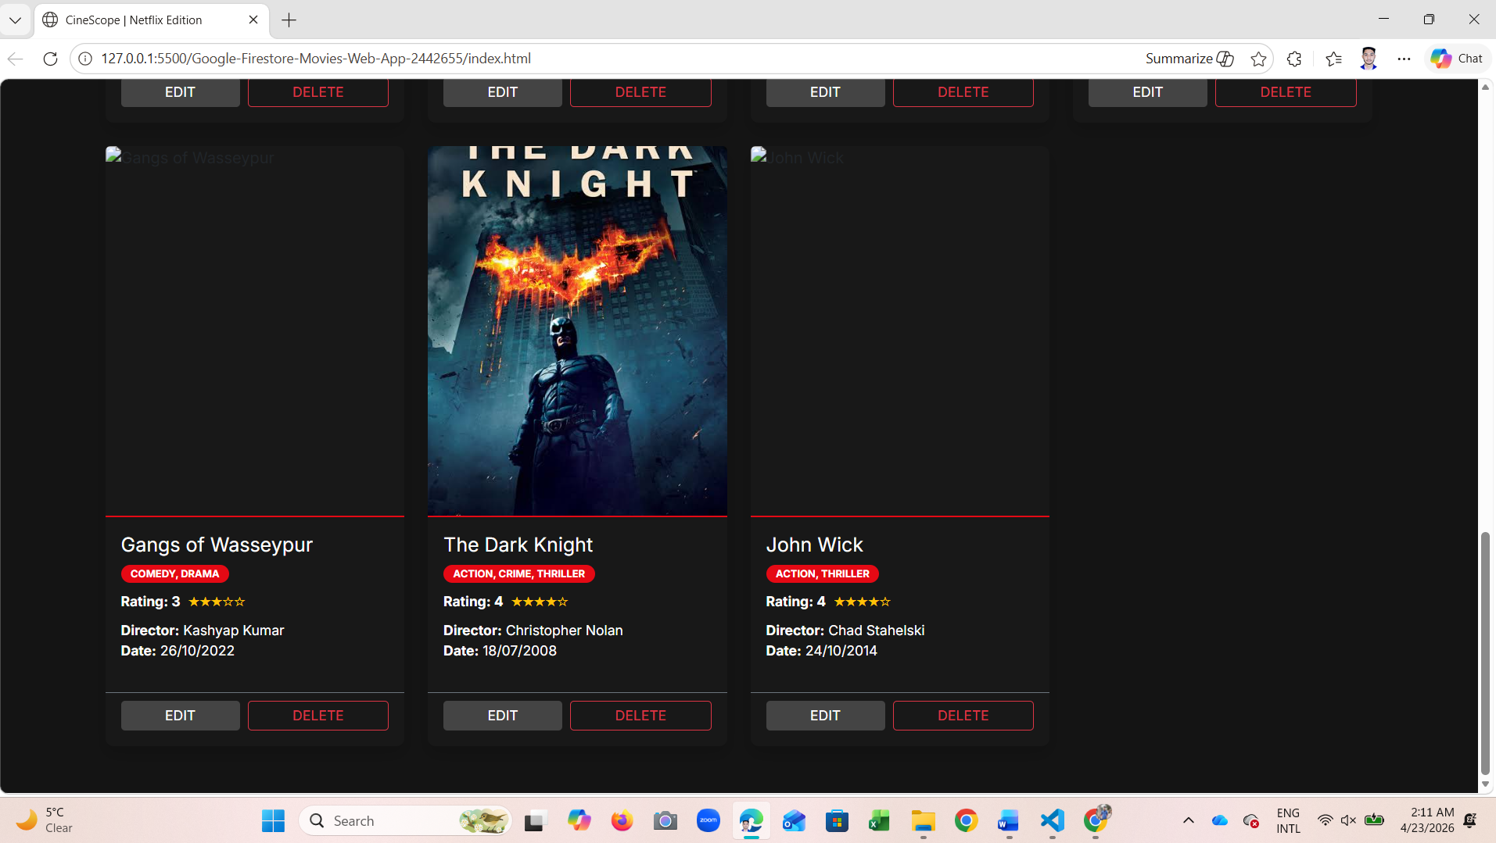
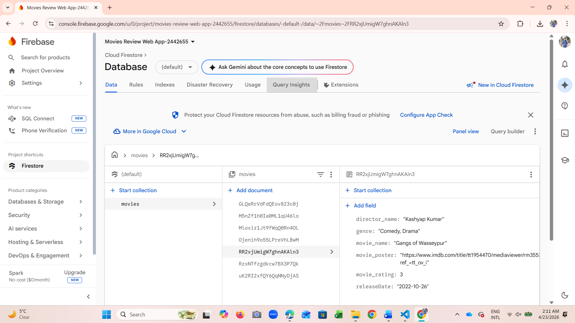

Evidence 5: Deleting a Movie (Delete Function)
A screenshot demonstrating the successful removal of a movie review from the list and the database.
Before Remove the movie named “Gangs of Wasseypur”

After Remove the Movie named "Gangs of Wasseypur”
Deleted From the My Movies Library
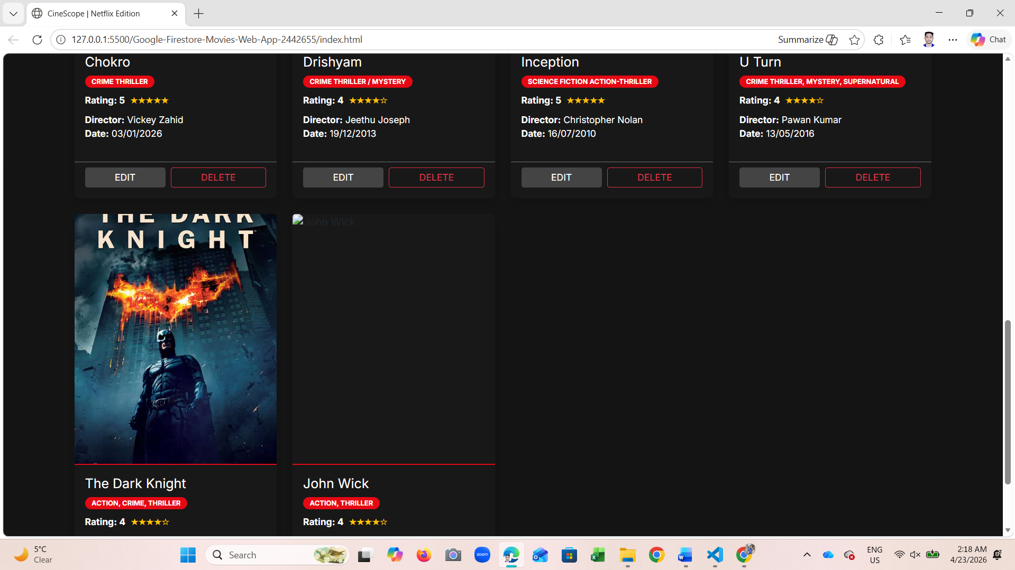
Deleted From the Cloud Firestore Database
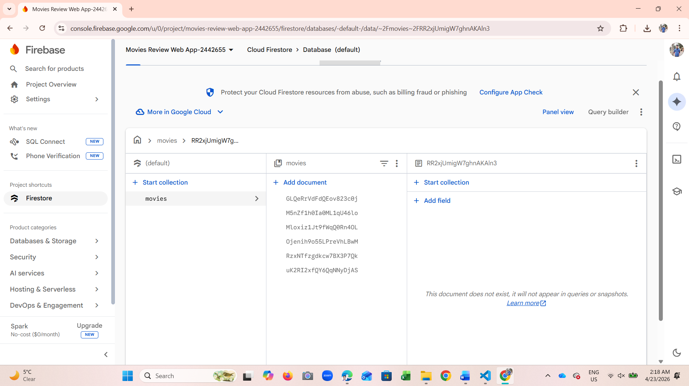

Evidence 6: Sorting Movies (Sort Function)
A screenshot showing the list of movies sorted by a specific field (e.g., Rating or Name) using the dropdown menu.
If I sorted specified the field e.g., “Top Rated”
When Default
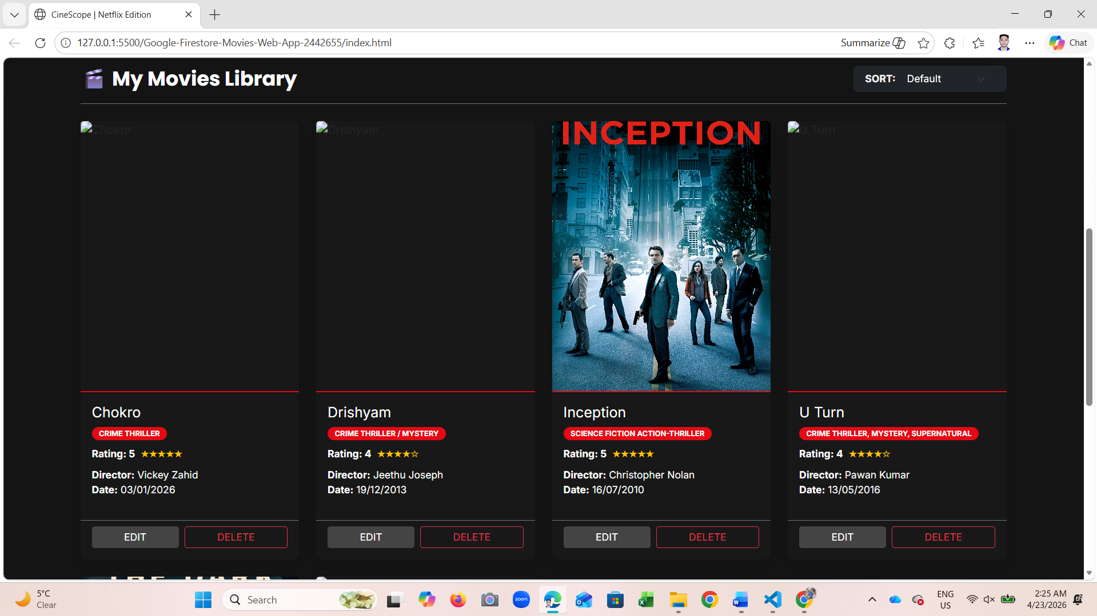
When sorted a specified field “Top Rated”
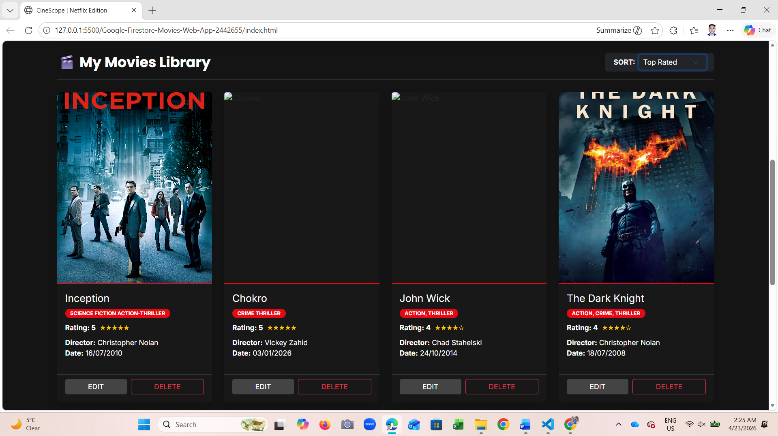
When Default
When sorted a specified field “Release Date”
