Bangla CV Model Performance Report

Model: Logistic Regression
precision recall f1-score support
Experience 0.98 0.93 0.95 165
Skill 0.87 0.97 0.91 89
Education 0.99 0.97 0.98 74
Objective 1.00 1.00 1.00 20
accuracy 0.95 348
macro avg 0.96 0.97 0.96 348
weighted avg 0.95 0.95 0.95 348
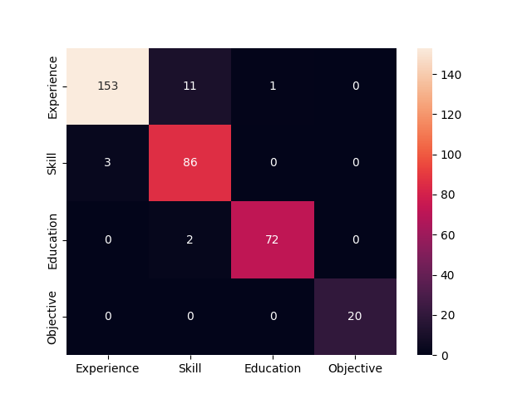

Model: SVM
precision recall f1-score support
Experience 0.98 0.93 0.96 165
Skill 0.90 0.97 0.93 89
Education 0.99 1.00 0.99 74
Objective 1.00 1.00 1.00 20
accuracy 0.96 348
macro avg 0.97 0.97 0.97 348
weighted avg 0.96 0.96 0.96 348
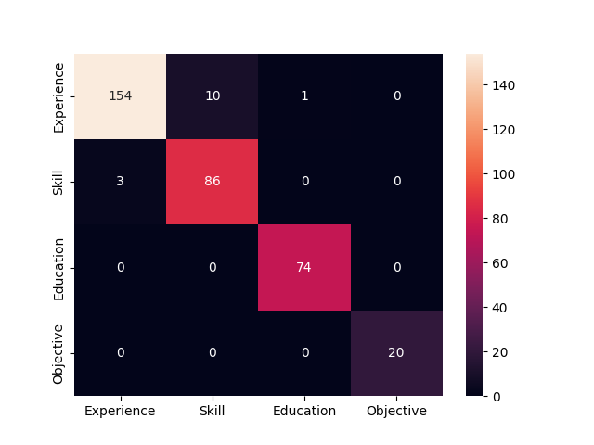

Model: KNN
precision recall f1-score support
Experience 0.95 0.62 0.75 165
Skill 0.65 0.89 0.75 89
Education 0.91 0.97 0.94 74
Objective 0.49 1.00 0.66 20
accuracy 0.78 348
macro avg 0.75 0.87 0.77 348
weighted avg 0.84 0.78 0.79 348
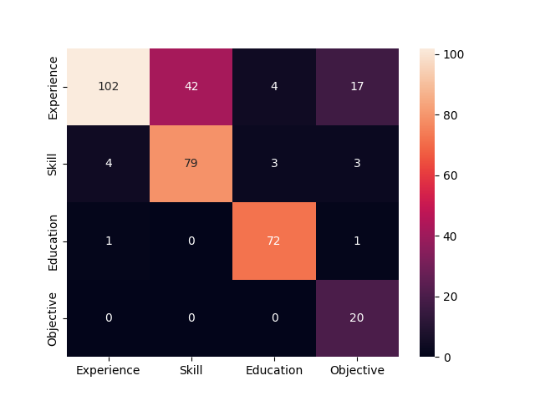

Accuracy Graph
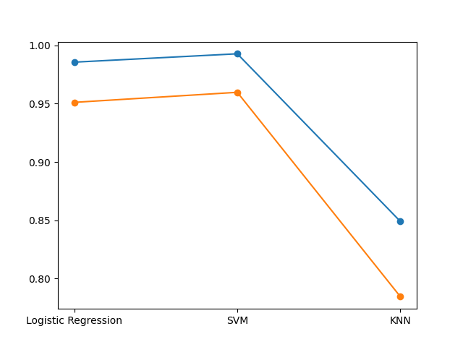

Loss Graph
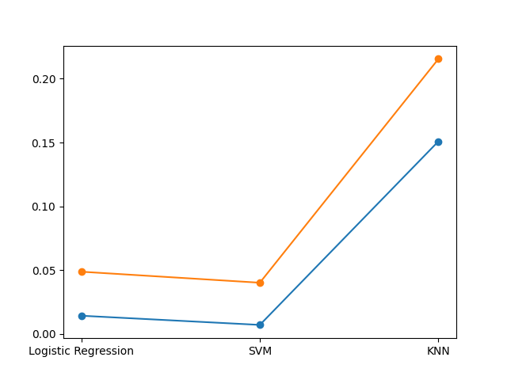

ROC Curve
