**1.**

**Introduction:**

**1.1**

**Objectives:**

**1.2**

**Motivation:**

**1.3**

**Existing works:**

**1.4**

**Necessity:**

**2.**

**Methodology:**

We have used K-means and Agglomerative clustering in our project. Elbow Method is used for determining the optimal number of clusters and silhouette score is used for validation while clustering.

**Elbow Method:**

Elbow method is applied to calculate value of K for the dataset This method works by finding the SSE of each data point with its nearest centroid with different values of K. As value of K increases the SSE will decrease and at a particular value of K where there is most decline in the SSE is the elbow, the point at which we should stop dividing data further.

**Formula:**

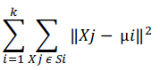

Xj = data point in Si cluster

μi = centroid of the cluster

After applying elbow method, a sample graph like below will show for our project.

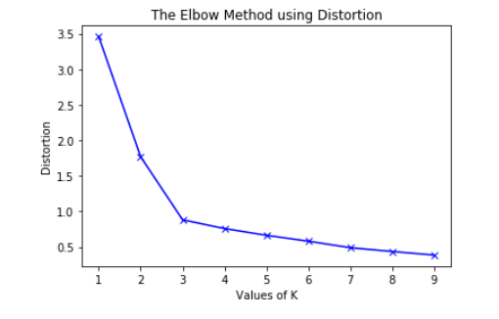

**Silhouette Method:**

With the help of the silhouette method, we can measure the quality of our clustering operation. With this, we can determine how well within the cluster is the data object. If we obtain a high silhouette width, it means that we have good clustering. The silhouette method calculates the mean of silhouette observations for different k values. With the optimal number of k clusters, one can maximize the silhouette over significant values for k cluster.

Silhouette Coefficient or silhouette score is a metric used to calculate the goodness of a clustering technique. Its value ranges from -1 to 1.

1: Means clusters are well apart from each other and clearly distinguished.

0: Means clusters are indifferent, or we can say that the distance between clusters is not significant.

-1: Means clusters are assigned in the wrong way.

Silhouette Score = (b-a)/max(a,b)

Where

a= average intra-cluster distance i.e the average distance between each point within a cluster.

b= average inter-cluster distance i.e the average distance between all clusters.

**K-means Algorithm:**

It is based on partitioning principle. The algorithm is sensitive to the initialization of the centroids position, the number of K (centroids) is calculated by elbow method (discussed in later section), after calculation of K centroids by the terms of Euclidean distance data points are assigned to the closest centroid forming the cluster, after the cluster formation the barycentre’s are once again calculated by the means of the cluster and this process is repeated until there is no change in centroid position.

**Working Method:**

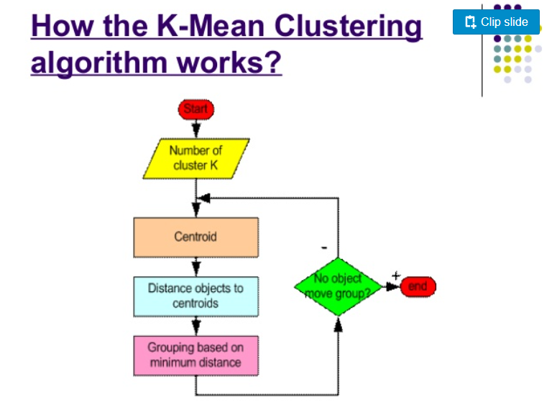

After clustering we get a result like the sample below:



**Agglomerative Clustering:**

Agglomerative Clustering is based on forming a hierarchy represented by dendrograms. Dendrogram acts as memory for the algorithm to tell about how the clusters are being formed. The clustering starts with forming N clusters for N data points and then merging along the closest data points together in each step such that the current step contains one cluster less than the previous one.

**Working Method:**

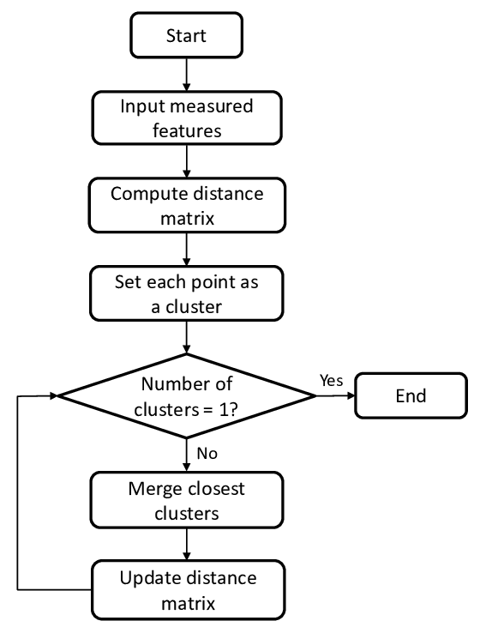

After clustering we get a result like the sample below:

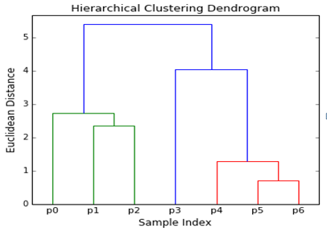

**3.**

**Implementation:**

**3.1**

**Data Collection:**

<https://www.kaggle.com/somesh24/customer-segmentation>

Data Information

This dataset is composed by the following nine features:

Customer id: Unique ID assigned to the customer

Age: Age of the customer

Edu: Customer education qualification

Years Employed: The work experience of customer in years

Income: Annual Income of the customer

Defaulted: Determine whether the customer is defaulted or not

Address: Address of the customer

DebtIncomeRatio: Percentage of ratio between spending score and income

Spending_score: Score assigned by the mall based on customer behavior and spending nature.

NB: We created spending score column by adding Card Debt and Other Debt column.

In this particular dataset we have 850 samples to study.

**3.2**

**Data Processing:**

* we have checked and dropped null values
* dropped few unnecessary columns: (Customer id, Defaulted, Address, DebtIncomeRatio)
* handled categorized values that exits in dataset
* Standardizing data, so that all features have equal weight.

**3.3**

**Model Development:**

We have used Anaconda, Jupiter Notebook as our project environment, used Python language to develop our code.

**3.4**

**Result:**

Data visualization: We have studied and analyzed our dataset by various graph and plots they are:

* We are plotting the histograms where we are only going to consider the following features: Income, Spending_score and Age.

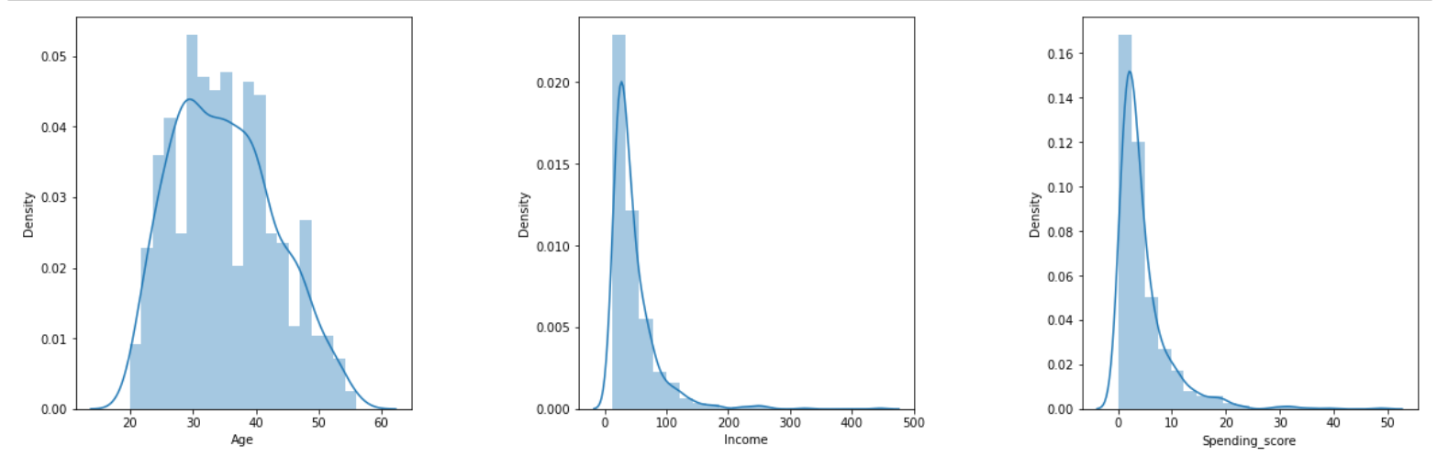

In these histograms we can observe that the Age distribution of these values resembles a Gaussian distribution, where the vast majority of the values lay in the middle with some exceptions in the extremes.

* we analyze the "Age" feature using Boxplot, it's a continuous variable.

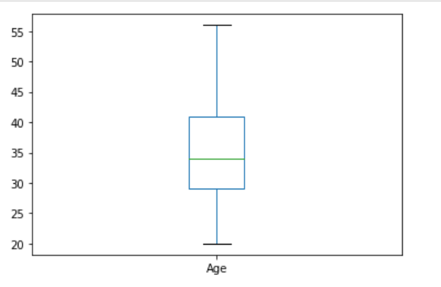

From the above graphs, we can obviously conclude that most of the customers have an age between 29 and 41, also the minimum age of customers is 20, whereas the maximum age is 56.

* Now we will create a piechart and a Countplot on "Edu" and "Years Employed" to show distribution across our customers dataset

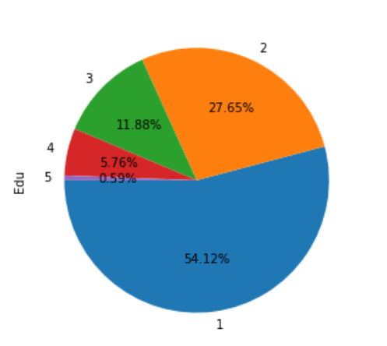

From the above graph, we conclude that the percentage of

Edu 1 is 54.12%,

Edu 2 is 27.65%,

Edu 3 is 11.88%,

Edu 4 is 5.76%,

Edu 5 is 0.59% .

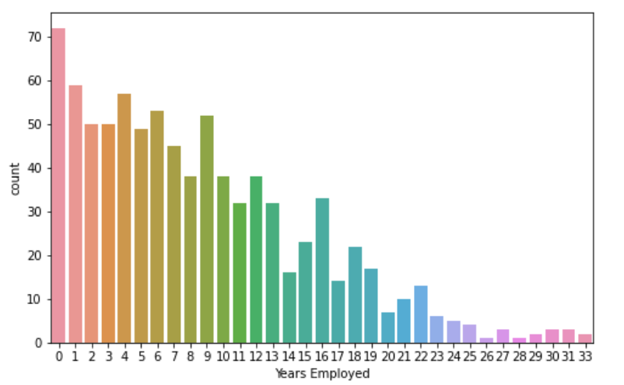

Here we see the number of each Year Employed of our customers.

* Now we will explore the "Income" and "Spending_score" feature using a histogram and a density plots and Boxplot to get insights from this feature

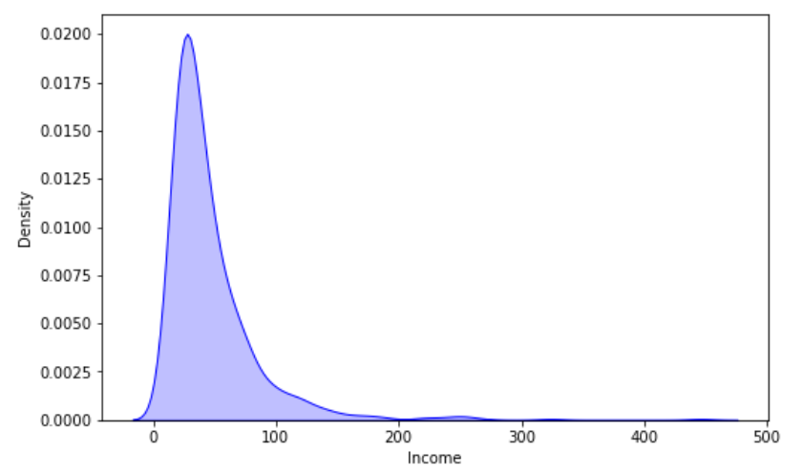

From the above graphs, we can obviously see that the minimum annual income of the customers is 13 while the maximum income is 446. People earning an average income of 446 have the highest frequency count in our histogram distribution. The average income of all the customers is 46.67. In the Kernel Density Plot that we displayed above, we observe that the annual income has not a normal distribution.

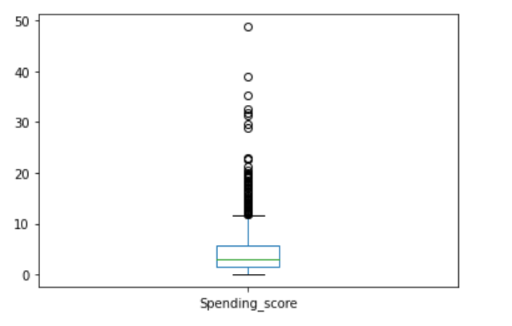

The minimum spending score is 0.075 while the maximum is 48.75 and the average is 4.65. From the Box plot, we can conclude that class of customers having a spending score between 1 and 12 have the highest frequency among all classes.

* let's plot the relation between variables using "Edu" as a class distinction. In order to do so we are using the function pairplot and some parameters as well so we can visualize the "Edu" class separation better.

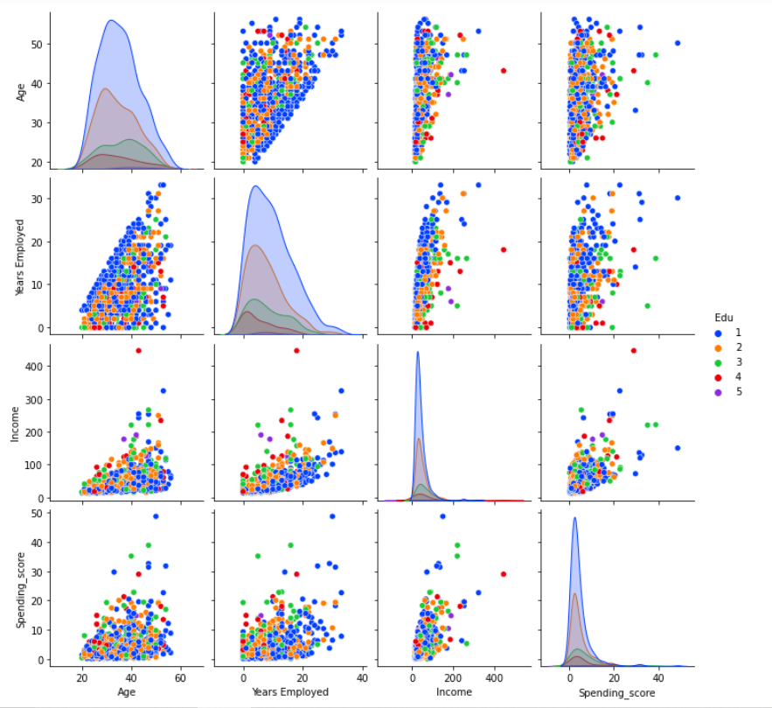

After analyzing our dataset and clustering we have made some questions from which we can say how clustering help customer segmentation

We can understand the variables much better and take good decisions, prompting us to take careful decisions. With the identification of customers, companies can release products and services that target customers based on several parameters like income, age, spending patterns, etc.

1. Which age group has highest income?

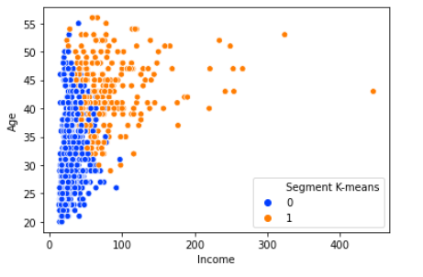

* In this graphic we can clearly see how people in their thirty threes, forties and fifties tend to earn more money annually than the ones younger than thirty threes or older than fifty years old. That is to say people whose age lays between thirty-three and fifty years old seem to get better jobs since they might be better prepared or be already more experienced than younglings or older people. In the graphic we can also see how cluster 0 people tend to earn a little bit more money than cluster 1 people, at least until fifty years old.

1. Which age group comes into the mall most and their income?

* we can see people age from 29 to 41 come to mall most and their Income is in between 10k to 80k.

1. Which Age group comes into mall most and their spending score?

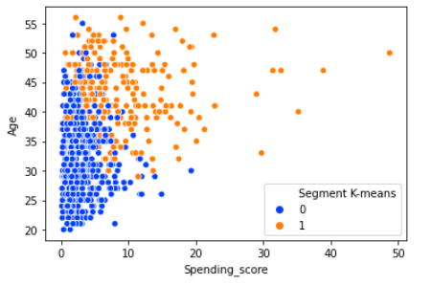

* we can see people age from 29 to 41 come to mall most and their Spending_score is in between 1k to 14k.

1. Which Education groups have highest spending score?

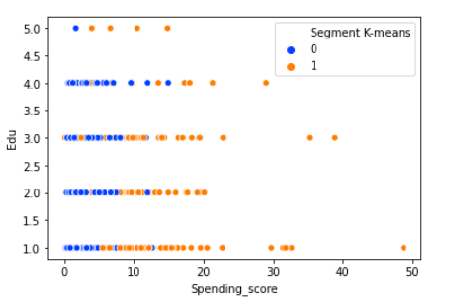

* We noticed that 54.12% people of our Mall are in Edu group-1 which have high spending score of 1 to 20 and most of them are from Cluster 0. Again about 27.65% people of our Mall are in Edu group-2 and their spending score of 1 to 15 and most of them are also from Cluster 0.

1. What years employed range have highest income?

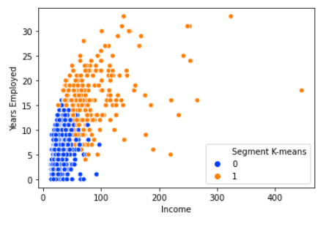

* From the above graph we see that the person whose Years Employed in between 12 to 23 have higher income and most of them are from Cluster 0.

1. Relation between years employed and spending score.

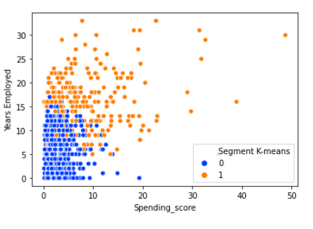

* Here we can observe how a better Years Employed leads to having a higher spending score. With the increasing of Years Employed people have more spending score in the Mall.

**4.**

**Conclusions:**

KMeans Clustering is a powerful technique in order to achieve a decent customer segmentation.

Customer segmentation is a good way to understand the behaviour of different customers and plan a good marketing strategy accordingly

From our cluster analysis:

Yellow Cluster –

The yellow cluster groups middle-aged people with moderate to low annual income who actually spend a lot.

As middle-aged people spend more money in malls, the main target when it comes to marketing, then we have to doing deeper studies about what they are interested in may lead to higher profits.

Promoting discounts on some shops can be something of interest to those who don't actually spend a lot and they may end up spending more!

Blue Cluster – The blue cluster basically groups people of all ages whose salary isn't pretty high and their spending score is low.

Although middle-aged seem to be the ones spending the most, we can't forget there are more people we have to consider, like people who belong to the blue cluster, they are what we would commonly name after "Younger" and it seems to be the biggest cluster.

**4.1**

**Challenges:**

* 1. We had to use many kinds of graphs and plots at first to analyze our data and only selected a few plots because all plots were not good for analysis
  2. We have faced accuracy determining problem at first because it is unsupervised technique
  3. We did not find any dataset with sufficient quality.

**4.2**

**Limitations:**

* 1. Our project cannot handle any dataset containing images

**4.3**

**Future decision:**

Furthermore, more complex patterns like product reviews are taken into consideration for better segmentation.

This work can be extended to perform incremental way of clustering as new data

is streamed in. Also, identifying appropriate number of clusters for a particular

data set through some kind of evaluation instead of empirical analysis could also

be a possible extension. In addition to labeling the clusters using the top terms,

methods like Wikipedia cluster labeling which identifies top terms from the cluster

results and search in Wikipedia for best possible titles that match top terms can

be an enhancement to this work