

**CSE303 (Section 1)**

**[Spring 2022]**

**Lab Assignment Submission Report**

**Assignment Title: Lab 0 (Basic Python Programming)**

**Submitted by:**

**Tanvir Mobasshir**

**2019-2-60-025**

1. **Code Link**

https://colab.research.google.com/drive/1wWToAvGeHrcmNv3Xiki4mSwtYM5Bd3ge

1. **Screenshots**

**Problem 1:**

**Valid Triangle:**

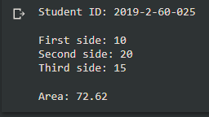

**Invalid Triangle:**

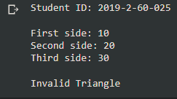

**Problem 3:**

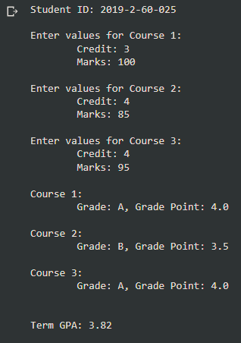

1. **Learning Outcomes**

We have learned two things during this lab:

* **Python**
* Printing statements and user input
* Different object types (aka data types)
* Operators (Arithmetic, Comparison, Logical)
* Loops
* **Anaconda**