Jhenaidah Cadet College

The Learned are Judicious

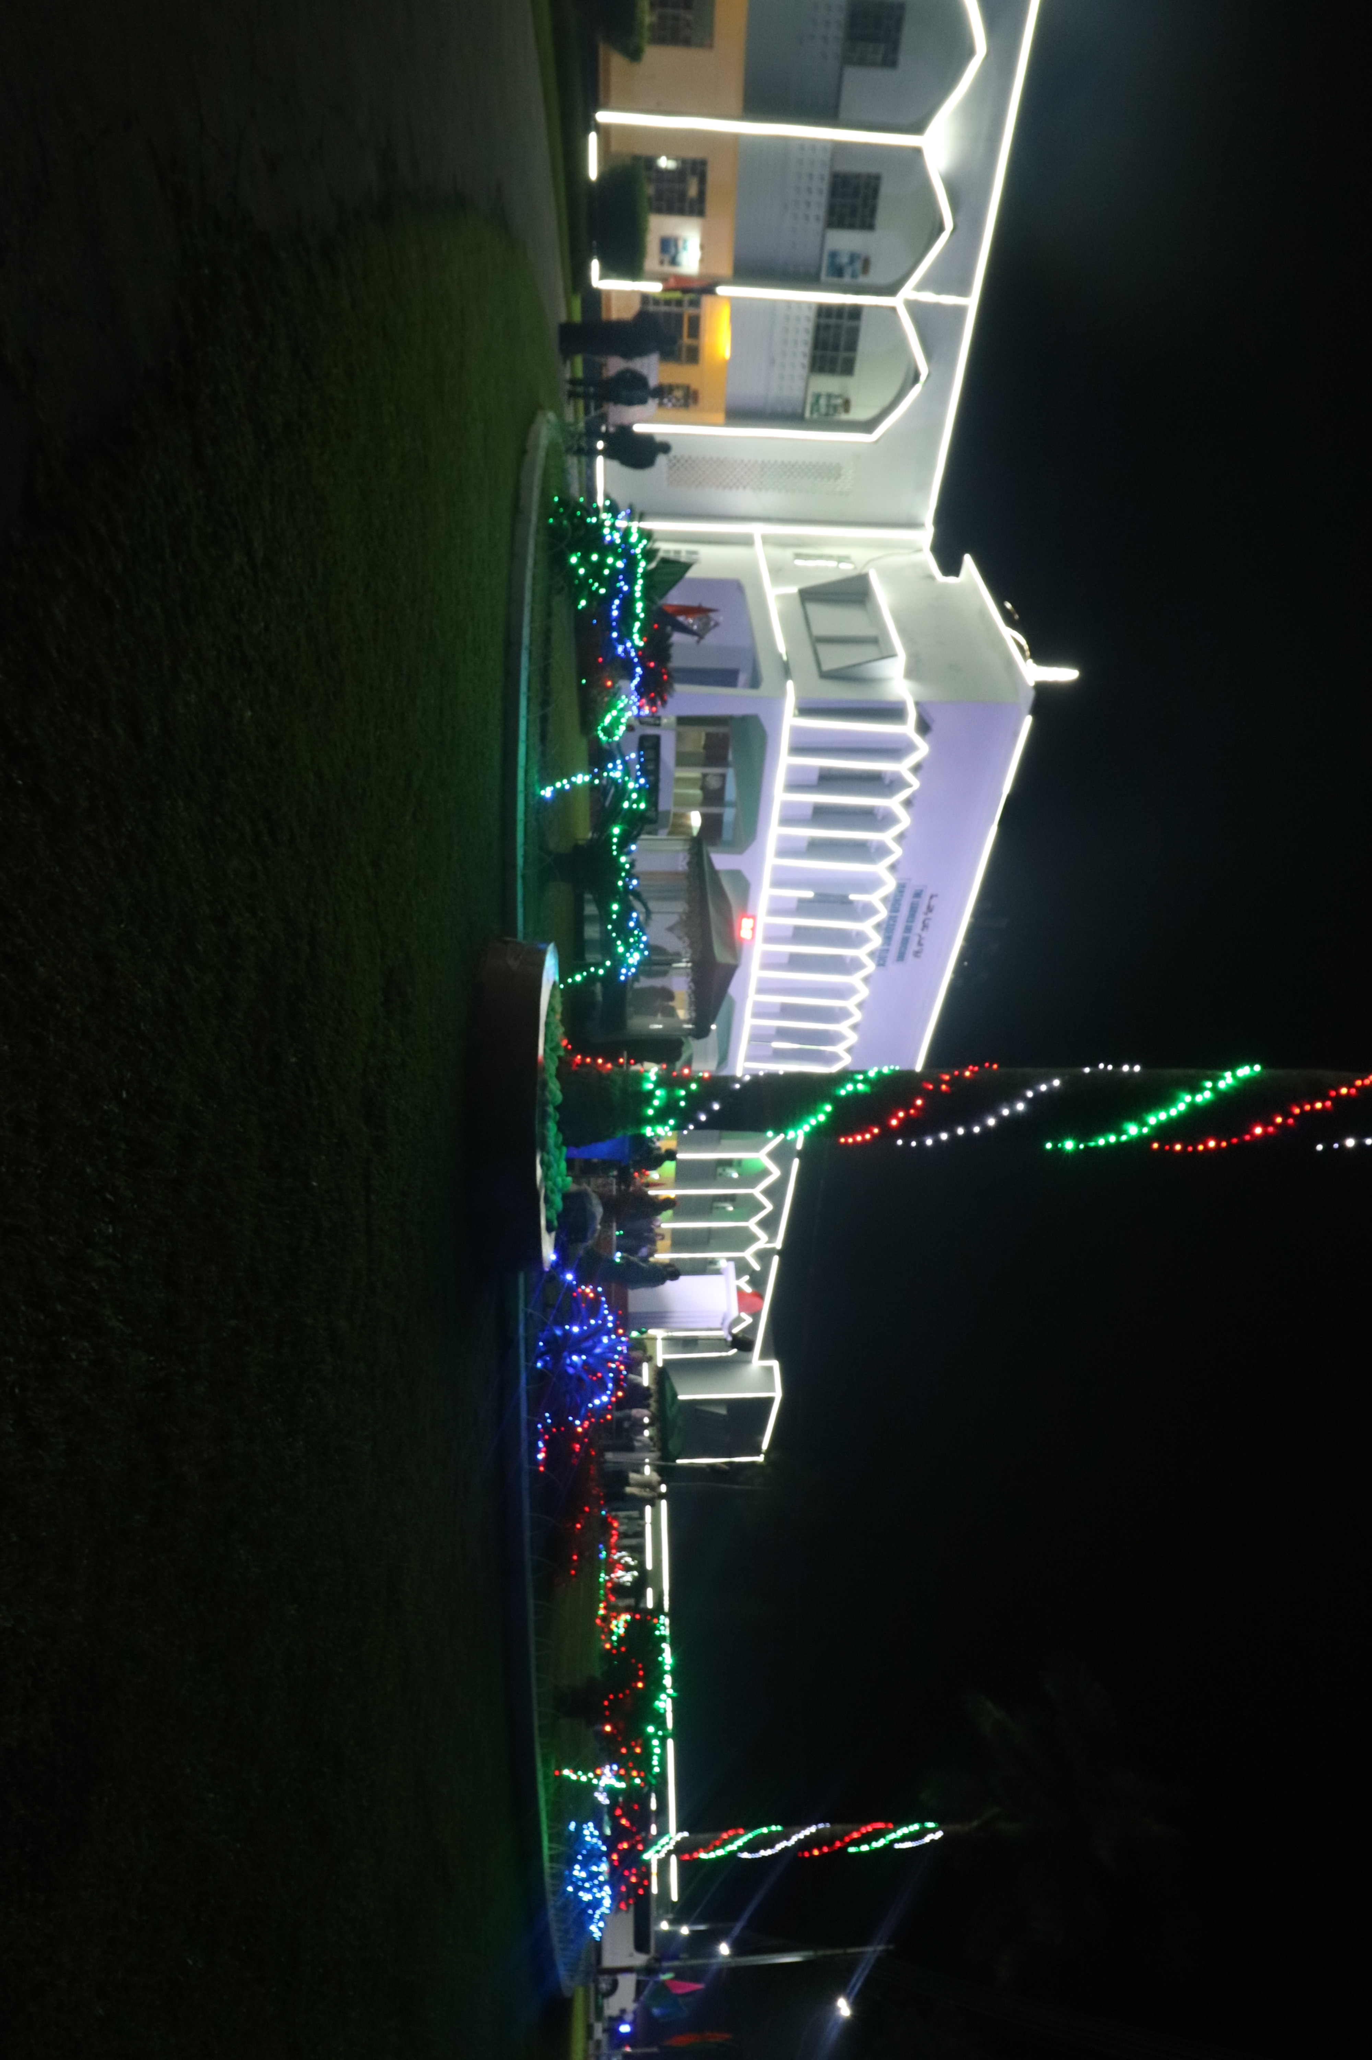

* **Cadet college** is a special military school system of [British India](https://en.wikipedia.org/wiki/British_India) and later, [Pakistan](https://en.wikipedia.org/wiki/Pakistan) and [Bangladesh](https://en.wikipedia.org/wiki/Bangladesh).
* Cadet Colleges are specifically intended to prepare young students from a very broad range of socioeconomic and linguistic backgrounds to pass the demanding physical, educational, psychological and behavioral standards of the [Inter Services Selection Board](https://en.wikipedia.org/wiki/Inter_Services_Selection_Board) (ISSB). This is distinct from the purpose of regular cantonment schools intended to educate the children of service members.
* There are 12 total cadet colleges in Bangladesh.
  1. Faujdarhat Cadet College
  2. Jhenaidah Cadet College
  3. Mirzapur Cadet College
  4. Rajshahi Cadet College
  5. Rangpur Cadet College
  6. Barisal Cadet College
  7. Pabna Cadet College
  8. Mymensingh Girls Cadet College
  9. Comilla Cadet College
  10. Feni Girls Cadet College
  11. Joypurhat Girls Cadet College