Prime number

Fibonacci🡪

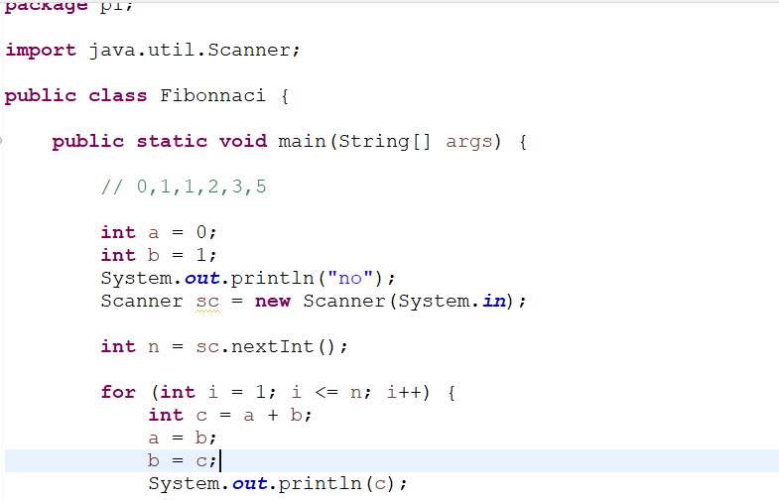

Armstrong Number 🡪

