1. **Reverse number And String**

**Palindrome String and palindrome number**

**Min Max Number with their index**

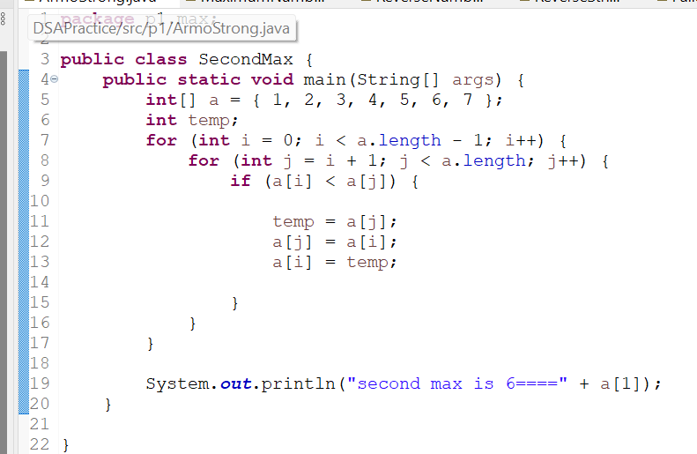 Second max min

Duplicate Array And String

Sum of elements in array

Odd Even Array

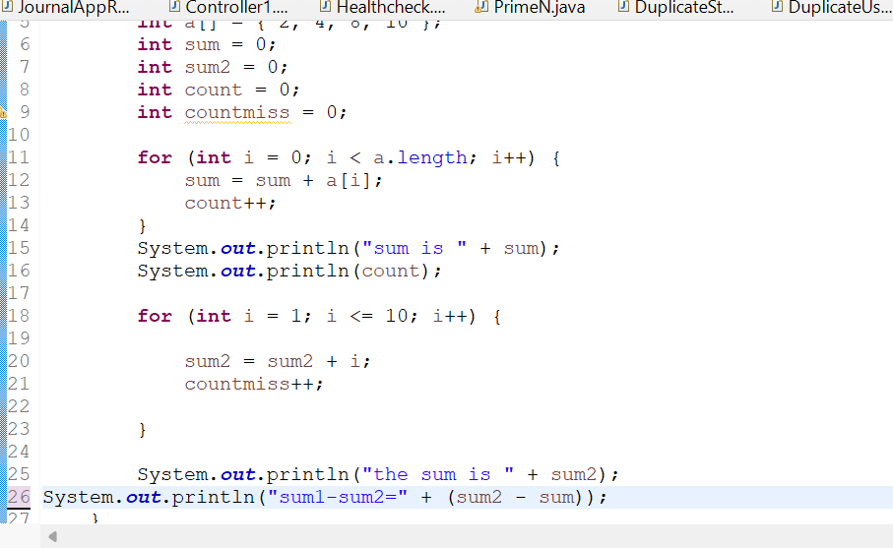Missing elements

Armstrong Number

Prime number

Fibonacci Series

hjkjbkjkjbhb

Factorial

