1. What is wireless network examples and Advantages and disadvantages

* A **wireless network** is a type of network that connects devices without cables, using radio waves to transmit data

E.g. • Smartphones,• Laptops,• Tablets,• Smart TVs,• Wireless printers

Adventages🡪**No Cables Needed**: Easier to set up and move devices

**Flexibility**: Connect from anywhere within range.

**Easy to Expand**: Add devices without extra wiring.

Disaventages🡪• **Less Secure**: Easier for unauthorized access.

• **Signal Interference**: Other devices can slow it down.

1. What is Wireless LAN and where we used Advantages and disadvantages

* A Wireless LAN (WLAN) is a network that connects without using any wires. It uses radio waves or to transmit data.
* Work on half duplex (only one station can transmit otherwise collision occur)

Advantages🡪 Easy to setup

**Flexible**: Easy to add more devices without running new wires.

**Disadvantages**🡪**Less Secure**: Other people might try to connect or hack into it.

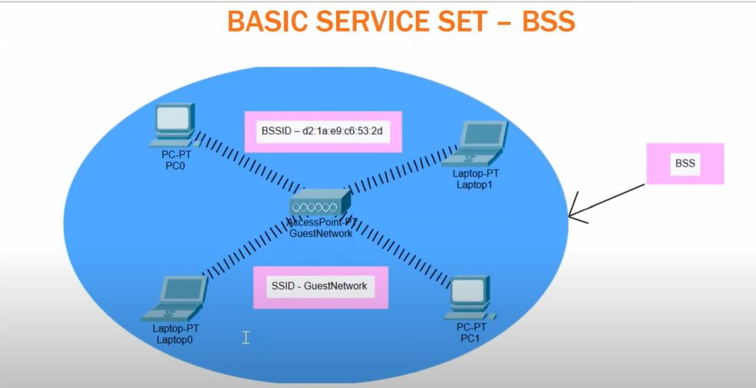 **Range Limits: It only works within a certain area, so you may need extra devices to cover larger spaces.**

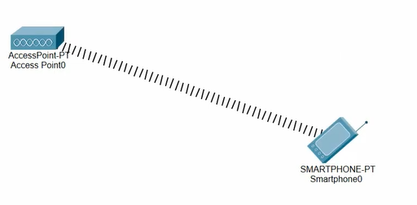

This Range are called BSS (Basic Service Set)



BSA BSS both terms are used in Wireless network

BSS🡪this is Wi-Fi network created by single router where all devices connected to router

BSA🡪this is area covered by your Wi-Fi signal devices within this area can connect to the network

The physical area covered by the BSS's signal.

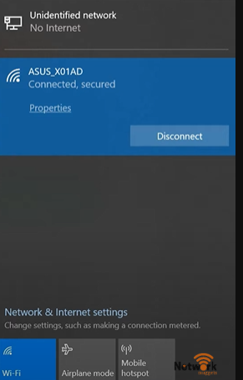

SSID🡪( Service set Identifier)

This is the simple name of Wi-Fi that user see at the time of connecting

BSSID (Basic Service Set Identifier)🡪 This is the unique hardware address (like a MAC address) of the specific Wi-Fi router or access point

It's used by devices to identify and connect to that exact router

**Example: In a large office with multiple Wi-Fi routers, each router will have the same SSID for seamless connection, but each will have a unique BSSID.**

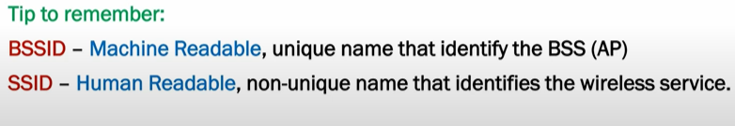

BSS Association🡪

**BSS Association** refers to the process by which a wireless device connects to a Basic Service Set (BSS) through an access point (AP)

End device is called Stations

Working of BSS Association

• **Discovery**: The device scans for available Wi-Fi networks (SSIDs) in the area.

• **Authentication**: Once it selects a network, the device sends an authentication request to the access point.

• **Association**: After authentication, the access point and the device establish a connection. The device is now associated with the BSS, allowing it to communicate with the access point and other devices on the network.

BSS Security Concerns 🡪

**Unauthorized Access**: Hackers may connect to the network if it's not properly secured.

**Rogue Access Points**: Fake access points can trick users into connecting, capturing their data.

**Weak Passwords**: Easily guessable passwords can allow unauthorized access.

Distribution System🡪

* If we have building and there is lots of offices on each floor and you want to Provide Wi-Fi service that time different access points connected to switches so each floor Can have good internet service
* The **Distribution System** can be set up to allow different networks (VLANs) to use separate Wi-Fi names (SSIDs).
* For example:

**VLAN 10** connects to SSID **"VIP"**

**VLAN 20** connects to SSID **"Blizzard"**

**VLAN 30** connects to SSID **"Open Network"**

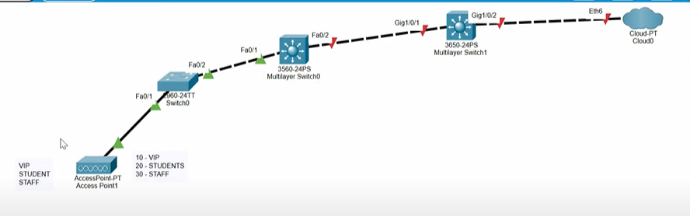• The **Access Point (AP)** connects to a **switch** that handles multiple networks (VLANs).

• The AP uses **tags** to match each network to a specific Wi-Fi name.

Single AP

Note – Access points like Wi-Fi Routers, Wireless Access Points, Hotspots

• **Enterprise APs** - Advanced access points used in large buildings, schools, or campuses.

• **Outdoor APs** - Durable APs used in outdoor areas like parks and stadiums.

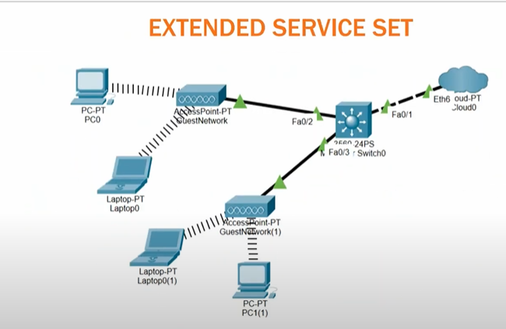Extended Service Set 🡪

An **Extended Service Set (ESS)** is a group of connected Wi-Fi access points that share the same network name (SSID) to provide seamless coverage across a larger area

E.g. In a large office building with multiple access points, all access points are part of the ESS, so employees can move around the building without losing Wi-Fi connection

**Independent Basic service set (IBSS)**

is a type of Wi-Fi network where devices connect directly to each other without needing a router or access point. This is also known as an ad hoc network.

When you connect two laptops directly over Wi-Fi to share files

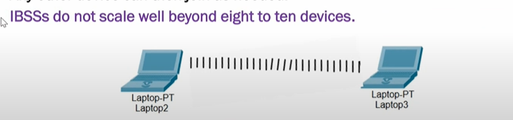

Other Wireless topologies🡪

Repeater 🡪 A wireless repeater takes the signals and repeat same signals or transmit it in new cells

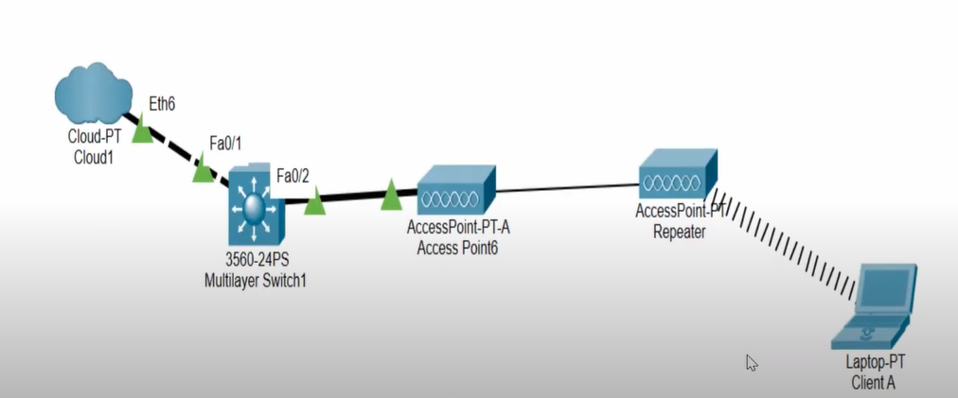helping cover larger areas without extra cabling.

**Outdoor Bridge**

* **What it is:** A setup that connects two separate networks over long distances using wireless signals.
* A blue spiral on a white background

  Description automatically generated**Example:** Think of two office buildings that are far apart but need to share the same internet connection. An outdoor bridge can link the two buildings wirelessly, allowing them to communicate and share resources, like printers and files, without running cables between them.

**3. Mesh Network**

* **What it is:** A network made up of several devices (nodes) that work together to cover a large area with Wi-Fi. If one node stops working, the others still keep the connection going.
* 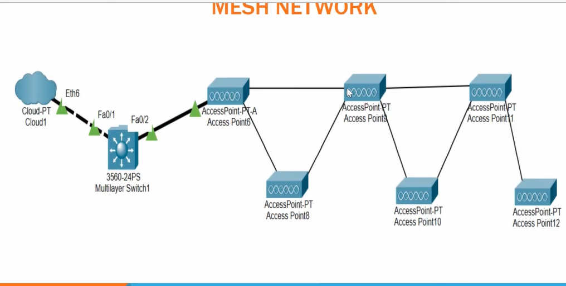**Example:** In a large coffee shop, instead of having one router, the owner can set up multiple mesh nodes around the shop. This ensures that customers can connect to Wi-Fi no matter where they sit. If one node fails, the others continue to provide coverage, so customers stay connected.

**• What are the differences between WLAN, Wi-Fi, and WWAN?**

* **Answer:**
  + **WLAN (Wireless Local Area Network): Connects devices within a local area, like a home or office.**
    - **Example: Your home Wi-Fi network.**
  + **Wi-Fi: The technology that enables devices to connect to WLANs wirelessly.**
    - **Example: Connecting your laptop to your home Wi-Fi.**
  + **WWAN (Wireless Wide Area Network): Covers larger geographic areas, like cellular networks (4G, 5G).**
    - **Example: Your smartphone’s mobile data connection.**

**• Explain the 802.11 wireless standards and their key differences.**

* **Answer:**
  + **Standards like 802.11a/b/g/n/ac/ax improve speed and range.**
    - **Example: 802.11ac supports faster speeds for streaming compared to 802.11n, while 802.11ax (Wi-Fi 6) enhances performance in crowded places, like stadiums.**

**• What are the roles of an access point (AP) and a wireless controller in a wireless network?**

* **Answer:**
  + **Access Point (AP): Connects devices to the network wirelessly.**
    - **Example: A hotspot in a café.**
  + **Wireless Controller: Manages multiple APs for centralized control.**
    - **Example: IT managing all APs in a large office from one central location.**

**• Describe the security protocols used in wireless networks (e.g., WEP, WPA, WPA2, WPA3).**

* **Answer:**
  + **WEP: Outdated and weak.**
  + **WPA: More secure than WEP.**
  + **WPA2/WPA3: Provide stronger encryption.**
    - **Example: Home networks often use WPA2 or WPA3 to ensure security.**

**• What is SSID, and why is it important?**

* **Answer:**
  + **SSID (Service Set Identifier): The Wi-Fi network name users see.**
    - **Example: When connecting to “Home_WiFi,” the SSID indicates which network you’re joining.**

**• Explain the process of wireless network authentication.**

* **Answer:**
  + **The network checks your credentials (like a password) when you try to connect.**
    - **Example: You enter the café's Wi-Fi password to gain access.**

**• What is the difference between infrastructure mode and ad-hoc mode in WLAN?**

* **Answer:**
  + **Infrastructure Mode: Uses APs to connect devices.**
    - **Example: Your phone connecting to a home router.**
  + **Ad-Hoc Mode: Connects devices directly without an AP.**
    - **Example: Two laptops sharing files directly.**

**• How do you prevent interference in a wireless network?**

* **Answer:**
  + **Choose a clear channel, keep APs away from other electronics, or use the 5 GHz band.**
    - **Example: Changing your Wi-Fi channel if neighbors are on the same one reduces interference.**

**• Describe the purpose of frequency channels in Wi-Fi and how channel overlap affects performance.**

* **Answer:**
  + **Wi-Fi channels help networks operate without interference; overlapping channels slow performance.**
    - **Example: Setting your router to a unique channel avoids interference from nearby networks.**

**• How does roaming work in wireless networks, and what is a handoff?**

* **Answer:**
  + **Roaming allows devices to switch APs without losing connection; a handoff occurs when a device moves to a new AP.**
    - **Example: Walking through an office while on a call, your phone connects to different APs seamlessly.**

**• What is MIMO, and how does it improve wireless communication?**

* **Answer:**
  + **MIMO (Multiple Input, Multiple Output): Uses multiple antennas to send/receive more data simultaneously.**
    - **Example: A smart TV streams movies faster using multiple antennas.**

**• Explain the difference between 2.4 GHz and 5 GHz bands and their pros and cons.**

* **Answer:**
  + **2.4 GHz: Covers longer distances but is slower.**
  + **5 GHz: Faster but has a shorter range.**
    - **Example: Use 5 GHz for speed near the router; 2.4 GHz for wider coverage throughout a house.**

**• What is the purpose of a wireless LAN controller (WLC), and how does it operate?**

* **Answer:**
  + **A WLC manages multiple APs for easier control of large networks.**
    - **Example: A campus network where IT configures all APs from one place.**

**• What tools and commands can be used to troubleshoot a wireless network?**

* **Answer:**
  + **Tools like ping, traceroute, and Wi-Fi analyzers help troubleshoot issues.**
    - **Example: Using a Wi-Fi analyzer app to check for channel interference if the connection is slow.**

**• How does signal-to-noise ratio (SNR) impact wireless performance?**

* **Answer:**
  + **SNR measures the strength of the signal compared to noise; higher SNR means better quality.**
    - **Example: Wi-Fi works better in a quiet room (high SNR) than in a crowded café (low SNR).**

**• What is RSSI, and how is it measured?**

* **Answer:**
  + **RSSI (Received Signal Strength Indicator): Measures Wi-Fi signal strength, usually from -30 dBm (strong) to -90 dBm (weak).**
    - **Example: If RSSI is -70 dBm, moving closer to the router improves the signal.**

**• Explain the concept of wireless channel bonding.**

* **Answer:**
  + **Channel bonding combines two channels for higher data rates.**
    - **Example: A router bonding two 5 GHz channels increases speed for streaming HD video.**

**• How do you secure a wireless network against unauthorized access?**

* **Answer:**
  + **Use WPA2/WPA3 encryption, change default passwords, and enable MAC filtering.**
    - **Example: Setting a strong password and using WPA2 keeps outsiders from accessing your Wi-Fi.**

**• What are some common wireless network topologies (e.g., mesh, star)?**

* **Answer:**
  + **Star: Devices connect to a central AP.**
  + **Mesh: Multiple APs connect to create a wider network.**
    - **Example: A mesh Wi-Fi system ensures full coverage in a large house.**

**• How does QoS (Quality of Service) work in a wireless network?**

* **Answer:**
  + **QoS prioritizes important traffic (like video calls) to prevent lag.**
    - **Example: Your Zoom calls won’t lag even if someone else is streaming Netflix.**

**• What is the function of a wireless access point?**

* **Answer:**
  + **An AP provides wireless connectivity to devices, allowing them to access the network.**
    - **Example: A public Wi-Fi hotspot in a library.**

**• How do environmental factors affect wireless signals?**

* **Answer:**
  + **Physical barriers (walls, furniture) can weaken signals, and interference from other devices can cause problems.**
    - **Example: Wi-Fi signal may drop in a basement due to thick walls.**

**• What is the significance of bandwidth in a wireless network?**

* **Answer:**
  + **Bandwidth determines the amount of data transmitted over the network; higher bandwidth allows more data transfer.**
    - **Example: A higher bandwidth connection enables multiple users to stream videos simultaneously without buffering.**

**• Explain the concept of beamforming.**

* **Answer:**
  + **Beamforming directs the Wi-Fi signal towards specific devices rather than broadcasting it in all directions.**
    - **Example: A router using beamforming improves the connection for your phone by focusing the signal directly at it.**

**• How does network congestion affect wireless performance?**

* **Answer:**
  + **High traffic can slow down the network, causing delays or dropped connections.**
    - **Example: If too many devices connect to the same Wi-Fi, streaming videos may become choppy.**

**• What are the benefits of using a mesh network?**

* **Answer:**
  + **Mesh networks provide wider coverage and better reliability by using multiple interconnected APs.**
    - **Example: In a large home, a mesh system ensures every room has strong Wi-Fi without dead spots.**

**• How can firmware updates improve wireless network performance?**

* **Answer:**
  + **Updates can fix bugs, improve security, and enhance performance features.**
    - **Example: Updating your router's firmware may resolve connectivity issues or improve speeds.**

**• What is the impact of physical barriers on Wi-Fi signals?**

* **Answer:**
  + **Walls, furniture, and other obstacles can weaken Wi-Fi signals, reducing range and performance.**
    - **Example: A signal might be strong in one room but weak in another due to a thick wall.**

**• How do antennas affect wireless communication?**

* **Answer:**
  + **Antennas determine the range and quality of the wireless signal; better antennas can provide a stronger signal.**
    - **Example: An AP with high-gain antennas can cover a larger area than one with standard antennas.**